Technical taskГоризонтальная линия

The purpose of the assignment is to test the practical knowledge and skills of the candidate that are relevant to the daily work processes in the **DEVNRISE** team.

Please apply your best programming practices and be careful with code formatting, structure and documentation.

Technologies to use

**Programming language** - PHP (^7)  
  
**Web-server -** Apache / Nginx  
 **Client side (markup languages, client languages)**- JavaScript  
- HTML  
- CSS

**Database management systems** - MySQL

Project Structure

**Authorization page** (login.html) **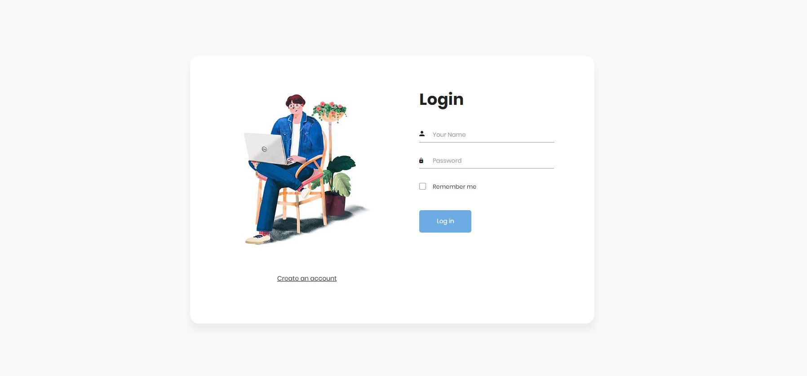  
  
Registration Page** (registration.html) **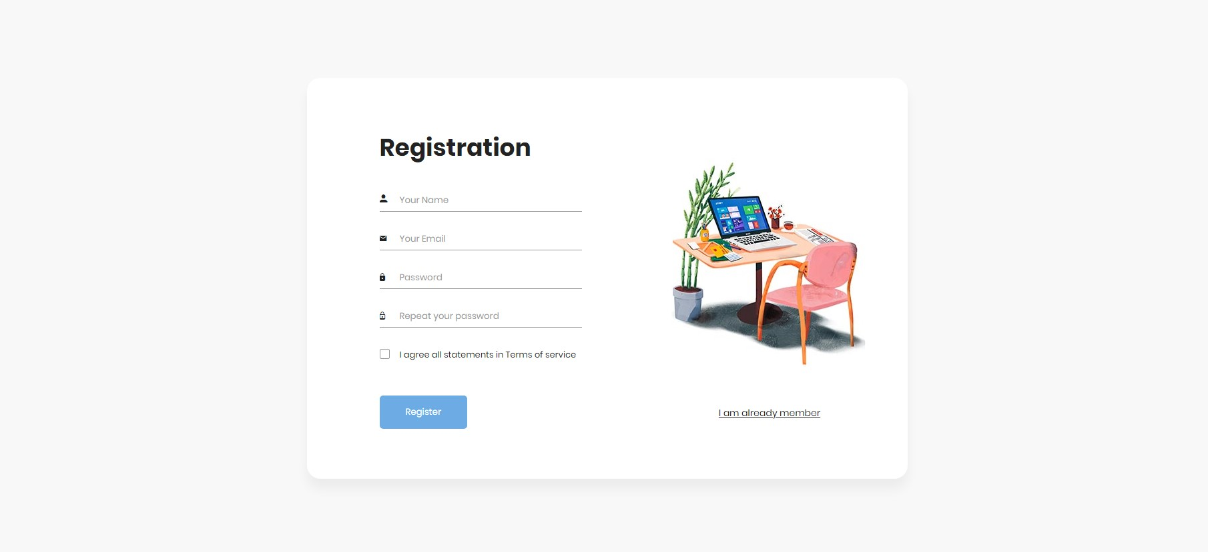  
  
User Profile** (profile.html) 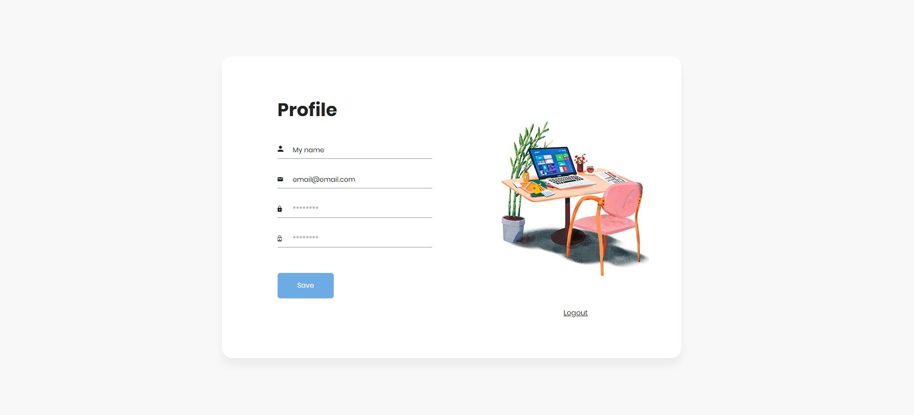

Functional

Based on the provided template (template folder), create the user registration, authorization and authentication functionality, aiming to apply the best skills in the field of OOP standards, security and other PHP practices.

**Avoid using frameworks or CMS systems.** However, for the client side, you can use any libraries or frameworks of your choice (jQuery, Vue, React, etc.).

**Requirements**

User data as well as session states must be stored in a MYSQL database.

Validation of user-entered data on the server side should display errors to the user, if any.

Checking the email address during registration and change on the profile page. The user has the opportunity to specify only the email to which he has access (email verification should be done).