Sample 1

Interface Design
The process of producing the layout, the visual and interactive elements that make users interact with system in efficient manner. It pays attention to the ease of usage, reliability, and the fluent user experience and guarantees that users can use the service with little effort and negligible mistakes. In the case of the AI-enabled multimodal medical data fusion model on the disease prediction, the interface design entails several wireframes to assist the healthcare professionals in their job. Doctors can upload patient information to Data Upload Screen, e.g. X-ray images, lab reports, voice recordings, etc. in an easy structured form. The Prediction Result Screen will show the disease prediction made by the AI (with a confidence percentage level) and an option to have the result read out, via a text-to-speech feature. The Speech Interaction Screen allows the physicians to dictate notes of their patients, which are interpreted by the system and are integrated into the workflow of diagnosis being stored in the database. This interface design will provide a smooth experience since there will be consistent interaction between healthcare professionals and the system, which promotes efficiency, accuracy, and usability.

Wireframes
Figure 26
Wireframe of Login Page
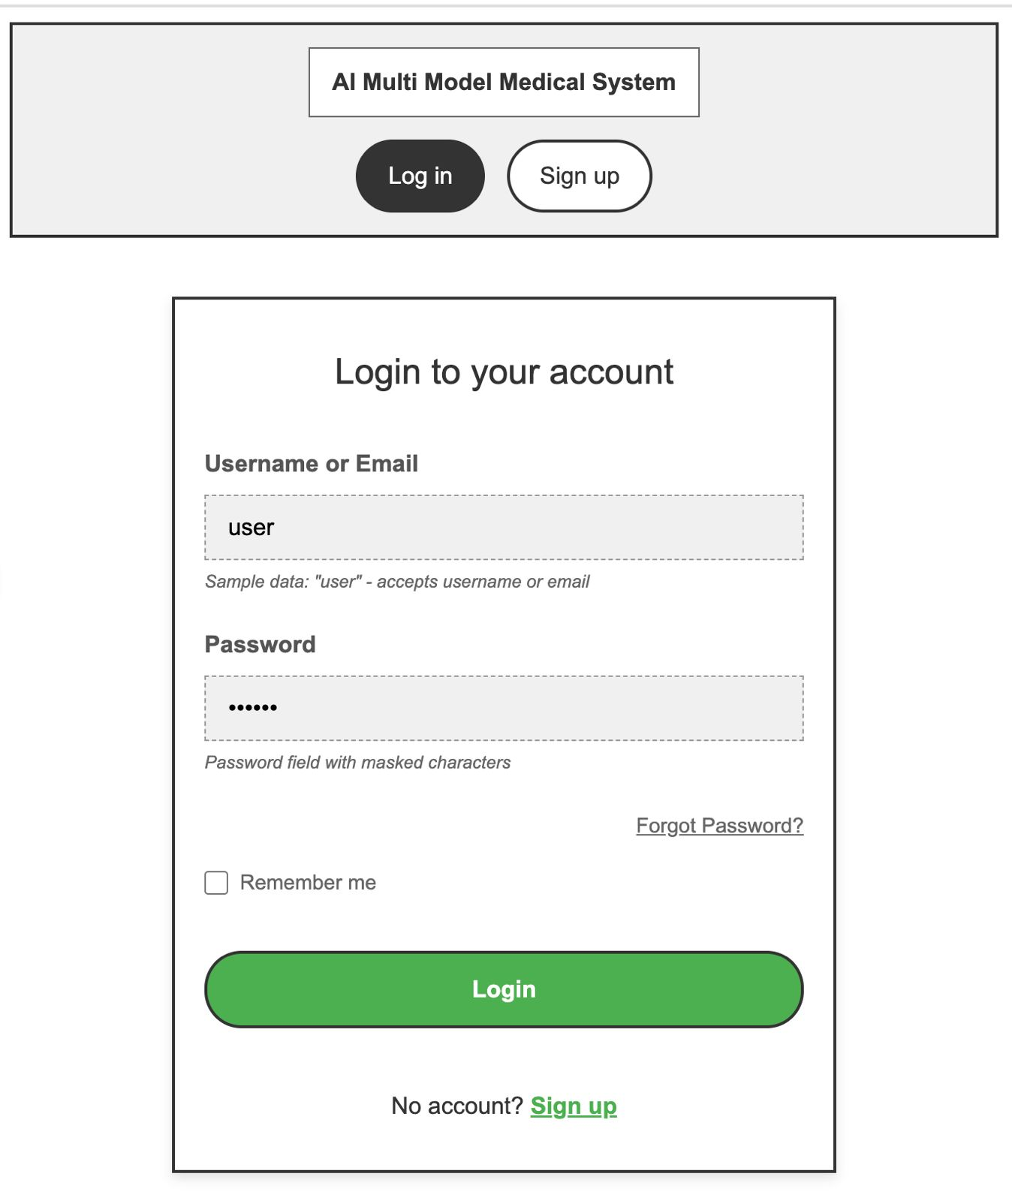
Figure 27
Wireframe of Signup Page
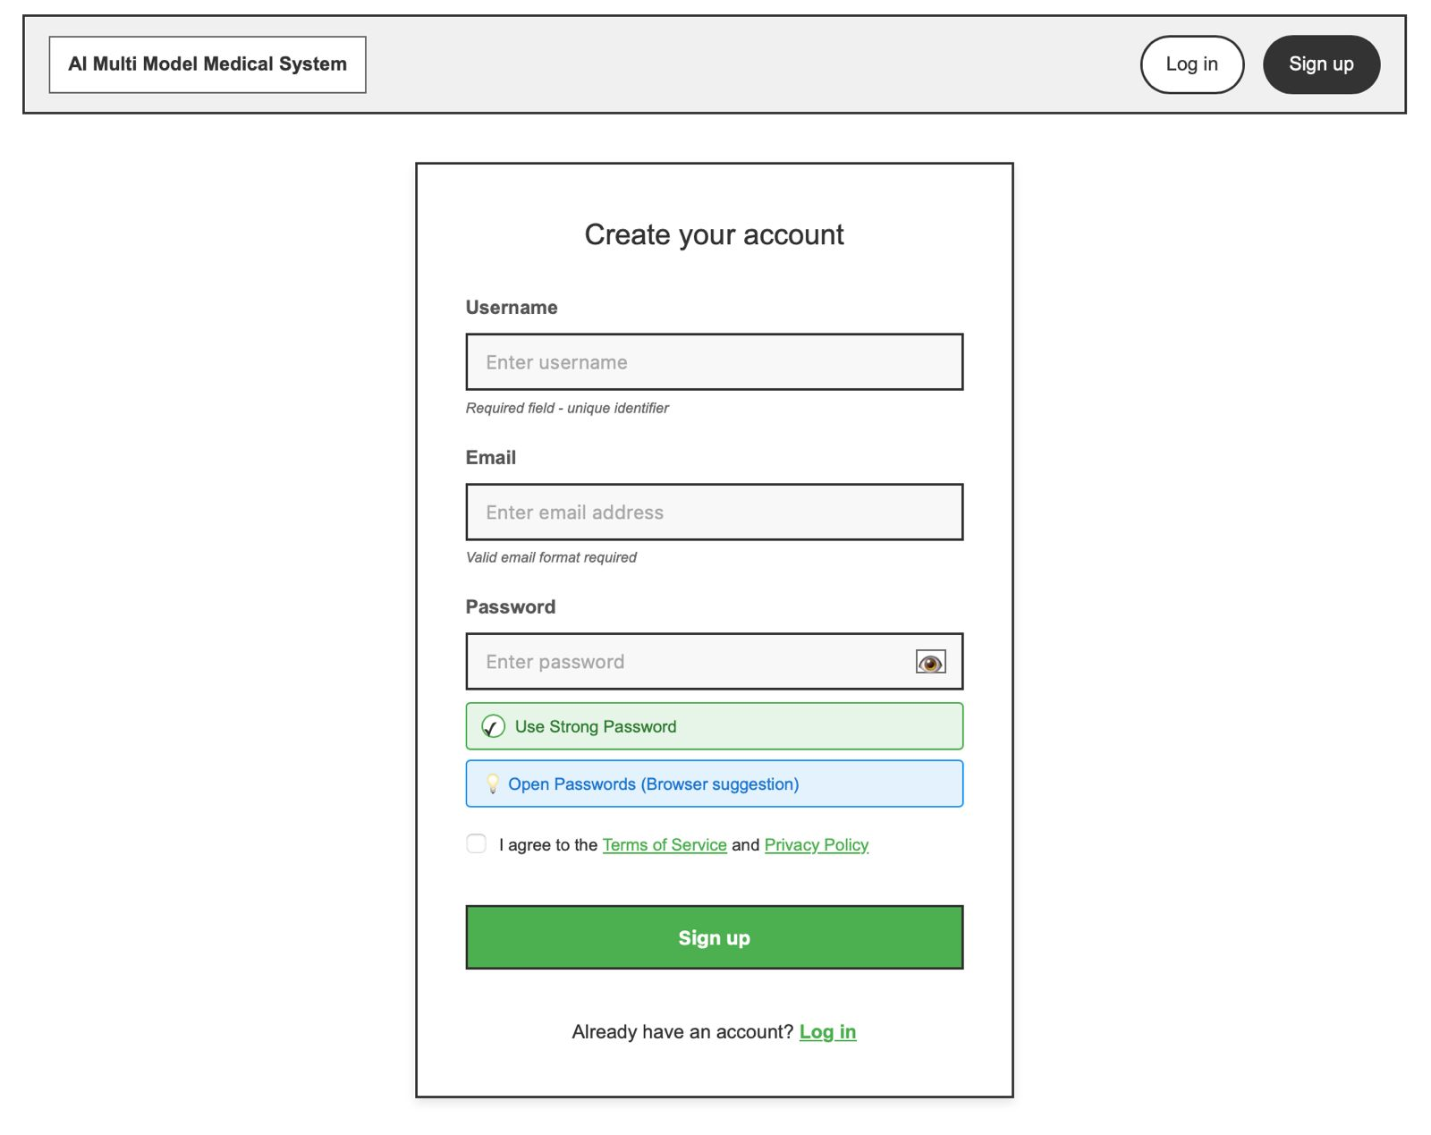
Figure 28
Wireframe of Home Page of Multimodal system
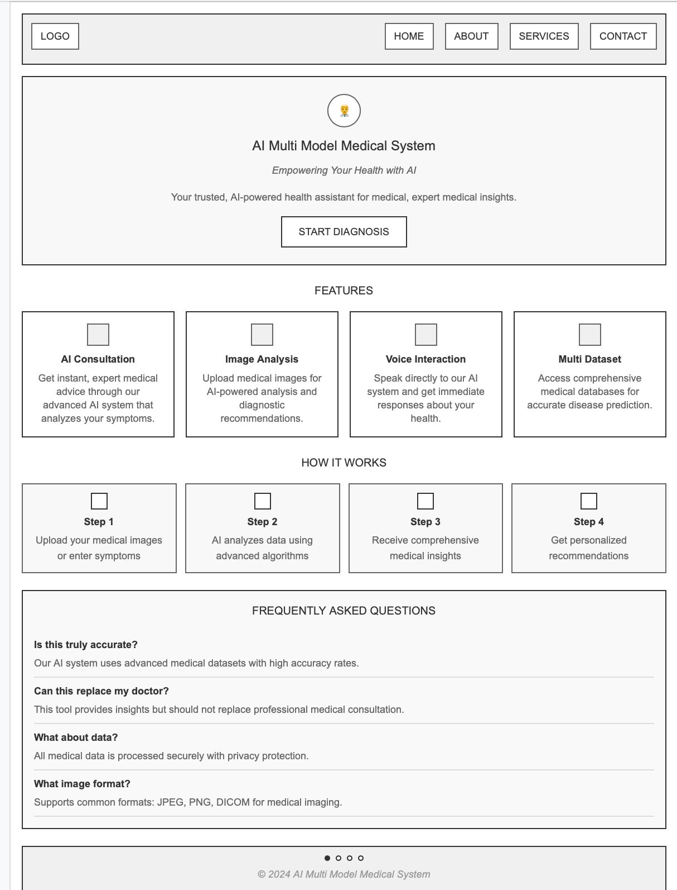
Figure 29
Wireframe of Medical Insight/Report
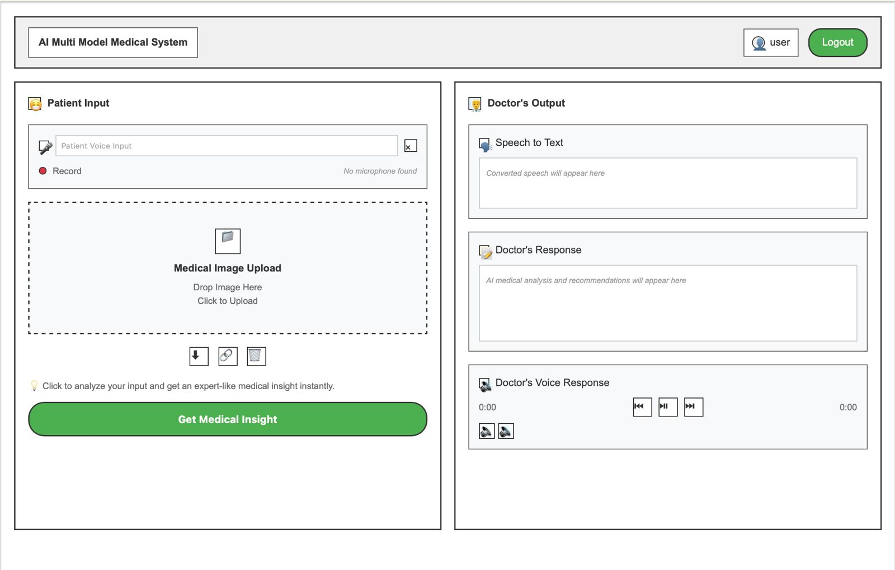
Figure 30
Wireframe of Health Analytics Dashboard
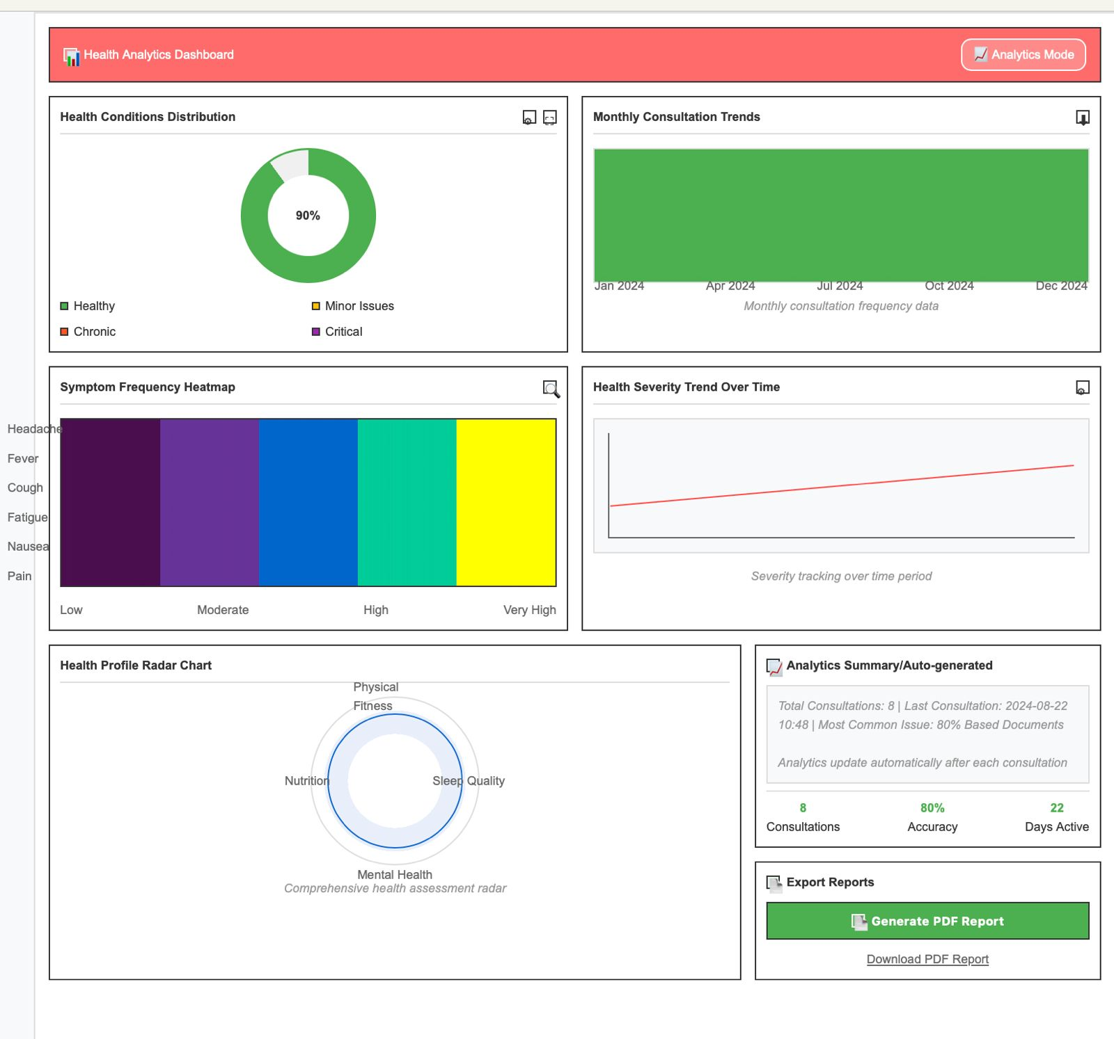

UI Screenshots

Home Page
Figure 31
Homepage of the system
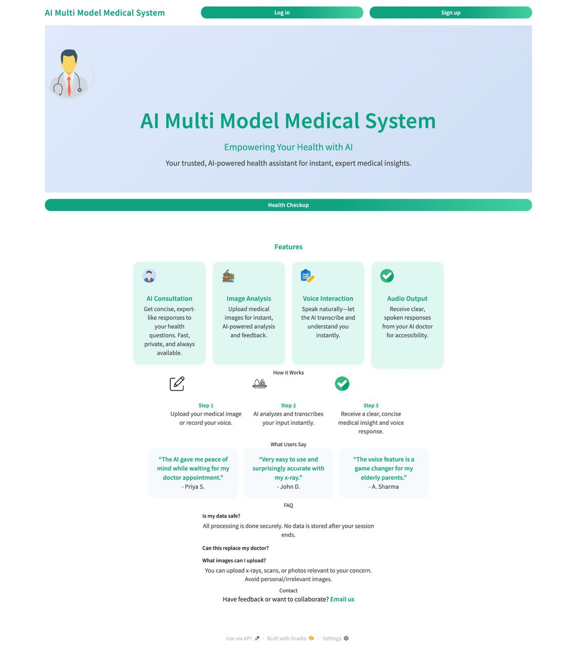
Note: Home Page is the gateway to different opportunities to log in to the system and sign up. It has a center banner with a headline focusing on the AI enabled capacities in regards to health consultation, and cards with co-ordinated titles explaining key features, which include AI Consultation, Image Analysis, Voice Interaction, and Audio Output. Thesection Understanding the Mechanism of How it Works describes the three-stage process of uploading medical data, receiving the AI analysis and getting clear feedback, whereas user feedback shows reliability. A frequently asked questions (FAQ) panel at the bottom covers the most common questions, making it user friendly, intuitive, as well as informative to both first-time and returning users.

Signup Page
Figure 32
Signup Page of the System
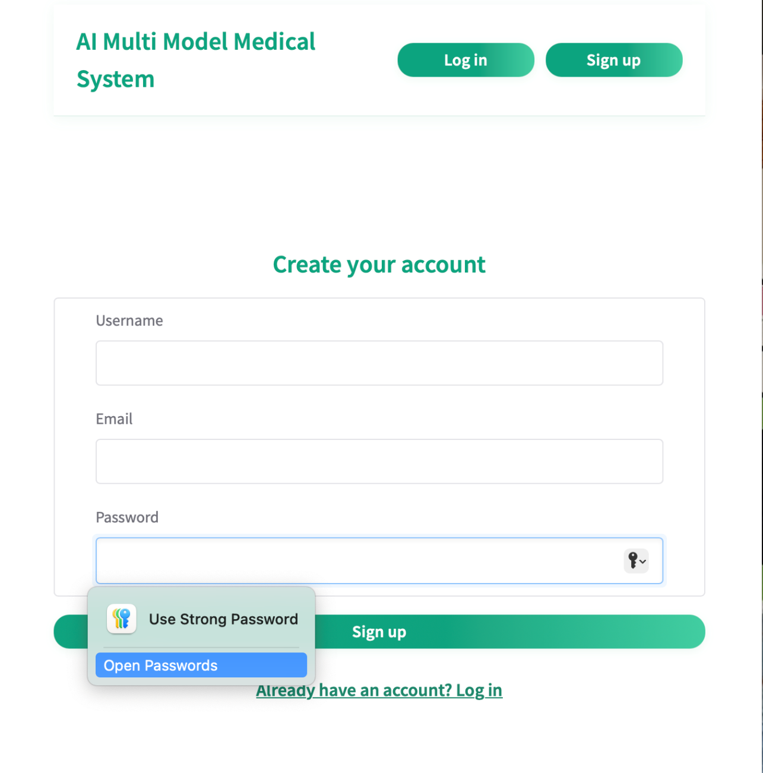
Note: The Signup Page enables medical professionals to sign-up by filling in some important information, including Name, Email, Password, and Role (e.g. Doctor, Nurse). The system also does validation data integrity tests where it checks that the email is not already registered and the password fulfils the required strength criterion. A confirmation message is sent on a successful submission, and the user can securely access the system.

Login Page
Figure 33
Login Page of the system
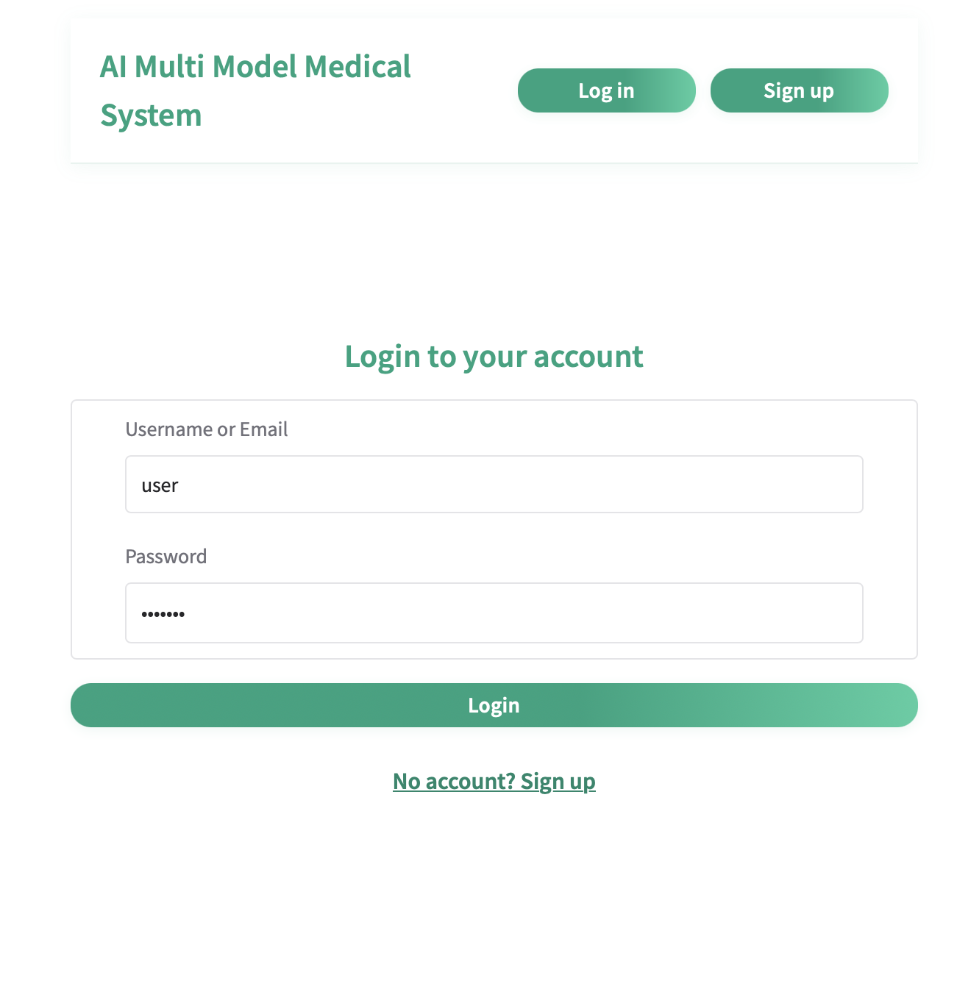
Note: The Login Page allows registered members to enter the system at the point of obtaining their credentials to access the system using their email address and passwords. It grants a flawless authentication procedure and redirects user to their dashboard after a successful log in. The page is also well handled on errors since clear messages are given in cases where the credentials entered were not correct or the user is not registered thus making them aware of the problem during the log in process.

Health Checkup
Figure 34
Health Checkup & Report Generator of the system
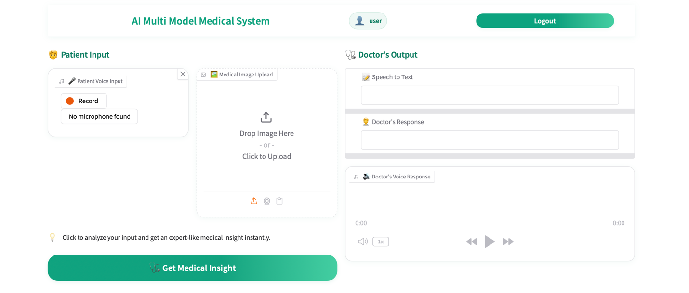
Note: Health care professionals can use this page to record copious patient information like the medical images and lab results as well as leave voice notes on clinical observations. It contains validation processes to accommodate errors like unrecognized file formats, high image size or incomplete lab data to provide sound and precise data entry to be utilized in the problem-solving approach.

Health Analytics
Figure 35
Health Analytics of the system
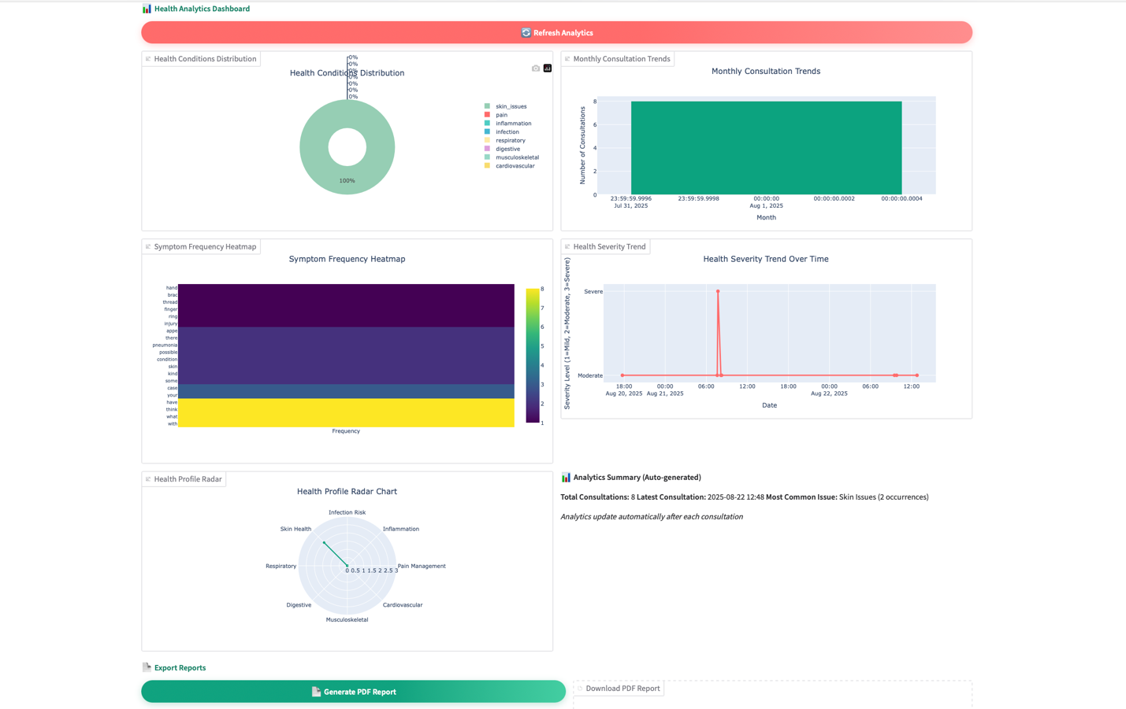
The Health Analytics Dashboard gives a view of the patient data, predictions, and clinical insights in the form of visualizations such as charts and graphs. It presents the predictions of the disease and gives confidence scores and can converse freely with the user. The text-to-speech has also been incorporated in the page so that the predicted results can be audio and thus help healthcare providers make informed decisions within the limited time available.

Execution
The implementation of the proposed AI Multimodal Medical Data Fusion system was carried out using a modular and well-structured development approach to ensure scalability, maintainability, and usability. The system was primarily built with Gradio to provide an intuitive, web-based user interface that supports real-time interactions. Core AI integration combines Groq API for high-performance inference, Speech Processing Engine for speech-to-text transcription, and Vision-based Analysis Module for multimodal medical data analysis.
To ensure safe and stable storage, the system will employ the use of PostgreSQL/SQLite databases stored by SQLAlchemy ORM and user authentication and password manipulation will be done under implementation of Passlib/Bcrypt as a security. Several tools, APIs and libraries were used at various project phases. Data manipulation and visualization used Pandas and NumPy, with Plotly, Matplotlib, and Seaborn forming part of the visualization process of both static and interactive visualizations. Kaleido helped to export charts to be incorporated into reports and ReportLab to create automated invoice reports with visualizations embedded in them. The web and UI aspects enabled interventions to be chained easily and interaction design through event-driven programming in Gradio.
The implementation was carried out in a modular style within six different dedicated modules: user interface, an AI with processing, data handling, authentication, visualization, and reporting modules. This made clean communication between layers and made maintenance easy. The system built-in several essential features such as multimodal consultation (voice and image analysis), real-time analytics dashboard (presenting a variety of chart types), programmed PDF report generation, and authentication/secure session management. Attribute To overcome the performance bottleneck, asynchronous processing was incorporated to avoid UI blocking, the temporary files processing capability was streamlined and powerful DataFrame operations were enabled to access large datasets. Additionally, strong error handling mechanisms were established, to offer an elegant degradation in case of errors. Comprehensively, the development of the in-build modern AI model, a robust database, trusted authentication, and an interactive user interface are meritoriously integrated during the implementation phase to achieve a fully-functional system that can provide the service of disease prediction and professional reporting in medicine.

Testing & Discussion of the System
Unit Testing and User Acceptance Testing (UAT) were used to ensure that the system worked and was correct and used to make sure that the system was easy to use. Module level testing was also done to test each of the core features against their expectations. The performance of key functionalities including registration, log in/out, medical image upload, lab results entry, voice input, disease prediction, access to their records, and text- to- speech conversion was also being tested. To ensure system robustness, valid and invalid inputs were presented in each of the test cases. The results were as follows: all of the critical features passed their desired outcomes and that there were the proper error messages when non-valid or incomplete data was provided (Beck, 2022).
After validation of the system in unit level, User Acceptance Testing was conducted as a way of considering the system its end users. Healthcare professionals simulated patients and system administrators were put to tests to make the interface user-friendly and responses repetitive. Testing revealed that medical images and laboratory reports were uploaded correctly, and disease predictions were created with confidence levels and reports could be retrieved and played as audio. The UAT also confirmed that the system enabled the appropriateness of security measures like no duplication of entries, unauthorized users could not access patient records and proper handling of user sessions.
The results of all the tests revealed that the system is stable, reliable, and works effectively in fulfilling its intended features. The multimodal disease prediction had predictable outputs and accuracy when used with complete data (image lab results) and could gracefully accept incomplete or error data inputs. Error handling mechanisms were also in top form and helped the user to get feedback in a clear and actionable manner. Generally, the testing implementation process confirmed that the combination of AI-models, databases and web interface are functional and in unison with each other, and the results proved that the system could achieve its design goals in real-life medical utility support practices.

Summary
Design and Implementation describes the architectural framework of the system and the successive development of the system in conceptual and technical details. It will contain Use Case Diagrams and Specifications to indicate how users interact with the system and what capabilities it will have and Sequence Diagrams to be able to see how the system processes will flow with time. Presenting the chapter is Database Design, ER Diagrams and Database Table Structures to provide efficiencies in terms of storage and integrity of the medical data with support of PostgreSQL Data Dictionary as a technical reference. Last but not least, implementation paragraph explains in detail how the front-end, back-end, database and AI components were developed and incorporated to give a complete picture of how the AI Multimodal Medical System runs within efficiencies.

Sample 2

Interface Design
The Smart Desktop Control System interface design has been made to be easy to use, intuitive, and straightforward to facilitate easy interaction by the users. The system is designed so that each screen will give the user a clear and immediate response when it comes to the voice commands and the screens are simplified so that they are easy to navigate and user friendly. The minimalist nature and clean layouts of the site provide the assurance that no needless information is overloaded on the user. The system has an easy user experience with a user being able to access all that is important in the system such as application control, file navigation and system settings using voice commands.

Main Desktop Home Screen
Figure: 36
Desktop Home Screen
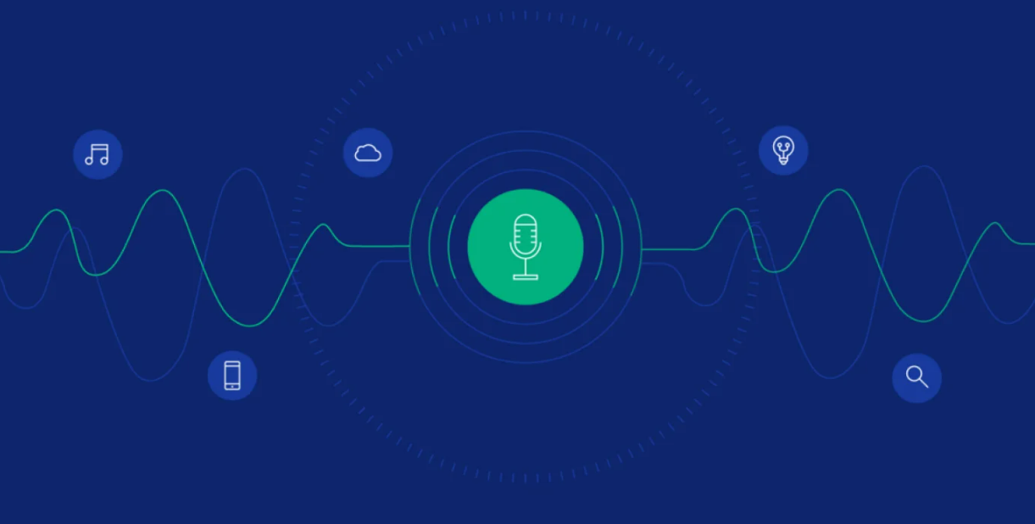
The image below symbolizes the Main Desktop Home Screen of your Smart Desktop Control System. The interface is well designed and simple with a centralized text box that shows that the system is on idle mode and is waiting to be told things through voice. The layout of this screen is intuitive and user friendly and the voice control system has a start button that is easily accessible. The interface is user friendly and has very few distractions. It can visually prove the fact that the system is prepared to receive the orders and is thus easy to use and convenient.

Voice Listening Screen
Figure: 37
Voice Listening Screen
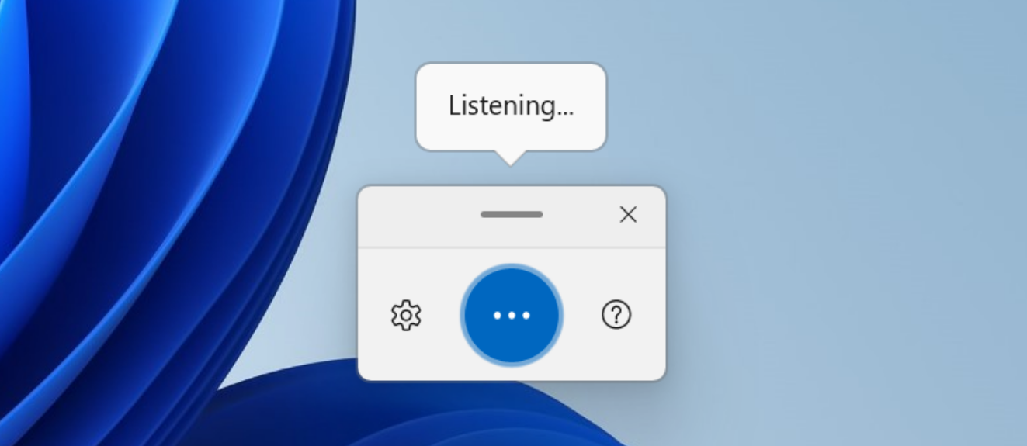
The voice listening functionality is enabled in this interface. There is a mic icon in the middle that is animated to indicate that the system is listening to get commands. It also has a message bubble on top to show that the system is at the listening mode and has a simple text, which reads, Listening. The design is very minimal and it makes the user aware that the system is ready to receive the voice input. This interface establishes the atmosphere of the smooth interaction process and accentuates the simplicity and ease of voice control activation (Laddha et al., 2026).

Voice Recognition (Speech → Text)
Figure: 38
Voice Recognition
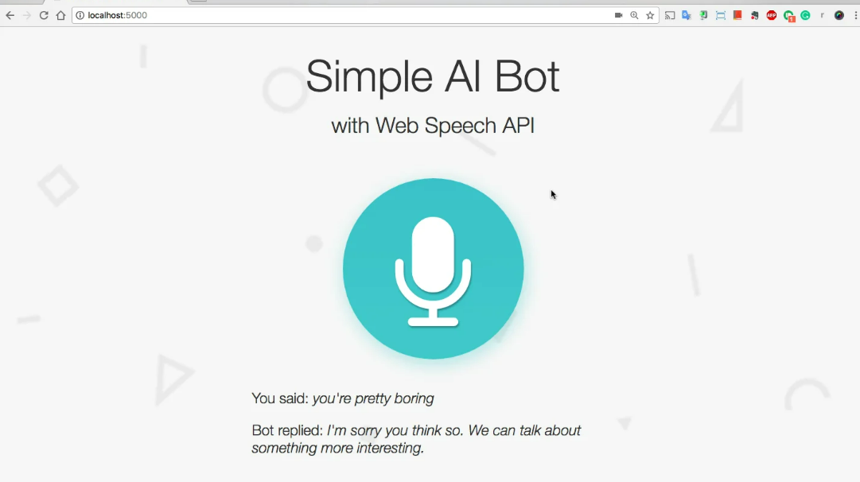
This Voice Recognition interface is displayed when the command is listened and processed by the system. It shows the identified speech-to-text output which is the command spoken by the user. The identified text of the type of the text Open Google Chrome is written readable. It displays the dynamic communication between voice entry and the command processing mechanism giving the user transparency. The system can also show a confirmation message (such as the word Executing) to the user that the command is being executed to maintain a sense of clarity during the voice command experience.

Dashboard Interface
Figure: 39
Dashboard Interface
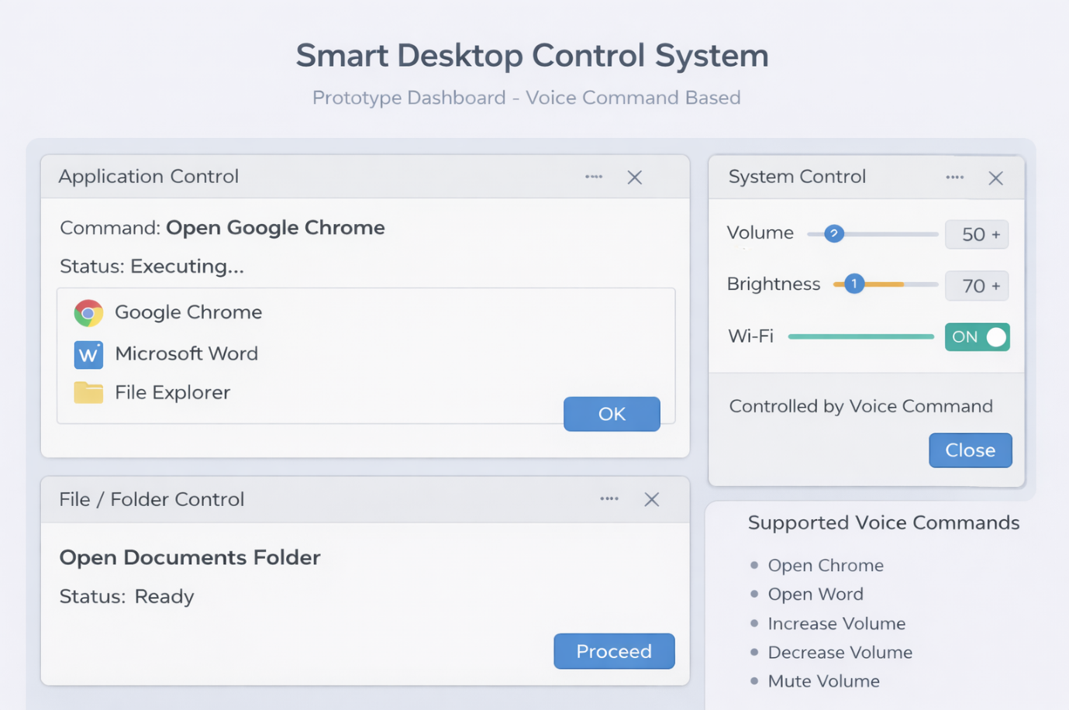

Various functional panels are combined in this prototype dashboard interface. The Application Control section displays the command itself in action (e.g., Open Google Chrome), and after it, there is the system control panel, where the user can also modify the settings, such as volume, brightness, and Wi-Fi, with voice commands. When the command is issued to open the Documents folder, the File / Folder Control section displays the folder opening, which illustrates the system with files. The Supported Voice Commands section appears on the side and it contains supported commands. This interface provides an overview of the functionalities of the system on the core of the system in a dashboard format.

Command Usage Log Interface
Figure: 40
Command Usage Log Interface
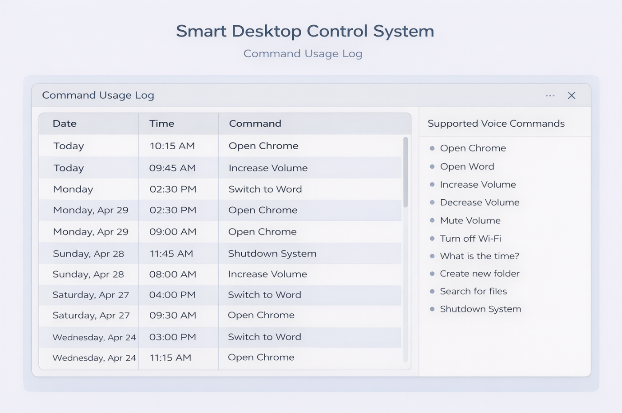
The Command Usage Log of the Smart Desktop Control System is displayed in this interface. It logs the date, time and command input and the voice command logs can easily be read to give a list of voice commands called upon by the user. The log can be scrolled over whereby the previous commands are displayed with the respective timestamps. This interface is significant in monitoring usage trends and enhancing an understanding of the system as it is used with time. It is a plain table that is easy to read and review the history of voice interactions as it gives the user a clear method of reviewing previous commands.

Implementation & Execution

System Used Libraries
Figure: 41
System Used Libraries Code
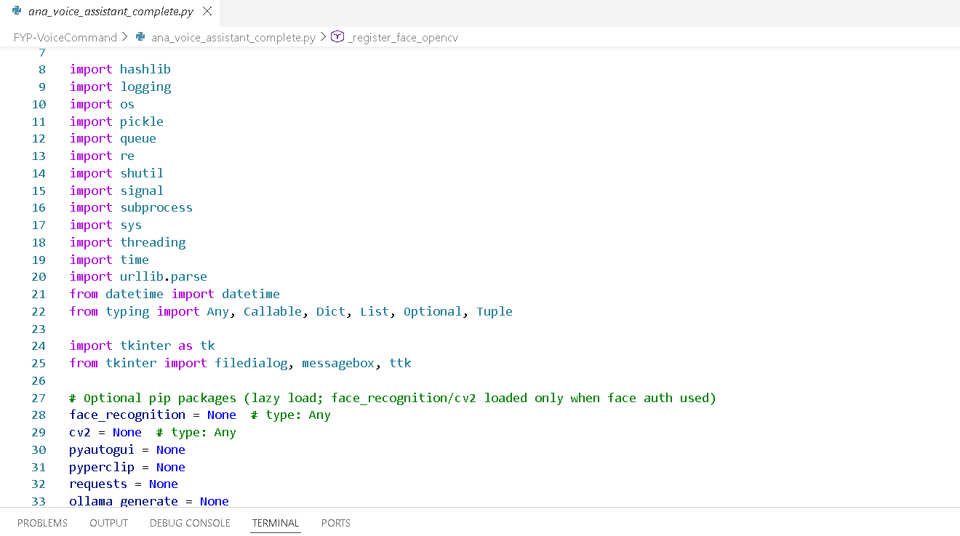

The given part of the file demonstrates the basic module imports and dependency set-up of the ANA Voice Assistant. Security (Password hashing), logging, file handling, data serialization, command processing, multiprocessing and concurrency functionality is offered by standard Python libraries like hashlib, logging, os, pickle, queue, re, subprocess, threading and time. Among the modules, such as urllib.parse and datetime, are the URL handling and timestamp management modules, typing hints (Any, Callable, Dict, List, Optional, Tuple), help to create a clearer and more structured code. Tkinter library (tkinter, filedialog, messagebox, ttk) is imported to construct the graphical user interface. Lower down, there are optional third-party packages face recognition, cv2 (OpenCV), pyautogui, pyperclip, requests, and ollama generate are initialised as None, meaning that they are only imported when the corresponding feature (e.g. face authentication, automation clicks, clipboard operations, web requests or AI text generation) is actually used. This will ensure optimal startup speed and dependency loading is avoided unless load specific functionality is necessary (Thota et al., 2026).

Config & Constants
Figure: 42
Config & Constants Code1
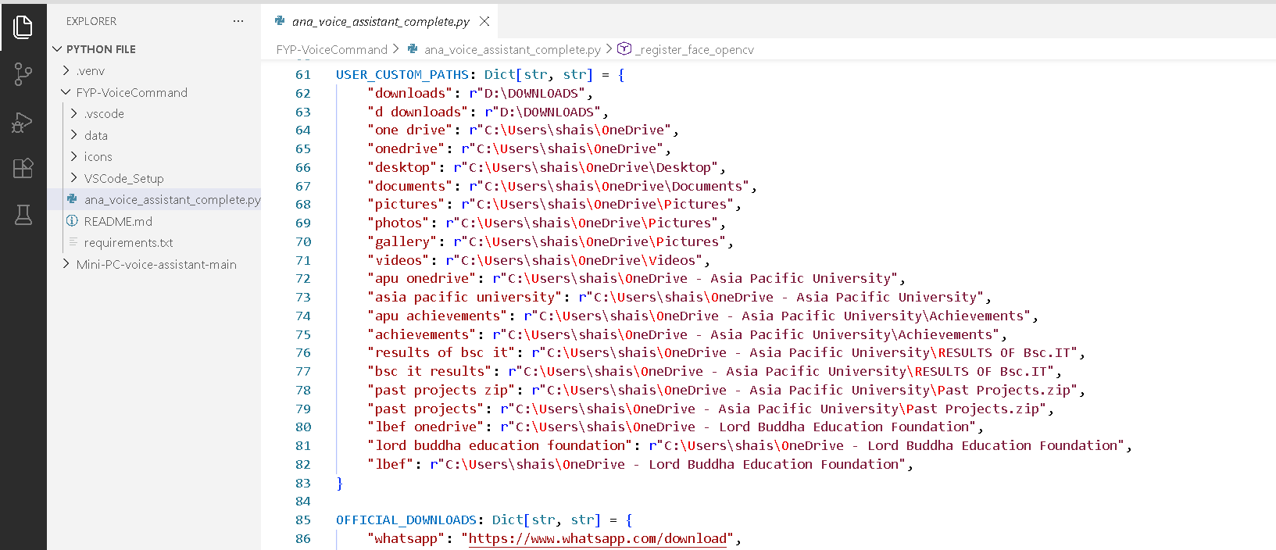
Figure: 43
Config & Constants Code2
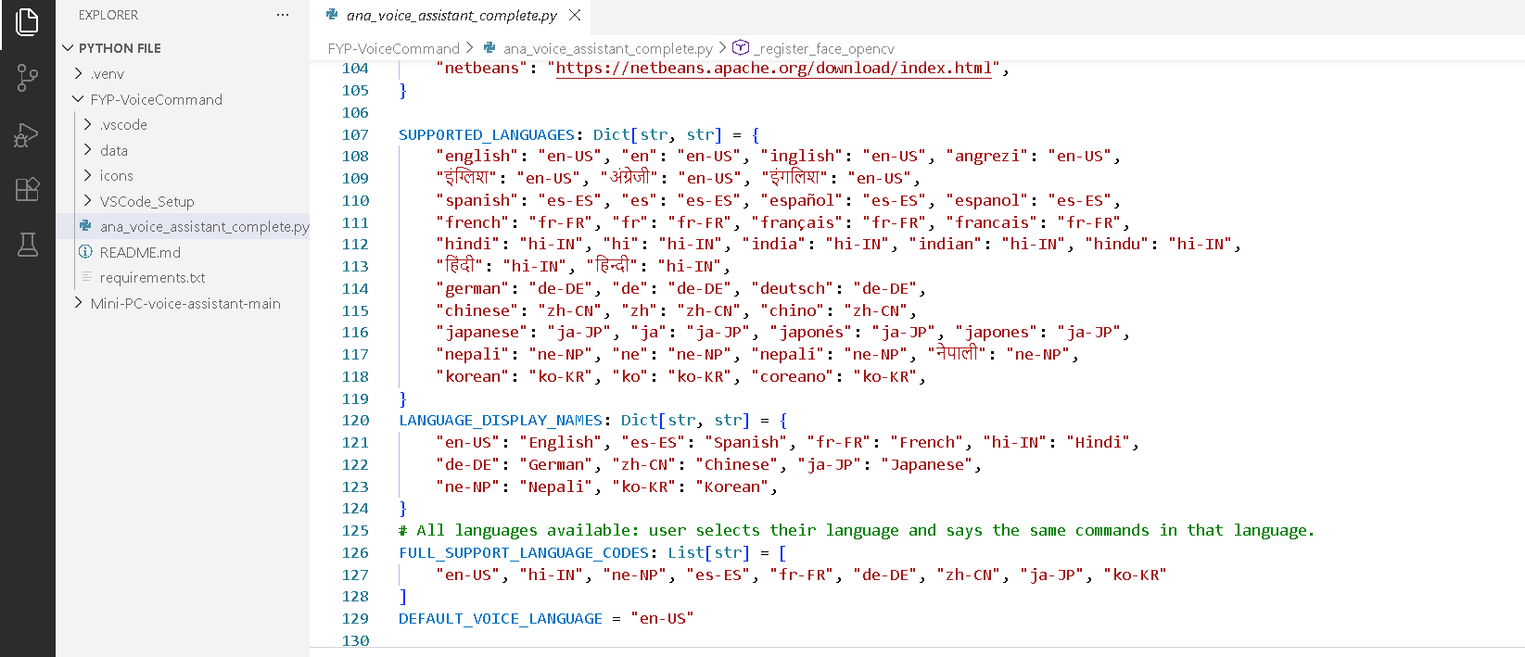

Figure: 44
Config & Constants Code3
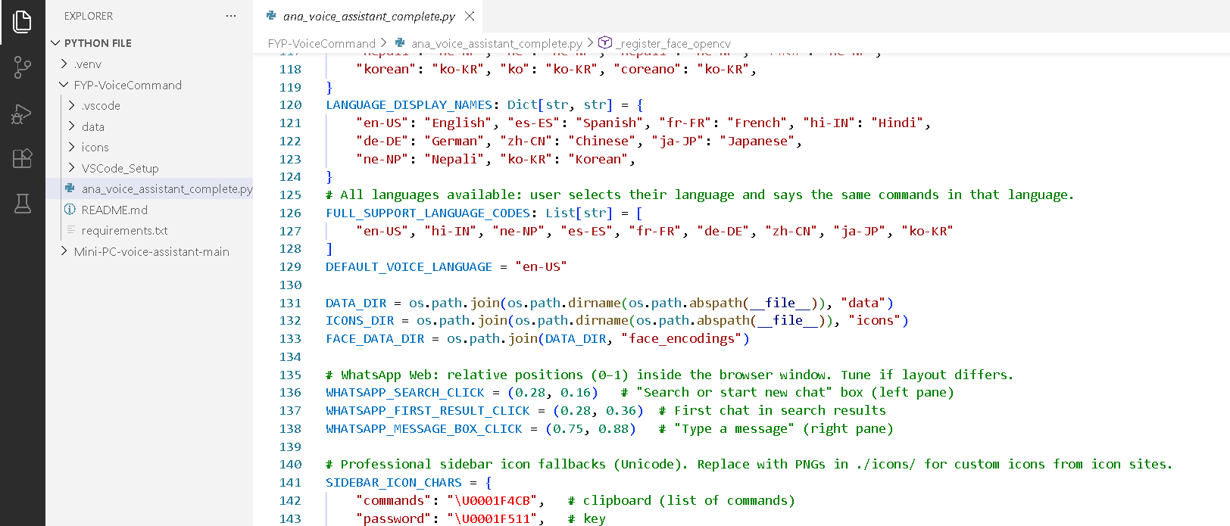

A centralized section of configuration determines core application constants and settings to govern the overall behavior of the ANA Voice Assistant at the start of the file. This contains metadata like application name and version which can be properly identified and tracked in terms of version. The SUPPORTED_LANGUAGES dictionary would contain the human readable names of languages (e.g. English, Hindi, Nepali) and the corresponding speech recognition codes and FULL_SUPPORT_LANGUage_CODES would contain all the fully supported locale codes the speech engine uses to process multilingual inputs. The automation of WhatsApp Web can be configured to work on some preset coordinate co-ordinates, like WHATSAPP_SEARCH_CLICK, WHATSAPP_FIRST_RESULT_CLICK and WHATSAPP_MESSAGE_BOX_CLICK, which enable the system to respond to certain interface elements in a program-like manner. The mapping of the USER CUSTOM PATHs allows the storage of spoken folder names such as downloads or desktop in a mapping of their true system directory names, allowing file navigation through natural speech. Also, the THEME set up determines visual attributes, including the background color, sidebar color, and accent tones, which maintain the same style and allow the user to customize the dashboard interface across the user interface.

Security-Unlock Screen & Face
Figure: 45
Unlock Screen Code
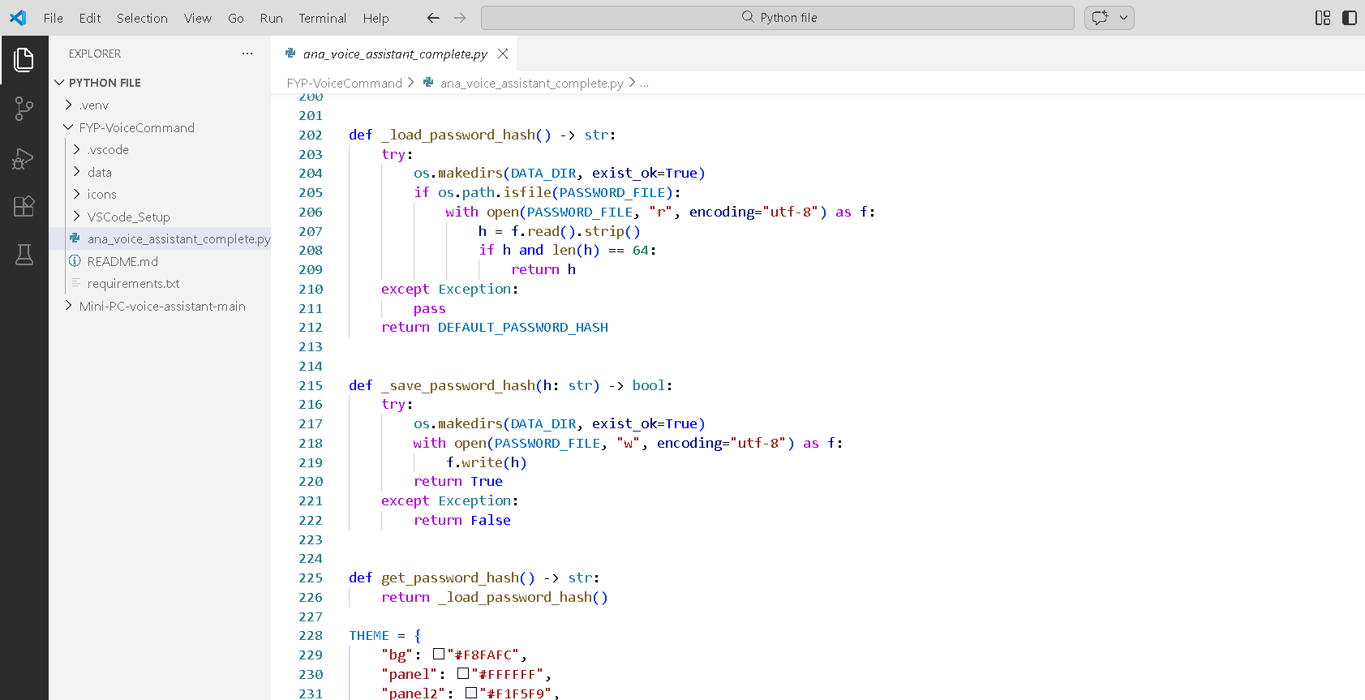
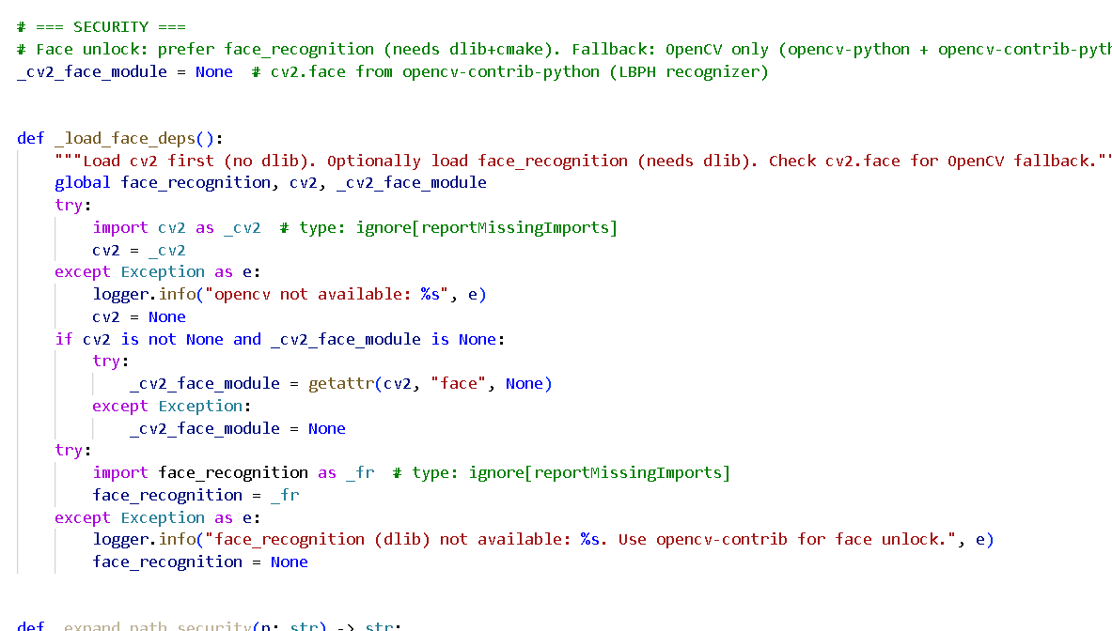
Security component starts with an UnlockScreen which is an implementation of Tkinter that opens as soon as the application has been started in order to prevent unauthorized access. The user is able to access them by means of a password, which is checked against a stored hash in the data/password_hash.txt file, or face recognition when facial data has been stored earlier. The verification check of the face is done in verify face and it uses the face recognition library or the LBPH (Local Binary Patterns Histograms) algorithm of OpenCV to make the biometric matches. In UnlockScreen, the form of the password and face authentications can be turned on or off based on the initialisation parameters, and face login can only be enabled when there is stored face data. Upon a successful authentication, the try unlock method makes verification complete, and invokes the switch to dashboard method, which invokes the supplied on unlock method. The root window is not introduced but instead the existing root is used by destroying the child windows and calling build dashboard () so that the application runs in one mainloop to effectively manage the resource and provide a smooth transition between lock screen and the main dashboard.

Voice Engine- TTS & STT
Figure: 46
Voice Engine Code
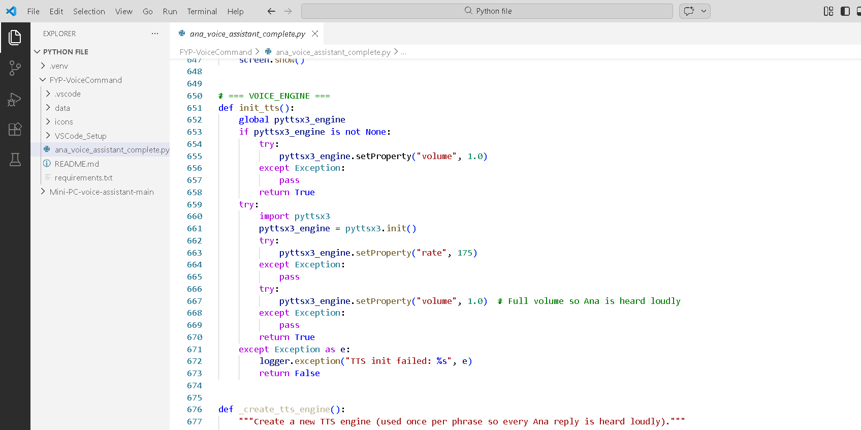
The Voice Engine combines both the Text-to-Speech (TTS) and Speech-to-Text (STT) in order to allow voice interaction in real-time. In the case of TTS, every answer is read out by a separate Python subprocess so that every word phrase is consistently read without any interference with the main application stream. The main process copies the response text to a temporary file and causes the same script to be run with an addition of the argument, which is a --tts-speak <tempfile, so that the subprocess may read the file and generate speech on its own and the file is subsequently deleted. Such a design separates speech output and blocks are avoided. In the case of STT, a continuous listen service, which operates in its own thread, constantly records audio on the microphone and pushes (audio, language) pairs into a queue. An independent recognition worker thread gets this audio and works with it through Google recognize google () with the voice language that is being selected. The identified text is then passed to on-text callback that forwards the text to handle-command to be interpreted and executed and thereby, facilitating the processing of voice commands in a smooth, asynchronous and responsive manner.

Command Handler & Multi Language
Figure: 47
Command Handler Code
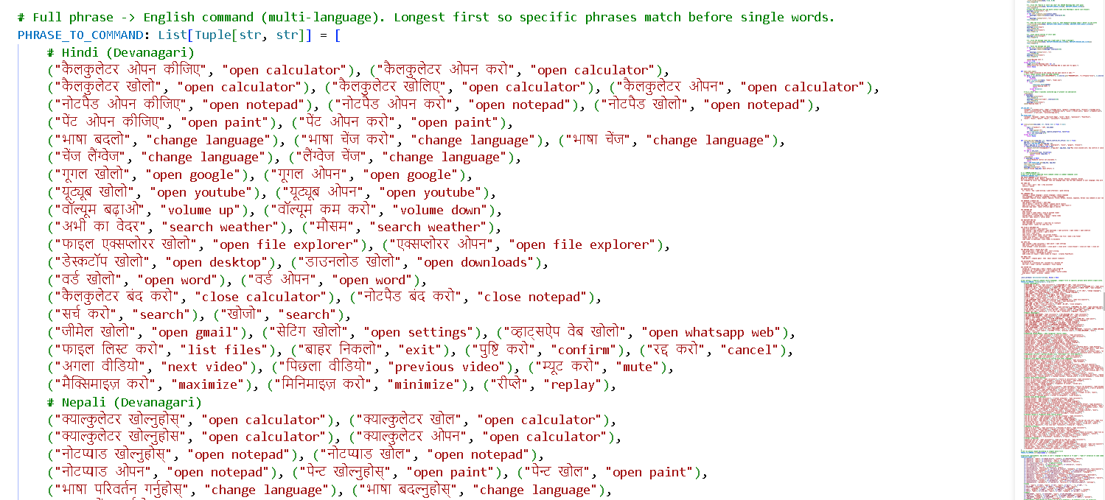
The Command Handler processes all the recognized voice input and then calls upon handle command () function that first standardizes the multilingual input to a standard and consistent format of an English command. This begins with the translate-to-english(cmd) whereby the system diffuses the whole statement spoken against predefined mappings in PHRASE-to-command. These mappings consist of complete phrases in languages such as Hindi, Nepali, Spanish etc and each of them is associated with a similar command in English language. The specific or normalized match is promptly returned with a related command which is used in English. When a complete-phrase match is not found, the function will then perform pattern-based replacements in accordance with TRANSLATE_VERBS which involves the use of regular-expressions to replace foreign language verbs or other wordings with uniform action words in English. After translation, normalize_cmd_order reformats the words into the required executable format correcting errors such as the variants of calculator open into open calculator or the variants of hello to Luckysend into send hello to Luckysend. This stratification is such that the orders issued in different languages or sentence structure always get themselves adjusted to standard form, which can be affected.

Automation (Windows)
Figure: 48
Automation Code
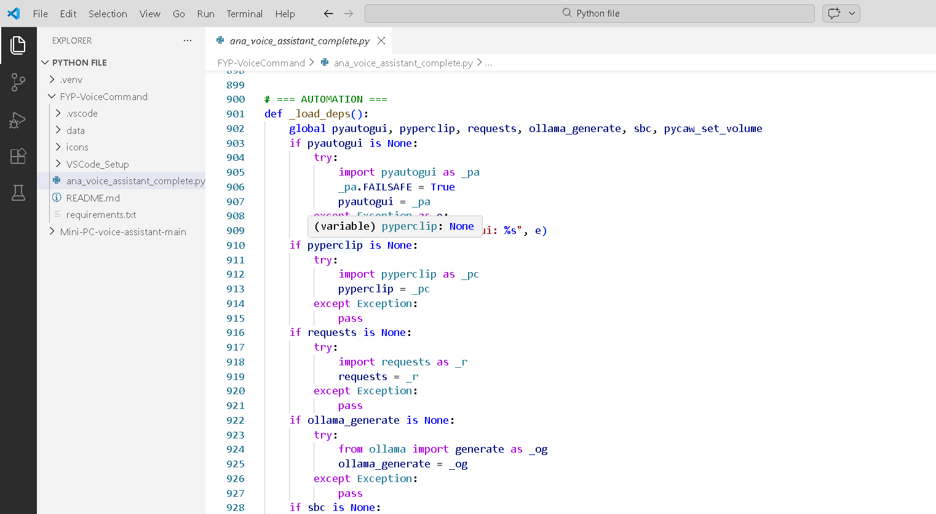
Automation module runs real level system operations on the basis of interpreted commands, with a combination of browser operation, desktop apps and file operations. In the case of WhatsApp Web, to open WhatsApp in the browser, activate the window with the Windows API call _activate_whatsapp_browser_window () that uses EnumWindows in the API to identify an open browser window that contains the title WhatsApp and click inside the window is done using the API call, click in the window, which is a program, click inside the window (hwnd, rel_x, rel_y). The workflow is automated through the use of the whatsapp_send_message (contact, message) function of clicking on the search box, pasting the contact’s name, clicking on the first result, pasting the message and then hitting Enter to send the message. In the case of Microsoft Word, the open word application is found and run by open word app () and the word start writing fix accordingly by word start writing fix () which ensures the window is focused and a new document is created by use of an open word based ollama based llm () function in case it exists and the generated content like report or paragraphs can be pasted into the active document. In the case with YouTube automation, yt_fetch_video_ids () will grammatically scrape a list of video IDs out of a search result, youtube_play_query will open the first result in the browser, and navigate current tab(url) will update the current browser tab by focusing the address bar.

Dashboard UI
Figure: 49
Dashboard Code
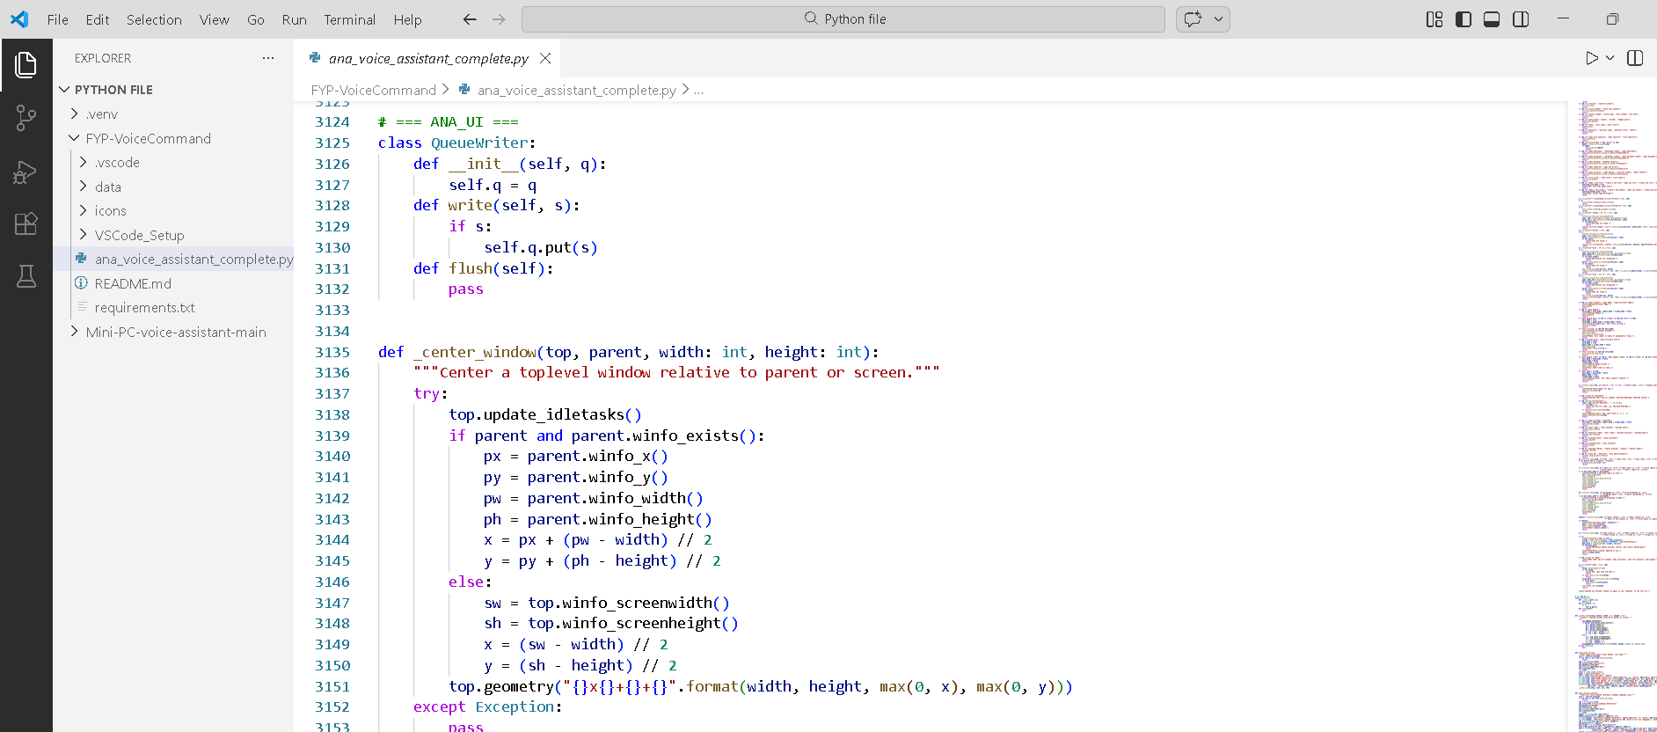
The Dashboard UI is built using a build_dashboard () function which sets the application interface into structured sections to monitor and be able to control. Vertical sidebar is formed using a Tkinter Frame, a Frame that has been configured with theme based color and has icon based navigational features like Commands, Password settings, Statistics, Language selection, Face management, Export options and a Listening switch. The main content area also has a header with system status and Minimize and Maximize buttons, which is followed by live terminal output and Realtime Activity list panels, and the last one is command history tracking. The interface incorporates a QueueWriter system that redirects normal output and error streams (stdout and stderr) to a logging queue so that any print statements which are produced by the system will be dynamically displayed in the dashboard log section. Such a design offers real time visibility of the operations of the systems and is structured in such a way that it is easy to use.

Actual System Interface
The Smart Desktop Control System is an all-round voice-activated assistant which essentially changes the way in which users associate with their computers since it makes it to be effectively hands-free with regards to the control of virtually all the operations of the desktop. Fundamentally, the system is designed to listen indefinitely to voice commands and converts verbal commands to action in real-time, which does not require the use of traditional input gadgets such as keyboards and mice. When a user gives a command like open Chrome or launches Microsoft word, the sound is recorded by the system, and with the help of the speech recognition technology, it turns into a text, then the system interprets what the user wants and takes the necessary step by programmatically starting that given application. Other than its simple application launching, the system offers excellent file management that enables its users to navigate the entire file system without the use of hands. An example is when someone can say open my Downloads folder to access their download folder immediately, open the project report in Documents to find and open a certain file or create a new folder known as Work files to organize their files. The system also facilitates sophisticated file managements such as delete the old presentation, name the budget file to Q1 budget or move the quarterly report to the Finance folder allowing full management of files without the manual touch of the files.
Figure: 50
Autogenerated Paragraph/Report on Word/Google docs
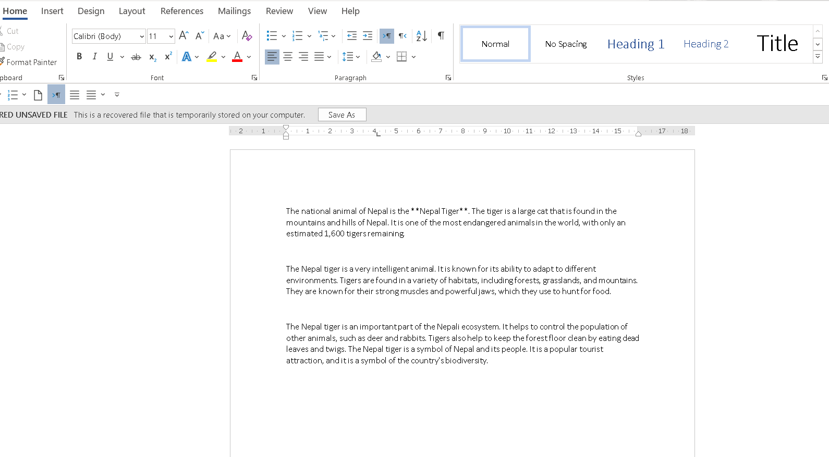
Figure: 51
Autogenerated Slides in Powerpoint
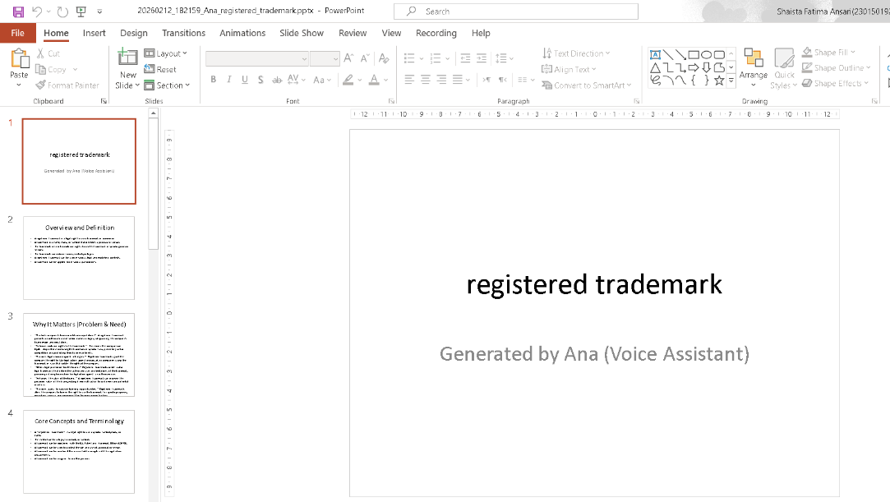
Figure: 52
Autogenerated Gmail
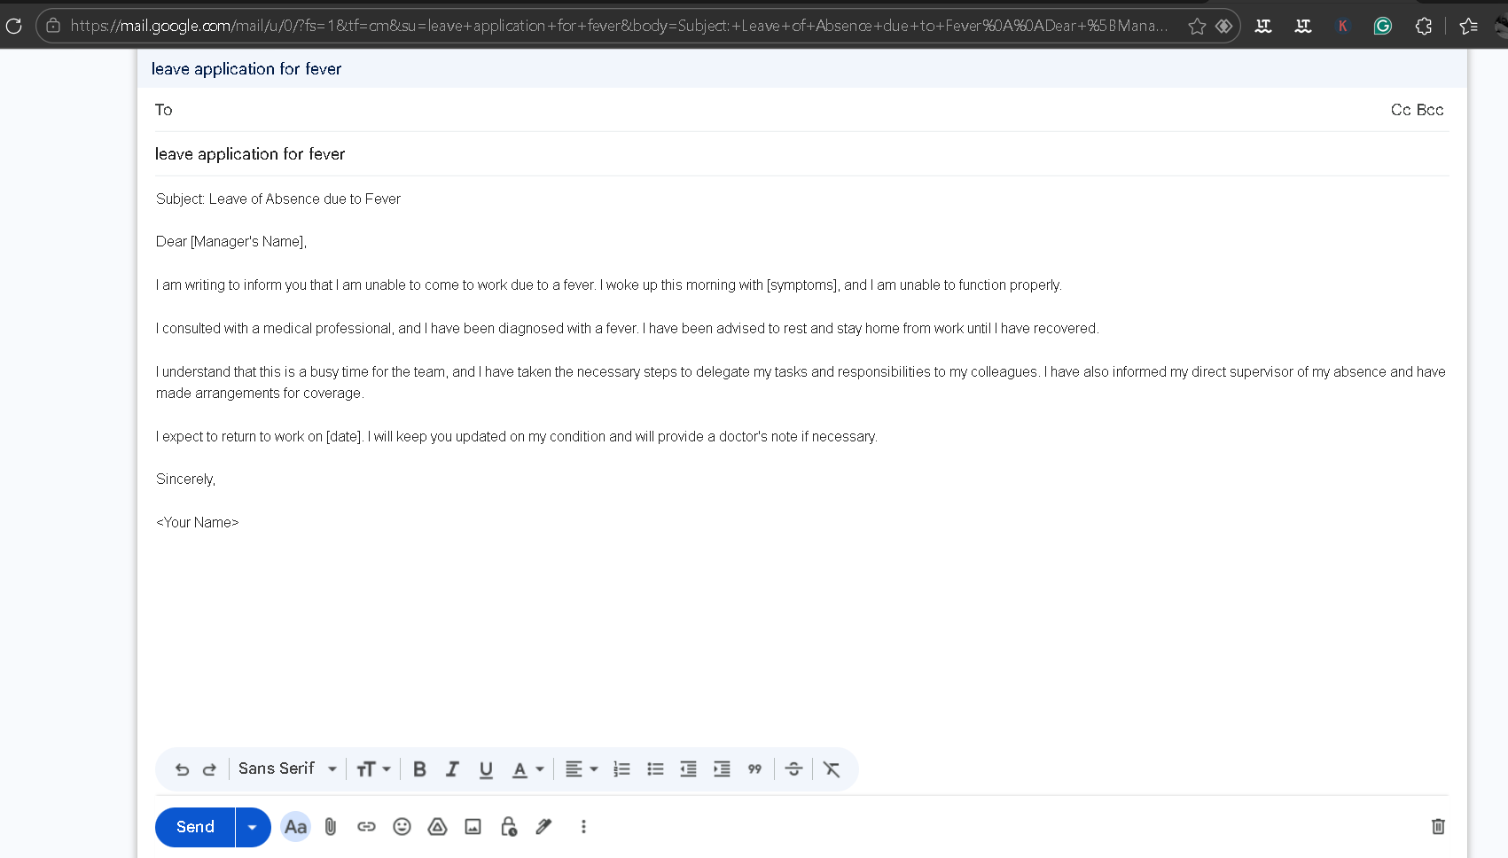
It has advanced features of creating PowerPoint slides, and one can say make slides on this topic and the system will create a full presentation with professionally formatted slides, with titles, bullet points, and structured identifiable contents depending on the topic specified. Likewise, where a user in word processing programs has to say: give a paragraph on this topic or generate a report on this topic: the system will then smartly generate a well written paragraph on the topic or a complete report on the topic, saving users a lot of time and efforts of writing the content. In the case of email management, the system has an advanced Gmail interface where one can place a subject line like subject on meeting schedule and the system will automatically create the full content of the email depending on the subject line that will enable the user view, edit and send the email in its entirety with the help of voice commands.
Software downloads are also smart in the system; when a user clicks on the word download Java, the system will first locate the official download page and will automatically take him/her to the relevant source where he/she can start the download. Voice-controlled basic system controls have features like open calculator to start the application, close calculator to end the application and increase brightness or decrease brightness to change the screen settings. The system is smart enough to deal with applications that are not installed on the computer; one types in open WhatsApp and the system will automatically open WhatsApp Web on the browser where the user can log in and view his or her messages. The system also has strong dictation features and one can say to the computer; open Notice pad, dictate on and the speech is translated to text and is typed to the text file. Entertainment and browsing can be achieved by the user saying, open YouTube and play the song and the system opens the YouTube and the music starts playing and after the completion, the user can just say close the tab and his/her session on the system will come to an end. Another feature of the system is that it allows an accurate web search, when a user inputs a query like search for coolyavada the system will give the search results of that query specifically. This all-purpose voice control enables the system to become invaluable to physically challenged people who can use it without limitation despite their physical inability to do so, remote workers who have to perform various tasks simultaneously, and students who can use various applications in one way or the other and feel the audio feedback and voice navigation as a visual deficiency. Capable of giving a user an intuitive, responsive, and completely hands-free computing experience, the Smart Desktop Control System, which sports speech recognition, natural language processing, desktop automation libraries, and system control APIs, can do so.

Realtime Activity Panel
Figure: 53
Realtime Actual Interface
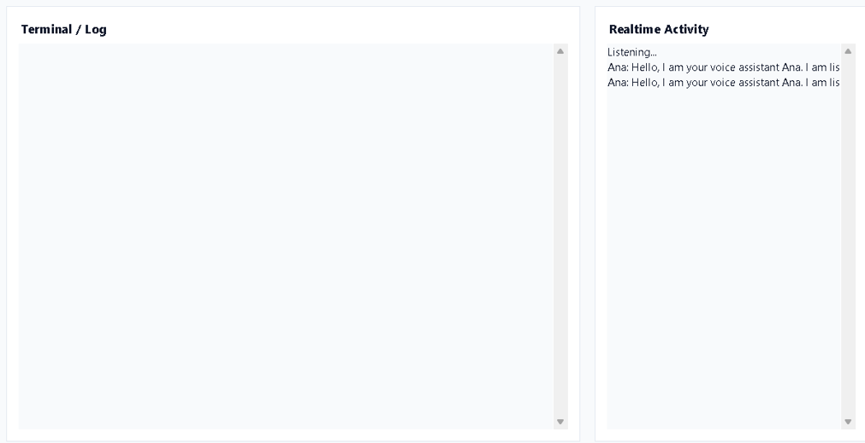
Realtime Activity Panel is an interactive conversation monitor, which indicates the chat between the user and ANA in a time sequence. It includes entries such as:
“Listening…”
Ana: Welcome, my name is Ana and I am your voice assistant. I am listening.”
“You: open Word”
“Ana: Opening Word.”
This panel is a form of conversation transcript in which the user commands and assistant replies are clearly shown in visual terms. It will show us what voice input is doing and how the speech is being responded as soon as it is detected and processed to offer us a sense of transparency. It comes in handy particularly when debugging, monitoring the accuracy of the commands, and previous interaction review within a session.

Unlock Screen
Figure: 54
Actual Unlock Screen
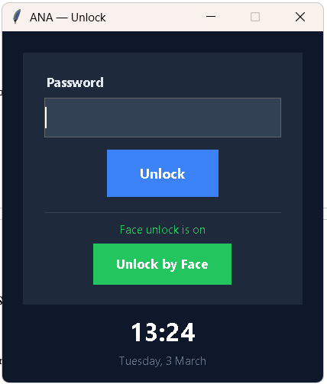
ANA voice assistant starts with the Unlock Screen as it is the first screen that is shown when the system is launched and serves as the security gate to the system. It displays the title, ANA, a subtitle, sign in to continue, a masked password field and an Unlock button. The user should have the right password stored in a safe file as a hash in data/ password-hash.txt to access. Given a registered face data, one can choose Register Face or Unlock by Face whereby face recognition can then be used to either authenticate the person using either face recognition library or LBPH method of OpenCV. After the verification, the initial Tkinter window will be immediately switched to the main dashboard without a new application instance and safely and efficiently control access.

Dashboard
Figure: 55
Dashboard Actual Interface
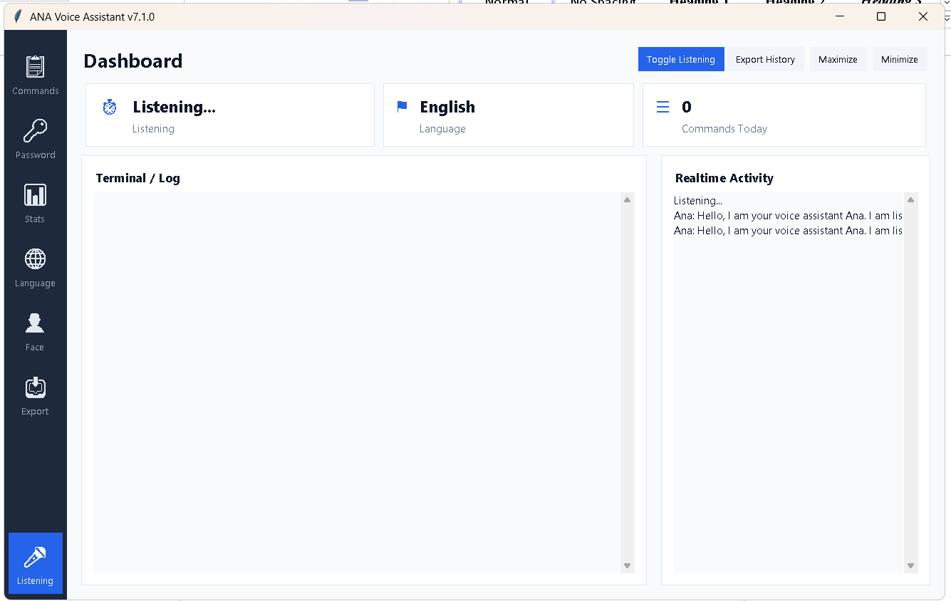
Dashboard is the primary control panel of ANA Voice Assistant that will be shown once the user has successfully logged in. The design is separated into two major parts, a vertical sidebar on the left and the bigger main content section on the right.
The navigator on the sidebar will have iconic navigation choices such as:
- Commands- voice commands supported.
- Password -Change/ manage password
- Stats – View usage statistics
- Language - Choose recognition language.
- Face - Face authentication is manageable or registered.
- Export -Export records or history.
- Listening Toggle - microphone listening/stop.
On the right side, there is a Dashboard header, after which there is a status line which shows whether the system is in the process of listening or not (Listening... or Not Listening). The language chosen is also presented in neat language. Under this header are the content area that contains Live Log output section and Realtime Activity panel which together give dynamic feedback on commands, system activities, and assistant responses. The entire dashboard view shows that monitoring, control, and interaction are integrated in a single interface.

Commands Popup
Figure: 56
Commands Popup
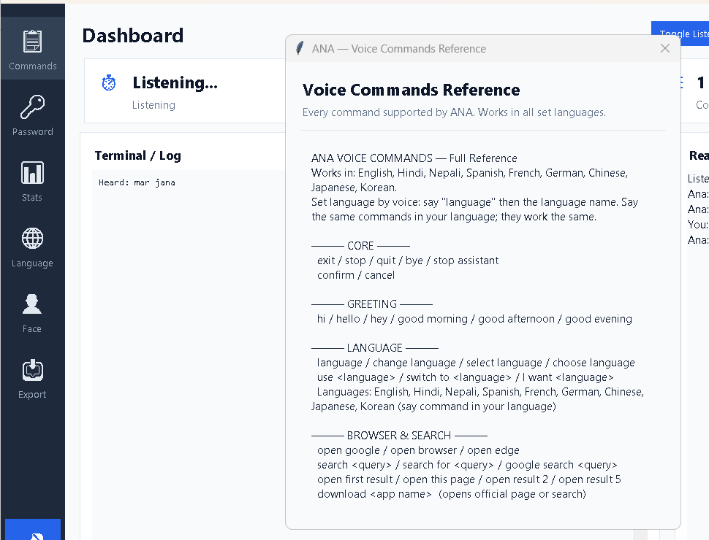
The Commands Popup is displayed when the user clicks on the Commands icon within the side bar. This dialog gives a tabularized list of all the supported voice commands fitted in categories to be referred to easily. There are usually categories, including: Basic Vocabulary (start, stop listening, exit), Greeting Commands, Language Commands, Browser & Search, YouTube Controls, WhatsApp Messaging, File & Folder Operations, Application Control (Apps), Text Generation & Document Secondary, Gmail Automation, Dictation Mode, System Commands. Every category has sample phrases which can be spoken by users. This popup is essentially a user manual built in whereby it assists users to know what they can do and make the process easier to use without having to refer to external documentation.

Password - Change / Manage Password
Figure: 57
Password Interface
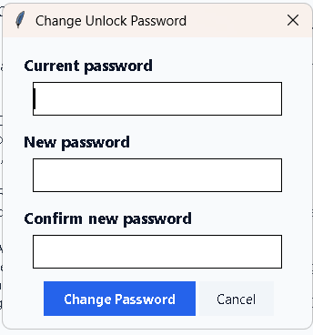
The Password section can be used to manage the authentication of the system in a secure way. Using this interface, the user is able to update the current password by typing the current password and typing in a new password. The password is not stored in plain text but rather it is hashed into a secure hash and stored in the data/ password hash.txt file. This keeps the information of sensitive logins safe. The section enhances protection of the system since it allows periodic updating of the passwords and block the unauthorized access of automation functionality.

Stats – View Usage Statistics
Figure: 58
Statistics Actual Interface
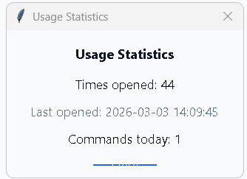
The Stats section will give an overview of activity tracking and usage of the system. It shows the actual number of commands that have been run, most commonly used commands, duration of listening and potentially the number of successful or unsuccessful recognitions. These statistics will help track the utilization of the assistant and compare performance with time. This is a convenient aspect of analysis, debugging, and realizing the pattern of user interactions with the voice assistant.

Face- Face Authentication Management.
Figure: 59
Face Recognition Registration
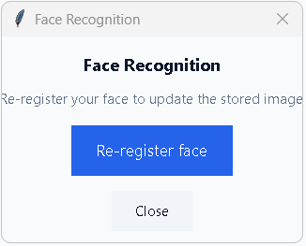
Face section controls the biometric authentication options. Through this interface, the user can first time enter the facial data, update facial data, or delete the registered face data. The webcam uses facial features in order to capture and encode the information during the registration process that may be used in verification later. Face authentication is enabled to unlock the system without using a password. This part offers easy access control which is very safe, but leaves complete authority of biometric data to the user.

Export -Export Records or History
Figure: 60
Export Actual Interface
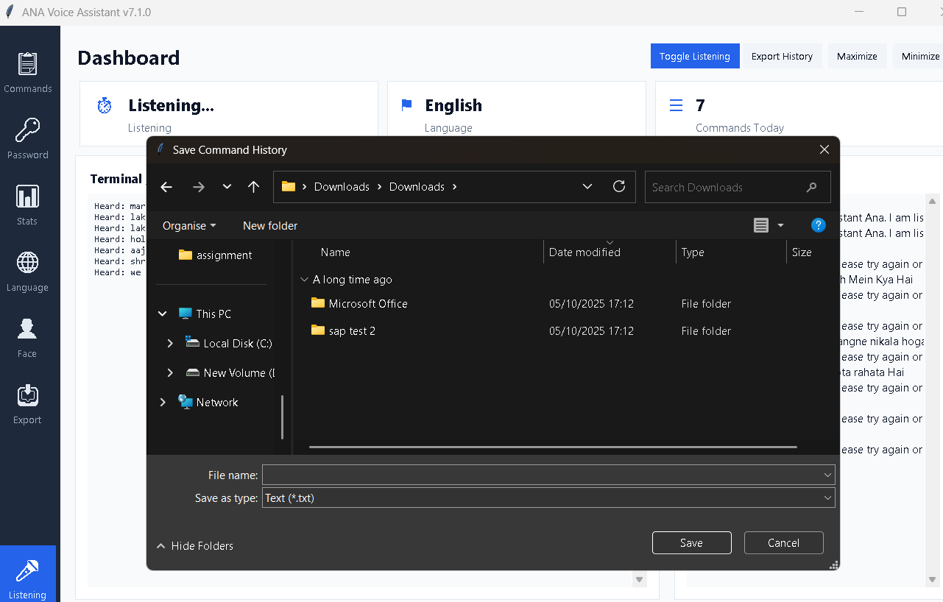

The Export option enables one to export the activity logs, command history or system recordings to an external file. This could be in the form of conversation history, run commands, time-stamps or responses of the system. Data export is useful when one needs to document or report or debug or submit projects. The file that is exported is usually saved in text or CSV format, and thus it is easy to check the records or even share them even when not using the application.

Listening Toggle-Microphone Start/Stop
Figure: 61
Toggling Actual Interface


Listening Toggle is used to determine the voice input capture activity by the microphone. Once this feature is activated, the system goes into continuous listening and it shows a status of Listening... on the dashboard. In the case of a disability, the assistant ceases audio capture and displays the text of Not Listening to avoid unintentional running of the commands. This feature provides the users with direct control on the voice input, whenever user needed, they can resume listening or paused listening this will help ni accuracy of input and avoiding noises.

Language Picker
Figure: 62
Language Selection
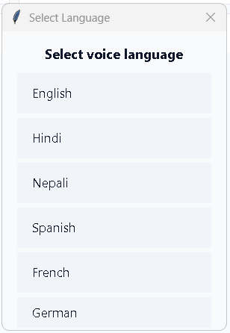
The Language Picker dialog can be opened by clicking the Language icon on the sidebar. It has a list of supported languages that include English, Hindi, Nepali, Spanish, French, German, Chinese, Japanese and Korean. On selecting a language, the system modifies the speech recognition engine to incorporate the respective locale code (e.g., en-US, hi-IN, ne-NP).
This is the characteristic of multilingual communication and the ability to provide commands using the language of choice. Upon a selection, the status line on the dashboard shows the active language, and it is certain that one can understand which model of recognition should be used at the moment. The language choice system is directly coupled with the translation and command normalization system, where language spoken commands can be translated appropriately to executable English actions.
ANA Voice Assistant interface is created based on clarity, real-time feedback, and modular navigation. The Unlock Screen is secured access, the Dashboard is the place to monitor and control, the Realtime Activity panel is where the conversation flow is seen, the Commands Popup is where the structured guidance is given, and the Language Picker is where the multilingual working is provided. Collectively, these elements form a safe, engaging and friendly voice assistance setting which integrates automation, tracking, and customization into one integrated desktop software.

Summary
ANA Voice Assistant manages to integrate voice recognition, multilingual command processing, desktop automation, and secure authentication in one desktop solution successfully. The design is modular and single process, which guarantees efficiency without chaos of separation of concerns. Password hashing and optional face recognition are used to restrict access to the strong automation capabilities (Gündoğan, 2026).
The threaded speech recognition, subprocess speech synthesis and real-time dashboard monitoring offer a rich and interactive user experience. Accessibility is made easier with multilingual support and productivity is made easier with automation through voice commands to manage applications, files, web services, and messaging platforms.
In general, the system shows a viable application of smart voice-controlled automation which includes the features of security, usability and extensibility as its strong points which make it a reliable and scalable desktop assistant system (Almaliki et al., 2026).

