Raymon Bickell

CST-117

Dinesh Sthapit

11/4/2020

**Milestone Project: Milestone 2**

**GitBucket:** https://github.com/RBickell/CST117

Class Diagram:

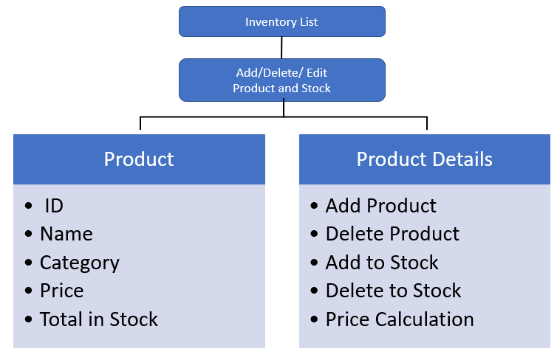

Class Code:

using System;

using System.Collections.Generic;

using System.ComponentModel;

using System.Data;

using System.Drawing;

using System.Linq;

using System.Text;

using System.Threading.Tasks;

using System.Windows.Forms;

using System.IO;

namespace MilestoneProjectCST117__InventoryList

{

public partial class Form1 : Form

{

public class Product

{

public int ID { get; set; }

public String Name { get; set; }

public int CatagoryID { get; set; }

public Double Price { get; set; }

public Double TotalInStock { get; set; }

public Double AddToStock;

public Double DeletefromStock;

public class ProductDetails

{

private string inputfile;

public List<Product> Listofproducts { get; set; }

public bool Add(Product Product)

{

inputfile = "C:\\Users\\Raymo\\source\\repos\\MilestoneProjectCST117- InventoryList";

throw new NotImplementedException();

}

public bool Delete(int ID)

{

inputfile = "C:\\Users\\Raymo\\source\\repos\\MilestoneProjectCST117- InventoryList";

throw new NotImplementedException();

}

public Product GetProductByID(int productID)

{

throw new NotImplementedException();

inputfile = "C:\\Users\\Raymo\\source\\repos\\MilestoneProjectCST117- InventoryList";

}

public Product GetProductByName(String ProductName)

{

inputfile = "C:\\Users\\Raymo\\source\\repos\\MilestoneProjectCST117- InventoryList";

throw new NotImplementedException();

}

public List<Product> GetProductList()

{

inputfile = "C:\\Users\\Raymo\\source\\repos\\MilestoneProjectCST117- InventoryList"; throw new NotImplementedException();

}

}

}

public Form1()

{

InitializeComponent();

}

private void Form1_Load(object sender, EventArgs e)

{

ProductIDNumbox.Value='0';

ProductNameTextbox.Text = "";

CategoryTextbox.Text = "";

PriceNumbox.Value = '0';

AddStockNumbox.Value = '0';

DeleteStockNumbox.Value = '0';

TotalStockNumbox.Value = '0';

}

}

}