Website Redesign

National Legal Center

Robert Broden

2016

Contents

Project Description 2

Technologies 3

Inspirations 4

debt.com 4

Top Fold Components 4

Hero Image 4

lawyers.com 5

Template Ideas: 5

Navigation 6

# Project Description

Redesign the website. Not changing the structure or content. Simply updating the look.

# Technologies

* HTML5
* CSS3
* JavaScript
* PHP – Server Script
* Bootstrap – UI Framework
* Oracle VM VirtualBox (Linux) – Testing Environment

# Inspirations

## debt.com

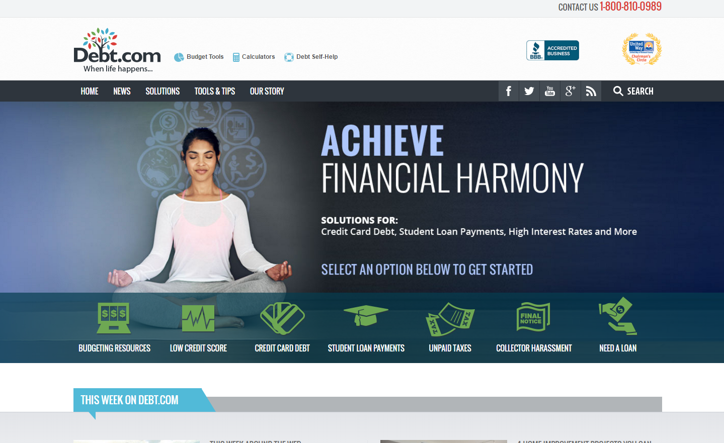

### Top Fold Components

* Tools
* Social Networking
* Search
* Phone Number
* Icon Navigation

### Hero Image

Small

## lawyers.com

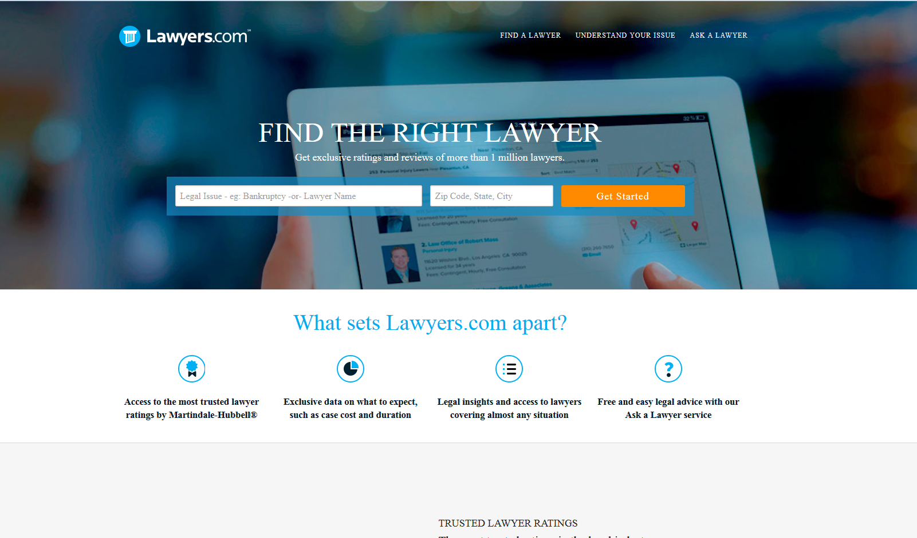

# Template Ideas:

<http://getbootstrap.com/examples/carousel/>

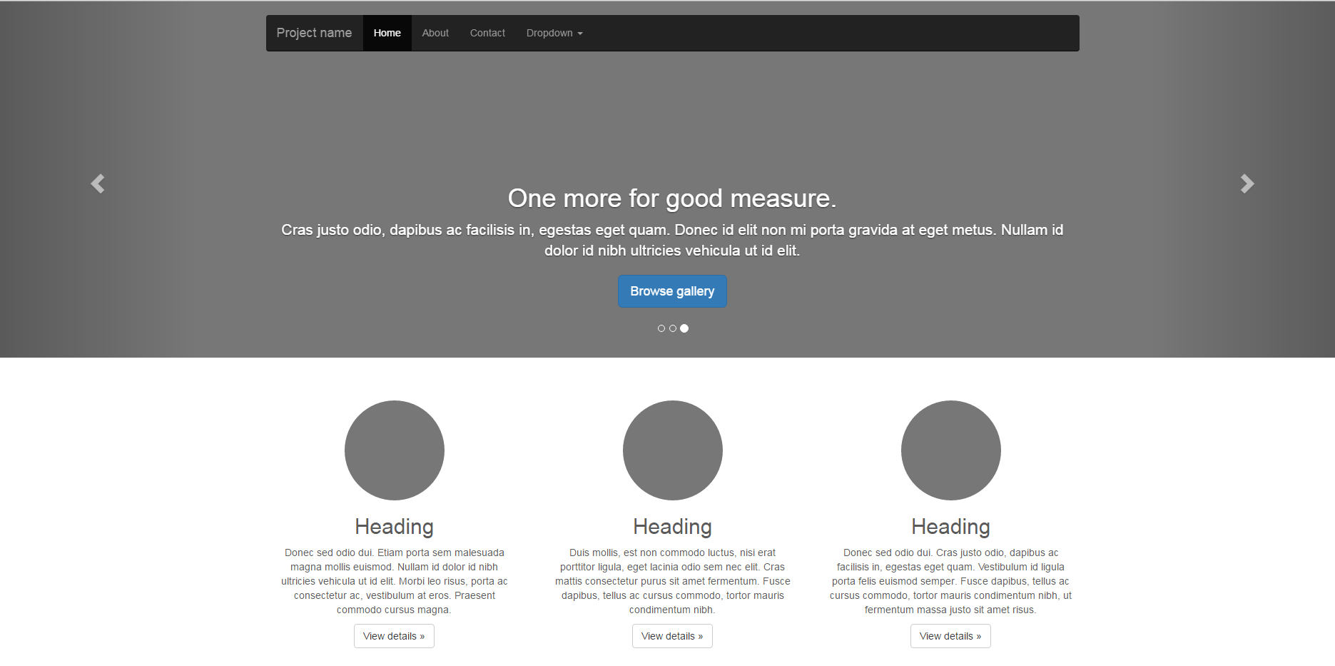

There are three slides and three headings.

1. FAQ
2. Practice Areas
3. Contact

## Additional Resources

<http://www.w3schools.com/bootstrap/bootstrap_templates.asp>

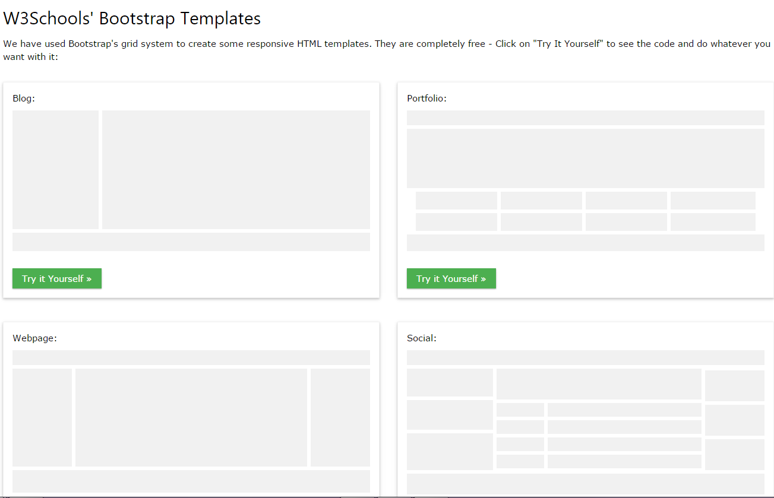

Some basic template ideas. Save these to a folder.

# Navigation

A popular navigation is one that starts off large and then scales down into a fixed navigation that follows with user scroll. Resources:

* <http://jsfiddle.net/cse_tushar/Dxtyu/141/>
* <http://stackoverflow.com/questions/20222369/jquery-navigation-color-and-height-change-on-scroll>
* <http://jsfiddle.net/rcAev/17/>
* <http://cyft.com>