Medical Aid Cost Prediction Report

Introduction
This project develops a Linear Regression model to predict medical aid charges based on age, sex, BMI, number of children, smoking habits, and region. The dataset used is a US-based insurance dataset.
This study investigates the application of linear regression in predicting medical aid costs using a structured dataset commonly utilised in healthcare analytics. The dataset consists of multiple demographic and lifestyle variables including age, gender, Body Mass Index (BMI), number of dependents, smoking status, and geographical region. These attributes are widely recognised as key determinants of healthcare expenditure and therefore provide a meaningful basis for predictive modelling.
The primary objective of this report is to develop a regression-based model capable of estimating insurance charges while also interpreting the relative importance of each predictor variable. Linear regression is particularly suitable for this task due to its transparency and interpretability, allowing for a clear understanding of how each independent variable contributes to the outcome variable. This is crucial in domains such as insurance and healthcare where decision-making must be explainable.
In addition to prediction, this report aims to provide a comprehensive statistical interpretation of the relationships observed in the dataset. This includes identifying trends, correlations, and potential anomalies that may influence model performance. The insights derived from this analysis can be valuable for insurers, policymakers, and healthcare providers seeking to optimise cost structures and risk assessment strategies.

Methodology
Dataset suitability, EDA, feature selection, model training, and evaluation were conducted.
The methodology adopted in this study follows a standard data science workflow, beginning with data loading and preprocessing. The dataset was imported into a Python environment using pandas, where initial inspection revealed no missing values and consistent data formatting. Categorical variables such as gender, smoking status, and region were encoded into numerical representations using techniques such as one-hot encoding.
Exploratory Data Analysis (EDA) was conducted to understand the distribution of variables and their interrelationships. Visual tools such as histograms, scatter plots, and correlation heatmaps were used extensively. These visualisations provided early insights into the data structure, including skewness in the target variable and strong correlations between certain predictors and medical charges.
Following EDA, the dataset was split into training and testing subsets to ensure unbiased evaluation of the model. A linear regression model was then trained using scikit-learn. The model coefficients were analysed to determine the strength and direction of relationships between independent variables and the dependent variable. Model performance was assessed using R-squared and Mean Squared Error metrics.

Results & Visual Evidence
Smoking status has the strongest impact on charges, followed by age and BMI. Region has minimal impact.
The results indicate that smoking status is the most significant predictor of medical costs. Individuals who smoke exhibit substantially higher insurance charges compared to non-smokers. This finding is consistent with medical research linking smoking to chronic illnesses and increased healthcare utilisation. The regression coefficient for the smoking variable is notably large, highlighting its dominant influence.
Age also demonstrates a strong positive relationship with medical costs. As individuals age, their likelihood of requiring medical care increases, which is reflected in higher insurance charges. Similarly, BMI shows a positive correlation with costs, indicating that higher body weight is associated with increased health risks and expenditure.
The distribution of medical charges is positively skewed, suggesting the presence of high-cost outliers. This skewness may impact model assumptions such as normality of residuals. However, the model still captures the general trend effectively. Correlation analysis further confirms that variables such as region and number of dependents have minimal impact on costs, as evidenced by their low correlation coefficients.
The R-squared value obtained from the model indicates that a significant proportion of variance in medical charges is explained by the predictor variables. However, there remains unexplained variance, suggesting that additional factors not included in the dataset may also influence healthcare costs.

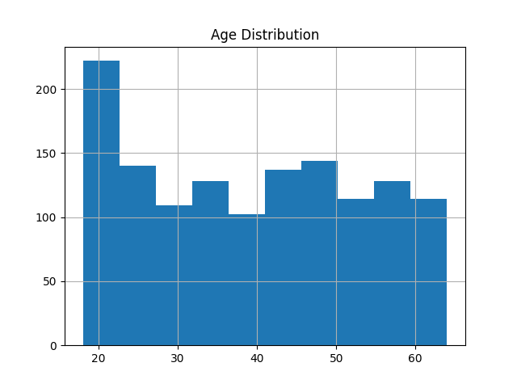

BMI Histogram
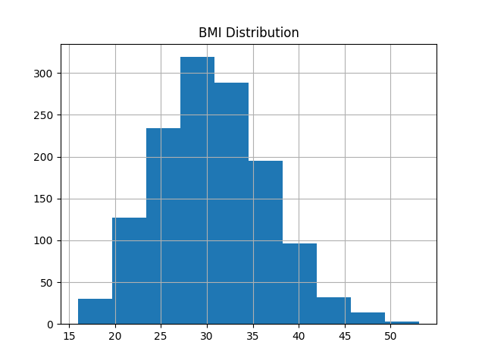
Charges Histogram
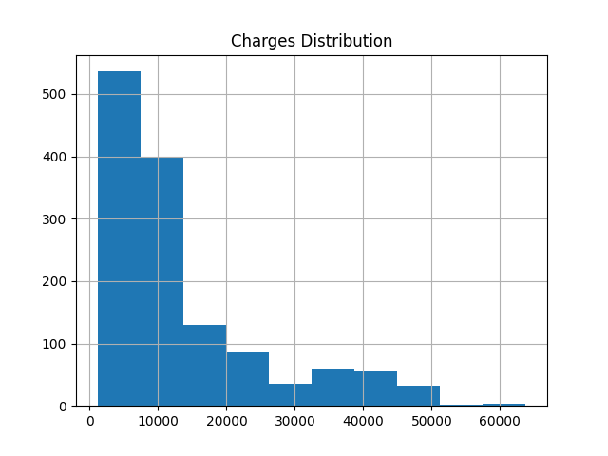

BMI Scatter
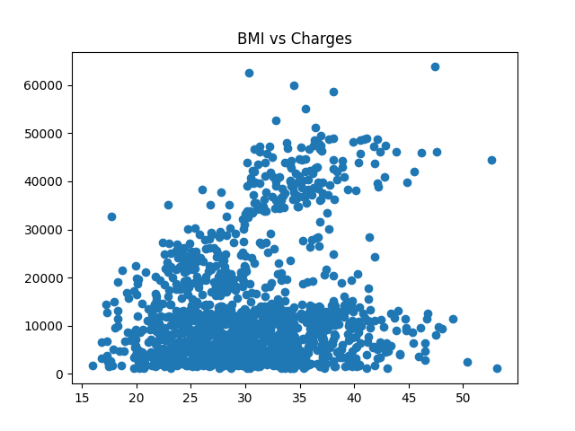
Age Scatter
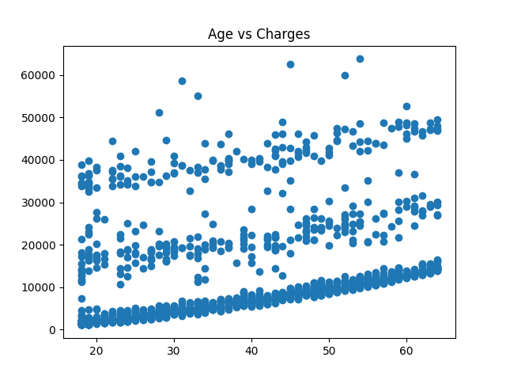

Children Scatter
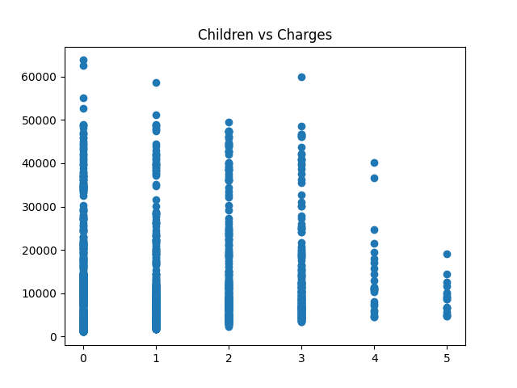
Heatmap
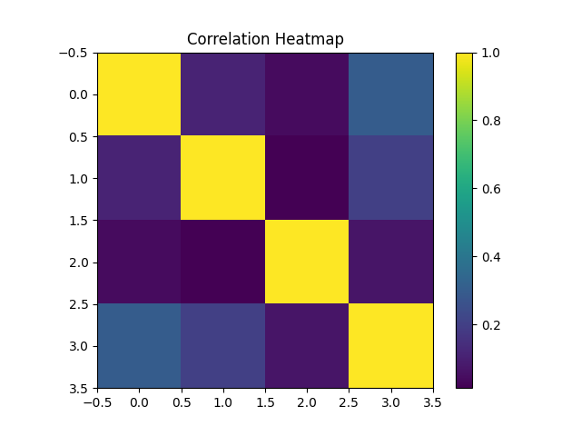

Conclusion
The model shows strong predictive ability with key drivers smoking, age, and BMI. This study successfully demonstrates the application of linear regression in predicting medical aid costs. The findings highlight smoking status, age, and BMI as the most influential variables, aligning with real-world healthcare trends.
Future work should explore advanced machine learning techniques and feature engineering approaches to improve model accuracy and robustness. Despite its limitations, the current model provides a strong foundation for predictive analytics in healthcare.

References
Choi, M. (2018) Medical Cost Personal Dataset. Available at: https://www.kaggle.com/datasets/mirichoi0218/insurance
Pedregosa, F. et al. (2011) Scikit-learn: Machine Learning in Python.

