Medical Insurance Cost Prediction Report

Mmakema Mokoana – ST10537616
PDAN – POE Part 1

1. Introduction
The purpose of this report is to develop and evaluate a predictive model for estimating medical insurance charges. The analysis aims to identify the key factors that influence healthcare costs and provide actionable insights for business decision-making.

2. Dataset Overview
The dataset contains 1,338 observations, including variables such as age, body mass index (BMI), smoking status, and medical charges. The dataset was assessed for completeness and consistency and found to contain no missing or null values.

3. Data Cleaning and Preparation
Data quality checks were conducted to ensure reliability. Duplicate records were identified and removed. All variables were verified to be in the correct format, and categorical variables were encoded into numerical form to enable model training.

4. Exploratory Data Analysis (EDA)
Exploratory analysis was performed to understand patterns and relationships within the data. Visualizations revealed that medical charges are positively skewed and strongly influenced by smoking status, with age and BMI also contributing.

Plot 1: Age vs Charges
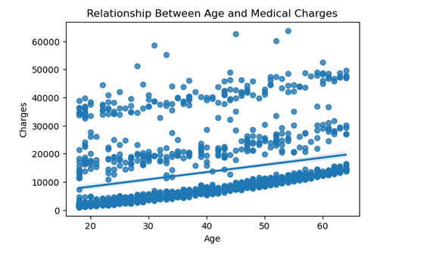
Plot 2: BMI vs Charges
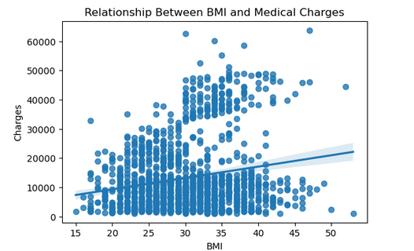
Plot 3: Smoking Status vs Charges
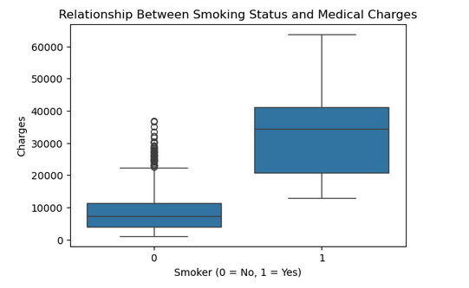

5. Model Development
A linear regression model was trained using age, BMI, and smoking status as predictors. These predictors were selected based on correlation analysis that revealed them to having the highest correlation or influence to the medical aid charges. The dataset was split into training and testing sets to ensure unbiased model evaluation.

6. Model Evaluation
The model achieved an R-squared value of approximately 0.80, indicating that 80% of the variation in medical charges is explained by the model. The Root Mean Squared Error (RMSE) was approximately 5,988, meaning that predictions differ from actual values by this amount on average.
Business Interpretation:
- The model is able to explain most of the drivers of medical costs, making it reliable for forecasting.
- The average prediction error (≈ 6,000) is acceptable given the wide range of healthcare expenses.
- The model can support pricing, risk assessment, and customer segmentation decisions.

Plot 4: Actual vs Predicted Charges
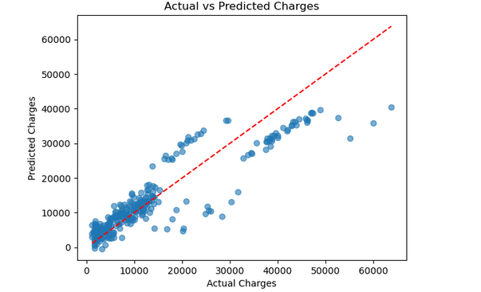

7. Key Findings
Smoking status is the most significant factor influencing medical charges, with smokers incurring substantially higher costs. Age and BMI also contribute positively, but to a lesser extent. These insights highlight the importance of lifestyle factors in healthcare risk.

8. Conclusion
The linear regression model provides a strong and interpretable baseline for predicting medical insurance charges. While effective, further improvements could be achieved by incorporating additional variables or using more advanced modeling techniques.

