Show It All v0.9.25
‘All in one’ widget for OpenTX and EdgeTX transmitters with colour screens
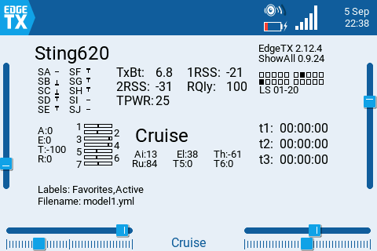

Description
Displays essential info about the currently selected model:
- Model name
- Operating system and version
- Switch states SA - SH
- Tx voltage
- Telemetry:
  - Airborne pack voltage (auto-selects first of Cels, RxBt, A1, A2, A3, A4)
  - RSSI, 1RSSI, 2RSSI (depending on protocol)
  - VFR, RQLY, TPWR (depending on protocol)
- Logical switch states for LS 1-20
- Raw stick values (for checking calibration)
- A, E, T, R, T5, T6 trim values
- Mixer outputs for channels 1-7
- Active flight mode
- Timers
- Filename and labels (TX15, GX15, TX16S Mk 3 only)
- Optionally displays flashing ‘motor armed’ banner.

Minimum requirements
- Transmitter with colour displays of width 320, 480 or 800 px (PL01, TX16S Mk1/2/3, TX15 etc.)
- OpenTX v 2.2+ or EdgeTX v 2.4+
If the display does not meet the above requirements, an error message is displayed.

Installation (first time)
- Create sub-folder on SD card: \WIDGETS\SHOWALL
- Copy file 'main.lua' into SHOWALL folder
- Select the model that you want the widget to be active in.
- Long press on the {Telemetry} button
- Choose a full screen layout
- Configure the widget as required (see below).

Upgrading from a previous version
To upgrade from a previous version, replace the existing main.lua.

Widget configuration
There are three configuration options for customising the colours:
- Use dflt clrs - if checked, uses default (theme) colours.
- BackColor - background colour (ignored if using defaults).
- ForeColor - foreground colour (ignored if using defaults).

‘Motor armed’ alert (optional, for advanced users)
If you have an electric model, you can have a flashing ‘motor armed’ alert when your motor is armed (note this is the armed state of the motor in the EdgeTX setup, not the ELRS armed state).
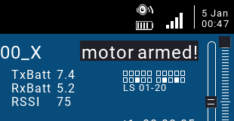
To add this feature to your model:
- In the Outputs menu, identify a spare channel and name it ‘armed’. The spelling must be exact.
- For the ‘armed’ channel, add a single mix with source = {switch that you use for motor arming}. It can be a regular or a logical switch. For example, if your motor arming switch is logical switch L12, then add the following mix:
CH:armed
Mix: source=L12 weight=100% offset=0%
- Power cycle the transmitter to activate the change

Troubleshooting
If the expected fields are not displayed, go to the Telemetry screen, and discover sensors. If it still fails, then delete and rediscover sensors.

Licence
This script is provided under the GNU General Public License v3.
See https://www.gnu.org/licenses/gpl-3.0.en.html for details.

Disclaimer
The script has been extensively tested, however given the limitless combinations of operating system versions, model setups and hardware it’s impossible test every scenario. It is therefore the user's responsibility to check for correct operation with the model before use. If in doubt do not use the script!
Please report any problems to the author: https://rc-soar.com/email.htm
Mike Shellim

9 September 2026

