Research

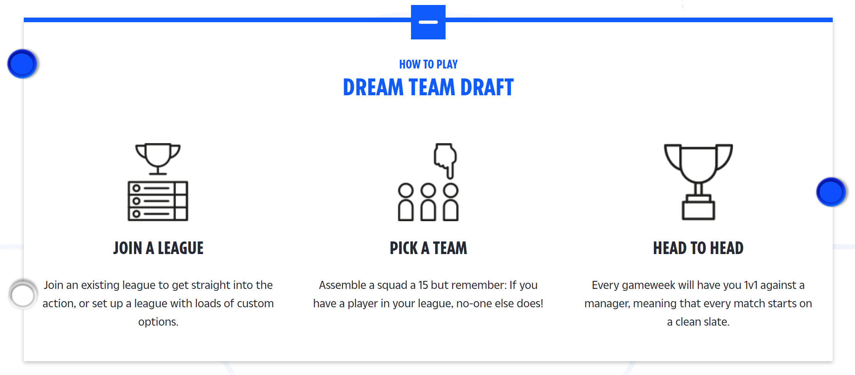
Include a section on what a fantasy draft is

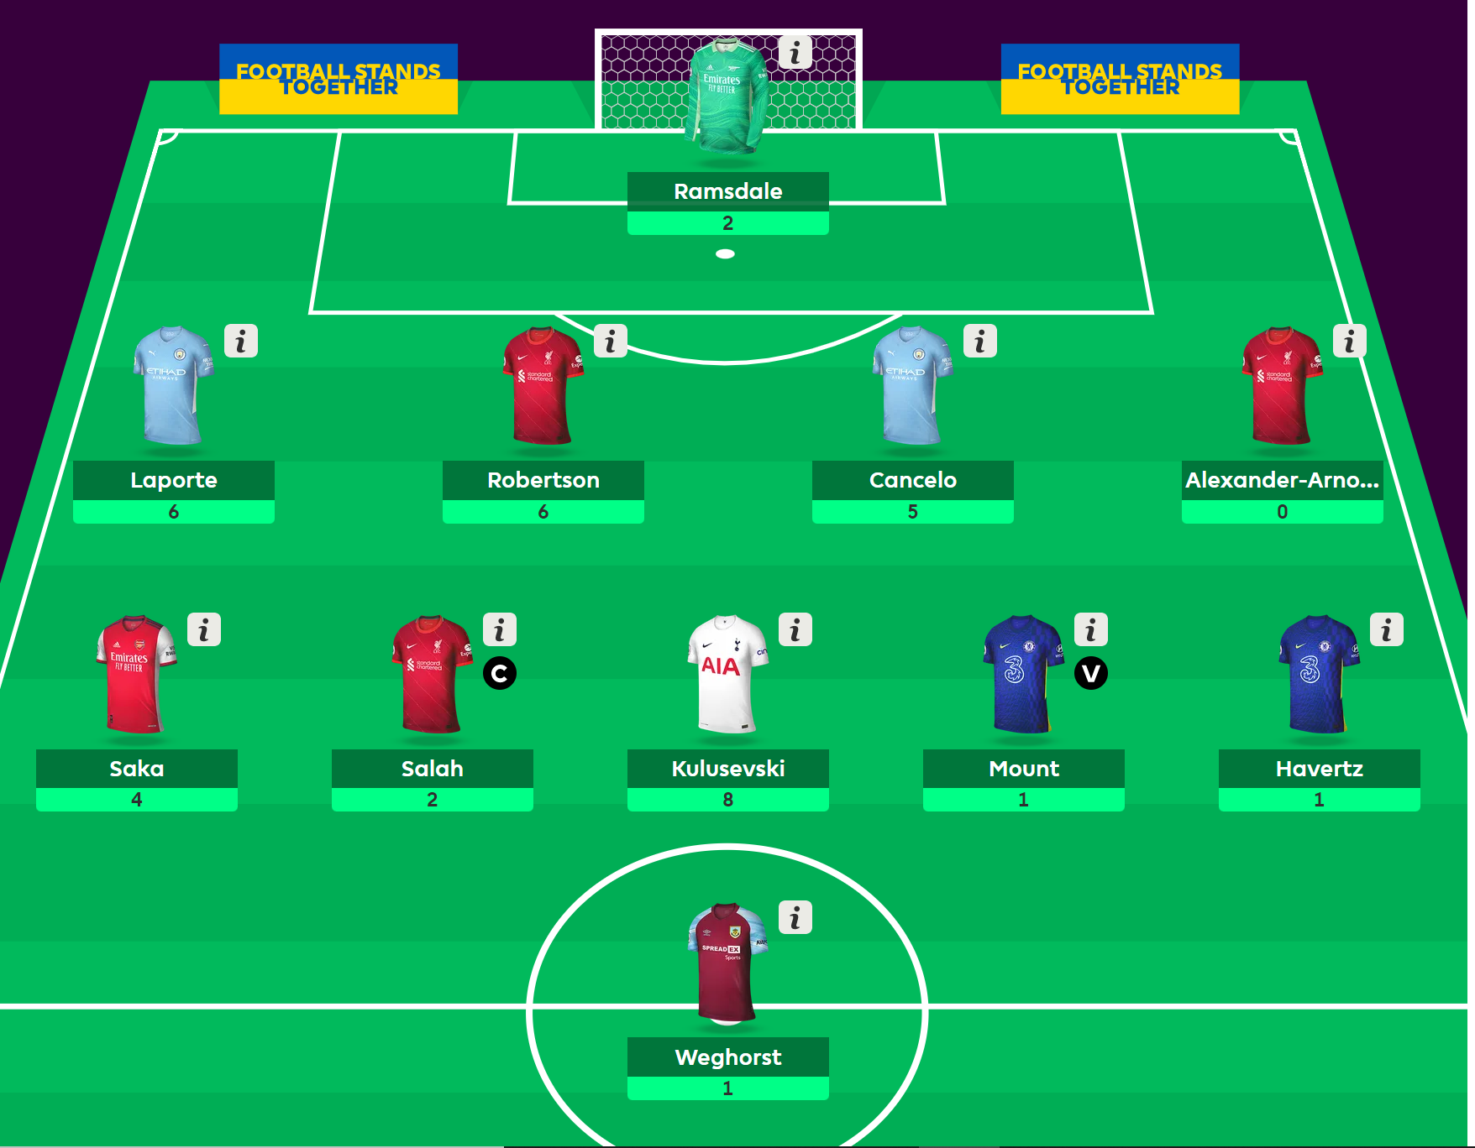
Have a football pitch background on the team selection page

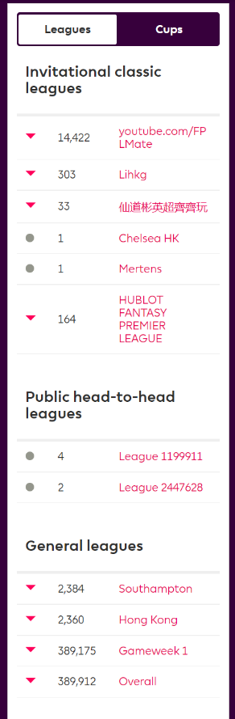
a section to shows the rank of the users in all of their league
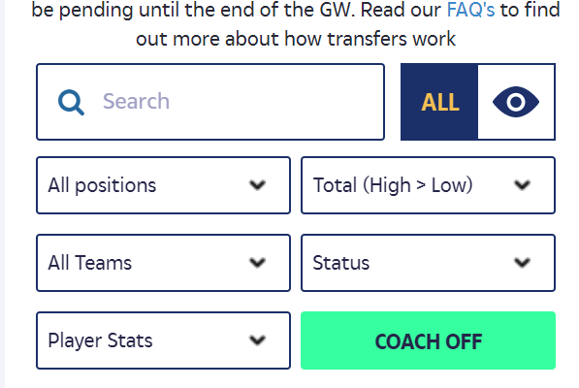
a section for the users to search / filter players
Subpages
Name
Points
Upcoming fixture
