BILL OF MATERIALS

PRODUCT NAME | Smart Desk Dashboard (RCSD) | CONTACT INFO |  |  |  | 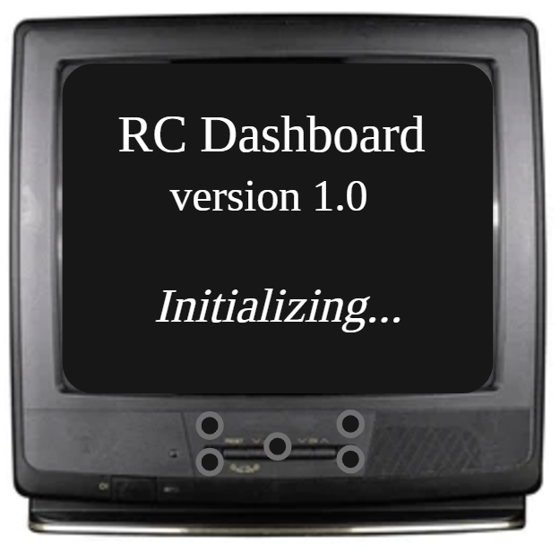
APPROVED BY | Personal Project | Ryan Cohn
DATE OF APPROVAL | July 11, 2026 | 667-305-5588
PART COUNT |  | Ryancohn007@gmail.com
TOTAL COST |  | Amazon Purchases
PART NUMBER | PART NAME | DESCRIPTION |  |  | UNITS |  | PART IMAGE |  | TOTAL COST |  | AMOUNT
1 | Lonely Binary ESP32-S3 | Lonely Binary ESP32-S3 N16R8 2.54mm Expansion Board for Arduino IDE | 16MB Flash, 8MB PSRAM, 240MHz; WiFi + BT 5.0 LE; dual USB-C 5V, VIN 5-12V; 2.54mm GPIO breakout, male/female; MicroPython |  |  | 1 |  | 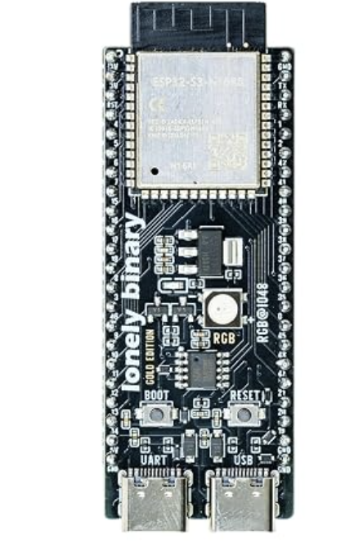 |  | $18.99 |  | $18.99
2 | ST7796S Display | Hosyond 4.0 Inch 320x480 TN Capacitive Touch Screen LCD Display Module SPI Serial ST7796S Driver for Arduino R3/Mega2560/ESP32 |  |  | 1 |  | 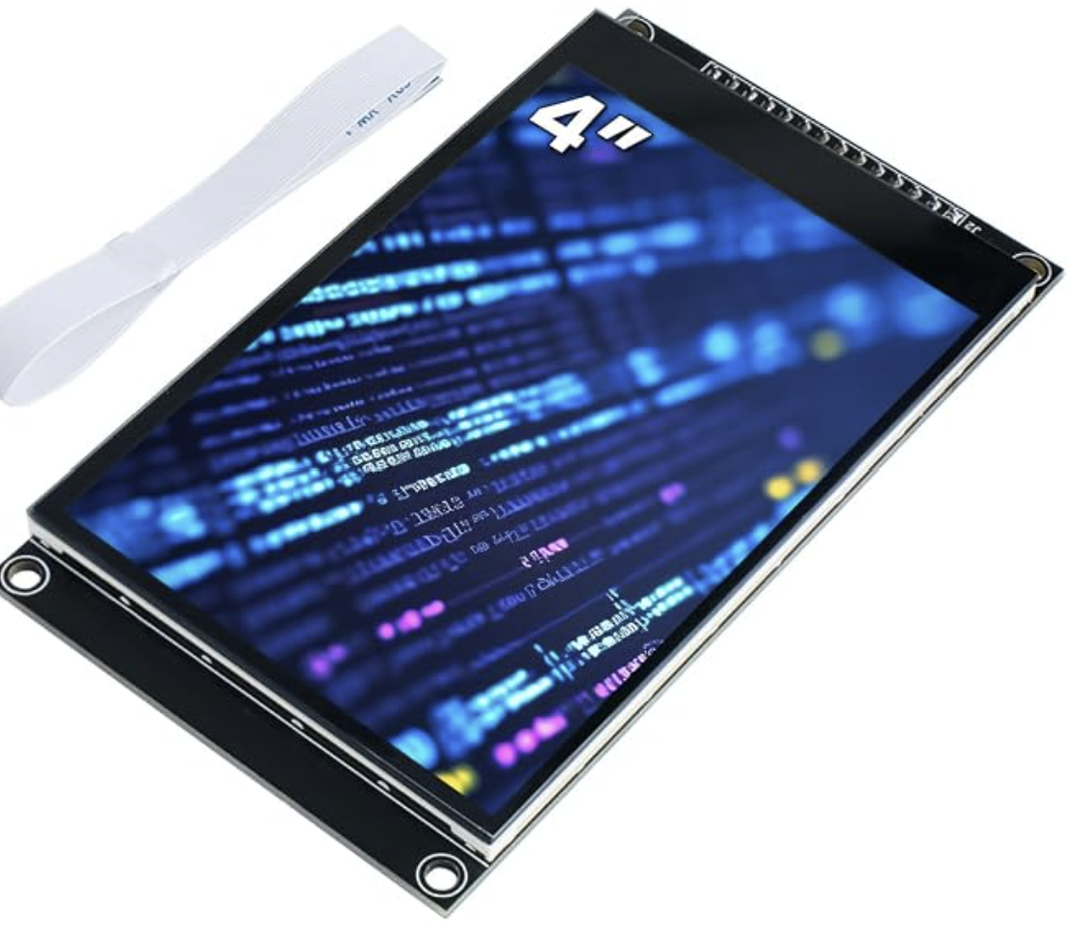 |  | $20.99
3 | MAX98357A I2S Amplifier | MAX98357A I2S 3W Class D Amplifier Breakout Interface I2S DAC Decoder for Audio Raspberry Pi Esp32 Arduino Zero |  |  | 2 |  | 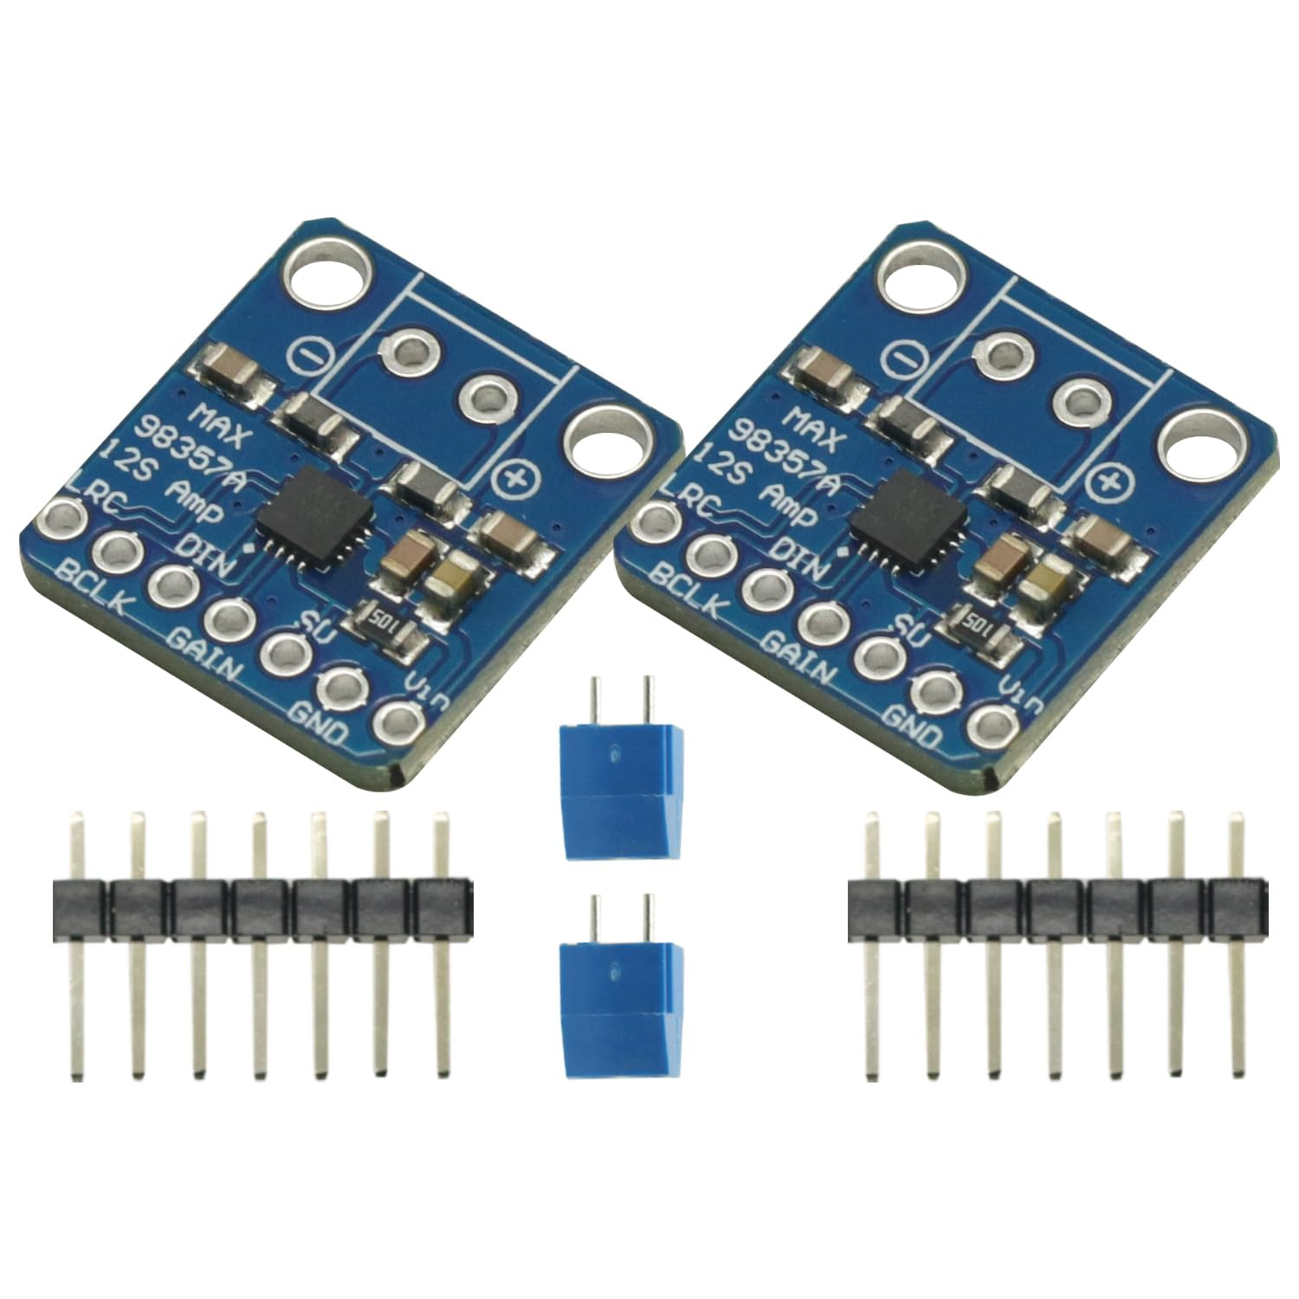 |  | $6.88
4 | Navigation Module | KOOBOOK 5-Channel Five Direction Navigation Button Module 5D Rocker Joystick Independent Keyboard for Arduino MCU |  |  | 5 |  | 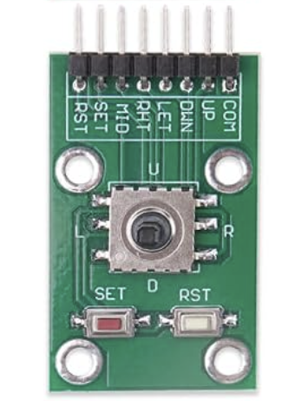 |  | $7.29
5 | EK1794 Speaker Stereo | Gikfun 4Ohm 40mm Diameter 3W Full Range Audio Speaker Stereo Woofer Loudspeaker for Arduino (Pack of 2pcs) EK1794 |  |  | 2 |  | 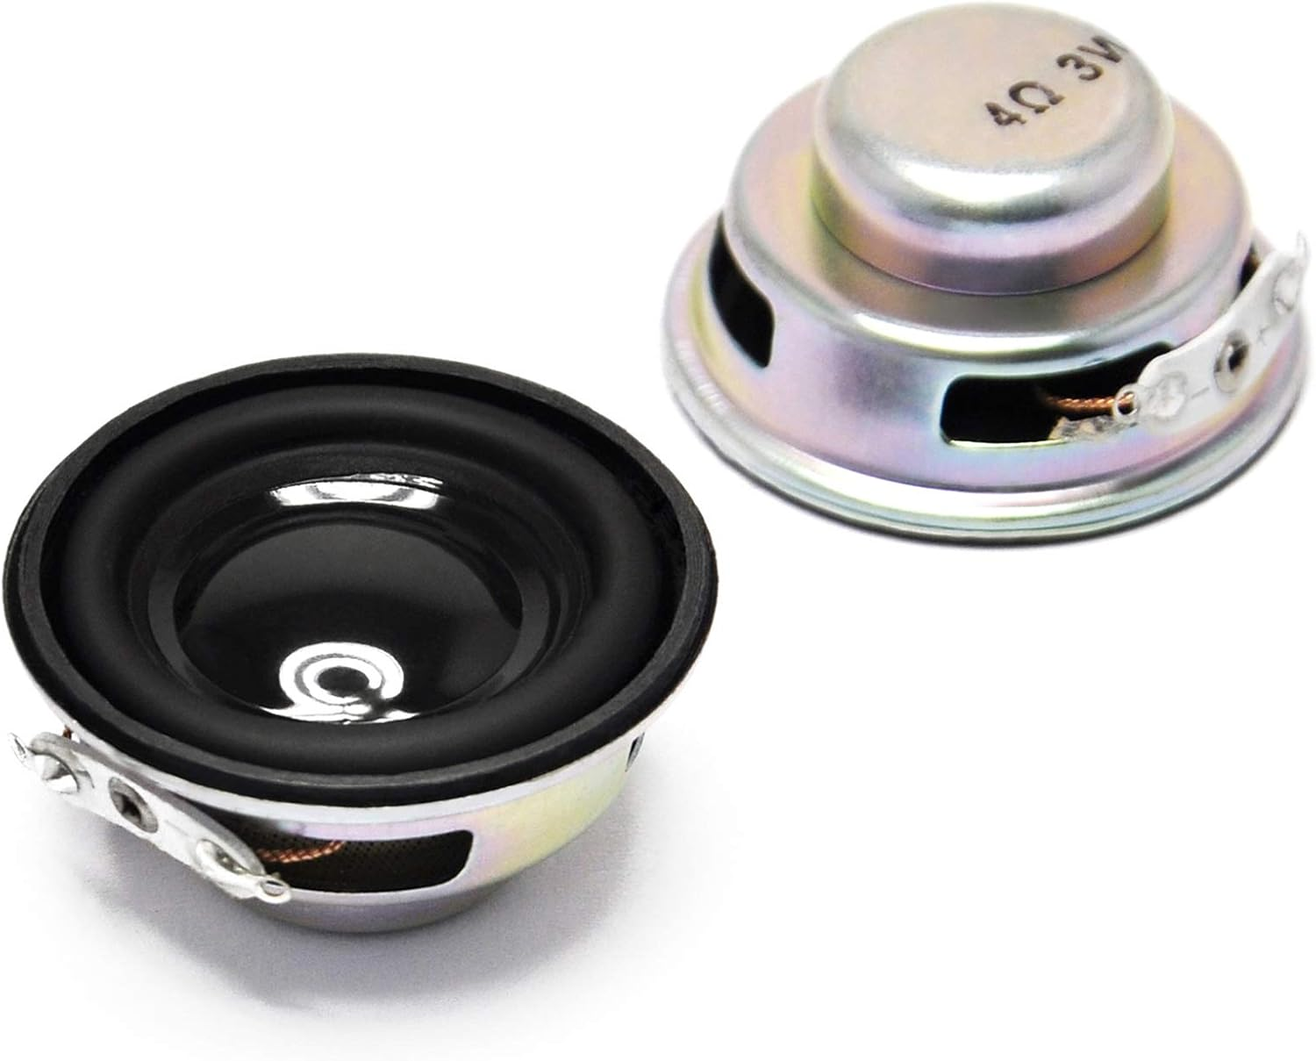 |  | $8.99
6 | 3.7V LiPo Battery | 3.7V Lipo Battery 2000mAh Rechargeable Lithium Polymer Batteries Pack with Wire PH 2.0mm Connector Integrated Protection Circuit for Arduino ESP32 Development Board |  |  | 1 |  | 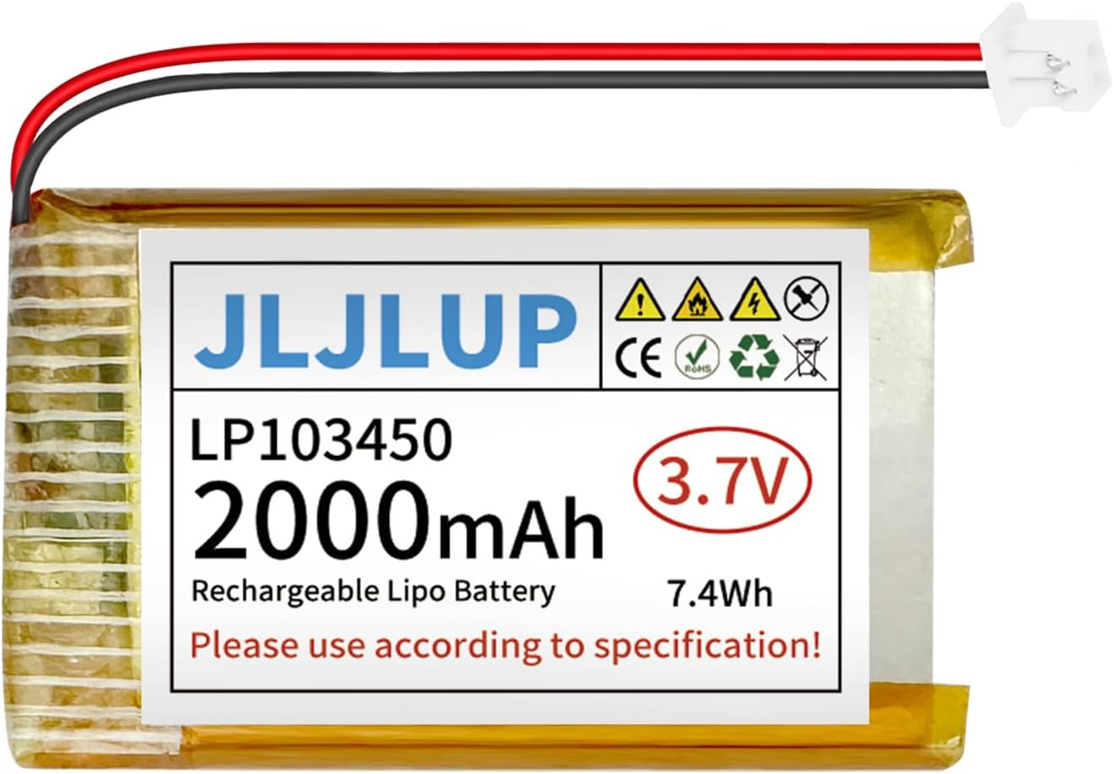 |  | $9.99
7 | Rocker Switch | Mini Rocker Switch On/Off 2 Pin 2 Position 10 x 15mm Boat Rocker Switch 3A 250V 6A125V SPST KCD11 Black Square Switches |  |  | 10 |  | 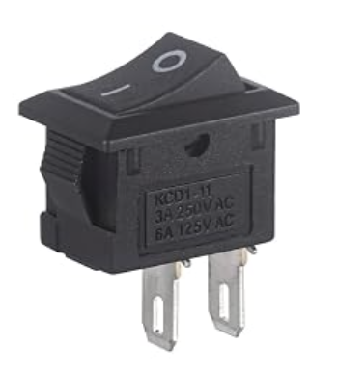 |  | $5.99
8 | Charge/Boost module | Type-C USB 5V 2A Boost Converter Step-Up Power Module 2A 5V Charge Discharge Integrated Module Lithium Battery Charging Protection Board with LED Indicator |  |  | 6 |  | 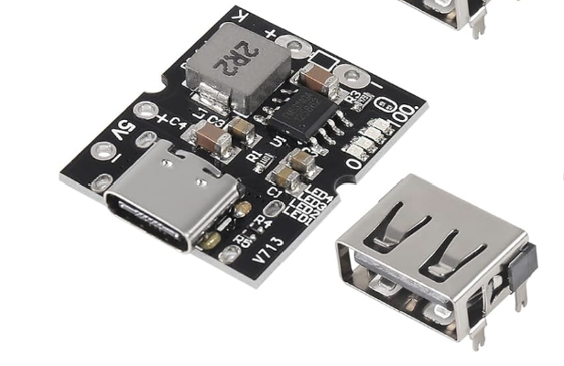 |  | $8.99
9 | Pin Headers | Pin Header, 2.54mm 40Pin Male and Female Header Pins Breakaway PCB Board Connector Single Row Pin Headers Strip for Arduino Shield |  |  | 20 |  | 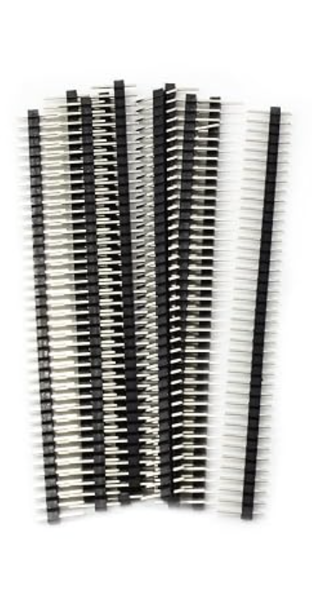 |  | $7.49
10 | Connector Cable | Upgraded Tiny Whoop JST-PH 2.0 Male and Female Connector Cable for Battery JJRC H36 H67 Blade Inductrix E010 E013 |  |  | 10 |  | 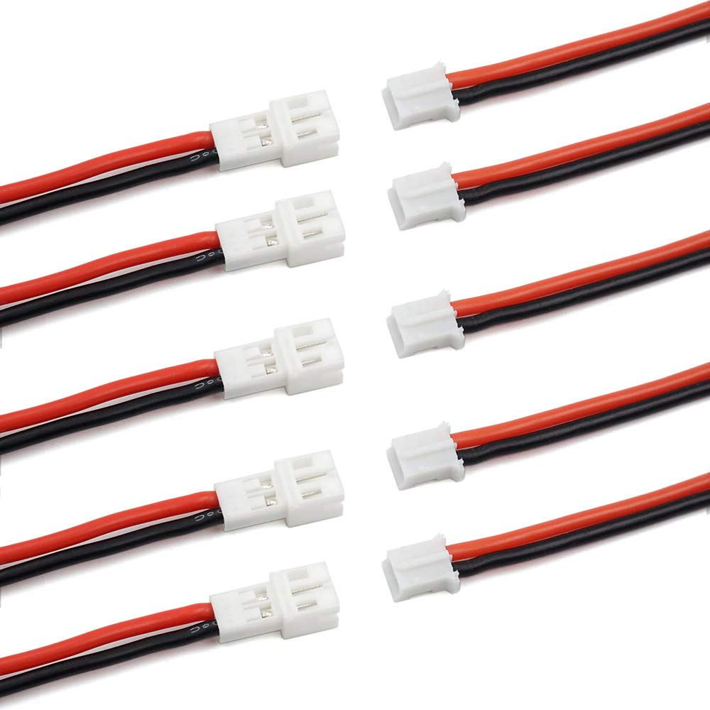 |  | $7.99
11 | Double Sided Perfboards | ELEGOO Double Sided PCB Board Prototype Kit Compatible with Arduino Kits |  |  | 32 |  | 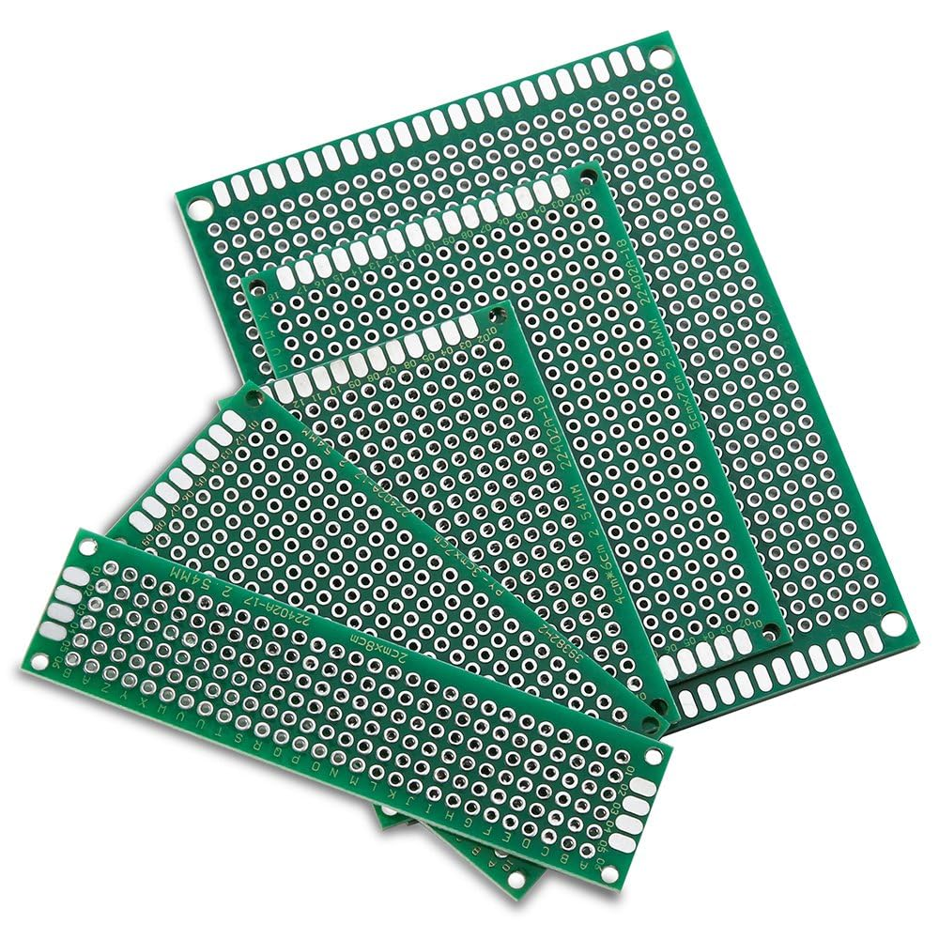 |  | $9.99

