EAP_v1_diversified_announcement_premium
Qlib-backed Earnings Factor Research Report

Research Decision
Field | Value
Research status | research_only
Selected events | 279
Net cumulative return | 0.88%
Net annualized return | 0.14%
Net Sharpe / IR | 0.08
Max drawdown | -7.81%
Exposure-matched excess vs QQQ | 1.02%
Excess Sharpe / IR | 0.10
Avg event return after cost | 0.09%
Avg event excess vs QQQ | 0.31%
Selected rank IC vs QQQ excess | 0.033

Research Interpretation
This behaves as a weak baseline. The diversified announcement-premium idea is not enough by itself in the current technology sample; it needs stronger conditioning or a broader PIT universe.

Economic Hypothesis
Scheduled earnings announcements carry an event-risk premium when held as a diversified, liquid, non-mega-cap technology basket.

Factor Expression
alpha_score: 0.35*prior_excess_component + 0.25*prior_hit_component + 0.20*liquidity_component - 0.12*runup_penalty - 0.08*volatility_penalty
selection: holdable non-indicator symbol, liquid, volatility <= max_volatility_20, runup_5 <= max_runup_5, rolling score percentile >= 30% after history exists

Experiment Design
Field | Value
Date range | 2020-01-02 to 2026-05-07
Benchmark | QQQ
Universe size | 49
Entry | previous trading-day close before reported earnings date
Exit | next trading-day close after reported earnings date
Hold days | 2
Max active positions | 40
Max weight | 0.035
One-way cost bps | 10.0

Signal Diagnostics / IC
Rank IC is computed against the actual strategy holding-horizon return, not just the earnings announcement window. This makes PEAD and basket variants comparable despite different horizons.
bucket | n | rank_ic_score_vs_ret | rank_ic_score_vs_excess | rank_ic_pct_vs_excess
eligible | 417 | 0.043 | 0.046 | 0.049
tradable | 417 | 0.043 | 0.046 | 0.049
selected | 279 | 0.046 | 0.033 | 0.051

Performance Charts
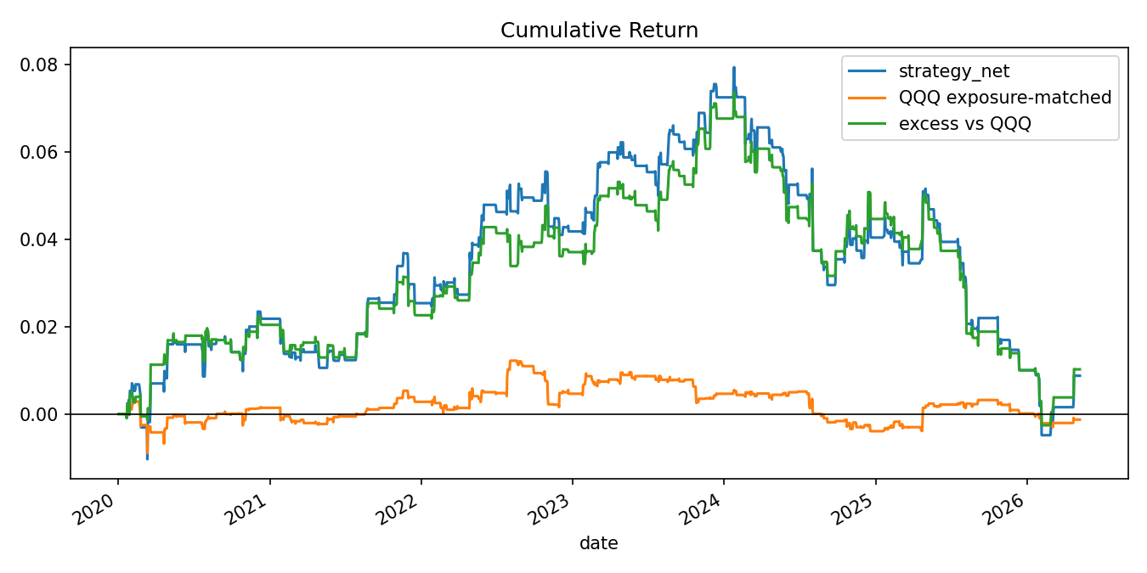
Cumulative return: strategy, exposure-matched QQQ, and excess return.
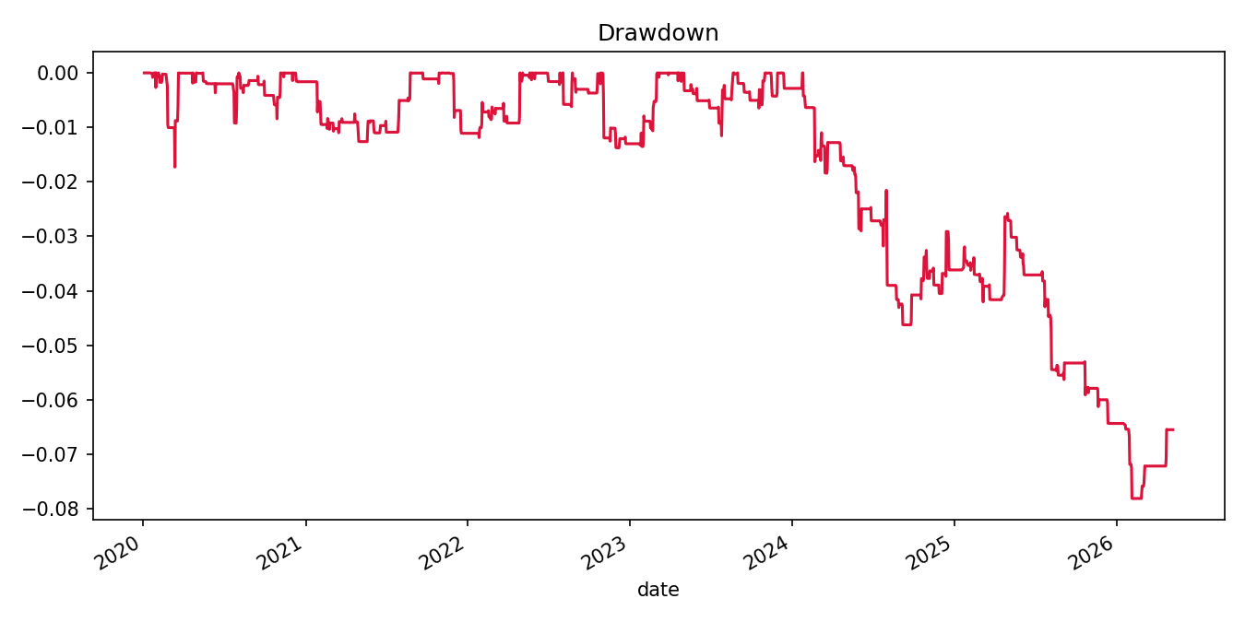
Net strategy drawdown.
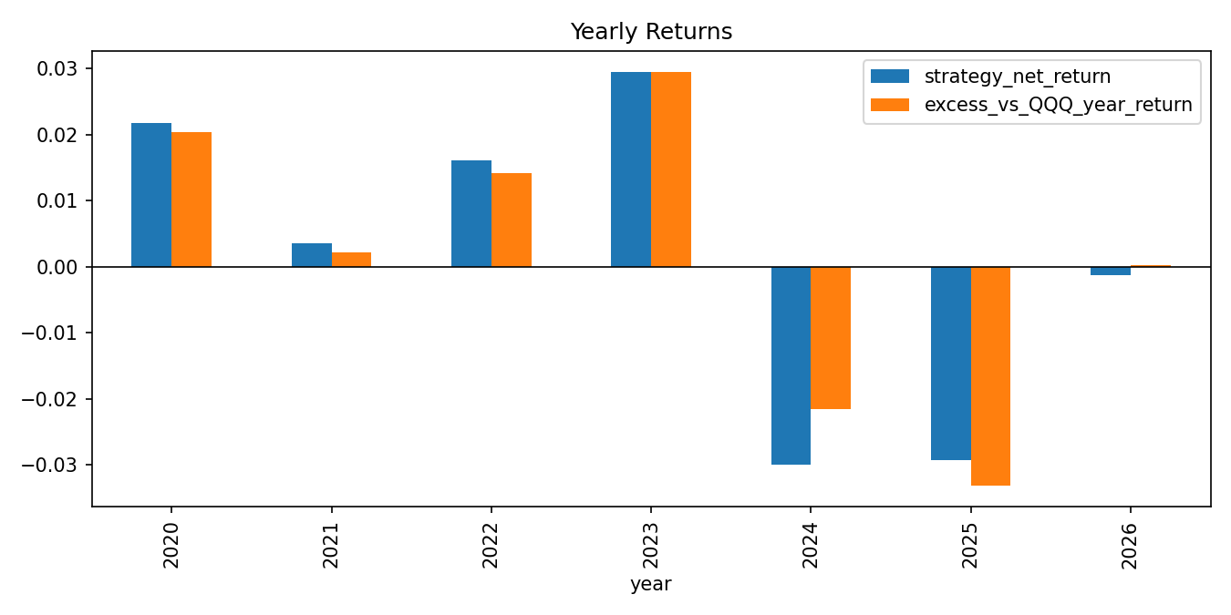
Yearly strategy and excess returns.
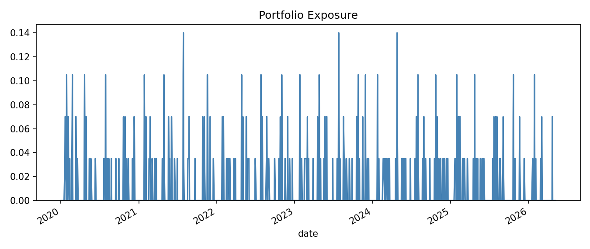
Daily portfolio exposure.
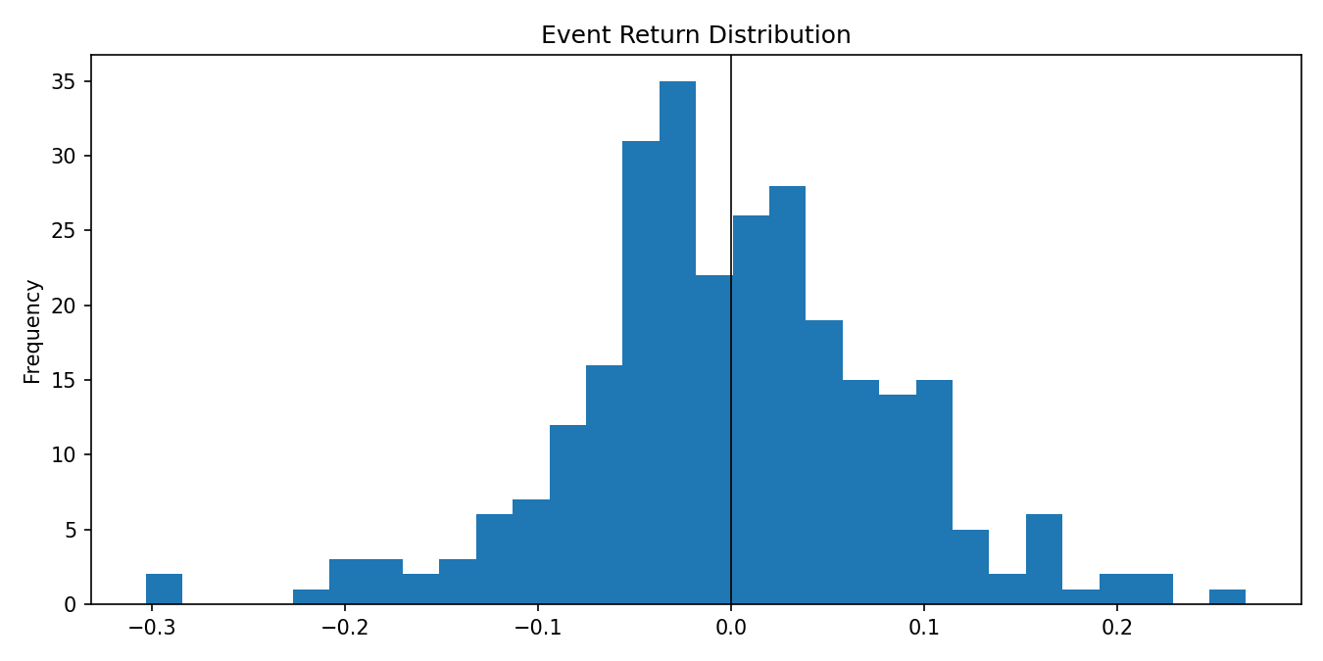
Selected event return distribution after cost.
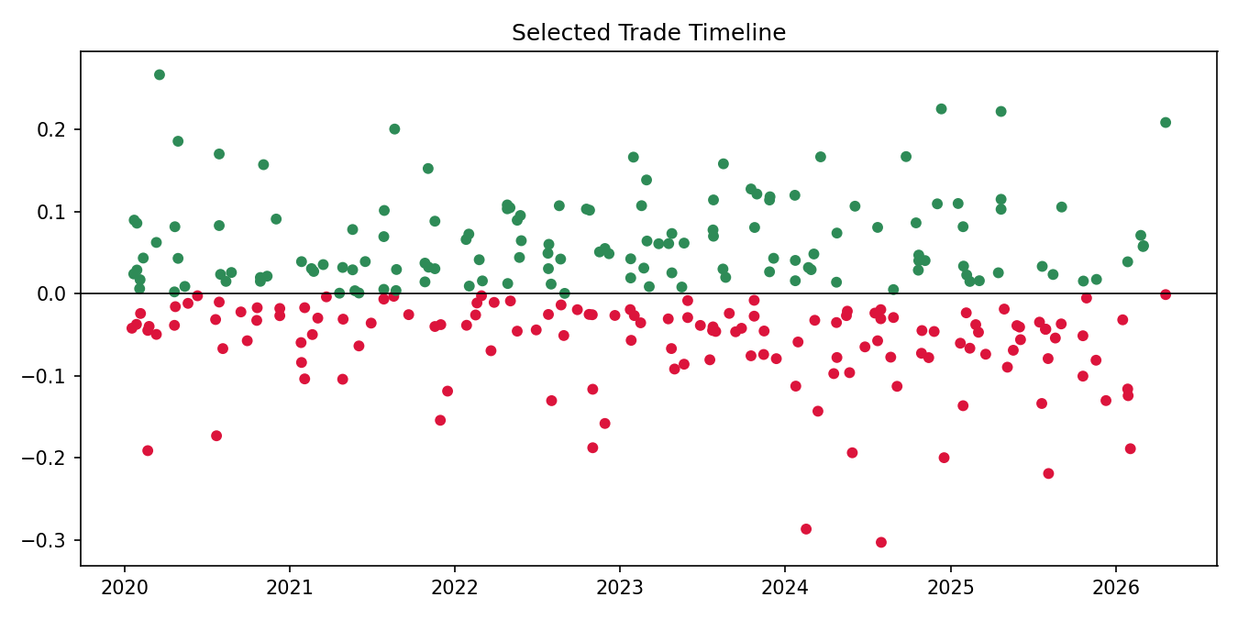
Selected trade timeline.
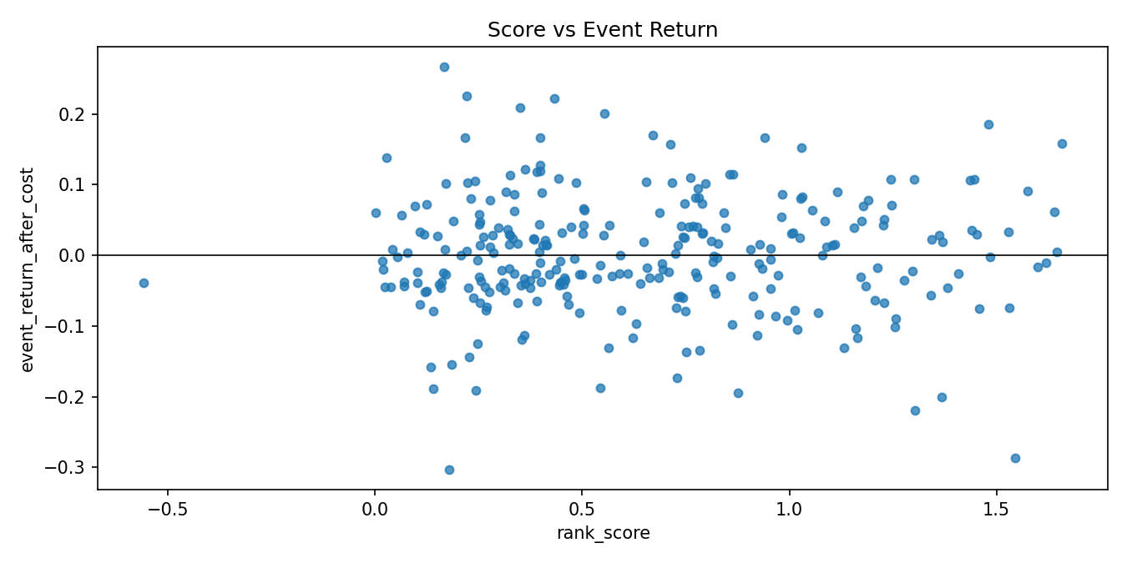
Score versus realized event return.
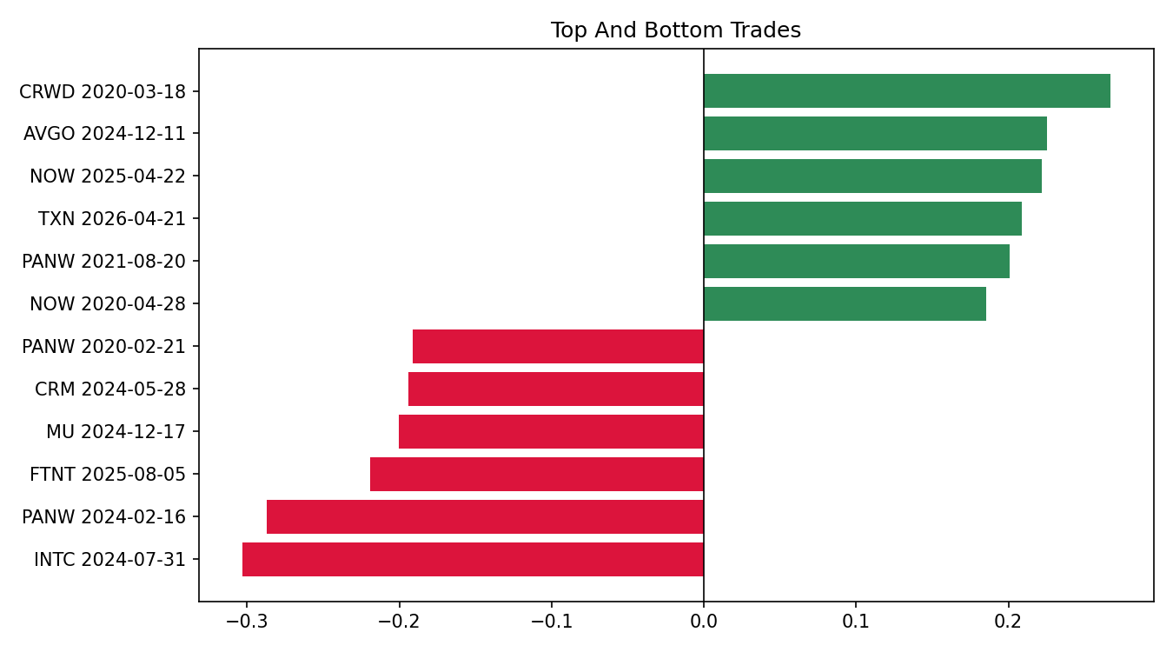
Top and bottom selected trades.

Metrics by Year
year | strategy_net_return | excess_vs_QQQ_year_return | max_drawdown | sharpe | avg_exposure | selected_events | avg_event_return_after_cost
2020 | 2.18% | 2.04% | -1.73% | 0.96 | 1.25% | 45 | 1.35%
2021 | 0.35% | 0.22% | -1.11% | 0.23 | 1.14% | 41 | 0.26%
2022 | 1.60% | 1.41% | -1.38% | 0.83 | 1.25% | 45 | 0.99%
2023 | 2.95% | 2.95% | -1.15% | 1.65 | 1.43% | 51 | 1.64%
2024 | -3.00% | -2.15% | -4.63% | -1.07 | 1.28% | 46 | -1.90%
2025 | -2.92% | -3.32% | -3.96% | -1.46 | 1.15% | 41 | -2.04%
2026 | -0.12% | 0.02% | -1.47% | -0.19 | 0.80% | 10 | -0.29%

Selected Trades

Top trades
symbol | entry_date | exit_date | event_return_after_cost | excess_vs_QQQ_event_return | rank_score
CRWD | 2020-03-18 | 2020-03-20 | 0.2667 | 0.3021 | 0.1672
AVGO | 2024-12-11 | 2024-12-13 | 0.2251 | 0.2259 | 0.2205
NOW | 2025-04-22 | 2025-04-24 | 0.2220 | 0.1725 | 0.4335
TXN | 2026-04-21 | 2026-04-23 | 0.2085 | 0.1995 | 0.3501
PANW | 2021-08-20 | 2021-08-24 | 0.2005 | 0.1844 | 0.5543
NOW | 2020-04-28 | 2020-04-30 | 0.1856 | 0.1526 | 1.4799
QCOM | 2020-07-28 | 2020-07-30 | 0.1701 | 0.1553 | 0.6703
MU | 2024-09-24 | 2024-09-26 | 0.1669 | 0.1605 | 0.2182

Bottom trades
symbol | entry_date | exit_date | event_return_after_cost | excess_vs_QQQ_event_return | rank_score
INTC | 2024-07-31 | 2024-08-02 | -0.3032 | -0.2539 | 0.1799
PANW | 2024-02-16 | 2024-02-21 | -0.2870 | -0.2735 | 1.5447
FTNT | 2025-08-05 | 2025-08-07 | -0.2193 | -0.2333 | 1.3032
MU | 2024-12-17 | 2024-12-19 | -0.2001 | -0.1577 | 1.3681
CRM | 2024-05-28 | 2024-05-30 | -0.1940 | -0.1744 | 0.8764
PANW | 2020-02-21 | 2020-02-25 | -0.1915 | -0.1248 | 0.2427
AMD | 2026-02-02 | 2026-02-04 | -0.1891 | -0.1545 | 0.1408
FTNT | 2022-11-01 | 2022-11-03 | -0.1879 | -0.1328 | 0.5430

Literature Support
Earnings Announcements and Systematic Risk - Savor and Wilson. https://papers.ssrn.com/sol3/papers.cfm?abstract_id=1786308

Data and Research Caveats
Field | Value
Requested symbols | 51
Available price symbols | 49
Event count | 638
Missing price symbols | SNOW, TSM
Missing earnings symbols | ADI, ADSK, ANET, ASML, CSCO, DDOG, DE, DELL, GOOG, HPE, HPQ, IBM, MPWR, MRVL, NXPI, ON, PYPL, SHOP, SMCI, TSLA, TTD, UBER, WDAY, ZS
- Alpha Vantage earnings history is research-grade and may not be point-in-time revised history.
- US universe is curated/current and therefore survivorship-biased.
- Daily close-to-close execution approximates earnings timing.
- No revenue surprise, guidance, analyst revision, or option-implied move feed is included.

Reproducibility
Field | Value
Run directory | .tmp\factor_runs\EAP_v1_diversified_announcement_premium\20260508_122946
Provider URI | ~/.qlib/qlib_data/us_data_recent
Command | 'scripts\run_earnings_seasonal_factors.py' --factor all --tracking-uri=

