EBS_v1_leader_confirmed_basket_drift_10d
Qlib-backed Earnings Factor Research Report

Research Decision
Field | Value
Research status | research_only
Selected events | 260
Net cumulative return | 8.01%
Net annualized return | 1.23%
Net Sharpe / IR | 0.26
Max drawdown | -8.15%
Exposure-matched excess vs QQQ | 10.66%
Excess Sharpe / IR | 0.63
Avg event return after cost | 0.72%
Avg event excess vs QQQ | 1.13%
Selected rank IC vs QQQ excess | 0.154

Research Interpretation
This is a weak but economically coherent basket-timing candidate. QQQ-relative excess is better than the absolute return headline, which means the basket timing is partially hedging market beta, but the absolute return and Sharpe remain too low.

Economic Hypothesis
After several leaders in a technology basket report positive surprise and positive benchmark-excess reaction, the whole basket drifts higher over the next 10 trading days.

Factor Expression
leader_score: 0.35*z(leader_surprise_mean) + 0.35*z(leader_excess_mean) + 0.20*leader_excess_hit_component - 0.10*basket_overextension_penalty
selection: leader_count >= 3, leader_surprise_mean > 0, leader_excess_mean > 0, leader_excess_hit_rate >= 55%, basket response <= 12%, QQQ 20d return > -8%

Experiment Design
Field | Value
Date range | 2020-01-02 to 2026-05-07
Benchmark | QQQ
Universe size | 49
Entry | close after the confirming leader event is observable
Exit | entry close plus 10 trading days
Hold days | 10
Max active positions | 50
Max weight | 0.04
One-way cost bps | 10.0

Signal Diagnostics / IC
Rank IC is computed against the actual strategy holding-horizon return, not just the earnings announcement window. This makes PEAD and basket variants comparable despite different horizons.
bucket | n | rank_ic_score_vs_ret | rank_ic_score_vs_excess | rank_ic_pct_vs_excess
eligible | 260 | 0.295 | 0.154 | n/a
tradable | 260 | 0.295 | 0.154 | n/a
selected | 260 | 0.295 | 0.154 | n/a

Performance Charts
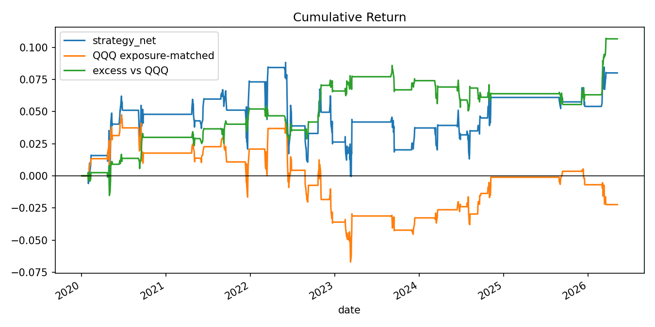
Cumulative return: strategy, exposure-matched QQQ, and excess return.
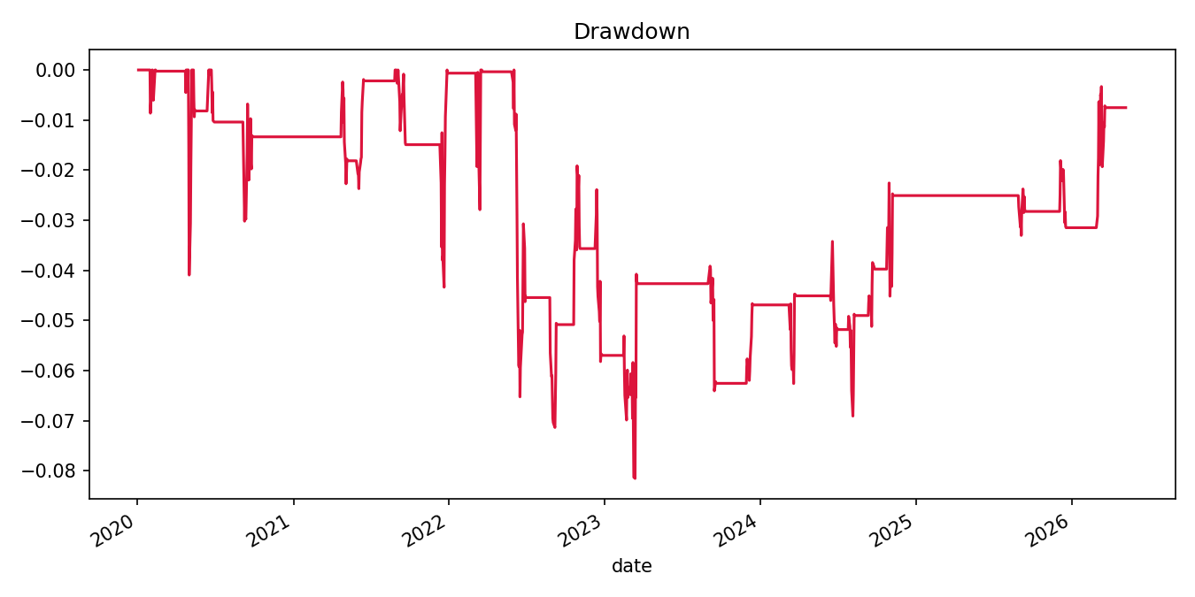
Net strategy drawdown.
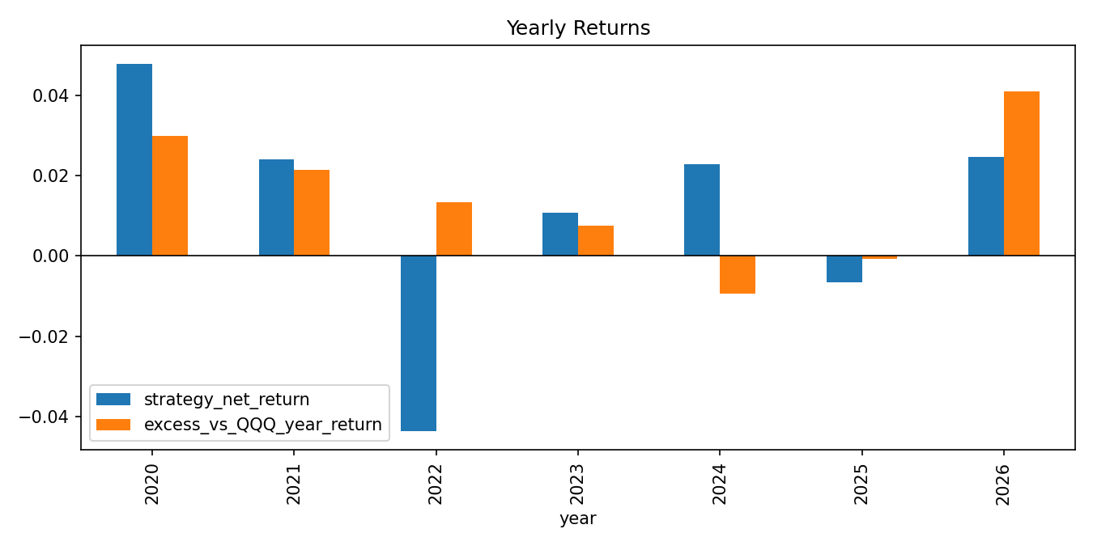
Yearly strategy and excess returns.
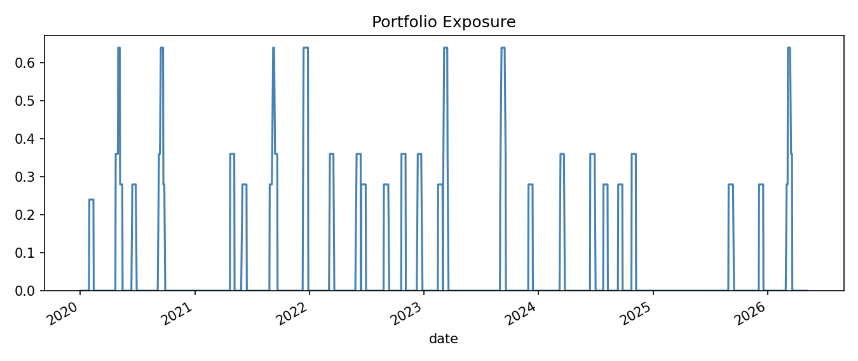
Daily portfolio exposure.
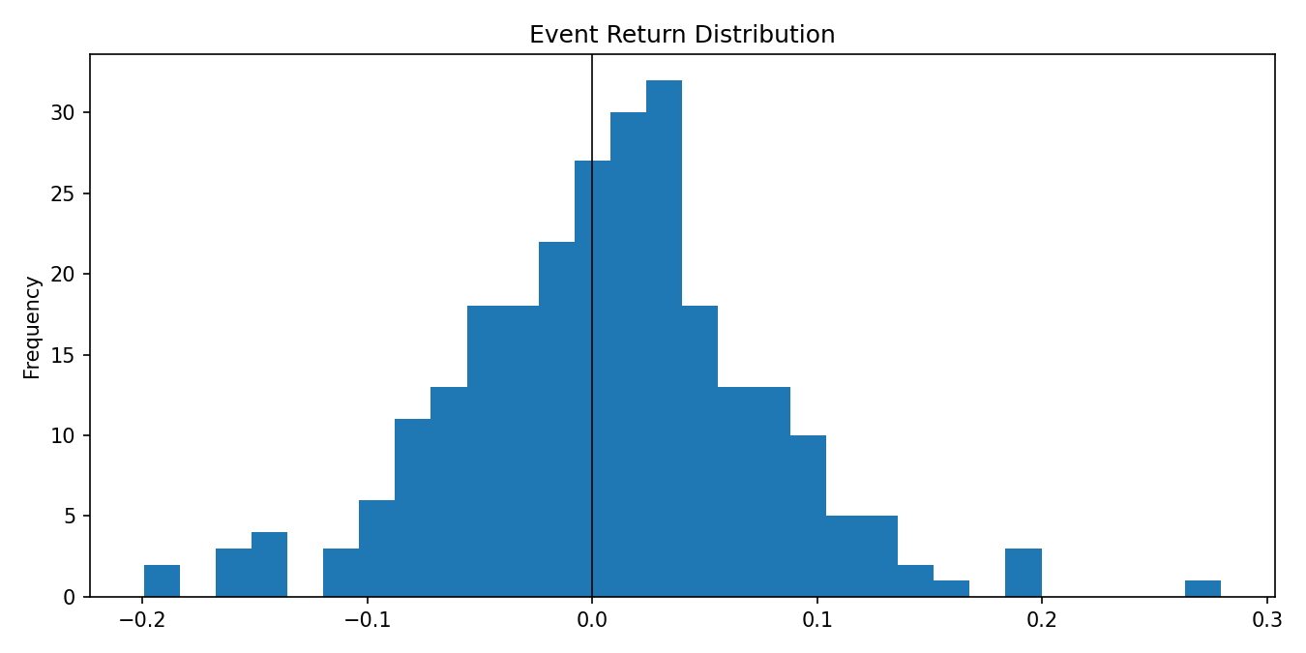
Selected event return distribution after cost.
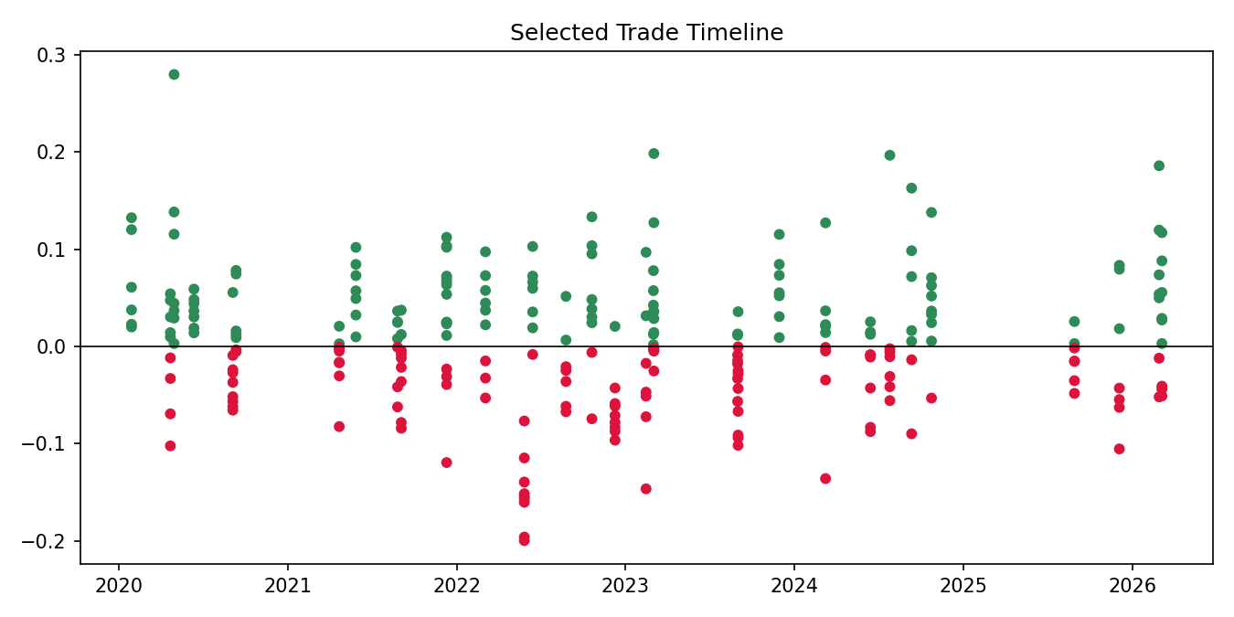
Selected trade timeline.
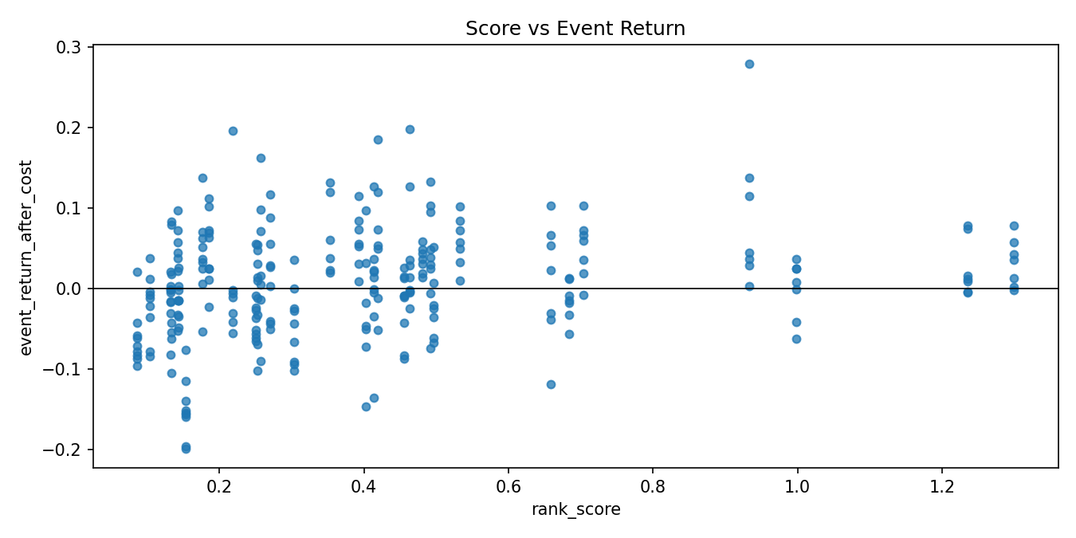
Score versus realized event return.
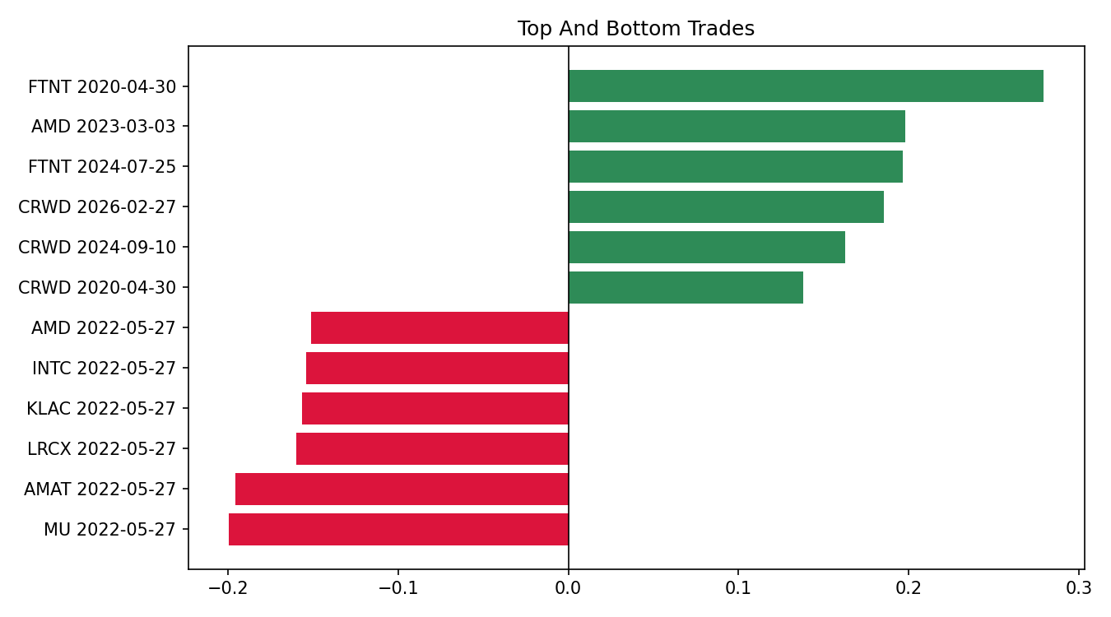
Top and bottom selected trades.

Metrics by Year
year | strategy_net_return | excess_vs_QQQ_year_return | max_drawdown | sharpe | avg_exposure | selected_events | avg_event_return_after_cost
2020 | 4.79% | 2.99% | -4.09% | 0.82 | 7.14% | 45 | 2.52%
2021 | 2.41% | 2.14% | -4.34% | 0.47 | 7.62% | 48 | 1.22%
2022 | -4.36% | 1.33% | -7.13% | -0.60 | 7.97% | 50 | -2.17%
2023 | 1.07% | 0.76% | -3.00% | 0.24 | 7.36% | 46 | 0.62%
2024 | 2.29% | -0.94% | -3.61% | 0.56 | 6.51% | 41 | 1.28%
2025 | -0.66% | -0.08% | -1.36% | -0.36 | 2.24% | 14 | -1.22%
2026 | 2.47% | 4.10% | -1.61% | 1.47 | 7.36% | 16 | 3.77%

Selected Trades

Top trades
symbol | entry_date | exit_date | event_return_after_cost | excess_vs_QQQ_event_return | rank_score
FTNT | 2020-04-30 | 2020-05-14 | 0.2794 | 0.2681 | 0.9330
AMD | 2023-03-03 | 2023-03-17 | 0.1982 | 0.1812 | 0.4629
FTNT | 2024-07-25 | 2024-08-08 | 0.1964 | 0.2207 | 0.2186
CRWD | 2026-02-27 | 2026-03-13 | 0.1856 | 0.2100 | 0.4190
CRWD | 2024-09-10 | 2024-09-24 | 0.1627 | 0.1050 | 0.2569
CRWD | 2020-04-30 | 2020-05-14 | 0.1381 | 0.1268 | 0.9330
INTC | 2024-10-23 | 2024-11-06 | 0.1377 | 0.1044 | 0.1761
KLAC | 2022-10-20 | 2022-11-03 | 0.1331 | 0.1672 | 0.4915

Bottom trades
symbol | entry_date | exit_date | event_return_after_cost | excess_vs_QQQ_event_return | rank_score
MU | 2022-05-27 | 2022-06-13 | -0.1995 | -0.0885 | 0.1537
AMAT | 2022-05-27 | 2022-06-13 | -0.1958 | -0.0848 | 0.1537
LRCX | 2022-05-27 | 2022-06-13 | -0.1601 | -0.0491 | 0.1537
KLAC | 2022-05-27 | 2022-06-13 | -0.1566 | -0.0456 | 0.1537
INTC | 2022-05-27 | 2022-06-13 | -0.1542 | -0.0432 | 0.1537
AMD | 2022-05-27 | 2022-06-13 | -0.1513 | -0.0403 | 0.1537
ADBE | 2023-02-14 | 2023-03-01 | -0.1463 | -0.0936 | 0.4031
TXN | 2022-05-27 | 2022-06-13 | -0.1393 | -0.0283 | 0.1537

Literature Support
Algorithmic Trading and Intra-industry Information Transfers - Zhang, Jiang, and Young. https://link.springer.com/article/10.1007/s11142-026-09954-3
ETFs and Information Transfer Across Firms - Bhojraj, Mohanram, and Zhang. https://papers.ssrn.com/sol3/papers.cfm?abstract_id=3175382

Data and Research Caveats
Field | Value
Requested symbols | 51
Available price symbols | 49
Event count | 638
Missing price symbols | SNOW, TSM
Missing earnings symbols | ADI, ADSK, ANET, ASML, CSCO, DDOG, DE, DELL, GOOG, HPE, HPQ, IBM, MPWR, MRVL, NXPI, ON, PYPL, SHOP, SMCI, TSLA, TTD, UBER, WDAY, ZS
- Alpha Vantage earnings history is research-grade and may not be point-in-time revised history.
- US universe is curated/current and therefore survivorship-biased.
- Daily close-to-close execution approximates earnings timing.
- No revenue surprise, guidance, analyst revision, or option-implied move feed is included.

Reproducibility
Field | Value
Run directory | .tmp\factor_runs\EBS_v1_leader_confirmed_basket_drift_10d\20260508_123039
Provider URI | ~/.qlib/qlib_data/us_data_recent
Command | 'scripts\run_earnings_seasonal_factors.py' --factor all --tracking-uri=

