EBS_v2_leader_follower_gap_40d
Qlib-backed Earnings Factor Research Report

Research Decision
Field | Value
Research status | research_only
Selected events | 220
Net cumulative return | 32.57%
Net annualized return | 4.56%
Net Sharpe / IR | 0.59
Max drawdown | -23.32%
Exposure-matched excess vs QQQ | 8.47%
Excess Sharpe / IR | 0.34
Avg event return after cost | 2.81%
Avg event excess vs QQQ | 1.06%
Selected rank IC vs QQQ excess | -0.021

Research Interpretation
This version produces positive absolute return but weak score IC and material drawdown. It is a candidate for redesign, not a final factor: the leader-follower gap mechanism needs better timing and broader data before it can be trusted.

Economic Hypothesis
When leader earnings are strong but later-reporting followers have not fully responded, buy the follower gap and exit before the follower's own earnings date or after 20 trading days.

Factor Expression
gap_score: leader_strength + 0.25*(-follower_response_to_trigger / 8% clipped); leader_strength = 0.45*z(leader_surprise_mean) + 0.45*z(leader_excess_mean) + 0.10*leader_hit_component
selection: leader_count >= 2, positive leader surprise/excess, follower response <= 8%, holdable follower has not yet reported

Experiment Design
Field | Value
Date range | 2020-01-02 to 2026-05-07
Benchmark | QQQ
Universe size | 49
Entry | close after leader confirmation
Exit | earlier of previous close before follower earnings or entry plus 40 trading days
Hold days | 40
Max active positions | 30
Max weight | 0.05
One-way cost bps | 10.0

Signal Diagnostics / IC
Rank IC is computed against the actual strategy holding-horizon return, not just the earnings announcement window. This makes PEAD and basket variants comparable despite different horizons.
bucket | n | rank_ic_score_vs_ret | rank_ic_score_vs_excess | rank_ic_pct_vs_excess
eligible | 220 | -0.070 | -0.021 | n/a
tradable | 220 | -0.070 | -0.021 | n/a
selected | 220 | -0.070 | -0.021 | n/a

Performance Charts
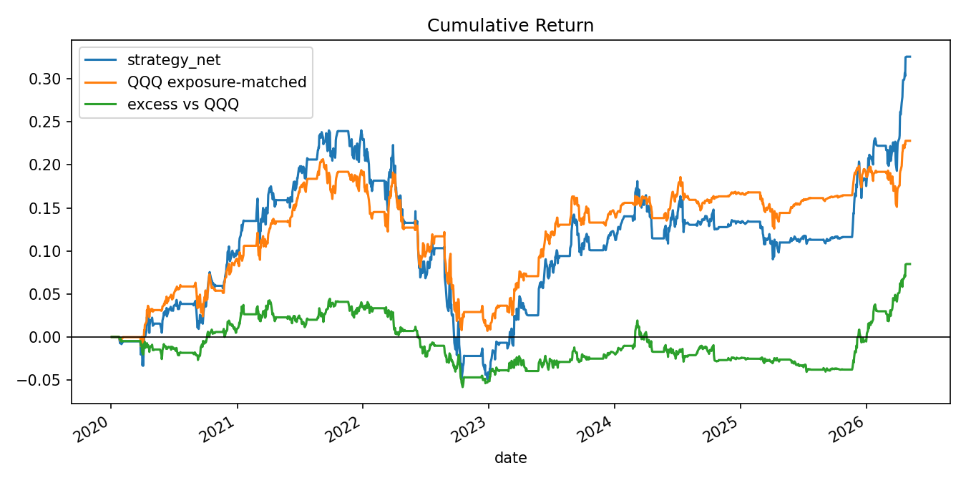
Cumulative return: strategy, exposure-matched QQQ, and excess return.
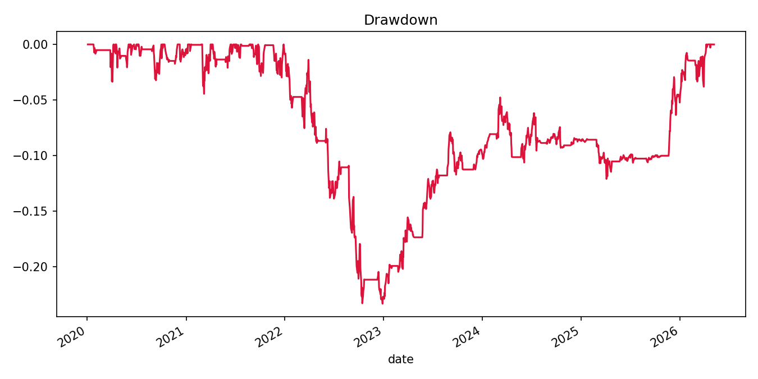
Net strategy drawdown.
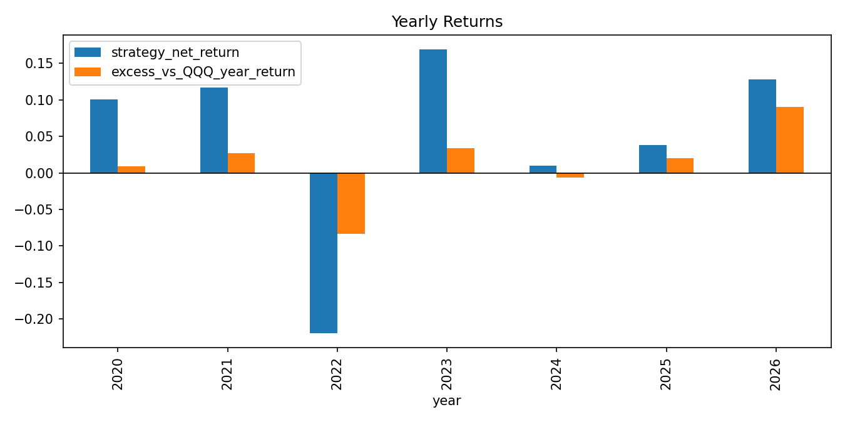
Yearly strategy and excess returns.
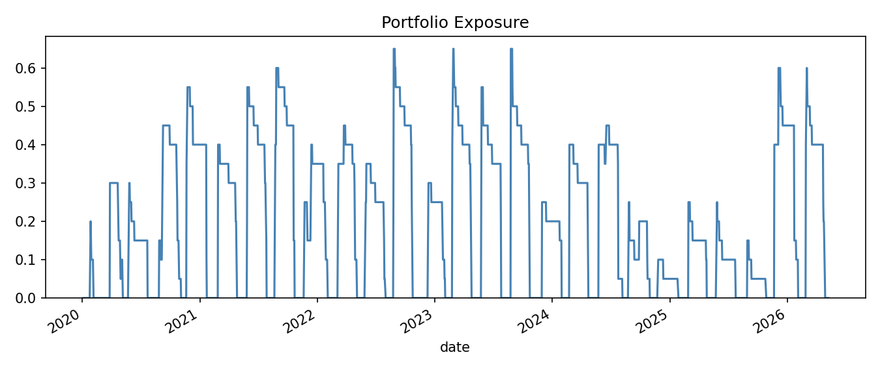
Daily portfolio exposure.
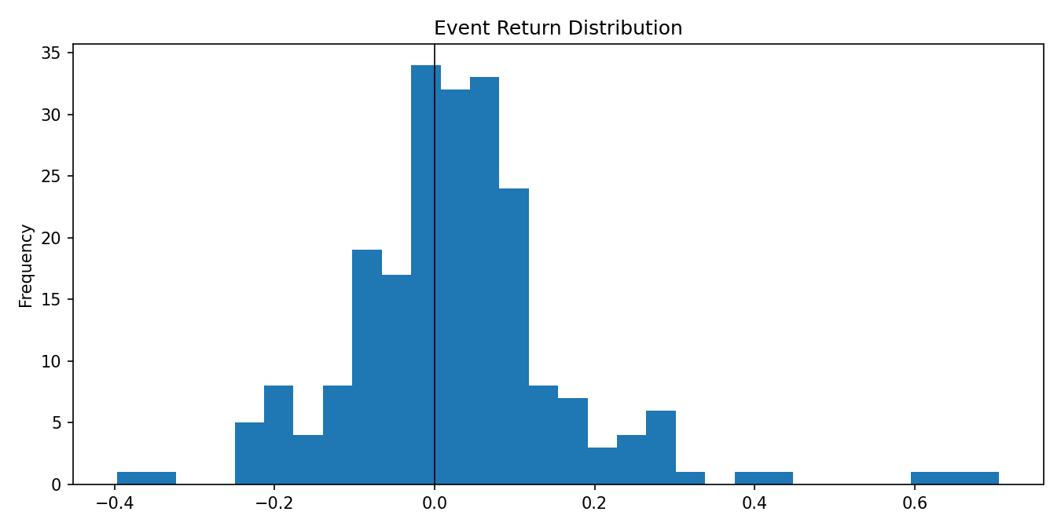
Selected event return distribution after cost.
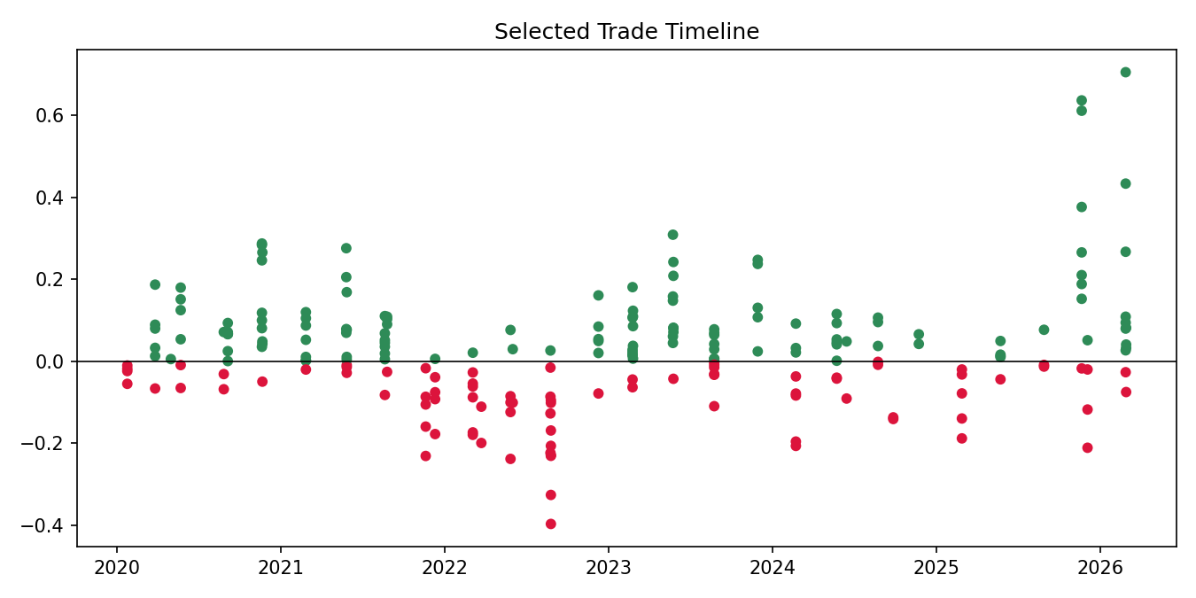
Selected trade timeline.
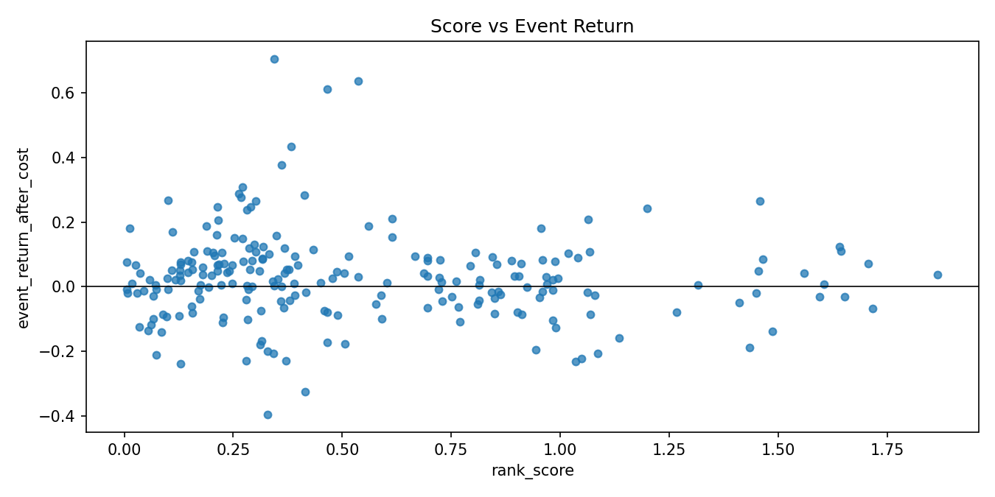
Score versus realized event return.
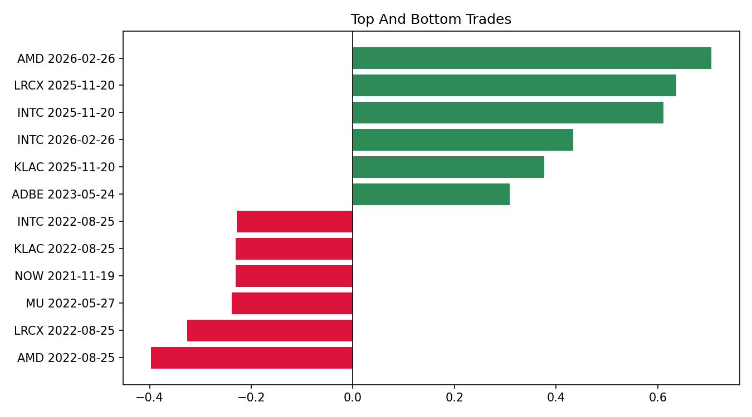
Top and bottom selected trades.

Metrics by Year
year | strategy_net_return | excess_vs_QQQ_year_return | max_drawdown | sharpe | avg_exposure | selected_events | avg_event_return_after_cost
2020 | 10.05% | 0.91% | -3.36% | 1.27 | 16.51% | 38 | 6.57%
2021 | 11.69% | 2.67% | -4.44% | 1.34 | 25.32% | 41 | 1.85%
2022 | -21.98% | -8.37% | -22.68% | -2.12 | 21.95% | 35 | -9.42%
2023 | 16.94% | 3.41% | -4.14% | 2.15 | 24.46% | 42 | 6.75%
2024 | 0.98% | -0.67% | -6.15% | 0.19 | 16.73% | 27 | -0.61%
2025 | 3.79% | 2.00% | -3.93% | 0.74 | 10.90% | 25 | 7.10%
2026 | 12.79% | 9.06% | -3.07% | 3.54 | 27.01% | 12 | 14.76%

Selected Trades

Top trades
symbol | entry_date | exit_date | event_return_after_cost | excess_vs_QQQ_event_return | rank_score
AMD | 2026-02-26 | 2026-04-24 | 0.7056 | 0.6166 | 0.3443
LRCX | 2025-11-20 | 2026-01-21 | 0.6368 | 0.5852 | 0.5365
INTC | 2025-11-20 | 2026-01-21 | 0.6116 | 0.5600 | 0.4660
INTC | 2026-02-26 | 2026-04-22 | 0.4338 | 0.3591 | 0.3826
KLAC | 2025-11-20 | 2026-01-21 | 0.3767 | 0.3251 | 0.3606
ADBE | 2023-05-24 | 2023-06-14 | 0.3091 | 0.2078 | 0.2705
LRCX | 2020-11-19 | 2021-01-20 | 0.2876 | 0.1803 | 0.2627
INTC | 2020-11-19 | 2021-01-20 | 0.2841 | 0.1767 | 0.4127

Bottom trades
symbol | entry_date | exit_date | event_return_after_cost | excess_vs_QQQ_event_return | rank_score
AMD | 2022-08-25 | 2022-10-21 | -0.3967 | -0.2554 | 0.3281
LRCX | 2022-08-25 | 2022-10-18 | -0.3259 | -0.1723 | 0.4151
MU | 2022-05-27 | 2022-06-29 | -0.2380 | -0.1559 | 0.1289
NOW | 2021-11-19 | 2022-01-19 | -0.2308 | -0.1371 | 1.0344
KLAC | 2022-08-25 | 2022-10-21 | -0.2305 | -0.0892 | 0.2799
INTC | 2022-08-25 | 2022-10-21 | -0.2290 | -0.0877 | 0.3712
NOW | 2022-08-24 | 2022-10-20 | -0.2233 | -0.0771 | 1.0487
NOW | 2025-12-03 | 2026-01-27 | -0.2108 | -0.2223 | 0.0737

Literature Support
Algorithmic Trading and Intra-industry Information Transfers - Zhang, Jiang, and Young. https://link.springer.com/article/10.1007/s11142-026-09954-3

Data and Research Caveats
Field | Value
Requested symbols | 51
Available price symbols | 49
Event count | 638
Missing price symbols | SNOW, TSM
Missing earnings symbols | ADI, ADSK, ANET, ASML, CSCO, DDOG, DE, DELL, GOOG, HPE, HPQ, IBM, MPWR, MRVL, NXPI, ON, PYPL, SHOP, SMCI, TSLA, TTD, UBER, WDAY, ZS
- Alpha Vantage earnings history is research-grade and may not be point-in-time revised history.
- US universe is curated/current and therefore survivorship-biased.
- Daily close-to-close execution approximates earnings timing.
- No revenue surprise, guidance, analyst revision, or option-implied move feed is included.

Reproducibility
Field | Value
Run directory | .tmp\factor_runs\EBS_v2_leader_follower_gap_40d\20260508_123103
Provider URI | ~/.qlib/qlib_data/us_data_recent
Command | 'scripts\run_earnings_seasonal_factors.py' --factor all --tracking-uri=

