PEAD_v1_quality_drift_60d
Qlib-backed Earnings Factor Research Report

Research Decision
Field | Value
Research status | research_only
Selected events | 125
Net cumulative return | 65.07%
Net annualized return | 8.25%
Net Sharpe / IR | 0.85
Max drawdown | -12.98%
Exposure-matched excess vs QQQ | 16.62%
Excess Sharpe / IR | 0.60
Avg event return after cost | 8.15%
Avg event excess vs QQQ | 2.59%
Selected rank IC vs QQQ excess | 0.115

Research Interpretation
This is the strongest current candidate in the suite. The result supports the revised research question: confirmed post-earnings drift has more signal than pre-earnings jump prediction. The sample has 125 selected events, positive QQQ-relative excess, and usable but still not production-grade rank IC.

Economic Hypothesis
Positive EPS surprise confirmed by positive benchmark-excess announcement reaction drifts over the following 60 trading days, especially outside mega-cap indicators.

Factor Expression
alpha_score: 0.34*surprise_component + 0.36*announcement_excess_component + 0.15*prior_excess_component + 0.10*prior_beat_component - 0.05*runup_penalty
selection: positive EPS surprise, positive QQQ-excess announcement reaction, liquid, volatility controlled, rolling score percentile >= 45% after history exists

Experiment Design
Field | Value
Date range | 2020-01-02 to 2026-05-07
Benchmark | QQQ
Universe size | 49
Entry | close of the first full trading day after reported earnings date
Exit | entry close plus 60 trading days
Hold days | 60
Max active positions | 30
Max weight | 0.05
One-way cost bps | 10.0

Signal Diagnostics / IC
Rank IC is computed against the actual strategy holding-horizon return, not just the earnings announcement window. This makes PEAD and basket variants comparable despite different horizons.
bucket | n | rank_ic_score_vs_ret | rank_ic_score_vs_excess | rank_ic_pct_vs_excess
eligible | 192 | 0.077 | 0.042 | -0.025
tradable | 192 | 0.077 | 0.042 | -0.025
selected | 125 | 0.089 | 0.115 | -0.059

Performance Charts
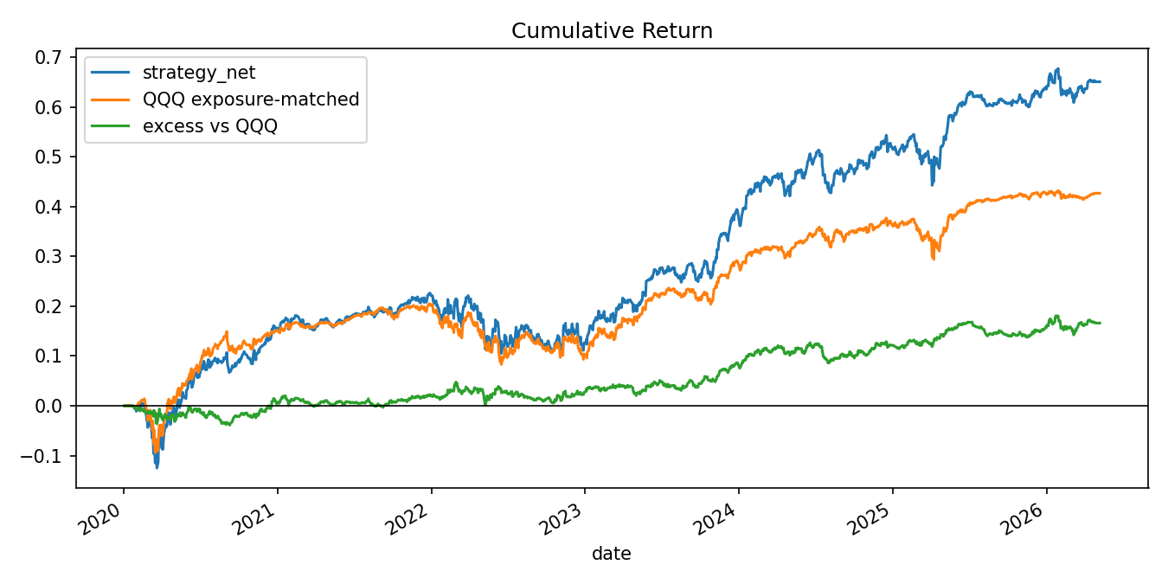
Cumulative return: strategy, exposure-matched QQQ, and excess return.
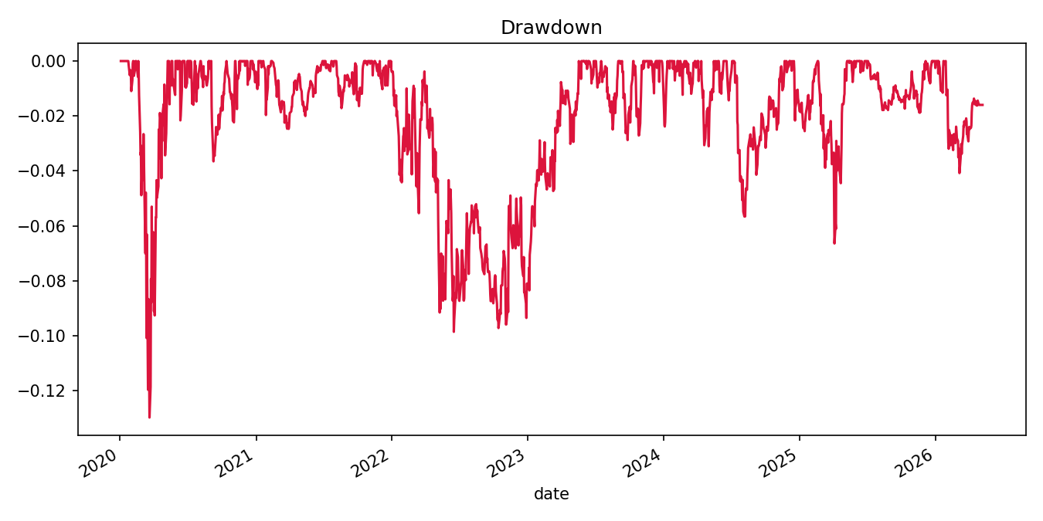
Net strategy drawdown.
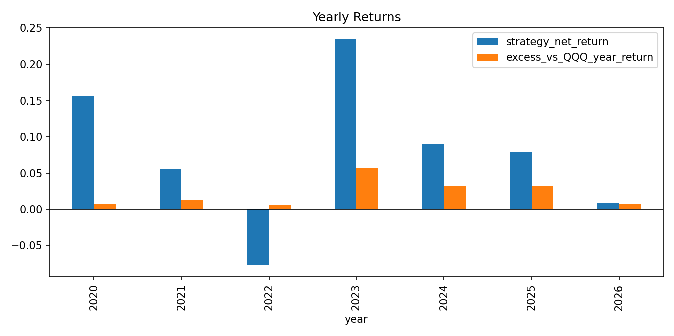
Yearly strategy and excess returns.
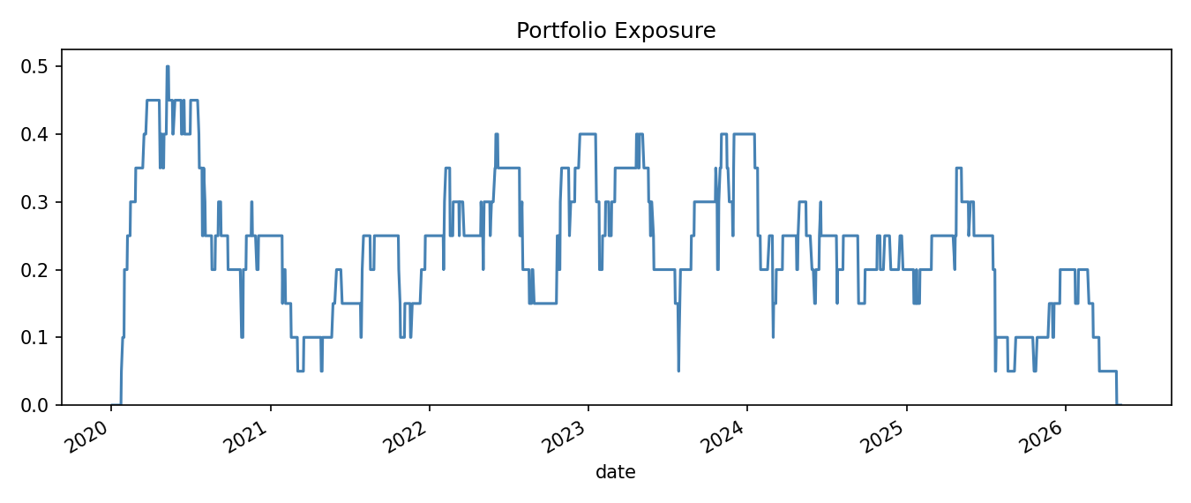
Daily portfolio exposure.
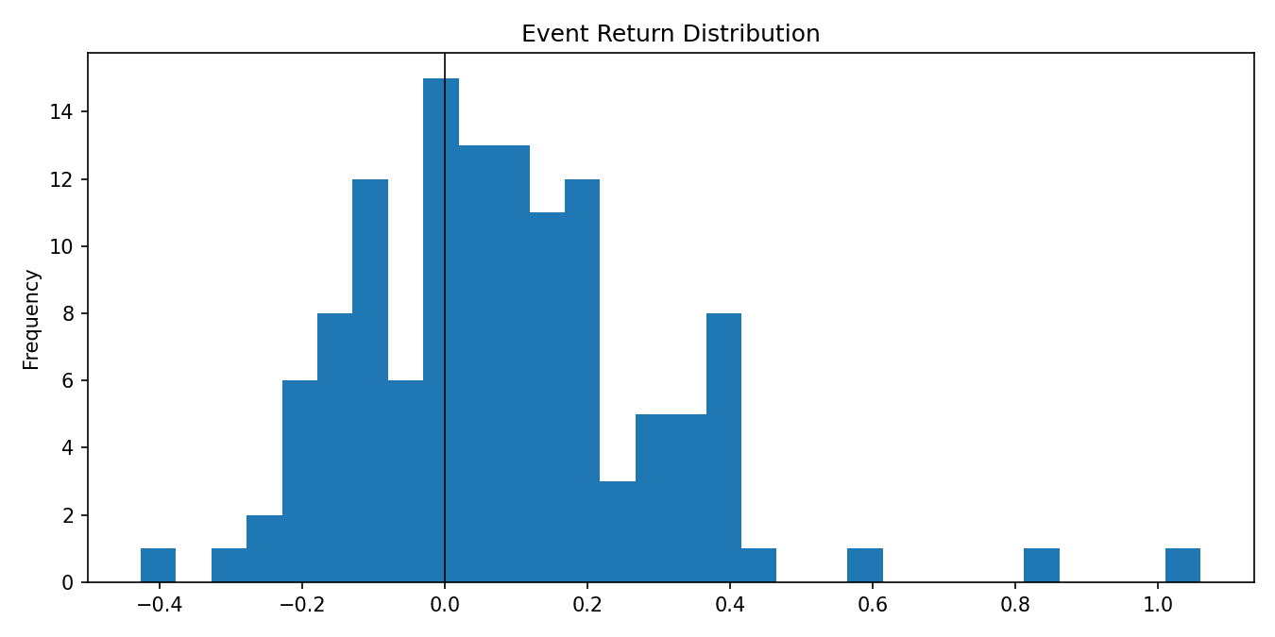
Selected event return distribution after cost.
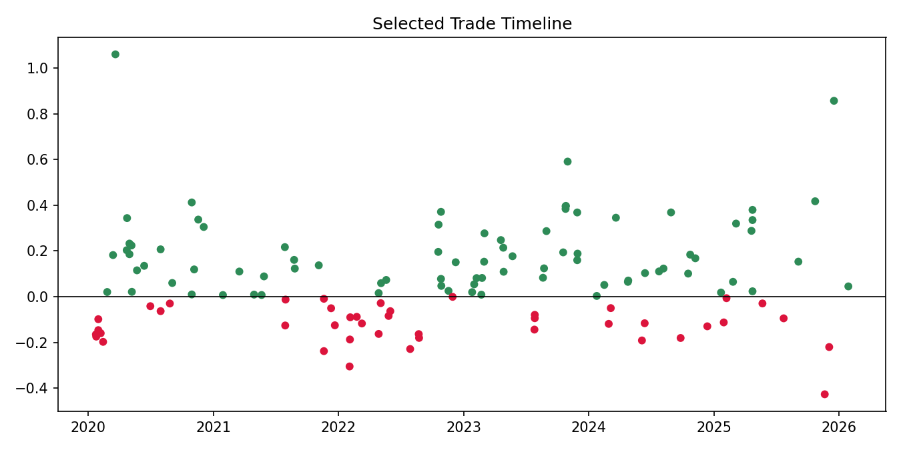
Selected trade timeline.
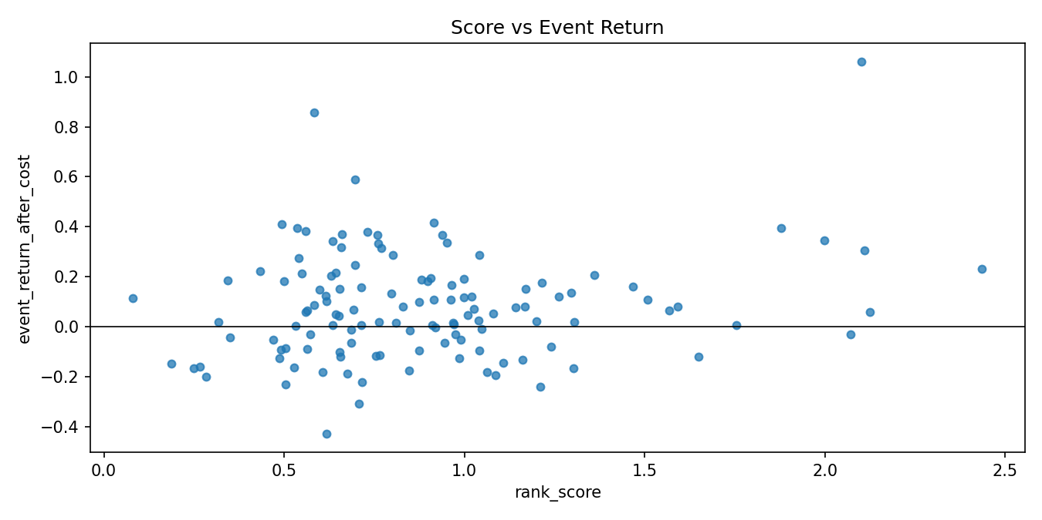
Score versus realized event return.
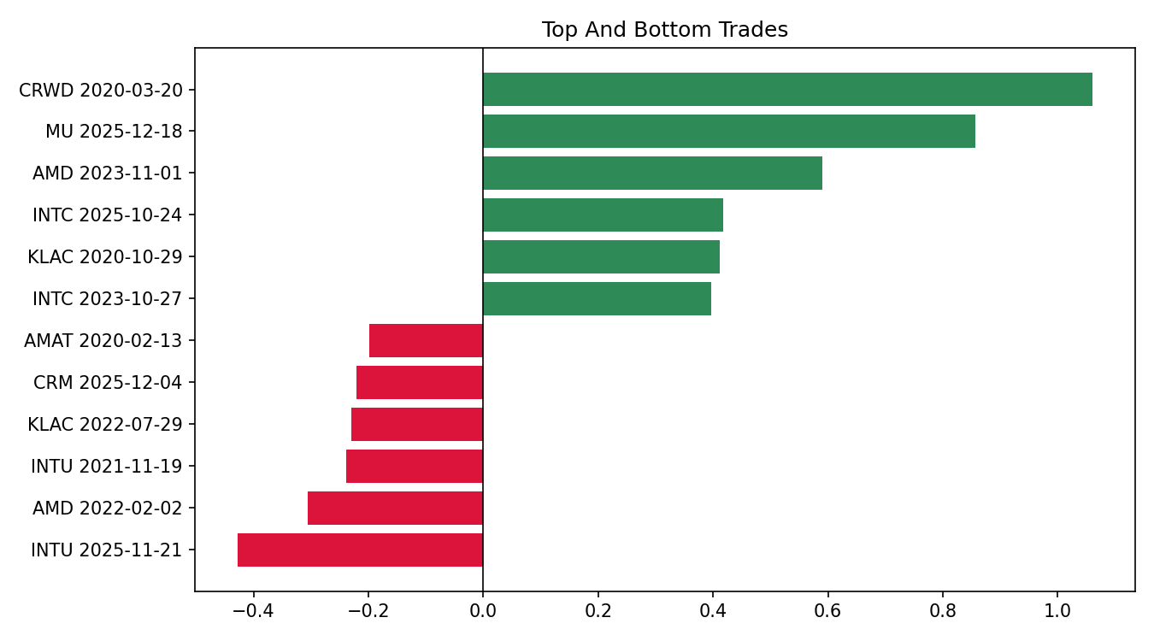
Top and bottom selected trades.

Metrics by Year
year | strategy_net_return | excess_vs_QQQ_year_return | max_drawdown | sharpe | avg_exposure | selected_events | avg_event_return_after_cost
2020 | 15.64% | 0.75% | -12.98% | 0.95 | 29.54% | 27 | 11.44%
2021 | 5.59% | 1.31% | -2.47% | 1.26 | 16.73% | 15 | 1.97%
2022 | -7.74% | 0.63% | -9.52% | -0.59 | 27.39% | 23 | -1.63%
2023 | 23.44% | 5.74% | -2.88% | 2.97 | 29.66% | 25 | 17.08%
2024 | 8.95% | 3.26% | -5.66% | 1.28 | 23.39% | 18 | 5.01%
2025 | 7.94% | 3.16% | -6.64% | 1.15 | 18.18% | 16 | 12.26%
2026 | 0.92% | 0.79% | -4.08% | 0.49 | 11.61% | 1 | 4.48%

Selected Trades

Top trades
symbol | entry_date | exit_date | event_return_after_cost | excess_vs_QQQ_event_return | rank_score
CRWD | 2020-03-20 | 2020-06-16 | 1.0596 | 0.6359 | 2.1000
MU | 2025-12-18 | 2026-03-18 | 0.8564 | 0.8805 | 0.5831
AMD | 2023-11-01 | 2024-01-30 | 0.5906 | 0.3981 | 0.6975
INTC | 2025-10-24 | 2026-01-22 | 0.4170 | 0.4118 | 0.9139
KLAC | 2020-10-29 | 2021-01-27 | 0.4119 | 0.2561 | 0.4921
INTC | 2023-10-27 | 2024-01-25 | 0.3968 | 0.1610 | 1.8790
KLAC | 2023-10-26 | 2024-01-24 | 0.3951 | 0.1549 | 0.5360
NOW | 2023-10-26 | 2024-01-24 | 0.3836 | 0.1434 | 0.5603

Bottom trades
symbol | entry_date | exit_date | event_return_after_cost | excess_vs_QQQ_event_return | rank_score
INTU | 2025-11-21 | 2026-02-20 | -0.4271 | -0.4582 | 0.6167
AMD | 2022-02-02 | 2022-04-29 | -0.3054 | -0.1545 | 0.7066
INTU | 2021-11-19 | 2022-02-16 | -0.2383 | -0.1187 | 1.2097
KLAC | 2022-07-29 | 2022-10-24 | -0.2291 | -0.1114 | 0.5031
CRM | 2025-12-04 | 2026-03-04 | -0.2205 | -0.2002 | 0.7154
AMAT | 2020-02-13 | 2020-05-11 | -0.1978 | -0.1675 | 0.2828
CRWD | 2024-06-05 | 2024-08-30 | -0.1917 | -0.2188 | 1.0862
QCOM | 2022-02-03 | 2022-05-02 | -0.1875 | -0.0874 | 0.6758

Literature Support
Post-Earnings-Announcement Drift - Bernard and Thomas. https://econpapers.repec.org/RePEc:bla:joares:v:27:y:1989:i::p:1-36
Revenue Surprises and Stock Returns - Jegadeesh and Livnat. https://papers.ssrn.com/sol3/papers.cfm?abstract_id=903767

Data and Research Caveats
Field | Value
Requested symbols | 51
Available price symbols | 49
Event count | 638
Missing price symbols | SNOW, TSM
Missing earnings symbols | ADI, ADSK, ANET, ASML, CSCO, DDOG, DE, DELL, GOOG, HPE, HPQ, IBM, MPWR, MRVL, NXPI, ON, PYPL, SHOP, SMCI, TSLA, TTD, UBER, WDAY, ZS
- Alpha Vantage earnings history is research-grade and may not be point-in-time revised history.
- US universe is curated/current and therefore survivorship-biased.
- Daily close-to-close execution approximates earnings timing.
- No revenue surprise, guidance, analyst revision, or option-implied move feed is included.

Reproducibility
Field | Value
Run directory | .tmp\factor_runs\PEAD_v1_quality_drift_60d\20260508_123018
Provider URI | ~/.qlib/qlib_data/us_data_recent
Command | 'scripts\run_earnings_seasonal_factors.py' --factor all --tracking-uri=

