Python Libraries For Project Use
import numpy as np
import pandas as pd
import math
import statistics
from pandas.plotting import scatter_matrix, parallel_coordinates
from sklearn import preprocessing
import scipy.stats
from scipy.stats import anderson
from scipy.stats import ttest_ind
import seaborn as sns
import matplotlib.pyplot as plt
import matplotlib as mpl
import statsmodels.api as sm
import statsmodels.formula.api as smf
import statsmodels.stats.api as sms
from statsmodels.stats.outliers_influence import variance_inflation_factor
from statsmodels.graphics.gofplots import qqplot
from sklearn.model_selection import train_test_split, cross_val_predict, cross_val_score, cross_validate
from sklearn.model_selection import GridSearchCV, KFold
from sklearn.preprocessing import StandardScaler
from sklearn.linear_model import LogisticRegression
from sklearn.metrics import accuracy_score, confusion_matrix, classification_report, make_scorer, recall_score, precision_recall_fscore_support
from sklearn.metrics import precision_score, recall_score, f1_score, roc_auc_score
from sklearn.svm import SVC
from sklearn.inspection import permutation_importance
import shap
from boruta import BorutaPy
from sklearn.ensemble import RandomForestClassifier
from sklearn.ensemble import GradientBoostingClassifier
from sklearn.ensemble import AdaBoostClassifier
from sklearn.tree import DecisionTreeClassifier
from sklearn.cluster import KMeans
import xgboost as xgb from xgboost import XGBClassifier
import tensorflow as tf
import keras
from keras.models import Sequential
from keras.layers import Dense, Dropout
from keras.callbacks import EarlyStopping
%matplotlib inline

I. Load & Perform A General Evaluation Of The Titanic Dataset
# Load 'titanic' dataset.
titanic_df = pd.read_csv('titanic.csv')
pd.set_option("display.max_rows", None, "display.max_columns", None)
# View 'titanic' dataset initial records.
titanic_df.head()
PassengerId Survived Pclass \
0 1 0.0 3
1 2 1.0 1
2 3 1.0 3
3 4 1.0 1
4 5 0.0 3
Name Sex Age SibSp \
0 Braund, Mr. Owen Harris male 22.0 1
1 Cumings, Mrs. John Bradley (Florence Briggs Th... female 38.0 1
2 Heikkinen, Miss. Laina female 26.0 0
3 Futrelle, Mrs. Jacques Heath (Lily May Peel) female 35.0 1
4 Allen, Mr. William Henry male 35.0 0
Parch Ticket Fare Cabin Embarked
0 0 A/5 21171 7.2500 NaN S
1 0 PC 17599 71.2833 C85 C
2 0 STON/O2. 3101282 7.9250 NaN S
3 0 113803 53.1000 C123 S
4 0 373450 8.0500 NaN S
# Generate 'titanic' dataset dimensions.
titanic_df.shape
(1309, 12)
# Generate 'titanic' dataset data types.
titanic_df.info()
<class 'pandas.core.frame.DataFrame'>
RangeIndex: 1309 entries, 0 to 1308
Data columns (total 12 columns):
# Column Non-Null Count Dtype
--- ------ -------------- -----
0 PassengerId 1309 non-null int64
1 Survived 891 non-null float64
2 Pclass 1309 non-null int64
3 Name 1309 non-null object
4 Sex 1309 non-null object
5 Age 1046 non-null float64
6 SibSp 1309 non-null int64
7 Parch 1309 non-null int64
8 Ticket 1309 non-null object
9 Fare 1308 non-null float64
10 Cabin 295 non-null object
11 Embarked 1307 non-null object
dtypes: float64(3), int64(4), object(5)
memory usage: 122.8+ KB
# View 'titanic' dataset descriptive statistics.
titanic_df.describe().map('{:,.3f}'.format)
PassengerId Survived Pclass Age SibSp Parch \
count 1,309.000 891.000 1,309.000 1,046.000 1,309.000 1,309.000
mean 655.000 0.384 2.295 29.881 0.499 0.385
std 378.020 0.487 0.838 14.413 1.042 0.866
min 1.000 0.000 1.000 0.170 0.000 0.000
25% 328.000 0.000 2.000 21.000 0.000 0.000
50% 655.000 0.000 3.000 28.000 0.000 0.000
75% 982.000 1.000 3.000 39.000 1.000 0.000
max 1,309.000 1.000 3.000 80.000 8.000 9.000
Fare
count 1,308.000
mean 33.295
std 51.759
min 0.000
25% 7.896
50% 14.454
75% 31.275
max 512.329
*The dataset came in one file, when traditionally it had been divided into training and testing files. I prefer this, because it is better to have access to both combined during pre-processing. Training and testing datasets can be created before the modeling process.
# Assess missing values per feature in 'titanic' dataset.
titanic_missing = titanic_df.isna().sum()
titanic_missing
PassengerId 0
Survived 418
Pclass 0
Name 0
Sex 0
Age 263
SibSp 0
Parch 0
Ticket 0
Fare 1
Cabin 1014
Embarked 2
dtype: int64
*Ignoring the 'Survived' outcome variable, existence of missing values will merit the consideration of feature removal, imputation, and/or variable creation.

II. Perform An Outcome & Potential Explanatory Variable Evaluation
# Evaluate the 'Survived' binary outcome variable for the training dataset.
titanic_df['Survived'].value_counts()
Survived
0.0 549
1.0 342
Name: count, dtype: int64
# Barchart for the 'Survived' binary variable (0 = No, 1 = Yes) for the training dataset.
dfg = titanic_df['Survived'].value_counts()
ax = dfg.plot(kind='bar', title='Barchart of The Survival Outcome Variable', ylabel='Count', xlabel='Titanic Survival (0=No, 1=Yes)', color= ['r','g'], rot=0, figsize=(6,5))
ax.bar_label(ax.containers[0], label_type='center', color='w', fontsize=14)
plt.yticks(np.arange(0,601,step=50))
plt.show()
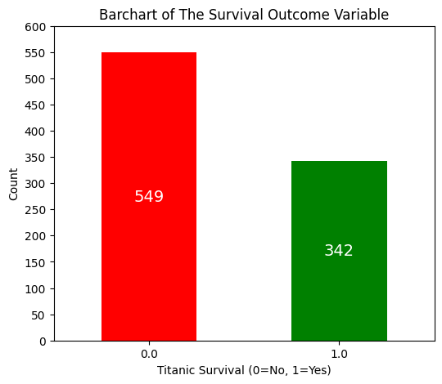
*Historically of the 1309 passengers, only 500 survived (38.2% chance of survival). Given that the 'Survival' variable results for the test data are missing and meant to be predicted, the barchart above only considers the training data (891 passengers with a 38.4% chance of survival). By way of subtraction, this leaves the test data with 260 deaths and 158 survivals (418 passengers with a 37.8% chance of survival).

# Evaluate the 'Pclass' numeric categorical variable distribution.
titanic_df['Pclass'].value_counts()
Pclass
3 709
1 323
2 277
Name: count, dtype: int64

# Barchart for the 'Pclass' numeric categorical variable (1=1st, 2=2nd, 3=3rd) distribution.
dfg = titanic_df['Pclass'].value_counts()
ax = dfg.plot(kind='bar', title='Barchart of The Passenger Class Categorical Variable', ylabel='Count', xlabel='Passenger Class (1=1st, 2=2nd, 3=3rd)', color= ['#CD7F32','gold','silver'], rot=0, figsize=(6,5))
ax.bar_label(ax.containers[0], label_type='center', color='black', fontsize=14)
plt.yticks(np.arange(0,751,step=50))
plt.show()
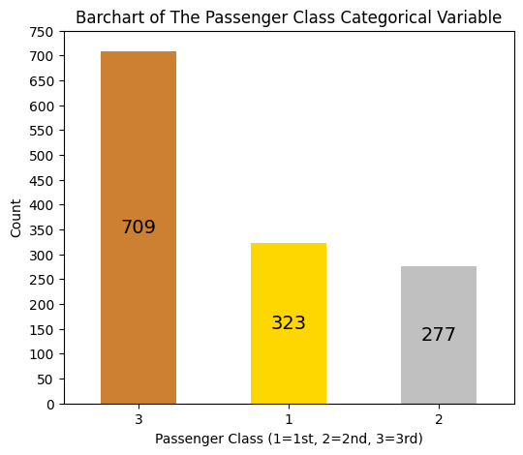
# Bar chart for 'Pclass' distribution with counts of Survived (0 and 1) for the training dataset.
plt.figure(figsize=(8, 6))
ax = sns.countplot(x='Pclass', hue='Survived', data=titanic_df, palette={0: 'red', 1: 'green'})

# Add numeric values centered inside each bar with white font
for p in ax.patches:
height = p.get_height()
# Only add text if height is greater than 0 to avoid the "0" label
if height > 0:
ax.text(p.get_x() + p.get_width() / 2., height / 2, # Center vertically
int(height), # Convert to integer for clean display
ha="center", va="center", color="white", fontsize=12)
plt.title('Survival Counts by Passenger Class')
plt.xlabel('Passenger Class (1=1st, 2=2nd, 3=3rd)')
plt.ylabel('Count')
plt.yticks(np.arange(0,401,step=50))
plt.legend(title='Survived', labels=['No', 'Yes']) # Customize legend labels
plt.show()
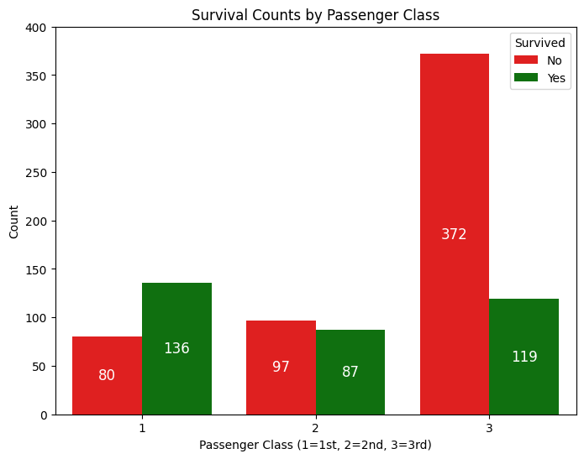
*Regarding the training data: 1st Class passengers definitely had the best survival rate (63%) with more survivors than deaths. 2nd Class passenger survival rate (47.3%) begins to show more deaths than survivors. 3rd Class passenger survival rate (24.2%) showed considerably more deaths than survivors.
# Create a 'Title' variable from the 'Name' character variable.
titanic_df['Title'] = titanic_df['Name'].str.extract(' ([A-Za-z]+)\.')
# Create a 'Surname' variable from the 'Name' character variable for family grouping.
titanic_df['Surname'] = titanic_df['Name'].str.split(', ').str[0]
<>:2: SyntaxWarning: invalid escape sequence '\.'
<>:2: SyntaxWarning: invalid escape sequence '\.'
C:\Users\rcc_0\AppData\Local\Temp\ipykernel_11612\1205623714.py:2: SyntaxWarning: invalid escape sequence '\.'
titanic_df['Title'] = titanic_df['Name'].str.extract(' ([A-Za-z]+)\.')
# Evaluate the 'Title' string character variable distribution.
titanic_df['Title'].value_counts()
Title
Mr 757
Miss 260
Mrs 197
Master 61
Rev 8
Dr 8
Col 4
Mlle 2
Major 2
Ms 2
Lady 1
Sir 1
Mme 1
Don 1
Capt 1
Countess 1
Jonkheer 1
Dona 1
Name: count, dtype: int64

# Barchart for the 'Title' string character variable distribution.
dfg = titanic_df['Title'].value_counts()
ax = dfg.plot(kind='bar', title='Barchart of Title Character Variable', ylabel='Count', xlabel='Title', color= ['teal'], rot=0, figsize=(15,5))
ax.bar_label(ax.containers[0], color='black', fontsize=11)
plt.yticks(np.arange(0,801,step=50))
plt.show()
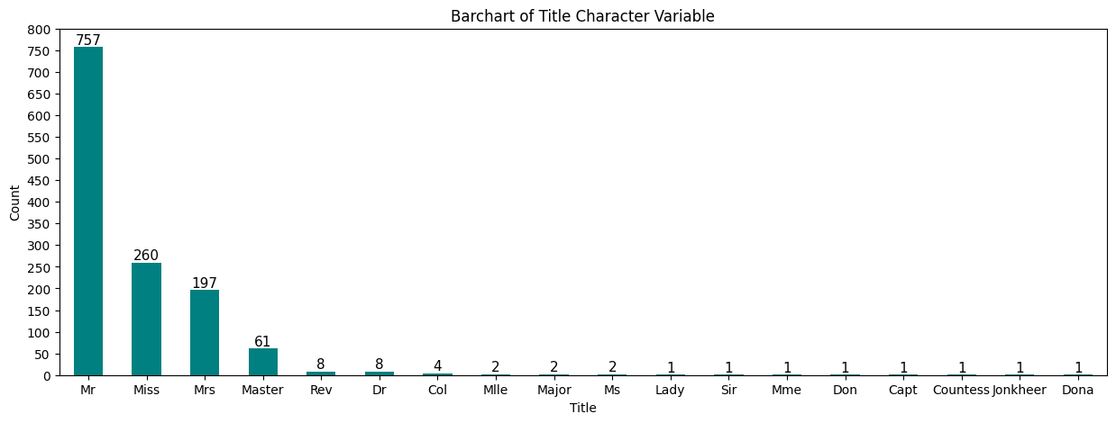
# Bar chart for 'Title' distribution with counts of Survived (0 and 1) for the training dataset.
plt.figure(figsize=(18, 6))
ax = sns.countplot(x='Title', hue='Survived', data=titanic_df, palette={0: 'red', 1: 'green'})
# Add numeric values centered inside each bar with white font
for p in ax.patches:
height = p.get_height()
# Only add text if height is greater than 0 to avoid the "0" label
if height > 0:
ax.text(p.get_x() + p.get_width() / 2., height + 10, # Center vertically
int(height), # Convert to integer for clean display
ha="center", va="center", color="black", fontsize=12)
plt.title('Survival Counts by Passenger Title')
plt.xlabel('Title')
plt.ylabel('Count')
plt.yticks(np.arange(0,451,step=50))
plt.legend(title='Survived', labels=['No', 'Yes']) # Customize legend labels
plt.show()
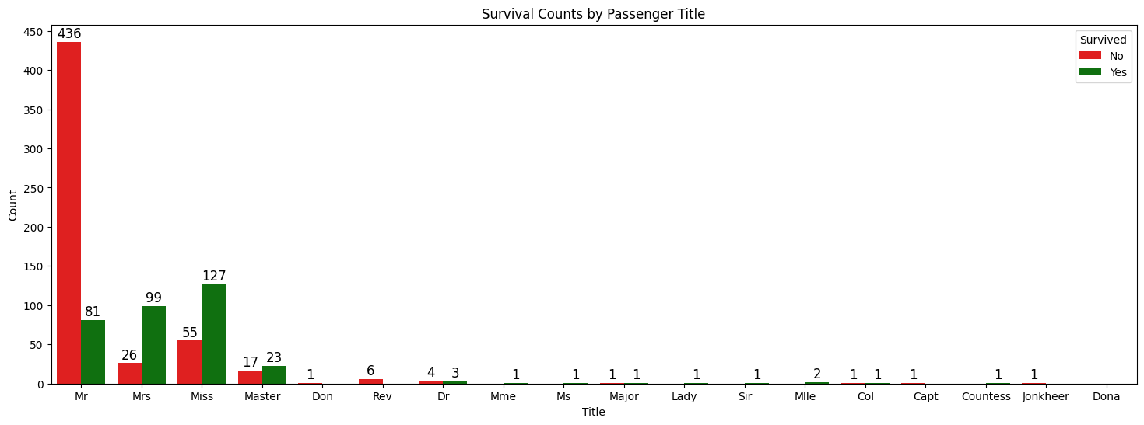
*The creation of the parsed ‘Title’ variable enabled improved Age imputation by helping define family relationships, and demonstrated predicted influence in model development.
# Evaluate the 'Surname' string character variable distribution.
titanic_df['Surname'].value_counts()
Surname
Andersson 11
Sage 11
Goodwin 8
Asplund 8
Davies 7
Brown 6
Panula 6
Skoog 6
Carter 6
Rice 6
Smith 6
Fortune 6
Johnson 6
Ford 6
Lefebre 5
Williams 5
Ryerson 5
Palsson 5
Kelly 5
Thomas 5
Baclini 4
Hansen 4
Hart 4
Laroche 4
Harris 4
Elias 4
West 4
Johnston 4
Ware 4
Harper 4
Boulos 4
Gustafsson 4
Johansson 4
Goldsmith 4
Dean 4
Becker 4
Olsen 4
Cacic 4
Vander Planke 4
Herman 4
Hocking 4
Allison 4
Wells 3
Compton 3
Jussila 3
Olsson 3
Hickman 3
McCoy 3
Karlsson 3
White 3
Abbott 3
Svensson 3
Rosblom 3
Graham 3
van Billiard 3
Bourke 3
Thayer 3
O'Brien 3
Douglas 3
Kink-Heilmann 3
Crosby 3
Klasen 3
Newell 3
Hoyt 3
Peacock 3
Collyer 3
Taussig 3
Murphy 3
Navratil 3
Minahan 3
Daly 3
Carlsson 3
Touma 3
Mallet 3
Chapman 3
Peter 3
Quick 3
Hays 3
Van Impe 3
Keane 3
Phillips 3
Warren 3
Meyer 3
Dodge 3
Widener 3
Samaan 3
Nakid 3
Coutts 3
Giles 3
Flynn 3
Frauenthal 3
Moubarek 3
Oreskovic 3
Jensen 3
Cor 3
Nilsson 3
Howard 3
Richards 3
Drew 3
Danbom 3
Moran 3
Spedden 3
Sandstrom 3
Wick 3
Caldwell 3
Larsson 2
Angle 2
Carr 2
Betros 2
Snyder 2
Ryan 2
Wiklund 2
Coleff 2
Hold 2
Louch 2
Franklin 2
Silvey 2
Thorneycroft 2
Jacobsohn 2
Jefferys 2
Kiernan 2
Cumings 2
Rothschild 2
Clarke 2
Risien 2
Ali 2
Beane 2
Strom 2
Gale 2
Harder 2
Lahtinen 2
Hamalainen 2
Hirvonen 2
Buckley 2
Foley 2
Hippach 2
Aks 2
Connolly 2
Stengel 2
Bishop 2
Lines 2
Stanley 2
Renouf 2
Khalil 2
Dennis 2
Wright 2
Fleming 2
Dyker 2
Penasco y Castellana 2
Andrews 2
Straus 2
Beckwith 2
Duran y More 2
Abelseth 2
Hagland 2
Lobb 2
Abelson 2
del Carlo 2
Goldenberg 2
Kenyon 2
Bradley 2
Mellinger 2
Zakarian 2
O'Connor 2
Canavan 2
Davison 2
Fox 2
Morley 2
Burns 2
Barbara 2
Braund 2
Duff Gordon 2
Andrew 2
Lennon 2
Marvin 2
Lindell 2
Rogers 2
Zabour 2
Attalah 2
Baxter 2
Moore 2
Webber 2
Turpin 2
Moor 2
Robins 2
Weisz 2
Nicola-Yarred 2
Holverson 2
Frolicher-Stehli 2
Hakkarainen 2
Arnold-Franchi 2
Gibson 2
Faunthorpe 2
Kimball 2
Bryhl 2
Ilmakangas 2
Chambers 2
Kink 2
Carrau 2
Backstrom 2
Bowen 2
Yasbeck 2
Ostby 2
Chaffee 2
Greenfield 2
Doling 2
Kantor 2
Cavendish 2
Petroff 2
McNamee 2
Astor 2
Pokrnic 2
Chronopoulos 2
Allen 2
Jonsson 2
Karun 2
Lam 2
Cardeza 2
Bonnell 2
Calic 2
Saad 2
McGowan 2
Watt 2
Nasser 2
Cribb 2
McCarthy 2
Davidson 2
Mahon 2
Taylor 2
Dick 2
Caram 2
Futrelle 2
Clark 2
Spencer 2
Cook 2
Pears 2
de Messemaeker 2
Christy 2
Name: count, dtype: int64
*The creation of the parsed ‘Surname’ variable was valuable for the creation of the FamilyID variable concatenating it with the Ticket variable.
# Create FamilyID (Surname + Ticket) concatenated variable.
titanic_df['FamilyID'] = titanic_df['Surname'] + '_' + titanic_df['Ticket']
titanic_df['FamilyID'].head()
0 Braund_A/5 21171
1 Cumings_PC 17599
2 Heikkinen_STON/O2. 3101282
3 Futrelle_113803
4 Allen_373450
Name: FamilyID, dtype: object
*This concatenated 'FamilyID' variable allowed for the identification of family groups, which in turn allowed for Age imputation of their members.
# Evaluate the 'Sex' character categorical variable distribution.
titanic_df['Sex'].value_counts()
Sex
male 843
female 466
Name: count, dtype: int64
# Barchart for the 'Sex' numeric variable distribution.
dfg = titanic_df['Sex'].value_counts()
ax = dfg.plot(kind='bar', title='Barchart of the Sex Variable', ylabel='Count', xlabel='Sex', color= ['teal','b'], rot=0, figsize=(6,5))
ax.bar_label(ax.containers[0], label_type='center', color='white', fontsize=14)
plt.yticks(np.arange(0,901,step=100))
plt.show()
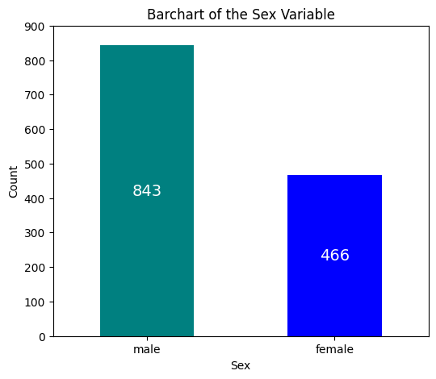
*When considering crew along with passengers, there were easily twice as many males than females on the voyage.
# Bar chart for 'Sex' distribution with counts of Survived (0 and 1) for the training dataset.
plt.figure(figsize=(8, 6))
ax = sns.countplot(x='Sex', hue='Survived', data=titanic_df, palette={0: 'red', 1: 'green'})
# Add numeric values centered inside each bar with white font
for p in ax.patches:
height = p.get_height()
# Only add text if height is greater than 0 to avoid the "0" label
if height > 0:
ax.text(p.get_x() + p.get_width() / 2., height / 2, # Center vertically
int(height), # Convert to integer for clean display
ha="center", va="center", color="white", fontsize=12)
plt.title('Survival Counts by Passenger Sex')
plt.xlabel('Passenger Sex')
plt.ylabel('Count')
plt.yticks(np.arange(0,501,step=50))
plt.legend(title='Survived', labels=['No', 'Yes']) # Customize legend labels
plt.show()
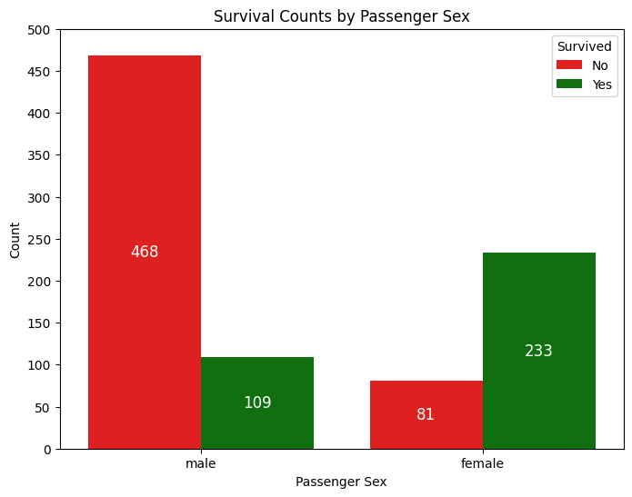
*Regarding the training data: Female survival rate (74.2%) was much higher than the male survival rate (18.9%).
# Create temporary data with NaN values removed for 'Age' numeric variable charting.
agetemp_df = titanic_df.dropna(subset=['Age'])
# Histogram for the 'Age' numerical variable.
plt.hist(agetemp_df['Age'], bins = 32, alpha = 0.75, color = 'green', edgecolor = 'black')
plt.xlabel('Age')
plt.ylabel('Frequency')
plt.xlim(0, 86)
plt.xticks(np.arange(0,86,step=5))
plt.yticks(np.arange(0,121,step=10))
mean_value = agetemp_df['Age'].mean()
median_value = agetemp_df['Age'].median()
std_value = agetemp_df['Age'].std()
plt.axvline(mean_value, color='red', linewidth=2, label=f'Mean: {mean_value: .2f}')
plt.axvline(median_value, color='blue', linestyle='dashed', linewidth=1.5, label=f'Median: {median_value: .2f}')
plt.axvline(mean_value+std_value, color='red', linestyle='dashed', linewidth=1.5, label=f'1 SD')
plt.axvline(mean_value-std_value, color='red', linestyle='dashed', linewidth=1.5)
plt.axvline(mean_value+2*std_value, color='red', linestyle='dashed', linewidth=1, label=f'2 SD')
plt.axvline(mean_value-2*std_value, color='red', linestyle='dashed', linewidth=1)
plt.axvline(mean_value+3*std_value, color='red', linestyle='dashed', linewidth=0.5, label=f'3 SD')
plt.axvline(mean_value-3*std_value, color='red', linestyle='dashed', linewidth=0.5)
plt.show()
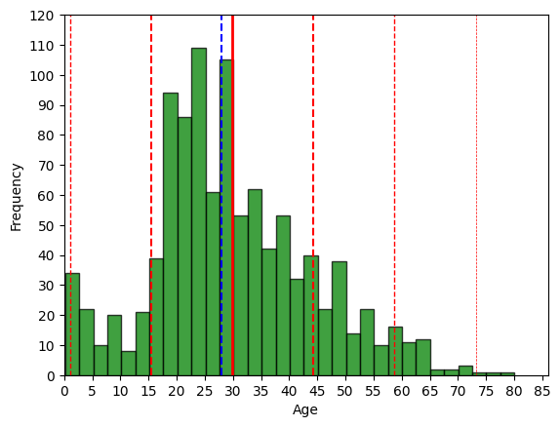
# Boxplot for the 'Age' numeric variable distribution.
fig = plt.figure(figsize =(5, 7))
ax = fig.add_subplot(111)
# Creating axes instance
bp = ax.boxplot(agetemp_df['Age'], patch_artist = True,
notch ='True')
for patch, color in zip(bp['boxes'], 'green'):
patch.set_facecolor('green')
# Changing color and linewidth of whiskers.
for whisker in bp['whiskers']:
whisker.set(color ='green',
linewidth = 1.5,
linestyle =":")
# Changing color and linewidth of caps.
for cap in bp['caps']:
cap.set(color ='black',
linewidth = 2)
# Changing color and linewidth of median.
for median in bp['medians']:
median.set(color ='blue',
linewidth = 3)
# Changing style of fliers.
for flier in bp['fliers']:
flier.set(marker ='D',
alpha = 0.5)
# Set axis labels.
ax.set_ylabel('Age')
ax.set_xticklabels('')
# Set axis limits.
plt.yticks(np.arange(0,86,step=5))
# Display the mean.
plt.axhline(mean_value, color='red', linewidth=1, linestyle='dashed', label=f'Mean: {mean_value: .2f}')
plt.show()
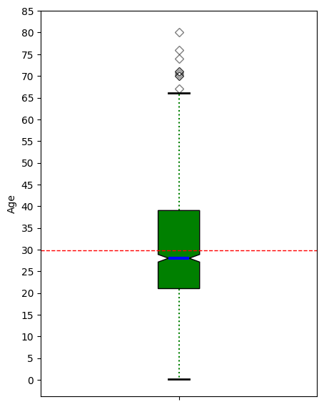
*Distribution analysis helped determine a binning strategy for an Age categorization variable. The outliers basically represent the sparse number of elderly among the passengers.

# 'Age' Anderson-Darling Normality Test
result = anderson(agetemp_df['Age'])
print('Statistic: %.3f' % result.statistic)
p = 0
for i in range(len(result.critical_values)):
sl, cv = result.significance_level[i], result.critical_values[i]
if result.statistic < result.critical_values[i]:
print('%.3f: %.3f, data looks normal (fail to reject H0)' % (sl, cv))
else:
print('%.3f: %.3f, data does not look normal (reject H0)' % (sl, cv))
Statistic: 7.130
15.000: 0.574, data does not look normal (reject H0)
10.000: 0.654, data does not look normal (reject H0)
5.000: 0.784, data does not look normal (reject H0)
2.500: 0.915, data does not look normal (reject H0)
1.000: 1.088, data does not look normal (reject H0)
# 'Age' QQ plot
qqplot(agetemp_df['Age'], line='s')
plt.show()
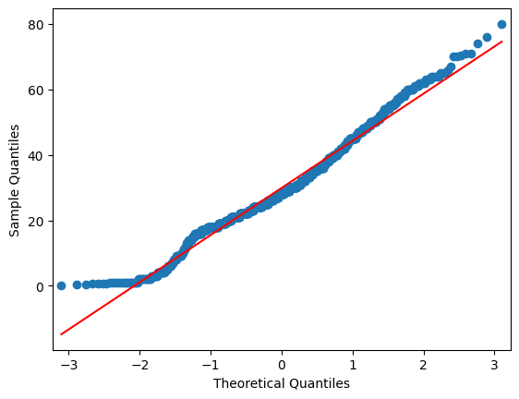
# Evaluate skewness of the distribution for the 'Age' numeric variable.
age_skew = agetemp_df['Age'].skew()
print(f"Age distribution has a skewness of{age_skew: .3f}")
Age distribution has a skewness of 0.408
*Normality analysis determined that the Age variable had a reasonable amount of normality, though the distribution possessed some right skew.
# Evaluate the 'SibSp' binary outcome variable distribution.
titanic_df['SibSp'].value_counts()
SibSp
0 891
1 319
2 42
4 22
3 20
8 9
5 6
Name: count, dtype: int64
# Barchart for the 'SibSp' numeric variable distribution.
dfg = titanic_df['SibSp'].value_counts()
ax = dfg.plot(kind='bar', title='Barchart of the Spouse And Siblings Variable', ylabel='Count', xlabel='Spouse and Siblings', color= ['b'], rot=0, figsize=(6,5))
ax.bar_label(ax.containers[0], color='black', fontsize=14)
plt.yticks(np.arange(0,1001,step=100))
plt.show()
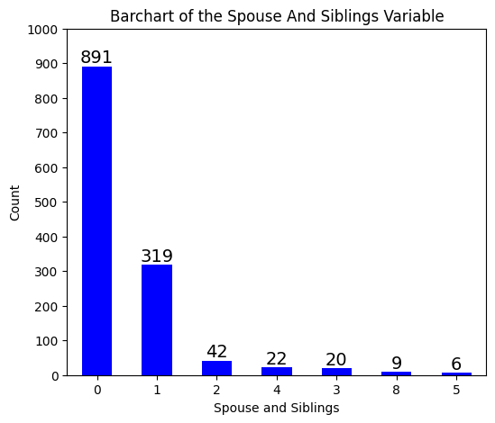
# Bar chart for 'SibSp' distribution with counts of Survived (0 and 1) for the training dataset.
plt.figure(figsize=(8, 6))
ax = sns.countplot(x='SibSp', hue='Survived', data=titanic_df, palette={0: 'red', 1: 'green'})
# Add numeric values centered inside each bar with white font
for p in ax.patches:
height = p.get_height()
# Only add text if height is greater than 0 to avoid the "0" label
if height > 0:
ax.text(p.get_x() + p.get_width()/2, height + 20, # Center vertically
int(height), # Convert to integer for clean display
ha="center", va="top", color="black", fontsize=12)
plt.title('Survival Counts by Spouse and Siblings')
plt.xlabel('Spouse and Siblings')
plt.ylabel('Count')
plt.yticks(np.arange(0,451,step=50))
plt.legend(title='Survived', labels=['No', 'Yes']) # Customize legend labels
plt.show()
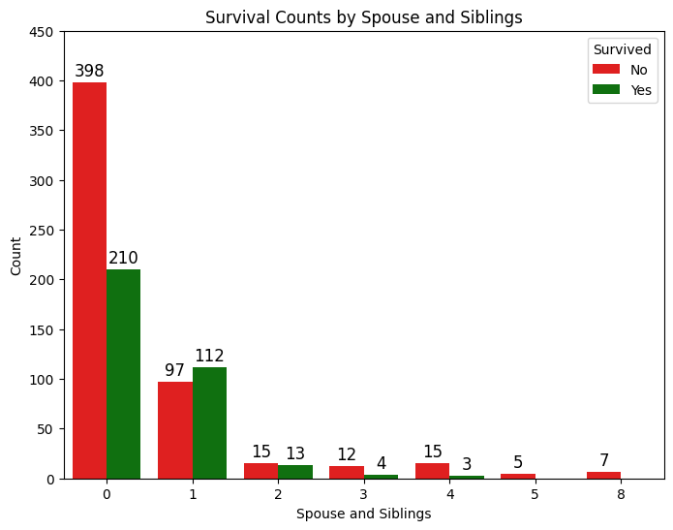
*The 'SibSp' variable proved useful when trying to establish family member relationships for Age imputation.
# Evaluate the 'Parch' numeric variable distribution.
titanic_df['Parch'].value_counts()
Parch
0 1002
1 170
2 113
3 8
5 6
4 6
6 2
9 2
Name: count, dtype: int64
# Barchart for the 'Parch' numeric variable distribution.
dfg = titanic_df['Parch'].value_counts()
ax = dfg.plot(kind='bar', title='Barchart of the Parents and Children Variable', ylabel='Count', xlabel='Parents and Children', color= ['b'], rot=0, figsize=(6,5))
ax.bar_label(ax.containers[0], color='black', fontsize=14)
plt.yticks(np.arange(0,1101,step=100))
plt.show()
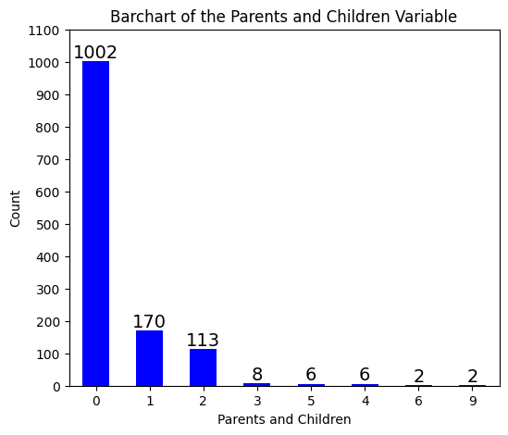
# Bar chart for 'Parch' distribution with counts of Survived (0 and 1) for the training dataset.
plt.figure(figsize=(8, 6))
ax = sns.countplot(x='Parch', hue='Survived', data=titanic_df, palette={0: 'red', 1: 'green'})
# Add numeric values centered inside each bar with white font
for p in ax.patches:
height = p.get_height()
# Only add text if height is greater than 0 to avoid the "0" label
if height > 0:
ax.text(p.get_x() + p.get_width()/2, height + 20, # Center vertically
int(height), # Convert to integer for clean display
ha="center", va="top", color="black", fontsize=12)
plt.title('Survival Counts by Parents and Children')
plt.xlabel('Parents and Children')
plt.ylabel('Count')
plt.yticks(np.arange(0,501,step=50))
plt.legend(title='Survived', labels=['No', 'Yes']) # Customize legend labels
plt.show()
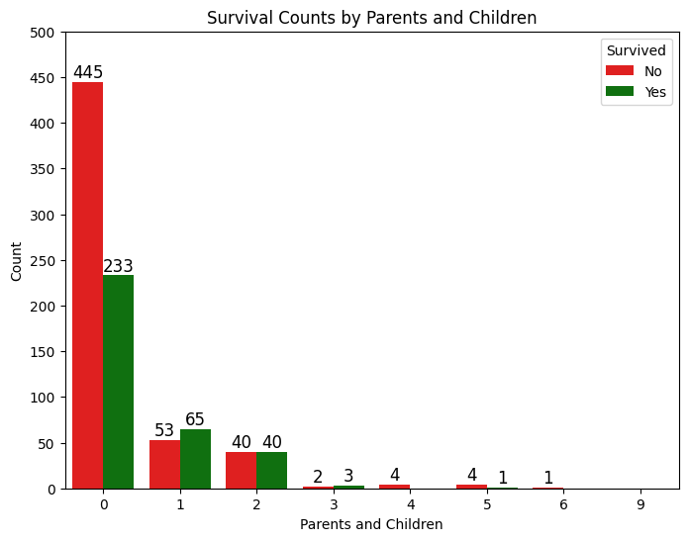
*The 'Parch' variable proved useful when trying to establish family member relationships for Age imputation.
# Create 'FamilySize' variable by summing 'SibSp' and "Parch' variables.
titanic_df['FamilySize'] = titanic_df['SibSp'] + titanic_df['Parch']
# Evaluate the 'FamilySize' numeric variable distribution.
titanic_df['FamilySize'].value_counts()
FamilySize
0 790
1 235
2 159
3 43
5 25
4 22
6 16
10 11
7 8
Name: count, dtype: int64
# Barchart for the 'FamilySize' numeric variable distribution.
dfg = titanic_df['FamilySize'].value_counts()
ax = dfg.plot(kind='bar', title='Barchart of the Family Size Variable', ylabel='Count', xlabel='Family Size', color= ['b'], rot=0, figsize=(6,5))
ax.bar_label(ax.containers[0], color='black', fontsize=14)
plt.yticks(np.arange(0,901,step=100))
plt.show()
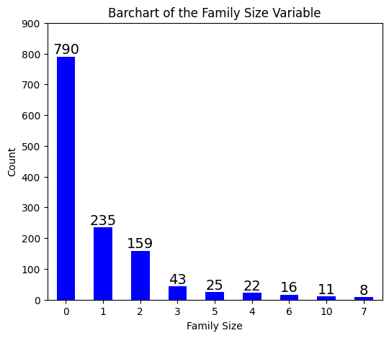
# Bar chart for 'FamilySize' distibution with counts of Survived (0 and 1) for the training dataset.
plt.figure(figsize=(8, 6))
ax = sns.countplot(x='FamilySize', hue='Survived', data=titanic_df, palette={0: 'red', 1: 'green'})
# Add numeric values centered inside each bar with white font
for p in ax.patches:
height = p.get_height()
# Only add text if height is greater than 0 to avoid the "0" label
if height > 0:
ax.text(p.get_x() + p.get_width()/2, height + 20, # Center vertically
int(height), # Convert to integer for clean display
ha="center", va="top", color="black", fontsize=12)
plt.title('Survival Counts by Family Size')
plt.xlabel('Family Size')
plt.ylabel('Count')
plt.yticks(np.arange(0,401,step=50))
plt.legend(title='Survived', labels=['No', 'Yes']) # Customize legend labels
plt.show()
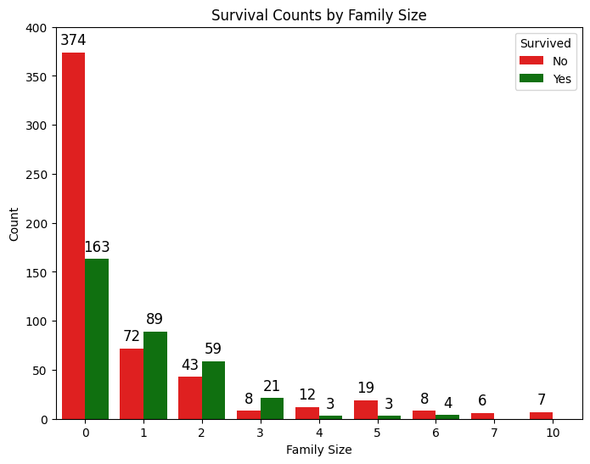
*The summed 'FamilySize' variable from the 'SibSp' and 'Parch" variables proved useful for Age imputation, and demonstrated predicted influence in model development.
# Step 1: Function to parse Ticket into Prefix and Number.
def parse_ticket(ticket):
# Split on the last space to separate prefix and number
parts = ticket.rsplit(' ', 1) # rsplit splits from the right, max 1 split
if len(parts) == 2:
# If there's a prefix and number
prefix, number = parts
# Clean up prefix (remove trailing dots or spaces)
# prefix = prefix.strip().rstrip('.')
return prefix, number
else:
# If there's no space, it's just a number
return None, ticket
# Apply the parsing function and create new columns.
titanic_df[['TicketPrefix', 'TicketNumber']] = pd.DataFrame(
titanic_df['Ticket'].apply(parse_ticket).tolist(),
index=titanic_df.index
)
# Step 2: Update TicketPrefix to include "LINE" for 3rd-class zero-fare tickets
# Identify 3rd-class passengers with Fare = 0 and assign "LINE" as TicketPrefix
zero_fare_3rd = titanic_df[(titanic_df['Pclass'] == 3) & (titanic_df['Fare'] == 0)]
titanic_df.loc[zero_fare_3rd.index, 'TicketPrefix'] = 'LINE'
# Step 3: Verify the updated TicketPrefix
print("\nUpdated TicketPrefix (first 20 rows):")
titanic_df[['Ticket', 'TicketPrefix', 'TicketNumber']].head(20)
Updated TicketPrefix (first 20 rows):
Ticket TicketPrefix TicketNumber
0 A/5 21171 A/5 21171
1 PC 17599 PC 17599
2 STON/O2. 3101282 STON/O2. 3101282
3 113803 None 113803
4 373450 None 373450
5 330877 None 330877
6 17463 None 17463
7 349909 None 349909
8 347742 None 347742
9 237736 None 237736
10 PP 9549 PP 9549
11 113783 None 113783
12 A/5. 2151 A/5. 2151
13 347082 None 347082
14 350406 None 350406
15 248706 None 248706
16 382652 None 382652
17 244373 None 244373
18 345763 None 345763
19 2649 None 2649
# Evaluate the 'TicketPrefix' character variable distribution.
titanic_df['TicketPrefix'].value_counts()
TicketPrefix
PC 92
C.A. 46
SOTON/O.Q. 16
W./C. 14
STON/O 2. 14
A/5 12
CA. 12
SC/PARIS 11
CA 10
A/5. 10
F.C.C. 9
SOTON/OQ 8
C 8
S.O.C. 7
STON/O2. 7
S.O./P.P. 7
A/4 6
SC/Paris 5
PP 4
LINE 4
SC/AH 4
S.C./PARIS 3
SOTON/O2 3
A.5. 3
A./5. 3
F.C. 3
A/4. 3
SC 2
P/PP 2
WE/P 2
W.E.P. 2
C.A./SOTON 1
SC/A.3 1
STON/OQ. 1
AQ/4 1
A. 2. 1
LP 1
SC/A4 1
SW/PP 1
S.W./PP 1
SC/AH Basle 1
A/S 1
SCO/W 1
S.C./A.4. 1
W/C 1
Fa 1
S.O.P. 1
A4. 1
SO/C 1
S.P. 1
AQ/3. 1
Name: count, dtype: int64
# Barchart for the 'TicketPrefix' character variable distribution.
dfg = titanic_df['TicketPrefix'].value_counts()
ax = dfg.plot(kind='bar', title='Barchart of the Ticket Prefix Variable', ylabel='Count', xlabel='Ticket Prefix Label', color= ['b'], rot=0, figsize=(15,5))
ax.bar_label(ax.containers[0], color='black', fontsize=11)
plt.xticks(rotation=90)
plt.yticks(np.arange(0,101,step=10))
plt.show()
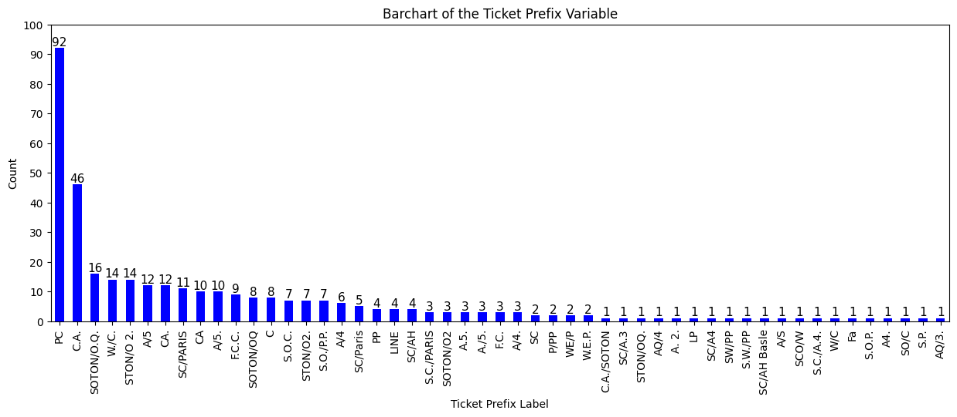

# Bar chart for 'TicketPrefix' with counts of Survived (0 and 1) for the training dataset.
plt.figure(figsize=(18, 6))
ax = sns.countplot(x='TicketPrefix', hue='Survived', data=titanic_df, palette={0: 'red', 1: 'green'})
# Add numeric values centered inside each bar with white font
for p in ax.patches:
height = p.get_height()
# Only add text if height is greater than 0 to avoid the "0" label
if height > 0:
ax.text(p.get_x() + p.get_width()/2, height + 1.5, # Center vertically
int(height), # Convert to integer for clean display
ha="center", va="top", color="black", fontsize=8, fontweight='bold')
plt.title('Survival Counts by Ticket Prefix')
plt.xlabel('Ticket Prefix Label')
plt.ylabel('Count')
plt.xticks(rotation=90)
plt.yticks(np.arange(0,46,step=5))
plt.legend(title='Survived', labels=['No', 'Yes']) # Customize legend labels
plt.show()
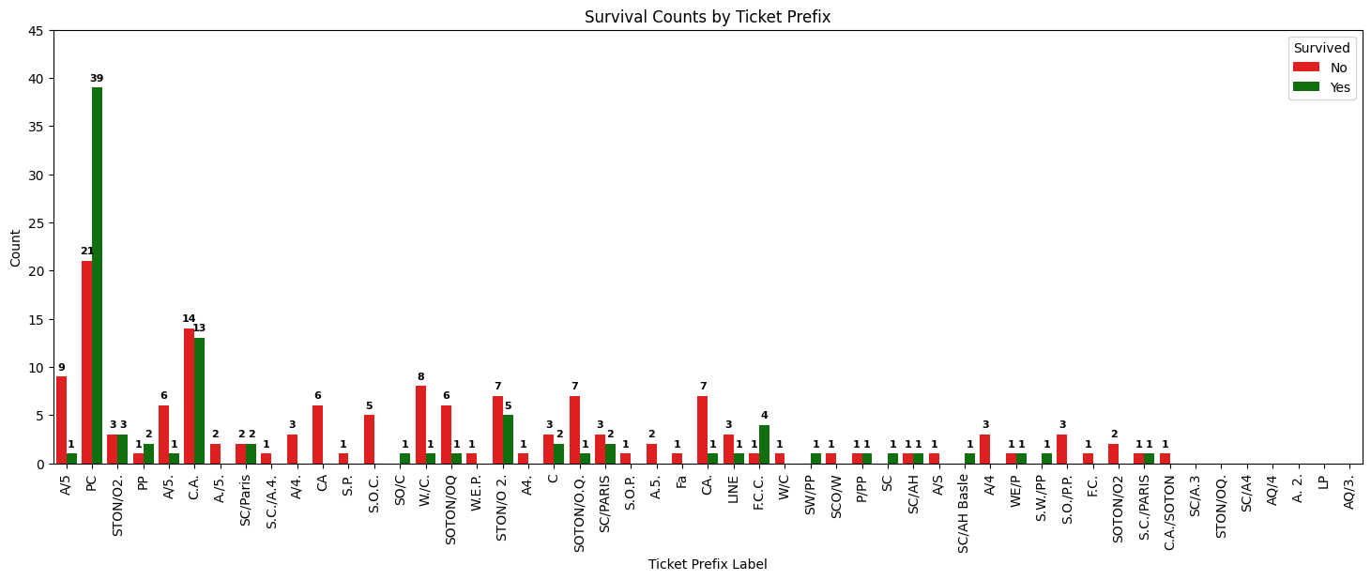
*The 'TicketPrefix' variable was originally thought to be potentially useful for 'Deck' variable imputation, but later found otherwise. It lacked the necessary predictive power for model development.

# Create temporary data with NaN values removed for 'Fare' numeric variable charting.
faretemp_df = titanic_df.dropna(subset=['Fare'])

# Histogram for the 'Fare' numerical variable.
plt.hist(faretemp_df['Fare'], bins = 36, alpha = 0.75, color = 'green', edgecolor = 'black')
plt.xlabel('Fare')
plt.ylabel('Frequency')
plt.xlim(0, 86)
plt.xticks(np.arange(0,551,step=50))
plt.yticks(np.arange(0,701,step=50))
mean_value = faretemp_df['Fare'].mean()
median_value = faretemp_df['Fare'].median()
std_value = faretemp_df['Fare'].std()
plt.axvline(mean_value, color='red', linewidth=2, label=f'Mean: {mean_value: .2f}')
plt.axvline(median_value, color='blue', linestyle='dashed', linewidth=1.5, label=f'Median: {median_value: .2f}')
plt.axvline(mean_value+std_value, color='red', linestyle='dashed', linewidth=1.5, label=f'1 SD')
plt.axvline(mean_value-std_value, color='red', linestyle='dashed', linewidth=1.5)
plt.axvline(mean_value+2*std_value, color='red', linestyle='dashed', linewidth=1, label=f'2 SD')
plt.axvline(mean_value-2*std_value, color='red', linestyle='dashed', linewidth=1)
plt.axvline(mean_value+3*std_value, color='red', linestyle='dashed', linewidth=0.5, label=f'3 SD')
plt.axvline(mean_value-3*std_value, color='red', linestyle='dashed', linewidth=0.5)
plt.show()
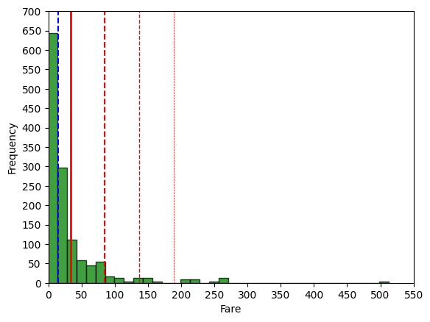
# Boxplot for the 'Fare' numeric variable distribution.
fig = plt.figure(figsize =(5, 7))
ax = fig.add_subplot(111)
# Creating axes instance
bp = ax.boxplot(faretemp_df['Fare'], patch_artist = True,
notch ='True')
for patch, color in zip(bp['boxes'], 'green'):
patch.set_facecolor('green')
# Changing color and linewidth of whiskers.
for whisker in bp['whiskers']:
whisker.set(color ='green',
linewidth = 1.5,
linestyle =":")
# Changing color and linewidth of caps.
for cap in bp['caps']:
cap.set(color ='black',
linewidth = 2)
# Changing color and linewidth of median.
for median in bp['medians']:
median.set(color ='blue',
linewidth = 3)
# Changing style of fliers.
for flier in bp['fliers']:
flier.set(marker ='D',
alpha = 0.5)
# Set axis labels.
ax.set_ylabel('Fare')
ax.set_xticklabels('')
# Set axis limits.
plt.yticks(np.arange(0,551,step=50))
# Display the mean.
plt.axhline(mean_value, color='red', linewidth=1, linestyle='dashed', label=f'Mean: {mean_value: .2f}')
plt.show()
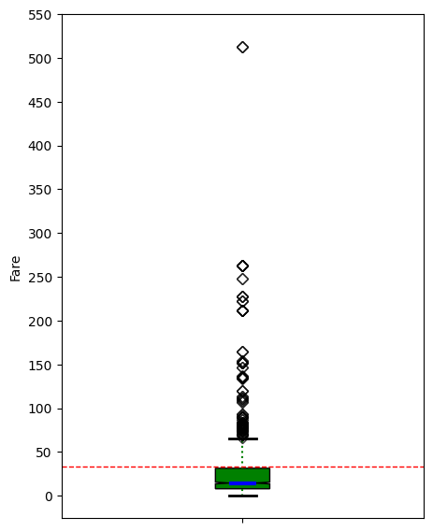
*The significant number of outliers related to the 'Fare' variable is due to the Titanic's varied accommodations and amenities.
# 'Fare' Anderson-Darling Normality Test
result = anderson(faretemp_df['Fare'])
print('Statistic: %.3f' % result.statistic)
p = 0
for i in range(len(result.critical_values)):
sl, cv = result.significance_level[i], result.critical_values[i]
if result.statistic < result.critical_values[i]:
print('%.3f: %.3f, data looks normal (fail to reject H0)' % (sl, cv))
else:
print('%.3f: %.3f, data does not look normal (reject H0)' % (sl, cv))
Statistic: 186.890
15.000: 0.574, data does not look normal (reject H0)
10.000: 0.654, data does not look normal (reject H0)
5.000: 0.785, data does not look normal (reject H0)
2.500: 0.915, data does not look normal (reject H0)
1.000: 1.089, data does not look normal (reject H0)
# 'Fare' QQ plot
qqplot(faretemp_df['Fare'], line='s')
plt.show()
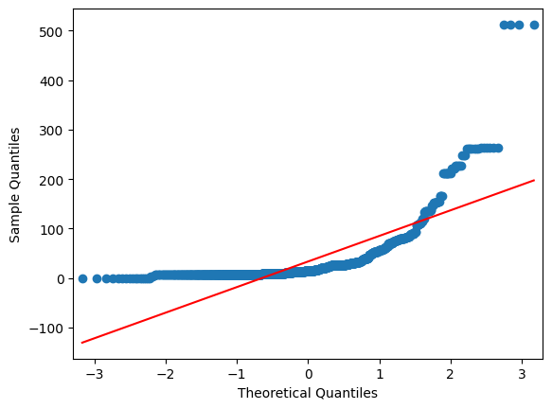

# Evaluate skewness of the distribution for the 'Fare' numeric variable.
fare_skew = faretemp_df['Fare'].skew()
print(f"Fare distribution has a skewness of{fare_skew: .3f}")
Fare distribution has a skewness of 4.368
*Normality analysis determined that the 'Fare' variable is not normally distributed, and the distribution possessed a significant right skew.

# Verify zero fares.
print("\nPassengers with Fare = 0:")
titanic_df[titanic_df['Fare'] == 0][['PassengerId', 'Pclass', 'Name', 'Fare', 'Embarked', 'TicketPrefix']]
Passengers with Fare = 0:
PassengerId Pclass Name Fare \
179 180 3 Leonard, Mr. Lionel 0.0
263 264 1 Harrison, Mr. William 0.0
271 272 3 Tornquist, Mr. William Henry 0.0
277 278 2 Parkes, Mr. Francis "Frank" 0.0
302 303 3 Johnson, Mr. William Cahoone Jr 0.0
413 414 2 Cunningham, Mr. Alfred Fleming 0.0
466 467 2 Campbell, Mr. William 0.0
481 482 2 Frost, Mr. Anthony Wood "Archie" 0.0
597 598 3 Johnson, Mr. Alfred 0.0
633 634 1 Parr, Mr. William Henry Marsh 0.0
674 675 2 Watson, Mr. Ennis Hastings 0.0
732 733 2 Knight, Mr. Robert J 0.0
806 807 1 Andrews, Mr. Thomas Jr 0.0
815 816 1 Fry, Mr. Richard 0.0
822 823 1 Reuchlin, Jonkheer. John George 0.0
1157 1158 1 Chisholm, Mr. Roderick Robert Crispin 0.0
1263 1264 1 Ismay, Mr. Joseph Bruce 0.0
Embarked TicketPrefix
179 S LINE
263 S None
271 S LINE
277 S None
302 S LINE
413 S None
466 S None
481 S None
597 S LINE
633 S None
674 S None
732 S None
806 S None
815 S None
822 S None
1157 S None
1263 S None
*For my information, I wanted to understand how many, and which passengers were getting a free trip. Surprisingly, there was a notable distribution between classes.
# Function to create 'Deck' variable from 'Cabin' variable.
def extract_deck(cabin):
if pd.isna(cabin): # Handle NaN values
return "Lower"
# Split on space and take the first cabin (if multiple)
first_cabin = cabin.split()[0]
# Take the first letter as the deck
return first_cabin[0]
# Create the Deck variable
titanic_df['Deck'] = titanic_df['Cabin'].apply(extract_deck)
# Evaluate the 'TicketPrefix' character variable distribution.
titanic_df['Deck'].value_counts()
Deck
Lower 1014
C 94
B 65
D 46
E 41
A 22
F 21
G 5
T 1
Name: count, dtype: int64
# Barchart for the 'Deck' character variable distribution.
dfg = titanic_df['Deck'].value_counts()
ax = dfg.plot(kind='bar', title='Barchart of the Deck Variable', ylabel='Count', xlabel='Deck', color= ['b'], rot=0, figsize=(10,5))
ax.bar_label(ax.containers[0], color='black', fontsize=11)
plt.yticks(np.arange(0,1101,step=100))
plt.show()
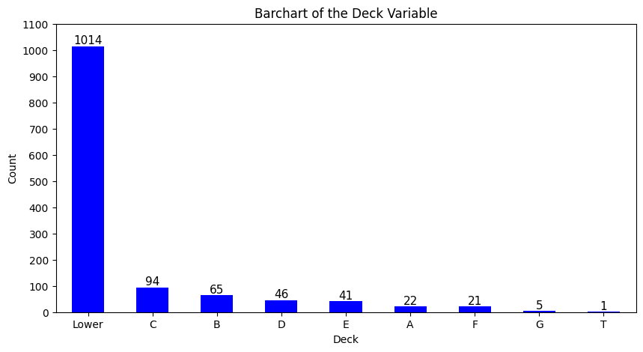
*The parsed 'Deck' variable was created from the 'Cabin' variable with the hopes of somehow imputing passengers to those decks to determine deck location survival prediction power in modeling. 'Lower' represents the currently 1014 unassigned passengers.
# Bar chart for 'Deck' distribution with counts of Survived (0 and 1) for the training dataset.
plt.figure(figsize=(12, 6))
ax = sns.countplot(x='Deck', hue='Survived', data=titanic_df, palette={0: 'red', 1: 'green'})
# Add numeric values centered inside each bar with white font
for p in ax.patches:
height = p.get_height()
# Only add text if height is greater than 0 to avoid the "0" label
if height > 0:
ax.text(p.get_x() + p.get_width()/2, height + 20, # Center vertically
int(height), # Convert to integer for clean display
ha="center", va="top", color="black", fontsize=11)
plt.title('Survival Counts by Deck')
plt.xlabel('Deck')
plt.ylabel('Count')
plt.yticks(np.arange(0,551,step=50))
plt.legend(title='Survived', labels=['No', 'Yes']) # Customize legend labels
plt.show()
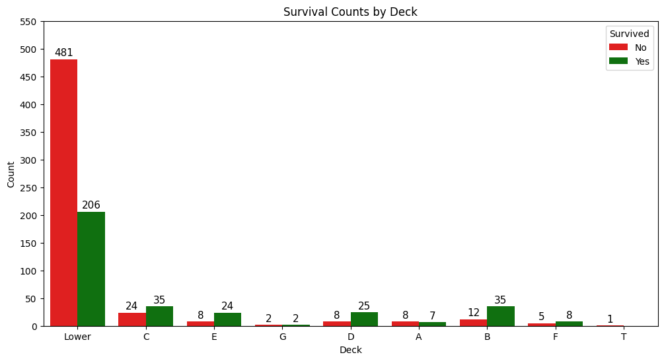
*Most of passengers with available cabin designations were 1st Class survivors, and probably retained their ticket information noting it.

# Evaluate the 'Embarked' categorical variable.
titanic_df['Embarked'].value_counts()
Embarked
S 914
C 270
Q 123
Name: count, dtype: int64
# Barchart for the 'Embarked' categorical variable.
dfg = titanic_df['Embarked'].value_counts()
ax = dfg.plot(kind='bar', title='Barchart of the Embarkment Variable', ylabel='Count', xlabel='Embarked From (S=Southhampton, C=Cherbourg, Q=Queenstown)', color= ['blue', 'indigo', 'violet'], rot=0, figsize=(6,5))
ax.bar_label(ax.containers[0], color='black', fontsize=14)
plt.yticks(np.arange(0,1001,step=100))
plt.show()
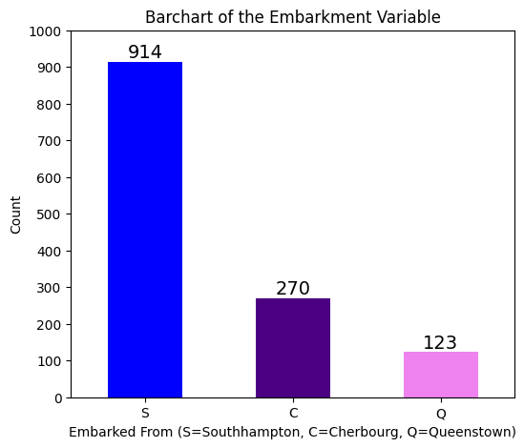
*As depicted, the port embarkment sequence was Southhampton in England, Cherbourg in France, and Queenstown in Ireland.

# Bar chart for 'Embarked' with counts of Survived (0 and 1) for the training dataset.
plt.figure(figsize=(8, 6))
ax = sns.countplot(x='Embarked', hue='Survived', data=titanic_df, palette={0: 'red', 1: 'green'})
# Add numeric values centered inside each bar with white font
for p in ax.patches:
height = p.get_height()
# Only add text if height is greater than 0 to avoid the "0" label
if height > 0:
ax.text(p.get_x() + p.get_width()/2, height + 25, # Center vertically
int(height), # Convert to integer for clean display
ha="center", va="top", color="black", fontsize=12)
plt.title('Survival Counts by Location of Embarkment')
plt.xlabel('Embarked From (S=Southhampton, C=Cherbourg, Q=Queenstown)')
plt.ylabel('Count')
plt.yticks(np.arange(0,501,step=50))
plt.legend(title='Survived', labels=['No', 'Yes']) # Customize legend labels
plt.show()
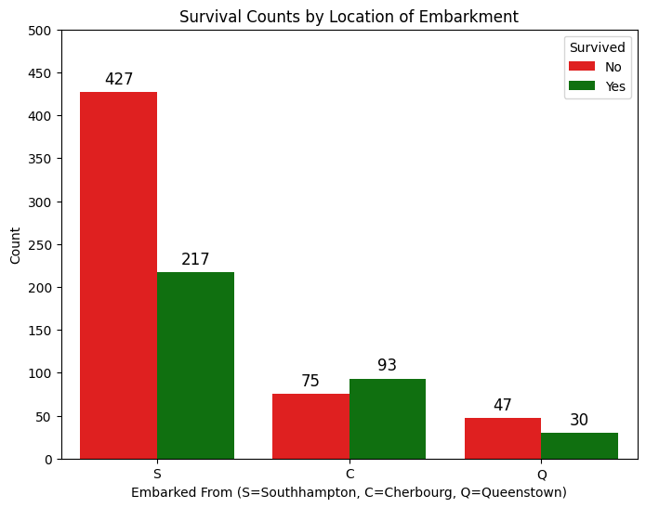
*Southhampton passengers reasonably represented all classes. Cherbourg passengers represented a high number of 1st Class. Queenstown passengers represented a high number of 3rd Class.
III. Perform Imputation For The Fare (1), Embarked (2), Deck (1014), and Age (263) Variables.
A. Fare And Embarked Variable Imputation
# Step 1: Analyze missing values
print("Missing values before cleaning:")
print(titanic_df[['Fare', 'Embarked']].isnull().sum())
# Step 2: Clean Fare
# Identify Storey in test set (assuming test set starts at index 891)
test_df = titanic_df[titanic_df.index >= 891] # Adjust index based on your dataset split
storey_row = test_df[(test_df['Name'].str.contains('Storey', case=True, na=False)) &
(test_df['Pclass'] == 3) &
(test_df['Embarked'] == 'S') &
(test_df['Fare'].isnull())]
if not storey_row.empty:
median_fare_3rd_s = titanic_df[(titanic_df['Pclass'] == 3) & (titanic_df['Embarked'] == 'S')]['Fare'].median()
titanic_df.loc[storey_row.index, 'Fare'] = median_fare_3rd_s
print(f"\nImputed Fare for Storey: {median_fare_3rd_s} at index {storey_row.index[0]}")
# Step 3: Verify missing Embarked and original distribution
missing_embarked = titanic_df[titanic_df['Embarked'].isnull()]
print("Passengers with missing Embarked before imputation:")
print(missing_embarked[['PassengerId', 'Name', 'Pclass', 'Cabin', 'Ticket', 'Fare', 'Survived']])
print("\nOriginal Embarked distribution:")
print(titanic_df['Embarked'].value_counts())
# Step 4: Impute Embarked for Icard and Stone using PassengerId
titanic_df.loc[titanic_df['PassengerId'] == 62, 'Embarked'] = 'S' # Icard, Southampton
titanic_df.loc[titanic_df['PassengerId'] == 830, 'Embarked'] = 'S' # Stone, Southampton
# Step 5: Verify imputation
print("\nMissing Embarked after imputation:")
print(titanic_df['Embarked'].isnull().sum())
print("\nUpdated Embarked distribution:")
print(titanic_df['Embarked'].value_counts())
# Step 6: Confirm affected rows
affected_rows = titanic_df[titanic_df['PassengerId'].isin([62, 830])]
print("\nVerification of Icard (62) and Stone (830) after imputation:")
print(affected_rows[['PassengerId', 'Name', 'Embarked']])
Missing values before cleaning:
Fare 1
Embarked 2
dtype: int64
Imputed Fare for Storey: 8.05 at index 1043
Passengers with missing Embarked before imputation:
PassengerId Name Pclass Cabin \
61 62 Icard, Miss. Amelie 1 B28
829 830 Stone, Mrs. George Nelson (Martha Evelyn) 1 B28
Ticket Fare Survived
61 113572 80.0 1.0
829 113572 80.0 1.0
Original Embarked distribution:
Embarked
S 914
C 270
Q 123
Name: count, dtype: int64
Missing Embarked after imputation:
0
Updated Embarked distribution:
Embarked
S 916
C 270
Q 123
Name: count, dtype: int64
Verification of Icard (62) and Stone (830) after imputation:
PassengerId Name Embarked
61 62 Icard, Miss. Amelie S
829 830 Stone, Mrs. George Nelson (Martha Evelyn) S
*The missing 'Fare' variable value was identified, and a median fare was imputed related to the passenger's class (Pclass) and port of embarkment (Embarked). The two missing 'Embarked' variable values were identified, and the passengers were found to be sharing the same cabin. Researched to identify their relationship (passenger and maid) and port of embarkment (Southhampton), then imputed accordingly.

B1. Exploratory Preliminary Analysis For Deck Imputation
# Filter out "Lower" deck passengers
known_decks_df = titanic_df[(titanic_df['Deck'] != 'Lower') & (titanic_df['Fare'] > 0) & (titanic_df['Fare'] < 300)]
# Descriptive statistics for Fare by Deck (excluding Lower)
fare_by_deck_stats = titanic_df[(titanic_df['Deck'] != 'Lower') & (titanic_df['Fare'] > 0) & (titanic_df['Fare'] < 300)].groupby('Deck')['Fare'].describe().round(2)
print("Descriptive Statistics for Fare by Deck (Excluding Lower):")
print(fare_by_deck_stats)
# Cleaned version with selected stats
cleaned_stats = fare_by_deck_stats[['count', 'mean', 'std', 'min', '50%', 'max']]
cleaned_stats = cleaned_stats.rename(columns={'50%': 'median'})
print("\nCleaned Descriptive Statistics for Fare by Deck:")
print(cleaned_stats)
# Box plot to visualize Fare distribution by Deck (excluding Lower)
plt.figure(figsize=(10, 6))
sns.boxplot(x='Deck', y='Fare', data=known_decks_df, palette='viridis')
plt.title('Fare Distribution by Deck (Excluding Lower & (0 < Fare < 300))')
plt.xlabel('Deck')
plt.ylabel('Fare')
plt.yticks(np.arange(0,301,step=30))
plt.axhline(y=titanic_df['Fare'].median(), color='red', linestyle='--', label='Median Fare')
plt.legend()
plt.show()
Descriptive Statistics for Fare by Deck (Excluding Lower):
count mean std min 25% 50% 75% max
Deck
A 21.0 43.21 18.35 26.00 30.50 35.50 50.50 81.86
B 59.0 108.78 76.45 5.00 57.49 82.27 133.26 262.38
C 94.0 107.93 72.91 25.70 52.00 86.29 151.55 263.00
D 46.0 53.01 28.13 12.88 27.72 52.55 76.73 113.28
E 41.0 54.56 37.74 8.05 26.29 53.10 79.65 134.50
F 21.0 18.08 12.22 7.23 7.65 13.00 26.00 39.00
G 5.0 14.21 3.42 10.46 10.46 16.70 16.70 16.70
T 1.0 35.50 NaN 35.50 35.50 35.50 35.50 35.50

Cleaned Descriptive Statistics for Fare by Deck:
count mean std min median max
Deck
A 21.0 43.21 18.35 26.00 35.50 81.86
B 59.0 108.78 76.45 5.00 82.27 262.38
C 94.0 107.93 72.91 25.70 86.29 263.00
D 46.0 53.01 28.13 12.88 52.55 113.28
E 41.0 54.56 37.74 8.05 53.10 134.50
F 21.0 18.08 12.22 7.23 13.00 39.00
G 5.0 14.21 3.42 10.46 16.70 16.70
T 1.0 35.50 NaN 35.50 35.50 35.50
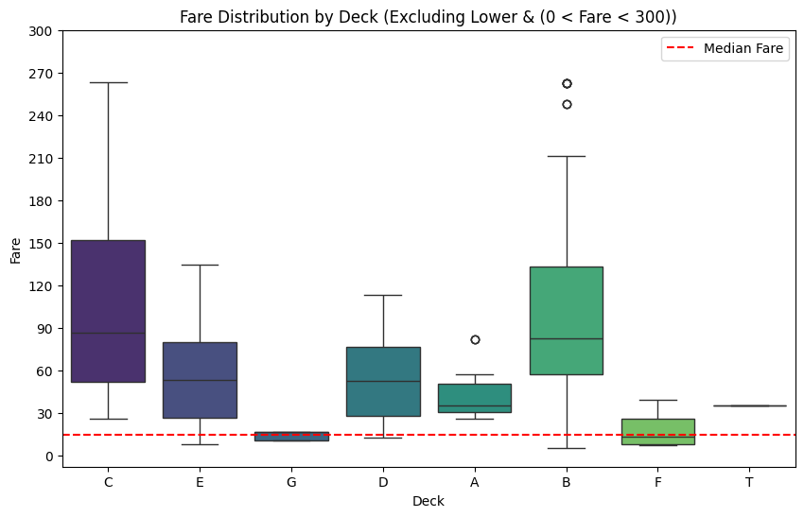
*Explored the possibility of using the 'Fare' variable for potential deck assignment. Removed the previously identified zero fares to provide a clear picture of each distribution. There was one fare value around 500 in Deck B that was removed to improve the boxplot display. The fare distributions for Deck B, C, D, and E seemed wide and often overlapping for passengers with known cabin assignments. Research uncovered that those decks varying accommodations.
# Ticket Number Sequence Analysis
print("\nTicket Number Sequence Analysis:")
# Use the existing TicketNumber column, convert to numeric and exclude NaN values
titanic_df['TicketNumber'] = pd.to_numeric(titanic_df['TicketNumber'], errors='coerce')
ticket_groups = titanic_df.groupby(pd.qcut(titanic_df['TicketNumber'].dropna(), 10, duplicates='drop'))['Pclass'].value_counts()
print("Ticket Number Ranges and Class Distribution:")
print(ticket_groups)
Ticket Number Sequence Analysis:
Ticket Number Ranges and Class Distribution:
TicketNumber Pclass
(1.999, 2667.4] 3 95
2 31
1 5
(2667.4, 9549.0] 3 117
2 9
1 5
(9549.0, 17569.0] 1 93
2 28
3 10
(17569.0, 28210.2] 1 101
2 17
3 11
(28210.2, 111163.0] 2 68
1 32
3 31
(111163.0, 236853.0] 1 87
2 44
3 0
(236853.0, 330971.8] 2 80
3 49
1 0
(330971.8, 349215.2] 3 131
1 0
2 0
(349215.2, 368347.6] 3 130
1 0
2 0
(368347.6, 3101317.0] 3 131
1 0
2 0
Name: count, dtype: int64
*Ticket Number analysis indicated to some degree that the White Star Line had likely developed the tickets with cabin assignments to separate 3rd class at some point.

# Step 1: Verify that titanic_df is defined and has the required columns
try:
if not isinstance(titanic_df, pd.DataFrame):
raise NameError("titanic_df is not a DataFrame. Please ensure the dataset is loaded correctly.")
required_columns = ['TicketNumber', 'Cabin']
missing_columns = [col for col in required_columns if col not in titanic_df.columns]
if missing_columns:
raise KeyError(f"Missing required columns: {missing_columns}. Please check the dataset.")
except NameError:
print("Error: 'titanic_df' is not defined. Please load the dataset first.")
raise
# Step 2: Identify passengers with a cabin assignment
# A cabin assignment exists if Cabin is not NaN and not an empty string
passengers_with_cabin = titanic_df[
(titanic_df['Cabin'].notna()) & (titanic_df['Cabin'] != '')
].copy()
# Step 3: Display relevant information
if not passengers_with_cabin.empty:
# Select columns to display: PassengerId, Name, Pclass, TicketNumber, Cabin
display_columns = ['PassengerId', 'Name', 'Pclass', 'TicketNumber', 'Cabin']
# Ensure all display columns exist in the dataset
display_columns = [col for col in display_columns if col in titanic_df.columns]
print("\nPassengers with Cabin Assignments and Their Ticket Numbers:")
print(passengers_with_cabin[display_columns])
# Additional info: Total number of passengers with cabins
total_with_cabin = len(passengers_with_cabin)
print(f"\nTotal number of passengers with a cabin assignment: {total_with_cabin}")
# Breakdown by Pclass
print("\nBreakdown of passengers with cabin assignments by Pclass:")
print(passengers_with_cabin['Pclass'].value_counts().sort_index())
# Focus on "Dr" passengers with cabins
if 'Title' in titanic_df.columns:
dr_with_cabin = passengers_with_cabin[passengers_with_cabin['Title'] == 'Dr']
if not dr_with_cabin.empty:
print("\nDr Passengers with Cabin Assignments:")
print(dr_with_cabin[display_columns])
else:
print("\nNo Dr passengers found with a cabin assignment.")
else:
print("\nNote: 'Title' column not found, skipping Dr passengers check.")
else:
print("No passengers found with a cabin assignment in the dataset.")
Total number of passengers with a cabin assignment: 295
Breakdown of passengers with cabin assignments by Pclass:
Pclass
1 256
2 23
3 16
Name: count, dtype: int64
Dr Passengers with Cabin Assignments:
PassengerId Name Pclass TicketNumber Cabin
245 246 Minahan, Dr. William Edward 1 19928.0 C78
632 633 Stahelin-Maeglin, Dr. Max 1 13214.0 B50
796 797 Leader, Dr. Alice (Farnham) 1 17465.0 D17
1184 1185 Dodge, Dr. Washington 1 33638.0 A34
# Step 1: Verify that titanic_df is defined and has the required columns
try:
if not isinstance(titanic_df, pd.DataFrame):
raise NameError("titanic_df is not a DataFrame. Please ensure the dataset is loaded correctly.")
required_columns = ['TicketNumber', 'Cabin']
missing_columns = [col for col in required_columns if col not in titanic_df.columns]
if missing_columns:
raise KeyError(f"Missing required columns: {missing_columns}. Please check the dataset.")
except NameError:
print("Error: 'titanic_df' is not defined. Please load the dataset first.")
raise
# Step 2: Identify passengers with a cabin assignment
passengers_with_cabin = titanic_df[
(titanic_df['Cabin'].notna()) & (titanic_df['Cabin'] != '')
].copy()
# Step 3: Extract the deck from the Cabin column
def extract_deck(cabin):
if pd.isna(cabin) or cabin == '':
return None
# Take the first letter of the first cabin (in case of multiple cabins like "C23 C25")
first_cabin = cabin.split()[0]
return first_cabin[0].upper()
passengers_with_cabin['Deck'] = passengers_with_cabin['Cabin'].apply(extract_deck)
# Step 4: Group by Deck and sort by TicketNumber
if not passengers_with_cabin.empty:
# Define columns to display
display_columns = ['PassengerId', 'Name', 'Pclass', 'TicketNumber', 'Cabin']
display_columns = [col for col in display_columns if col in titanic_df.columns]
# Group by Deck and sort by TicketNumber within each group
grouped_by_deck = passengers_with_cabin.groupby('Deck')
print("\nPassengers with Cabin Assignments Grouped by Deck (Sorted by TicketNumber):")
for deck, group in grouped_by_deck:
# Sort the group by TicketNumber
sorted_group = group.sort_values(by='TicketNumber')
print(f"\nDeck {deck}:")
print(sorted_group[display_columns])
# Highlight "Dr" passengers in this deck
if 'Title' in titanic_df.columns:
dr_in_deck = sorted_group[sorted_group['Title'] == 'Dr']
if not dr_in_deck.empty:
print(f"\nDr Passengers on Deck {deck} (Sorted by TicketNumber):")
print(dr_in_deck[display_columns])
else:
print(f"\nNo Dr passengers found on Deck {deck}.")
# Total passengers in this deck
print(f"\nTotal passengers on Deck {deck}: {len(group)}")
# Summary: Total passengers with cabins and deck distribution
total_with_cabin = len(passengers_with_cabin)

Passengers with Cabin Assignments Grouped by Deck (Sorted by TicketNumber):
Total passengers on Deck A: 22
Total passengers on Deck B: 65
Total passengers on Deck C: 94
Total passengers on Deck D: 46
Total passengers on Deck E: 41
Total passengers on Deck F: 21
Total passengers on Deck G: 5
Deck T:
PassengerId Name Pclass TicketNumber Cabin
339 340 Blackwell, Mr. Stephen Weart 1 113784.0 T
Total passengers on Deck T: 1

# Step 1: Filter passengers with a cabin assignment
try:
passengers_with_cabin = titanic_df[
(titanic_df['Cabin'].notna()) & (titanic_df['Cabin'] != '')
].copy()
print("Filtering successful: Passengers with cabins identified.")
except Exception as e:
print(f"Error filtering passengers with cabins: {e}")
raise
# Step 2: Verify and use existing TicketPrefix (assuming it exists)
if 'TicketPrefix' not in passengers_with_cabin.columns:
print("Warning: TicketPrefix column not found. Please ensure it exists in titanic_df.")
else:
print("TicketPrefix column found and will be used.")
# Step 3: Sort by TicketNumber in ascending order
try:
sorted_passengers = passengers_with_cabin.sort_values(by='TicketNumber')
print("Sorting by TicketNumber successful.")
except Exception as e:
print(f"Error sorting by TicketNumber: {e}")
raise
# Step 4: Display results
display_columns = ['TicketNumber', 'Pclass', 'Survived', 'Embarked', 'Fare', 'TicketPrefix', 'Cabin']
try:
print("\nPassengers with Cabin Assignments Sorted by TicketNumber (Ascending):")
print(sorted_passengers[display_columns])
# Summary: Total passengers with cabins
total_with_cabin = len(sorted_passengers)
print(f"\nTotal number of passengers with a cabin assignment: {total_with_cabin}")
# Summary: Total passengers with cabins
total_with_cabin = len(sorted_passengers)
print(f"\nTotal number of passengers with a cabin assignment: {total_with_cabin}")
# Highlight "Dr" passengers
dr_with_cabin = sorted_passengers[sorted_passengers['Title'] == 'Dr']
if not dr_with_cabin.empty:
print("\nDr Passengers with Cabin Assignments (Sorted by TicketNumber):")
print(dr_with_cabin[display_columns])
else:
print("\nNo Dr passengers found with a cabin assignment.")
except Exception as e:
print(f"Error displaying results: {e}")
raise
Filtering successful: Passengers with cabins identified.
TicketPrefix column found and will be used.
Sorting by TicketNumber successful.
Total number of passengers with a cabin assignment: 295
*Knowing the cabin assignments were placed on passenger tickets, thorough review and analysis of 'TicketNumber' and 'TicketPrefix' for known cabin assignments took place to see if they could be used for deck assignment purposes for unknown cabin assignments.

B2. Deck Variable Imputation
# Step 1: Preprocess TicketNumber
# Ensure TicketNumber is numeric and handle 'LINE' tickets.
titanic_df['TicketNumber'] = titanic_df['TicketNumber'].fillna(399999).apply(
lambda x: 399999 if str(x).strip().upper() == 'LINE' else int(x)
)
# Step 1.5: Generate 'FamilySize' distributions for 1st Class passengers.
print("\nDebug: FamilySize Distribution in 1st Class (Pclass 1):")
print(titanic_df[titanic_df['Pclass'] == 1]['FamilySize'].value_counts())
print("\nDebug: FamilySize Distribution in 1st Class with Deck 'Lower':")
print(titanic_df[(titanic_df['Pclass'] == 1) & (titanic_df['Deck'] == 'Lower')]['FamilySize'].value_counts())
# Step 2: Define expected Deck-to-Pclass associations from Passenger Class cabin configurations and historical accounts.
historical_counts = {
1: {'A': 42, 'B': 78, 'C': 128, 'D': 40, 'E': 34, 'T': 1}, # Total 323
2: {'D': 118, 'E': 145, 'F': 14}, # Total 277
3: {'D': 50, 'E': 51, 'F': 444, 'G': 164} # Total 709
}
class_limits = {1: 323, 2: 277, 3: 709}
deck_limits = {'A': 42, 'B': 78, 'C': 128, 'D': 208, 'E': 230, 'F': 458, 'G': 164, 'T': 1}
allowed_decks = {
1: ['A', 'B', 'C', 'D', 'E', 'T'],
2: ['D', 'E', 'F'],
3: ['D', 'E', 'F', 'G']
}
# Existing counts from Cabin and Pclass designations.
existing_counts = {
1: {'A': 22, 'B': 65, 'C': 94, 'D': 40, 'E': 34, 'T': 1},
2: {'D': 6, 'E': 4, 'F': 13},
3: {'D': 0, 'E': 3, 'F': 8, 'G': 5}
}
# Initialize current counts and deck totals based on existing assignments
current_counts = {pclass: {deck: existing_counts[pclass].get(deck, 0) for deck in allowed_decks[pclass]} for pclass in [1, 2, 3]}
deck_totals = {'A': 22, 'B': 65, 'C': 94, 'D': 46, 'E': 43, 'F': 21, 'G': 5, 'T': 1}
print("\nDebug: Initial Current Counts:")
print(current_counts)
print("\nDebug: Initial Deck Totals:")
print(deck_totals)
# Step 2.5: Pre-Assign 113 Queenstown 3rd Class Passengers to G Deck.
print("\n--- Pre-Assigning Queenstown 3rd Class Passengers to G Deck ---")
queenstown_target = 113
mask_queenstown = (titanic_df['Pclass'] == 3) & (titanic_df['Embarked'] == 'Q')
queenstown_passengers = titanic_df[mask_queenstown].sort_values(['TicketNumber', 'Ticket'])
queenstown_count = min(queenstown_target, len(queenstown_passengers))
assigned_count = 0
queenstown_indices = []
# First, count how many Queenstown passengers are already on G Deck.
current_queenstown_on_g = len(titanic_df[(titanic_df['Pclass'] == 3) & (titanic_df['Embarked'] == 'Q') & (titanic_df['Deck'] == 'G')])
remaining_queenstown = queenstown_target - current_queenstown_on_g
if remaining_queenstown > 0:
# Filter Queenstown passengers not already on G Deck
mask_queenstown_not_g = (titanic_df['Pclass'] == 3) & (titanic_df['Embarked'] == 'Q') & (titanic_df['Deck'] != 'G')
queenstown_not_g = titanic_df[mask_queenstown_not_g].sort_values(['TicketNumber', 'Ticket'])
grouped_by_ticket = queenstown_not_g.groupby('Ticket')
for ticket, group in grouped_by_ticket:
if assigned_count >= remaining_queenstown:
break
indices = group.index
# Update deck assignment
old_decks = titanic_df.loc[indices, 'Deck']
for idx in indices:
old_deck = titanic_df.loc[idx, 'Deck']
if old_deck in current_counts[3]:
current_counts[3][old_deck] -= 1
deck_totals[old_deck] -= 1
titanic_df.loc[indices, 'Deck'] = 'G'
current_counts[3]['G'] += len(indices)
deck_totals['G'] += len(indices)
assigned_count += len(indices)
queenstown_indices.extend(indices)
print(f"\nAssigned {len(indices)} Queenstown passengers to G Deck for Pclass 3 (Ticket: {ticket}):")
print(titanic_df.loc[indices, ['PassengerId', 'TicketNumber', 'Deck', 'Pclass', 'FamilySize']])
print("\nDebug: Current Counts After Queenstown Pre-Assignment:")
print(current_counts)
print("\nDebug: Deck Totals After Queenstown Pre-Assignment:")
print(deck_totals)
# Use actual Pclass distribution to identify discrepancies
class_counts = titanic_df['Pclass'].value_counts().to_dict()
print("\nDebug: Class Counts (from Pclass distribution):", class_counts)
# Step 3: Adjust assignments to meet targets
# First, handle excess passengers by moving them to 'Lower'
for pclass in [1, 2, 3]:
current_total = sum(current_counts[pclass].values())
target_total = class_limits[pclass]
if current_total > target_total:
excess = current_total - target_total
print(f"\nDebug: Pclass {pclass} has {excess} excess passengers. Moving to 'Lower'.")
for deck in allowed_decks[pclass]:
if excess <= 0:
break
current = current_counts[pclass][deck]
target = historical_counts[pclass].get(deck, 0)
if current > target:
to_move = min(current - target, excess)
# Find passengers on this deck to move to 'Lower'
mask = (titanic_df['Pclass'] == pclass) & (titanic_df['Deck'] == deck)
passengers_to_move = titanic_df[mask].sort_values(['TicketNumber', 'Ticket']).index[:to_move]
titanic_df.loc[passengers_to_move, 'Deck'] = 'Lower'
current_counts[pclass][deck] -= to_move
deck_totals[deck] -= to_move
excess -= to_move
print(f"\nMoved {to_move} passengers from {deck} (Pclass {pclass}) to 'Lower':")
print(titanic_df.loc[passengers_to_move, ['PassengerId', 'TicketNumber', 'Deck', 'Pclass', 'FamilySize']])
# Step 3.5: Fix Deck A FamilySize violations
deck_a_violations = (titanic_df['Pclass'] == 1) & (titanic_df['Deck'] == 'A') & (titanic_df['FamilySize'] > 1)
if deck_a_violations.sum() > 0:
print(f"\nDebug: Moving {deck_a_violations.sum()} Deck A passengers with FamilySize > 1 back to Lower")
titanic_df.loc[deck_a_violations, 'Deck'] = 'Lower'

# Step 4: Reassignment with strict limits and ascending TicketNumber
historical_counts = {
1: {'A': 42, 'B': 78, 'C': 128, 'D': 40, 'E': 34, 'T': 1},
2: {'D': 118, 'E': 145, 'F': 14},
3: {'D': 50, 'E': 51, 'F': 444, 'G': 164}
}
deck_limits = {'A': 42, 'B': 78, 'C': 128, 'D': 208, 'E': 230, 'F': 458, 'G': 164, 'T': 1}
remaining_lower = titanic_df['Deck'] == 'Lower'
initial_lower_count = remaining_lower.sum()
print(f"\nDebug: Initial Total Lower Count: {initial_lower_count}")
for pclass in [1, 2, 3]:
class_mask = remaining_lower & (titanic_df['Pclass'] == pclass)
remaining = class_mask.sum()
print(f"\nDebug: Pclass {pclass} - Remaining Lower: {remaining}")
if remaining > 0:
# Group by ticket to ensure ticket groups stay together
unassigned = titanic_df[class_mask].sort_values(['TicketNumber', 'Ticket']).copy()
ticket_groups = unassigned.groupby('Ticket').agg({
'PassengerId': 'count',
'TicketNumber': 'first',
'FamilySize': 'first'
}).rename(columns={'PassengerId': 'GroupSize'}).reset_index()
ticket_groups = ticket_groups.sort_values('TicketNumber')
decks = {
1: ['A', 'B', 'C', 'D', 'E', 'T'],
2: ['D', 'E', 'F'],
3: ['D', 'E', 'F', 'G']
}[pclass]
for deck in decks:
if remaining <= 0:
break
# Get current counts directly from DataFrame
current_dist = pd.crosstab(titanic_df['Pclass'], titanic_df['Deck'])
current = current_dist.get(deck, pd.Series(0, index=[pclass])).get(pclass, 0)
historical = historical_counts[pclass].get(deck, 0)
deck_total = titanic_df['Deck'].value_counts().get(deck, 0)
deck_limit = deck_limits.get(deck, 0)
available_slots = min(historical - current, deck_limit - deck_total, remaining)
print(f"\nDebug: Checking Deck {deck} - Current: {current}, Historical: {historical}, Deck Total: {deck_total}, Deck Limit: {deck_limit}, Available Slots: {available_slots}")
if available_slots <= 0:
print(f"Debug: Skipping Deck {deck} - No available slots.")
continue
assigned_count = 0
for _, row in ticket_groups.iterrows():
ticket = row['Ticket']
group_size = row['GroupSize']
family_size = row['FamilySize']
ticket_number = row['TicketNumber']
if assigned_count + group_size > available_slots:
continue # Skip if group doesn't fit
if pclass == 1 and deck == 'A' and family_size > 1:
print(f"Debug: Skipping Ticket {ticket} (TicketNumber: {ticket_number}) for Deck A - FamilySize {family_size} > 1")
continue
indices = unassigned[unassigned['Ticket'] == ticket].index
titanic_df.loc[indices, 'Deck'] = deck
assigned_count += group_size
remaining -= group_size
print(f"\nReassigned {group_size} Lower to {deck} for Pclass {pclass} (Ticket: {ticket}, TicketNumber: {ticket_number}):")
print(titanic_df.loc[indices, ['PassengerId', 'TicketNumber', 'Deck', 'Pclass', 'FamilySize']])
unassigned = unassigned.drop(indices)
ticket_groups = ticket_groups[~ticket_groups['Ticket'].isin(titanic_df[titanic_df['Deck'] != 'Lower']['Ticket'])]
class_mask = (titanic_df['Deck'] == 'Lower') & (titanic_df['Pclass'] == pclass)
remaining = class_mask.sum()
print(f"\nDebug: Pclass {pclass} - Remaining Lower After Deck {deck}: {remaining}")
# Step 5: Final Sweep with strict limits
remaining_lower = titanic_df['Deck'] == 'Lower'
if remaining_lower.sum() > 0:
for pclass in [1, 2, 3]:
class_mask = remaining_lower & (titanic_df['Pclass'] == pclass)
remaining = class_mask.sum()
if remaining > 0:
unassigned = titanic_df[class_mask].sort_values(['TicketNumber', 'Ticket']).copy()
ticket_groups = unassigned.groupby('Ticket').agg({
'PassengerId': 'count',
'TicketNumber': 'first',
'FamilySize': 'first'
}).rename(columns={'PassengerId': 'GroupSize'}).reset_index()
ticket_groups = ticket_groups.sort_values('TicketNumber')
decks = {
1: ['B', 'C', 'D', 'E', 'T'],
2: ['D', 'E', 'F'],
3: ['D', 'E', 'F', 'G']
}[pclass]
for deck in decks:
if remaining <= 0:
break
current_dist = pd.crosstab(titanic_df['Pclass'], titanic_df['Deck'])
current = current_dist.get(deck, pd.Series(0, index=[pclass])).get(pclass, 0)
historical = historical_counts[pclass].get(deck, 0)
deck_total = titanic_df['Deck'].value_counts().get(deck, 0)
deck_limit = deck_limits.get(deck, 0)
available_slots = min(historical - current, deck_limit - deck_total, remaining)
print(f"\nDebug: Final Sweep - Checking Deck {deck} - Current: {current}, Historical: {historical}, Deck Total: {deck_total}, Deck Limit: {deck_limit}, Available Slots: {available_slots}")
if available_slots <= 0:
print(f"Debug: Final Sweep - Skipping Deck {deck} - No available slots.")
continue
assigned_count = 0
for _, row in ticket_groups.iterrows():
ticket = row['Ticket']
group_size = row['GroupSize']
family_size = row['FamilySize']
ticket_number = row['TicketNumber']
if assigned_count + group_size > available_slots:
continue
indices = unassigned[unassigned['Ticket'] == ticket].index
titanic_df.loc[indices, 'Deck'] = deck
assigned_count += group_size
remaining -= group_size
print(f"\nFinal Sweep: Reassigned {group_size} Lower to {deck} for Pclass {pclass} (Ticket: {ticket}, TicketNumber: {ticket_number}):")
print(titanic_df.loc[indices, ['PassengerId', 'TicketNumber', 'Deck', 'Pclass', 'FamilySize']])
unassigned = unassigned.drop(indices)
ticket_groups = ticket_groups[~ticket_groups['Ticket'].isin(titanic_df[titanic_df['Deck'] != 'Lower']['Ticket'])]
class_mask = (titanic_df['Deck'] == 'Lower') & (titanic_df['Pclass'] == pclass)
remaining = class_mask.sum()
print(f"\nDebug: Pclass {pclass} - Remaining Lower After Final Sweep Deck {deck}: {remaining}")
# Final Validation
print("\n--- Final Validation ---")
print("\nDebug: Deck Counts After Final Reassignment:")
print(titanic_df['Deck'].value_counts())
print("\nDebug: Tickets with Deck == 'Lower' After Final Reassignment:")
print(titanic_df[titanic_df['Deck'] == 'Lower'][['PassengerId', 'TicketNumber', 'Pclass', 'Deck', 'FamilySize']])
print("\nDebug: Final Pclass Distribution:")
print(titanic_df['Pclass'].value_counts().to_dict())
print("\nCurrent Deck Distribution by Pclass:")
print(pd.crosstab(titanic_df['Pclass'], titanic_df['Deck']))
print("\nNumber of 3rd Class Queenstown Passengers on G Deck:")
queenstown_g = titanic_df[(titanic_df['Pclass'] == 3) & (titanic_df['Embarked'] == 'Q') & (titanic_df['Deck'] == 'G')]
print(len(queenstown_g))
print("\nFamilySize Distribution on Deck A (Pclass 1):")
print(titanic_df[(titanic_df['Pclass'] == 1) & (titanic_df['Deck'] == 'A')]['FamilySize'].value_counts())
print("\nSample of Passengers with Imputed Deck:")
print(titanic_df[titanic_df['Cabin'].isna()][['PassengerId', 'Pclass', 'Embarked', 'Deck', 'Ticket', 'TicketNumber', 'FamilySize']].head(10))
Debug: FamilySize Distribution in 1st Class (Pclass 1):
FamilySize
0 160
1 104
2 39
3 9
5 6
4 5
Name: count, dtype: int64
Debug: FamilySize Distribution in 1st Class with Deck 'Lower':
FamilySize
0 53
1 11
2 3
Name: count, dtype: int64
Debug: Initial Current Counts:
{1: {'A': 22, 'B': 65, 'C': 94, 'D': 40, 'E': 34, 'T': 1}, 2: {'D': 6, 'E': 4, 'F': 13}, 3: {'D': 0, 'E': 3, 'F': 8, 'G': 5}}
Debug: Initial Deck Totals:
{'A': 22, 'B': 65, 'C': 94, 'D': 46, 'E': 43, 'F': 21, 'G': 5, 'T': 1}
--- Pre-Assigning Queenstown 3rd Class Passengers to G Deck ---
Final Sweep: Reassigned 2 Lower to G for Pclass 3 (Ticket: 2668, TicketNumber: 2668):
PassengerId TicketNumber Deck Pclass FamilySize
533 534 2668 G 3 2
1308 1309 2668 G 3 2
Debug: Pclass 3 - Remaining Lower After Final Sweep Deck G: 0
--- Final Validation ---
Debug: Deck Counts After Final Reassignment:
Deck
F 457
E 229
D 208
G 164
C 128
B 78
A 42
Lower 2
T 1
Name: count, dtype: int64
Debug: Tickets with Deck == 'Lower' After Final Reassignment:
PassengerId TicketNumber Pclass Deck FamilySize
427 428 250655 2 Lower 0
705 706 250655 2 Lower 0
Debug: Final Pclass Distribution:
{3: 709, 1: 323, 2: 277}
Current Deck Distribution by Pclass:
Deck A B C D E F G Lower T
Pclass
1 42 78 128 40 34 0 0 0 1
2 0 0 0 118 144 13 0 2 0
3 0 0 0 50 51 444 164 0 0
Number of 3rd Class Queenstown Passengers on G Deck:
113
FamilySize Distribution on Deck A (Pclass 1):
FamilySize
0 34
1 8
Name: count, dtype: int64
Sample of Passengers with Imputed Deck:
PassengerId Pclass Embarked Deck Ticket TicketNumber \
0 1 3 S F A/5 21171 21171
2 3 3 S G STON/O2. 3101282 3101282
4 5 3 S F 373450 373450
5 6 3 Q G 330877 330877
7 8 3 S F 349909 349909
8 9 3 S F 347742 347742
9 10 2 C E 237736 237736
12 13 3 S D A/5. 2151 2151
13 14 3 S F 347082 347082
14 15 3 S F 350406 350406
FamilySize
0 1
2 0
4 0
5 0
7 4
8 2
9 1
12 0
13 6
14 0
*A historical constraint indicated that only singles and couples (FamilySize= 0 or 1) could allocated to Deck A, the promenade deck. Initial current counts and deck totals represent the allocation of those with cabin values. From historical research, 113 Queenstown 3rd Class passengers were assigned to a forward steerage area on Deck G. All, but two deck assignments in 2nd Class were completed, and after a review of the 3rd Class Queenstown passengers, one was found to have a cabin in F deck.

B3. Investigate & Reallocate Two Unimputed Lower Values In 2nd Class & One Imputed Value In 3rd Class For Deck Variable
# Standalone block to display 2nd Class ticket numbers in ascending order with assigned decks
print("\n2nd Class Ticket Numbers (Ascending) with Assigned Decks:")
# Filter for 2nd Class and select relevant columns
second_class = titanic_df[(titanic_df['Pclass'] == 2) & (titanic_df['Cabin'].isna())]
# Group by Ticket to get unique ticket numbers and their decks
second_class_unique = second_class.groupby('Ticket').first().reset_index()
# Sort by TicketNumber in ascending order
second_class_sorted = second_class_unique.sort_values('TicketNumber')
# Print the results
print("TicketNumber Deck")
print("-" * 20)
for _, row in second_class_sorted.iterrows():
print(f"{row['TicketNumber']:<12} {row['Deck']}")
2nd Class Ticket Numbers (Ascending) with Assigned Decks:
TicketNumber Deck
--------------------
250653 E
250655 Lower
# Standalone block to investigate ticket 29750 in 2nd Class
print("\nInvestigating Ticket 29750 in 2nd Class:")
# Filter for ticket 29750 in 2nd Class
ticket_29750 = titanic_df[
(titanic_df['Pclass'] == 2) &
(titanic_df['Ticket'] == '29750')
][['PassengerId', 'Ticket', 'TicketNumber', 'Deck', 'Pclass', 'FamilySize', 'Cabin']]
# Check if the ticket exists
if not ticket_29750.empty:
passenger_count = len(ticket_29750)
print(f"\nTicket 29750 - Number of Passengers: {passenger_count}")
print("Details:")
print(ticket_29750)
# Check if the deck was imputed (Cabin was originally null)
if ticket_29750['Cabin'].isna().all():
print("\nNote: Deck was imputed (original Cabin value was missing).")
else:
print("\nNote: Deck was not imputed (original Cabin value exists).")
else:
print("\nTicket 29750 not found in 2nd Class.")
Investigating Ticket 29750 in 2nd Class:
Ticket 29750 - Number of Passengers: 3
Details:
PassengerId Ticket TicketNumber Deck Pclass FamilySize Cabin
670 671 29750 29750 E 2 2 NaN
684 685 29750 29750 E 2 2 NaN
1066 1067 29750 29750 E 2 2 NaN
Note: Deck was imputed (original Cabin value was missing).

# Standalone block to list 2nd Class Deck F ticket numbers in ascending order
print("\n2nd Class Deck F Ticket Numbers (Ascending Order):")
# Filter for 2nd Class passengers on Deck F
deck_f_2nd_class = titanic_df[
(titanic_df['Pclass'] == 2) &
(titanic_df['Deck'] == 'F')
][['Ticket', 'TicketNumber']]
# Group by Ticket to get unique ticket numbers
deck_f_unique = deck_f_2nd_class.groupby('Ticket').first().reset_index()
# Sort by TicketNumber in ascending order
deck_f_sorted = deck_f_unique.sort_values('TicketNumber')
# Check the count of unique ticket numbers
ticket_count = len(deck_f_sorted)
print(f"\nTotal Unique Ticket Numbers on Deck F: {ticket_count}")
# Print the sorted ticket numbers
print("TicketNumber")
print("-" * 12)
for _, row in deck_f_sorted.iterrows():
print(f"{row['TicketNumber']}")
2nd Class Deck F Ticket Numbers (Ascending Order):
Total Unique Ticket Numbers on Deck F: 8
TicketNumber
------------
14266
29395
34260
230080
230136
244368
248733
248734
# Standalone block to investigate ticket 250653 in 2nd Class
print("\nInvestigating Ticket 250653 in 2nd Class:")
# Filter for ticket 250653 in 2nd Class
ticket_250653 = titanic_df[
(titanic_df['Pclass'] == 2) &
(titanic_df['Ticket'] == '250653')
][['PassengerId', 'Ticket', 'TicketNumber', 'Deck', 'Pclass', 'FamilySize', 'Cabin']]

# Check if the ticket exists
if not ticket_250653.empty:
passenger_count = len(ticket_250653)
print(f"\nTicket 250653 - Number of Passengers: {passenger_count}")
print("Details:")
print(ticket_250653)
# Check if the deck was imputed (Cabin was originally null)
if ticket_250653['Cabin'].isna().all():
print("\nNote: Deck was imputed (original Cabin value was missing).")
else:
print("\nNote: Deck was not imputed (original Cabin value exists).")
else:
print("\nTicket 250653 not found in 2nd Class.")
Investigating Ticket 250653 in 2nd Class:
Ticket 250653 - Number of Passengers: 1
Details:
PassengerId Ticket TicketNumber Deck Pclass FamilySize Cabin
178 179 250653 250653 E 2 0 NaN
Note: Deck was imputed (original Cabin value was missing).
# Standalone block to reassign tickets 250653 and 250655 in 2nd Class in specified order
print("\nReassigning Tickets 250653 and 250655 in 2nd Class (In Specified Order):")
# Step 1: Check and move ticket 250653 to F (First Action)
print("\nChecking and Moving Ticket 250653:")
ticket_250653 = titanic_df[
(titanic_df['Pclass'] == 2) &
(titanic_df['Ticket'] == '250653')
][['PassengerId', 'Ticket', 'TicketNumber', 'Deck', 'Pclass', 'FamilySize']]
if not ticket_250653.empty:
passenger_count_250653 = len(ticket_250653)
print(f"\nTicket 250653 - Number of Passengers: {passenger_count_250653}")
print("Details:")
print(ticket_250653)
current_deck_250653 = ticket_250653['Deck'].iloc[0]
if current_deck_250653 == 'E':
titanic_df.loc[ticket_250653.index, 'Deck'] = 'F'
print(f"\nMoved ticket 250653 from Deck E to Deck F:")
print(titanic_df.loc[ticket_250653.index, ['PassengerId', 'TicketNumber', 'Deck', 'Pclass']])
elif current_deck_250653 == 'Lower':
titanic_df.loc[ticket_250653.index, 'Deck'] = 'F'
print(f"\nAssigned ticket 250653 from Lower to Deck F:")
print(titanic_df.loc[ticket_250653.index, ['PassengerId', 'TicketNumber', 'Deck', 'Pclass']])
else:
print(f"\nTicket 250653 is on Deck {current_deck_250653}, no action taken for reassignment to F.")
else:
print("\nTicket 250653 not found in 2nd Class.")
# Step 2: Check and assign both ticket 250655 passengers from Lower to E (Second Action)
print("\nChecking and Assigning Ticket 250655:")
ticket_250655 = titanic_df[
(titanic_df['Pclass'] == 2) &
(titanic_df['Ticket'] == '250655')
][['PassengerId', 'Ticket', 'TicketNumber', 'Deck', 'Pclass', 'FamilySize']]
if not ticket_250655.empty:
passenger_count_250655 = len(ticket_250655)
print(f"\nTicket 250655 - Number of Passengers: {passenger_count_250655}")
print("Details:")
print(ticket_250655)
if (ticket_250655['Deck'] == 'Lower').all():
titanic_df.loc[ticket_250655.index, 'Deck'] = 'E'
print(f"\nAssigned all ticket 250655 passengers from Lower to Deck E:")
print(titanic_df.loc[ticket_250655.index, ['PassengerId', 'TicketNumber', 'Deck', 'Pclass']])
else:
print(f"\nNot all ticket 250655 passengers are in Lower, current decks:")
print(ticket_250655[['PassengerId', 'TicketNumber', 'Deck', 'Pclass']])
else:
print("\nTicket 250655 not found in 2nd Class.")
# Step 3: Verify the new deck distribution for 2nd Class
print("\nNew Deck Distribution for 2nd Class:")
deck_distribution = pd.crosstab(titanic_df[titanic_df['Pclass'] == 2]['Pclass'], titanic_df[titanic_df['Pclass'] == 2]['Deck'])
print(deck_distribution)
print(f"\nTotal 2nd Class Passengers: {deck_distribution.sum().sum()}")
# Step 4: Check for any remaining Lower passengers in 2nd Class
print("\nRemaining Lower Passengers in 2nd Class:")
lower_remaining = titanic_df[
(titanic_df['Pclass'] == 2) &
(titanic_df['Deck'] == 'Lower')
][['PassengerId', 'TicketNumber', 'Deck', 'Pclass']]
print(lower_remaining)
Reassigning Tickets 250653 and 250655 in 2nd Class (In Specified Order):
Checking and Moving Ticket 250653:
Ticket 250653 - Number of Passengers: 1
Details:
PassengerId Ticket TicketNumber Deck Pclass FamilySize
178 179 250653 250653 E 2 0
Moved ticket 250653 from Deck E to Deck F:
PassengerId TicketNumber Deck Pclass
178 179 250653 F 2
Checking and Assigning Ticket 250655:
Ticket 250655 - Number of Passengers: 2
Details:
PassengerId Ticket TicketNumber Deck Pclass FamilySize
427 428 250655 250655 Lower 2 0
705 706 250655 250655 Lower 2 0
Assigned all ticket 250655 passengers from Lower to Deck E:
PassengerId TicketNumber Deck Pclass
427 428 250655 E 2
705 706 250655 E 2
New Deck Distribution for 2nd Class:
Deck D E F
Pclass
2 118 145 14
Total 2nd Class Passengers: 277
Remaining Lower Passengers in 2nd Class:
Empty DataFrame
Columns: [PassengerId, TicketNumber, Deck, Pclass]
Index: []
# Standalone block to identify misassigned passenger and list swap candidates from F to G
print("\nIdentifying Misassigned 3rd Class Queenstown Passenger and Swap Candidates:")
# Step 1: Identify 3rd Class Queenstown passenger on G with F cabin
queenstown_g_with_f = titanic_df[
(titanic_df['Pclass'] == 3) &
(titanic_df['Embarked'] == 'Q') &
(titanic_df['Deck'] == 'G') &
(titanic_df['Cabin'].notna()) &
(titanic_df['Cabin'].str.startswith('F', na=False))
][['PassengerId', 'Ticket', 'TicketNumber', 'Deck', 'Cabin', 'Pclass', 'Embarked']]
if not queenstown_g_with_f.empty:
print("\nMisassigned Queenstown 3rd Class Passenger on G with F Cabin:")
print(queenstown_g_with_f)
misassigned_passenger = queenstown_g_with_f.iloc[0]
misassigned_index = queenstown_g_with_f.index[0]
else:
print("\nNo 3rd Class Queenstown passengers found on G with F cabin assignment.")
exit()
# Step 2: List 3rd Class imputed passengers on F as swap candidates, sorted by TicketNumber
imputed_f_candidates = titanic_df[
(titanic_df['Pclass'] == 3) &
(titanic_df['Deck'] == 'F') &
(titanic_df['Cabin'].isna())
][['PassengerId', 'Ticket', 'TicketNumber', 'Deck', 'Cabin', 'Pclass']].sort_values('TicketNumber')
if not imputed_f_candidates.empty:
print("\nPotential Swap Candidates on Deck F (Imputed Decks, Sorted by TicketNumber):")
print(imputed_f_candidates)
else:
print("\nNo imputed 3rd Class passengers found on F for swap.")
exit()
Identifying Misassigned 3rd Class Queenstown Passenger and Swap Candidates:
Misassigned Queenstown 3rd Class Passenger on G with F Cabin:
PassengerId Ticket TicketNumber Deck Cabin Pclass Embarked
776 777 383121 383121 G F38 3 Q
# Standalone block to swap 3rd Class passengers with TicketNumbers 383121 and 3101277
print("\nSwapping 3rd Class Passengers with TicketNumbers 383121 and 3101277:")

# Step 1: Identify passenger with TicketNumber 383121
passenger_383121 = titanic_df[
(titanic_df['Pclass'] == 3) &
(titanic_df['TicketNumber'] == '383121') # Try as string, adjust if needed
][['PassengerId', 'Ticket', 'TicketNumber', 'Deck', 'Cabin', 'Pclass', 'Embarked']]
if not passenger_383121.empty:
print("\nPassenger with TicketNumber 383121:")
print(passenger_383121)
index_383121 = passenger_383121.index[0]
current_deck_383121 = passenger_383121['Deck'].iloc[0]
else:
passenger_383121 = titanic_df[
(titanic_df['Pclass'] == 3) &
(titanic_df['Ticket'] == '383121') # Try Ticket column as fallback
][['PassengerId', 'Ticket', 'TicketNumber', 'Deck', 'Cabin', 'Pclass', 'Embarked']]
if not passenger_383121.empty:
print("\nFound passenger with Ticket 383121 using 'Ticket' column:")
print(passenger_383121)
index_383121 = passenger_383121.index[0]
current_deck_383121 = passenger_383121['Deck'].iloc[0]
else:
print("\nError: No passenger found with TicketNumber or Ticket 383121 in 3rd Class.")
index_383121 = None
current_deck_383121 = None
# Step 2: Identify passenger with TicketNumber 3101277
passenger_3101277 = titanic_df[
(titanic_df['Pclass'] == 3) &
(titanic_df['TicketNumber'] == '3101277') # Try as string, adjust if needed
][['PassengerId', 'Ticket', 'TicketNumber', 'Deck', 'Cabin', 'Pclass', 'Embarked']]
if not passenger_3101277.empty:
print("\nPassenger with TicketNumber 3101277:")
print(passenger_3101277)
index_3101277 = passenger_3101277.index[0]
current_deck_3101277 = passenger_3101277['Deck'].iloc[0]
else:
passenger_3101277 = titanic_df[
(titanic_df['Pclass'] == 3) &
(titanic_df['Ticket'] == '3101277') # Try Ticket column as fallback
][['PassengerId', 'Ticket', 'TicketNumber', 'Deck', 'Cabin', 'Pclass', 'Embarked']]
if not passenger_3101277.empty:
print("\nFound passenger with Ticket 3101277 using 'Ticket' column:")
print(passenger_3101277)
index_3101277 = passenger_3101277.index[0]
current_deck_3101277 = passenger_3101277['Deck'].iloc[0]
else:
print("\nError: No passenger found with TicketNumber or Ticket 3101277 in 3rd Class.")
index_3101277 = None
current_deck_3101277 = None
# Step 3: Perform the swap only if both passengers are found
if index_383121 is not None and index_3101277 is not None:
titanic_df.loc[index_383121, 'Deck'] = 'F'
titanic_df.loc[index_3101277, 'Deck'] = 'G'
print(f"\nSwapped Decks:")
print(f"Passenger with TicketNumber 383121 moved from {current_deck_383121} to F:")
print(titanic_df.loc[index_383121, ['PassengerId', 'TicketNumber', 'Deck', 'Pclass']])
print(f"Passenger with TicketNumber 3101277 moved from {current_deck_3101277} to G:")
print(titanic_df.loc[index_3101277, ['PassengerId', 'TicketNumber', 'Deck', 'Pclass']])
else:
print("\nError: Cannot perform swap. One or both passengers not found.")
# Step 4: Verify the new deck distribution for 3rd Class
print("\nNew Deck Distribution for 3rd Class:")
deck_distribution = pd.crosstab(titanic_df[titanic_df['Pclass'] == 3]['Pclass'], titanic_df[titanic_df['Pclass'] == 3]['Deck'])
print(deck_distribution)
print(f"\nTotal 3rd Class Passengers: {deck_distribution.sum().sum()}")
# Step 5: Check for any remaining misassigned Queenstown passengers on G with F cabins
print("\nRemaining 3rd Class Queenstown Passengers on G with F Cabin:")
remaining_misassigned = titanic_df[
(titanic_df['Pclass'] == 3) &
(titanic_df['Embarked'] == 'Q') &
(titanic_df['Deck'] == 'G') &
(titanic_df['Cabin'].notna()) &
(titanic_df['Cabin'].str.startswith('F', na=False))
][['PassengerId', 'TicketNumber', 'Deck', 'Cabin', 'Pclass', 'Embarked']]
print(remaining_misassigned)

Swapping 3rd Class Passengers with TicketNumbers 383121 and 3101277:
Found passenger with Ticket 383121 using 'Ticket' column:
PassengerId Ticket TicketNumber Deck Cabin Pclass Embarked
776 777 383121 383121 G F38 3 Q
Found passenger with Ticket 3101277 using 'Ticket' column:
PassengerId Ticket TicketNumber Deck Cabin Pclass Embarked
392 393 3101277 3101277 F NaN 3 S
Swapped Decks:
Passenger with TicketNumber 383121 moved from G to F:
PassengerId 777
TicketNumber 383121
Deck F
Pclass 3
Name: 776, dtype: object
Passenger with TicketNumber 3101277 moved from F to G:
PassengerId 393
TicketNumber 3101277
Deck G
Pclass 3
Name: 392, dtype: object
New Deck Distribution for 3rd Class:
Deck D E F G
Pclass
3 50 51 444 164
Total 3rd Class Passengers: 709
Remaining 3rd Class Queenstown Passengers on G with F Cabin:
Empty DataFrame
Columns: [PassengerId, TicketNumber, Deck, Cabin, Pclass, Embarked]
Index: []
# Step 4: Validate with survival counts
train_df = titanic_df[titanic_df['Survived'].notna()]
plt.figure(figsize=(10, 6))
ax = sns.countplot(x=titanic_df['Deck'], hue='Survived', data=train_df, palette={0: 'red', 1: 'green'})
for p in ax.patches:
height = p.get_height()
if height > 0:
ax.text(p.get_x() + p.get_width() / 2., height + 5, int(height),
ha="center", va="center", color="black", fontsize=10)
plt.title('Survival Counts by Imputed Deck')
plt.yticks(np.arange(0,301,step=25))
plt.show()
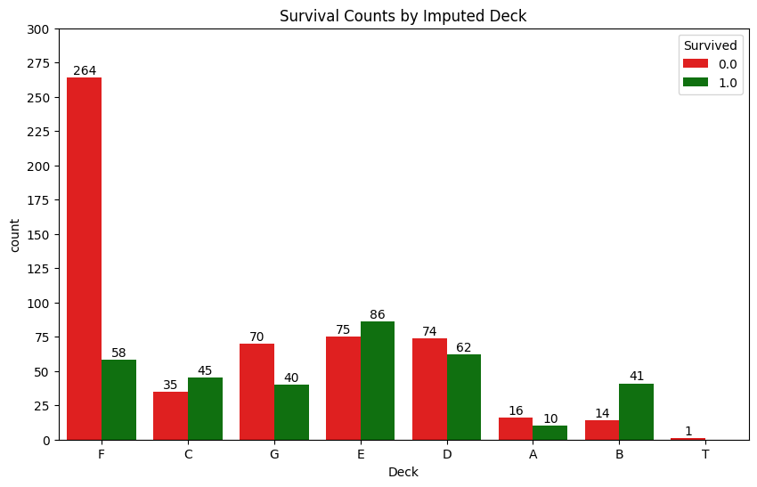
*There was too little supporting information and too much uncertainty in potential 'Deck' variable assignment strategy, even though I do think deck location would be predictive to survival if enough passengers could accurately be allocated to them. After much rigor and research, it was determined that a reliable deck imputation is not possible, and the use of the variable was abandoned.

C1. Exploratory Preliminary Analysis For Age Imputation
# Compute descriptive statistics for Age by Title for non-missing Age values.
titanic_df.groupby('Title')['Age'].describe()
count mean std min 25% 50% 75% max
Title
Capt 1.0 70.000000 NaN 70.00 70.00 70.0 70.00 70.0
Col 4.0 54.000000 5.477226 47.00 51.50 54.5 57.00 60.0
Countess 1.0 33.000000 NaN 33.00 33.00 33.0 33.00 33.0
Don 1.0 40.000000 NaN 40.00 40.00 40.0 40.00 40.0
Dona 1.0 39.000000 NaN 39.00 39.00 39.0 39.00 39.0
Dr 7.0 43.571429 11.731115 23.00 38.00 49.0 51.50 54.0
Jonkheer 1.0 38.000000 NaN 38.00 38.00 38.0 38.00 38.0
Lady 1.0 48.000000 NaN 48.00 48.00 48.0 48.00 48.0
Major 2.0 48.500000 4.949747 45.00 46.75 48.5 50.25 52.0
Master 53.0 5.482642 4.161554 0.33 2.00 4.0 9.00 14.5
Miss 210.0 21.774238 12.249077 0.17 15.00 22.0 30.00 63.0
Mlle 2.0 24.000000 0.000000 24.00 24.00 24.0 24.00 24.0
Mme 1.0 24.000000 NaN 24.00 24.00 24.0 24.00 24.0
Mr 581.0 32.252151 12.422089 11.00 23.00 29.0 39.00 80.0
Mrs 170.0 36.994118 12.901767 14.00 27.00 35.5 46.50 76.0
Ms 1.0 28.000000 NaN 28.00 28.00 28.0 28.00 28.0
Rev 8.0 41.250000 12.020815 27.00 29.50 41.5 51.75 57.0
Sir 1.0 49.000000 NaN 49.00 49.00 49.0 49.00 49.0
*An important first step was to understand 'Age' distribution by 'Title'. Master related directly to young boys, while Mr could in rare cases. Miss could relate to young girls or adult women. Mr mainly related to adult men and fathers. Mrs mainly related to adult women and mothers.

# Filter dataset to non-missing ages
titanic_non_missing = titanic_df[titanic_df['Age'].notnull()]
# Group by FamilyID to identify families with Mrs., Master, Miss, and Mr.
family_groups = titanic_non_missing.groupby('FamilyID')
# Initialize lists to store age differences
mother_child_diffs = []
# Iterate through families to calculate age differences
for family_id, group in family_groups:
# Identify Mrs., Master, Miss, and Mr. in the family with non-missing ages
mrs = group[group['Title'] == 'Mrs']
master = group[group['Title'] == 'Master']
miss = group[group['Title'] == 'Miss']
mr = group[group['Title'] == 'Mr']
# Case 1: Mother (Mrs.) and Children (Master/Mr/Miss)
if not mrs.empty and (not master.empty or not mr.empty or not miss.empty):
mrs_age = mrs['Age'].mean() # Average age if multiple Mrs.
# Calculate difference with Master (boys)
if not master.empty:
for child_age in master['Age']:
diff = mrs_age - child_age
if diff > 0: # Ensure positive difference
mother_child_diffs.append(diff)
# Calculate difference with Mr (boys)
if not mr.empty:
# Filter Mr. to likely sons (age < 19)
potential_sons = mr[mr['Age'] < 19]
for child_age in potential_sons['Age']:
diff = mrs_age - child_age
if diff > 0: # Ensure positive difference
mother_child_diffs.append(diff)
# Calculate difference with Miss (age < 19)
if not miss.empty:
# Filter Miss to likely daughters (age < 19)
potential_daughters = miss[miss['Age'] < 19]
for child_age in potential_daughters['Age']:
diff = mrs_age - child_age
if diff > 0: # Ensure positive difference
mother_child_diffs.append(diff)
# Mother-Child Age Differences
if mother_child_diffs:
print("\nMother (Mrs.) to Child (Master/Mr/Miss) Age Differences (Non-Missing Ages):")
print(f"Count: {len(mother_child_diffs)}")
print(f"Mean: {np.mean(mother_child_diffs):.2f}")
print(f"Std: {np.std(mother_child_diffs):.2f}")
print(f"Min: {np.min(mother_child_diffs):.2f}")
print(f"25%: {np.percentile(mother_child_diffs, 25):.2f}")
print(f"Median: {np.median(mother_child_diffs):.2f}")
print(f"75%: {np.percentile(mother_child_diffs, 75):.2f}")
print(f"Max: {np.max(mother_child_diffs):.2f}")
else:
print("\nNo families with non-missing ages found for Mrs. and Master/Mr/Miss age difference calculation.")

Mother (Mrs.) to Child (Master/Mr/Miss) Age Differences (Non-Missing Ages):
Count: 104
Mean: 28.16
Std: 6.76
Min: 15.58
25%: 23.00
Median: 27.00
75%: 33.00
Max: 50.00
*It was important to understand the median 'Age' difference between mothers and children to estimate a missing age if either is known in a family group.
# Filter dataset to rows with missing Age values
missing_age_df = titanic_df[titanic_df['Age'].isnull()]
# Calculate the distribution of Title for missing Age values
title_distribution = missing_age_df['Title'].value_counts()
# Display the distribution
print("Distribution of Title for Missing Age Values:")
print(title_distribution)
Distribution of Title for Missing Age Values:
Title
Mr 176
Miss 50
Mrs 27
Master 8
Dr 1
Ms 1
Name: count, dtype: int64
*It was important to understand the titles associated with the missing age values.
# Group by FamilyID and collect Titles, Ages, and Missing Ages, only for families with missing ages.
family_summary = titanic_df.groupby('FamilyID').agg({
'Title': lambda x: list(x), # List of titles in the family
'Age': lambda x: list(x), # List of ages (including NaN)
'PassengerId': 'count' # Count of passengers in the family
}).reset_index()
# Filter for families with at least one missing age.
family_summary = family_summary[family_summary['Age'].apply(lambda x: any(pd.isna(x)))]
# Add columns for missing and known ages
family_summary['MissingAgeCount'] = family_summary['Age'].apply(lambda x: sum(pd.isna(x)))
family_summary['KnownAges'] = family_summary['Age'].apply(lambda x: [age for age in x if pd.notna(age)])
family_summary['KnownAgeCount'] = family_summary['KnownAges'].apply(len)
# Display the summary for families with missing ages only.
print("\nFamilyID Summary with Titles, Ages, and Missing Ages (Only Families with Missing Ages):")
for _, row in family_summary.iterrows():
print(f"\nFamilyID: {row['FamilyID']}")
print(f"Total Passengers: {row['PassengerId']}")
print(f"Titles: {row['Title']}")
print(f"Ages (including missing): {row['Age']}")
print(f"Known Ages: {row['KnownAges']}")
print(f"Missing Ages Count: {row['MissingAgeCount']}")
print(f"Known Ages Count: {row['KnownAgeCount']}")
# Additional: Total missing ages by title
missing_by_title = titanic_df[titanic_df['Age'].isna()].groupby('Title').size().reset_index(name='MissingCount')
print("\nTotal Missing Ages by Title:")
print(missing_by_title)
FamilyID Summary with Titles, Ages, and Missing Ages (Only Families with Missing Ages):
FamilyID: Boulos_2678
Total Passengers: 3
Titles: ['Mrs', 'Miss', 'Master']
Ages (including missing): [nan, 9.0, 6.0]
Known Ages: [9.0, 6.0]
Missing Ages Count: 1
Known Ages Count: 2
FamilyID: Caram_2689
Total Passengers: 2
Titles: ['Mrs', 'Mr']
Ages (including missing): [nan, nan]
Known Ages: []
Missing Ages Count: 2
Known Ages Count: 0
FamilyID: Davison_386525
Total Passengers: 2
Titles: ['Mrs', 'Mr']
Ages (including missing): [nan, nan]
Known Ages: []
Missing Ages Count: 2
Known Ages Count: 0
FamilyID: Frauenthal_PC 17611
Total Passengers: 2
Titles: ['Mrs', 'Dr']
Ages (including missing): [nan, 50.0]
Known Ages: [50.0]
Missing Ages Count: 1
Known Ages Count: 1
FamilyID: Goldenberg_17453
Total Passengers: 2
Titles: ['Mr', 'Mrs']
Ages (including missing): [49.0, nan]
Known Ages: [49.0]
Missing Ages Count: 1
Known Ages Count: 1
FamilyID: Johnston_W./C. 6607
Total Passengers: 4
Titles: ['Mr', 'Miss', 'Mrs', 'Master']
Ages (including missing): [nan, nan, nan, nan]
Known Ages: []
Missing Ages Count: 4
Known Ages Count: 0
FamilyID: Kenyon_17464
Total Passengers: 2
Titles: ['Mrs', 'Mr']
Ages (including missing): [nan, 41.0]
Known Ages: [41.0]
Missing Ages Count: 1
Known Ages Count: 1
FamilyID: Khalil_2660
Total Passengers: 2
Titles: ['Mr', 'Mrs']
Ages (including missing): [nan, nan]
Known Ages: []
Missing Ages Count: 2
Known Ages Count: 0
FamilyID: Lam_1601
Total Passengers: 2
Titles: ['Mr', 'Mr']
Ages (including missing): [nan, nan]
Known Ages: []
Missing Ages Count: 2
Known Ages Count: 0
FamilyID: Lefebre_4133
Total Passengers: 5
Titles: ['Master', 'Miss', 'Miss', 'Miss', 'Mrs']
Ages (including missing): [nan, nan, nan, nan, nan]
Known Ages: []
Missing Ages Count: 5
Known Ages Count: 0
FamilyID: McCoy_367226
Total Passengers: 3
Titles: ['Mr', 'Miss', 'Miss']
Ages (including missing): [nan, nan, nan]
Known Ages: []
Missing Ages Count: 3
Known Ages Count: 0
FamilyID: Moran_371110
Total Passengers: 2
Titles: ['Miss', 'Mr']
Ages (including missing): [nan, nan]
Known Ages: []
Missing Ages Count: 2
Known Ages Count: 0
FamilyID: Moubarek_2661
Total Passengers: 3
Titles: ['Master', 'Master', 'Mrs']
Ages (including missing): [nan, nan, nan]
Known Ages: []
Missing Ages Count: 3
Known Ages Count: 0
FamilyID: Murphy_367230
Total Passengers: 2
Titles: ['Miss', 'Miss']
Ages (including missing): [nan, nan]
Known Ages: []
Missing Ages Count: 2
Known Ages Count: 0
FamilyID: O'Brien_370365
Total Passengers: 2
Titles: ['Mrs', 'Mr']
Ages (including missing): [nan, nan]
Known Ages: []
Missing Ages Count: 2
Known Ages Count: 0
FamilyID: Peter_2668
Total Passengers: 3
Titles: ['Miss', 'Mrs', 'Master']
Ages (including missing): [nan, nan, nan]
Known Ages: []
Missing Ages Count: 3
Known Ages Count: 0
FamilyID: Risien_364498
Total Passengers: 2
Titles: ['Mr', 'Mrs']
Ages (including missing): [nan, nan]
Known Ages: []
Missing Ages Count: 2
Known Ages Count: 0
FamilyID: Sage_CA. 2343
Total Passengers: 11
Titles: ['Master', 'Miss', 'Mr', 'Mr', 'Miss', 'Mr', 'Miss', 'Miss', 'Mr', 'Master', 'Mrs']
Ages (including missing): [nan, nan, nan, nan, nan, nan, nan, nan, nan, 14.5, nan]
Known Ages: [14.5]
Missing Ages Count: 10
Known Ages Count: 1
FamilyID: Samaan_2662
Total Passengers: 3
Titles: ['Mr', 'Mr', 'Mr']
Ages (including missing): [nan, nan, nan]
Known Ages: []
Missing Ages Count: 3
Known Ages Count: 0
FamilyID: Spencer_PC 17569
Total Passengers: 2
Titles: ['Mrs', 'Mr']
Ages (including missing): [nan, 57.0]
Known Ages: [57.0]
Missing Ages Count: 1
Known Ages Count: 1
FamilyID: Taylor_19996
Total Passengers: 2
Titles: ['Mrs', 'Mr']
Ages (including missing): [nan, 48.0]
Known Ages: [48.0]
Missing Ages Count: 1
Known Ages Count: 1
FamilyID: Thorneycroft_376564
Total Passengers: 2
Titles: ['Mrs', 'Mr']
Ages (including missing): [nan, nan]
Known Ages: []
Missing Ages Count: 2
Known Ages Count: 0
FamilyID: van Billiard_A/5. 851
Total Passengers: 3
Titles: ['Mr', 'Master', 'Master']
Ages (including missing): [40.5, 11.5, nan]
Known Ages: [40.5, 11.5]
Missing Ages Count: 1
Known Ages Count: 2
Total Missing Ages by Title:
Title MissingCount
0 Dr 1
1 Master 8
2 Miss 50
3 Mr 176
4 Mrs 27
5 Ms 1
*This analysis was useful to understand how the missing age values are distributed amongst specific family groups.

# Filter dataset to rows with non-missing Age values
titanic_non_missing = titanic_df[titanic_df['Age'].notnull()]
# Group by FamilyID to identify couples and parent pairs
family_groups = titanic_non_missing.groupby('FamilyID')
# Initialize lists to store age differences
wife_husband_diffs = []
mother_father_diffs = []
# Iterate through families to calculate age differences
for family_id, group in family_groups:
# Identify Mr. and Mrs. in the family with non-missing ages
mr = group[group['Title'] == 'Mr']
mrs = group[group['Title'] == 'Mrs']
# Case 1: Wife-Husband (Mr. and Mrs. pair, FamilySize = 1, Parch = 0, no children)
if not mr.empty and not mrs.empty and len(group) == 2 and group['FamilySize'].iloc[0] == 1 and group['Parch'].all() == 0:
mr_age = mr['Age'].mean()
mrs_age = mrs['Age'].mean()
diff = mrs_age - mr_age
if diff > -10 and diff < 10:
wife_husband_diffs.append(diff)
# Case 2: Mother-Father (Mrs. and Mr. with children, FamilySize >= 2, Parch >= 1)
children = group[group['Title'].isin(['Master', 'Miss']) | ((group['Title'] == 'Mr') & (group['Age'] < 19))]
if not mrs.empty and not mr.empty and not children.empty and group['FamilySize'].iloc[0] >= 2 and group['Parch'].max() >= 1:
mr_age = mr['Age'].mean()
mrs_age = mrs['Age'].mean()
diff = mrs_age - mr_age
if diff > -10 and diff < 10:
mother_father_diffs.append(diff)
# Calculate statistics for age differences
if wife_husband_diffs:
print("\nWife (Mrs.) to Husband (Mr.) Age Differences (Non-Missing Ages, FamilySize = 1, Parch = 0):")
print(f"Count: {len(wife_husband_diffs)}")
print(f"Mean: {np.mean(wife_husband_diffs):.2f}")
print(f"Std: {np.std(wife_husband_diffs):.2f}")
print(f"Min: {np.min(wife_husband_diffs):.2f}")
print(f"25%: {np.percentile(wife_husband_diffs, 25):.2f}")
print(f"Median: {np.median(wife_husband_diffs):.2f}")
print(f"75%: {np.percentile(wife_husband_diffs, 75):.2f}")
print(f"Max: {np.max(wife_husband_diffs):.2f}")
else:
print("\nNo valid Wife-Husband pairs found with non-missing ages and FamilySize = 1, Parch = 0 for age difference calculation.")
if mother_father_diffs:
print("\nMother (Mrs.) to Father (Mr.) Age Differences (Non-Missing Ages, FamilySize >= 2, Parch >= 1):")
print(f"Count: {len(mother_father_diffs)}")
print(f"Mean: {np.mean(mother_father_diffs):.2f}")
print(f"Std: {np.std(mother_father_diffs):.2f}")
print(f"Min: {np.min(mother_father_diffs):.2f}")
print(f"25%: {np.percentile(mother_father_diffs, 25):.2f}")
print(f"Median: {np.median(mother_father_diffs):.2f}")
print(f"75%: {np.percentile(mother_father_diffs, 75):.2f}")
print(f"Max: {np.max(mother_father_diffs):.2f}")
else:
print("\nNo valid Mother-Father pairs with children found with non-missing ages and FamilySize >= 2, Parch >= 1 for age difference calculation.")
# Optional: Display sample families with differences
if wife_husband_diffs or mother_father_diffs:
print("\nSample Families with Age Differences:")
for family_id, group in family_groups:
mr = group[group['Title'] == 'Mr']
mrs = group[group['Title'] == 'Mrs']
children = group[group['Title'].isin(['Master', 'Miss']) | ((group['Title'] == 'Mr') & (group['Age'] < 19))]
if (not mr.empty and not mrs.empty and len(group) == 2 and group['FamilySize'].iloc[0] == 1 and group['Parch'].all() == 0) or \
(not mrs.empty and not mr.empty and not children.empty and group['FamilySize'].iloc[0] >= 2 and group['Parch'].max() >= 1):
mr_age = mr['Age'].mean() if not mr.empty else None
mrs_age = mrs['Age'].mean() if not mrs.empty else None
if (mrs_age and mr_age and mrs_age - mr_age > -10 and mrs_age - mr_age < 10) or not children.empty:
print(f"\nFamilyID: {family_id}")
print(group[['Title', 'Age', 'Pclass', 'FamilySize', 'SibSp', 'Parch']].to_string(index=False))
Wife (Mrs.) to Husband (Mr.) Age Differences (Non-Missing Ages, FamilySize = 1, Parch = 0):
Count: 41
Mean: -2.40
Std: 3.12
Min: -8.00
25%: -4.00
Median: -2.00
75%: -1.00
Max: 6.00

Mother (Mrs.) to Father (Mr.) Age Differences (Non-Missing Ages, FamilySize >= 2, Parch >= 1):
Count: 21
Mean: -1.71
Std: 4.03
Min: -8.00
25%: -5.00
Median: -2.00
75%: 0.00
Max: 7.00
Sample Families with Age Differences:
FamilyID: Abbott_C.A. 2673
Title Age Pclass FamilySize SibSp Parch
Mrs 35.0 3 2 1 1
Mr 16.0 3 2 1 1
Master 13.0 3 2 0 2
FamilyID: Abelson_P/PP 3381
Title Age Pclass FamilySize SibSp Parch
Mr 30.0 2 1 1 0
Mrs 28.0 2 1 1 0
FamilyID: Allison_113781
Title Age Pclass FamilySize SibSp Parch
Miss 2.00 1 3 1 2
Master 0.92 1 3 1 2
Mrs 25.00 1 3 1 2
Mr 30.00 1 3 1 2
FamilyID: Andersson_347082
Title Age Pclass FamilySize SibSp Parch
Mr 39.0 3 6 1 5
Miss 2.0 3 6 4 2
Miss 9.0 3 6 4 2
Miss 11.0 3 6 4 2
Mrs 39.0 3 6 1 5
Miss 6.0 3 6 4 2
Master 4.0 3 6 4 2
FamilyID: Angle_226875
Title Age Pclass FamilySize SibSp Parch
Mrs 36.0 2 1 1 0
Mr 34.0 2 1 1 0
FamilyID: Arnold-Franchi_349237
Title Age Pclass FamilySize SibSp Parch
Mrs 18.0 3 1 1 0
Mr 25.0 3 1 1 0
FamilyID: Asplund_347077
Title Age Pclass FamilySize SibSp Parch
Mrs 38.0 3 6 1 5
Master 9.0 3 6 4 2
Miss 5.0 3 6 4 2
Master 3.0 3 6 4 2
Master 13.0 3 6 4 2
Mr 40.0 3 6 1 5
Master 5.0 3 6 4 2
FamilyID: Bishop_11967
Title Age Pclass FamilySize SibSp Parch
Mrs 19.0 1 1 1 0
Mr 25.0 1 1 1 0
FamilyID: Brown_29750
Title Age Pclass FamilySize SibSp Parch
Mrs 40.0 2 2 1 1
Mr 60.0 2 2 1 1
Miss 15.0 2 2 0 2
FamilyID: Caldwell_248738
Title Age Pclass FamilySize SibSp Parch
Master 0.83 2 2 0 2
Mrs 22.00 2 2 1 1
Mr 26.00 2 2 1 1
FamilyID: Carter_113760
Title Age Pclass FamilySize SibSp Parch
Mr 36.0 1 3 1 2
Miss 14.0 1 3 1 2
Mrs 36.0 1 3 1 2
Master 11.0 1 3 1 2
FamilyID: Chaffee_W.E.P. 5734
Title Age Pclass FamilySize SibSp Parch
Mr 46.0 1 1 1 0
Mrs 47.0 1 1 1 0
FamilyID: Chambers_113806
Title Age Pclass FamilySize SibSp Parch
Mr 27.0 1 1 1 0
Mrs 33.0 1 1 1 0
FamilyID: Chapman_SC/AH 29037
Title Age Pclass FamilySize SibSp Parch
Mr 37.0 2 1 1 0
Mrs 29.0 2 1 1 0
FamilyID: Clark_13508
Title Age Pclass FamilySize SibSp Parch
Mr 27.0 1 1 1 0
Mrs 26.0 1 1 1 0
FamilyID: Clarke_2003
Title Age Pclass FamilySize SibSp Parch
Mrs 28.0 2 1 1 0
Mr 29.0 2 1 1 0
FamilyID: Collyer_C.A. 31921
Title Age Pclass FamilySize SibSp Parch
Miss 8.0 2 2 0 2
Mr 31.0 2 2 1 1
Mrs 31.0 2 2 1 1
FamilyID: Compton_PC 17756
Title Age Pclass FamilySize SibSp Parch
Miss 39.0 1 2 1 1
Mrs 64.0 1 2 0 2
Mr 37.0 1 2 1 1
FamilyID: Cumings_PC 17599
Title Age Pclass FamilySize SibSp Parch
Mrs 38.0 1 1 1 0
Mr 39.0 1 1 1 0
FamilyID: Danbom_347080
Title Age Pclass FamilySize SibSp Parch
Mrs 28.00 3 2 1 1
Mr 34.00 3 2 1 1
Master 0.33 3 2 0 2
FamilyID: Davidson_F.C. 12750
Title Age Pclass FamilySize SibSp Parch
Mr 31.0 1 1 1 0
Mrs 27.0 1 3 1 2
FamilyID: Dean_C.A. 2315
Title Age Pclass FamilySize SibSp Parch
Mr 26.00 3 3 1 2
Master 1.00 3 3 1 2
Mrs 33.00 3 3 1 2
Miss 0.17 3 3 1 2
FamilyID: Douglas_PC 17761
Title Age Pclass FamilySize SibSp Parch
Mr 50.0 1 1 1 0
Mrs 48.0 1 1 1 0
FamilyID: Drew_28220
Title Age Pclass FamilySize SibSp Parch
Mrs 34.0 2 2 1 1
Master 8.0 2 2 0 2
Mr 42.0 2 2 1 1
FamilyID: Dyker_347072
Title Age Pclass FamilySize SibSp Parch
Mrs 22.0 3 1 1 0
Mr 23.0 3 1 1 0
FamilyID: Ford_W./C. 6608
Title Age Pclass FamilySize SibSp Parch
Mr 16.0 3 4 1 3
Miss 9.0 3 4 2 2
Miss 21.0 3 4 2 2
Mrs 48.0 3 4 1 3
Mr 18.0 3 4 2 2
FamilyID: Fortune_19950
Title Age Pclass FamilySize SibSp Parch
Mr 19.0 1 5 3 2
Miss 23.0 1 5 3 2
Miss 24.0 1 5 3 2
Mr 64.0 1 5 1 4
Miss 28.0 1 5 3 2
Mrs 60.0 1 5 1 4
FamilyID: Futrelle_113803
Title Age Pclass FamilySize SibSp Parch
Mrs 35.0 1 1 1 0
Mr 37.0 1 1 1 0
FamilyID: Goldsmith_363291
Title Age Pclass FamilySize SibSp Parch
Master 9.0 3 2 0 2
Mrs 31.0 3 2 1 1
Mr 33.0 3 2 1 1

FamilyID: Goodwin_CA 2144
Title Age Pclass FamilySize SibSp Parch
Master 11.0 3 7 5 2
Miss 16.0 3 7 5 2
Master 1.0 3 7 5 2
Master 9.0 3 7 5 2
Mrs 43.0 3 7 1 6
Mr 14.0 3 7 5 2
Mr 40.0 3 7 1 6
Miss 10.0 3 7 5 2
FamilyID: Hakkarainen_STON/O2. 3101279
Title Age Pclass FamilySize SibSp Parch
Mrs 24.0 3 1 1 0
Mr 28.0 3 1 1 0
FamilyID: Harder_11765
Title Age Pclass FamilySize SibSp Parch
Mr 25.0 1 1 1 0
Mrs 25.0 1 1 1 0
FamilyID: Harper_PC 17572
Title Age Pclass FamilySize SibSp Parch
Mrs 49.0 1 1 1 0
Mr 48.0 1 1 1 0
FamilyID: Hart_F.C.C. 13529
Title Age Pclass FamilySize SibSp Parch
Mr 43.0 2 2 1 1
Mrs 45.0 2 2 1 1
Miss 7.0 2 2 0 2
FamilyID: Herman_220845
Title Age Pclass FamilySize SibSp Parch
Miss 24.0 2 3 1 2
Mrs 48.0 2 3 1 2
Mr 49.0 2 3 1 2
Miss 24.0 2 3 1 2
FamilyID: Holverson_113789
Title Age Pclass FamilySize SibSp Parch
Mr 42.0 1 1 1 0
Mrs 35.0 1 1 1 0
FamilyID: Howard_24065
Title Age Pclass FamilySize SibSp Parch
Mr 63.0 2 1 1 0
Mrs 60.0 2 1 1 0
FamilyID: Hoyt_19943
Title Age Pclass FamilySize SibSp Parch
Mr 38.0 1 1 1 0
Mrs 35.0 1 1 1 0
FamilyID: Kimball_11753
Title Age Pclass FamilySize SibSp Parch
Mr 42.0 1 1 1 0
Mrs 45.0 1 1 1 0
FamilyID: Kink-Heilmann_315153
Title Age Pclass FamilySize SibSp Parch
Miss 4.0 3 2 0 2
Mrs 26.0 3 2 1 1
Mr 29.0 3 4 3 1
FamilyID: Laroche_SC/Paris 2123
Title Age Pclass FamilySize SibSp Parch
Miss 3.0 2 3 1 2
Mrs 22.0 2 3 1 2
Mr 25.0 2 3 1 2
Miss 1.0 2 3 1 2
FamilyID: Lindell_349910
Title Age Pclass FamilySize SibSp Parch
Mr 36.0 3 1 1 0
Mrs 30.0 3 1 1 0
FamilyID: Lobb_A/5. 3336
Title Age Pclass FamilySize SibSp Parch
Mr 30.0 3 1 1 0
Mrs 26.0 3 1 1 0
FamilyID: Louch_SC/AH 3085
Title Age Pclass FamilySize SibSp Parch
Mrs 42.0 2 1 1 0
Mr 50.0 2 1 1 0
FamilyID: Mallet_S.C./PARIS 2079
Title Age Pclass FamilySize SibSp Parch
Mr 31.0 2 2 1 1
Master 1.0 2 2 0 2
Mrs 24.0 2 2 1 1
FamilyID: Marvin_113773
Title Age Pclass FamilySize SibSp Parch
Mr 19.0 1 1 1 0
Mrs 18.0 1 1 1 0
FamilyID: McNamee_376566
Title Age Pclass FamilySize SibSp Parch
Mr 24.0 3 1 1 0
Mrs 19.0 3 1 1 0
FamilyID: Nakid_2653
Title Age Pclass FamilySize SibSp Parch
Miss 1.0 3 2 0 2
Mr 20.0 3 2 1 1
Mrs 19.0 3 2 1 1
FamilyID: Panula_3101295
Title Age Pclass FamilySize SibSp Parch
Master 7.0 3 5 4 1
Master 1.0 3 5 4 1
Mr 16.0 3 5 4 1
Mrs 41.0 3 5 0 5
Mr 14.0 3 5 4 1
Master 2.0 3 5 4 1
FamilyID: Pears_113776
Title Age Pclass FamilySize SibSp Parch
Mrs 22.0 1 1 1 0
Mr 29.0 1 1 1 0
FamilyID: Penasco y Castellana_PC 17758
Title Age Pclass FamilySize SibSp Parch
Mrs 17.0 1 1 1 0
Mr 18.0 1 1 1 0
FamilyID: Renouf_31027
Title Age Pclass FamilySize SibSp Parch
Mr 34.0 2 1 1 0
Mrs 30.0 2 3 3 0
FamilyID: Robins_A/5. 3337
Title Age Pclass FamilySize SibSp Parch
Mrs 47.0 3 1 1 0
Mr 50.0 3 1 1 0
FamilyID: Rosblom_370129
Title Age Pclass FamilySize SibSp Parch
Mrs 41.0 3 2 0 2
Mr 18.0 3 2 1 1
Miss 2.0 3 2 1 1

FamilyID: Rothschild_PC 17603
Title Age Pclass FamilySize SibSp Parch
Mrs 54.0 1 1 1 0
Mr 55.0 1 1 1 0
FamilyID: Ryerson_PC 17608
Title Age Pclass FamilySize SibSp Parch
Miss 18.0 1 4 2 2
Miss 21.0 1 4 2 2
Mrs 48.0 1 4 1 3
Master 13.0 1 4 2 2
Mr 61.0 1 4 1 3
FamilyID: Skoog_347088
Title Age Pclass FamilySize SibSp Parch
Master 4.0 3 5 3 2
Mrs 45.0 3 5 1 4
Mr 40.0 3 5 1 4
Miss 9.0 3 5 3 2
Miss 2.0 3 5 3 2
Master 10.0 3 5 3 2
FamilyID: Smith_13695
Title Age Pclass FamilySize SibSp Parch
Mr 24.0 1 1 1 0
Mrs 18.0 1 1 1 0
FamilyID: Snyder_21228
Title Age Pclass FamilySize SibSp Parch
Mrs 23.0 1 1 1 0
Mr 24.0 1 1 1 0
FamilyID: Spedden_16966
Title Age Pclass FamilySize SibSp Parch
Mrs 40.0 1 2 1 1
Master 6.0 1 2 0 2
Mr 45.0 1 2 1 1
FamilyID: Straus_PC 17483
Title Age Pclass FamilySize SibSp Parch
Mr 67.0 1 1 1 0
Mrs 63.0 1 1 1 0
FamilyID: Taussig_110413
Title Age Pclass FamilySize SibSp Parch
Mr 52.0 1 2 1 1
Mrs 39.0 1 2 1 1
Miss 18.0 1 2 0 2
FamilyID: Thayer_17421
Title Age Pclass FamilySize SibSp Parch
Mr 17.0 1 2 0 2
Mrs 39.0 1 2 1 1
Mr 49.0 1 2 1 1
FamilyID: Turpin_11668
Title Age Pclass FamilySize SibSp Parch
Mrs 27.0 2 1 1 0
Mr 29.0 2 1 1 0
FamilyID: Van Impe_345773
Title Age Pclass FamilySize SibSp Parch
Miss 10.0 3 2 0 2
Mr 36.0 3 2 1 1
Mrs 30.0 3 2 1 1
FamilyID: Vander Planke_345763
Title Age Pclass FamilySize SibSp Parch
Mrs 31.0 3 1 1 0
Mr 31.0 3 3 3 0
FamilyID: Ware_CA 31352
Title Age Pclass FamilySize SibSp Parch
Mr 30.0 2 1 1 0
Mrs 31.0 2 0 0 0
FamilyID: Warren_110813
Title Age Pclass FamilySize SibSp Parch
Mrs 60.0 1 1 1 0
Mr 64.0 1 1 1 0
FamilyID: Weisz_228414
Title Age Pclass FamilySize SibSp Parch
Mrs 29.0 2 1 1 0
Mr 27.0 2 1 1 0
FamilyID: West_C.A. 34651
Title Age Pclass FamilySize SibSp Parch
Miss 5.00 2 3 1 2
Mr 36.00 2 3 1 2
Mrs 33.00 2 3 1 2
Miss 0.92 2 3 1 2
FamilyID: Wick_36928
Title Age Pclass FamilySize SibSp Parch
Miss 31.0 1 2 0 2
Mrs 45.0 1 2 1 1
Mr 57.0 1 2 1 1
FamilyID: de Messemaeker_345572
Title Age Pclass FamilySize SibSp Parch
Mrs 36.0 3 1 1 0
Mr 36.5 3 1 1 0
FamilyID: del Carlo_SC/PARIS 2167
Title Age Pclass FamilySize SibSp Parch
Mr 29.0 2 1 1 0
Mrs 24.0 2 1 1 0
*This analyis revealed that the median difference between a husband/father and a wife/mother is 2 years, and how the 'SibSp' and 'Parch' variables could be used to identify them, their children, and brothers/sisters.

C2. Age_Cat Variable Creation
# Step 1: Create Age_Cat with suggested categories based on survival rates.
def assign_age_category(age):
if pd.isna(age):
return np.nan
elif age <= 4: # Infant
return 'Infant'
elif age <= 13: # Child
return 'Child'
elif age <= 24: # Young Adult
return 'Young Adult'
elif age <= 39: # Adult
return 'Adult'
elif age <= 59: # Mature Adult
return 'Mature Adult'
else: # Senior
return 'Senior'
titanic_df['Age_Cat'] = titanic_df['Age'].apply(assign_age_category)
# Display the distribution of Age_Cat for passengers with known ages
print("\nDistribution of Age_Cat for Passengers with Known Ages:")
print(titanic_df[titanic_df['Age'].notna()]['Age_Cat'].value_counts())

# Plot distribution of Age_Cat for known ages
plt.figure(figsize=(10, 6))
sns.countplot(x='Age_Cat', data=titanic_df[titanic_df['Age'].notna()],
order=['Infant', 'Child', 'Young Adult', 'Adult', 'Mature Adult', 'Senior'])
plt.title('Distribution of Age_Cat for Passengers with Known Ages')
plt.xlabel('Age Category')
plt.ylabel('Count')
plt.xticks(rotation=45)
plt.show()
Distribution of Age_Cat for Passengers with Known Ages:
Age_Cat
Adult 393
Young Adult 309
Mature Adult 205
Infant 51
Child 48
Senior 40
Name: count, dtype: int64
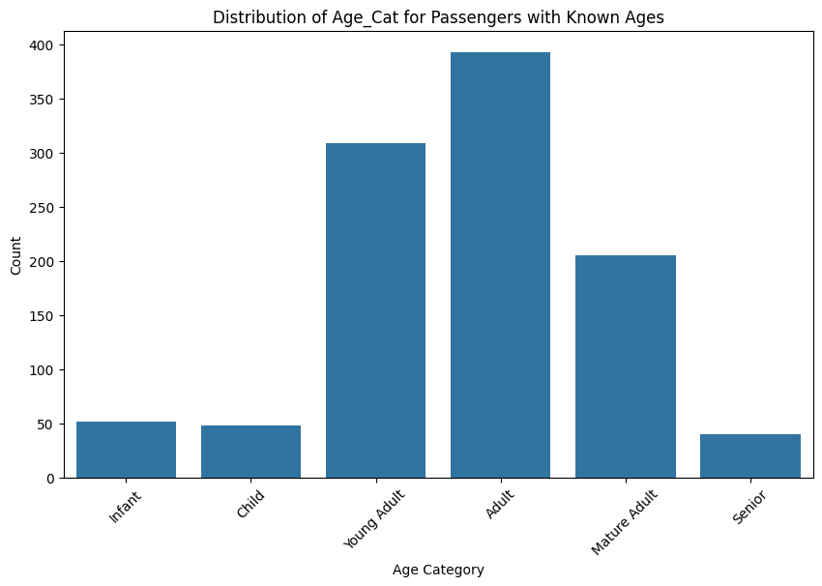

# Bar chart for 'Age_Cat' distribution with counts of Survived (0 and 1) for the training dataset.
plt.figure(figsize=(10, 6))
ax = sns.countplot(x='Age_Cat', hue='Survived', data=titanic_df, palette={0: 'red', 1: 'green'},
order=['Infant', 'Child', 'Young Adult', 'Adult', 'Mature Adult', 'Senior'])
# Add numeric values centered inside each bar with white font
for p in ax.patches:
height = p.get_height()
# Only add text if height is greater than 0 to avoid the "0" label
if height > 0:
ax.text(p.get_x() + p.get_width() / 2., height + 4, # Center vertically
int(height), # Convert to integer for clean display
ha="center", va="center", color="black", fontsize=12)
plt.title('Survival Counts by Age Category')
plt.xlabel('Age Category (Infant: 0-4, Child: 5-13, Young Adult: 14-24, Adult: 25-39, Mature Adult: 40-59, Senior: 60+)')
plt.ylabel('Count')
plt.xticks(rotation=45)
plt.yticks(np.arange(0,201,step=25))
plt.legend(title='Survived', labels=['No', 'Yes']) # Customize legend labels
plt.show()
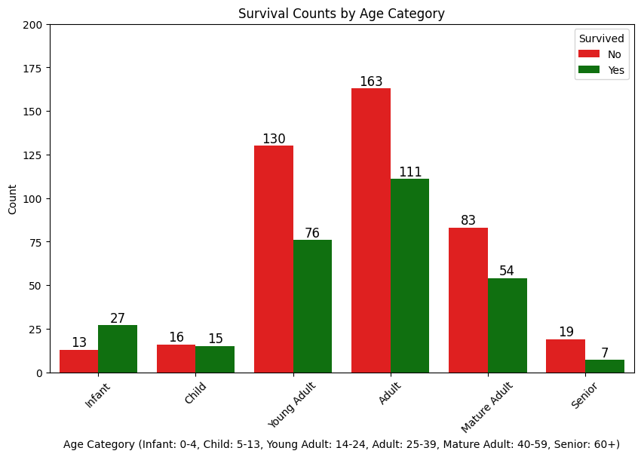
*The 'Age_Cat' variable was created to hopefully represent the 'Age' variable by focusing in on age groups and their potential predictiveness. Most of the binning cut-off points represented transition points in the histogram, but the cut-off between child and young adult was due to one of passengers having a 14-year-old wife.
C3. Exploratory Analysis For Age_Cat Imputation
# Standalone block for descriptive statistics of Mr and Miss > 18 years
print("\nDescriptive Statistics for Mr and Miss Passengers Over 18 Years:")
# Step 1: Extract or verify Title column
if 'Title' not in titanic_df.columns:
# Extract titles from Name (common Titanic pattern)
titanic_df['Title'] = titanic_df['Name'].str.extract(r' ([A-Za-z]+)\.', expand=False)
# Map and clean titles
title_mapping = {
'Mr': 'Mr', 'Miss': 'Miss', 'Mrs': 'Mrs', 'Master': 'Master',
'Dr': 'Dr', 'Rev': 'Rev', 'Col': 'Military', 'Major': 'Military',
'Capt': 'Military', 'Don': 'Noble', 'Lady': 'Noble', 'Sir': 'Noble',
'Mlle': 'Miss', 'Ms': 'Miss', 'Mme': 'Mrs'
}
titanic_df['Title'] = titanic_df['Title'].map(title_mapping).fillna('Other')
print("\nTitles extracted and mapped from Name column:")
print(titanic_df['Title'].value_counts())
# Step 2: Filter passengers over 18
df_adults = titanic_df[titanic_df['Age'].notna() & (titanic_df['Age'] > 18)].copy()
# Step 3: Categorize Mr and Miss
df_mr = df_adults[df_adults['Title'] == 'Mr']
df_miss = df_adults[df_adults['Title'] == 'Miss']
# Step 4: Compute descriptive statistics
print("\nDescriptive Statistics for Mr (Adult Males > 18):")
stats_mr = df_mr[['Age', 'Pclass', 'Fare', 'Survived']].describe()
print(stats_mr)
print("\nDescriptive Statistics for Miss (Adult Unmarried Females > 18):")
stats_miss = df_miss[['Age', 'Pclass', 'Fare', 'Survived']].describe()
print(stats_miss)
# Step 5: Additional categorization check (optional)
print("\nVerification of Categorization:")
print(f"Total Mr over 18: {len(df_mr)}")
print(f"Total Miss over 18: {len(df_miss)}")
print(f"Percentage of Miss who are over 18: {(len(df_miss) / len(df_adults[df_adults['Sex'] == 'female'])):.2%}")

Descriptive Statistics for Mr and Miss Passengers Over 18 Years:
Descriptive Statistics for Mr (Adult Males > 18):
Age Pclass Fare Survived
count 533.000000 533.000000 533.000000 363.000000
mean 33.648218 2.277674 27.500921 0.176309
std 12.016733 0.828197 47.022356 0.381608
min 18.500000 1.000000 0.000000 0.000000
25% 24.000000 2.000000 7.895800 0.000000
50% 30.000000 3.000000 11.500000 0.000000
75% 40.000000 3.000000 26.550000 0.000000
max 80.000000 3.000000 512.329200 1.000000
Descriptive Statistics for Miss (Adult Unmarried Females > 18):
Age Pclass Fare Survived
count 129.000000 129.000000 129.000000 85.000000
mean 29.073643 1.992248 59.863922 0.764706
std 8.933369 0.888258 82.992403 0.426700
min 18.500000 1.000000 6.950000 0.000000
25% 22.000000 1.000000 7.925000 1.000000
50% 27.000000 2.000000 13.858300 1.000000
75% 33.000000 3.000000 78.850000 1.000000
max 63.000000 3.000000 512.329200 1.000000
Verification of Categorization:
Total Mr over 18: 533
Total Miss over 18: 129
Percentage of Miss who are over 18: 43.58%
*Because Miss and Mr titles could potentially be children or adults, it was necessary to look at age statistics separating the young (18 or less) from the adult (19 or more).
# Standalone block to analyze Miss passengers with age categories
print("\nAnalysis of Miss Passengers with Age Categories:")
# Step 1: Extract or verify Title column
if 'Title' not in titanic_df.columns:
# Extract titles from Name
titanic_df['Title'] = titanic_df['Name'].str.extract(r' ([A-Za-z]+)\.', expand=False)
# Map and clean titles
title_mapping = {
'Mr': 'Mr', 'Miss': 'Miss', 'Mrs': 'Mrs', 'Master': 'Master',
'Dr': 'Dr', 'Rev': 'Rev', 'Col': 'Military', 'Major': 'Military',
'Capt': 'Military', 'Don': 'Noble', 'Lady': 'Noble', 'Sir': 'Noble',
'Mlle': 'Miss', 'Ms': 'Miss', 'Mme': 'Mrs'
}
titanic_df['Title'] = titanic_df['Title'].map(title_mapping).fillna('Other')
print("\nTitles extracted and mapped from Name column:")
print(titanic_df['Title'].value_counts())
# Step 2: Filter for Miss passengers
df_miss = titanic_df[titanic_df['Title'] == 'Miss'].copy()
# Step 3: Handle missing ages (optional imputation)
# For now, we'll exclude missing ages; uncomment the next line to impute with median
# df_miss['Age'] = df_miss['Age'].fillna(df_miss['Age'].median())
df_miss = df_miss[df_miss['Age'].notna()]
# Step 4: Define age categories
bins = [0, 4, 13, 18, float('inf')]
labels = ['Infant (0-4)', 'Child (5-13)', 'Teen (14-18)', 'Adult (>18)']
df_miss['AgeCategory'] = pd.cut(df_miss['Age'], bins=bins, labels=labels, include_lowest=True)
# Step 5: Distribution of Miss passengers by age category
print("\nDistribution of Miss Passengers by Age Category:")
age_distribution = df_miss['AgeCategory'].value_counts().reindex(labels)
age_distribution_pct = (age_distribution / age_distribution.sum()) * 100
print(age_distribution)
print("\nPercentage Distribution:")
print(age_distribution_pct)
# Step 6: Descriptive statistics for each age category
print("\nDescriptive Statistics by Age Category for Miss Passengers:")
for category in labels:
print(f"\n{category}:")
stats = df_miss[df_miss['AgeCategory'] == category][['Age', 'Pclass', 'Fare', 'Survived']].describe()
print(stats)
# Step 7: Validation of >50% being 18 or younger
total_miss = len(df_miss)
miss_18_or_younger = len(df_miss[df_miss['Age'] <= 18])
percentage_18_or_younger = (miss_18_or_younger / total_miss) * 100
print(f"\nValidation Check:")
print(f"Total Miss passengers (with age): {total_miss}")
print(f"Miss passengers 18 or younger: {miss_18_or_younger}")
print(f"Percentage of Miss passengers 18 or younger: {percentage_18_or_younger:.2f}%")

Analysis of Miss Passengers with Age Categories:
Distribution of Miss Passengers by Age Category:
AgeCategory
Infant (0-4) 24
Child (5-13) 22
Teen (14-18) 35
Adult (>18) 129
Name: count, dtype: int64
Percentage Distribution:
AgeCategory
Infant (0-4) 11.428571
Child (5-13) 10.476190
Teen (14-18) 16.666667
Adult (>18) 61.428571
Name: count, dtype: float64
Descriptive Statistics by Age Category for Miss Passengers:
Infant (0-4):
Age Pclass Fare Survived
count 24.000000 24.000000 24.000000 17.000000
mean 2.107917 2.666667 27.268229 0.705882
std 1.239930 0.564660 28.008830 0.469668
min 0.170000 1.000000 10.462500 0.000000
25% 1.000000 2.000000 15.250025 0.000000
50% 2.000000 3.000000 20.393750 1.000000
75% 3.000000 3.000000 27.787500 1.000000
max 4.000000 3.000000 151.550000 1.000000
Child (5-13):
Age Pclass Fare Survived
count 22.000000 22.000000 22.000000 17.000000
mean 8.590909 2.636364 25.571209 0.529412
std 2.594116 0.492366 9.327942 0.514496
min 5.000000 2.000000 7.229200 0.000000
25% 6.250000 2.000000 19.318725 0.000000
50% 9.000000 3.000000 26.250000 1.000000
75% 10.000000 3.000000 31.275000 1.000000
max 13.000000 3.000000 46.900000 1.000000

Teen (14-18):
Age Pclass Fare Survived
count 35.000000 35.000000 35.00000 27.000000
mean 16.642857 2.428571 34.88048 0.703704
std 1.390997 0.814779 57.18029 0.465322
min 14.000000 1.000000 6.75000 0.000000
25% 16.000000 2.000000 7.81460 0.000000
50% 17.000000 3.000000 12.00000 1.000000
75% 18.000000 3.000000 31.00000 1.000000
max 18.000000 3.000000 262.37500 1.000000
Adult (>18):
Age Pclass Fare Survived
count 129.000000 129.000000 129.000000 85.000000
mean 29.073643 1.992248 59.863922 0.764706
std 8.933369 0.888258 82.992403 0.426700
min 18.500000 1.000000 6.950000 0.000000
25% 22.000000 1.000000 7.925000 1.000000
50% 27.000000 2.000000 13.858300 1.000000
75% 33.000000 3.000000 78.850000 1.000000
max 63.000000 3.000000 512.329200 1.000000
Validation Check:
Total Miss passengers (with age): 210
Miss passengers 18 or younger: 81
Percentage of Miss passengers 18 or younger: 38.57%
*After looking at statistics for 19 or older Miss titles, it seemed reasonable to look at Miss titles that were 18 or less and how they fit in the younger age categories.

# Step 1: Descriptive Statistics for FamilySize = 0 (Single Travelers, >18 for Miss and Mr)
single_travelers = titanic_df[titanic_df['FamilySize'] == 0].copy()
single_travelers_filtered = single_travelers[
((single_travelers['Title'].isin(['Miss', 'Mr'])) & (single_travelers['Age'] > 18)) |
(~single_travelers['Title'].isin(['Miss', 'Mr']))
].copy()
print("\nDescriptive Statistics for Single Travelers (FamilySize = 0, Miss/Mr >18):")
single_stats = single_travelers_filtered.groupby(['Title', 'Pclass', 'Survived'])['Age'].describe()
print(single_stats)
# Step 2: Descriptive Statistics for Child Relationships (Parch >= 1, <=18 for Miss and Mr)
child_relationships = titanic_df[titanic_df['Parch'] >= 1].copy()
child_relationships_filtered = child_relationships[
((child_relationships['Title'].isin(['Miss', 'Mr'])) & (child_relationships['Age'] <= 18)) |
(~child_relationships['Title'].isin(['Miss', 'Mr']))
].copy()
print("\nDescriptive Statistics for Child Relationships (Parch >= 1, Miss/Mr <=18):")
child_stats = child_relationships_filtered.groupby(['Title', 'Pclass', 'Survived'])['Age'].describe()
print(child_stats)
# Step 3: Visualize Distributions with Boxplots
plt.figure(figsize=(14, 8))
# Boxplot for Single Travelers
plt.subplot(1, 2, 1)
sns.boxplot(x='Pclass', y='Age', hue='Survived',
data=single_travelers_filtered[single_travelers_filtered['Title'].isin(['Miss', 'Mr'])],
palette='Set2')
plt.title('Age Distribution of Miss/Mr (Single Travelers, Age >18) by Pclass and Survived')
plt.xlabel('Passenger Class')
plt.ylabel('Age')
# Boxplot for Child Relationships
plt.subplot(1, 2, 2)
sns.boxplot(x='Pclass', y='Age', hue='Survived',
data=child_relationships_filtered[child_relationships_filtered['Title'].isin(['Miss', 'Mr'])],
palette='Set2')
plt.title('Age Distribution of Miss/Mr (Parch >= 1, Age <=18) by Pclass and Survived')
plt.xlabel('Passenger Class')
plt.ylabel('Age')
plt.tight_layout()
plt.show()

# Step 4: Count of Mr <=18 to Confirm
mr_under_18 = titanic_df[(titanic_df['Title'] == 'Mr') & (titanic_df['Age'] <= 18) & (titanic_df['Age'].notna())]
print(f"\nNumber of Mr passengers <=18: {len(mr_under_18)}")
print("\nSample of Mr passengers <=18:")
print(mr_under_18[['PassengerId', 'Title', 'Age', 'Pclass', 'Survived', 'Parch', 'SibSp', 'FamilySize']].head())
Descriptive Statistics for Single Travelers (FamilySize = 0, Miss/Mr >18):
count mean std min 25% 50% \
Title Pclass Survived
Col 1 0.0 1.0 60.000000 NaN 60.0 60.00 60.00
1.0 1.0 56.000000 NaN 56.0 56.00 56.00
Countess 1 1.0 1.0 33.000000 NaN 33.0 33.00 33.00
Don 1 0.0 1.0 40.000000 NaN 40.0 40.00 40.00
Dr 1 0.0 0.0 NaN NaN NaN NaN NaN
1.0 2.0 40.500000 12.020815 32.0 36.25 40.50
2 0.0 2.0 38.500000 21.920310 23.0 30.75 38.50
Jonkheer 1 0.0 1.0 38.000000 NaN 38.0 38.00 38.00
Major 1 0.0 1.0 45.000000 NaN 45.0 45.00 45.00
1.0 1.0 52.000000 NaN 52.0 52.00 52.00
Miss 1 0.0 1.0 50.000000 NaN 50.0 50.00 50.00
1.0 22.0 33.818182 10.116636 19.0 29.25 31.00
2 0.0 2.0 31.000000 9.899495 24.0 27.50 31.00
1.0 14.0 32.607143 9.360676 19.0 27.25 31.25
3 0.0 13.0 27.576923 7.199092 20.0 22.00 25.00
1.0 11.0 23.636364 3.202272 19.0 22.00 22.00
Mlle 1 1.0 2.0 24.000000 0.000000 24.0 24.00 24.00
Mme 1 1.0 1.0 24.000000 NaN 24.0 24.00 24.00
Mr 1 0.0 30.0 47.750000 14.151124 22.0 36.75 47.00
1.0 17.0 38.411765 13.076978 26.0 28.00 35.00
2 0.0 46.0 34.565217 12.248632 19.0 25.25 30.50
1.0 5.0 37.600000 15.946787 19.0 31.00 34.00
3 0.0 148.0 30.462838 11.034592 19.0 22.00 28.00
1.0 24.0 29.166667 6.578401 19.0 25.75 29.00
Mrs 1 1.0 3.0 51.333333 9.451631 44.0 46.00 48.00
2 0.0 1.0 57.000000 NaN 57.0 57.00 57.00
1.0 10.0 36.400000 9.395034 23.0 29.75 35.00
3 0.0 0.0 NaN NaN NaN NaN NaN
1.0 2.0 47.000000 22.627417 31.0 39.00 47.00
Ms 2 1.0 1.0 28.000000 NaN 28.0 28.00 28.00
Rev 2 0.0 4.0 44.250000 13.047988 27.0 38.25 46.50

75% max
Title Pclass Survived
Col 1 0.0 60.00 60.0
1.0 56.00 56.0
Countess 1 1.0 33.00 33.0
Don 1 0.0 40.00 40.0
Dr 1 0.0 NaN NaN
1.0 44.75 49.0
2 0.0 46.25 54.0
Jonkheer 1 0.0 38.00 38.0
Major 1 0.0 45.00 45.0
1.0 52.00 52.0
Miss 1 0.0 50.00 50.0
1.0 38.00 58.0
2 0.0 34.50 38.0
1.0 35.75 50.0
3 0.0 30.50 45.0
1.0 26.00 30.0
Mlle 1 1.0 24.00 24.0
Mme 1 1.0 24.00 24.0
Mr 1 0.0 60.25 71.0
1.0 42.00 80.0
2 0.0 39.00 70.0
1.0 42.00 62.0
3 0.0 35.00 74.0
1.0 32.00 45.0
Mrs 1 1.0 55.00 62.0
2 0.0 57.00 57.0
1.0 41.50 55.0
3 0.0 NaN NaN
1.0 55.00 63.0
Ms 2 1.0 28.00 28.0
Rev 2 0.0 52.50 57.0

Descriptive Statistics for Child Relationships (Parch >= 1, Miss/Mr <=18):
count mean std min 25% 50% \
Title Pclass Survived
Capt 1 0.0 1.0 70.000000 NaN 70.00 70.00 70.0
Master 1 1.0 3.0 5.306667 5.165475 0.92 2.46 4.0
2 1.0 9.0 2.258889 2.342634 0.67 0.83 1.0
3 0.0 15.0 5.400000 3.480558 1.00 2.00 4.0
1.0 8.0 4.427500 3.302690 0.42 2.50 3.5
Miss 1 0.0 1.0 2.000000 NaN 2.00 2.00 2.0
1.0 6.0 16.166667 1.602082 14.00 15.25 16.0
2 1.0 11.0 8.000000 5.761944 2.00 4.00 6.0
3 0.0 14.0 8.142857 4.943638 2.00 3.75 9.0
1.0 11.0 4.045455 4.627119 0.75 1.00 4.0
Mr 1 1.0 1.0 17.000000 NaN 17.00 17.00 17.0
3 0.0 9.0 16.000000 1.500000 14.00 15.00 16.0
Mrs 1 0.0 1.0 25.000000 NaN 25.00 25.00 25.0
1.0 12.0 45.750000 7.034008 36.00 39.75 44.5
2 0.0 1.0 26.000000 NaN 26.00 26.00 26.0
1.0 17.0 34.352941 10.415980 22.00 24.00 33.0
3 0.0 13.0 37.615385 7.089176 28.00 30.00 39.0
1.0 9.0 28.111111 6.050712 18.00 24.00 27.0
Rev 2 0.0 1.0 28.000000 NaN 28.00 28.00 28.0
75% max
Title Pclass Survived
Capt 1 0.0 70.00 70.0
Master 1 1.0 7.50 11.0
2 1.0 3.00 8.0
3 0.0 8.50 11.0
1.0 6.75 9.0
Miss 1 0.0 2.00 2.0
1.0 17.50 18.0
2 1.0 10.50 18.0
3 0.0 9.75 18.0
1.0 4.50 17.0
Mr 1 1.0 17.00 17.0
3 0.0 17.00 18.0
Mrs 1 0.0 25.00 25.0
1.0 50.50 58.0
2 0.0 26.00 26.0
1.0 41.00 54.0
3 0.0 43.00 48.0
1.0 31.00 38.0
Rev 2 0.0 28.00 28.0
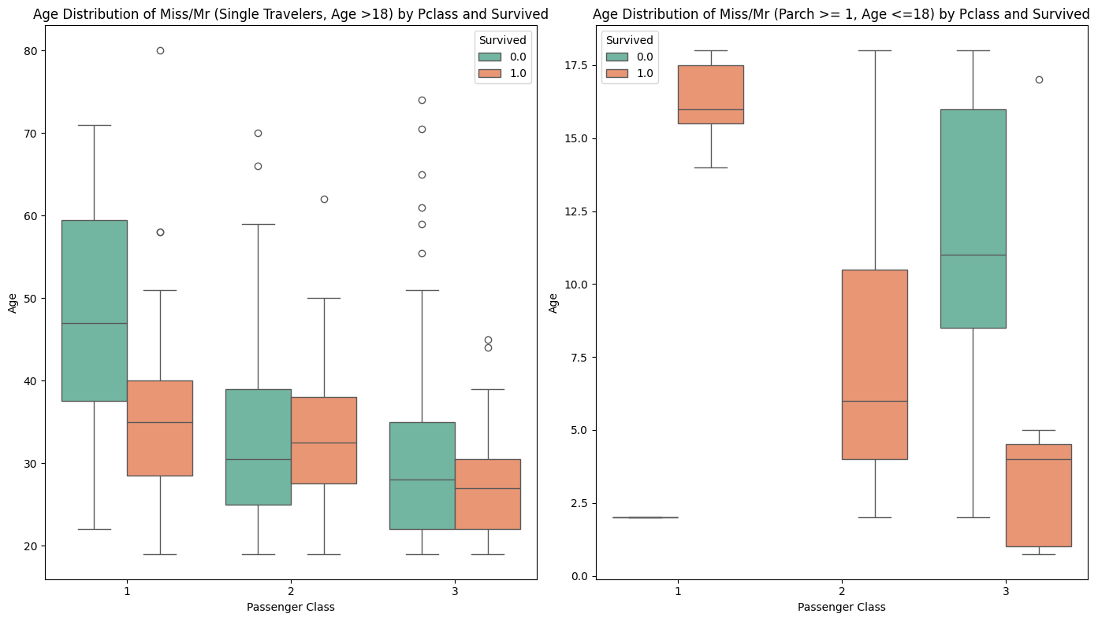
Number of Mr passengers <=18: 48
Sample of Mr passengers <=18:
PassengerId Title Age Pclass Survived Parch SibSp FamilySize
86 87 Mr 16.0 3 0.0 3 1 4
138 139 Mr 16.0 3 0.0 0 0 0
144 145 Mr 18.0 2 0.0 0 0 0
163 164 Mr 17.0 3 0.0 0 0 0
175 176 Mr 18.0 3 0.0 1 1 2
*Additional analysis and reporting were performed to be understand Mr and Miss titles, given Mr and Miss could be used for a son or daughter under the age of 19, or could be used for an adult above the age of 18. It was important to understand the distinction for Age imputation.

C4. Age & Age_Cat Variable Imputation
# Step 1: Define age categories and mapping function
def map_age_to_category(age):
if pd.isna(age):
return None
try:
age = float(age)
print(f"Mapping age {age} to category...") # Debug print
except (TypeError, ValueError) as e:
print(f"Error converting age to float: {age} (type: {type(age)}). Setting to NaN.")
return None
if 0 <= age <= 4:
return 'Infant'
elif 5 <= age <= 13: # Ensure all 5-13 are in Child
return 'Child'
elif 14 <= age <= 25:
return 'Young Adult'
elif 26 <= age <= 39:
return 'Adult'
elif 40 <= age <= 59:
return 'Mature Adult'
else:
return 'Senior'
# Step 2: Impute Age_Cat with family-based rules
def impute_age_category(df):
try:
df_copy = df.copy()
except NameError:
raise NameError("Error: 'titanic_df' is not defined. Please ensure the dataset is loaded.")
# Debug: Print columns to confirm presence
print("Columns in df_copy:", df_copy.columns.tolist())
# Verify required columns
required_columns = ['Age', 'Pclass', 'Survived', 'Title', 'FamilySize', 'SibSp', 'Parch', 'FamilyID', 'PassengerId', 'Sex', 'Embarked']
missing_columns = [col for col in required_columns if col not in df_copy.columns]
if missing_columns:
raise KeyError(f"Error: Missing required columns in dataset: {missing_columns}")
# Ensure columns have correct types
try:
df_copy['Age'] = pd.to_numeric(df_copy['Age'], errors='coerce')
df_copy['Pclass'] = pd.to_numeric(df_copy['Pclass'], errors='coerce', downcast='integer')
df_copy['Survived'] = pd.to_numeric(df_copy['Survived'], errors='coerce')
df_copy['FamilySize'] = pd.to_numeric(df_copy['FamilySize'], errors='coerce')
df_copy['SibSp'] = pd.to_numeric(df_copy['SibSp'], errors='coerce')
df_copy['Parch'] = pd.to_numeric(df_copy['Parch'], errors='coerce')
df_copy['FamilyID'] = df_copy['FamilyID'].astype(str)
df_copy['Embarked'] = df_copy['Embarked'].astype(str) # Ensure Embarked is string
except Exception as e:
raise ValueError(f"Error converting column types: {str(e)}")
# Check for non-numeric values in critical columns
for col in ['Age', 'Pclass', 'Survived', 'FamilySize', 'SibSp', 'Parch']:
non_numeric = df_copy[col][df_copy[col].apply(lambda x: not pd.isna(x) and not isinstance(x, (int, float)))].index
if not non_numeric.empty:
print(f"Warning: Non-numeric values found in {col} at indices {non_numeric.tolist()}: {df_copy.loc[non_numeric, col].tolist()}")
# Initialize Age_Cat column only if it doesn't exist
if 'Age_Cat' not in df_copy.columns:
df_copy['Age_Cat'] = None # Initialize with None
# Calculate median ages by Title, Pclass, Embarked, and age subgroups (<=18, >18)
df_copy['Age_Group'] = pd.cut(df_copy['Age'], bins=[-np.inf, 18, np.inf], labels=['<=18', '>18'])
try:
# Calculate counts to handle sparse data
group_counts = df_copy.groupby(['Title', 'Pclass', 'Embarked', 'Age_Group']).size().reset_index(name='Count')
median_ages = df_copy.groupby(['Title', 'Pclass', 'Embarked', 'Age_Group'])['Age'].median().reset_index()
# Merge counts with medians
median_ages = median_ages.merge(group_counts, on=['Title', 'Pclass', 'Embarked', 'Age_Group'])
# Fallback for sparse data (less than 3 passengers in a group)
title_medians = df_copy.groupby(['Title'])['Age'].median().to_dict() # Broadest fallback
fallback_medians = df_copy.groupby(['Title', 'Pclass'])['Age'].median().reset_index(name='Fallback_Median')
for idx, row in median_ages.iterrows():
if row['Count'] < 3: # If fewer than 3 passengers, use fallback
title = row['Title']
pclass = row['Pclass']
fallback_median = fallback_medians[(fallback_medians['Title'] == title) & (fallback_medians['Pclass'] == pclass)]['Fallback_Median']
if not fallback_median.empty:
median_ages.loc[idx, 'Age'] = fallback_median.iloc[0]
else:
median_ages.loc[idx, 'Age'] = title_medians.get(title, 30.0)
print("Median Ages by Title, Pclass, Embarked, and Age_Group:")
print(median_ages[['Title', 'Pclass', 'Embarked', 'Age_Group', 'Age', 'Count']])
except Exception as e:
print(f"Error during median age calculation: {str(e)}")
raise
df_copy = df_copy.drop(columns=['Age_Group'])
median_ages_dict = {}
for _, row in median_ages.iterrows():
title = row['Title']
pclass = row['Pclass']
embarked = row['Embarked']
age_group = row['Age_Group']
age = row['Age']
if pd.isna(title) or pd.isna(pclass) or pd.isna(embarked) or pd.isna(age_group) or pd.isna(age):
print(f"Skipping median age entry due to NaN: Title={title}, Pclass={pclass}, Embarked={embarked}, AgeGroup={age_group}, Age={age}")
continue
if age_group == '>18':
if title == 'Miss' and age < 20:
age = 25.0
elif title == 'Mr' and age < 25:
age = 35.0
elif age_group == '<=18':
if title == 'Master' and age > 13: # Cap Master at 13 for <=18 group
age = 13.0
elif title == 'Miss' and age > 13: # Cap Miss at 13 for <=18 group
age = 13.0
median_ages_dict[(title, pclass, embarked, age_group)] = age
default_median_age = df_copy['Age'].median() if not df_copy['Age'].isna().all() else 30.0
# Group by FamilyID
try:
family_groups = df_copy.groupby('FamilyID')
print("Successfully grouped by FamilyID")
except Exception as e:
raise KeyError(f"Error grouping by FamilyID: {str(e)}")
for family_id, group in family_groups:
if pd.isna(family_id) or family_id == 'nan':
continue
# FamilySize = 0 (Single Travelers)
if group['FamilySize'].iloc[0] == 0:
for idx in group.index:
if pd.isna(df_copy.loc[idx, 'Age_Cat']):
if pd.isna(df_copy.loc[idx, 'Age']):
pclass = df_copy.loc[idx, 'Pclass']
title = df_copy.loc[idx, 'Title']
embarked = df_copy.loc[idx, 'Embarked']
if pd.isna(pclass) or pd.isna(title) or pd.isna(embarked):
print(f"Skipping index {idx} due to missing Pclass, Title, or Embarked")
continue
age_group = '<=18' if pd.isna(df_copy.loc[idx, 'Age']) or df_copy.loc[idx, 'Age'] <= 18 else '>18'
try:
lookup_key = (title, pclass, embarked, age_group)
median_age = median_ages_dict.get(lookup_key)
if median_age is None:
# Fallback to Title-only median
median_age = title_medians.get(title, default_median_age)
print(f"Key {lookup_key} not found in median_ages_dict. Falling back to Title median: {median_age}")
except Exception as e:
print(f"Error during median_ages_dict lookup for index {idx}: {str(e)}")
raise
if title == 'Master' and median_age > 13: # Cap at 13 for Child
median_age = 13
elif title == 'Miss' and median_age > 13 and age_group == '<=18': # Cap at 13 for <=18 group
median_age = 13
df_copy.loc[idx, 'Age'] = median_age
print(f"Imputed Age = {median_age} for {title} at index {idx} (FamilySize=0, Pclass={pclass}, Embarked={embarked}, AgeGroup={age_group})")
df_copy.loc[idx, 'Age_Cat'] = map_age_to_category(df_copy.loc[idx, 'Age'])
# FamilySize > 0 (Family Groups)
else:
parents = group[group['Title'].isin(['Mr', 'Mrs', 'Dr']) & (group['Parch'] > 0)]
children = group[(group['Title'].isin(['Master', 'Miss']) | ((group['Title'] == 'Mr') & (group['Age'] <= 18)) | (group['Parch'] > 0))]
# Handle parent-child relationships (Parch = 1)
if group['Parch'].sum() == 1 and group['SibSp'].sum() == 0:
for parent_idx in parents.index:
for child_idx in children.index:
if pd.isna(df_copy.loc[parent_idx, 'Age']) or pd.isna(df_copy.loc[child_idx, 'Age']):
parent_title = df_copy.loc[parent_idx, 'Title']
child_title = df_copy.loc[child_idx, 'Title']
pclass = df_copy.loc[parent_idx, 'Pclass']
embarked = df_copy.loc[parent_idx, 'Embarked']
if parent_title == 'Mrs' and child_title in ['Master', 'Miss', 'Mr']:
age_diff = 25
elif parent_title == 'Mr' and child_title in ['Master', 'Miss']:
age_diff = 27
else:
continue
parent_age = df_copy.loc[parent_idx, 'Age']
child_age = df_copy.loc[child_idx, 'Age']
if not pd.isna(parent_age):
new_child_age = max(5, parent_age - age_diff)
if child_title == 'Master' and new_child_age > 13:
new_child_age = 13
elif child_title == 'Miss' and new_child_age > 13:
new_child_age = 13
df_copy.loc[child_idx, 'Age'] = new_child_age
print(f"Imputed Age = {new_child_age} for {child_title} at index {child_idx} from parent")
elif not pd.isna(child_age):
new_parent_age = child_age + age_diff
if new_parent_age < 20:
new_parent_age = 20
df_copy.loc[parent_idx, 'Age'] = new_parent_age
print(f"Imputed Age = {new_parent_age} for {parent_title} at index {parent_idx} from child")
else:
age_group = '>18'
try:
lookup_key = (parent_title, pclass, embarked, age_group)
median_age = median_ages_dict.get(lookup_key)
if median_age is None:
median_age = title_medians.get(parent_title, default_median_age)
print(f"Key {lookup_key} not found in median_ages_dict. Falling back to Title median: {median_age}")
except Exception as e:
print(f"Error during median_ages_dict lookup for parent-child: {str(e)}")
raise
new_child_age = max(5, median_age - age_diff)
if child_title == 'Master' and new_child_age > 13:
new_child_age = 13
elif child_title == 'Miss' and new_child_age > 13:
new_child_age = 13
df_copy.loc[parent_idx, 'Age'] = median_age
df_copy.loc[child_idx, 'Age'] = new_child_age
print(f"Imputed Age = {median_age} for {parent_title} and {new_child_age} for {child_title}")
# Handle sibling relationships (SibSp = 1) or spousal pairs
if group['SibSp'].sum() == 1 and group['Parch'].sum() == 0:
siblings = group[group['SibSp'] > 0]
if len(siblings) >= 2:
idx1, idx2 = siblings.index[:2]
title1 = df_copy.loc[idx1, 'Title']
title2 = df_copy.loc[idx2, 'Title']
pclass = df_copy.loc[idx1, 'Pclass']
embarked = df_copy.loc[idx1, 'Embarked']
if {title1, title2} in [{'Mr', 'Mrs'}, {'Mr', 'Miss'}, {'Mr', 'Mr'}, {'Miss', 'Miss'}]:
age1 = df_copy.loc[idx1, 'Age']
age2 = df_copy.loc[idx2, 'Age']
if pd.isna(age1) and not pd.isna(age2):
new_age = max(5, age2 + 2)
if title1 in ['Master', 'Miss'] and new_age > 13:
new_age = 13
df_copy.loc[idx1, 'Age'] = new_age
print(f"Imputed Age = {df_copy.loc[idx1, 'Age']} for {title1} at index {idx1}")
elif pd.isna(age2) and not pd.isna(age1):
new_age = max(5, age1 - 2)
if title2 in ['Master', 'Miss'] and new_age > 13:
new_age = 13
df_copy.loc[idx2, 'Age'] = new_age
print(f"Imputed Age = {df_copy.loc[idx2, 'Age']} for {title2} at index {idx2}")
else:
age_group = '>18'
try:
lookup_key = (title1, pclass, embarked, age_group)
median_age = median_ages_dict.get(lookup_key)
if median_age is None:
median_age = title_medians.get(title1, default_median_age)
print(f"Key {lookup_key} not found in median_ages_dict. Falling back to Title median: {median_age}")
except Exception as e:
print(f"Error during median_ages_dict lookup for siblings: {str(e)}")
raise
df_copy.loc[idx1, 'Age'] = median_age
new_age = max(5, median_age + 2) if title2 in ['Master', 'Miss'] else max(20, median_age - 2)
if title2 in ['Master', 'Miss'] and new_age > 13:
new_age = 13
df_copy.loc[idx2, 'Age'] = new_age
print(f"Imputed Age = {median_age} and {df_copy.loc[idx2, 'Age']} for {title1} and {title2}")
# Handle FamilySize >= 2 with multiple children
if group['FamilySize'].iloc[0] >= 2:
known_ages = group[~group['Age'].isna()].sort_values('Age')
unknown_ages = group[group['Age'].isna()]
if not known_ages.empty and not unknown_ages.empty:
base_age = known_ages['Age'].iloc[0]
base_title = known_ages['Title'].iloc[0]
if base_title in ['Master', 'Miss'] and base_age <= 18:
parent_idx = parents.index[0] if not parents.empty else unknown_ages.index[0]
if pd.isna(df_copy.loc[parent_idx, 'Age']):
pclass = df_copy.loc[parent_idx, 'Pclass']
embarked = df_copy.loc[parent_idx, 'Embarked']
age_diff = 25
df_copy.loc[parent_idx, 'Age'] = base_age + age_diff
if df_copy.loc[parent_idx, 'Title'] in ['Mrs', 'Mr'] and df_copy.loc[parent_idx, 'Age'] < 20:
df_copy.loc[parent_idx, 'Age'] = 20
print(f"Imputed Age = {df_copy.loc[parent_idx, 'Age']} for parent at index {parent_idx}")
elif base_title in ['Mr', 'Mrs', 'Dr']:
child_idx = unknown_ages.index[0]
if pd.isna(df_copy.loc[child_idx, 'Age']):
pclass = df_copy.loc[child_idx, 'Pclass']
embarked = df_copy.loc[child_idx, 'Embarked']
age_diff = 25
new_child_age = max(5, base_age - age_diff)
if new_child_age > 13 and df_copy.loc[child_idx, 'Title'] in ['Master', 'Miss']:
new_child_age = 13
df_copy.loc[child_idx, 'Age'] = new_child_age
print(f"Imputed Age = {new_child_age} for child at index {child_idx}")
sibling_indices = unknown_ages.index[1:]
for i, idx in enumerate(sibling_indices):
if pd.isna(base_age):
print(f"Skipping sibling imputation at index {idx} due to missing base_age")
continue
offset = (-2, 2, -4, 4, -6, 6, -8)[i % 7] if i > 0 else 0
new_age = max(5, base_age + offset)
if df_copy.loc[idx, 'Title'] in ['Master', 'Miss'] and new_age > 13:
new_age = 13
elif df_copy.loc[idx, 'Title'] in ['Mr', 'Mrs'] and new_age < 20:
new_age = 20
df_copy.loc[idx, 'Age'] = new_age
print(f"Imputed Age = {new_age} for sibling at index {idx}")
# Set Age_Cat for all imputed or existing ages
for idx in group.index:
if pd.isna(df_copy.loc[idx, 'Age_Cat']):
age = df_copy.loc[idx, 'Age']
if pd.isna(age):
print(f"Skipping Age_Cat assignment at index {idx} due to missing age")
continue
df_copy.loc[idx, 'Age_Cat'] = map_age_to_category(age)
# Post-imputation validation for titles
for idx in df_copy.index:
title = df_copy.loc[idx, 'Title']
age = df_copy.loc[idx, 'Age']
if not pd.isna(age):
if title == 'Master' and age > 13: # Cap Master at 13
df_copy.loc[idx, 'Age'] = 13.0
df_copy.loc[idx, 'Age_Cat'] = map_age_to_category(13.0)
print(f"Adjusted Age = 13.0 for Master at index {idx}")
elif title == 'Miss' and 5 <= age <= 13: # Preserve Miss ages 5-13 as Child
df_copy.loc[idx, 'Age_Cat'] = 'Child'
print(f"Preserved Age = {age} for Miss at index {idx} as Child")
elif title in ['Miss', 'Mr', 'Mrs'] and age < 20: # Only adjust if below 20
df_copy.loc[idx, 'Age'] = 20.0
df_copy.loc[idx, 'Age_Cat'] = map_age_to_category(20.0)
print(f"Adjusted Age = 20.0 for {title} at index {idx}")
# Final fallback for any remaining missing Age_Cat
for idx in df_copy.index:
if pd.isna(df_copy.loc[idx, 'Age_Cat']):
age = df_copy.loc[idx, 'Age']
if pd.isna(age):
pclass = df_copy.loc[idx, 'Pclass']
title = df_copy.loc[idx, 'Title']
embarked = df_copy.loc[idx, 'Embarked']
if pd.isna(pclass) or pd.isna(title) or pd.isna(embarked):
print(f"Skipping final fallback at index {idx} due to missing data")
continue
age_group = '<=18' if pd.isna(df_copy.loc[idx, 'Age']) or df_copy.loc[idx, 'Age'] <= 18 else '>18'
try:
lookup_key = (title, pclass, embarked, age_group)
median_age = median_ages_dict.get(lookup_key)
if median_age is None:
median_age = title_medians.get(title, default_median_age)
print(f"Key {lookup_key} not found in median_ages_dict. Falling back to Title median: {median_age}")
except Exception as e:
print(f"Error during final fallback median_ages_dict lookup: {str(e)}")
raise
if title == 'Master' and median_age > 13:
median_age = 13
elif title == 'Miss' and median_age > 13 and age_group == '<=18':
median_age = 13
df_copy.loc[idx, 'Age'] = median_age
print(f"Fallback imputed Age = {median_age} for {title} at index {idx}")
df_copy.loc[idx, 'Age_Cat'] = map_age_to_category(df_copy.loc[idx, 'Age'])
# Ensure ages are within bounds (0 to 100)
df_copy['Age'] = df_copy['Age'].clip(0, 100)
return df_copy
# Step 3: Apply imputation
try:
titanic_imputed = impute_age_category(titanic_df)
except Exception as e:
print(f"Error during imputation: {str(e)}")
raise
# Step 4: Calculate counts and create bar chart
age_cat_counts = titanic_imputed['Age_Cat'].value_counts().reindex(
['Infant', 'Child', 'Young Adult', 'Adult', 'Mature Adult', 'Senior'], fill_value=0
)
# Print counts for verification
print("\nPassenger Counts by Age_Cat:")
print(age_cat_counts)
# Verify Infant + Child total (0-13)
infant_child_total = age_cat_counts['Infant'] + age_cat_counts['Child']
print(f"\nTotal Infant + Child (0-13): {infant_child_total} (Expected: >87)")
# Create bar chart
plt.figure(figsize=(10, 6))
age_cat_counts.plot(kind='bar', color=['#FF6F61', '#6B5B95', '#88B04B', '#F7CAC9', '#92A8D1', '#955251'])
# Customize the chart
plt.title('Passenger Distribution by Age Category')
plt.xlabel('Age Category')
plt.ylabel('Number of Passengers')
plt.xticks(rotation=45)
plt.legend(['Number of Passengers']) # Single legend for clarity
# Display the chart
plt.tight_layout()
plt.show()
# Step 5: Display imputed passengers with previously missing ages
print("\nImputed Passengers with Previously Missing Ages:")
missing_age_ids = titanic_df[titanic_df['Age'].isna()]['PassengerId']
sample_imputed = titanic_imputed[titanic_imputed['PassengerId'].isin(missing_age_ids)][['PassengerId', 'Title', 'Age', 'Age_Cat', 'Pclass', 'Survived', 'FamilySize', 'SibSp', 'Parch', 'FamilyID', 'Sex', 'Embarked']]
if not sample_imputed.empty:
print(sample_imputed)
else:
print("Note: No previously missing ages found after imputation.")
# Step 6: Display all passengers to confirm imputation
print("\nSample of All Passengers After Imputation (First 10 rows):")
print(titanic_imputed[['PassengerId', 'Title', 'Age', 'Age_Cat', 'Pclass', 'Survived', 'FamilySize', 'SibSp', 'Parch', 'FamilyID', 'Sex', 'Embarked']].head(10))
# Step 7: Validate imputation
print("\nValidation of Age_Cat Imputation:")
missing_age_cat = titanic_imputed['Age_Cat'].isna().sum()
print(f"Number of remaining missing Age_Cat values: {missing_age_cat}")
Columns in df_copy: ['PassengerId', 'Survived', 'Pclass', 'Name', 'Sex', 'Age', 'SibSp', 'Parch', 'Ticket', 'Fare', 'Cabin', 'Embarked', 'Title', 'Surname', 'FamilyID', 'FamilySize', 'TicketPrefix', 'TicketNumber', 'Deck', 'Age_Cat']
Median Ages by Title, Pclass, Embarked, and Age_Group:
Title Pclass Embarked Age_Group Age Count
5 Capt 1 S >18 70.00 1
19 Col 1 C >18 53.00 3
23 Col 1 S >18 54.50 1
41 Countess 1 S >18 33.00 1
55 Don 1 C >18 40.00 1
73 Dona 1 C >18 39.00 1
91 Dr 1 C >18 49.00 1
93 Dr 1 Q >18 49.00 1
95 Dr 1 S >18 50.00 3
101 Dr 2 S >18 38.50 2
113 Jonkheer 1 S >18 38.00 1
127 Lady 1 C >18 48.00 1
149 Major 1 S >18 48.50 2
162 Master 1 C <=18 6.00 2
166 Master 1 S <=18 4.00 3
168 Master 2 C <=18 2.00 1
172 Master 2 S <=18 2.00 10
174 Master 3 C <=18 6.50 4
176 Master 3 Q <=18 7.00 5
178 Master 3 S <=18 5.50 28
180 Miss 1 C <=18 30.00 2
181 Miss 1 C >18 34.00 26
183 Miss 1 Q >18 30.00 1
184 Miss 1 S <=18 15.50 6
185 Miss 1 S >18 29.50 24
186 Miss 2 C <=18 3.00 3
187 Miss 2 C >18 20.00 2
189 Miss 2 Q >18 20.00 1
190 Miss 2 S <=18 8.00 17
191 Miss 2 S >18 26.00 25
192 Miss 3 C <=18 9.00 13
194 Miss 3 Q <=18 16.50 6
195 Miss 3 Q >18 24.00 13
196 Miss 3 S <=18 8.50 34
197 Miss 3 S >18 23.00 37
199 Mlle 1 C >18 24.00 2
217 Mme 1 C >18 24.00 1
234 Mr 1 C <=18 41.50 2
235 Mr 1 C >18 39.00 53
238 Mr 1 S <=18 41.50 1
239 Mr 1 S >18 42.00 76
241 Mr 2 C >18 29.50 12
243 Mr 2 Q >18 61.00 3
244 Mr 2 S <=18 18.00 10
245 Mr 2 S >18 30.50 112
246 Mr 3 C <=18 16.00 4
247 Mr 3 C >18 26.25 30
249 Mr 3 Q >18 30.00 16
250 Mr 3 S <=18 17.00 31
251 Mr 3 S >18 28.00 231
252 Mrs 1 C <=18 45.00 2
253 Mrs 1 C >18 48.00 30
255 Mrs 1 Q >18 45.00 1
256 Mrs 1 S <=18 18.00 3
257 Mrs 1 S >18 47.00 31
258 Mrs 2 C <=18 30.50 1
259 Mrs 2 C >18 24.00 5
263 Mrs 2 S >18 32.50 48
264 Mrs 3 C <=18 16.00 3
265 Mrs 3 C >18 33.50 6
267 Mrs 3 Q >18 31.00 2
268 Mrs 3 S <=18 31.00 2
269 Mrs 3 S >18 32.00 36
281 Ms 2 S >18 28.00 1
297 Rev 2 Q >18 41.50 1
299 Rev 2 S >18 41.00 7
307 Sir 1 C >18 49.00 1
group_counts = df_copy.groupby(['Title', 'Pclass', 'Embarked', 'Age_Group']).size().reset_index(name='Count')
median_ages = df_copy.groupby(['Title', 'Pclass', 'Embarked', 'Age_Group'])['Age'].median().reset_index()

Passenger Counts by Age_Cat:
Age_Cat
Infant 27
Child 106
Young Adult 453
Adult 445
Mature Adult 238
Senior 40
Name: count, dtype: int64
Total Infant + Child (0-13): 133 (Expected: >87)
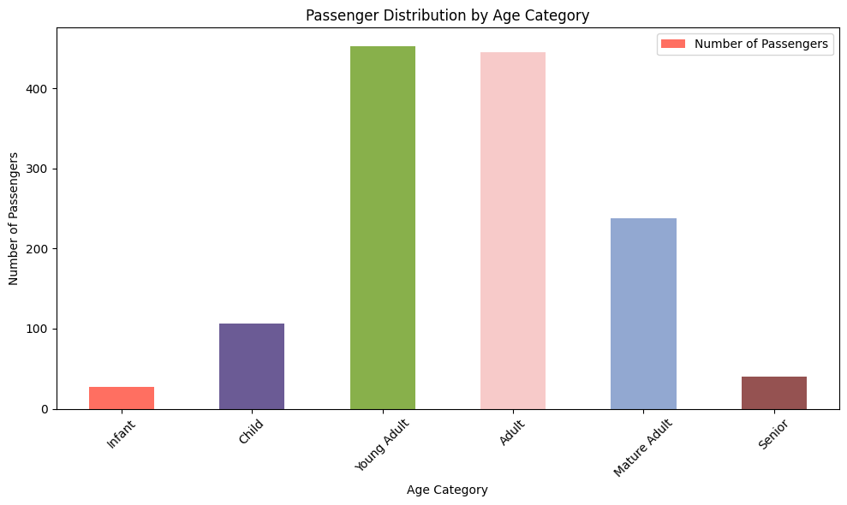
Sample of All Passengers After Imputation (First 10 rows):
PassengerId Title Age Age_Cat Pclass Survived FamilySize \
0 1 Mr 22.0 Young Adult 3 0.0 1
1 2 Mrs 38.0 Adult 1 1.0 1
2 3 Miss 26.0 Adult 3 1.0 0
3 4 Mrs 35.0 Adult 1 1.0 1
4 5 Mr 35.0 Adult 3 0.0 0
5 6 Mr 26.0 Adult 3 0.0 0
6 7 Mr 54.0 Mature Adult 1 0.0 0
7 8 Master 2.0 Infant 3 0.0 4
8 9 Mrs 27.0 Adult 3 1.0 2
9 10 Mrs 20.0 Young Adult 2 1.0 1
SibSp Parch FamilyID Sex Embarked
0 1 0 Braund_A/5 21171 male S
1 1 0 Cumings_PC 17599 female C
2 0 0 Heikkinen_STON/O2. 3101282 female S
3 1 0 Futrelle_113803 female S
4 0 0 Allen_373450 male S
5 0 0 Moran_330877 male Q
6 0 0 McCarthy_17463 male S
7 3 1 Palsson_349909 male S
8 0 2 Johnson_347742 female S
9 1 0 Nasser_237736 female C
Validation of Age_Cat Imputation:
Number of remaining missing Age_Cat values: 0
# Filter for 13-year-old passengers
thirteen_year_olds = titanic_imputed[titanic_imputed['Age'] == 13]
# Count the number of 13-year-old passengers
num_thirteen_year_olds = len(thirteen_year_olds)
print(f"Number of 13-year-old passengers: {num_thirteen_year_olds}")
Number of 13-year-old passengers: 44
# Bar chart for 'Age_Cat' distribution with counts of Survived (0 and 1) for the training dataset.
plt.figure(figsize=(10, 6))
ax = sns.countplot(x='Age_Cat', hue='Survived', data=titanic_imputed, palette={0: 'red', 1: 'green'},
order=['Infant', 'Child', 'Young Adult', 'Adult', 'Mature Adult', 'Senior'])
# Add numeric values centered inside each bar with white font
for p in ax.patches:
height = p.get_height()
# Only add text if height is greater than 0 to avoid the "0" label
if height > 0:
ax.text(p.get_x() + p.get_width() / 2., height + 5, # Center vertically
int(height), # Convert to integer for clean display
ha="center", va="center", color="black", fontsize=12)
plt.title('Survival Counts by Age Category')
plt.xlabel('Age Category (Infant: 0-4, Child: 5-13, Young Adult: 14-24, Adult: 25-39, Mature Adult: 40-59, Senior: 60+)')
plt.ylabel('Count')
plt.xticks(rotation=45)
plt.yticks(np.arange(0,301,step=25))
plt.legend(title='Survived', labels=['No', 'Yes']) # Customize legend labels
plt.show()
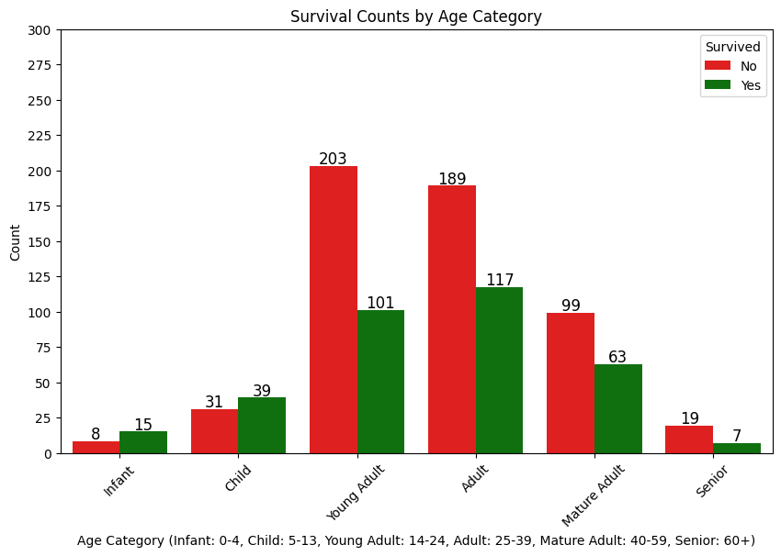
*Concerning this age imputation process in retrospect, do think some fine tuning could take place. I am comfortable with what I am seeing in the infant, child, mature adult, and senior categories, but noticed that the number of young adults compared to adults have surged considerably. What was 206 and 274 previously has now become 304 and 306. May need to make sure that <=18 and >18 criterion for median age estimation is being applied appropriately.

IV. Exploratory Classification Modeling
A1. Remove unnecessary variables from the training dataset.
# Columns to drop
columns_to_drop = ['PassengerId', 'Name', 'Surname', 'Ticket', 'TicketPrefix', 'TicketNumber', 'Cabin', 'Deck', 'FamilyID', 'SibSp', 'Parch']
# Drop the columns
titanic_cleaned = titanic_imputed.drop(columns=columns_to_drop, errors='ignore')
# Verify remaining columns
print("Remaining columns after dropping undesirable variables:")
print(titanic_cleaned.columns.tolist())
# Display the first few rows of the cleaned dataset
print("\nFirst 5 rows of the cleaned dataset:")
print(titanic_cleaned.head())
Remaining columns after dropping undesirable variables:
['Survived', 'Pclass', 'Sex', 'Age', 'Fare', 'Embarked', 'Title', 'FamilySize', 'Age_Cat']
First 5 rows of the cleaned dataset:
Survived Pclass Sex Age Fare Embarked Title FamilySize \
0 0.0 3 male 22.0 7.2500 S Mr 1
1 1.0 1 female 38.0 71.2833 C Mrs 1
2 1.0 3 female 26.0 7.9250 S Miss 0
3 1.0 1 female 35.0 53.1000 S Mrs 1
4 0.0 3 male 35.0 8.0500 S Mr 0
Age_Cat
0 Young Adult
1 Adult
2 Adult
3 Adult
4 Adult
A2. Group and encode necessary variable values.
# Define a function to group rare titles
def group_rare_titles(title):
rare_titles = ['Dr', 'Rev', 'Major', 'Don', 'Col', 'Jonkheer', 'Lady', 'Dona', 'Countess', 'Sir', 'Mme', 'Ms', 'Mlle', 'Capt']
if title in rare_titles:
return 'Other'
return title
# Apply the function to the Title column in the original titanic_cleaned DataFrame
titanic_cleaned['Title'] = titanic_cleaned['Title'].apply(group_rare_titles)

# Recheck the distribution of titles
print("Distribution of grouped titles:")
print(titanic_cleaned['Title'].value_counts())
Distribution of grouped titles:
Title
Mr 757
Miss 260
Mrs 197
Master 61
Other 34
Name: count, dtype: int64
# Encode Sex (male=0, female=1)
titanic_cleaned['Sex'] = titanic_cleaned['Sex'].map({'male': 0, 'female': 1})
# One-hot encode Embarked, Title, and Age_Cat without dropping the first category
titanic_encoded = pd.get_dummies(titanic_cleaned, columns=['Embarked', 'Title', 'Age_Cat'], drop_first=False)
# Verify the encoded columns
print("\nColumns after encoding:")
print(titanic_encoded.columns.tolist())
# Check if Embarked_C is present
if 'Embarked_C' not in titanic_encoded.columns:
print("Warning: Embarked_C is missing. This might be due to no variation or encoding issue.")
# Display the first few rows of the encoded dataset
print("\nFirst 5 rows of the encoded dataset:")
print(titanic_encoded.head())
Columns after encoding:
['Survived', 'Pclass', 'Sex', 'Age', 'Fare', 'FamilySize', 'Embarked_C', 'Embarked_Q', 'Embarked_S', 'Title_Master', 'Title_Miss', 'Title_Mr', 'Title_Mrs', 'Title_Other', 'Age_Cat_Adult', 'Age_Cat_Child', 'Age_Cat_Infant', 'Age_Cat_Mature Adult', 'Age_Cat_Senior', 'Age_Cat_Young Adult']
First 5 rows of the encoded dataset:
Survived Pclass Sex Age Fare FamilySize Embarked_C Embarked_Q \
0 0.0 3 0 22.0 7.2500 1 False False
1 1.0 1 1 38.0 71.2833 1 True False
2 1.0 3 1 26.0 7.9250 0 False False
3 1.0 1 1 35.0 53.1000 1 False False
4 0.0 3 0 35.0 8.0500 0 False False
Embarked_S Title_Master Title_Miss Title_Mr Title_Mrs Title_Other \
0 True False False True False False
1 False False False False True False
2 True False True False False False
3 True False False False True False
4 True False False True False False
Age_Cat_Adult Age_Cat_Child Age_Cat_Infant Age_Cat_Mature Adult \
0 False False False False
1 True False False False
2 True False False False
3 True False False False
4 True False False False
Age_Cat_Senior Age_Cat_Young Adult
0 False True
1 False False
2 False False
3 False False
4 False False
A3. Create train-test datasets and define features and target for training.
# Training dataset: Records where Survived is not missing
train_data = titanic_encoded[titanic_encoded['Survived'].notna()].copy()
# Testing dataset: Records where Survived is missing
test_data = titanic_encoded[titanic_encoded['Survived'].isna()].copy()
# Define features and target for training
X_train = train_data.drop(columns=['Survived'])
y_train = train_data['Survived'].astype(int)
# Features for testing
X_test = test_data.drop(columns=['Survived'])
# Ensure column consistency
missing_in_test = set(X_train.columns) - set(X_test.columns)
missing_in_train = set(X_test.columns) - set(X_train.columns)
for col in missing_in_test:
X_test[col] = 0
for col in missing_in_train:
X_train[col] = 0
X_test = X_test[X_train.columns]
# Verify shapes
print(f"\nShape of X_train: {X_train.shape}")
print(f"Shape of y_train: {y_train.shape}")
print(f"Shape of X_test: {X_test.shape}")
Shape of X_train: (891, 19)
Shape of y_train: (891,)
Shape of X_test: (418, 19)
# Define features (X_train) and target (y_train) for training
X_train = train_data.drop(columns=['Survived'])
y_train = train_data['Survived'].astype(int) # Ensure Survived is integer (0 or 1)
# For the testing dataset, we only need features (X_test)
X_test = test_data.drop(columns=['Survived'])
# Verify shapes
print(f"\nShape of X_train: {X_train.shape}")
print(f"Shape of y_train: {y_train.shape}")
print(f"Shape of X_test: {X_test.shape}")
# Check the distribution of Survived in the training set
print("\nDistribution of Survived in training set:")
print(y_train.value_counts(normalize=True))
Shape of X_train: (891, 19)
Shape of y_train: (891,)
Shape of X_test: (418, 19)
Distribution of Survived in training set:
Survived
0 0.616162
1 0.383838
Name: proportion, dtype: float64
B1. Create initial model with 19 features using the Random Forest Classifier. Generate confusion matrix, classification report, feature importance, and optimized parameters.
# Class weights
class_weights = {0: 1.0, 1: 1.6}
# Initialize the model
rf_model = RandomForestClassifier(random_state=42, n_estimators=135, max_depth=8, min_samples_split=8, class_weight=class_weights)
# Perform 5-fold cross-validation and get predictions
y_train_pred = cross_val_predict(rf_model, X_train, y_train, cv=5)
# Compute confusion matrix
conf_matrix = confusion_matrix(y_train, y_train_pred)
# Print confusion matrix
print("\nConfusion Matrix:")
print(conf_matrix)
# Print classification report (precision, recall, F1-score)
print("\nClassification Report:")
print(classification_report(y_train, y_train_pred))
# Optionally, retrain the model on the full training set for feature importance
rf_model.fit(X_train, y_train)
# Feature importance
feature_importance = pd.DataFrame({
'Feature': X_train.columns,
'Importance': rf_model.feature_importances_
}).sort_values(by='Importance', ascending=False)
print("\nFeature Importance:")
print(feature_importance) # Show top 10 features
Confusion Matrix:
[[482 67]
[ 77 265]]
Classification Report:
precision recall f1-score support
0 0.86 0.88 0.87 549
1 0.80 0.77 0.79 342
accuracy 0.84 891
macro avg 0.83 0.83 0.83 891
weighted avg 0.84 0.84 0.84 891

Feature Importance:
Feature Importance
1 Sex 0.190775
10 Title_Mr 0.173960
3 Fare 0.146319
0 Pclass 0.101993
2 Age 0.096001
4 FamilySize 0.073585
11 Title_Mrs 0.058260
9 Title_Miss 0.053759
7 Embarked_S 0.014237
13 Age_Cat_Adult 0.013138
5 Embarked_C 0.011987
8 Title_Master 0.011258
6 Embarked_Q 0.010121
18 Age_Cat_Young Adult 0.009757
14 Age_Cat_Child 0.009017
16 Age_Cat_Mature Adult 0.008675
15 Age_Cat_Infant 0.007314
12 Title_Other 0.005816
17 Age_Cat_Senior 0.004027
# Perform 5-fold cross-validation on the training set
cv_scores = cross_val_score(rf_model, X_train, y_train, cv=5, scoring='accuracy')
cv_roc_auc = cross_val_score(rf_model, X_train, y_train, cv=5, scoring='roc_auc')
print("\nCross-Validation Results (Training Set):")
print(f"Accuracy: {cv_scores.mean():.3f} (+/- {cv_scores.std() * 2:.3f})")
print(f"ROC-AUC: {cv_roc_auc.mean():.3f} (+/- {cv_roc_auc.std() * 2:.3f})")
Cross-Validation Results (Training Set):
Accuracy: 0.838 (+/- 0.051)
ROC-AUC: 0.866 (+/- 0.069)
# Feature importance
feature_importance = pd.DataFrame({
'Feature': X_train.columns,
'Importance': rf_model.feature_importances_
}).sort_values(by='Importance', ascending=False)
print("\nFeature Importance:")
print(feature_importance)

Feature Importance:
Feature Importance
1 Sex 0.190775
10 Title_Mr 0.173960
3 Fare 0.146319
0 Pclass 0.101993
2 Age 0.096001
4 FamilySize 0.073585
11 Title_Mrs 0.058260
9 Title_Miss 0.053759
7 Embarked_S 0.014237
13 Age_Cat_Adult 0.013138
5 Embarked_C 0.011987
8 Title_Master 0.011258
6 Embarked_Q 0.010121
18 Age_Cat_Young Adult 0.009757
14 Age_Cat_Child 0.009017
16 Age_Cat_Mature Adult 0.008675
15 Age_Cat_Infant 0.007314
12 Title_Other 0.005816
17 Age_Cat_Senior 0.004027
param_grid = {
'n_estimators': [135],
'max_depth': [8],
'min_samples_split': [8]
}
grid_search = GridSearchCV(RandomForestClassifier(random_state=42, class_weight=class_weights),
param_grid, cv=5, scoring='f1')
grid_search.fit(X_train, y_train)
print("\nBest parameters:", grid_search.best_params_)
print("Best F1-score:", grid_search.best_score_)
Best parameters: {'max_depth': 8, 'min_samples_split': 8, 'n_estimators': 135}
Best F1-score: 0.7841926254791581
B2. Create model with 14 features (Title features removed) using the Random Forest Classifier. Generate confusion matrix, classification report, feature importance, and optimized parameters.
# Identify Title-related columns
title_columns = [col for col in X_train.columns if col.startswith('Title_')]
# Drop Title columns from X_train and X_test
X_train_no_title = X_train.drop(columns=title_columns)
X_test_no_title = X_test.drop(columns=title_columns)
# Verify remaining columns
print("\nColumns after dropping Title variables:")
print(X_train_no_title.columns.tolist())
Columns after dropping Title variables:
['Pclass', 'Sex', 'Age', 'Fare', 'FamilySize', 'Embarked_C', 'Embarked_Q', 'Embarked_S', 'Age_Cat_Adult', 'Age_Cat_Child', 'Age_Cat_Infant', 'Age_Cat_Mature Adult', 'Age_Cat_Senior', 'Age_Cat_Young Adult']
# Initialize the model
rf_model_no_title = RandomForestClassifier(random_state=42, n_estimators=155, max_depth=18, min_samples_split=8, class_weight=class_weights)
# Perform 5-fold cross-validation and get predictions
y_train_pred_no_title = cross_val_predict(rf_model_no_title, X_train_no_title, y_train, cv=5)
# Compute confusion matrix
conf_matrix_no_title = confusion_matrix(y_train, y_train_pred_no_title)
# Print confusion matrix
print("\nConfusion Matrix (without Title):")
print(conf_matrix_no_title)
# Print classification report
print("\nClassification Report (without Title):")
print(classification_report(y_train, y_train_pred_no_title))
# Retrain on full training set for feature importance
rf_model_no_title.fit(X_train_no_title, y_train)
# Feature importance
feature_importance_no_title = pd.DataFrame({
'Feature': X_train_no_title.columns,
'Importance': rf_model_no_title.feature_importances_
}).sort_values(by='Importance', ascending=False)
print("\nFeature Importance (without Title):")
print(feature_importance_no_title)
Confusion Matrix (without Title):
[[472 77]
[ 77 265]]
Classification Report (without Title):
precision recall f1-score support
0 0.86 0.86 0.86 549
1 0.77 0.77 0.77 342
accuracy 0.83 891
macro avg 0.82 0.82 0.82 891
weighted avg 0.83 0.83 0.83 891
Feature Importance (without Title):
Feature Importance
1 Sex 0.309556
3 Fare 0.231851
2 Age 0.149360
0 Pclass 0.108094
4 FamilySize 0.082726
9 Age_Cat_Child 0.018323
7 Embarked_S 0.016943
5 Embarked_C 0.016264
8 Age_Cat_Adult 0.015629
13 Age_Cat_Young Adult 0.012949
10 Age_Cat_Infant 0.011856
11 Age_Cat_Mature Adult 0.011475
6 Embarked_Q 0.008501
12 Age_Cat_Senior 0.006471
# Perform 5-fold cross-validation on the training set
cv_scores = cross_val_score(rf_model, X_train_no_title, y_train, cv=5, scoring='accuracy')
cv_roc_auc = cross_val_score(rf_model, X_train_no_title, y_train, cv=5, scoring='roc_auc')
print("\nCross-Validation Results (Training Set):")
print(f"Accuracy: {cv_scores.mean():.3f} (+/- {cv_scores.std() * 2:.3f})")
print(f"ROC-AUC: {cv_roc_auc.mean():.3f} (+/- {cv_roc_auc.std() * 2:.3f})")
Cross-Validation Results (Training Set):
Accuracy: 0.819 (+/- 0.050)
ROC-AUC: 0.864 (+/- 0.060)
param_grid = {
'n_estimators': [155],
'max_depth': [18],
'min_samples_split': [8]
}
grid_search = GridSearchCV(RandomForestClassifier(random_state=42, class_weight=class_weights),
param_grid, cv=5, scoring='f1')
grid_search.fit(X_train_no_title, y_train)
print("\nBest parameters:", grid_search.best_params_)
print("Best F1-score:", grid_search.best_score_)
Best parameters: {'max_depth': 18, 'min_samples_split': 8, 'n_estimators': 155}
Best F1-score: 0.7732637070135309
B3. Create model with 8 features (Title and Age_Cat features removed) using the Random Forest Classifier. Generate confusion matrix, classification report, feature importance, and optimized parameters.
# Identify Age_Cat-related columns
age_cat_columns = [col for col in X_train_no_title.columns if col.startswith('Age_Cat_')]
# Drop Age_Cat columns from X_train and X_test
X_train_no_age_cat = X_train_no_title.drop(columns=age_cat_columns)
X_test_no_age_cat = X_test_no_title.drop(columns=age_cat_columns)
# Verify remaining columns
print("\nColumns after dropping Age_Cat variables:")
print(X_train_no_age_cat.columns.tolist())
Columns after dropping Age_Cat variables:
['Pclass', 'Sex', 'Age', 'Fare', 'FamilySize', 'Embarked_C', 'Embarked_Q', 'Embarked_S']
# Initialize the model
rf_model_no_age_cat = RandomForestClassifier(random_state=42, n_estimators=145, max_depth=10, min_samples_split=5, class_weight=class_weights)
# Perform 5-fold cross-validation and get predictions
y_train_pred_no_age_cat = cross_val_predict(rf_model_no_age_cat, X_train_no_age_cat, y_train, cv=5)
# Compute confusion matrix
conf_matrix_no_age_cat = confusion_matrix(y_train, y_train_pred_no_age_cat)
# Print confusion matrix
print("\nConfusion Matrix (without Age_Cat):")
print(conf_matrix_no_age_cat)
# Print classification report
print("\nClassification Report (without Age_Cat):")
print(classification_report(y_train, y_train_pred_no_age_cat))
# Retrain on full training set for feature importance
rf_model_no_age_cat.fit(X_train_no_age_cat, y_train)
# Feature importance
feature_importance_no_age_cat = pd.DataFrame({
'Feature': X_train_no_age_cat.columns,
'Importance': rf_model_no_age_cat.feature_importances_
}).sort_values(by='Importance', ascending=False)
print("\nFeature Importance (without Age_Cat):")
print(feature_importance_no_age_cat)
Confusion Matrix (without Age_Cat):
[[478 71]
[ 84 258]]
Classification Report (without Age_Cat):
precision recall f1-score support
0 0.85 0.87 0.86 549
1 0.78 0.75 0.77 342
accuracy 0.83 891
macro avg 0.82 0.81 0.81 891
weighted avg 0.83 0.83 0.83 891
Feature Importance (without Age_Cat):
Feature Importance
1 Sex 0.321490
3 Fare 0.234976
2 Age 0.211369
0 Pclass 0.101103
4 FamilySize 0.093550
5 Embarked_C 0.014845
7 Embarked_S 0.013753
6 Embarked_Q 0.008914
# Perform 5-fold cross-validation on the training set
cv_scores = cross_val_score(rf_model, X_train_no_age_cat, y_train, cv=5, scoring='accuracy')
cv_roc_auc = cross_val_score(rf_model, X_train_no_age_cat, y_train, cv=5, scoring='roc_auc')
print("\nCross-Validation Results (Training Set):")
print(f"Accuracy: {cv_scores.mean():.3f} (+/- {cv_scores.std() * 2:.3f})")
print(f"ROC-AUC: {cv_roc_auc.mean():.3f} (+/- {cv_roc_auc.std() * 2:.3f})")
Cross-Validation Results (Training Set):
Accuracy: 0.818 (+/- 0.057)
ROC-AUC: 0.872 (+/- 0.064)
from sklearn.model_selection import GridSearchCV
param_grid = {
'n_estimators': [145],
'max_depth': [10],
'min_samples_split': [5]
}
grid_search = GridSearchCV(RandomForestClassifier(random_state=42, class_weight=class_weights),
param_grid, cv=5, scoring='f1')
grid_search.fit(X_train_no_age_cat, y_train)
print("\nBest parameters:", grid_search.best_params_)
print("Best F1-score:", grid_search.best_score_)
Best parameters: {'max_depth': 10, 'min_samples_split': 5, 'n_estimators': 145}
Best F1-score: 0.7672966392436784
B4. Create model with 5 features (Title, Age_Cat, and Embarked features removed) using the Random Forest Classifier. Generate confusion matrix, classification report, feature importance, and optimized parameters.
# Identify Embarked-related columns
embarked_columns = [col for col in X_train_no_age_cat.columns if col.startswith('Embarked_')]
# Drop Embarked columns from X_train and X_test
X_train_no_embarked = X_train_no_age_cat.drop(columns=embarked_columns)
X_test_no_embarked = X_test_no_age_cat.drop(columns=embarked_columns)
# Verify remaining columns
print("\nColumns after dropping Embarked variables:")
print(X_train_no_embarked.columns.tolist())
Columns after dropping Embarked variables:
['Pclass', 'Sex', 'Age', 'Fare', 'FamilySize']
# Initialize the model
rf_model_no_embarked = RandomForestClassifier(random_state=42, n_estimators=200, max_depth=11, min_samples_split=5, class_weight=class_weights)
# Perform 5-fold cross-validation and get predictions
y_train_pred_no_embarked = cross_val_predict(rf_model_no_embarked, X_train_no_embarked, y_train, cv=5)
# Compute confusion matrix
conf_matrix_no_embarked = confusion_matrix(y_train, y_train_pred_no_embarked)
# Print confusion matrix
print("\nConfusion Matrix (without Embarked):")
print(conf_matrix_no_embarked)
# Print classification report
print("\nClassification Report (without Embarked):")
print(classification_report(y_train, y_train_pred_no_embarked))
# Retrain on full training set for feature importance
rf_model_no_embarked.fit(X_train_no_embarked, y_train)
# Feature importance
feature_importance_no_embarked = pd.DataFrame({
'Feature': X_train_no_embarked.columns,
'Importance': rf_model_no_embarked.feature_importances_
}).sort_values(by='Importance', ascending=False)
print("\nFeature Importance (without Embarked):")
print(feature_importance_no_embarked)
Confusion Matrix (without Embarked):
[[479 70]
[ 81 261]]
Classification Report (without Embarked):
precision recall f1-score support
0 0.86 0.87 0.86 549
1 0.79 0.76 0.78 342
accuracy 0.83 891
macro avg 0.82 0.82 0.82 891
weighted avg 0.83 0.83 0.83 891
Feature Importance (without Embarked):
Feature Importance
1 Sex 0.320602
3 Fare 0.258746
2 Age 0.229290
0 Pclass 0.103783
4 FamilySize 0.087579
from sklearn.model_selection import cross_val_score
# Perform 5-fold cross-validation on the training set
cv_scores = cross_val_score(rf_model, X_train_no_embarked, y_train, cv=5, scoring='accuracy')
cv_roc_auc = cross_val_score(rf_model, X_train_no_embarked, y_train, cv=5, scoring='roc_auc')
print("\nCross-Validation Results (Training Set):")
print(f"Accuracy: {cv_scores.mean():.3f} (+/- {cv_scores.std() * 2:.3f})")
print(f"ROC-AUC: {cv_roc_auc.mean():.3f} (+/- {cv_roc_auc.std() * 2:.3f})")
Cross-Validation Results (Training Set):
Accuracy: 0.826 (+/- 0.049)
ROC-AUC: 0.870 (+/- 0.078)
from sklearn.model_selection import GridSearchCV
param_grid = {
'n_estimators': [200],
'max_depth': [11],
'min_samples_split': [5]
}
grid_search = GridSearchCV(RandomForestClassifier(random_state=42, class_weight=class_weights),
param_grid, cv=5, scoring='f1')
grid_search.fit(X_train_no_embarked, y_train)
print("\nBest parameters:", grid_search.best_params_)
print("Best F1-score:", grid_search.best_score_)
Best parameters: {'max_depth': 11, 'min_samples_split': 5, 'n_estimators': 200}
Best F1-score: 0.7747123629518498

B5. Create model with 5 features (by RF Impoertance) using the Random Forest Classifier. Generate confusion matrix, classification report, feature importance, and optimized parameters.
# Initialize Random Forest for feature importance
rf_base = RandomForestClassifier(random_state=42)
rf_base.fit(X_train, y_train)
# Get feature importances using Random Forest
feature_importances = rf_base.feature_importances_
feature_names = X_train.columns if hasattr(X_train, 'columns') else [f'Feature_{i}' for i in range(X_train.shape[1])]
importance_df = pd.DataFrame({'Feature': feature_names, 'Importance': feature_importances})
importance_df = importance_df.sort_values(by='Importance', ascending=False)
# Specify the number of top features to select (adjustable)
top_n = 5 # Change this to 10, 12, etc., or try 17 or all
top_features = importance_df['Feature'].head(top_n).values
top_feature_indices_rf = [list(feature_names).index(f) for f in top_features]
# Display the top features
print(f"\nTop {top_n} Features by Importance (Random Forest):")
print(importance_df.head(top_n))
# Create reduced datasets
X_train_rf = X_train.iloc[:, top_feature_indices_rf] if hasattr(X_train, 'columns') else X_train[:, top_feature_indices_rf]
X_train_rf_df = pd.DataFrame(X_train_rf, columns=top_features)
# Initialize Random Forest with default parameters (no GridSearchCV for now)
rf = RandomForestClassifier(random_state=42, n_estimators=135, max_depth=8, min_samples_split=4, class_weight=class_weights)
# We'll fit the model separately for submission later
y_pred = cross_val_predict(rf, X_train_rf, y_train, cv=5)
# Perform 5-fold cross-validation on the training set
cv_scores_rf = cross_val_score(rf_model, X_train_rf, y_train, cv=5, scoring='accuracy')
cv_roc_auc = cross_val_score(rf_model, X_train_rf, y_train, cv=5, scoring='roc_auc')
print("\nCross-Validation Results (Training Set):")
print(f"Accuracy: {cv_scores_rf.mean():.3f} (+/- {cv_scores_rf.std() * 2:.3f})")
print(f"ROC-AUC: {cv_roc_auc.mean():.3f} (+/- {cv_roc_auc.std() * 2:.3f})")
# Compute confusion matrix
conf_matrix_rf_opt = confusion_matrix(y_train, y_pred)
# Print confusion matrix
print("\nConfusion Matrix (Top #):")
print(conf_matrix_rf_opt)
# Print classification report
print("\nClassification Report (Top #):")
print(classification_report(y_train, y_pred))
Top 5 Features by Importance (Random Forest):
Feature Importance
3 Fare 0.252213
2 Age 0.172475
1 Sex 0.123941
10 Title_Mr 0.096549
0 Pclass 0.086130
Cross-Validation Results (Training Set):
Accuracy: 0.841 (+/- 0.048)
ROC-AUC: 0.868 (+/- 0.070)
Confusion Matrix (Top #):
[[484 65]
[ 76 266]]
Classification Report (Top #):
precision recall f1-score support
0 0.86 0.88 0.87 549
1 0.80 0.78 0.79 342
accuracy 0.84 891
macro avg 0.83 0.83 0.83 891
weighted avg 0.84 0.84 0.84 891
from sklearn.model_selection import GridSearchCV
param_grid = {
'n_estimators': [135],
'max_depth': [8],
'min_samples_split': [4]
}
grid_search = GridSearchCV(RandomForestClassifier(random_state=42, class_weight=class_weights),
param_grid, cv=5, scoring='f1')
grid_search.fit(X_train_rf, y_train)
print("\nBest parameters:", grid_search.best_params_)
print("Best F1-score:", grid_search.best_score_)
Best parameters: {'max_depth': 8, 'min_samples_split': 4, 'n_estimators': 135}
Best F1-score: 0.7893031514215916
C1. Exploring Logistic Regression With Backward Elimination Feature Reduction
#Prepare the necessary data.
# Assuming X_train contains all features (e.g., ['Pclass', 'Sex', 'Age', 'FamilySize', 'Fare', 'Title_Mr', 'Title_Mrs', ...])
print("Initial features in X_train:", X_train.columns.tolist())
# Display data types
print("\nData types in X_train:")
print(X_train.dtypes)
# Identify boolean columns
boolean_columns = X_train.select_dtypes(include=['bool']).columns
print("\nBoolean columns in X_train:", boolean_columns.tolist())
# Convert boolean columns to numeric (True -> 1, False -> 0)
X_train_clean = X_train.copy()
boolean_columns = X_train_clean.select_dtypes(include=['bool']).columns
for col in boolean_columns:
X_train_clean[col] = X_train_clean[col].astype(int)
# Scale continuous features (Age, Fare, FamilySize)
scaler = StandardScaler()
continuous_features = ['Age', 'Fare', 'FamilySize'] # Adjust based on available features
continuous_features = [col for col in continuous_features if col in X_train_clean.columns]
X_train_clean[continuous_features] = scaler.fit_transform(X_train_clean[continuous_features])
# Add a constant term for statsmodels
X_train_with_const = sm.add_constant(X_train_clean)

# Verify preprocessing
print("\nData types after preprocessing:")
print(X_train_clean.dtypes)
Initial features in X_train: ['Pclass', 'Sex', 'Age', 'Fare', 'FamilySize', 'Embarked_C', 'Embarked_Q', 'Embarked_S', 'Title_Master', 'Title_Miss', 'Title_Mr', 'Title_Mrs', 'Title_Other', 'Age_Cat_Adult', 'Age_Cat_Child', 'Age_Cat_Infant', 'Age_Cat_Mature Adult', 'Age_Cat_Senior', 'Age_Cat_Young Adult']
Data types in X_train:
Pclass int8
Sex int64
Age float64
Fare float64
FamilySize int64
Embarked_C bool
Embarked_Q bool
Embarked_S bool
Title_Master bool
Title_Miss bool
Title_Mr bool
Title_Mrs bool
Title_Other bool
Age_Cat_Adult bool
Age_Cat_Child bool
Age_Cat_Infant bool
Age_Cat_Mature Adult bool
Age_Cat_Senior bool
Age_Cat_Young Adult bool
dtype: object
Boolean columns in X_train: ['Embarked_C', 'Embarked_Q', 'Embarked_S', 'Title_Master', 'Title_Miss', 'Title_Mr', 'Title_Mrs', 'Title_Other', 'Age_Cat_Adult', 'Age_Cat_Child', 'Age_Cat_Infant', 'Age_Cat_Mature Adult', 'Age_Cat_Senior', 'Age_Cat_Young Adult']
Data types after preprocessing:
Pclass int8
Sex int64
Age float64
Fare float64
FamilySize float64
Embarked_C int32
Embarked_Q int32
Embarked_S int32
Title_Master int32
Title_Miss int32
Title_Mr int32
Title_Mrs int32
Title_Other int32
Age_Cat_Adult int32
Age_Cat_Child int32
Age_Cat_Infant int32
Age_Cat_Mature Adult int32
Age_Cat_Senior int32
Age_Cat_Young Adult int32
dtype: object
*Implemented Class Weights that were representative of the proportion of non-survivors to survivors to insure a balanced focus on each model's results.
# Create sample weights to simulate class weights
class_weights = {0: 1.0, 1: 1.6}
sample_weights = y_train.map(class_weights)
# Backward elimination with sample weights
selected_features = X_train_with_const.columns.tolist()
while len(selected_features) > 1:
X_train_selected = X_train_with_const[selected_features]
model = sm.Logit(y_train, X_train_selected)
result = model.fit(method='bfgs', maxiter=1000, weights=sample_weights) # Use bfgs solver for stability
p_values = result.pvalues
max_p_value = p_values.max()
if max_p_value > 0.05:
remove_feature = p_values.idxmax()
selected_features.remove(remove_feature)
print(f"\nRemoving feature with highest p-value: {remove_feature} (p-value: {max_p_value:.4f})")
else:
break
print("\nFinal selected features after backward elimination with class weights:", selected_features)
Optimization terminated successfully.
Current function value: 0.405067
Iterations: 127
Function evaluations: 128
Gradient evaluations: 128
Final selected features after backward elimination with class weights: ['const', 'Pclass', 'Sex', 'Age', 'Fare', 'FamilySize', 'Embarked_C', 'Embarked_Q', 'Embarked_S', 'Title_Master', 'Title_Miss', 'Title_Mr', 'Title_Mrs', 'Title_Other', 'Age_Cat_Adult', 'Age_Cat_Child', 'Age_Cat_Infant', 'Age_Cat_Mature Adult', 'Age_Cat_Senior', 'Age_Cat_Young Adult']
c:\Users\rcc_0\anaconda3\Lib\site-packages\statsmodels\base\model.py:595: HessianInversionWarning: Inverting hessian failed, no bse or cov_params available
warnings.warn('Inverting hessian failed, no bse or cov_params '
Backward elimination did not recommend removing any features. The above HessianInversionWarning usually indicates that there is multicollinearity that needs to be addressed.
C2. Create initial Logistic Regression model with all 19 features. Generate confusion matrix and classification report.
# Prepare training data with selected features
X_train_final = X_train_clean[selected_features[1:]] # Exclude 'const'
# Train Logistic Regression with class weights
log_reg = LogisticRegression(random_state=42, max_iter=1000, class_weight=class_weights)
log_reg.fit(X_train_final, y_train)
# Cross-validation predictions
y_train_pred = cross_val_predict(log_reg, X_train_final, y_train, cv=5)
# Confusion Matrix and Classification Report
conf_matrix = confusion_matrix(y_train, y_train_pred)
print("\nConfusion Matrix (Logistic Regression with Class Weights and Scaling):")
print(conf_matrix)
print("\nClassification Report (Logistic Regression with Class Weights and Scaling):")
print(classification_report(y_train, y_train_pred))
# Cross-validation scores
cv_scores = cross_val_score(log_reg, X_train_final, y_train, cv=5, scoring='accuracy')
cv_roc_auc = cross_val_score(log_reg, X_train_final, y_train, cv=5, scoring='roc_auc')
print("\nCross-Validation Accuracy Scores:", cv_scores)
print("Mean CV Accuracy: {:.3f} (+/- {:.3f})".format(cv_scores.mean(), cv_scores.std() * 2))
print(f"ROC-AUC: {cv_roc_auc.mean():.3f} (+/- {cv_roc_auc.std() * 2:.3f})")
Confusion Matrix (Logistic Regression with Class Weights and Scaling):
[[459 90]
[ 76 266]]
Classification Report (Logistic Regression with Class Weights and Scaling):
precision recall f1-score support
0 0.86 0.84 0.85 549
1 0.75 0.78 0.76 342
accuracy 0.81 891
macro avg 0.80 0.81 0.80 891
weighted avg 0.82 0.81 0.81 891
Cross-Validation Accuracy Scores: [0.79888268 0.80898876 0.8258427 0.80898876 0.8258427 ]
Mean CV Accuracy: 0.814 (+/- 0.021)
ROC-AUC: 0.868 (+/- 0.052)
C3. Create a correlation heatmap matrix with all 19 features, and identify potential features to be removed.
# Ensure X_train_clean is the scaled dataset without the constant term
# Assuming X_train_clean is already scaled and contains all features
X_train_corr = X_train_clean.copy()
# Drop the target variable if accidentally included (e.g., 'Survived')
if 'Survived' in X_train_corr.columns:
X_train_corr = X_train_corr.drop(columns=['Survived'])
# Calculate the correlation matrix
corr_matrix = X_train_corr.corr()
# Plot the heatmap
plt.figure(figsize=(12, 10))
sns.heatmap(corr_matrix, annot=True, cmap="coolwarm", vmin=-1, vmax=1, center=0, fmt='.2f')
plt.title("Correlation Heatmap of Features in X_train_clean")
plt.xticks(rotation=45, ha='right')
plt.yticks(rotation=0)
plt.tight_layout()
plt.show()
# Optionally, print highly correlated pairs (|corr| > 0.7)
high_corr_pairs = np.where(np.abs(corr_matrix) > 0.7)
high_corr_pairs = [(corr_matrix.index[x], corr_matrix.columns[y], corr_matrix.iloc[x, y])
for x, y in zip(*high_corr_pairs) if x != y and x < y]
print("\nHighly Correlated Feature Pairs (|corr| > 0.7):")
for pair in high_corr_pairs:
print(f"{pair[0]} and {pair[1]}: {pair[2]:.3f}")
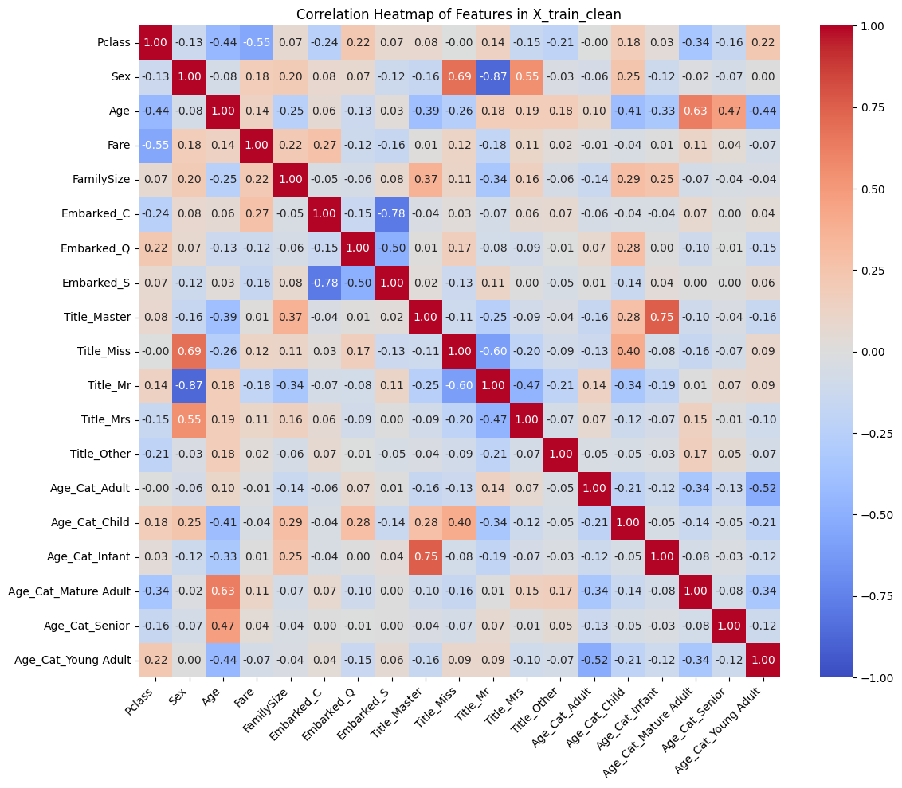
Highly Correlated Feature Pairs (|corr| > 0.7):
Sex and Title_Mr: -0.867
Embarked_C and Embarked_S: -0.783
Title_Master and Age_Cat_Infant: 0.751
*Through trial and error, the removal of Embarked_S and Age_Cat_Infant made the most sense. Embarked_C with its 1st Class passengers is likely more predictive of survivors, and though Title_Master represents one sex, it also represents a larger age demographic than Age_Cat_Infant. Sex and Title_Mr seemed to depreciate the model quality with their absence.

C4. Create Logistic Regression model with L1 Regularization (Lasso) using 17 features (correlated features removed). Generate confusion matrix, classification report, utilized features, and optimize C.
# Reduce feature set based on heatmap
features_to_keep = ['Pclass', 'Sex', 'Age', 'Fare', 'FamilySize', 'Embarked_C', 'Embarked_Q', 'Title_Master', 'Title_Miss', 'Title_Mr', 'Title_Mrs', 'Title_Other', 'Age_Cat_Adult', 'Age_Cat_Mature Adult',
'Age_Cat_Child', 'Age_Cat_Senior', 'Age_Cat_Young Adult']
X_train_reduced = X_train_clean[features_to_keep]
# L1 regularization (Lasso)
log_reg = LogisticRegression(random_state=42, max_iter=1000, class_weight={0: 1.0, 1: 1.6},
penalty='l1', solver='liblinear', C=0.6)
log_reg.fit(X_train_reduced, y_train)
# Cross-validation predictions
y_train_pred = cross_val_predict(log_reg, X_train_reduced, y_train, cv=5)
# Confusion Matrix and Classification Report
conf_matrix = confusion_matrix(y_train, y_train_pred)
print("\nConfusion Matrix (Logistic Regression (Lasso) with Class Weights and Scaling):")
print(conf_matrix)
print("\nClassification Report (Logistic Regression with L1 Regularization):")
print(classification_report(y_train, y_train_pred))
# Cross-validation scores
cv_scores = cross_val_score(log_reg, X_train_reduced, y_train, cv=5, scoring='accuracy')
cv_roc_auc = cross_val_score(log_reg, X_train_reduced, y_train, cv=5, scoring='roc_auc')
print("\nCross-Validation Accuracy Scores:", cv_scores)
print("Mean CV Accuracy: {:.3f} (+/- {:.3f})".format(cv_scores.mean(), cv_scores.std() * 2))
print(f"ROC-AUC: {cv_roc_auc.mean():.3f} (+/- {cv_roc_auc.std() * 2:.3f})")
# Check which coefficients were set to zero (feature selection)
print("\nCoefficients (Features with 0 are effectively dropped):")
for feature, coef in zip(features_to_keep, log_reg.coef_[0]):
print(f"{feature}: {coef:.4f}")

Confusion Matrix (Logistic Regression (Lasso) with Class Weights and Scaling):
[[464 85]
[ 73 269]]
Classification Report (Logistic Regression with L1 Regularization):
precision recall f1-score support
0 0.86 0.85 0.85 549
1 0.76 0.79 0.77 342
accuracy 0.82 891
macro avg 0.81 0.82 0.81 891
weighted avg 0.82 0.82 0.82 891
Cross-Validation Accuracy Scores: [0.82681564 0.80898876 0.8258427 0.81460674 0.83707865]
Mean CV Accuracy: 0.823 (+/- 0.020)
ROC-AUC: 0.871 (+/- 0.051)
Coefficients (Features with 0 are effectively dropped):
Pclass: -0.9457
Sex: 2.9503
Age: -0.2852
Fare: 0.1940
FamilySize: -0.6499
Embarked_C: 0.4187
Embarked_Q: 0.0000
Title_Master: 3.0529
Title_Miss: 0.0000
Title_Mr: -0.0457
Title_Mrs: 0.4787
Title_Other: 0.0000
Age_Cat_Adult: 0.3854
Age_Cat_Mature Adult: 0.0000
Age_Cat_Child: 0.0000
Age_Cat_Senior: 0.0000
Age_Cat_Young Adult: 0.0000
*10 features were identified and used from the 17 features made available: Pclass, Sex, Age, Fare, FamilySize, Embarked_C, Title_Master, Title_Mr, Title_Mrs, Age_Cat_Adult C was optimized to 0.6

C5. Create Logistic Regression model with L2 Regularization (Ridge) using 17 features (correlated features removed). Generate confusion matrix, classification report, and optimize C.
log_reg_l2 = LogisticRegression(random_state=42, max_iter=1000, class_weight={0: 1.0, 1: 1.6},
penalty='l2', solver='lbfgs', C=0.7)
log_reg_l2.fit(X_train_reduced, y_train)
# Cross-validation predictions
y_train_pred = cross_val_predict(log_reg, X_train_reduced, y_train, cv=5)
# Confusion Matrix and Classification Report
conf_matrix = confusion_matrix(y_train, y_train_pred)
print("\nConfusion Matrix (Logistic Regression (Ridge) with Class Weights and Scaling):")
print(conf_matrix)
print("\nClassification Report (Logistic Regression with L2 Regularization):")
print(classification_report(y_train, y_train_pred))
# Cross-validation scores
cv_scores_l2 = cross_val_score(log_reg_l2, X_train_reduced, y_train, cv=5, scoring='accuracy')
cv_roc_auc = cross_val_score(log_reg_l2, X_train_reduced, y_train, cv=5, scoring='roc_auc')
print("\nCross-Validation Accuracy Scores:", cv_scores_l2)
print("Mean CV Accuracy: {:.3f} (+/- {:.3f})".format(cv_scores_l2.mean(), cv_scores_l2.std() * 2))
print(f"ROC-AUC: {cv_roc_auc.mean():.3f} (+/- {cv_roc_auc.std() * 2:.3f})")
Confusion Matrix (Logistic Regression (Ridge) with Class Weights and Scaling):
[[464 85]
[ 73 269]]
Classification Report (Logistic Regression with L2 Regularization):
precision recall f1-score support
0 0.86 0.85 0.85 549
1 0.76 0.79 0.77 342
accuracy 0.82 891
macro avg 0.81 0.82 0.81 891
weighted avg 0.82 0.82 0.82 891
Cross-Validation Accuracy Scores: [0.81005587 0.81460674 0.8258427 0.81460674 0.8258427 ]
Mean CV Accuracy: 0.818 (+/- 0.013)
ROC-AUC: 0.868 (+/- 0.050)
*C was optimized to 0.7
C6. Create Logistic Regression model with porportional regularization (ElasticNet) using 17 features (correlated features removed). Generate confusion matrix, classification report, and optimize l1-ratio and C.
# Feature set (same as used previously)
features_to_keep = ['Pclass', 'Sex', 'Age', 'Fare', 'FamilySize', 'Embarked_C', 'Embarked_Q',
'Title_Master', 'Title_Miss', 'Title_Mr', 'Title_Mrs', 'Title_Other',
'Age_Cat_Adult', 'Age_Cat_Mature Adult', 'Age_Cat_Child', 'Age_Cat_Senior', 'Age_Cat_Young Adult']
X_train_reduced = X_train_clean[features_to_keep]
# Elastic Net regularization (C=0.6, l1_ratio=1.0)
log_reg_en = LogisticRegression(random_state=42, max_iter=1000, class_weight={0: 1.0, 1: 1.6},
penalty='elasticnet', solver='saga', l1_ratio=1.0, C=0.6)
log_reg_en.fit(X_train_reduced, y_train)
# Cross-validation predictions
y_train_pred = cross_val_predict(log_reg_en, X_train_reduced, y_train, cv=5)
# Confusion Matrix and Classification Report
conf_matrix = confusion_matrix(y_train, y_train_pred)
print("\nConfusion Matrix (Logistic Regression with Class Weights and Scaling):")
print(conf_matrix)
print("\nClassification Report (Elastic Net, l1_ratio=1.0):")
print(classification_report(y_train, y_train_pred))
# Cross-validation scores
cv_scores_en = cross_val_score(log_reg_en, X_train_reduced, y_train, cv=5, scoring='accuracy')
cv_roc_auc = cross_val_score(log_reg_en, X_train_reduced, y_train, cv=5, scoring='roc_auc')
print("\nCross-Validation Accuracy Scores:", cv_scores_en)
print("Mean CV Accuracy: {:.3f} (+/- {:.3f})".format(cv_scores_en.mean(), cv_scores_en.std() * 2))
print(f"ROC-AUC: {cv_roc_auc.mean():.3f} (+/- {cv_roc_auc.std() * 2:.3f})")
# Check coefficients
print("\nCoefficients (Elastic Net):")
for feature, coef in zip(features_to_keep, log_reg_en.coef_[0]):
print(f"{feature}: {coef:.4f}")
Confusion Matrix (Logistic Regression with Class Weights and Scaling):
[[461 88]
[ 73 269]]
Classification Report (Elastic Net, l1_ratio=1.0):
precision recall f1-score support
0 0.86 0.84 0.85 549
1 0.75 0.79 0.77 342
accuracy 0.82 891
macro avg 0.81 0.81 0.81 891
weighted avg 0.82 0.82 0.82 891
Cross-Validation Accuracy Scores: [0.82122905 0.80898876 0.8258427 0.81460674 0.8258427 ]
Mean CV Accuracy: 0.819 (+/- 0.013)
ROC-AUC: 0.869 (+/- 0.049)
Coefficients (Elastic Net):
Pclass: -1.0078
Sex: 2.5642
Age: -0.3143
Fare: 0.1719
FamilySize: -0.6441
Embarked_C: 0.3872
Embarked_Q: 0.0000
Title_Master: 2.6085
Title_Miss: 0.0000
Title_Mr: -0.4012
Title_Mrs: 0.5323
Title_Other: 0.0000
Age_Cat_Adult: 0.3259
Age_Cat_Mature Adult: -0.0926
Age_Cat_Child: 0.0000
Age_Cat_Senior: 0.0000
Age_Cat_Young Adult: -0.0275

*12 features were identified and used from the 17 features made available: Pclass, Sex, Age, Fare, FamilySize, Embarked_C, Title_Master, Title_Mr, Title_Mrs, Age_Cat_Adult, Age_Cat_Mature Adult, Age_Cat_Young Adult l1_ratio was optimized to 1.0, indicating full L1 regularization, and C was optimized 0.6, same as Lasso. Results differed because Lasso used the 'liblinear' solver and ElasticNet used the 'saga' solver.
D1. Create a Linear SVM model from L1 Regularization (Lasso) reduction 10 features. Generate confusion matrix, classification report, and optimize C.
# Linear SVM model features from L1 Regularization (Lasso) reduction.
final_features = ['Pclass', 'Sex', 'Age', 'Fare', 'FamilySize', 'Embarked_C',
'Title_Master', 'Title_Mr', 'Title_Mrs', 'Age_Cat_Adult']
X_train_final = X_train_clean[final_features]
# X_test_final = X_test_clean[final_features]
# Linear SVM with class weights
svm_linear = SVC(kernel='linear', class_weight={0: 1.0, 1: 1.6}, random_state=42, probability=True, C=2.0)
svm_linear.fit(X_train_final, y_train)
# Cross-validation predictions
y_train_pred = cross_val_predict(svm_linear, X_train_final, y_train, cv=5)
# Confusion Matrix and Classification Report
conf_matrix = confusion_matrix(y_train, y_train_pred)
print("\nConfusion Matrix (Linear SVM with Class Weights and Scaling):")
print(conf_matrix)
print("\nClassification Report (Linear SVM, C=2.0):")
print(classification_report(y_train, y_train_pred))
# Cross-validation scores
cv_scores_linear = cross_val_score(svm_linear, X_train_final, y_train, cv=5, scoring='accuracy')
cv_roc_auc = cross_val_score(svm_linear, X_train_final, y_train, cv=5, scoring='roc_auc')
print("\nCross-Validation Accuracy Scores:", cv_scores_linear)
print("Mean CV Accuracy: {:.3f} (+/- {:.3f})".format(cv_scores_linear.mean(), cv_scores_linear.std() * 2))
print(f"ROC-AUC: {cv_roc_auc.mean():.3f} (+/- {cv_roc_auc.std() * 2:.3f})")
Confusion Matrix (Linear SVM with Class Weights and Scaling):
[[470 79]
[ 87 255]]

Classification Report (Linear SVM, C=2.0):
precision recall f1-score support
0 0.84 0.86 0.85 549
1 0.76 0.75 0.75 342
accuracy 0.81 891
macro avg 0.80 0.80 0.80 891
weighted avg 0.81 0.81 0.81 891
Cross-Validation Accuracy Scores: [0.81564246 0.82022472 0.80337079 0.78651685 0.84269663]
Mean CV Accuracy: 0.814 (+/- 0.037)
ROC-AUC: 0.859 (+/- 0.068)
*C was optimized to 2.0
D2. Create a RBF SVM model from L1 Regularization (Lasso) reduction 10 features. Generate confusion matrix, classification report, and optimize C and gamma.
# RBF SVM with class weights
svm_rbf = SVC(kernel='rbf', class_weight={0: 1.0, 1: 1.6}, random_state=42, probability=True, C=2.3, gamma='scale')
svm_rbf.fit(X_train_final, y_train)
# Cross-validation predictions
y_train_pred_rbf = cross_val_predict(svm_rbf, X_train_final, y_train, cv=5)
# Confusion Matrix and Classification Report
conf_matrix = confusion_matrix(y_train, y_train_pred)
print("\nConfusion Matrix (RBF SVM with Class Weights and Scaling):")
print(conf_matrix)
print("\nClassification Report (RBF SVM, C=2.3, gamma='scale'):")
print(classification_report(y_train, y_train_pred_rbf))
# Cross-validation scores
cv_scores_rbf = cross_val_score(svm_rbf, X_train_final, y_train, cv=5, scoring='accuracy')
cv_roc_auc = cross_val_score(svm_rbf, X_train_final, y_train, cv=5, scoring='roc_auc')
print("\nCross-Validation Accuracy Scores:", cv_scores_rbf)
print("Mean CV Accuracy: {:.3f} (+/- {:.3f})".format(cv_scores_rbf.mean(), cv_scores_rbf.std() * 2))
print(f"ROC-AUC: {cv_roc_auc.mean():.3f} (+/- {cv_roc_auc.std() * 2:.3f})")

Confusion Matrix (RBF SVM with Class Weights and Scaling):
[[470 79]
[ 87 255]]
Classification Report (RBF SVM, C=2.3, gamma='scale'):
precision recall f1-score support
0 0.85 0.86 0.86 549
1 0.77 0.77 0.77 342
accuracy 0.82 891
macro avg 0.81 0.81 0.81 891
weighted avg 0.82 0.82 0.82 891
Cross-Validation Accuracy Scores: [0.82681564 0.82022472 0.83707865 0.78651685 0.84269663]
Mean CV Accuracy: 0.823 (+/- 0.039)
ROC-AUC: 0.854 (+/- 0.064)
# Define parameter grid
param_grid = {
'C': [2.2, 2.3, 2.4],
'gamma': ['scale', 'auto', 0.01, 0.1, 1.0]
}
# Grid search for RBF SVM
svm_rbf_grid = SVC(kernel='rbf', class_weight={0: 1.0, 1: 1.6}, random_state=42, probability=True)
grid_search = GridSearchCV(svm_rbf_grid, param_grid, cv=5, scoring='accuracy', n_jobs=-1)
grid_search.fit(X_train_final, y_train)
# Best parameters and performance
print("\nBest Parameters (RBF SVM):", grid_search.best_params_)
print("Best Mean CV Accuracy (RBF SVM): {:.3f}".format(grid_search.best_score_))
# Evaluate best model
best_svm = grid_search.best_estimator_
y_train_pred_best = cross_val_predict(best_svm, X_train_final, y_train, cv=5)
print("\nClassification Report (Tuned RBF SVM):")
print(classification_report(y_train, y_train_pred_best))
Best Parameters (RBF SVM): {'C': 2.3, 'gamma': 'scale'}
Best Mean CV Accuracy (RBF SVM): 0.823
Classification Report (Tuned RBF SVM):
precision recall f1-score support
0 0.85 0.86 0.86 549
1 0.77 0.77 0.77 342
accuracy 0.82 891
macro avg 0.81 0.81 0.81 891
weighted avg 0.82 0.82 0.82 891
*C was optimized at 2.3, and gamma was optimized at 'scale'.
D3. Use SHAP feature importance with all 19 features to find an optimal feature set. Create a RBF SVM model from those features. Generate confusion matrix, classification report, and optimize C and gamma.
# Step 1: Verify shapes to catch potential mismatches
print(f"X_train_clean shape: {X_train_clean.shape}")
print(f"y_train shape: {y_train.shape}")
# Ensure shapes match
if X_train_clean.shape[0] != y_train.shape[0]:
raise ValueError(f"Shape mismatch: X_train_clean has {X_train_clean.shape[0]} samples, but y_train has {y_train.shape[0]} samples")
# Step 2: Ensure X_train_clean is a DataFrame
if not isinstance(X_train_clean, pd.DataFrame):
X_train_clean = pd.DataFrame(X_train_clean, columns=[f'Feature_{i}' for i in range(X_train_clean.shape[1])])
# Step 3: Check for non-numeric data and NaNs
non_numeric_cols = X_train_clean.select_dtypes(exclude=[np.number]).columns
if len(non_numeric_cols) > 0:
raise ValueError(f"Non-numeric columns found in X_train_clean: {non_numeric_cols}")
if X_train_clean.isna().sum().sum() > 0:
print("NaNs found in X_train_clean. Imputing with mean...")
X_train_clean = X_train_clean.fillna(X_train_clean.mean())
# Verify the number of features in X_train_clean
print(f"Number of features in X_train_clean: {X_train_clean.shape[1]}") # Should be 19
# Get feature names
feature_names = X_train_clean.columns.tolist()
# Step 4: Train Random Forest for SHAP
rf_base = RandomForestClassifier(random_state=42)
rf_base.fit(X_train_clean, y_train)
# Compute SHAP values and debug shape
explainer = shap.TreeExplainer(rf_base)
shap_values = explainer.shap_values(X_train_clean)
# Debug: Check the type and structure of shap_values
print("Type of shap_values:", type(shap_values))
if isinstance(shap_values, list):
print(f"Number of elements in shap_values list: {len(shap_values)}")
print(f"shap_values[0] shape: {np.array(shap_values[0]).shape}") # Should be (891, 19)
print(f"shap_values[1] shape: {np.array(shap_values[1]).shape}") # Should be (891, 19)
else:
print(f"shap_values shape: {np.array(shap_values).shape}") # Should be (2, 891, 19) or (891, 19, 2)
# Calculate mean absolute SHAP values for the positive class (Survived)
# Handle both cases: shap_values as a list or as a 3D array
if isinstance(shap_values, list):
# Case 1: shap_values is a list of arrays (binary classification)
shap_values_pos = shap_values[1] # SHAP values for class 1 (Survived)
else:
# Case 2: shap_values is a 3D array (samples, features, classes)
# If shape is (891, 19, 2), select the last dimension for class 1
shap_values_pos = shap_values[:, :, 1] # Should be (891, 19)
# Verify the shape of shap_values_pos
print(f"shap_values_pos shape: {shap_values_pos.shape}") # Should be (891, 19)
# Compute mean absolute SHAP values across samples (axis=0)
shap_importance = np.abs(shap_values_pos).mean(axis=0)
print(f"shap_importance shape: {shap_importance.shape}") # Should be (19,)
if len(shap_importance) != len(feature_names):
raise ValueError(f"Mismatch: shap_importance has {len(shap_importance)} elements, but feature_names has {len(feature_names)} elements")
shap_importance_df = pd.DataFrame({'Feature': feature_names, 'SHAP Importance': shap_importance})
shap_importance_df = shap_importance_df.sort_values(by='SHAP Importance', ascending=False)
# Display the full feature importance list
print(f"\nFeature Importance by SHAP (All {X_train_clean.shape[1]} Features):")
print(shap_importance_df)
# Step 5: Select top features
top_n = 17 # Adjustable
top_features = shap_importance_df['Feature'].head(top_n).values
print(f"\nTop {top_n} Features by SHAP Importance for RBF SVM:")
print(shap_importance_df.head(top_n))
# Create reduced dataset
X_train_svm_df = X_train_clean[top_features]
# Step 6: Evaluate RBF SVM
svm_rbf = SVC(kernel='rbf', class_weight={0: 1.0, 1: 1.6}, random_state=42, probability=True, C=2.4, gamma='auto')
svm_rbf.fit(X_train_svm_df, y_train)
# Cross-validation predictions
y_train_pred_rbf = cross_val_predict(svm_rbf, X_train_svm_df, y_train, cv=5)
# Confusion Matrix and Classification Report
conf_matrix = confusion_matrix(y_train, y_train_pred_rbf)
print("\nConfusion Matrix (RBF SVM with Class Weights and SHAP Feature Selection):")
print(conf_matrix)
print("\nClassification Report (RBF SVM, C=2.4, gamma='auto'):")
print(classification_report(y_train, y_train_pred_rbf))
# Cross-validation scores
cv_scores_rbf = cross_val_score(svm_rbf, X_train_svm_df, y_train, cv=5, scoring='accuracy')
cv_roc_auc = cross_val_score(svm_rbf, X_train_svm_df, y_train, cv=5, scoring='roc_auc')
print("\nCross-Validation Accuracy Scores:", cv_scores_rbf)
print("Mean CV Accuracy: {:.3f} (+/- {:.3f})".format(cv_scores_rbf.mean(), cv_scores_rbf.std() * 2))
print(f"ROC-AUC: {cv_roc_auc.mean():.3f} (+/- {cv_roc_auc.std() * 2:.3f})")
# Fit the model on the full training set
#svm_rbf.fit(X_train_svm_df, y_train)

X_train_clean shape: (891, 19)
y_train shape: (891,)
Number of features in X_train_clean: 19
Type of shap_values: <class 'numpy.ndarray'>
shap_values shape: (891, 19, 2)
shap_values_pos shape: (891, 19)
shap_importance shape: (19,)
Feature Importance by SHAP (All 19 Features):
Feature SHAP Importance
1 Sex 0.103939
10 Title_Mr 0.082457
0 Pclass 0.079975
3 Fare 0.064846
2 Age 0.039795
11 Title_Mrs 0.032820
4 FamilySize 0.031289
9 Title_Miss 0.030077
7 Embarked_S 0.017285
5 Embarked_C 0.013930
13 Age_Cat_Adult 0.013491
18 Age_Cat_Young Adult 0.009890
8 Title_Master 0.008604
16 Age_Cat_Mature Adult 0.007632
6 Embarked_Q 0.005871
14 Age_Cat_Child 0.004868
15 Age_Cat_Infant 0.003061
12 Title_Other 0.002123
17 Age_Cat_Senior 0.002087
Top 17 Features by SHAP Importance for RBF SVM:
Feature SHAP Importance
1 Sex 0.103939
10 Title_Mr 0.082457
0 Pclass 0.079975
3 Fare 0.064846
2 Age 0.039795
11 Title_Mrs 0.032820
4 FamilySize 0.031289
9 Title_Miss 0.030077
7 Embarked_S 0.017285
5 Embarked_C 0.013930
13 Age_Cat_Adult 0.013491
18 Age_Cat_Young Adult 0.009890
8 Title_Master 0.008604
16 Age_Cat_Mature Adult 0.007632
6 Embarked_Q 0.005871
14 Age_Cat_Child 0.004868
15 Age_Cat_Infant 0.003061
Confusion Matrix (RBF SVM with Class Weights and SHAP Feature Selection):
[[481 68]
[ 86 256]]
Classification Report (RBF SVM, C=2.4, gamma='auto'):
precision recall f1-score support
0 0.85 0.88 0.86 549
1 0.79 0.75 0.77 342
accuracy 0.83 891
macro avg 0.82 0.81 0.82 891
weighted avg 0.83 0.83 0.83 891
Cross-Validation Accuracy Scores: [0.84357542 0.82022472 0.81460674 0.79213483 0.86516854]
Mean CV Accuracy: 0.827 (+/- 0.050)
ROC-AUC: 0.850 (+/- 0.075)
*After evaluating all feature group sizes, the top 17 SHAP features performed the best, excluding Age_Cat_Infant and Age_Cat_Child.
# Define parameter grid
param_grid = {
'C': [2.3, 2.4, 2.5],
'gamma': ['scale', 'auto', 0.01, 0.1, 1.0]
}
# Grid search for RBF SVM
svm_rbf_grid = SVC(kernel='rbf', class_weight={0: 1.0, 1: 1.6}, random_state=42, probability=True)
grid_search = GridSearchCV(svm_rbf_grid, param_grid, cv=5, scoring='accuracy', n_jobs=-1)
grid_search.fit(X_train_svm_df, y_train)
# Best parameters and performance
print("\nBest Parameters (RBF SVM):", grid_search.best_params_)
print("Best Mean CV Accuracy (RBF SVM): {:.3f}".format(grid_search.best_score_))
# Evaluate best model
best_svm = grid_search.best_estimator_
y_train_pred_best = cross_val_predict(best_svm, X_train_svm_df, y_train, cv=5)
print("\nClassification Report (Tuned RBF SVM):")
print(classification_report(y_train, y_train_pred_best))
Best Parameters (RBF SVM): {'C': 2.4, 'gamma': 'auto'}
Best Mean CV Accuracy (RBF SVM): 0.827
Classification Report (Tuned RBF SVM):
precision recall f1-score support
0 0.85 0.88 0.86 549
1 0.79 0.75 0.77 342
accuracy 0.83 891
macro avg 0.82 0.81 0.82 891
weighted avg 0.83 0.83 0.83 891
*C was optimized at 2.4, and gamma was optimized at 'auto'.
E. Use XGBoost feature importance with 17 features (correlated features removed) to find an optimal feature set. Create a XGBoost model from those features. Generate confusion matrix, classification report, and optimize all potentially relevant hyperparameters.
# Define the 17 features
reduced_features = ['Pclass', 'Sex', 'Age', 'Fare', 'Embarked_C', 'Embarked_Q',
'FamilySize', 'Title_Mr', 'Title_Mrs', 'Title_Miss', 'Title_Master', 'Title_Other',
'Age_Cat_Adult', 'Age_Cat_Young_Adult', 'Age_Cat_Mature_Adult', 'Age_Cat_Child', 'Age_Cat_Senior']
# Initialize XGBoost with optimized parameters
xgb = XGBClassifier(
random_state=42,
eval_metric='logloss',
max_depth=4,
learning_rate=0.2,
n_estimators=50,
min_child_weight=3,
reg_alpha=0.01,
reg_lambda=0,
gamma=0.1,
subsample=0.8,
colsample_bytree=0.8
)
# Fit with sample weights
sample_weights = np.array([1.0 if y == 0 else 1.6 for y in y_train]) # Custom weights
xgb.fit(X_train_reduced, y_train, sample_weight=sample_weights)
# After fitting gb.fit(X_train_reduced, y_train, sample_weight=sample_weights) in the Gradient Boosting code
perm_importance_xgb = permutation_importance(xgb, X_train_reduced, y_train, n_repeats=10, random_state=42, n_jobs=-1)
perm_importance_df_xgb = pd.DataFrame({
'Feature': reduced_features,
'Importance': perm_importance_xgb.importances_mean,
'Std': perm_importance_xgb.importances_std
}).sort_values(by='Importance', ascending=False)
print("\nXGBoost Permutation Feature Importance (17 features):")
print(perm_importance_df_xgb)
plt.figure(figsize=(12, 8))
plt.barh(perm_importance_df_xgb['Feature'], perm_importance_df_xgb['Importance'], xerr=perm_importance_df_xgb['Std'], color='skyblue')
plt.xlabel('Permutation Importance')
plt.title('XGBoost Permutation Feature Importance (17 Features)')
plt.gca().invert_yaxis()
plt.show()
# Extract feature importances
xgb_importances = pd.DataFrame({
'Feature': reduced_features,
'Importance': xgb.feature_importances_
}).sort_values(by='Importance', ascending=False)
print("\nXGBoost Feature Importances (17 features):")
print(xgb_importances)
# Select top unique features (15 yielded best results)
top_xgb_features = xgb_importances.nlargest(15, 'Importance')['Feature'].unique().tolist()
print(f"\nTop 15 XGBoost features: {top_xgb_features}")
# Create reduced dataset using iloc for DataFrame
top_xgb_indices = [reduced_features.index(f) for f in top_xgb_features]
X_train_xgb_reduced = X_train_reduced.iloc[:, top_xgb_indices].to_numpy() # Use iloc and convert to NumPy
# X_test_xgb_reduced = X_test_reduced.iloc[:, top_xgb_indices].to_numpy() # Use iloc and convert to NumPy
print(f"X_train_xgb_reduced shape: {X_train_xgb_reduced.shape}")
# print(f"X_test_xgb_reduced shape: {X_test_xgb_reduced.shape}")

XGBoost Permutation Feature Importance (17 features):
Feature Importance Std
9 Title_Miss 0.094164 0.005755
1 Sex 0.076431 0.005275
0 Pclass 0.071942 0.007452
2 Age 0.055331 0.006128
3 Fare 0.049495 0.007959
4 Embarked_C 0.040404 0.004318
11 Title_Other 0.008530 0.000898
12 Age_Cat_Adult 0.004489 0.003367
8 Title_Mrs 0.004265 0.001931
16 Age_Cat_Senior 0.003030 0.002357
5 Embarked_Q 0.003030 0.003055
13 Age_Cat_Young_Adult 0.001347 0.001571
14 Age_Cat_Mature_Adult 0.001122 0.001587
10 Title_Master 0.000561 0.000753
15 Age_Cat_Child 0.000224 0.000449
6 FamilySize -0.000112 0.001908
7 Title_Mr -0.000224 0.000673
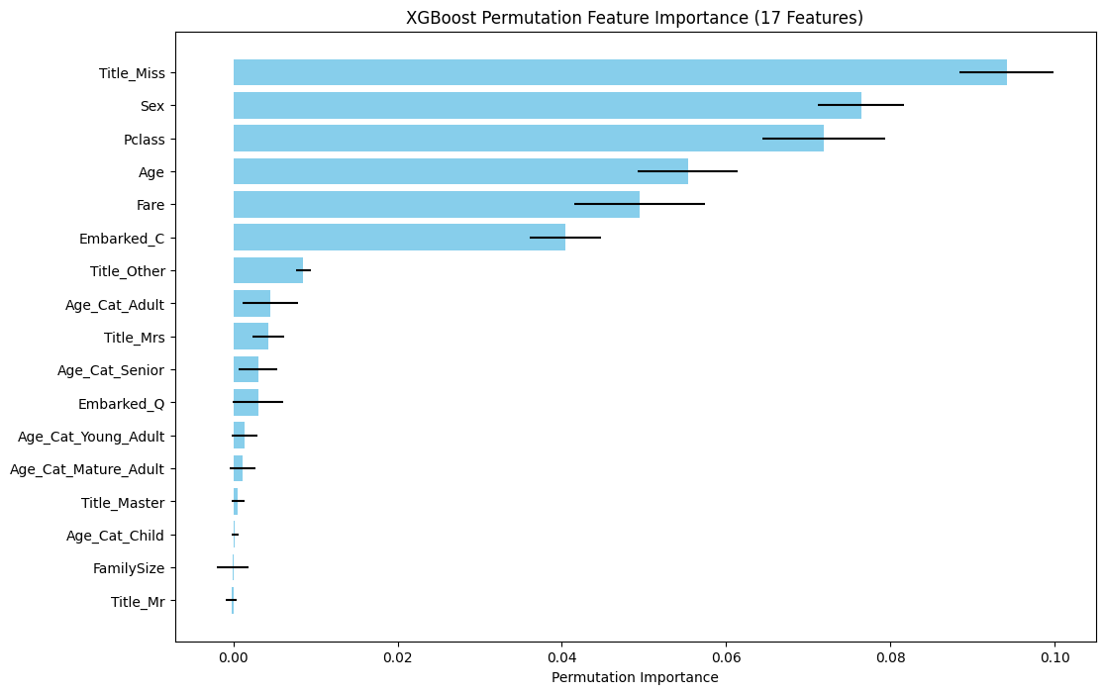

XGBoost Feature Importances (17 features):
Feature Importance
1 Sex 0.275807
9 Title_Miss 0.219355
7 Title_Mr 0.094512
11 Title_Other 0.068770
0 Pclass 0.056463
4 Embarked_C 0.051230
3 Fare 0.029573
14 Age_Cat_Mature_Adult 0.029109
15 Age_Cat_Child 0.027400
2 Age 0.026226
12 Age_Cat_Adult 0.024870
5 Embarked_Q 0.022167
6 FamilySize 0.018061
16 Age_Cat_Senior 0.016090
13 Age_Cat_Young_Adult 0.014734
8 Title_Mrs 0.014564
10 Title_Master 0.011069
Top 15 XGBoost features: ['Sex', 'Title_Miss', 'Title_Mr', 'Title_Other', 'Pclass', 'Embarked_C', 'Fare', 'Age_Cat_Mature_Adult', 'Age_Cat_Child', 'Age', 'Age_Cat_Adult', 'Embarked_Q', 'FamilySize', 'Age_Cat_Senior', 'Age_Cat_Young_Adult']
X_train_xgb_reduced shape: (891, 15)
*After evaluating all feature group sizes, the top 15 XGBoost importance features performed the best, excluding Title_Mrs and Title_Master.
# Initial XGBoost model with class weighting
xgb_model = XGBClassifier(
scale_pos_weight=1.6, # Matches class_weight={0: 1.0, 1: 1.6}
random_state=42,
eval_metric='logloss',
max_depth=4,
learning_rate=0.2,
n_estimators=50,
min_child_weight=3,
reg_alpha=0.01,
reg_lambda=0,
gamma=0.1,
subsample=0.8,
colsample_bytree=0.8
)
xgb_model.fit(X_train_xgb_reduced, y_train)

# Cross-validation scores
cv_scores_xgb = cross_val_score(xgb_model, X_train_xgb_reduced, y_train, cv=5, scoring='accuracy')
cv_roc_auc = cross_val_score(xgb_model, X_train_xgb_reduced, y_train, cv=5, scoring='roc_auc')
print("\nCross-Validation Accuracy Scores:", cv_scores_xgb)
print("Mean CV Accuracy: {:.3f} (+/- {:.3f})".format(cv_scores_xgb.mean(), cv_scores_xgb.std() * 2))
print(f"ROC-AUC: {cv_roc_auc.mean():.3f} (+/- {cv_roc_auc.std() * 2:.3f})")
# Cross-validation predictions
y_train_pred_xgb = cross_val_predict(xgb_model, X_train_xgb_reduced, y_train, cv=5)
# Confusion Matrix and Classification Report
conf_matrix = confusion_matrix(y_train, y_train_pred_xgb)
print("\nConfusion Matrix (XGBoost Classifier with Class Weights and Scaling):")
print(conf_matrix)
print("\nClassification Report (XGBoost):")
print(classification_report(y_train, y_train_pred_xgb))
Cross-Validation Accuracy Scores: [0.84357542 0.83707865 0.85393258 0.83146067 0.85393258]
Mean CV Accuracy: 0.844 (+/- 0.018)
ROC-AUC: 0.866 (+/- 0.056)
Confusion Matrix (XGBoost Classifier with Class Weights and Scaling):
[[479 70]
[ 69 273]]
Classification Report (XGBoost):
precision recall f1-score support
0 0.87 0.87 0.87 549
1 0.80 0.80 0.80 342
accuracy 0.84 891
macro avg 0.84 0.84 0.84 891
weighted avg 0.84 0.84 0.84 891

# Define parameter grid
param_grid = {
'max_depth': [4],
'learning_rate': [0.2],
'n_estimators': [50],
'min_child_weight': [3],
'reg_alpha': [0.01],
'reg_lambda': [0],
'gamma': [0.1],
'subsample': [0.8],
'colsample_bytree': [0.8]
}
# Initialize XGBoost model with class weighting
xgb_model = XGBClassifier(
scale_pos_weight=1.6, # Matches class_weight={0: 1.0, 1: 1.6}
random_state=42,
eval_metric='logloss'
)
# Grid search
grid_search = GridSearchCV(
estimator=xgb_model,
param_grid=param_grid,
cv=5,
scoring='accuracy',
n_jobs=-1, # Use all available cores
verbose=1
)
# Fit the grid search
grid_search.fit(X_train_xgb_reduced, y_train)
# Best parameters and performance
print("\nBest Parameters:", grid_search.best_params_)
print(f"Best Mean CV Accuracy: {grid_search.best_score_:.3f}")
# Evaluate best model
best_xgb = grid_search.best_estimator_
y_train_pred_best = cross_val_predict(best_xgb, X_train_xgb_reduced, y_train, cv=5)
print("\nClassification Report (Optimized XGBoost):")
print(classification_report(y_train, y_train_pred_best))

# Cross-validation scores for the best model
cv_scores_best = cross_val_score(best_xgb, X_train_xgb_reduced, y_train, cv=5, scoring='accuracy')
print(f"\nCross-Validation Accuracy Scores (Optimized XGBoost): {cv_scores_best}")
print(f"Mean CV Accuracy (Optimized XGBoost): {cv_scores_best.mean():.3f} (+/- {cv_scores_best.std() * 2:.3f})")
Fitting 5 folds for each of 1 candidates, totalling 5 fits
Best Parameters: {'colsample_bytree': 0.8, 'gamma': 0.1, 'learning_rate': 0.2, 'max_depth': 4, 'min_child_weight': 3, 'n_estimators': 50, 'reg_alpha': 0.01, 'reg_lambda': 0, 'subsample': 0.8}
Best Mean CV Accuracy: 0.829
Classification Report (Optimized XGBoost):
precision recall f1-score support
0 0.87 0.87 0.87 549
1 0.80 0.80 0.80 342
accuracy 0.84 891
macro avg 0.84 0.84 0.84 891
weighted avg 0.84 0.84 0.84 891
Cross-Validation Accuracy Scores (Optimized XGBoost): [0.84357542 0.83707865 0.85393258 0.83146067 0.85393258]
Mean CV Accuracy (Optimized XGBoost): 0.844 (+/- 0.018)
*XGBoost hyperparameters were optimized.
F. Use GradientBoosting feature importance with 17 features (correlated features removed) to find an optimal feature set. Create a GradientBoosting model from those features. Generate confusion matrix, classification report, and optimize all potentially relevant hyperparameters.
# Initialize Gradient Boosting with optimized parameters
gb = GradientBoostingClassifier(
max_depth=3,
learning_rate=0.05,
n_estimators=100,
min_samples_split=5,
subsample=0.8,
random_state=42
)
# Define sample weights
sample_weights = np.array([1.0 if y == 0 else 1.6 for y in y_train])
# Fit the model on the full training data to extract feature importance later
gb.fit(X_train_reduced, y_train, sample_weight=sample_weights)
# After fitting gb.fit(X_train_reduced, y_train, sample_weight=sample_weights) in the Gradient Boosting code
perm_importance_gb = permutation_importance(gb, X_train_reduced, y_train, n_repeats=10, random_state=42, n_jobs=-1)
perm_importance_df_gb = pd.DataFrame({
'Feature': reduced_features,
'Importance': perm_importance_gb.importances_mean,
'Std': perm_importance_gb.importances_std
}).sort_values(by='Importance', ascending=False)
print("\nGradient Boosting Permutation Feature Importance (17 features):")
print(perm_importance_df_gb)
plt.figure(figsize=(12, 8))
plt.barh(perm_importance_df_gb['Feature'], perm_importance_df_gb['Importance'], xerr=perm_importance_df_gb['Std'], color='skyblue')
plt.xlabel('Permutation Importance')
plt.title('Gradient Boosting Permutation Feature Importance (17 Features)')
plt.gca().invert_yaxis()
plt.show()
# Use cross_val_predict to get cross-validated predictions
y_pred_cv = cross_val_predict(gb, X_train_reduced, y_train, cv=5, method='predict', n_jobs=-1)
# Evaluate performance using cross-validated predictions
accuracy = accuracy_score(y_train, y_pred_cv)
print(f"Cross-Validated Training Accuracy (17 features): {accuracy:.3f}")
print("\nCross-Validated Training Classification Report (17 features):")
print(classification_report(y_train, y_pred_cv, target_names=['Not Survived', 'Survived']))
# Extract feature importance (from the model fitted on the full data)
feature_importance = gb.feature_importances_
feature_names = reduced_features # All 17 features: ['Sex', 'Title_Miss', 'Title_Mr', 'Title_Other', 'Pclass', 'Embarked_C', 'Fare', 'Age_Cat_Mature_Adult', 'Age_Cat_Child', 'Age', 'Age_Cat_Adult', 'Embarked_Q', 'FamilySize', 'Age_Cat_Senior', 'Age_Cat_Young_Adult', 'Title_Mrs', 'Title_Master']
# Create a DataFrame with all feature importances
importance_df_all = pd.DataFrame({
'Feature': feature_names,
'Importance': feature_importance
}).sort_values(by='Importance', ascending=False)
print("\nGradient Boosting Feature Importance (All 17 features):")
print(importance_df_all)
# Plot feature importance for all 17 features
plt.figure(figsize=(12, 8))
plt.barh(importance_df_all['Feature'], importance_df_all['Importance'], color='skyblue')
plt.xlabel('Feature Importance')
plt.title('Gradient Boosting Feature Importance (17 Features)')
plt.gca().invert_yaxis()
plt.show()
# Specify the number of top features to select
n_features = 17 # Change this to any number between 1 and 17 (e.g., 8, 10, 15)
# Select the top N features and create a DataFrame
gb_importance_df = importance_df_all.head(n_features).copy()
# List the top N features
top_features_list = gb_importance_df['Feature'].tolist()
print(f"\nTop {n_features} Features from Gradient Boosting:")
for i, feature in enumerate(top_features_list, 1):
print(f"{i}. {feature}")
# Display the DataFrame with the top N features
print(f"\nGradient Boosting Feature Importance (Top {n_features} features):")
print(gb_importance_df)
# Extract indices of top features for subsetting the dataset
top_feature_indices = [reduced_features.index(f) for f in top_features_list]
X_train_top = X_train_reduced.iloc[:, top_feature_indices].to_numpy()
# X_test_top = X_test_reduced.iloc[:, top_feature_indices].to_numpy()
print(f"\nX_train_top shape: {X_train_top.shape}") # Expected: (891, n_features)
# print(f"X_test_top shape: {X_test_top.shape}") # Expected: (418, n_features)
# Retrain the model with the top N features
gb.fit(X_train_top, y_train, sample_weight=sample_weights)
# Use cross_val_predict again for the top N features
y_pred_cv_top = cross_val_predict(gb, X_train_top, y_train, cv=5, method='predict', n_jobs=-1)

# Evaluate performance using cross-validated predictions for top N features
accuracy_top = accuracy_score(y_train, y_pred_cv_top)
print(f"Cross-Validated Training Accuracy (Top {n_features} features): {accuracy_top:.3f}")
print("\nCross-Validated Training Classification Report (Top {n_features} features):")
print(classification_report(y_train, y_pred_cv_top, target_names=['Not Survived', 'Survived']))
Gradient Boosting Permutation Feature Importance (17 features):
Feature Importance Std
9 Title_Miss 0.111111 0.006602
1 Sex 0.046914 0.004964
0 Pclass 0.046689 0.004846
4 Embarked_C 0.045342 0.002935
3 Fare 0.033446 0.007322
2 Age 0.023120 0.003222
11 Title_Other 0.010101 0.000869
5 Embarked_Q 0.002245 0.001587
13 Age_Cat_Young_Adult 0.002245 0.002188
16 Age_Cat_Senior 0.001235 0.001275
10 Title_Master 0.000449 0.000744
7 Title_Mr 0.000224 0.000978
14 Age_Cat_Mature_Adult 0.000000 0.000000
15 Age_Cat_Child 0.000000 0.000000
8 Title_Mrs 0.000000 0.000000
6 FamilySize -0.000112 0.000337
12 Age_Cat_Adult -0.000561 0.002668
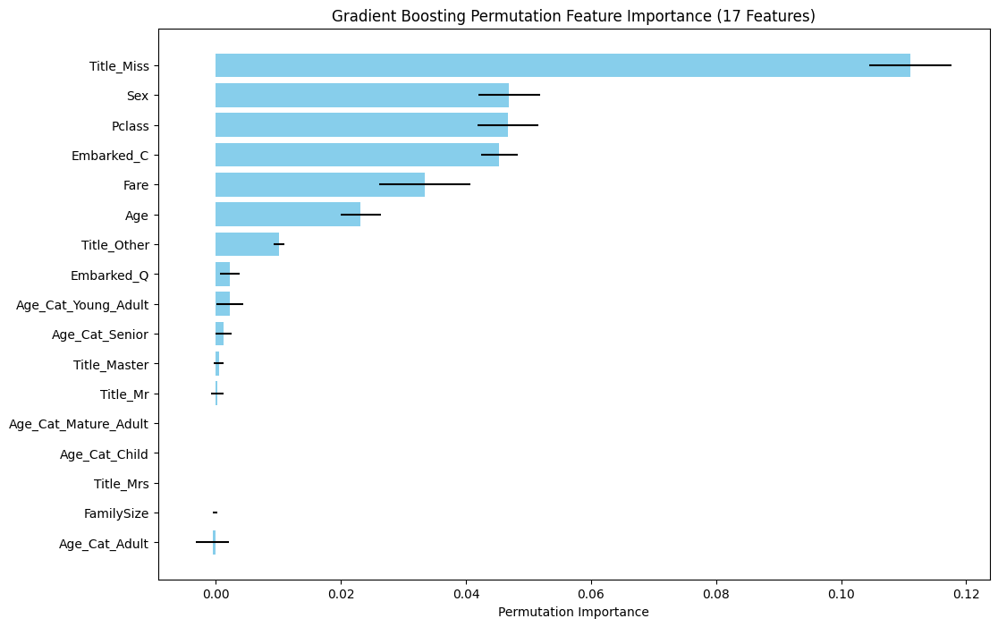
Cross-Validated Training Accuracy (17 features): 0.840
Cross-Validated Training Classification Report (17 features):
precision recall f1-score support
Not Survived 0.85 0.89 0.87 549
Survived 0.82 0.75 0.78 342
accuracy 0.84 891
macro avg 0.83 0.82 0.83 891
weighted avg 0.84 0.84 0.84 891
Gradient Boosting Feature Importance (All 17 features):
Feature Importance
9 Title_Miss 0.325720
1 Sex 0.171302
3 Fare 0.168732
4 Embarked_C 0.099521
0 Pclass 0.098934
2 Age 0.077405
11 Title_Other 0.015908
12 Age_Cat_Adult 0.009340
7 Title_Mr 0.008777
5 Embarked_Q 0.007922
13 Age_Cat_Young_Adult 0.007160
16 Age_Cat_Senior 0.003364
6 FamilySize 0.002256
8 Title_Mrs 0.002218
10 Title_Master 0.000963
14 Age_Cat_Mature_Adult 0.000480
15 Age_Cat_Child 0.000000
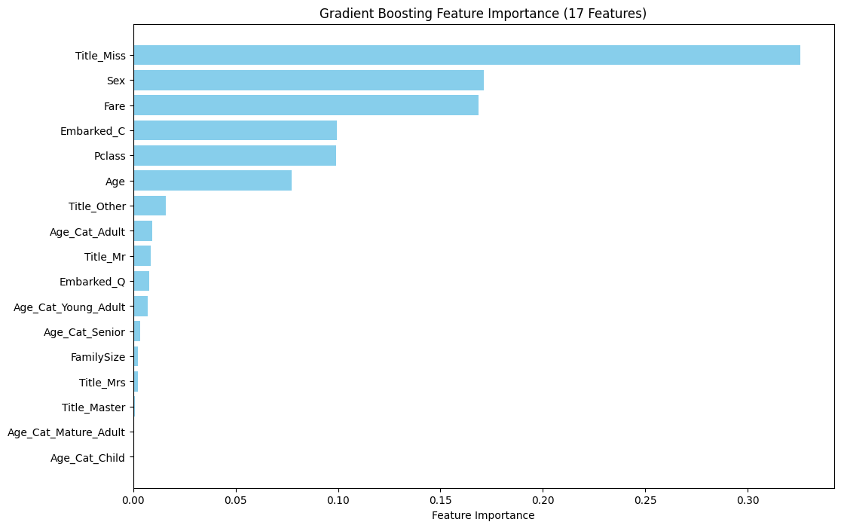
X_train_top shape: (891, 17)
Cross-Validated Training Accuracy (Top 17 features): 0.837
Cross-Validated Training Classification Report (Top {n_features} features):
precision recall f1-score support
Not Survived 0.85 0.89 0.87 549
Survived 0.81 0.75 0.78 342
accuracy 0.84 891
macro avg 0.83 0.82 0.83 891
weighted avg 0.84 0.84 0.84 891
*After evaluating all feature group sizes, all 17 GradientBoosting importance features performed the best.
# Initial Gradient Boosting model
gb_model = GradientBoostingClassifier(
max_depth=3,
learning_rate=0.05,
n_estimators=100,
min_samples_split=5,
subsample=0.8,
random_state=42
)
# Apply class weights manually via sample weights
sample_weights = y_train.map({0: 1.0, 1: 1.6})
gb_model.fit(X_train_reduced, y_train, sample_weight=sample_weights)
# Cross-validation scores
cv_scores_gb = cross_val_score(gb_model, X_train_reduced, y_train, cv=5, scoring='accuracy')
cv_roc_auc = cross_val_score(gb_model, X_train_reduced, y_train, cv=5, scoring='roc_auc')
print("\nCross-Validation Accuracy Scores (Gradient Boosting):", cv_scores_gb)
print(f"Mean CV Accuracy (Gradient Boosting): {cv_scores_gb.mean():.3f} (+/- {cv_scores_gb.std() * 2:.3f})")
print(f"ROC-AUC: {cv_roc_auc.mean():.3f} (+/- {cv_roc_auc.std() * 2:.3f})")
# Cross-validation predictions
y_train_pred_gb = cross_val_predict(gb_model, X_train_reduced, y_train, cv=5)

# Confusion Matrix and Classification Report
conf_matrix = confusion_matrix(y_train, y_train_pred_gb)
print("\nConfusion Matrix (Gradient Boosting Classifier with Class Weights and Scaling):")
print(conf_matrix)
print("\nClassification Report (Gradient Boosting):")
print(classification_report(y_train, y_train_pred_gb))
Cross-Validation Accuracy Scores (Gradient Boosting): [0.83240223 0.84269663 0.85393258 0.82022472 0.84831461]
Mean CV Accuracy (Gradient Boosting): 0.840 (+/- 0.024)
ROC-AUC: 0.879 (+/- 0.060)
Confusion Matrix (Gradient Boosting Classifier with Class Weights and Scaling):
[[491 58]
[ 85 257]]
Classification Report (Gradient Boosting):
precision recall f1-score support
0 0.85 0.89 0.87 549
1 0.82 0.75 0.78 342
accuracy 0.84 891
macro avg 0.83 0.82 0.83 891
weighted avg 0.84 0.84 0.84 891
# Ensure y_train is a pandas Series or numpy array
print("y_train shape:", y_train.shape)
# Define sample weights and convert to numpy array
sample_weights = y_train.map({0: 1.0, 1: 1.6}).to_numpy() # Convert to numpy array
print("Sample weights shape:", sample_weights.shape)
# Verify lengths match
assert len(sample_weights) == len(y_train), "Mismatch between sample weights and y_train lengths"
# Define the parameter grid
param_grid = {
'max_depth': [3],
'learning_rate': [0.05],
'n_estimators': [100],
'min_samples_split': [5],
'subsample': [0.8]
}
# Initialize the Gradient Boosting model
gb_model = GradientBoostingClassifier(random_state=42)
# Custom scoring to prioritize recall for Class 1
scorer = make_scorer(recall_score, average='binary', pos_label=1)
# Perform GridSearchCV with 5-fold cross-validation
grid_search = GridSearchCV(
estimator=gb_model,
param_grid=param_grid,
cv=5,
scoring=scorer, # Optimize for recall
n_jobs=-1, # Use all available cores
verbose=1
)
# Fit the grid search with sample weights
grid_search.fit(X_train_reduced, y_train, sample_weight=sample_weights)
# Print the best parameters and score
print("\nBest Parameters:", grid_search.best_params_)
print(f"Best Mean CV Recall (Class 1): {grid_search.best_score_:.3f}")
# Evaluate the best model on accuracy with manual cross-validation
best_gb = grid_search.best_estimator_
kf = KFold(n_splits=5, shuffle=True, random_state=42)
accuracy_scores = []
y_pred_all = np.zeros(len(y_train))
for train_idx, val_idx in kf.split(X_train_reduced):
X_train_fold = X_train_reduced.iloc[train_idx] if hasattr(X_train_reduced, 'iloc') else X_train_reduced[train_idx]
y_train_fold = y_train.iloc[train_idx] if hasattr(y_train, 'iloc') else y_train[train_idx]
X_val_fold = X_train_reduced.iloc[val_idx] if hasattr(X_train_reduced, 'iloc') else X_train_reduced[val_idx]
sample_weights_fold = sample_weights[train_idx]
best_gb.fit(X_train_fold, y_train_fold, sample_weight=sample_weights_fold)
y_pred_fold = best_gb.predict(X_val_fold)
accuracy = (y_pred_fold == y_train.iloc[val_idx] if hasattr(y_train, 'iloc') else y_train[val_idx]).mean()
accuracy_scores.append(accuracy)
y_pred_all[val_idx] = y_pred_fold
accuracy_mean = np.mean(accuracy_scores)
accuracy_std = np.std(accuracy_scores) * 2
print(f"Mean CV Accuracy with Best Model: {accuracy_mean:.3f} (+/- {accuracy_std:.3f})")
# Classification report
print("\nClassification Report (Optimized Gradient Boosting):")
print(classification_report(y_train, y_pred_all))
y_train shape: (891,)
Sample weights shape: (891,)
Fitting 5 folds for each of 1 candidates, totalling 5 fits
Best Parameters: {'learning_rate': 0.05, 'max_depth': 3, 'min_samples_split': 5, 'n_estimators': 100, 'subsample': 0.8}
Best Mean CV Recall (Class 1): 0.804
Mean CV Accuracy with Best Model: 0.825 (+/- 0.042)
Classification Report (Optimized Gradient Boosting):
precision recall f1-score support
0 0.87 0.85 0.86 549
1 0.76 0.79 0.78 342
accuracy 0.82 891
macro avg 0.81 0.82 0.82 891
weighted avg 0.83 0.82 0.83 891
*GradientBoosting hyperparameters were optimized.
G1. Create a AdaBoost model from 17 features (correlated features removed). Generate confusion matrix, classification report, and optimize all potentially relevant hyperparameters.
# Use optimized parameters (adjust these based on your results)
# Example: n_estimators=100, learning_rate=0.5, max_depth=1
# Replace with your actual optimized parameters
optimized_params = {
'n_estimators': 100, # Replace with your optimized value
'learning_rate': 1.0, # Replace with your optimized value
'estimator__max_depth': 1 # Replace with your optimized value
}

# Initialize AdaBoost with the optimized parameters
best_ada = AdaBoostClassifier( estimator=DecisionTreeClassifier(max_depth=optimized_params['estimator__max_depth']),
n_estimators=optimized_params['n_estimators'],
learning_rate=optimized_params['learning_rate'],
random_state=42
)
# Define sample weights
sample_weights = np.array([1.0 if y == 0 else 1.6 for y in y_train])
# Fit the model on the full training data
best_ada.fit(X_train_reduced, y_train, sample_weight=sample_weights)
# Use cross_val_predict to get cross-validated predictions
y_pred_cv_ada = cross_val_predict(best_ada, X_train_reduced, y_train, cv=5, method='predict', n_jobs=-1)
# Evaluate performance using cross-validated predictions
accuracy_ada = accuracy_score(y_train, y_pred_cv_ada)
cv_roc_auc = cross_val_score(best_ada, X_train_reduced, y_train, cv=5, scoring='roc_auc')
print(f"Cross-Validated Training Accuracy (17 features, AdaBoost): {accuracy_ada:.3f}")
print(f"ROC-AUC: {cv_roc_auc.mean():.3f} (+/- {cv_roc_auc.std() * 2:.3f})")
# Confusion Matrix and Classification Report
conf_matrix = confusion_matrix(y_train, y_pred_cv_ada)
print("\nConfusion Matrix (AdaBoost Classifier with Class Weights and Scaling):")
print(conf_matrix)
print("\nCross-Validated Training Classification Report (17 features, AdaBoost):")
print(classification_report(y_train, y_pred_cv_ada, target_names=['Not Survived', 'Survived']))
# Compute permutation importance for all 17 features
perm_importance_ada = permutation_importance(best_ada, X_train_reduced, y_train, n_repeats=10, random_state=42, n_jobs=-1)
# Create a DataFrame with permutation importance results
perm_importance_df_ada = pd.DataFrame({
'Feature': reduced_features,
'Importance': perm_importance_ada.importances_mean,
'Std': perm_importance_ada.importances_std
}).sort_values(by='Importance', ascending=False)
print("\nAdaBoost Permutation Feature Importance (17 features):")
print(perm_importance_df_ada)
# Plot permutation feature importance for all 17 features
plt.figure(figsize=(12, 8))
plt.barh(perm_importance_df_ada['Feature'], perm_importance_df_ada['Importance'], xerr=perm_importance_df_ada['Std'], color='lightgreen')
plt.xlabel('Permutation Importance')
plt.title('AdaBoost Permutation Feature Importance (17 Features)')
plt.gca().invert_yaxis()
plt.show()
Cross-Validated Training Accuracy (17 features, AdaBoost): 0.817
ROC-AUC: 0.864 (+/- 0.045)
Confusion Matrix (AdaBoost Classifier with Class Weights and Scaling):
[[472 77]
[ 86 256]]
Cross-Validated Training Classification Report (17 features, AdaBoost):
precision recall f1-score support
Not Survived 0.85 0.86 0.85 549
Survived 0.77 0.75 0.76 342
accuracy 0.82 891
macro avg 0.81 0.80 0.81 891
weighted avg 0.82 0.82 0.82 891
AdaBoost Permutation Feature Importance (17 features):
Feature Importance Std
9 Title_Miss 0.195960 0.016603
4 Embarked_C 0.052076 0.004265
0 Pclass 0.028395 0.006679
1 Sex 0.024691 0.004969
2 Age 0.018182 0.002449
3 Fare 0.012682 0.004574
11 Title_Other 0.004489 0.001506
12 Age_Cat_Adult 0.004153 0.002410
5 Embarked_Q 0.001347 0.001865
15 Age_Cat_Child 0.000000 0.000000
14 Age_Cat_Mature_Adult 0.000000 0.000000
13 Age_Cat_Young_Adult 0.000000 0.000000
8 Title_Mrs 0.000000 0.000000
10 Title_Master 0.000000 0.000000
7 Title_Mr 0.000000 0.000000
6 FamilySize 0.000000 0.000000
16 Age_Cat_Senior 0.000000 0.000000
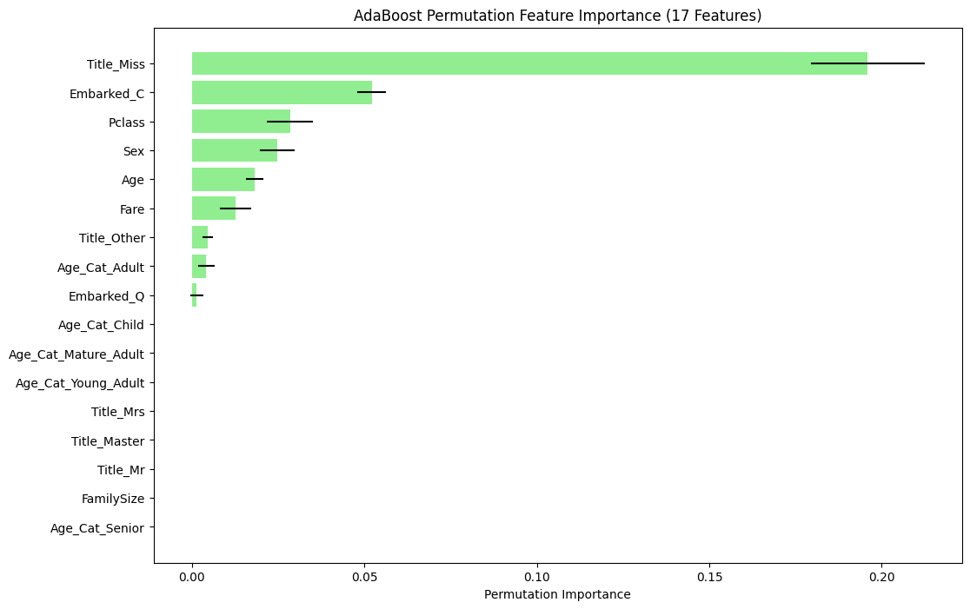
G2. Create a AdaBoost model from 9 features from Permutation Importance. Generate confusion matrix, classification report, and optimize all potentially relevant hyperparameters.
# Use optimized parameters (replace with your actual optimized values)
optimized_params = {
'n_estimators': 100, # Replace with your optimized value
'learning_rate': 1.0, # Replace with your optimized value
'estimator__max_depth': 1 # Replace with your optimized value
}
# Initialize AdaBoost with the optimized parameters
best_ada = AdaBoostClassifier(
estimator=DecisionTreeClassifier(max_depth=optimized_params['estimator__max_depth']),
n_estimators=optimized_params['n_estimators'],
learning_rate=optimized_params['learning_rate'],
random_state=42
)
# Define sample weights
sample_weights = np.array([1.0 if y == 0 else 1.6 for y in y_train])
# Select top 9 features based on AdaBoost permutation importance
top_features_ada = ['Title_Miss', 'Embarked_C', 'Pclass', 'Sex', 'Age', 'Fare', 'Title_Other', 'Age_Cat_Adult', 'Embarked_Q']
# Optionally add 'Age_Cat_Child' to make it 9 features if its importance > 0.01
# top_features_ada = ['Title_Miss', 'Embarked_C', 'Pclass', 'Sex', 'Age', 'Fare', 'Title_Other', 'Age_Cat_Adult', 'Age_Cat_Child']
# Extract indices of top features
top_feature_indices = [reduced_features.index(f) for f in top_features_ada]
X_train_top_ada = X_train_reduced.iloc[:, top_feature_indices].to_numpy()
# X_test_top_ada = X_test_reduced.iloc[:, top_feature_indices].to_numpy()
print(f"\nX_train_top_ada shape: {X_train_top_ada.shape}") # Expected: (891, 9)
# print(f"X_test_top_ada shape: {X_test_top_ada.shape}") # Expected: (418, 9)
# Fit the model on the top 9 features
best_ada.fit(X_train_top_ada, y_train, sample_weight=sample_weights)
# Use cross_val_predict to get cross-validated predictions
y_pred_cv_ada_top = cross_val_predict(best_ada, X_train_top_ada, y_train, cv=5, method='predict', n_jobs=-1)
# Evaluate performance using cross-validated predictions
accuracy_ada_top = accuracy_score(y_train, y_pred_cv_ada_top)
print(f"Cross-Validated Training Accuracy (9 features, AdaBoost): {accuracy_ada_top:.3f}")
# Cross-validation scores
cv_scores_ada = cross_val_score(best_ada, X_train_top_ada, y_train, cv=5, scoring='accuracy')
cv_roc_auc = cross_val_score(best_ada, X_train_top_ada, y_train, cv=5, scoring='roc_auc')
print("\nCross-Validation Accuracy Scores:", cv_scores_ada)
print("Mean CV Accuracy: {:.3f} (+/- {:.3f})".format(cv_scores_ada.mean(), cv_scores_ada.std() * 2))
print(f"ROC-AUC: {cv_roc_auc.mean():.3f} (+/- {cv_roc_auc.std() * 2:.3f})")

# Confusion Matrix and Classification Report
conf_matrix = confusion_matrix(y_train, y_pred_cv_ada_top)
print("\nConfusion Matrix (AdaBoost Classifier with Class Weights and Scaling):")
print(conf_matrix)
print("\nCross-Validated Training Classification Report (9 features, AdaBoost):")
print(classification_report(y_train, y_pred_cv_ada_top, target_names=['Not Survived', 'Survived']))
X_train_top_ada shape: (891, 9)
Cross-Validated Training Accuracy (9 features, AdaBoost): 0.820
Cross-Validation Accuracy Scores: [0.82122905 0.82022472 0.82022472 0.80898876 0.83146067]
Mean CV Accuracy: 0.820 (+/- 0.014)
ROC-AUC: 0.865 (+/- 0.042)
Confusion Matrix (AdaBoost Classifier with Class Weights and Scaling):
[[473 76]
[ 84 258]]
Cross-Validated Training Classification Report (9 features, AdaBoost):
precision recall f1-score support
Not Survived 0.85 0.86 0.86 549
Survived 0.77 0.75 0.76 342
accuracy 0.82 891
macro avg 0.81 0.81 0.81 891
weighted avg 0.82 0.82 0.82 891
# Convert inputs to numpy arrays
X_train_np = X_train_reduced.to_numpy() if hasattr(X_train_reduced, 'to_numpy') else X_train_reduced
y_train_np = y_train.to_numpy() if hasattr(y_train, 'to_numpy') else y_train
sample_weights = np.array([1.0 if y == 0 else 1.6 for y in y_train_np])
# Verify shapes
print("X_train_np shape:", X_train_np.shape)
print("y_train_np shape:", y_train_np.shape)
print("sample_weights shape:", sample_weights.shape)
assert len(sample_weights) == len(y_train_np), "Sample weights length does not match y_train length"
# Define the base estimator
estimator = DecisionTreeClassifier()
# Initialize AdaBoost
ada_model = AdaBoostClassifier(estimator=estimator, random_state=42)
# Define the refined parameter grid.
param_grid = {
'estimator__max_depth': [1],
'n_estimators': [150],
'learning_rate': [1.0]
}
# Custom scoring for recall
scorer = make_scorer(recall_score, average='binary', pos_label=1)
# Perform GridSearchCV
grid_search = GridSearchCV(
estimator=ada_model,
param_grid=param_grid,
cv=5,
scoring=scorer,
n_jobs=-1,
verbose=1
)
# Fit with sample weights
grid_search.fit(X_train_np, y_train_np, sample_weight=sample_weights)
# Print best parameters and recall
print("\nOptimized AdaBoost - Best Parameters:", grid_search.best_params_)
print(f"Optimized AdaBoost - Best Mean CV Recall (Class 1): {grid_search.best_score_:.3f}")
# Manual cross-validation for accuracy
best_ada = grid_search.best_estimator_
kf = KFold(n_splits=5, shuffle=True, random_state=42)
accuracy_scores = []
recall_scores = []
y_pred_all = np.zeros(len(y_train_np))
for train_idx, val_idx in kf.split(X_train_np):
X_train_fold = X_train_np[train_idx]
y_train_fold = y_train_np[train_idx]
X_val_fold = X_train_np[val_idx]
y_val_fold = y_train_np[val_idx]
sample_weights_fold = sample_weights[train_idx]
best_ada.fit(X_train_fold, y_train_fold,
sample_weight=sample_weights_fold)
y_pred_fold = best_ada.predict(X_val_fold)
accuracy_scores.append(accuracy_score(y_val_fold, y_pred_fold))
recall_scores.append(recall_score(y_val_fold, y_pred_fold, pos_label=1))
y_pred_all[val_idx] = y_pred_fold
accuracy_mean = np.mean(accuracy_scores)
accuracy_std = np.std(accuracy_scores) * 2
recall_mean = np.mean(recall_scores)
recall_std = np.std(recall_scores) * 2
print(f"Optimized AdaBoost - Mean CV Accuracy with Best Model: {accuracy_mean:.3f} (+/- {accuracy_std:.3f})")
print(f"Optimized AdaBoost - Mean CV Recall (Class 1): {recall_mean:.3f} (+/- {recall_std:.3f})")
# Confusion Matrix and Classification Report
conf_matrix = confusion_matrix(y_train, y_pred_all)
print("\nConfusion Matrix (Ada Boosting Classifier with Class Weights and Scaling):")
print(conf_matrix)
print("\nOptimized AdaBoost - Classification Report:")
print(classification_report(y_train_np, y_pred_all))
X_train_np shape: (891, 17)
y_train_np shape: (891,)
sample_weights shape: (891,)
Fitting 5 folds for each of 1 candidates, totalling 5 fits
Optimized AdaBoost - Best Parameters: {'estimator__max_depth': 1, 'learning_rate': 1.0, 'n_estimators': 150}
Optimized AdaBoost - Best Mean CV Recall (Class 1): 0.807
Optimized AdaBoost - Mean CV Accuracy with Best Model: 0.807 (+/- 0.034)
Optimized AdaBoost - Mean CV Recall (Class 1): 0.795 (+/- 0.105)
Confusion Matrix (Ada Boosting Classifier with Class Weights and Scaling):
[[447 102]
[ 70 272]]
Optimized AdaBoost - Classification Report:
precision recall f1-score support
0 0.86 0.81 0.84 549
1 0.73 0.80 0.76 342
accuracy 0.81 891
macro avg 0.80 0.80 0.80 891
weighted avg 0.81 0.81 0.81 891
*AdaBoost hyperparameters optimized.
H. Create a Tensorflow/Keras machine learning model with all 19 features. Generate confusion matrix, classification report, and try to optimize relevant parameters.
# Step 1: Verify TensorFlow and Keras integration
print(f"TensorFlow version: {tf.__version__}")
print("Keras version (via tf.keras):", tf.keras.__version__)
# Step 2: Verify shapes
print(f"X_train_clean shape: {X_train_clean.shape}")
print(f"y_train shape: {y_train.shape}")
if X_train_clean.shape[0] != y_train.shape[0]:
raise ValueError(f"Shape mismatch: X_train_clean has {X_train_clean.shape[0]} samples, but y_train has {y_train.shape[0]} samples")
# Step 3: Ensure X_train_clean is a DataFrame
if not isinstance(X_train_clean, pd.DataFrame):
X_train_clean = pd.DataFrame(X_train_clean, columns=[f'Feature_{i}' for i in range(X_train_clean.shape[1])])
# Step 4: Check for non-numeric data and NaNs
non_numeric_cols = X_train_clean.select_dtypes(exclude=[np.number]).columns
if len(non_numeric_cols) > 0:
raise ValueError(f"Non-numeric columns found in X_train_clean: {non_numeric_cols}")
if X_train_clean.isna().sum().sum() > 0:
print("NaNs found in X_train_clean. Imputing with mean...")
X_train_clean = X_train_clean.fillna(X_train_clean.mean())
# Verify the number of features
print(f"Number of features in X_train_clean: {X_train_clean.shape[1]}") # Should be 19
# Step 5: Scale the features
scaler = StandardScaler()
X_train_scaled = scaler.fit_transform(X_train_clean)
X_train_scaled = pd.DataFrame(X_train_scaled, columns=X_train_clean.columns)
# Convert y_train to numpy array
y_train = np.array(y_train)
# Step 6: Compute class weights
class_weights = {0: 1.0, 1: 1.6} # Same as previous models
# Step 7: Define function to create Keras model with final tweaks
def create_keras_model(input_dim):
model = tf.keras.Sequential([
tf.keras.layers.Dense(30, activation='relu', input_dim=input_dim),
tf.keras.layers.Dropout(0.3),
tf.keras.layers.Dense(15, activation='relu'),
tf.keras.layers.Dropout(0.3),
tf.keras.layers.Dense(1, activation='sigmoid')
])
optimizer = tf.keras.optimizers.Adam(learning_rate=0.0006) # Reduced further
model.compile(optimizer=optimizer, loss='binary_crossentropy', metrics=['accuracy'])
return model
# Step 8: Perform 5-fold cross-validation
kf = KFold(n_splits=5, shuffle=True, random_state=42)
fold = 1
y_pred_all = np.zeros_like(y_train)
cv_scores = []
cv_roc_scores = []
for train_idx, val_idx in kf.split(X_train_scaled):
print(f"\nTraining fold {fold}...")
X_train_fold = X_train_scaled.iloc[train_idx]
y_train_fold = y_train[train_idx]
X_val_fold = X_train_scaled.iloc[val_idx]
y_val_fold = y_train[val_idx]
# Create and train the model
model = create_keras_model(input_dim=X_train_scaled.shape[1])
early_stopping = tf.keras.callbacks.EarlyStopping(monitor='val_loss', patience=10, restore_best_weights=True)
model.fit(
X_train_fold, y_train_fold,
epochs=90, # Increased to allow more training
batch_size=30,
validation_data=(X_val_fold, y_val_fold),
callbacks=[early_stopping],
class_weight=class_weights,
verbose=0
)
# Predict probabilities and convert to classes
y_pred_prob = model.predict(X_val_fold, verbose=0)
y_pred = (y_pred_prob > 0.5).astype(int).flatten()
y_pred_all[val_idx] = y_pred
# Compute fold accuracy
fold_accuracy = np.mean(y_pred == y_val_fold)
cv_scores.append(fold_accuracy)
# Compute fold ROC-AUC
fold_roc_auc = tf.keras.metrics.AUC()(y_val_fold, y_pred_prob).numpy()
cv_roc_scores.append(fold_roc_auc)
fold += 1
# Step 9: Evaluate overall performance
conf_matrix = confusion_matrix(y_train, y_pred_all)
print("\nConfusion Matrix (Keras MLP with Final Parameters):")
print(conf_matrix)
print("\nClassification Report (Keras MLP):")
print(classification_report(y_train, y_pred_all))
# Cross-validation scores
print("\nCross-Validation Accuracy Scores:", cv_scores)
print("Mean CV Accuracy: {:.3f} (+/- {:.3f})".format(np.mean(cv_scores), np.std(cv_scores) * 2))
print(f"ROC-AUC: {np.mean(cv_roc_scores):.3f} (+/- {np.std(cv_roc_scores) * 2:.3f})")
# Step 10: Train final model on full training set for submission
final_model = create_keras_model(input_dim=X_train_scaled.shape[1])
final_model.fit(
X_train_scaled, y_train,
epochs=90,
batch_size=30,
class_weight=class_weights,
callbacks=[tf.keras.callbacks.EarlyStopping(monitor='loss', patience=10, restore_best_weights=True)],
verbose=0
)
TensorFlow version: 2.19.0
Keras version (via tf.keras): 3.10.0
X_train_clean shape: (891, 19)
y_train shape: (891,)
Number of features in X_train_clean: 19
Training fold 1...
Training fold 2...
Training fold 3...
Training fold 4...
Training fold 5...
Confusion Matrix (Keras MLP with Final Parameters):
[[469 80]
[ 83 259]]
Classification Report (Keras MLP):
precision recall f1-score support
0 0.85 0.85 0.85 549
1 0.76 0.76 0.76 342
accuracy 0.82 891
macro avg 0.81 0.81 0.81 891
weighted avg 0.82 0.82 0.82 891
Cross-Validation Accuracy Scores: [0.7877094972067039, 0.797752808988764, 0.8539325842696629, 0.797752808988764, 0.848314606741573]
Mean CV Accuracy: 0.817 (+/- 0.056)
ROC-AUC: 0.871 (+/- 0.053)
I. Use Boruta Feature reduction technique to see what features it deems important out of curiosity.
# Convert X_train to a NumPy array if it's a DataFrame
if isinstance(X_train, pd.DataFrame):
feature_names = X_train.columns.tolist()
X_train_np = X_train.to_numpy()
else:
X_train_np = np.array(X_train)
feature_names = [f'feature_{i}' for i in range(X_train_np.shape[1])]
# Convert y_train to a NumPy array
y_train_np = y_train.to_numpy() if isinstance(y_train, (pd.Series, pd.DataFrame)) else np.array(y_train)
# Verify shapes after conversion
print(f"X_train_np shape: {X_train_np.shape}")
print(f"y_train_np shape: {y_train_np.shape}")
# Convert to DataFrame for Boruta compatibility
X_train_df = pd.DataFrame(X_train_np, columns=feature_names)
# Define the Random Forest base estimator for Boruta
rf = RandomForestClassifier(n_estimators=100, n_jobs=-1, random_state=42)

# Initialize Boruta
boruta = BorutaPy(
estimator=rf,
n_estimators='auto',
max_iter=100,
perc=100,
random_state=42
)
# Fit Boruta
boruta.fit(X_train_np, y_train_np)
# Get selected features
selected_features = X_train_df.columns[boruta.support_].tolist()
print(f"\nSelected features: {selected_features}")
# Get importance rankings (1 = confirmed, 2 = tentative, higher = rejected)
feature_ranking = pd.DataFrame({
'Feature': feature_names,
'Ranking': boruta.ranking_
})
print("\nFeature Importance Rankings:")
print(feature_ranking.sort_values(by='Ranking'))
# Reduce X_train_np to selected features
X_train_boruta = X_train_np[:, boruta.support_]
print(f"Reduced X_train_reduced shape: {X_train_boruta.shape}")
# Apply the same reduction to X_test (assuming X_test has the same features)
if 'X_test' in globals():
X_test_np = X_test.to_numpy() if isinstance(X_test, pd.DataFrame) else np.array(X_test)
X_test_boruta = X_test_np[:, boruta.support_]
print(f"Reduced X_test_reduced shape: {X_test_boruta.shape}")
else:
print("Please provide X_test to reduce it accordingly.")
# Save the reduced datasets
np.save('X_train_reduced.npy', X_train_boruta)
if 'X_test_reduced' in locals():
np.save('X_test_reduced.npy', X_test_boruta)
print("\nReduced datasets saved as 'X_train_reduced.npy' and 'X_test_reduced.npy'.")
else:
print("\nReduced training dataset saved as 'X_train_reduced.npy'. Provide X_test to save the reduced test set.")
X_train_np shape: (891, 19)
y_train_np shape: (891,)
Selected features: ['Sex', 'Fare', 'Title_Mr']
Feature Importance Rankings:
Feature Ranking
1 Sex 1
3 Fare 1
10 Title_Mr 1
2 Age 2
0 Pclass 3
4 FamilySize 4
11 Title_Mrs 5
9 Title_Miss 6
5 Embarked_C 7
13 Age_Cat_Adult 8
7 Embarked_S 8
18 Age_Cat_Young Adult 10
16 Age_Cat_Mature Adult 11
6 Embarked_Q 12
14 Age_Cat_Child 12
8 Title_Master 14
12 Title_Other 15
15 Age_Cat_Infant 16
17 Age_Cat_Senior 17
Reduced X_train_reduced shape: (891, 3)
Reduced X_test_reduced shape: (418, 3)
Reduced training dataset saved as 'X_train_reduced.npy'. Provide X_test to save the reduced test set.
*Interesting that Boruta found Sex, Fare, and Title_Mr as variables to keep, and Age as an alternate.

J. Generate and export model results into a table.
# Placeholder metrics (replace with your actual values)
models = [
('Logistic Regression (19 features)', 459, 90, 76, 266, 0.814, 0.75, 0.78, 0.81, 0.868),
('LR with Lasso (17 features -> 10 used)', 464, 85, 73, 269, 0.823, 0.76, 0.79, 0.82, 0.871), # Features Removed Due To Multicollinearity: Age_Cat_Infant and Embarked_S
('LR with Ridge (17 features)', 464, 85, 73, 269, 0.818, 0.76, 0.79, 0.82, 0.868),
('LR with ElasticNet (17 features -> 12 used)', 461, 88, 73, 269, 0.819, 0.75, 0.79, 0.82, 0.869),
('Random Forest (19 features)', 482, 67, 77, 265, 0.838, 0.80, 0.77, 0.84, 0.866),
('Random Forest (14 features - Title Features Removed)', 472, 77, 77, 265, 0.819, 0.77, 0.77, 0.83, 0.864),
('Random Forest (8 features - Age_Cat Features Removed)', 478, 71, 84, 258, 0.818, 0.78, 0.75, 0.83, 0.872),
('Random Forest (5 features - Embarkment Features Removed)', 479, 70, 81, 261, 0.826, 0.79, 0.76, 0.83, 0.870),
('Random Forest (5 features - By RF Feature Importance)', 484, 65, 76, 266, 0.841, 0.8, 0.78, 0.84, 0.868),
('Linear SVM (10 features - Lasso Reduced)', 470, 79, 87, 255, 0.814, 0.76, 0.75, 0.81, 0.859),
('RBF SVM (10 features - Lasso Reduced)', 470, 79, 87, 255, 0.823, 0.77, 0.77, 0.82, 0.854),
('RBF SVM (17 features - By SHAP Feature Importance)', 481, 68, 86, 256, 0.827, 0.79, 0.75, 0.83, 0.854),
('XGBoost (15 features - By XGB Feature Importance)', 479, 69, 70, 273, 0.844, 0.80, 0.80, 0.84, 0.866),
('Gradient Boosting (17 features - By GB Feature Importance)', 491, 58, 85, 257, 0.84, 0.82, 0.75, 0.84, 0.879),
('AdaBoost (17 features)', 472, 77, 86, 256, 0.817, 0.77, 0.75, 0.82, 0.864),
('AdaBoost (9 features - By Permutation Feature Importance)', 473, 76, 84, 258, 0.820, 0.77, 0.75, 0.82, 0.865),
('Keras (19 features)', 466, 83, 76, 266, 0.822, 0.76, 0.78, 0.82, 0.87)
]
# Create a DataFrame for comparison
comparison_df = pd.DataFrame(models, columns=['Model', 'TP', 'FN', 'FP', 'TN', 'Accuracy', 'Class 1 Precision', 'Class 1 Recall', 'Macro F1-Score', 'ROC-AUC'])
# Display the table
print("\nModel Performance Comparison:")
print(comparison_df)
# Optionally, save to CSV for reporting
# comparison_df.to_csv('model_comparison.csv', index=False)
# print("\nComparison table saved as 'model_comparison.csv'.")
Model Performance Comparison:
Model TP FN FP TN \
0 Logistic Regression (19 features) 459 90 76 266
1 LR with Lasso (17 features -> 10 used) 464 85 73 269
2 LR with Ridge (17 features) 464 85 73 269
3 LR with ElasticNet (17 features -> 12 used) 461 88 73 269
4 Random Forest (19 features) 482 67 77 265
5 Random Forest (14 features - Title Features Re... 472 77 77 265
6 Random Forest (8 features - Age_Cat Features R... 478 71 84 258
7 Random Forest (5 features - Embarkment Feature... 479 70 81 261
8 Random Forest (5 features - By RF Feature Impo... 484 65 76 266
9 Linear SVM (10 features - Lasso Reduced) 470 79 87 255
10 RBF SVM (10 features - Lasso Reduced) 470 79 87 255
11 RBF SVM (17 features - By SHAP Feature Importa... 481 68 86 256
12 XGBoost (15 features - By XGB Feature Importance) 479 69 70 273
13 Gradient Boosting (17 features - By GB Featur... 491 58 85 257
14 AdaBoost (17 features) 472 77 86 256
15 AdaBoost (9 features - By Permutation Feature ... 473 76 84 258
16 Keras (19 features) 466 83 76 266
Accuracy Class 1 Precision Class 1 Recall Macro F1-Score ROC-AUC
0 0.814 0.75 0.78 0.81 0.868
1 0.823 0.76 0.79 0.82 0.871
2 0.818 0.76 0.79 0.82 0.868
3 0.819 0.75 0.79 0.82 0.869
4 0.838 0.80 0.77 0.84 0.866
5 0.819 0.77 0.77 0.83 0.864
6 0.818 0.78 0.75 0.83 0.872
7 0.826 0.79 0.76 0.83 0.870
8 0.841 0.80 0.78 0.84 0.868
9 0.814 0.76 0.75 0.81 0.859
10 0.823 0.77 0.77 0.82 0.854
11 0.827 0.79 0.75 0.83 0.854
12 0.844 0.80 0.80 0.84 0.866
13 0.840 0.82 0.75 0.84 0.879
14 0.817 0.77 0.75 0.82 0.864
15 0.820 0.77 0.75 0.82 0.865
16 0.822 0.76 0.78 0.82 0.870
*Considered generating a ROC-AUC chart, but there did not seem to much difference in the model ROC-AUC values (0.85 to 0.879). In additon, my final decision on a model did not rely on that statistic, but on Accuracy (0.844), Macro Average F1-Score (0.84), and general Confusion Matrix performance (752 Predicted and 139 Missed). XGBoost (15 features - by XGBoost Feature Importance) stood out from the rest. I found the project rewarding in the sense of delving more deeply into imputation strategy and model use and testing. Not sure that anyone has approached this problem the way that I did regarding imputation, and the review of multiple classification models with the training dataset.

V. Use the optimized XGBoost model to predict the Survived values for the test data set and save them in a .csv file.
# Step 1: Verify that titanic_imputed is available and is a DataFrame
print("Step 1: Verifying titanic_imputed...")
if 'titanic_imputed' not in globals():
raise NameError("titanic_imputed DataFrame not found in memory. Please ensure it is created and available.")
if not isinstance(titanic_imputed, pd.DataFrame):
raise TypeError("titanic_imputed is not a pandas DataFrame. Please ensure it is a DataFrame.")
# Convert X_test to a DataFrame if it is not
print("Step 1: Verifying X_test...")
if not isinstance(X_test, pd.DataFrame):
print("X_test is not a DataFrame. Converting to DataFrame...")
X_test_columns = X_train_clean.columns if 'X_train_clean' in globals() else [f'Feature_{i}' for i in range(X_test.shape[1])]
X_test = pd.DataFrame(X_test, columns=X_test_columns, index=X_test.index if hasattr(X_test, 'index') else None)
# Verify training and test data
print(f"X_train_xgb_reduced shape (15 features): {X_train_xgb_reduced.shape}")
print(f"X_test shape (initial): {X_test.shape}")
print(f"X_test columns: {list(X_test.columns)}")
print(f"X_test index: {X_test.index[:5]}")
# Step 2: Verify titanic_imputed and retrieve PassengerId
print("Step 2: Retrieving PassengerId from titanic_imputed...")
print(f"titanic_imputed shape: {titanic_imputed.shape}")
print(f"titanic_imputed columns: {list(titanic_imputed.columns)}")
print(f"titanic_imputed index: {titanic_imputed.index[:5]}")
# Ensure PassengerId exists in titanic_imputed
if 'PassengerId' not in titanic_imputed.columns:
raise ValueError("PassengerId column not found in titanic_imputed")

# Align X_test with titanic_imputed to retrieve PassengerId
if X_test.index.equals(titanic_imputed.index):
passenger_ids = titanic_imputed.loc[X_test.index, 'PassengerId']
else:
print("Indices do not match exactly. Assuming X_test's index corresponds to original positions in titanic_imputed...")
try:
passenger_ids = titanic_imputed.loc[X_test.index, 'PassengerId']
except KeyError as e:
print(f"Error: Some indices in X_test not found in titanic_imputed: {e}")
print("Falling back to row-order alignment...")
train_size = X_train_xgb_reduced.shape[0]
test_size = X_test.shape[0]
if titanic_imputed.shape[0] != (train_size + test_size):
raise ValueError(f"Size mismatch: titanic_imputed has {titanic_imputed.shape[0]} rows, but X_train_xgb_reduced ({train_size}) + X_test ({test_size}) = {train_size + test_size}")
passenger_ids = titanic_imputed['PassengerId'].iloc[-test_size:].reset_index(drop=True)
if len(passenger_ids) != X_test.shape[0]:
raise ValueError(f"PassengerId length ({len(passenger_ids)}) does not match X_test length ({X_test.shape[0]})")
print(f"Retrieved PassengerId shape: {passenger_ids.shape}")
print(f"First few PassengerId values: {passenger_ids.head()}")
# Step 3: Convert Boolean variables to integers in X_test
print("Step 3: Converting Boolean variables in X_test...")
boolean_columns = X_test.select_dtypes(include=['bool']).columns
print(f"Boolean columns in X_test: {boolean_columns.tolist()}")
X_test[boolean_columns] = X_test[boolean_columns].astype(int)
print(f"X_test data types after Boolean conversion: {X_test.dtypes}")
# Step 4: Scale numerical features
print("Step 4: Scaling numerical features in X_test...")
scaler = StandardScaler()
numerical_cols = [col for col in ['Age', 'Fare', 'SibSp', 'Parch'] if col in X_test.columns]
if not numerical_cols:
raise ValueError(f"None of the numerical columns ['Age', 'Fare', 'SibSp', 'Parch'] found in X_test. Available columns: {list(X_test.columns)}")
X_test[numerical_cols] = scaler.fit_transform(X_test[numerical_cols])
print(f"X_test columns after scaling: {list(X_test.columns)}")

# Step 5: Remove variables not in xgboost_top_15 to align features
print("Step 5: Removing variables not in xgboost_top_15 from X_test...")
# Define the top 15 features (to use for alignment early)
xgboost_top_15 = [
'Sex', 'Title_Miss', 'Title_Mr', 'Title_Other', 'Pclass',
'Embarked_C', 'Fare', 'Age_Cat_Mature Adult', 'Age_Cat_Child',
'Age', 'Age_Cat_Adult', 'Embarked_Q', 'FamilySize',
'Age_Cat_Senior', 'Age_Cat_Young Adult'
]
# Drop any columns in X_test that are not in xgboost_top_15
columns_to_keep = [col for col in X_test.columns if col in xgboost_top_15]
X_test_clean = X_test[columns_to_keep]
print(f"X_test_clean shape after removing variables: {X_test_clean.shape}")
print(f"X_test_clean columns: {list(X_test_clean.columns)}")
# Step 6: Align X_test_clean with XGBoost top 15 features
print("Step 6: Aligning X_test_clean with XGBoost top 15 features...")
# Convert X_train_xgb_reduced to DataFrame with correct column names
if not isinstance(X_train_xgb_reduced, pd.DataFrame):
print("X_train_xgb_reduced is not a DataFrame. Converting to DataFrame with XGBoost top 15 features...")
if X_train_xgb_reduced.shape[1] != len(xgboost_top_15):
raise ValueError(f"Feature count mismatch: X_train_xgb_reduced has {X_train_xgb_reduced.shape[1]} features, but XGBoost top 15 has {len(xgboost_top_15)} features")
X_train_xgb_reduced = pd.DataFrame(X_train_xgb_reduced, columns=xgboost_top_15)
# Check if all top 15 features are in X_test_clean
missing_features = [f for f in xgboost_top_15 if f not in X_test_clean.columns]
if missing_features:
print(f"Missing features in X_test_clean: {missing_features}")
# Attempt to map mislabeled features (e.g., if spaces are inconsistent)
potential_mappings = {col: idx for idx, col in enumerate(X_test_clean.columns) if 'Age_Cat' in col}
if potential_mappings:
print(f"Potential mappings for Age_Cat features: {potential_mappings}")
raise ValueError(f"Missing features in X_test_clean: {missing_features}. Check for naming inconsistencies.")
# Reorder X_test_clean to match XGBoost top 15 order
print(f"X_train_xgb_reduced columns after alignment: {list(X_train_xgb_reduced.columns)}")
X_test_clean = X_test_clean[xgboost_top_15]
# Step 7: Initialize and train xgb_model, then generate predictions
print("Step 7: Initializing and training xgb_model...")
# Print XGBoost version for debugging
# print(f"XGBoost version: {xgb.__version__}") # Corrected to use __version__
# Initialize XGBoost model with class weighting
xgb_model = xgb.XGBClassifier(
scale_pos_weight=1.6, # Matches class_weight={0: 1.0, 1: 1.6}
random_state=42,
eval_metric='logloss',
max_depth=4,
learning_rate=0.2,
n_estimators=50,
min_child_weight=3,
reg_alpha=0.01,
reg_lambda=0,
gamma=0.1,
subsample=0.8,
colsample_bytree=0.8
)
# Verify the model object
print(f"xgb_model type: {type(xgb_model)}")
print(f"xgb_model attributes before training: {dir(xgb_model)}")
# Ensure y_train is available
if 'y_train' not in globals():
print("y_train not found in memory. Attempting to recreate from titanic_imputed...")
if 'Survived' not in titanic_imputed.columns:
raise ValueError("Survived column not found in titanic_imputed to recreate y_train.")
# Assuming titanic_imputed contains both train and test data, extract y_train
train_size = X_train_xgb_reduced.shape[0]
y_train = titanic_imputed['Survived'].iloc[:train_size]
if len(y_train) != X_train_xgb_reduced.shape[0]:
raise ValueError(f"y_train length ({len(y_train)}) does not match X_train_xgb_reduced rows ({X_train_xgb_reduced.shape[0]})")
# Train the model
xgb_model.fit(X_train_xgb_reduced, y_train)
print("xgb_model trained successfully!")

# Verify the model has the predict method after training
print(f"xgb_model attributes after training: {dir(xgb_model)}")
if not hasattr(xgb_model, 'predict'):
raise AttributeError("xgb_model does not have a predict method after training. Check XGBoost version or environment.")
# Generate predictions
y_test = xgb_model.predict(X_test_clean)
print(f"y_test shape: {y_test.shape}")
print(f"First few predictions: {y_test[:5]}")
# Step 8: Create submission DataFrame
print("Step 8: Creating submission DataFrame...")
submission = pd.DataFrame({
'PassengerId': passenger_ids,
'Survived': y_test
})
# Verify the submission DataFrame
print(f"Submission shape: {submission.shape}")
print(submission.head())
# Step 9: Export to CSV
print("Step 9: Exporting to CSV...")
submission.to_csv('submission_xgboost_15_features_importance.csv', index=False)
print("Submission file 'submission_xgboost_15_features_importance.csv' created successfully!")
Step 1: Verifying titanic_imputed...
Step 1: Verifying X_test...
X_train_xgb_reduced shape (15 features): (891, 15)
X_test shape (initial): (418, 19)
X_test columns: ['Pclass', 'Sex', 'Age', 'Fare', 'FamilySize', 'Embarked_C', 'Embarked_Q', 'Embarked_S', 'Title_Master', 'Title_Miss', 'Title_Mr', 'Title_Mrs', 'Title_Other', 'Age_Cat_Adult', 'Age_Cat_Child', 'Age_Cat_Infant', 'Age_Cat_Mature Adult', 'Age_Cat_Senior', 'Age_Cat_Young Adult']
X_test index: Index([891, 892, 893, 894, 895], dtype='int64')
Step 2: Retrieving PassengerId from titanic_imputed...
titanic_imputed shape: (1309, 20)
titanic_imputed columns: ['PassengerId', 'Survived', 'Pclass', 'Name', 'Sex', 'Age', 'SibSp', 'Parch', 'Ticket', 'Fare', 'Cabin', 'Embarked', 'Title', 'Surname', 'FamilyID', 'FamilySize', 'TicketPrefix', 'TicketNumber', 'Deck', 'Age_Cat']
titanic_imputed index: RangeIndex(start=0, stop=5, step=1)
Indices do not match exactly. Assuming X_test's index corresponds to original positions in titanic_imputed...
Retrieved PassengerId shape: (418,)
First few PassengerId values: 891 892
892 893
893 894
894 895
895 896
Name: PassengerId, dtype: int64
Step 3: Converting Boolean variables in X_test...
Boolean columns in X_test: []
X_test data types after Boolean conversion: Pclass int8
Sex int64
Age float64
Fare float64
FamilySize int64
Embarked_C int32
Embarked_Q int32
Embarked_S int32
Title_Master int32
Title_Miss int32
Title_Mr int32
Title_Mrs int32
Title_Other int32
Age_Cat_Adult int32
Age_Cat_Child int32
Age_Cat_Infant int32
Age_Cat_Mature Adult int32
Age_Cat_Senior int32
Age_Cat_Young Adult int32
dtype: object
Step 4: Scaling numerical features in X_test...
X_test columns after scaling: ['Pclass', 'Sex', 'Age', 'Fare', 'FamilySize', 'Embarked_C', 'Embarked_Q', 'Embarked_S', 'Title_Master', 'Title_Miss', 'Title_Mr', 'Title_Mrs', 'Title_Other', 'Age_Cat_Adult', 'Age_Cat_Child', 'Age_Cat_Infant', 'Age_Cat_Mature Adult', 'Age_Cat_Senior', 'Age_Cat_Young Adult']
Step 5: Removing variables not in xgboost_top_15 from X_test...
X_test_clean shape after removing variables: (418, 15)
X_test_clean columns: ['Pclass', 'Sex', 'Age', 'Fare', 'FamilySize', 'Embarked_C', 'Embarked_Q', 'Title_Miss', 'Title_Mr', 'Title_Other', 'Age_Cat_Adult', 'Age_Cat_Child', 'Age_Cat_Mature Adult', 'Age_Cat_Senior', 'Age_Cat_Young Adult']
Step 6: Aligning X_test_clean with XGBoost top 15 features...
X_train_xgb_reduced columns after alignment: ['Sex', 'Title_Miss', 'Title_Mr', 'Title_Other', 'Pclass', 'Embarked_C', 'Fare', 'Age_Cat_Mature Adult', 'Age_Cat_Child', 'Age', 'Age_Cat_Adult', 'Embarked_Q', 'FamilySize', 'Age_Cat_Senior', 'Age_Cat_Young Adult']
Step 7: Initializing and training xgb_model...
---------------------------------------------------------------------------

