ANA 605 – Analytic Models & Data Systems

Week 2 - Midterm Exam
Randall Crawford
2024-11-09

This midterm was conducted using R Studio. The step instructions below were followed, and a copy of this file was submitted in the content area in Week 2 in Brightspace.

The provided Excel workbook named “data" had the following variables for 53 cities in the US:
X1 = death rate per 1000 residents
X2 = doctor availability per 100,000 residents
X3 = hospital bed availability per 100,000 residents
X4 = annual per capita income in thousands of dollars
X5 = population density people per square mile

Reference: Life in America's Small Cities, by G.S. Thomas

Step 1: Conduct exploratory data analysis. Provide a paragraph summary of your findings.

Descriptive Statistics and Histogram for X1

## min Q1 median Q3 max mean sd n missing
## 3.6 8.3 9.4 10.3 12.8 9.30566 1.66253 53 0
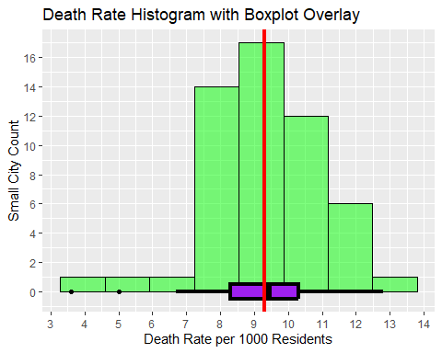

B. Descriptive Statistics & Histogram for X2, including a Scatterplot with X1

## min Q1 median Q3 max mean sd n missing
## 60 82 114 134 238 116.0943 37.8866 53 0
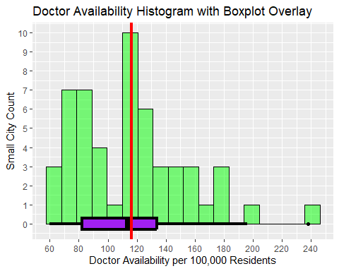
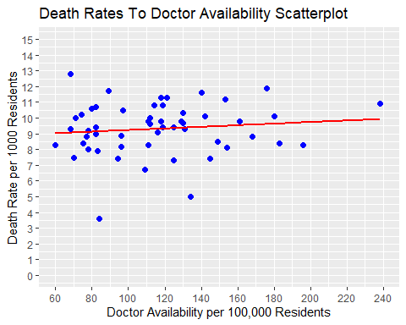

Descriptive Statistics & Histogram for X3, including a Scatterplot with X1

## min Q1 median Q3 max mean sd n missing
## 190 353 525 686 1792 589.7925 332.6183 53 0
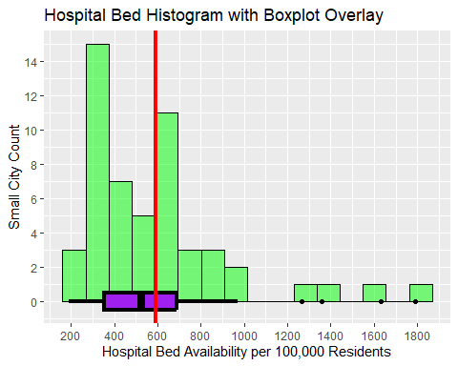
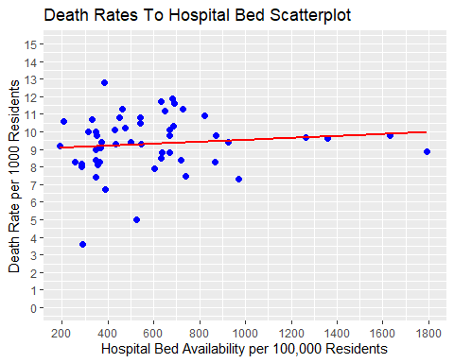

D. Descriptive Statistics & Histogram for X4, including a Scatterplot with X1

## min Q1 median Q3 max mean sd n missing
## 7.2 8.8 9.5 10.3 13 9.435849 1.075442 53 0
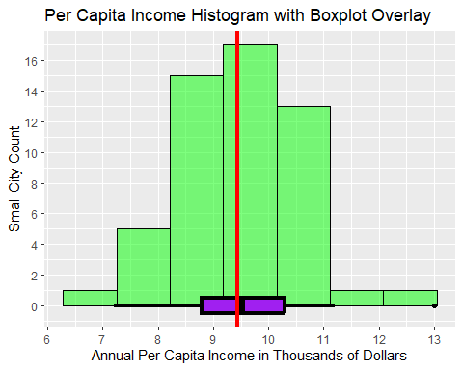
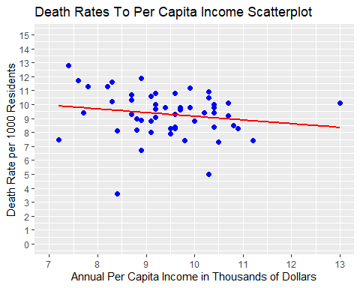

Descriptive Statistics & Histogram for X5, including a Scatterplot with X1

## min Q1 median Q3 max mean sd n missing
## 35 80 103 129 292 110.6415 47.17973 53 0
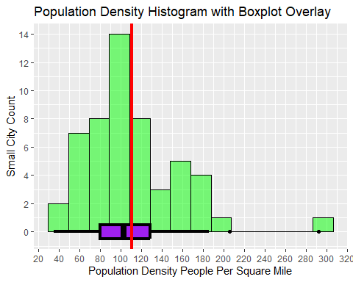
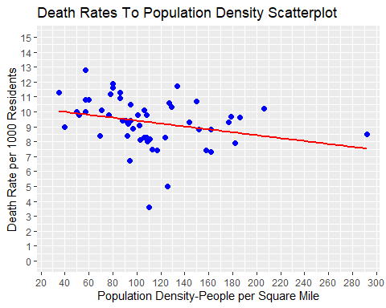

Summary of Findings
Small city death rates averaged 9.3 per 1,000 residents with two outliers below 6. Small city doctor availability averaged about 116 per 100,000 residents with an outlier above 200. Small city hospital bed availability averaged about 590 per 100,000 residents with four outliers above 1,000. Small city annual per capita income averaged $9,436 with an outlier above $11,500. Small city population density averaged about 111 people per square mile with two outliers above 190.
None of the outliers seemed unlikely, given the potential differences between small cities concerning environmental factors, hospital sizes, economic activity, and residential configuration. Although, the annual per capita income seemed quite low, even considering the possible non-working population. Believe this data could be from decades ago. Histogram distributions showed a modest level of normality with aforementioned outliers. The scatterplots did not reveal any obvious relationship between death rate (X1) and any of the other variables.

Step 2: Perform multiple linear regression analysis to test the association between X1 (dependent variable) and the remaining variables. Interpret your model.

A. Initial Multiple Linear Regression Analysis
##
## Call:
## lm(formula = X1 ~ X2 + X3 + X4 + X5, data = data)
##
## Coefficients:
## (Intercept) X2 X3 X4 X5
## 12.2662552 0.0073916 0.0005837 -0.3302302 -0.0094629

B. Initial Supernova Analysis of MLR Model
## Analysis of Variance Table (Type III SS)
## Model: X1 ~ X2 + X3 + X4 + X5
##
## SS df MS F PRE p
## ----- --------------- | ------- -- ----- ----- ----- -----
## Model (error reduced) | 20.654 4 5.164 2.014 .1437 .1075
## X2 | 2.914 1 2.914 1.136 .0231 .2917
## X3 | 1.676 1 1.676 0.654 .0134 .4228
## X4 | 5.083 1 5.083 1.982 .0397 .1656
## X5 | 9.614 1 9.614 3.750 .0725 .0587
## Error (from model) | 123.074 48 2.564
## ----- --------------- | ------- -- ----- ----- ----- -----
## Total (empty model) | 143.728 52 2.764

C. Establish GLM Equation for MLR Model
$$Y_{i}=b_{0}+b_{1}\left(X2_{i}\right)+b_{2}\left(X3_{i}\right)+b_{3}\left(X4_{i}\right)+b_{4}\left(X5_{i}\right)+e_{i}$$
$$X1_{i}=12.2662552+0.0073916\left(X2_{i}\right)+0.0005837\left(X3_{i}\right)-0.3302302\left(X4_{i}\right)-0.0094629\left(X5_{i}\right)+e_{i}$$

D. MLR Model Interpretation
The multiple linear regression model explained 14.37% of the variation in the empty model for X1, which indicates a small effect. The p-value of 0.1075 is greater than 0.05 alpha, which means that null hypothesis is not rejected (the model could potentially have no effect on the outcome). The F-Ratio of 2.104 is greater than 1, but far less than the desirable 5. Noticed that with four degrees of freedom, the MS model was 5.164, which happened to be less than the 9.614 for MS X5. In addition, the F-Ratio for X5 was greater than the model, and p-value for X5 was less than the model.
Given the model and variable results, the adjustment decision to move to a simple model using X5 to estimate X1 was made. Some additional experimentation was done using a reduced number and combination of variables, but none yielded a desirable p-value or F-Ratio.

Step 3: Investigate collinearity and adjust model accordingly. Interpret your new model.

A. Correlation Matrix of Dataframe
## X1 X2 X3 X4 X5
## X1 1.0000000 0.11576504 0.11059019 -0.17199239 -0.27760696
## X2 0.1157650 1.00000000 0.29562836 0.43328796 -0.01993791
## X3 0.1105902 0.29562836 1.00000000 0.02750354 0.18661628
## X4 -0.1719924 0.43328796 0.02750354 1.00000000 0.12874370
## X5 -0.2776070 -0.01993791 0.18661628 0.12874370 1.00000000

B. Adjusted Simple Model
##
## Call:
## lm(formula = X1 ~ X5, data = data)
##
## Coefficients:
## (Intercept) X5
## 10.387997 -0.009782

C. Supernova Analysis of Adjusted Simple Model
## Analysis of Variance Table (Type III SS)
## Model: X1 ~ X5
##
## SS df MS F PRE p
## ----- --------------- | ------- -- ------ ----- ----- -----
## Model (error reduced) | 11.077 1 11.077 4.259 .0771 .0442
## Error (from model) | 132.652 51 2.601
## ----- --------------- | ------- -- ------ ----- ----- -----
## Total (empty model) | 143.728 52 2.764

D. Establish GLM Equation for Adjusted Simple Model
$$Y_{i}=b_{0}+b_{1}\left(X_{i}\right)+e_{i}$$
$$X1_{i}=10.387997-0.009782\left(X5_{i}\right)+e_{i}$$

E. Adjusted Simple Model Interpretation
The adjusted simple model explained 7.71% of the variation in the empty model for X1, which was about half of the MLR model and indicated a small effect. The p-value of 0.0442 is less than 0.05 alpha, which means that null hypothesis is rejected (the model will have an effect on the outcome) and is deemed significant. The F-Ratio of 4.259 is less than the desired 5, but is a considerable improvement over the MLR model. With one degree of freedom, the MS model is 11.077, which is a considerable improvement over the MLR model.

Step 4: Conduct residual analysis for the new model.

A. Add Adjusted Simple Model Residuals To The Dataset & Calculate Descriptive Statistics For Residuals
## min Q1 median Q3 max mean sd n
## -5.711936 -1.0315 0.1011215 1.041328 2.969598 -9.081523e-17 1.597184 53
## missing
## 0

B. Develop Histogram of Adjusted Simple Model Residuals
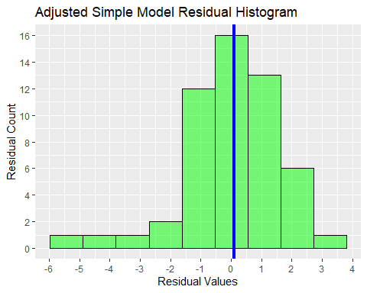

C. Add Original MLR Model Residuals To The Dataset & Calculate Descriptive Statistics For Residuals
## min Q1 median Q3 max mean sd n
## -5.64041 -0.7903754 0.3052957 0.9164389 2.79064 1.415191e-17 1.538443 53
## missing
## 0

D. Develop Histogram of Original MLR Model Residuals
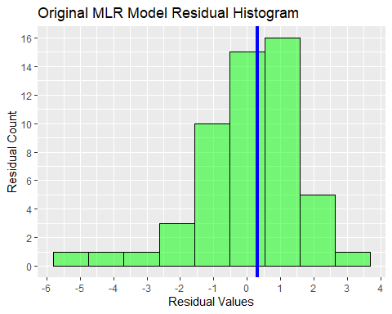

E. Residual Analysis Summary
The range and standard deviation of the residuals for the simple model exceeded the same for the MLR model, but the simple model residual values seemed to be more centered around the mean with a median being closer to it. The simple model residual histogram in B above shares a close resemblance to the histogram for X1 in step 1A.

Step 5: Conduct prediction analysis for the new model.

A. Add Adjusted Simple Model Predictions To The Dataset & Calculate Descriptive Statistics For Predictions
## min Q1 median Q3 max mean sd n missing
## 7.531543 9.126071 9.380413 9.605407 10.04561 9.30566 0.4615299 53 0

B. Develop Histogram of Adjusted Simple Model Predictions
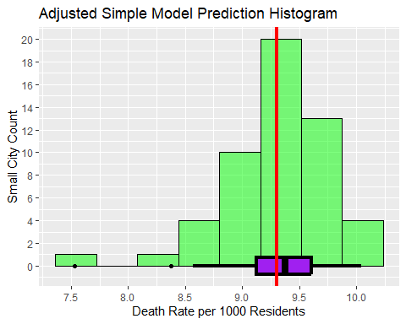

C. Develop Scatterplot of Actual Death Rates to Adjusted Simple Model Predictions
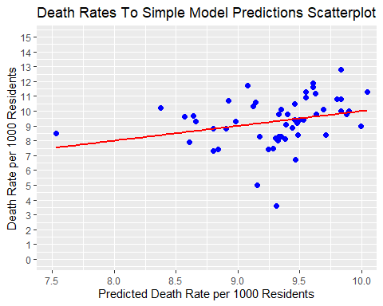

D. Determine Correlation Between Actual Death Rates to Adjusted MLR Model Predictions
## The Pearson's r correlation coefficient equals 0.277607

E. Add Original MLR Model Predictions To The Dataset & Calculate Descriptive Statistics For Predictions
## min Q1 median Q3 max mean sd n missing
## 7.406281 8.785975 9.341207 9.76807 10.50173 9.30566 0.6302369 53 0

F. Develop Histogram of Original MLR Model Predictions
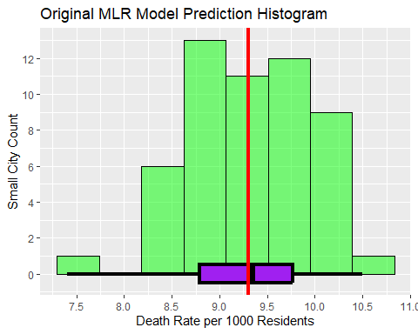

G. Develop Scatterplot of Actual Death Rates to Original MLR Model Predictions
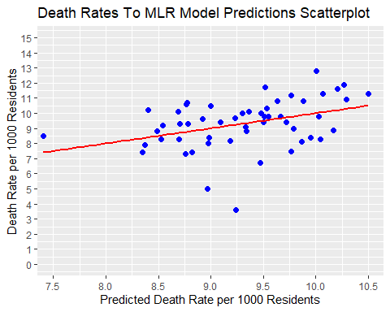

H. Determine Correlation Between Actual Death Rates to Original MLR Model Predictions
## The Pearson's r correlation coefficient equals 0.379083

I. Develop Scatterplot of Adjusted Simple to Original MLR Model Predictions
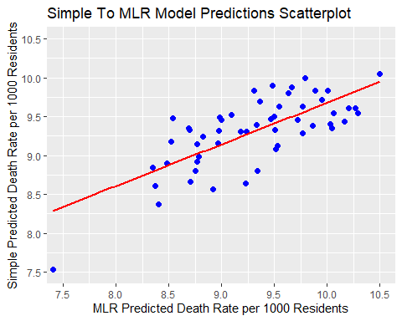

J. Determine Correlation Between Adjusted Simple to Original MLR Model Predictions
## The Pearson's r correlation coefficient equals 0.7323117

Step 6: Provide a summary of findings.
Neither the adjusted simple model nor the multiple linear regression model is able to predict values to the full range of what is in the dataset for X1. Further efforts to develop a model could require the removal of outliers from X1, X5, and/or other variables. Determining and introducing new variables to the dataset would probably be helpful, given that only one variable X5, population density, seemed useful. X2 and X3 relate to the availability of healthcare resources, which are likely present in most small cities. X4, annual per capita income, could be relevant if a potential patient is reluctant to pursue medical assistance due to the cost, but hospitals don’t normally turn away the sick or injured for lack of financial resources.
X5, population density, had a significant relationship to X1, death rate, and negative correlation of -0.278 to it. This was a higher absolute correlation than any other variable. I could understand how an increase in a small city’s population density could reduce its death rate from a medical emergency response standpoint. The more people in an area, the greater chance someone will be identified earlier when an emergency arises, thus giving them a better chance of survival.

