Developer Diary

## October:

Started working on the game I was assigned to. I have talked with the customer and clarified some of the information that was presented in the design document. With this, I have now started on basic mechanics of the game with the information I have.

## October 15th-19th:

This week I finished up on most of the mechanics of the game, including running and jumping, along with an enemy that chases the player when they enter close proximity. I am planning on now implementing some graphics such as better player models, backgrounds and obstacles. I will be in contact with the customer for any preferences on models and more mechanics regarding the score and win conditions.

## October 21st-25rd:

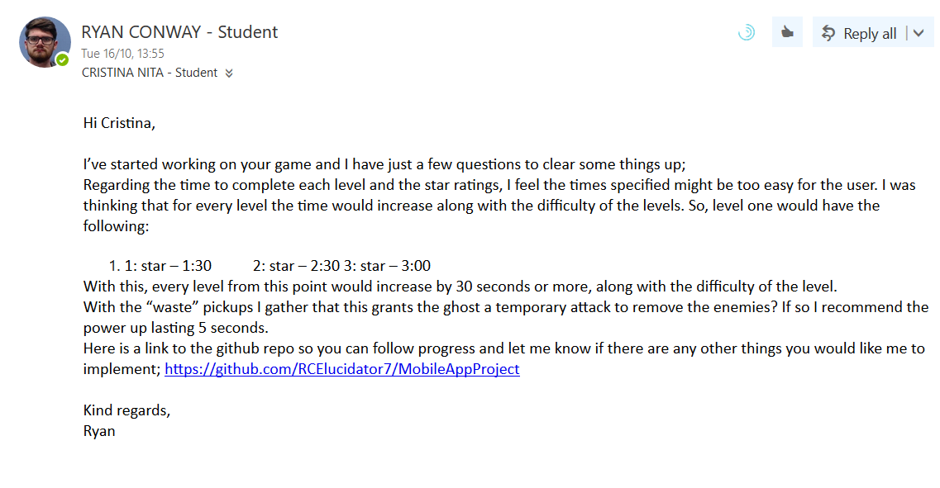This week I contacted the customer to clarify a few questions I had about the Design Document. I proposed a new idea on the way that the scores are obtained as I felt the initial way proposed made it too easy for the user and added more difficulty to the game. I also inquired about the “waste” pick-ups she had mentioned in the document just to clarify how it would work in game. I got a quick response and we agreed on how I should develop things going forward. This week I also added a menu with a basic navigation between the Scenes I currently have.

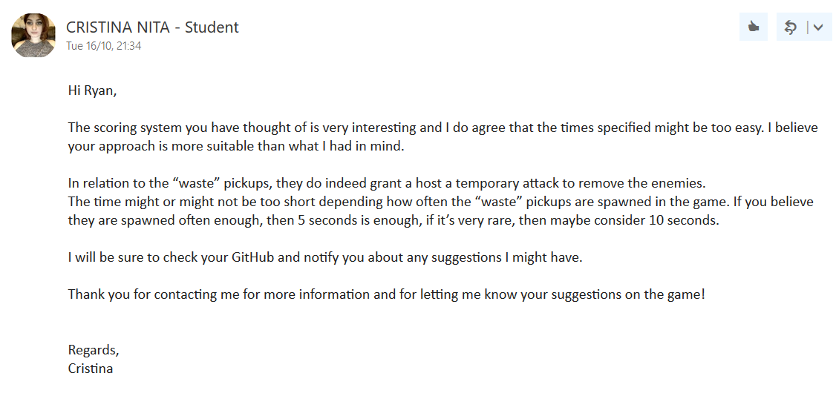

## October 29th-November 2nd:

This week I added in some menu navigation containing a main menu and a level selection. Currently on the main menu is four options, two of which are working. The buttons are “Play”, “Options”, “High Score” and “Quit”. I also added more obstacles to the first and second levels.

## November 2nd – November 14th:

During these two weeks, progress was slightly delayed as I had other projects that took priority. Within these two weeks I completed a Pause Menu that could be triggered by pressing the esc key on the keyboard. With this I also designed it so that when the user presses esc again that it would un-pause the game. On the Pause Menu I currently have two options, Un-pause and Quit. Un-pause would also resume the game whereas Quit would bring you to the main menu. With this I was ready for my demo.

## November 14th – November 26th:

Again, progress had stalled for a number of days as I had other projects and assessments to tend to. I have done some of the main mechanics, such as having the Player take damage when coming into contact with an enemy. The Player has 3 heart containers which will decrement whenever it comes into contact with an enemy. Waste pick-up is also functional, where when they come into contact with it the Player will turn green for 5 seconds, during this time if the Player comes into contact with the enemy it will destroy the enemy. Now that I have some of the more core mechanics complete, I can work on game design. I will also message the Designer on some questions brought up during the demo.

## November 26th – December 2nd:

I sent another email to Cristina just to clarify a few more issues that were brought up during the demo. I also enquired about some game mechanic changes that may benefit the product. She replied quickly and agreed with what I had proposed and cleared up some current blocking issues.

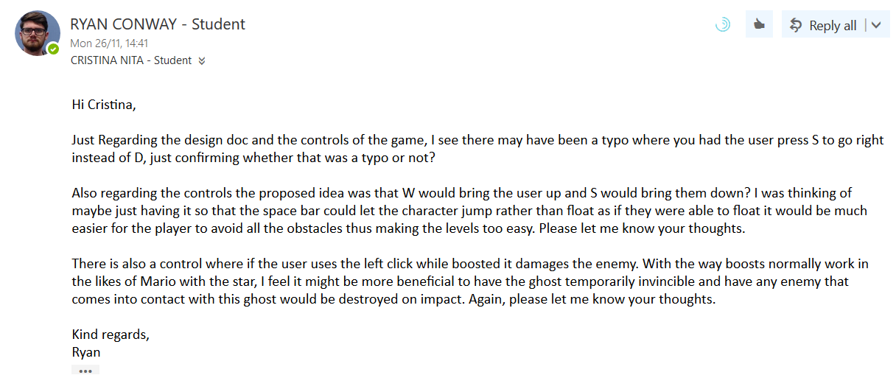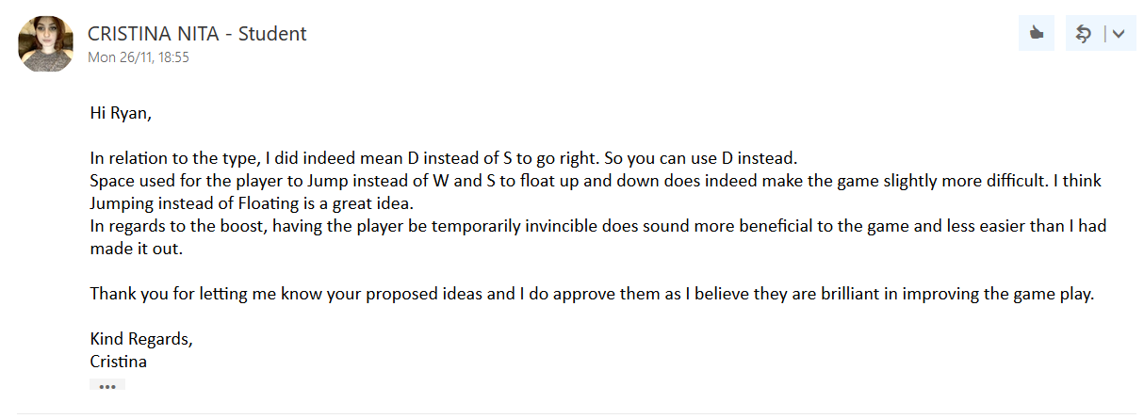

With this response I implemented the double jump feature and the temporary invincibility. During this time, I also added more design to the first level to make it less linear, adding more enemies and “waste” power ups and added a game over screen for when the player loses all their health.

## December 2nd – December 7th:

During the last week before the due date I implemented the high score menu, options menu and designed the rest of the game’s levels. On the high score menu, it displays the score the user has on each level. On the options menu there are two options. The first is an option to toggle Fullscreen of the game. When pressed, it changes the game from windowed to Fullscreen. If the game is already in Fullscreen when the toggle is pushed, then it makes it windowed again. The other option is a toggle sound option, which switches on and off the game’s music. And with this, development for the game has been completed.

## Test Plan:

Below is a test plan for the above project. For this test plan I carried out some basic movement, mechanics and menu transition tests. The goal of the below test plan is to make sure that the game passes the essential requirements for it to be playable, as such I have chosen not to include some specific situations where the result would vary each time it was attempted.

List of the areas tested:

1. Movement (Left and Right)
2. Jumping
3. Falling off the level
4. Enemy collisions
5. Death scenarios
6. Pausing the game
7. Natural death scenarios
8. Level transition

As this project was developed in unity, I was unable to write test scripts to execute these tests automatically. So the below test plan was carried out manually.

|  |  |  |  |  |
| --- | --- | --- | --- | --- |
| No. | TEST CASE DEFINITION | EXPECTED RESULT | ACTUAL RESULT | PASS/FAIL |
| 1.1 | The player was able to move right when pressing “D” | The player moves right | The player moved right | PASS |
| 1.2 | The player was able to move left when pressing “A” | The player moves left | The player moved left | PASS |
| 1.3 | The player was able to move right and left using the arrow keys | The player moves left and right | The player moved left and right | PASS |
| 2.1 | The player was able to jump when the spacebar was pressed | The player jumps | The player jumped | PASS |
| 2.2 | The player was able to jump continuously | The player can jump continuously | The player jumped twice and couldn’t jump again until they landed | FAIL |
| 2.3 | The player was able to double jump | The player jumps upward twice | The player jumped upward twice | PASS |
| 3.1 | The player was able to fall down a hole | The player falls through the hole | The player fell through to a certain point then the level reset | FAIL |
| 3.2 | The player dies of they fell down a hole | The player falls and dies | The player fell and died | PASS |
| 4.1 | The player lost health when colliding with an enemy | The player loses health | The player lost health | PASS |
| 4.2 | The player dies when colliding with the enemy | The player dies | The player loses health | FAIL |
| 4.3 | The player dies when on one health and collides with an enemy | The player dies | The player died | PASS |
| 5.1 | The level restarts when the player dies | The level restarts | The game over menu pops up | FAIL |
| 5.2 | The game over screen displays and the user can choose to restart the level | The game over screen displays and an option to restart appears | The game over screen displays and an option to restart appears | PASS |
| 6.1 | The game pauses when “ESC” is pressed | The game pauses | The game pauses | PASS |
| 6.2 | The game resumes when “ESC” is pressed while the game is paused | The game resumes play | The game resumes play | PASS |
| 7.1 | The player dies when colliding with spikes | The player dies | The player lost health | FAIL |
| 7.2 | The player loses health when colliding with spikes | The player loses health | The player lost health | PASS |
| 7.3 | The player dies when on one health and collides with a spike | The player dies | The player died | PASS |
| 8.1 | The player moves onto the next level once reaching the end | The player moves onto the next level | An overlay appears giving the user the option to go to the next level | FAIL |
| 8.2 | An overlay appears giving the user the option to move to the next level once reaching the end of the level | An overlay appears giving the user an option to move to the next level | An overlay appears giving the user an option to move to the next level | PASS |

## Customer Review:

Cristina was a great customer to work with. We talked frequently in private messages at the beginning of the project where we looked over her design document together and she guided me through her game. Whenever I had any questions about gameplay or any issue regarding the design document, she was quick to reply to my emails (as seen above) and extremely helpful. There were no conflicts or disagreements throughout development and she was great to work for.

## Developer Review:

Nuz was a good developer to work with on my project. He kept in contact quite often and private messaged me whenever any issues arose.

Link to my github: <https://github.com/RCElucidator7/MobileAppProject>