Software Development – Year 4

Mobile Applications Development 3 Project

Ryan Conway – Design Document

“Levels”

Author: Ryan Conway

ID: G00332826

Table of Contents

2D Genre Research 3

Shooters: 3

Platformers: 3

Puzzles: 4

Action Puzzles: 4

Desktop Puzzles: 4

Traditional Board Games: 4

The Maze Genre: 5

Pac-man: 5

Game Overview 5

Common Questions 6

What is the game? 6

What will I be able to play this game on 6

Why did I choose this genre? 6

What do I control? 6

How it works 6

Front end: 6

In-Game Menus 7

Main menu: 7

Help/Options: 7

High Scores: 7

Control Mechanisms: 8

The Game: 8

Storyboard: 9

References 10

# 2D Genre Research

## Shooters:

**Shooter games** are a type of action game, in which the players speed and reaction time are tested. It spawned off many subgenres that have the commonality of focusing on the actions of the avatar using some sort of weapons. Usually this weapon is a gun, try to get or some other long-range weapon. A common resource found in many shooter games is ammunition. Most commonly, the purpose of a shooter game is to shoot opponents and proceed through missions without the player character being killed or dying. A shooting game is a genre of video game where the player has limited spatial control of his or her character, and the focus is almost entirely on the defeat of the character's enemies using long-range weaponry.

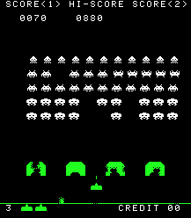**“Shoot 'em up”** games are a subgenre of the shooter genre. In a shoot 'em up, the player character moves forward automatically, often in a flying vehicle such as a spacecraft or aircraft, shooting large numbers of enemies while dodging obstacles. There is no consensus as to which design elements compose a shoot 'em up. Some restrict the definition to games featuring spacecraft and certain types of character movement; others allow a broader definition including characters on foot and a variety of perspectives.

## Platformers:

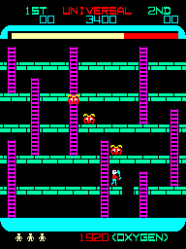A **platformer** is a video game genre and subgenre of action game. In a platformer the player controls a characters or avatar to jump between suspended platforms and avoid obstacles. Environments often feature uneven terrain requiring jumping and climbing in order to traverse them.

Platform games first came about in the late 70’s and early 80’s, with the first game being “Space Panic”, an arcade game in which the player had to dig holes downwards to destroy aliens. The player was limited to only moving downwards and could not jump. This led into the release of Donkey Kong in 1981, which was first to implement jump mechanics and define the platformer genre forever.

## Puzzles:

**Puzzle** video games make up a unique genre of video games that emphasize puzzle solving. The types of puzzles can test many problem-solving skills including logic, pattern recognition, sequence solving, and word completion.

### Action Puzzles:

Tetris, a tile matching puzzle game, was created in 1984 by Russian Alexey Pajitnov. The main mechanics of the game is to arrange falling blocks into lines without any gaps, if the player fills in a line (Horizontally) it is destroyed, and the player is rewarded points. I chose to do a puzzle game as I am a huge fan of Tetris and the puzzle genre in general. Also an interesting [article](https://www.thecut.com/2017/03/the-psychological-explanation-for-why-tetris-is-so-addicting.html) on why its an addicting game.

### Desktop Puzzles:

Minesweeper, a mine detection game, was developed by Curt Johnson and Robert Donner in 1992. It debuted back in 1990 as part of the Windows Entertainment Pack, before being promoted to a standard feature in Windows 3.1 and onwards in 1992. The player starts off with an empty field (size and number of mines were determined by difficulty settings), they then have to uncover squares one at a time. Underneath each space there is either a space, a number or a mine. The numbers tell you how many mines are in the adjacent boxes, whereas the mines kill you and you lose. To win, the player must uncover all of the spaces without stepping on any mines.

## 

### Traditional Board Games:

A board game is a tabletop game that involves a board and game pieces that the player controls. Usually a game of strategy where a player must out-maneuver one or more players by using these pieces on the board. Classical examples of this are Backgammon, chess and checkers. [Checkers](http://www.247checkers.com/) (or Draughts) is a game with 24 pieces total (12 to each player) on an 8x8 grid of squares. The pieces can only move diagonally one space at a time. The objective is to leap over the opponent’s pieces until they have no pieces left.

[Chess](https://www.chess.com/play/computer) is also another board game where the board is an 8x8 grid of squares, with 32 pieces (16 to each player). Unlike checkers where the player can only move diagonally, in chess each piece has its own individual movement assigned to only that piece. The objective is to take the king piece by using all the pieces at your disposal. The player has the option of taking most if not all the other pieces then going for the king or going for the king from the beginning. It is more complicated than checkers but follows the same ideas.

## The Maze Genre:

Maze games, such as Pac-Man, are one of the earliest **genres** of video games. The entire screen is a maze through which players must find their way. Sometimes players compete against each other, and sometimes a player tries to earn as many points as possible before time runs out or he is eaten by a monster or some other alien creature.

## Pac-man:

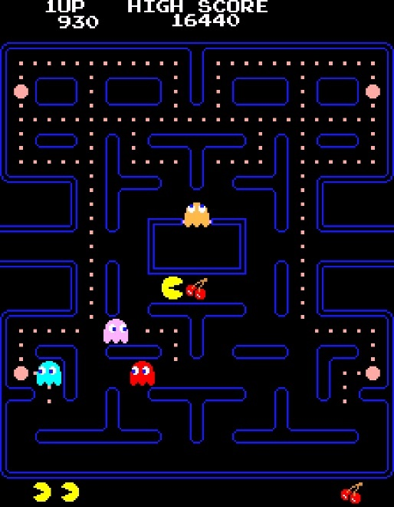Pac-man is an arcade game developed by Namco and released in 1980. Initially released in Japan May 22nd, 1980, it was eventually licensed for distribution in the US in October of that year. The gameplay revolves around the player navigating Pac-man, a small yellow circle, through a maze full of small dots that the player has to collect. The maze also contains four ghost enemies that wander around the maze attempting to trap the player, if the Pac-man comes into contact with these enemies then the player loses one of three lives. If the players life count drops to zero, then its game over. When Pac-man was released, the most popular games were space invaders and Asteroids. Pac-man succeeded in becoming popular and became on of the most famous arcade games of all time and successfully defined a new genre. I chose to do a maze game as Pac-man is an interesting and popular game.

# Game Overview

**Genre:** Maze

**Platform:** UWP Devices

**Age Rating**: +7

The objective of this game is to climb to the top level. I plan to have five levels of mazes, and more than one exit route on each level. The exit will either bring you up one level, or down a level. The objective is to get to the top level and complete the maze. The player will be timed through-out and their times will be recorded on a leaderboard.

# Common Questions

## What is the game?

The game is a 2D puzzle game in which the player must navigate through a set of 5 different mazes. Each maze will have many exits but only one correct exit. If the player chooses the correct exit then they will progress up one level, whereas if they choose the wrong exit, they will be brought down a level or more.

## What will I be able to play this game on

I plan to build the game for mobile devices, with the main focus on UWP.

## Why did I choose this genre?

I chose to do a puzzle game as I’ve always had an interest in the puzzle genre, especially with the mobile gaming boom in recent years. Classic games like “[Minesweeper](https://en.wikipedia.org/wiki/Microsoft_Minesweeper)”, “[Tetris](https://en.wikipedia.org/wiki/Tetris)” and “Pac-man”, and in more recent years, games such as “[2048](http://2048game.com/)” peaked my interest in the puzzle genre.

## What do I control?

The player will be in control of the character model that will explore the maze. The maze will be pre-rendered whereas the exit points will be randomly generated through-out the course of the game.

# 

# How it works

Front end:The main menu will have the title of the game displayed on the top half of the screen, with the user options placed on the lower side of the screen.

There will be three options:

* 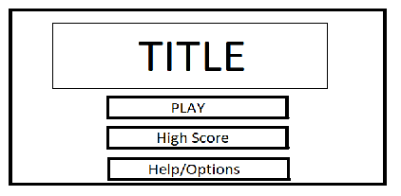Play - With the Play option the user will be redirected to the first maze where they will start the game.
* High Scores – The High score option will bring the user to a page that displays all the high scores of players who have played the game and recorded their time.
* Help/Options – The help/options page will contain a guideline on controls to the game, along with the objective of the game.

In-Game Menus**:**

The in-game menu will be a pause menu that the user can access during the game. It will pause the timer and grant the user access to more options.

### 

### Main menu:

There will be three options:

* Resume – The resume option will bring the user back to the game where they can continue where they left off.
* Restart - The restart option will restart the maze and the timer, bringing the user back to the bottom level. All progress up to the current point will be lost.
* Quit – the quit option will exit the user from the current game and back to the main menu. All progress up to the current point will be lost.

### 

### Help/Options:

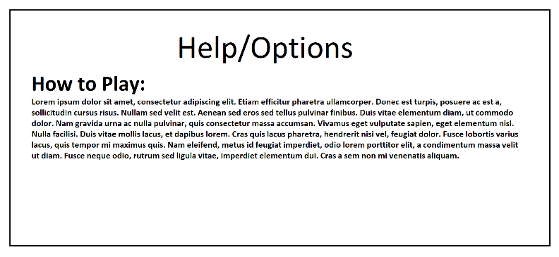A page containing controls and how to play the game.

### High Scores:

The high scores will display the name and the time in a leaderboard. It will display the top 5/10 scores and the name of the player who achieved this time.

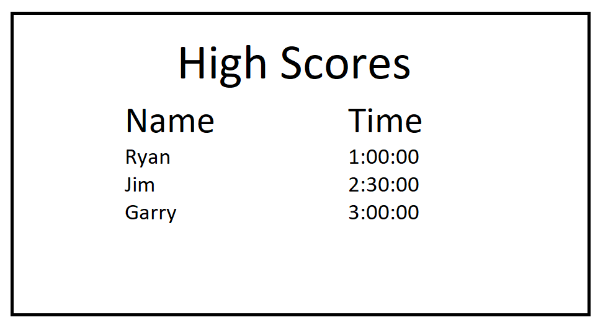

## 

## Control Mechanisms:

The control mechanisms for this game will be:

* Mouse – The mouse will be used to navigate through the menus and to select these options.
* Directional arrows – The model movement will be controlled with the directional arrows (up, down, left, right).

## 

## The Game:

* The player will be dropped into the first level of the maze. They will have to navigate through this maze to reach an exit point. On the first level there will be only one exit that will progress the player up to the next level.
* The level number will be displayed on the top left of the screen to show which level the player is currently on.
* On the second level the maze will be different and have more than one exit. Only one of these exits will bring the player to the next level, whereas the other exits will be false exits, bringing the player down to level one again. The objective of the game is for the player to get to the final level and chose the correct exit.
* The competitive aspect of this game is to complete the game with the quickest time. There will be a local leader board where the player will be able to see previous times and try to best those scores.

# Storyboard:

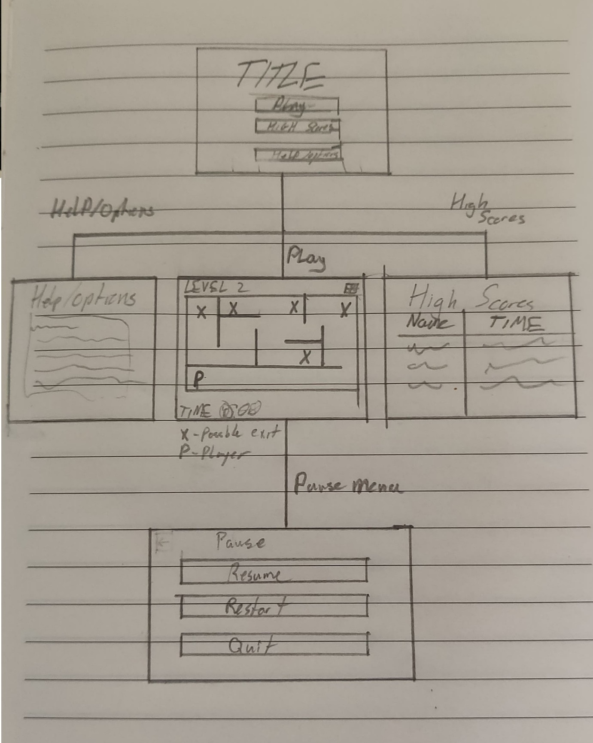

# References

* Space Invaders - <https://en.wikipedia.org/w/index.php?curid=17676369>, <http://theconversation.com/what-40-years-of-space-invaders-says-about-the-1970s-and-today-97518>
* Tetris, Article - <https://en.wikipedia.org/wiki/Tetris>, <https://www.thecut.com/2017/03/the-psychological-explanation-for-why-tetris-is-so-addicting.html>
* Minesweeper - <https://en.wikipedia.org/wiki/Microsoft_Minesweeper#Development> , <https://www.techradar.com/news/gaming/the-most-successful-game-ever-a-history-of-minesweeper-596504>
* The Maze Genre - <http://science.jrank.org/kids/pages/251/Exploring-Genres-Video-Games.html>
* Pac- man - <https://en.wikipedia.org/wiki/Pac-Man> , <https://www.thoughtco.com/pac-man-game-1779412>
* 2048 - <http://2048game.com/>
* Platform Genre - <https://en.wikipedia.org/wiki/Platform_game>
* Checkers - <http://www.247checkers.com/>
* Chess - <https://www.chess.com/play/computer>