Multimedia System Homework
Student information
Name : Richard Rafer Guy
Student ID : M11509801
The program was developed and tested on Windows using Visual Studio Code. All commands were executed through the integrated terminal in Visual Studio Code. Python 3.10.11 was used as the programming language, with a virtual environment (`venv`) created to isolate the required dependencies. The required Python packages were installed from `requirements.txt`. The program can be run from the project root directory after activating the virtual environment and executing `python main.py`. No special environment variables are required for this program.

To run the program from a clean environment:
- Open the project folder in Visual Studio Code.
- Open the integrated terminal.
- Create a virtual environment: python -m venv .venv
- Activate the virtual environment: .venv\Scripts\activate
- Install the required dependencies: pip install -r requirements.txt
- Run the program from the project root directory: python main.py
- No special environment variables are required.

Part 1 : Two Roads to the Same Curve
The following section presents the results of my work for Part 1, including the implementation results, generated figures, measurements, and the required analysis for each point.
Point 1 : Implement both. Choose four control points that give a clearly curved shape spanning most of your canvas, and show the curve each construction produces (one overlaid figure is enough, at a shallow depth where the two are still visibly different).
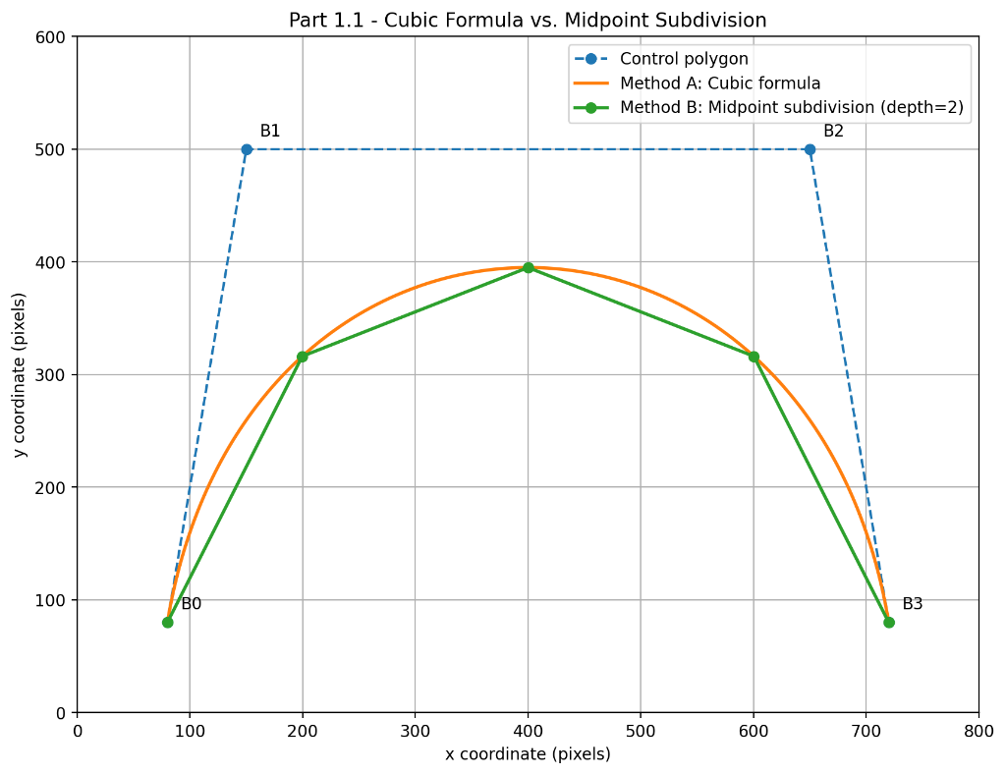
For this experiment, I implemented the Bézier curve using two different constructions. Method A evaluates the cubic Bézier formula directly, while Method B uses recursive midpoint subdivision.
The same four control points were used for both methods:
- Control Point 0 = (80,80)
- Control Point 1 = (150,500)
- Control Point 2 = (650,500)
- Control Point 3 = (720,80)
An 800 × 600 coordinate space was used, with one coordinate unit treated as one pixel for the measurements.
For Method A, the curve coordinates were computed using the cubic Bézier formula
C(t) = (1−t)³b₀ + 3t(1−t)²b₁ + 3t²(1−t)b₂ + t³b₃ and 1000 parameter samples were used to display the curve.
For Method B, recursive midpoint subdivision was used with a subdivision depth of 2. At this depth, the construction produces (2²=4) line segments and (2²+1=5) polyline vertices.
The figure above overlays the two results. The cubic-formula curve is shown as the smooth curve, while the midpoint construction is shown as a polyline. At this shallow subdivision depth, the difference between the two constructions is still clearly visible, especially between consecutive polyline vertices.

