1. Name (Project heading): **Android based** **Total security for system authentication**

2. Remote Centre ID (RC_ID): 1067

3. College / Institute Name: St.Francis Institute of Technology

4. City, State, Pin Code: Borivali –Mumbai, Maharashtra, 400066

5. Name/’s of the Student: Asst. Prof. Bhavesh Pandya

6. about (Short Description / Summary):

This project describes a method of implementing two factor authentication using mobile phones. The proposed method guarantees that authenticating to services, such as online banking or ATM machines, is done in a very secure manner. The proposed system involves using a mobile phone as a software token for One Time Password generation. The generated One Time Password is valid for only a short user defined period of time and is generated by factors that are unique to both, the user and the mobile device itself. Additionally, an SMS-based mechanism is implemented as both a backup mechanism for retrieving the password and as a possible mean of synchronization. The proposed method has been implemented and tested. Initial results show the success of the proposed method.

7. Install (Installation procedure): Step by step procedure to install software.

* In this project all employee needs to enter username password and auto generated number from admin to log in.
* If anybody wants to use a computer of another employee then also without that employee permission with the help of mobile message nobody can access that machine.

**Architectural Design**

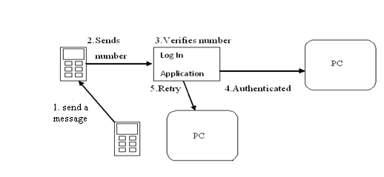

**User Interface Design:**

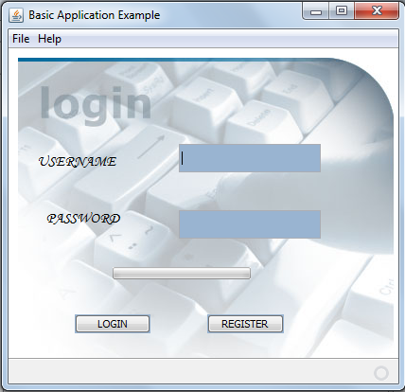

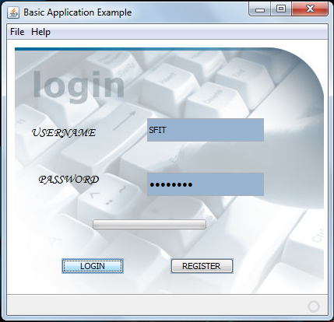



8. Usage (add instruction on how to use the app, or you can redirect to

External link if you have one):-

* We can add this software for attendance measurement in company as well as college or any organization.
* Employer needs to send message to the machine for security reason which will send message with time and date.
* Here we are checking both the machines system time and date. (User as well as Admin).

9. Contact (email id or mailing list link/google-group):- bhaveshpandya2009@gmail.com

10. License (GNU GPL version 3 with link to full license on gnu.org site.)