**How to run the cyber Cafe Management System Django Python**

1. Download the zip file

2. Extract the file , copy cybercafe folder and paste on the desktop

3. Open PyCharm and click on the terminal

4. Now enter the below command given in the screenshots

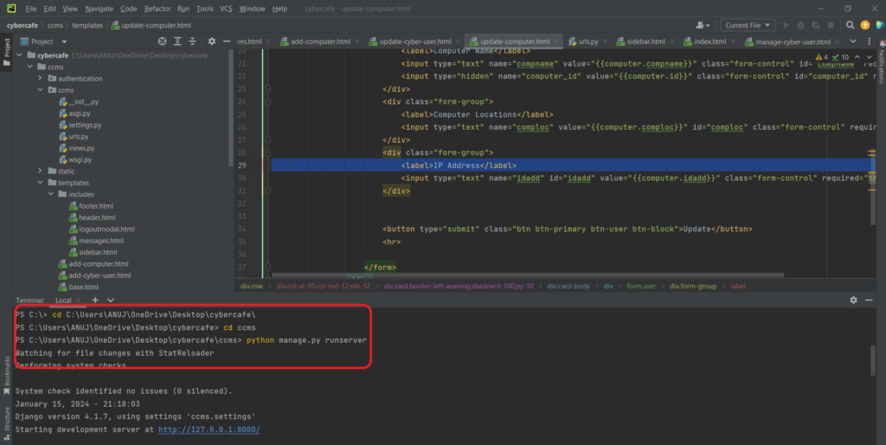

Now click the url http://127.0.0.1:8000 and the Project will Run

**Login Credentials**

**Admin**  
**Username:** admin@gmail.com  
**Password:** Test@123