**How to run the Doctor Appointment System Django Python**

1. Download the zip file

2. Extract the file, copy doctorappointment folder, and paste it on the desktop

3. Open MySQL Create a database docaspythondb then import the SQL File available in the MySQL File Folder (For MySQL we used [XAMPP](https://phpgurukul.com/how-to-install-xampp/)server)

4. Open PyCharm and click on the terminal

5. Navigate the project folder using the cd command

cd project_path

**For ex:**cd C:\Users\ANUJ\OneDrive\Desktop\doctorappointment

6. Now Navigate to the Company Visitor Management System folder

cd docappsystem

7. Run the Project using the following command

python manage.py runserver

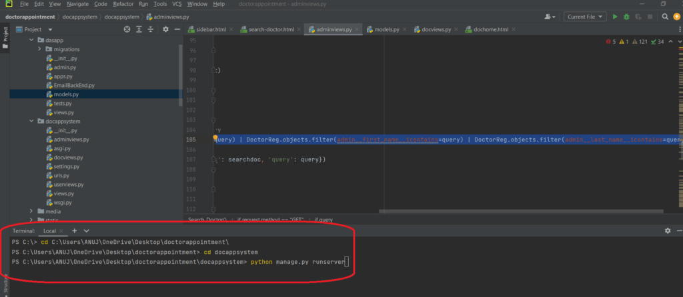

Now click the URL http://127.0.0.1:8000 and the Project will Run