**How to run the Online Notes Sharing System Django Python**

1. Download the zip file

2. Extract the file, copy nss folder, and paste it on the desktop.

3. Open MySQL Create a database nsspythondb then import the SQL File available in the SQL File Folder (For MySQL we used [XAMPP](https://phpgurukul.com/how-to-install-xampp/)server).

4. Open PyCharm and click on the terminal.

5. Navigate the project folder using the cd command

cd project_path

**For ex:**cd C:\Users\ANUJ\OneDrive\Desktop\nss

6. Now Navigate to the Notes Sharing Folder folder

cd notessharing

7. Run the Project using the following command

python manage.py runserver

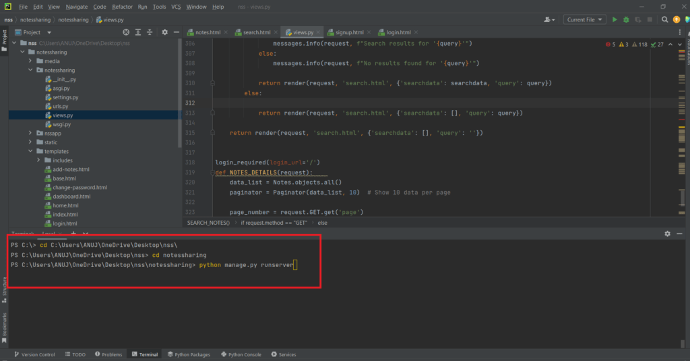

Now click the URL http://127.0.0.1:8000 and the Project will Run

**Login Details**

**\*\*\*\*\*User\*\*\*\*\***

**Username:**john123

**Password:** Test@123 OR Register a new user.