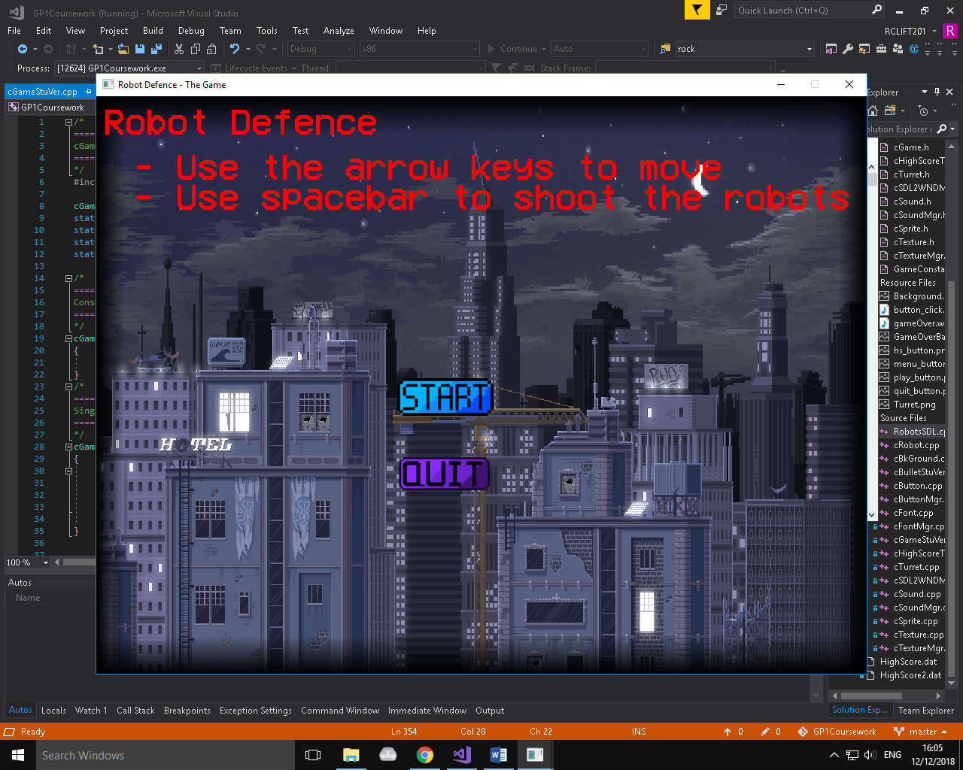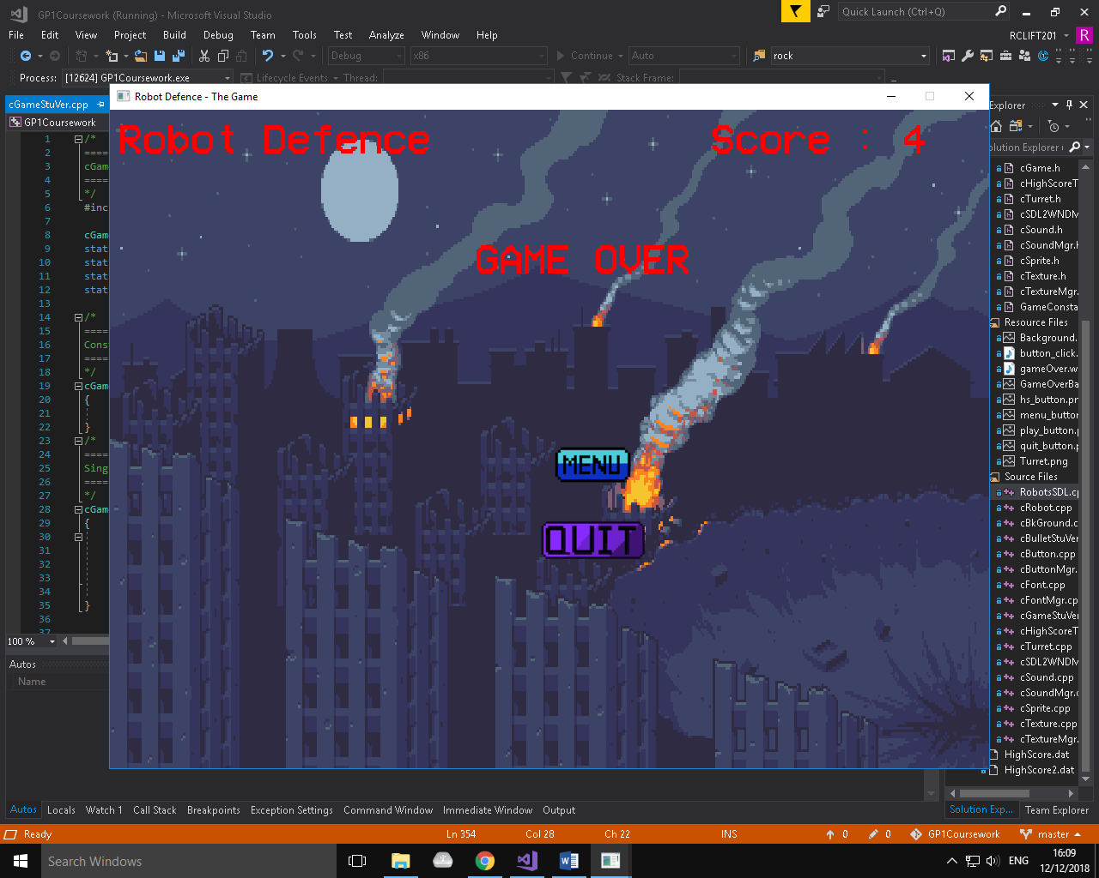

**Game Over Screen**

*Display* – Title, ‘Game Over’, Score Value, Buttons (Menu, Quit), Background

*SFX* – Button Click

*Music* – Retro Music

*Buttons* – Main Menu, Quit Game

**Main Menu**

*Display* – Title, Instructions, Buttons (Start, Quit), Background

*SFX* – Button Click

*Music* – Retro Music

*Buttons* – Play Game, Quit Game