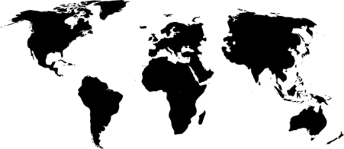

{book1}

{book4}

{book3}

{book2}

{book5}

World Population: {world_pop}

UK Population: {uk_pop}

* {celebrity1}
* {celebrity2}
* {celebrity3}
* {celebrity4}
* {celebrity5}
* Monarch {monarch}
* {movie1}
* {movie2}
* {movie3}
* {movie4}
* {movie5}

What movies were there?

Who was born?

**Monarch**

Publications:

{years_ago} years ago back in {year}

**HAPPY BIRTHDAY!**