EMOR (Mobile Robots), 14L edition, exercise 3

1. Building a map
If your program is able to drive the robot along the wall or explore the environment avoiding the obstacles, you can use it to build a map of the simulated world.
Launch ROS-based simulation of Elektron robot using Stage simulator
roslaunch emor_configs cave_simple.launch
then start SLAM application, which will take in laser scans (in this case, base_scan topic) and produce a map
rosrun gmapping slam_gmapping scan:=base_scan
You can watch the progress of the mapping process in rviz, from /map topic
rosrun rviz rviz
Now you can run your wall following robot controller
rosrun emor_project wall

When all the interesting area is covered by map produced by slam_gmapping, stop your wall program and save resulting map
rosrun map_server map_saver
Now you can stop slam_gmapping.
The map is saved locally as map.pgm and map.yaml. You can watch it in any viewer, for example
eog map.pgm

2. Monte Carlo localization
In the simulation place the robot in a region covered by the produced map. Run a map server that will publish the map
rosrun map_server map_server map.yaml
and localization algorithm
roslaunch emor_configs amcl.launch
After start of amcl you need to point the area in which particles will be located in initial phase. In rviz
click the "2D Pose Estimate" button,
click on the map where the robot is and drag in the direction the robot is pointing.
In rviz you can observe a collection of red arrows – particles that represent the hypotheses of robot's position and orientation. Now you can run your program
rosrun emor_project wall
and observe how the cloud of particles evolves, gathering around the real position of the robot.

3. Navigation
Stop your program and run navigation algorithm
roslaunch emor_configs navigation_sick.launch
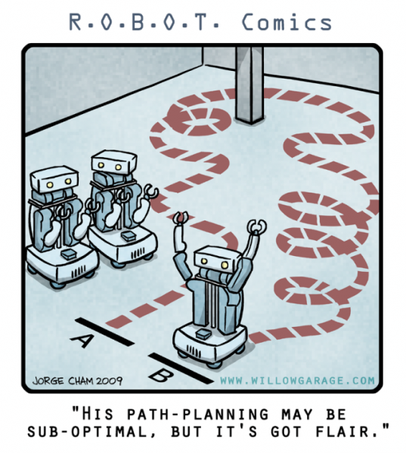
As long as robot is precisely localized using amcl, you can command the navigation node to move the robot to a specific goal. To set the goal, in rviz
click the "2D Nav Goal" button,
click on the map where you want the robot to go and drag in the direction of desired yaw.

4. Implementing guarding behavior
~/ros_workspace/elektron_emor/emor_project/src/action_guard_node.cpp
is example code showing how to command navigation node to go to a specified position and verify whether the goal was achieved. Use the code to implement guarding behavior. Define three points on a map and make the robot move between them in a loop.

To be evaluated:
Building a map(1) 0..4pts
Monte Carlo (2) 0..3pts
Exercises are performed in groups of two. Navigation in Rviz (3) 0..3pts
Max mark: 15pts Guarding behavior (4) 0..5pts
Comments in code -3..0pts
https://robotyka.ia.pw.edu.pl/twiki/bin/view/Courses/EMOR14L Code readability -3..0pts

