Robert Porter

24.SP.CIS.2250/1375.M01 PHP/Javascript

5/2/24

Final Project Write Up

I put my name in the footer as well as in the top of each page in the comments.

Note: The database file is in the other folder within the project.

I utilized a txt file of words that I found at <https://www.mit.edu/~ecprice/wordlist.10000>. This file contained a bunch of “non-words” like ‘aaa’ along with the real words. Also, I thought that it would be a good idea to put a length limit (min 4 max 8) on the words that I would be using. I used these words for the password generator. A study (<https://www.ncsc.gov.uk/collection/top-tips-for-staying-secure-online/three-random-words>) found that a good way to make a password is to use three unrelated words. So, my password generator first pulls three random words from the newly created file before changing some of the letters to similar numbers and special characters. Anyway, the file that shows the code that I used to cut down the original text file is found in ‘alter_words.php’ file in the ‘other’ folder. I then passed the filtered words into the database to be pulled for password creation.

Note: It has come to my attention that this list contains bad words. I did my best to remove them. I sincerely apologize if I was unsuccessful in removing them all.

On the Say Word page, I used a technique not mentioned in the books to get my JavaScript Function to work. To make sure that at least one of the Lower-Case and Upper-Case toggle switches were active at all times, I created a function to check them whenever they were checked/unchecked. It is possible to write a listener for checked, but not for unchecked. So, I added the JavaScript function directly to the onchange attribute of both of those switches. If I understand correctly, it forces an event to occur at any change in the switch and directly assigns the event a function.

Okay. I apologize for this long winded write-up, but I have had issues with file transfer in the past. And as it is 5:30 am on the date this project is due, I just want to convey what I saw on my end and how I met the criteria given for the project.

PHP:

Database w/ 2 tables:

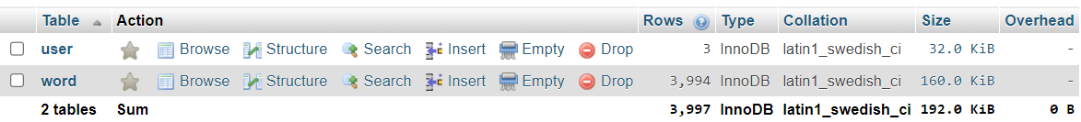

Web app that allows users to interact with the database. As I mentioned, the password generator pulls random words from the database. Also, the “Word Up” page allows users to save hints (potentially the ones generated for them):

First page contains a menu of choices that link to other pages. Every page has a navigation bar that leads to the main 3 pages.



Design Principles used. I’ll let the code speak for itself on this one. I did pull quite a bit for the hint saving from the book applications. I wish I could have done more (like an edit hints button), but I simply ran out of time.

JAVASCRIPT:

At least 3 pages. There are 6 pages in total, including the add hint and sign in pages. Those two do not have any javascript in them (besides the bootstrap stuff).

In the What’s the Word (Home) page I used Javascript to verify (live) if the password being entered has lower-case, upper-case, numbers, and special characters. I used regex for that functionality.

Using design principles in this course: I used a utility script that holds the util “namespace” used in the other scripts. It’s a bit silly, but I made a class for the session storage interaction. I used the session storage to bring the hints from the password generator page to the hint saving page.

Admittedly, as I look back over the code, I do not have any arrays in the javascript. I used an if else decision structure. I did not include any loops. I utilized event handlers for the password checker. Obviously used the DOM to access the values of various tags.

I know the javascript is a bit lacking, I could have done more.

Overall, I am proud of this work. There are many many things I would change and improve if I had the time. I still may, before I post it to my github. Thank you so much for your time and effort this semester. I know it was a pain for you and I appreciate it. You are an excellent instructor, you helped me understand concepts that I was unable to grasp before. I can’t thank you enough.