Ultimate Store & Koko Chat Documentation

1. Project Summary
Ultimate Store is a modern, AI-powered e-commerce marketplace that redefines the shopping experience through conversation. At its core is "Koko", a cheeky and context-aware AI shopping assistant powered by Groq (Llama 3.3). Unlike traditional e-commerce sites where users browse grids of products, Ultimate Store allows users to chat with Koko to find products, get recommendations, and place orders in natural language.

2. Interface Preview
Below is a visual representation of the AI Chat Interface:
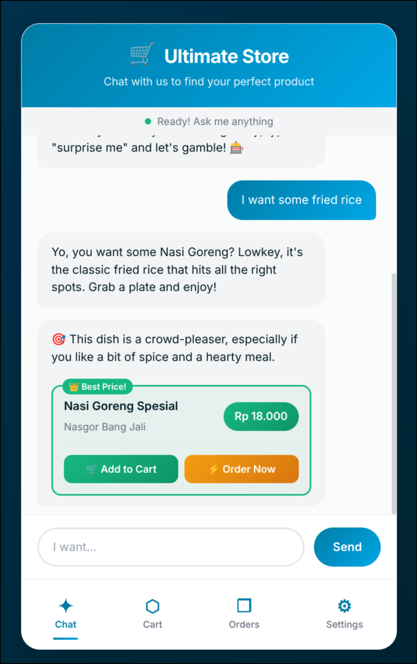
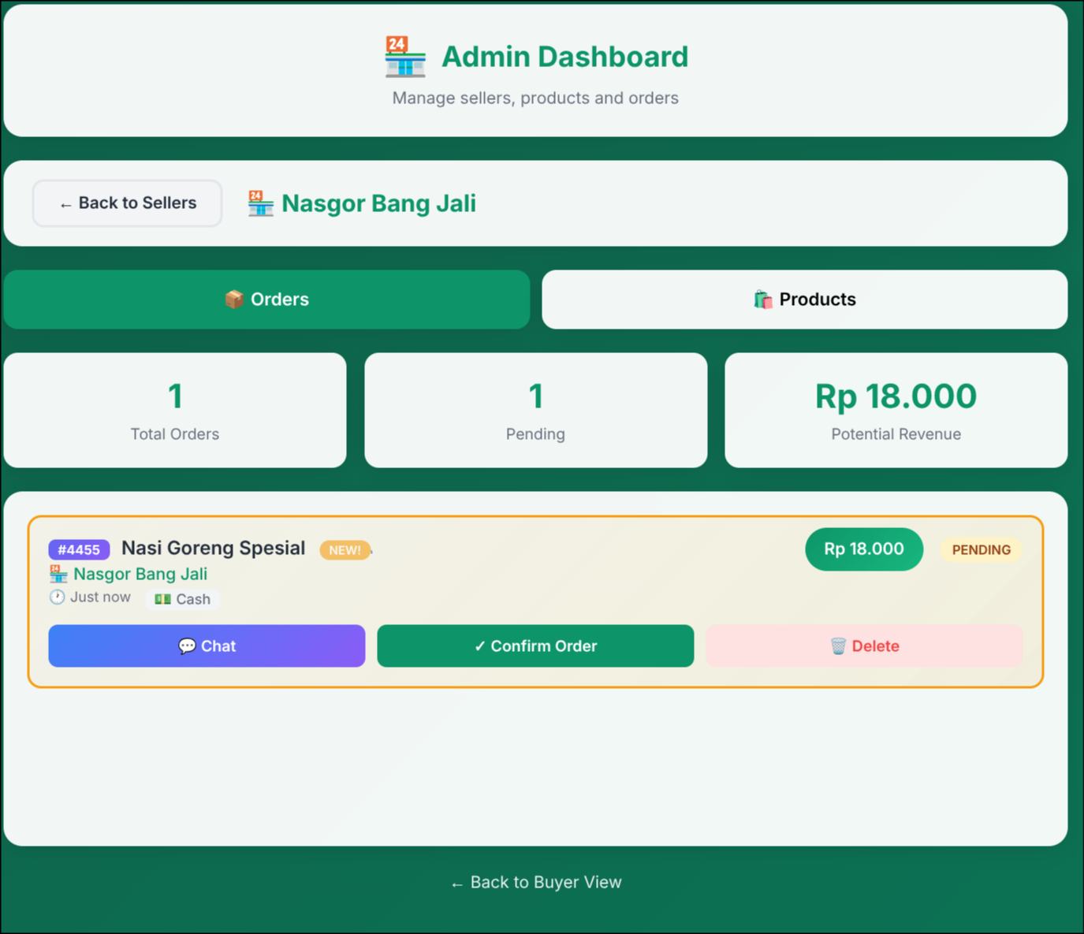

Figure 1: The mobile chat interface showing Koko suggesting products.
Figure 2: The admin interface showing user orders products.

3. How It Works

3.1 The Tech Stack
The project is built using a modern but lightweight stack:
• Frontend: Vanilla JavaScript, HTML5, CSS3 (No heavy frameworks like React/Vue).
• Backend/Database: Firebase Firestore for real-time data synchronization.
• AI Engine: Groq API running Llama 3.3 70B for extremely fast inference.

3.2 The AI Brain (Koko)
The application doesn't just send user text to an LLM. It employs a sophisticated 'System Prompt' strategy. When the app loads, the entire product catalog is fetched from Firebase and injected into the AI's context. This allows Koko to:
1. Know exactly what products are available in real-time.
2. Recommend products based on price, category, or description.
3. Detect user intent (e.g., 'buy', 'search', 'chat').
4. Respond with structured JSON data to trigger UI actions (like showing a product card).

3.3 King Mode
A unique feature called 'King Mode' (Alpha) changes the AI's persona to that of a loyal butler. It also enables 'One-Click Auto Checkout', streamlining the buying process for VIP users by bypassing confirmation screens and using default payment settings.

4. Key Features

User Side (Buyer)
- Natural Language Search: 'I need some rice'.
- Interactive Cart: Add items directly from the chat.
- Order Tracking: Real-time status updates.
- Direct Chat: Communicate with sellers about specific orders.

Admin Side (Seller)
- Dashboard Overview: Track orders, revenue, and product counts.
- Product Management: Add/Edit/Delete products real-time.
- Order Fulfillment: Confirm or reject orders showing up instantly.
- Availability Toggle: Mark items as out of stock with one click.

