**Event-Based Control**

**Rui Carapinha 248728**

**Third Task**

The third task was to control three car, with a controller (represented by the lights). The cars can only enter the tunnel when the controller gives permission and when the tunnel is free.

Tunnel

Controller

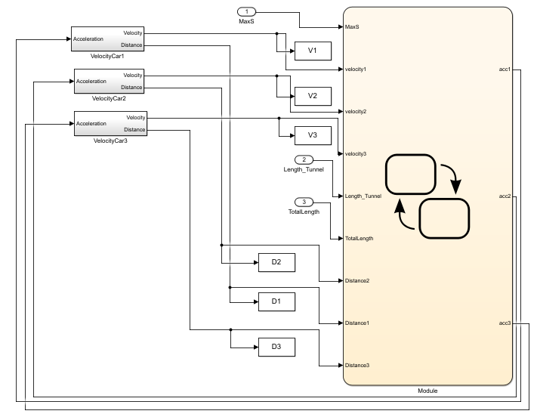To do this I made a program with SimuLink and StateFlow scripts. This program consists in one StateFlow module to control the controller and the cars and three SimuLinks modules to control the velocity of the cars The global graph is the following:

To control the cars, I used three of the following module, one for each car.

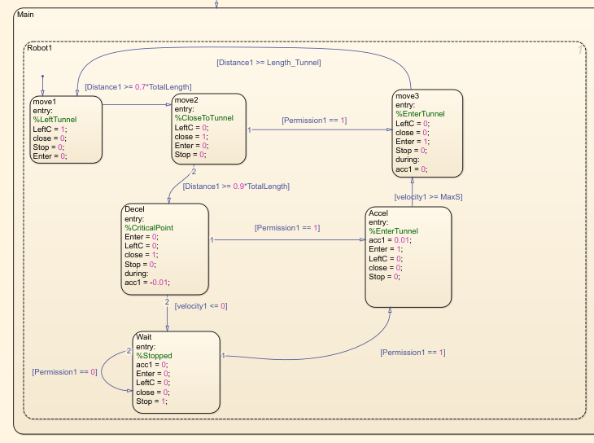

This graph sends all the logic to the Main Controller and gives the acceleration to the SimuLink modules that transform that to velocity and distance.

The following graph is for the Main Controller, this gives permission (or not) to let the cars enter in the tunnel.

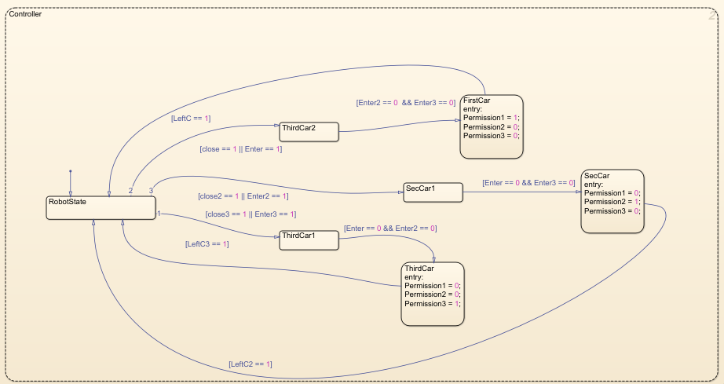

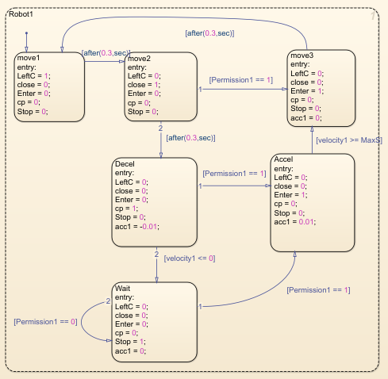

The SimuLink graph was done so I can access the velocity and distance of the three cars.

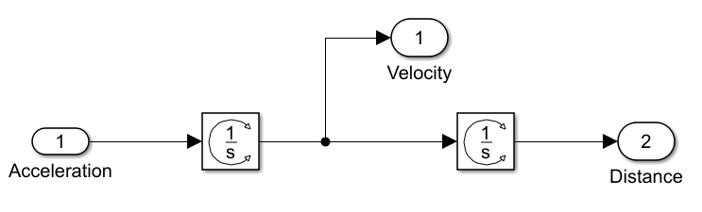

With this I can make a script to plot the velocity and the distance of each car. In the script I wrote we can change the length of the tunnel, the total length of the circle and the max speed of the cars.

clear all

close all

clc

Length_Tunnel = 2; %Size of Tunnel

MaxS = 2; %Max Speed

TotalLength = 10; %Total Length of the circuit

sim('RobotController3');

figure(1)

hold on

plot(D1)

plot(V1)

title('Car 1')

figure(2)

hold on

plot(D2)

plot(V2)

title('Car 2')

figure(3)

hold on

plot(D3)

plot(V3)

title('Car 3')

The results were the following:

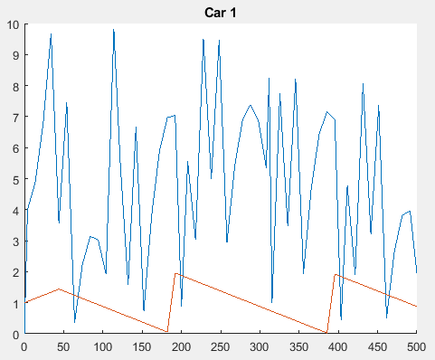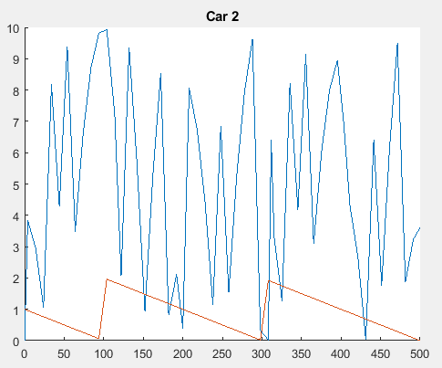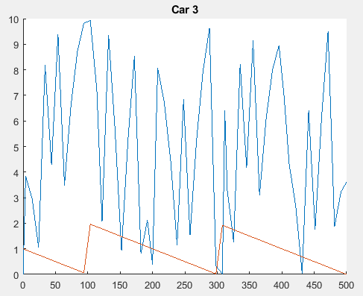

The results were a little awkward, the speed of the cars (orange) is good but the distance of the cars doesn’t make any sense.

My results show that the problem was not well solved. I had problem with the distance that I couldn’t fix. It doesn’t make any sense such high and lows in the distance.