**Rui Carapinha 248728**

**Event-Based Control Fourth Task**

The fourth task was to control two robots in an open space and making sure they don’t collide, to help with the collision control we have a controller that gives permission to the robots.

To do this I made a program with SimuLink and StateFlow scripts. This program consists in one SimuLink module and two StateFlow modules to control the robots. The global graph is the following:

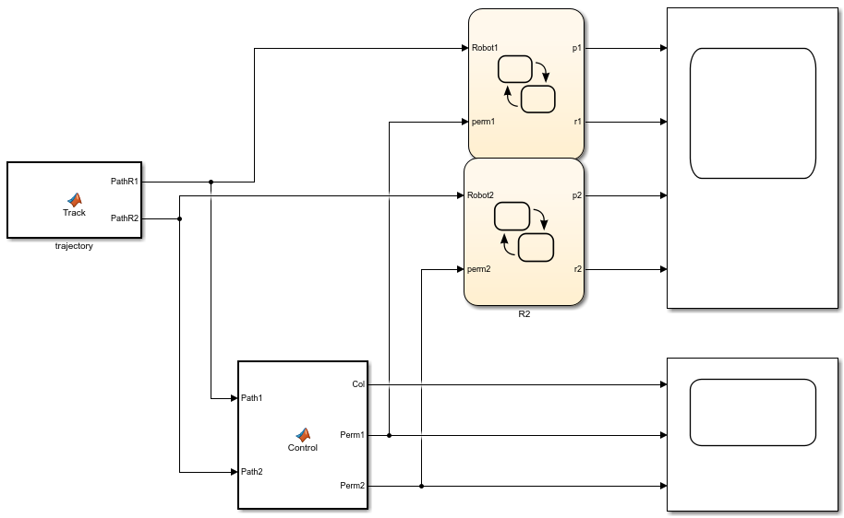

To control the robots, I used two of the following modules, one for each robot.



This graph only allows the robot to pass to the next path when the controller gives permission to do so. The path is generated by a function named Track.

The function track is the following:

function [PathR1, PathR2] = Track()

PathR1 = zeros(1,6);

PathR2 = zeros(1,6);

for k = 1:6

PathR1(1,k) = randi(10,1);

PathR2(1,k) = randi(10,1);

end

This function creates two arrays with 6 positions, each position has random integers from 1 to 10. This will be the path that the robots will follow.

For the collision controller I also have a MATLAB Function, the function is the following:

function [Col, Perm1 , Perm2] = Control(Path1, Path2)

for i = 1:length(Path1)

if(Path1(i) == Path2(i))

Col = 1;

Perm1 = 1;

Perm2 = 0;

else

Col = 0;

Perm1 = 1;

Perm2 = 1;

end

end

This function receives both paths and checks when the paths have the same number in the same position, if that happens there will be a collision so he stops the second robot and lets the first robot continue.

The results I had were the following:

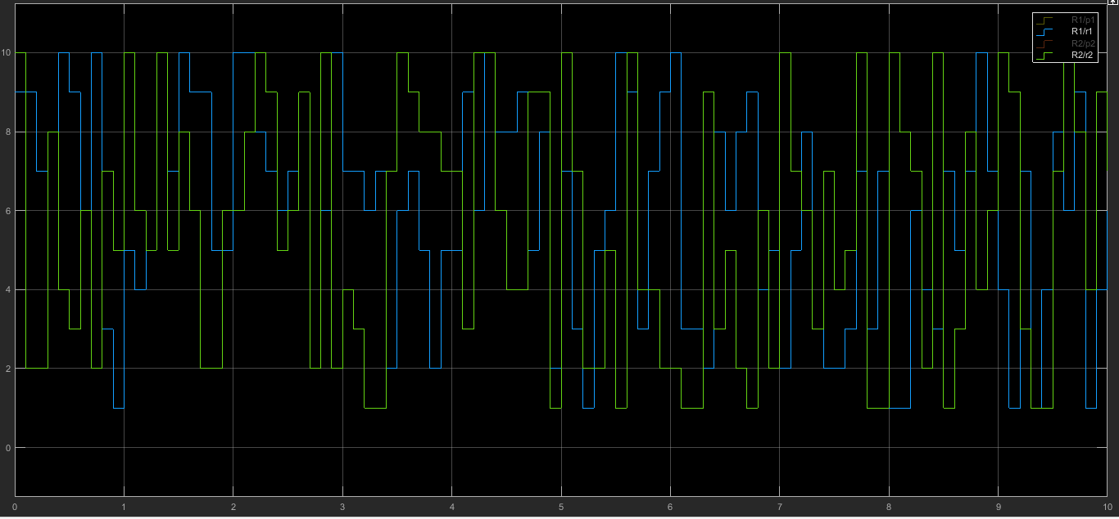

This is the path that the robots followed during the simulation, we can easily see that we have positions that go from 1 to 10.

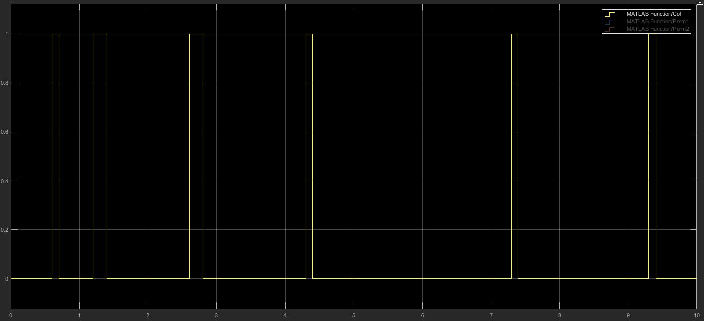

Here we can see when the collisions happened, in this moment the second robot stopped and the first one continued.

The results were good, we can that the problem was solved with success.