G C

RCarson10

Abstract

This project implements the processes of calculating the solutions of a differential equation using the Taylor and Power Series methods.

Benchmark – Project 6 – Numeric Computations with Taylor Polynomials

By Gaj Carson

# **Abstract**

**Taylor Series**

A Taylor series is a [series expansion](https://mathworld.wolfram.com/SeriesExpansion.html) of a [function](https://mathworld.wolfram.com/Function.html) about a point. A one-dimensional Taylor series is an expansion of a [real function](https://mathworld.wolfram.com/RealFunction.html) f(x) about a point x=a is given by

|  |  |
| --- | --- |
| f(x)=f(a)+f^'(a)(x-a)+(f^('')(a))/(2!)(x-a)^2+(f^((3))(a))/(3!)(x-a)^3+...+(f^((n))(a))/(n!)(x-a)^n+.... | (1) |

If a=0, the expansion is known as a [Maclaurin series](https://mathworld.wolfram.com/MaclaurinSeries.html).

[Taylor's theorem](https://mathworld.wolfram.com/TaylorsTheorem.html) (actually discovered first by Gregory) states that any function satisfying certain conditions can be expressed as a Taylor series.

The Taylor (or more general) series of a function f(x) about a point a up to order n may be found using [Series](https://reference.wolfram.com/language/ref/Series.html)[*f*, {*x*, *a*, *n*}]. The nth term of a Taylor series of a function f can be computed in the [Wolfram Language](https://www.wolfram.com/language/) using Series Coefficient [*f*, {*x*, *a*, *n*}] and is given by the inverse [Z-transform](https://mathworld.wolfram.com/Z-Transform.html)

|  |  |
| --- | --- |
| a_n=Z^(-1)[1/(z-a)](n). | (2) |

Taylor series of some common functions include

|  |  |  |  |
| --- | --- | --- | --- |
| 1/(1-x) | = | 1/(1-a)+(x-a)/((1-a)^2)+((x-a)^2)/((1-a)^3)+... | (3) |
| cosx | = | cosa-sina(x-a)-1/2cosa(x-a)^2+1/6sina(x-a)^3+... | (4) |
| e^x | = | e^a[1+(x-a)+1/2(x-a)^2+1/6(x-a)^3+...] | (5) |
| lnx | = | lna+(x-a)/a-((x-a)^2)/(2a^2)+((x-a)^3)/(3a^3)-... | (6) |
| sinx | = | sina+cosa(x-a)-1/2sina(x-a)^2-1/6cosa(x-a)^3+... | (7) |
| tanx | = | tana+sec^2a(x-a)+sec^2atana(x-a)^2+sec^2a(sec^2a-2/3)(x-a)^3+.... | (8) |

To derive the Taylor series of a function f(x), note that the integral of the (n+1)st [derivative](https://mathworld.wolfram.com/Derivative.html) f^((n+1)) of f(x) from the point x_0 to an arbitrary point x is given by

|  |  |
| --- | --- |
| int_(x_0)^xf^((n+1))(x)dx=[f^((n))(x)]_(x_0)^x=f^((n))(x)-f^((n))(x_0), | (9) |

where f^((n))(x_0) is the nth derivative of f(x) evaluated at x_0, and is therefore simply a constant. Now integrate a second time to obtain

|  |  |
| --- | --- |
| int_(x_0)^x[int_(x_0)^xf^((n+1))(x)dx]dx  =int_(x_0)^x[f^((n))(x)-f^((n))(x_0)]dx  =[f^((n-1))(x)]_(x_0)^x-(x-x_0)f^((n))(x_0)  =f^((n-1))(x)-f^((n-1))(x_0)-(x-x_0)f^((n))(x_0), | (10) |

where f^((k))(x_0) is again a constant. Integrating a third time,

|  |  |
| --- | --- |
| int_(x_0)^xint_(x_0)^xint_(x_0)^xf^((n+1))(x)(dx)^3=f^((n-2))(x)-f^((n-2))(x_0)  -(x-x_0)f^((n-1))(x_0)-((x-x_0)^2)/(2!)f^((n))(x_0), | (11) |

and continuing up to n+1 integrations then gives

|  |  |
| --- | --- |
| int...int_(x_0)^x_()_(n+1)f^((n+1))(x)(dx)^(n+1)=f(x)-f(x_0)-(x-x_0)f^'(x_0)   -((x-x_0)^2)/(2!)f^('')(x_0)-...-((x-x_0)^n)/(n!)f^((n))(x_0). | (12) |

Rearranging then gives the one-dimensional Taylor series

|  |  |  |  |
| --- | --- | --- | --- |
| f(x) | = | f(x_0)+(x-x_0)f^'(x_0)+((x-x_0)^2)/(2!)f^('')(x_0)+...+((x-x_0)^n)/(n!)f^((n))(x_0)+R_n | (13) |
|  | = | sum_(k=0)^(n)((x-x_0)^kf^((k))(x_0))/(k!)+R_n. | (14) |

Here, R_n is a remainder term known as the [Lagrange remainder](https://mathworld.wolfram.com/LagrangeRemainder.html), which is given by

|  |  |
| --- | --- |
| R_n=int...int_(x_0)^x_()_(n+1)f^((n+1))(x)(dx)^(n+1). | (15) |

Rewriting the [repeated integral](https://mathworld.wolfram.com/RepeatedIntegral.html) then gives

|  |  |
| --- | --- |
| R_n=int_(x_0)^xf^((n+1))(t)((x-t)^n)/(n!)dt. | (16) |

Now, from the [mean-value theorem](https://mathworld.wolfram.com/Mean-ValueTheorem.html) for a function g(x), it must be true that

|  |  |
| --- | --- |
| int_(x_0)^xg(x)dx=(x-x_0)g(x^*) | (17) |

for some x^* in [x_0,x]. Therefore, integrating n+1 times gives the result

|  |  |
| --- | --- |
| R_n=((x-x_0)^(n+1))/((n+1)!)f^((n+1))(x^*) | (18) |

(Abramowitz and Stegun 1972, p. 880), so the maximum error after n terms of the Taylor series is the maximum value of ([18](https://mathworld.wolfram.com/TaylorSeries.html#eqn18)) running through all x^* in [x_0,x]. Note that the Lagrange remainder R_n is also sometimes taken to refer to the remainder when terms up to the (n-1)st power are taken in the Taylor series (Whittaker and Watson 1990, pp. 95-96).

Taylor series can also be defined for functions of a [complex](https://mathworld.wolfram.com/ComplexNumber.html) variable. By the [Cauchy integral formula](https://mathworld.wolfram.com/CauchyIntegralFormula.html),

|  |  |  |  |
| --- | --- | --- | --- |
| f(z) | = | 1/(2pii)int_C(f(z^')dz^')/(z^'-z) | (19) |
|  | = | 1/(2pii)int_C(f(z^')dz^')/((z^'-z_0)-(z-z_0)) | (20) |
|  | = | 1/(2pii)int_C(f(z^')dz^')/((z^'-z_0)(1-(z-z_0)/(z^'-z_0))). | (21) |

In the interior of C,

|  |  |
| --- | --- |
| (|z-z_0|)/(|z^'-z_0|)<1 | (22) |

so, using

|  |  |
| --- | --- |
| 1/(1-t)=sum_(n=0)^inftyt^n, | (23) |

it follows that

|  |  |  |  |
| --- | --- | --- | --- |
| f(z) | = | 1/(2pii)int_Csum_(n=0)^(infty)((z-z_0)^nf(z^')dz^')/((z^'-z_0)^(n+1)) | (24) |
|  | = | 1/(2pii)sum_(n=0)^(infty)(z-z_0)^nint_C(f(z^')dz^')/((z^'-z_0)^(n+1)). | (25) |

Using the [Cauchy integral formula](https://mathworld.wolfram.com/CauchyIntegralFormula.html) for derivatives,

|  |  |
| --- | --- |
| f(z)=sum_(n=0)^infty(z-z_0)^n(f^((n))(z_0))/(n!). | (26) |

An alternative form of the one-dimensional Taylor series may be obtained by letting

|  |  |
| --- | --- |
| x-x_0=Deltax | (27) |

so that

|  |  |
| --- | --- |
| x=x_0+Deltax. | (28) |

Substitute this result into (◇) to give

|  |  |
| --- | --- |
| f(x_0+Deltax)=f(x_0)+Deltaxf^'(x_0)+1/(2!)(Deltax)^2f^('')(x_0)+.... | (29) |

A Taylor series of a [real function](https://mathworld.wolfram.com/RealFunction.html) in two variables f(x,y) is given by

|  |  |
| --- | --- |
| f(x+Deltax,y+Deltay)=f(x,y)+[f_x(x,y)Deltax+f_y(x,y)Deltay]+1/(2!)[(Deltax)^2f_(xx)(x,y)+2DeltaxDeltayf_(xy)(x,y)+(Deltay)^2f_(yy)(x,y)]+1/(3!)[(Deltax)^3f_(xxx)(x,y)+3(Deltax)^2Deltayf_(xxy)(x,y)+3Deltax(Deltay)^2f_(xyy)(x,y)+(Deltay)^3f_(yyy)(x,y)]+.... | (30) |

This can be further generalized for a [real function](https://mathworld.wolfram.com/RealFunction.html) in n variables,

|  |  |
| --- | --- |
| f(x_1,...,x_n)=sum_(j=0)^infty{1/(j!)[sum_(k=1)^n(x_k-a_k)partial/(partialx_k^')]^jf(x_1^',...,x_n^')}_(x_1^'=a_1,...,x_n^'=a_n). | (31) |

Rewriting,

|  |  |
| --- | --- |
| f(x_1+a_1,...,x_n+a_n)=sum_(j=0)^infty{1/(j!)(sum_(k=1)^na_kpartial/(partialx_k^'))^jf(x_1^',...,x_n^')}_(x_1^'=x_1,...,x_n^'=x_n). | (32) |

For example, taking n=2 in ([31](https://mathworld.wolfram.com/TaylorSeries.html#eqn31)) gives

|  |  |
| --- | --- |
| f(x_1,x_2)=sum_(j=0)^(infty){1/(j!)[(x_1-a_1)partial/(partialx_1^')+(x_2-a_2)partial/(partialx_2^')]^jf(x_1^',x_2^')}_(x_1^'=a_1,x_2^'=a_2) | (33) |
| =f(a_1,a_2)+[(x_1-a_1)(partialf)/(partialx_1)+(x_2-a_2)(partialf)/(partialx_2)]+1/(2!)[(x_1-a_1)^2(partial^2f)/(partialx_1^2)+2(x_1-a_1)(x_2-a_2)(partial^2f)/(partialx_1partialx_2)+(x_2-a_2)^2(partial^2f)/(partialx_2^2)]+.... | (34) |

Taking n=3 in ([32](https://mathworld.wolfram.com/TaylorSeries.html#eqn32)) gives

|  |  |
| --- | --- |
| f(x_1+a_1,x_2+a_2,x_3+a_3)  =sum_(j=0)^infty{1/(j!)(a_1partial/(partialx_1^')+a_2partial/(partialx_2^')+a_3partial/(partialx_3^'))^jf(x_1^',x_2^',x_3^')}_(x_1^'=x_1,x_2^'=x_2,x_3^'=x_3), | (35) |

or, in [vector](https://mathworld.wolfram.com/Vector.html) form

|  |  |
| --- | --- |
| f(r+a)=sum_(j=0)^infty[1/(j!)(a·del _(r^'))^jf(r^')]_(r^'=r). | (36) |

The zeroth- and first-order terms are f(r) and (a·del _(r^'))f(r^')|_(r^'=r), respectively. The second-order term is

|  |  |  |  |
| --- | --- | --- | --- |
| 1/2(a·del _(r^'))(a·del _(r^'))f(r^')|_(r^'=r) | = | 1/2a·del _(r^')[a·(del f(r^'))]_(r^'=r) | (37) |
|  | = | 1/2a·[a·del _(r^')(del _(r^')f(r^'))]|_(r^'=r), | (38) |

so, the first few terms of the expansion are

|  |
| --- |
| f(r+a)=f(r)+(a·del _(r^'))f(r^')|_(r^'=r)+1/2a·[a·del _(r^')(del _(r^')f(r^'))]|_(r^'=r). Power Series **Power series**, in [mathematics](https://www.britannica.com/science/mathematics), an [infinite series](https://www.britannica.com/science/infinite-series) that can be thought of as a [polynomial](https://www.britannica.com/science/polynomial) with an [infinite](https://www.merriam-webster.com/dictionary/infinite) number of terms, such as 1 + x + x2 + x3 +⋯. Usually, a given power series will [converge](https://www.britannica.com/science/convergence-mathematics) (that is, approach a finite sum) for all values of x within a certain interval around zero—in particular, whenever the absolute value of x is less than some positive number r, known as the radius of [convergence](https://www.britannica.com/science/convergence-mathematics). Outside of this interval the series diverges (is infinite), while the series may converge or diverge when x = ± r. The radius of convergence can often be determined by a version of the ratio test for power series: given a general power seriesa0 + a1x + a2x2 +⋯, in which the coefficients are known, the radius of convergence is equal to the [limit](https://www.britannica.com/science/limit-mathematics) of the ratio of successive coefficients. Symbolically, the series will converge for all values of x such thatEquation.  For instance, the infinite series 1 + x + x2 + x3 +⋯ has a radius of convergence of 1 (all the coefficients are 1)—that is, it converges for all −1 < x < 1—and within that interval the infinite series is equal to 1/(1 − x). Applying the ratio test to the series1 + x/1! + x2/2! + x3/3! +⋯ (in which the [factorial](https://www.britannica.com/science/factorial) notation n! means the product of the counting numbers from 1 to n) gives a radius of convergence ofEquation.so that the series converges for any value of x.  Most functions can be represented by a power series in some interval (seePower series for three trigonometry functionstable). Although a series may converge for all values of x, the convergence may be so slow for some values that using it to approximate a [function](https://www.britannica.com/science/function-mathematics) will require calculating too many terms to make it useful. Instead of powers of x, sometimes a much faster convergence occurs for powers of (x − c), where c is some value near the desired value of x. Power series have also been used for calculating constants such as π and the natural [logarithm](https://www.britannica.com/science/logarithm) base e and for solving [differential equations](https://www.britannica.com/science/differential-equation). |

**The Problem**

**Flowchart**

The flowchart below explains the steps that are to be taken to solve an ODE with both the Taylor and Power Series method.

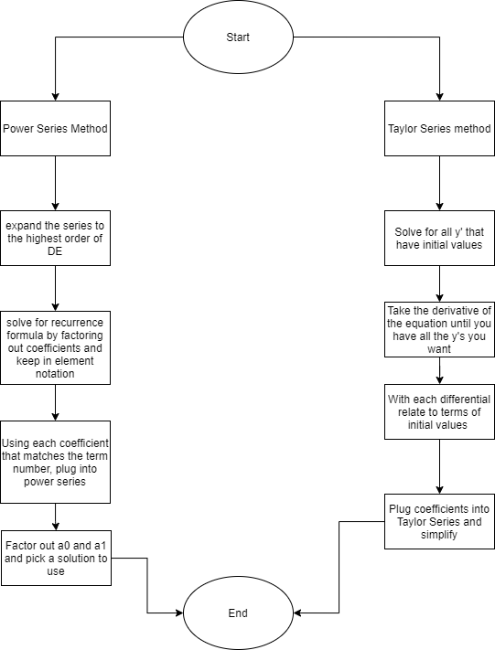

**Hand Calculations with Parts 1 and 2.**

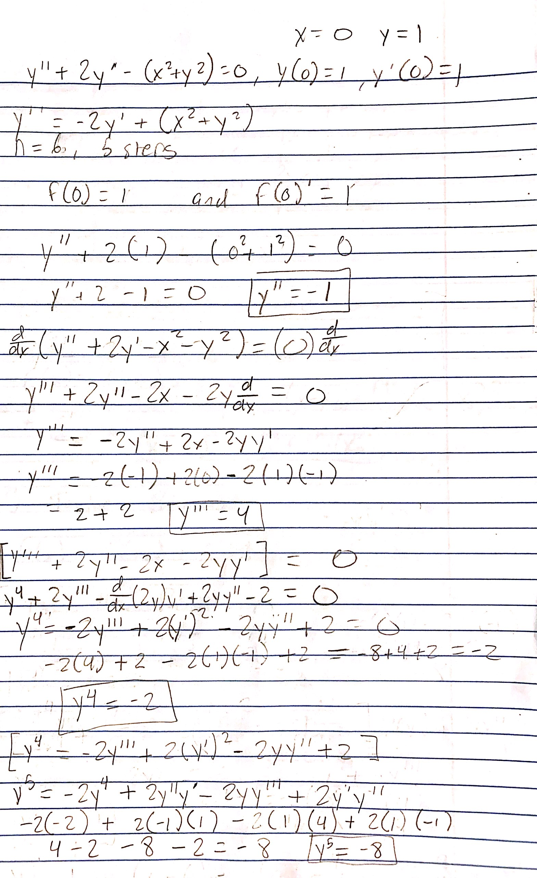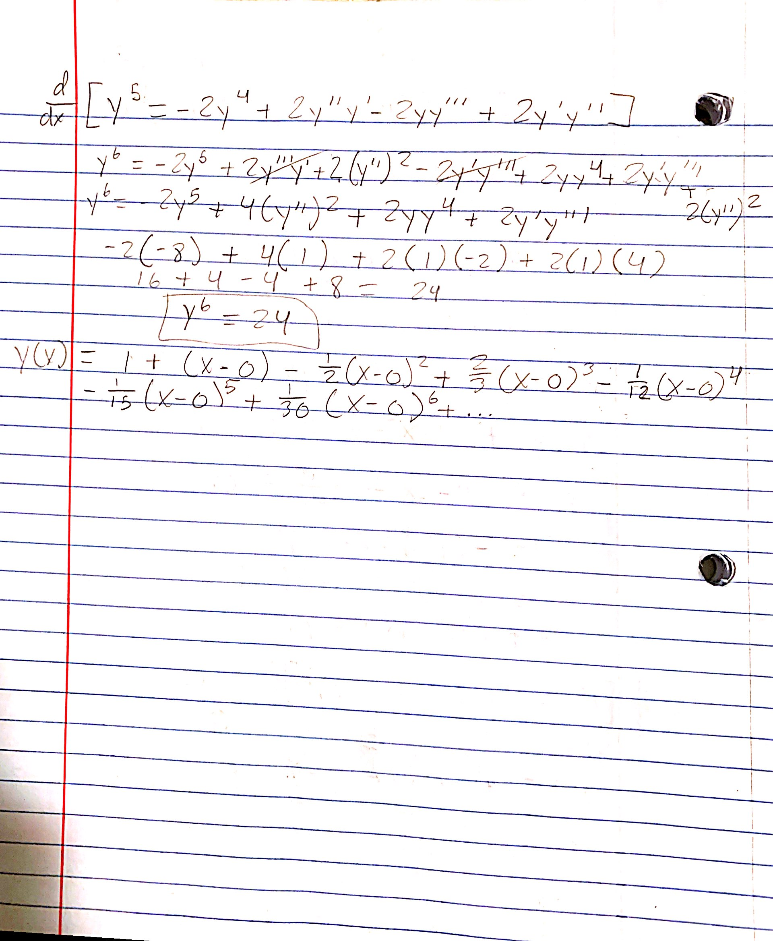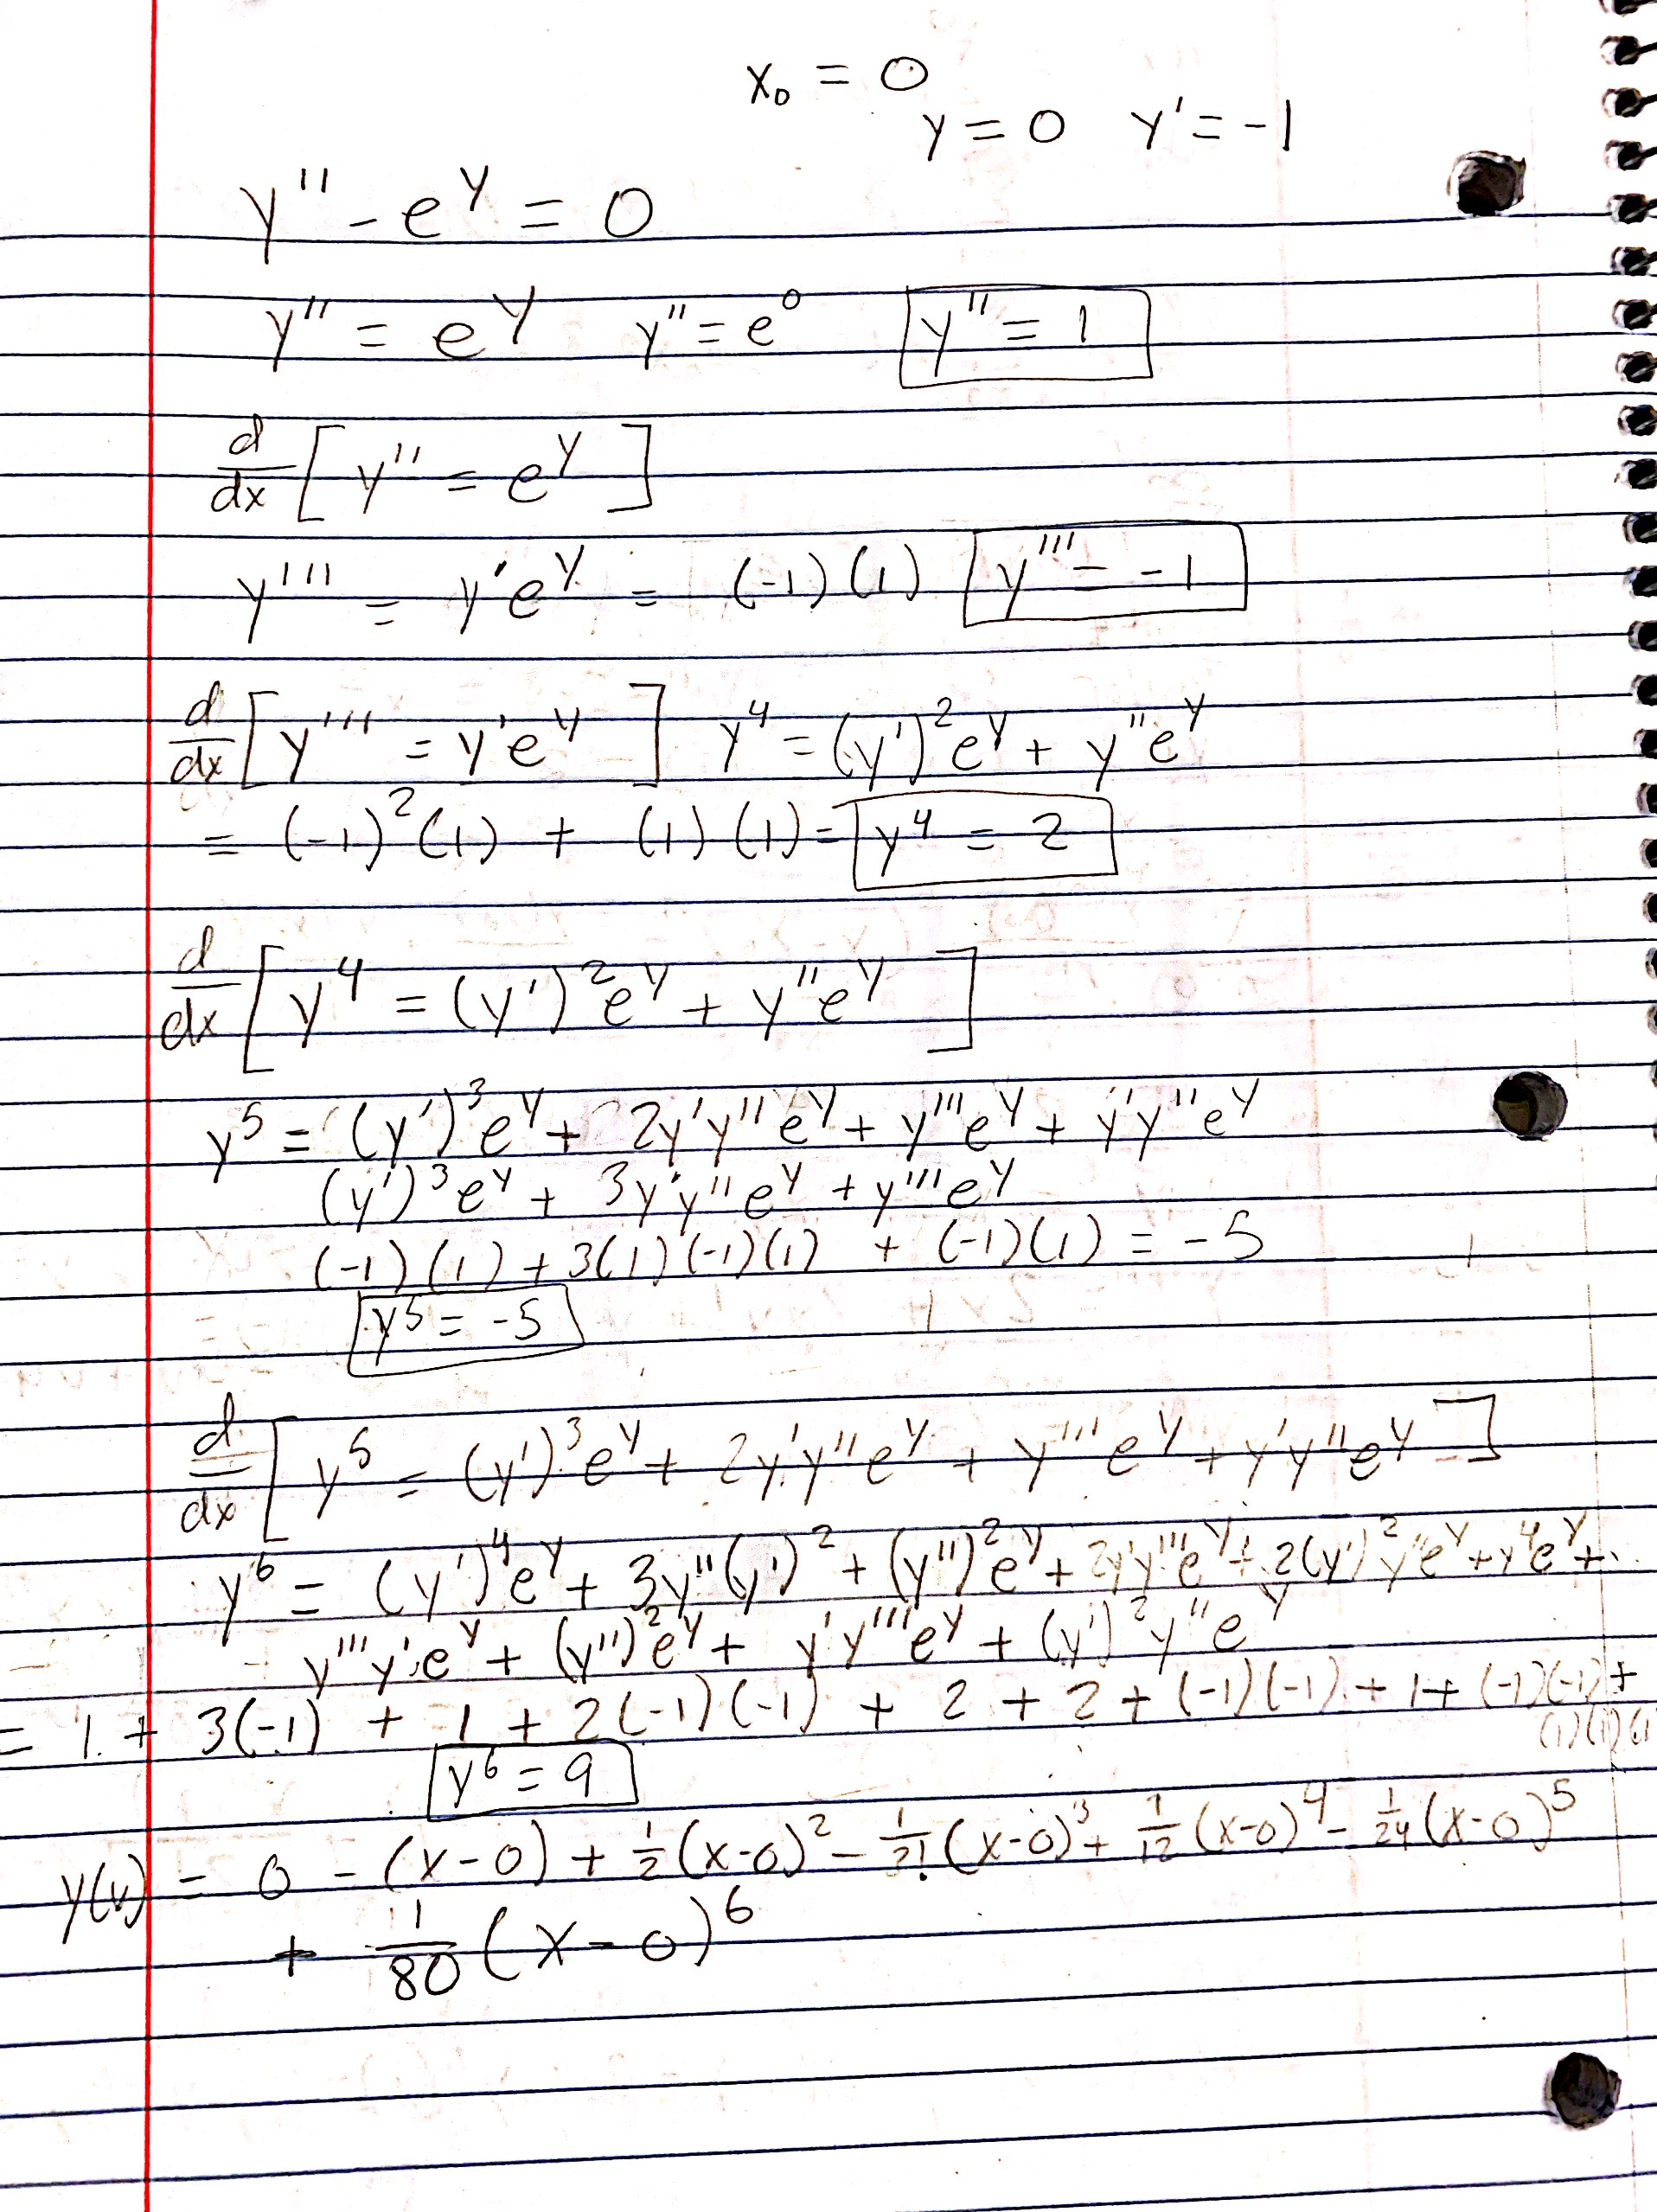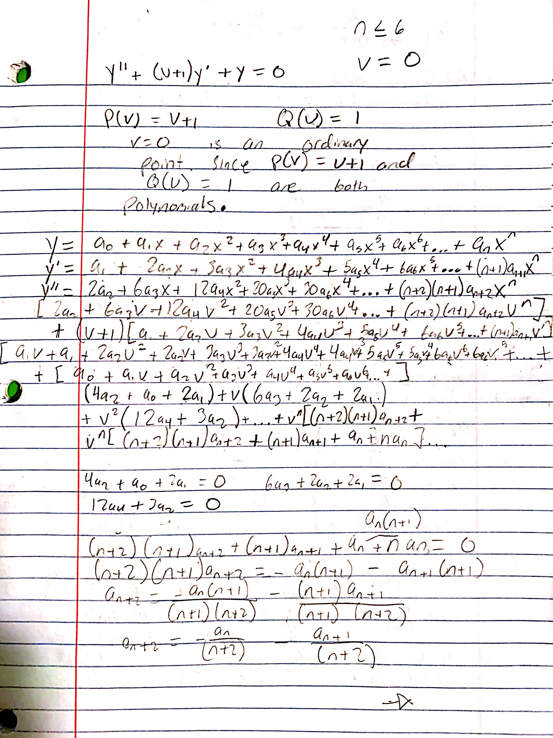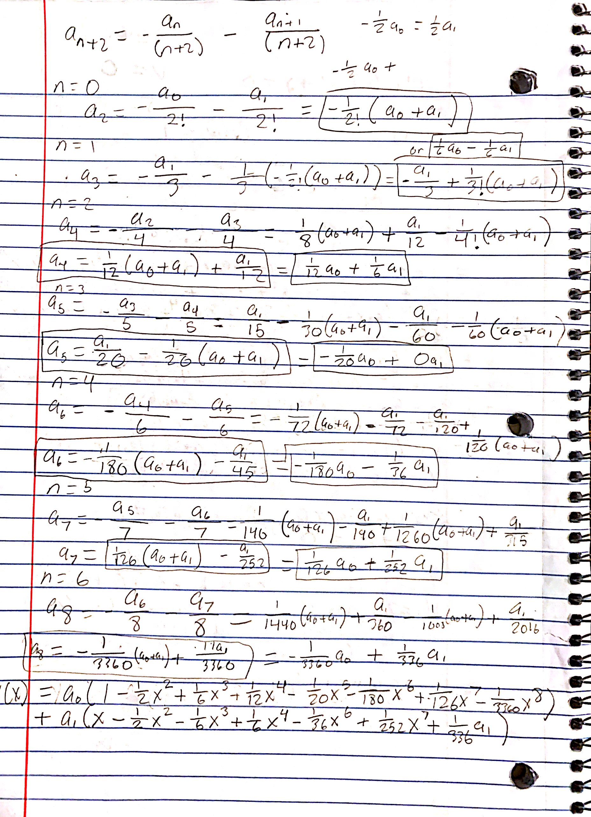

### Code Output and Code

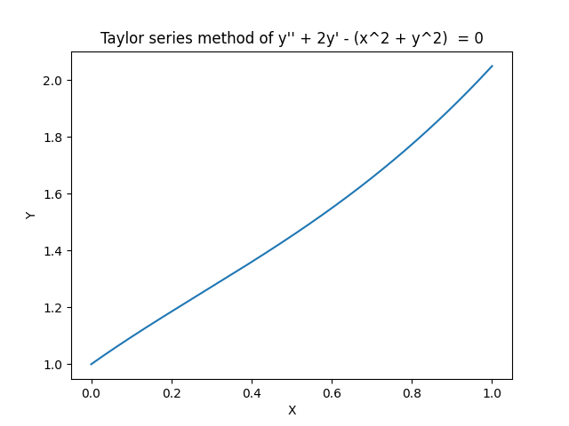

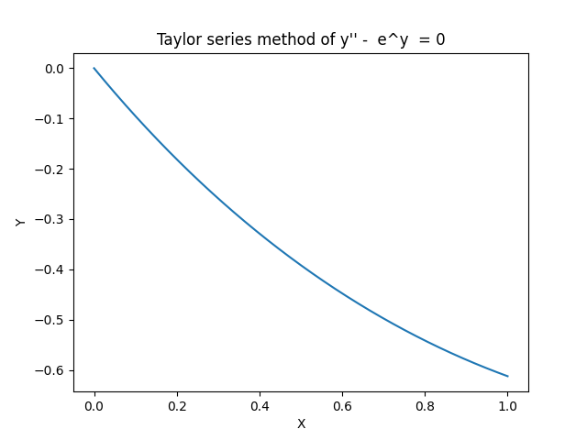

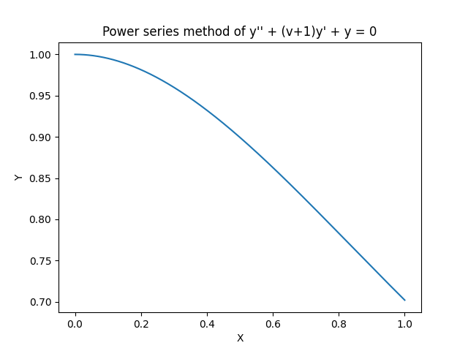

**Final Analysis:**

Analyzing the graphs from part 1, the graphs both seem to converge at 0 as n increases to infinity. The graphs both start to look more and more like an exponential curve as the numbers of points increase, eventually they will converge at 0. As stated in the abstract, understanding whether or not a series converges and its constraints is important when calculating the Taylor series. Convergence tests help you determine where power series make sense. Infinite series are also used to define new functions (e.g., Bessel functions, zeta-functions, elliptic functions), to extend the meaning of familiar functions to new settings (e.g., the exponential or sine of a *matrix* or of a *complex number*), and to solve differential equations (series solutions). Because the Taylor series is a form of power series, every Taylor series also has an interval of convergence. When this interval is the entire set of real numbers, you can use the series to find the value of *f*(*x*) for every real value of *x.* A function, , is called **analytic** at  if the Taylor series for  about  has a positive radius of convergence and converges to  Testing for convergence is an important step that must be taken in order to correctly solve a DE using a series method. There are many simple tests to be done when trying to figure out where the series converges and whether or not it is convergence, this is shown by the graph below.

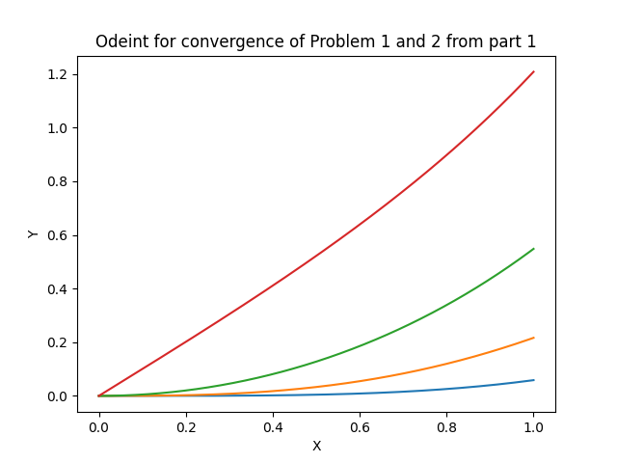

Next was trying to determine the convergence restraints, this was done by using python and graphing the two series from -10 to 10. The next graph shows the two series on the same graph and you can see where the graph reaches a value that it will get close to, but never reach.

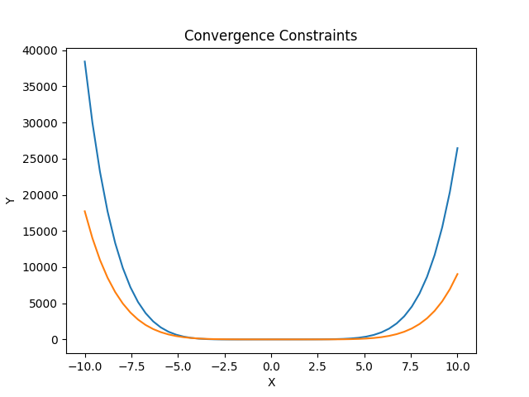

Here are screenshots of the code I made to do Parts 1 and 2.

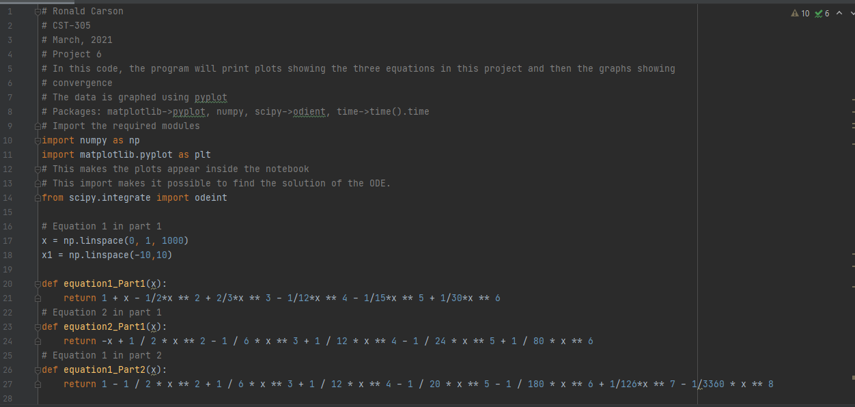

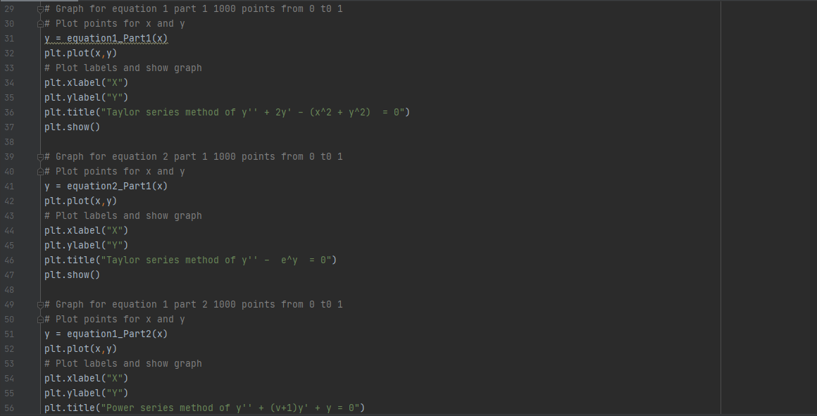

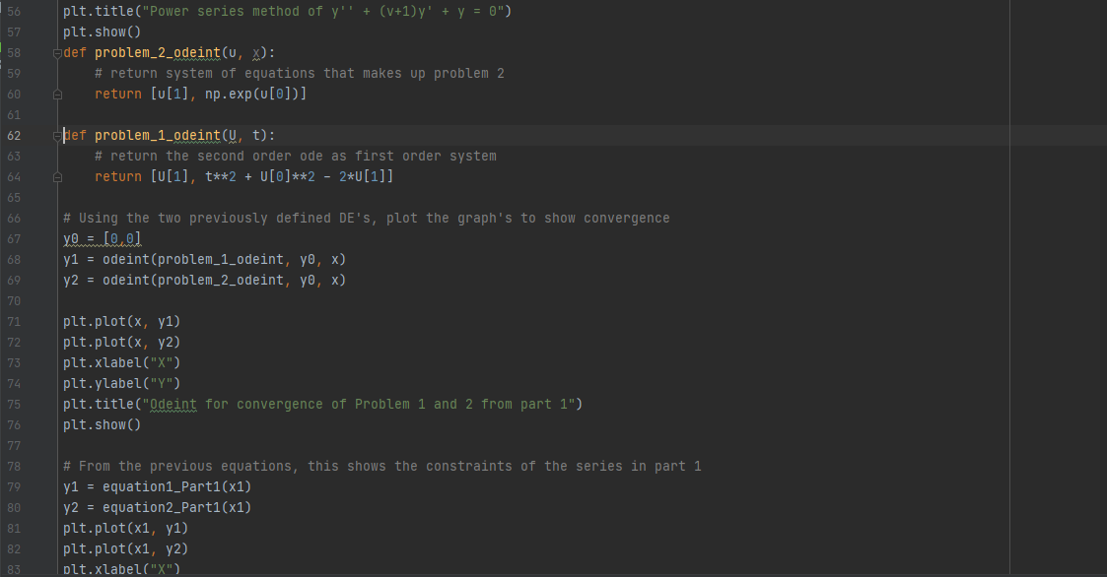

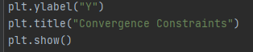

Now for the final part I decided to focus on the computer instruction execution time. The equation for CPU time is

CPU = I(instructions)\* CPI (cycles per instruction) \* T (time). Depending on the CPU and system one could argue that CPI is a constant and T is a constant. It will change depending on the program, for this case I am focusing on a very simple scenario. The CPI is specific to the processor, the number I use will be 50, there will be 100 instructions and the time will be a minute. I will use odeint to calculate

Here is the graph and code from the odeint answer:

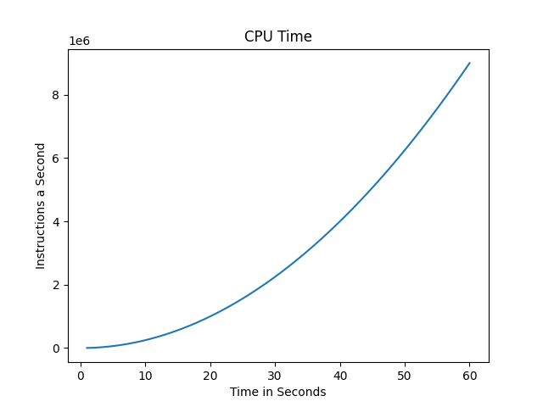

The code below is for part 3 and it shows me implementing a processor into python and executing it. The differential equation represents a single system which in this case is a multicore processor.

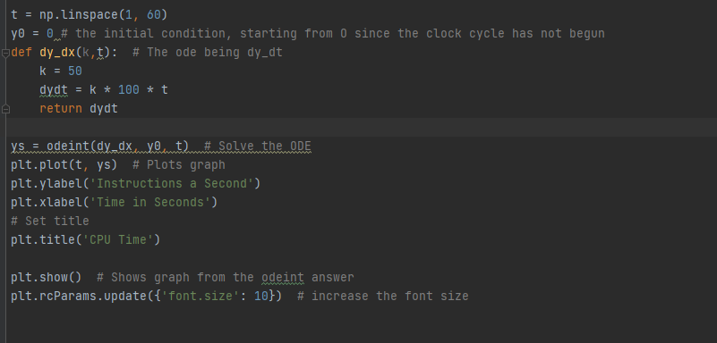

The technique that was taken to derive this ODE is similar to the ones earlier in the assignment in the way that the instruction execution time can be approximated among many similar processors by looking at each series and estimating its correct CPU time. The model would be at the most n=2 for either the power or Taylor series method since it is a first order differential equation. If it were a system of multiple processors, it could be modeled using the matrix method as a system of first order differential equations. There are cases where a processor with higher complexity can be modeled as a partial differential equation for both clock cycles per instruction (CPI) or in the other derivation of the formula, rate (R). With regard to this system, which in this case is a CPU and its execution time, there are many factors to consider when trying to create a system that is cost effective and has high performance.

**Cores**

Less than a decade ago, all processors came with a single core. Nowadays single-core processors are the exception and not the rule. Multi-core processors have become more popular as their availability has become increasingly common and software has been designed to utilize multi-core technology. From dual-core to eight-core processors, there are a number of options to choose from. When deciding how many cores are needed, first it is necessary to understand what “multiple cores” means.

When processors were running on a single core, that one core was responsible for handling all the data sent to the processor. As more cores are integrated into a processor, those cores are able to split up the processor’s tasks. This makes the processor faster and more efficient. However, it is important to remember that a processor can only perform as well as the existing software running it. If the software is only able to utilize three of the eight cores, then five cores are going to be unused. To maximize cost and use, it is best to match system requirements with core availability.

**Cache**

A processor’s cache is similar to the memory of a computer. A processor’s cache is a small amount of very fast memory that is used for temporary storage. This allows a computer to retrieve the files that are in the processor’s cache very quickly. The larger a processor’s cache, the more files it will be able to store for that quick retrieval.

**Socket Compatibility**

Socket compatibility is a primary concern when it comes to buying a processor. The socket compatibility enables the interface between a motherboard and its CPU. If a motherboard has already been acquired, make sure that the processor installed is compatible with the motherboard’s socket. Alternately, when building a computer around the processor, make sure that the motherboard is compatible with the existing processor.

**Integrated Graphics Processing Units (GPUs)**

Many of today’s processors have integrated graphics processing units, which are designed to perform the calculations related to graphics. If a processor does not have an integrated GPU, the computer can still display graphics if a separate graphics card is present or if the motherboard offers onboard video. If the computer will be used for graphics-intensive software and programs, then a CPU with an integrated GPU will likely not perform as needed.

**Frequency**

The frequency of a CPU, measured in hertz (Hz), is the speed at which it operates. In the past, a merely faster frequency equaled better performance. This is not necessarily the case any longer. In some cases, a CPU running at a lower frequency may actually perform better than a processor running at a higher frequency due to the infrastructure of the CPU. It is important to look at a CPU’s “instructions per clock” in addition to the frequency of the CPU. While frequency is still a good indication of how quickly a processor can perform, it is no longer the only factor that impacts the actual speed of a processor.

**Thermal Design Power**

Processors generate heat. The thermal design power specification assigned to a CPU explains how much heat the processor is going to give off. This will directly affect the type of cooling device needed for a CPU. If the CPU does not come with a cooling device or if the cooling device provided is not used, a device must be installed that can cool the system sufficiently. Overheating is a primary danger to a computer’s componentry.

When it comes to ethics regarding computers, making sure the system is not susceptible to computer crime and protecting the crime of the user is very important. Below are areas of ethical concern when building computer architecture, paying the necessary attention to ethical safety will take care of most legal concerns that can come with the system.

**Computer Crime**

Computer Crime is intellectual, white-collar crime. Those that commit such crimes must be intelligent enough to manipulate a computer system and in such a position to access it in the first place. One example of computer crime is stealing funds via computer. Often the worst that can happen to such a thief is that he/she is merely required to return the stolen money. Many times, that person will be fired, assuming he/she is an employee, but may be quickly hired by a competitor because of his/her skill. This creates practically no deterrent to committing computer theft because legal action is not often taken against the perpetrator. Another example is unauthorized computer entry. In entering a computer unauthorized, the perpetrator can [steal a company's trade secrets and data](https://www.comptia.org/content/articles/what-is-ransomware/). Such a crime could be committed by an employee aiming to sell such secrets to a competitor or by an outside source wanting to steal such secrets to promote his/her own well-being. This crime involves both an invasion of property and privacy and also [compromises the computer system](https://www.comptia.org/content/articles/what-is-malware) itself.

This crime goes along with the idea of hacking. [Hacking](https://www.comptia.org/content/guides/what-is-a-ddos-attack-how-it-works) is defined as "any computer-related activity which is not sanctioned or approved of by an employer or owner of a system or network” (Forester 44). Such an activity deals with the ethical dilemma of who actually owns information and who should have access to that information. At many universities, Computer Science professors have their students hack into the university's system to prove their skill and knowledge of computer systems.

This poses a serious ethical dilemma. Since the students are not causing any harm to the system, is such an action morally reprehensible or acceptable? Many computer professionals feel that this act is not ethically sanctioned and the Computer Science professors must address the issue of computer ethics more fervently in their classes.

**Privacy**

Another area of computer ethics regards [privacy](https://www.comptia.org/blog/it-pros-and-data-curation). The privacy issue focuses on the computer's most basic functions, "its capacity to store, organized, and exchange records”. (Johnson 58) A great deal of the concern has to do with the amount of information gathering that is made possible by computers. This puts people's personal information in a vulnerable position. If someone hacks into a computer system, all this information is at his/her disposal. In this way, such crimes as identity theft can occur.

Furthermore, when stored information can be easily exchanged, the effect of a small error can be magnified. Such errors can stay in the system indefinitely. Computers "create the possibility that incidents in one's life or errors in one's records will follows one through life, profoundly affecting how one is perceived and treated”. (Johnson 60) It is because of this effect that people lose control over their lives and the information about them. Thus, it seems that there are both good and bad consequences of computerized records. A good consequence is that an organization's need for information suggests "access to relevant information might improve decision making and, therefore, make organizations more efficient”. (Johnson 63) This in turn provides a positive result for the individual because it could mean better services or savings. However, bad consequences still exist. These are related to the fact that "information is used to make decisions about individuals and such decisions may be based on irrelevant and inaccurate information."(Johnson 63). There is no way to ensure that the power exercised by organizations because of this access to information is used fairly. Thus, it seems that there should be a balance between the need for information on the part of an organization and the interests of the individual.

Lastly, the considerations that need to be focused on deal with the legal issues. Arguable, professional considerations include all aspects: legal, ethical, and financial. But since the model I presented is prominent in the IT field, it falls in line with other computer aspects to be at risk of some of the biggest technology problems we face today. Discussing privacy once again, most people have their personal data spread throughout the digital world. Even things thought to be secure, such as email or private accounts, can be accessed by unintended sources. Most employers actively check their employees’ computer habits. Privacy has evolving legal implications, but there are also ethical considerations.

**Digital Ownership**

Digital mediums have allowed information to flow more freely than before. This exchange of ideas comes with a legal and ethical backlash. How can ownership be established in the digital realm? Things can be easily copied and pasted online, which makes intellectual property hard to control. Legal notions such as copyright have struggled to keep up with the digital era. Companies in the music and entertainment industries have pushed for greater legal protections for intellectual properties while other activists have sought to provide greater freedoms for the exchange of ideas in the digital realm.

**Data Gathering**

On some level, everyone knows that their online lives are monitored. The United States has even passed legislation allowing the government to actively monitor private citizens in the name of national security. These measures have revived a debate about what information can be gathered and why. This debate applies on a smaller scale as well because companies need to consider what information to collect from their employees. This issue invokes a question of consent. Do people know what information is being monitored? Do they have a right to know how their data is being used?

**Security Liability**

In the past, security issues were resolved by locking a door. Digital security is much more complicated. Security systems for digital networks are computerized in order to protect vital information and important assets. However, this increased security comes with increased surveillance. All security systems have inherent risks, which means it is a question of what risks are acceptable and what freedoms can be forfeited. Ultimately, IT professionals need to balance risk with freedom to create a security system that is effective and ethical at the same time.

**Access Costs**

Net neutrality has become a trendy issue thanks to legislative efforts in the last few years. The issue of net neutrality is essentially a question of access. Proponents want the Internet to remain open to everyone while some businesses want to create tiered access for those who are willing to pay. The issue even extends to private Internet usage since the cost of service in some areas may be cost prohibitive. The larger ethical question is whether or not digital exchange is now a universal right. The cost of access can impede business growth, entrepreneurial spirit and individual expression.

In conclusion, these would be the areas I consider when building my system for a computer company. Each legal and ethical aspect must be taken into account along with current problems facing the technology world today. My model can be represented in many different ways but one of the most accurate ways would involve the solutions from a Power or Taylor series method.

## References

1. <https://mathworld.wolfram.com/TaylorSeries.html>
2. <https://www.britannica.com/science/limit-mathematics>
3. <https://math.stackexchange.com/questions/1692062/what-is-the-importance-of-knowing-if-a-series-converges-or-diverges/1692080#:~:text=The%20main%20reason%20you're,where%20power%20series%20make%20sense>.
4. <https://www.dummies.com/education/math/calculus/determining-whether-a-taylor-series-is-convergent-or-divergent/>
5. <https://www.newegg.com/insider/how-to-choose-a-cpu/>
6. Computer Ethics – Johnson, Deborah G. Englewood cliffs, NJ: Prentice-Hall, Inc., 1985
7. <https://www.comptia.org/blog/ethical-problems-in-computing#:~:text=To%20begin%20with%2C%20it%20seems,%2C%20workers%2C%20and%20customers%E2%80%9D>.
8. https://www.bestcomputersciencedegrees.com/lists/5-legal-and-ethical-issues-in-it/