Gaj Carson

RCarson10

Abstract

This project implements solutions to integrals using the Reimann Sum

Project 8 – Numerical Integration

# **Abstract**

###### Left & right Riemann sums

Suppose we want to find the area under this curve:

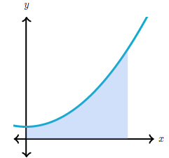

A function is graphed. The x-axis is unnumbered. The graph is a curve. The curve starts on the positive y-axis, moves upward concave up and ends in quadrant 1. An area between the curve and the axes is shaded.

We may struggle to find the exact area, but we can approximate it using rectangles:

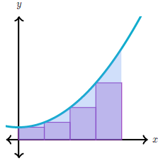

The shaded area below the curve is divided into 4 rectangles of equal width. Each rectangle moves upward from the x-axis and touches the curve at the top left corner.

And our approximation gets better if we use more rectangles:

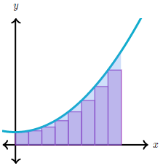

The shaded area in the graph above, below the curve is divided into 8 rectangles of equal width.

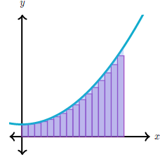

The shaded area in the graph above, below the curve is divided into 16 rectangles of equal width.

These sorts of approximations are called **Riemann sums**, and they're a foundational tool for integral calculus. Our goal, for now, is to focus on understanding two types of Riemann sums: left Riemann sums, and right Riemann sums. To make a Riemann sum, we must choose how we're going to make our rectangles. One possible choice is to make our rectangles touch the curve with their top-left corners. This is called a **left Riemann sum**.

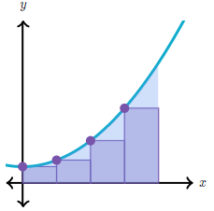

The shaded area below the curve is divided into 4 rectangles of equal width. Each rectangle moves upward from the x-axis and touches the curve at the top left corner. Therefore, each rectangle is below the curve.

Another choice is to make our rectangles touch the curve with their top-right corners. This is a **right Riemann sum**.

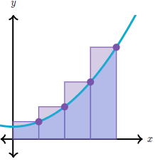

The shaded area below the curve is divided into 4 rectangles of equal width. Each rectangle moves upward from the x-axis and touches the curve at the top right corner. Therefore, each rectangle moves upward above the curve. Neither choice is strictly better than the other.

Riemann sum subdivisions/partitions

Terms commonly mentioned when working with Riemann sums are "subdivisions" or "partitions." These refer to the number of parts we divided the x*x*x-interval into, in order to have the rectangles. Simply put, the number of subdivisions (or partitions) is the number of rectangles we use. Subdivisions can be **uniform**, which means they are of equal length, or **nonuniform**.

| **Uniform subdivisions** | **Nonuniform subdivisions** |
| --- | --- |

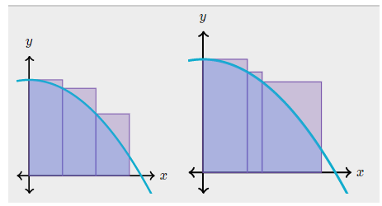

### Code Output and Code

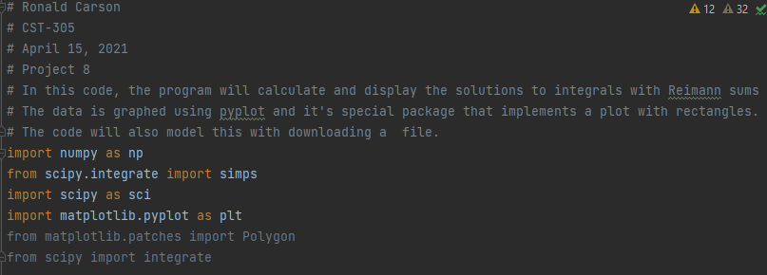

**A.**

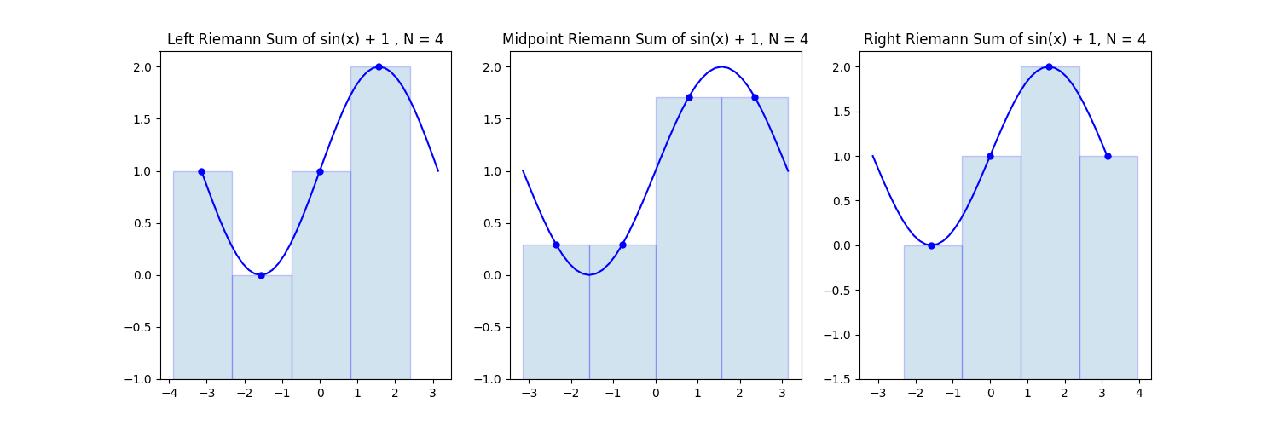

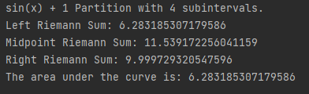

**B.**

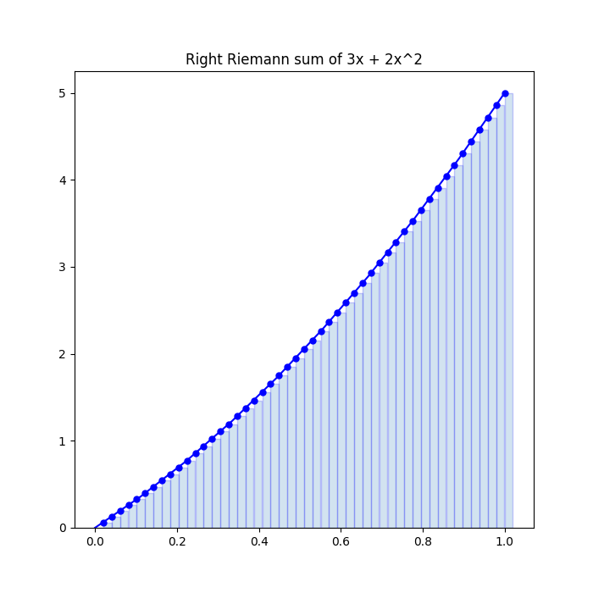

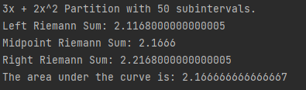

C.1

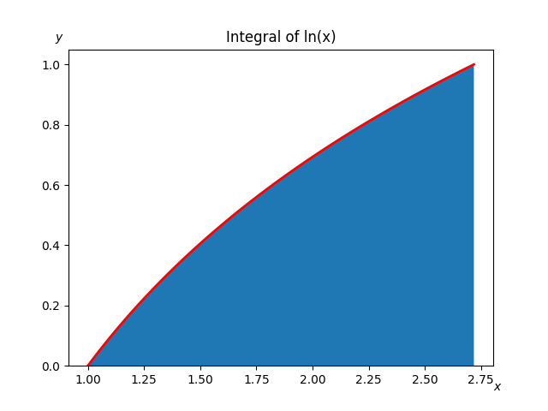



#### C.2

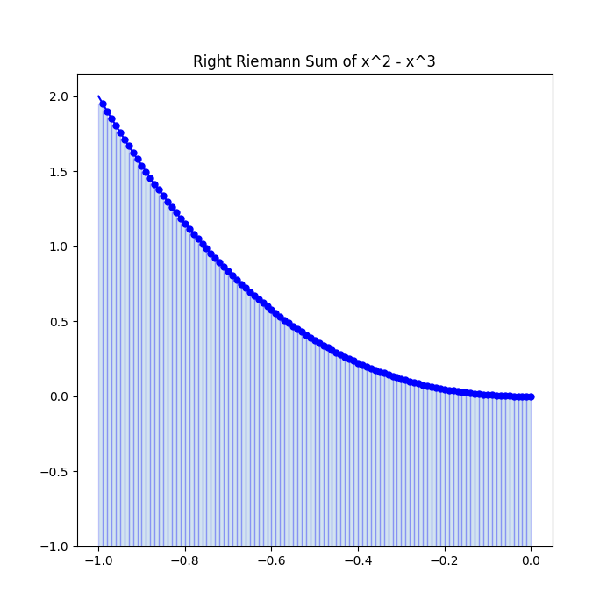

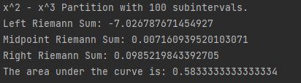

#### Part 2

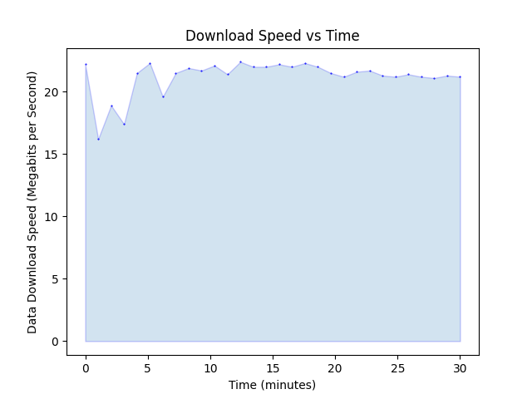



**Handwritten Work**

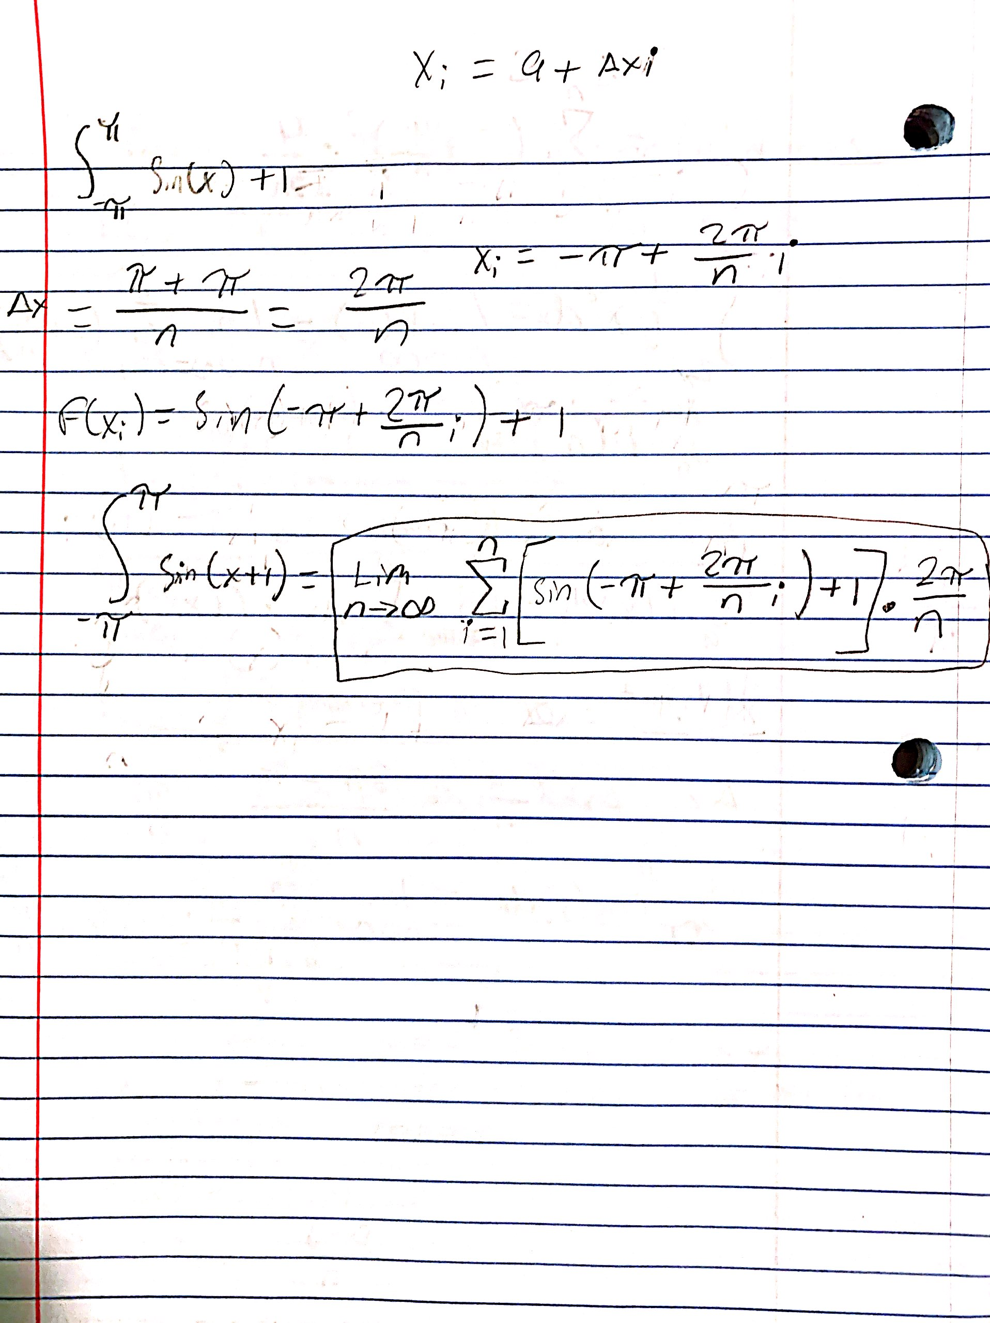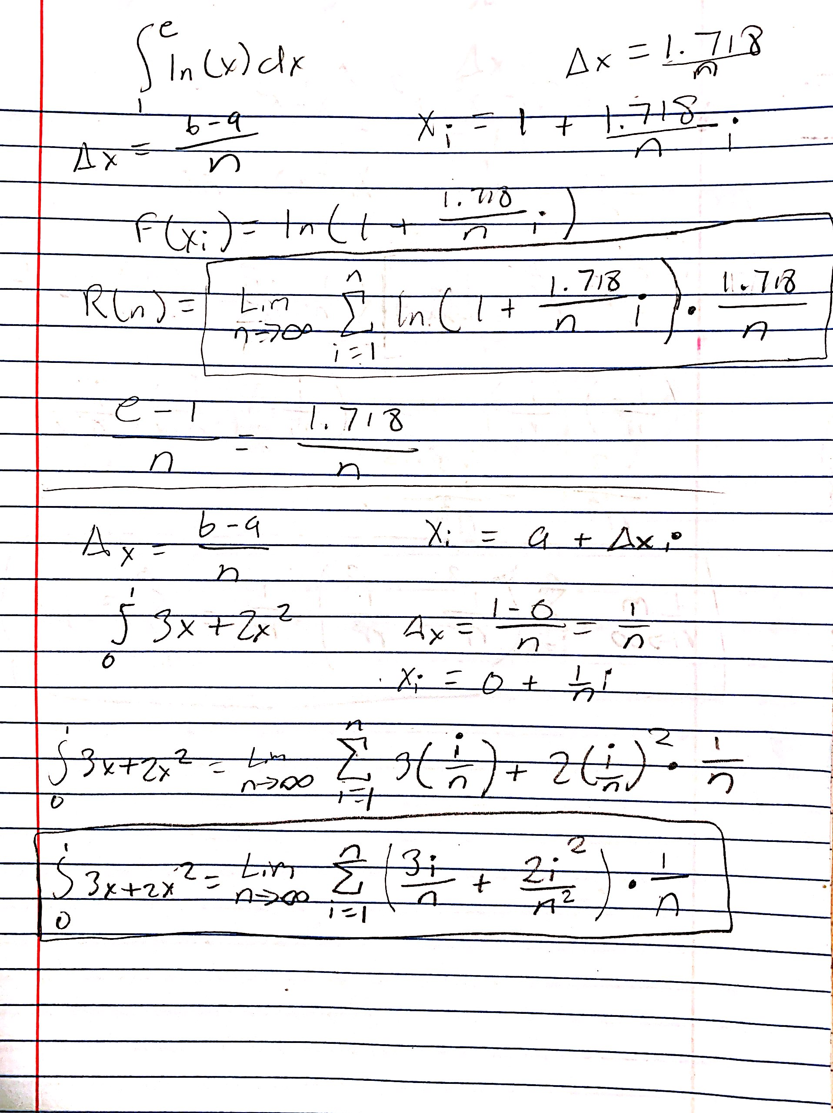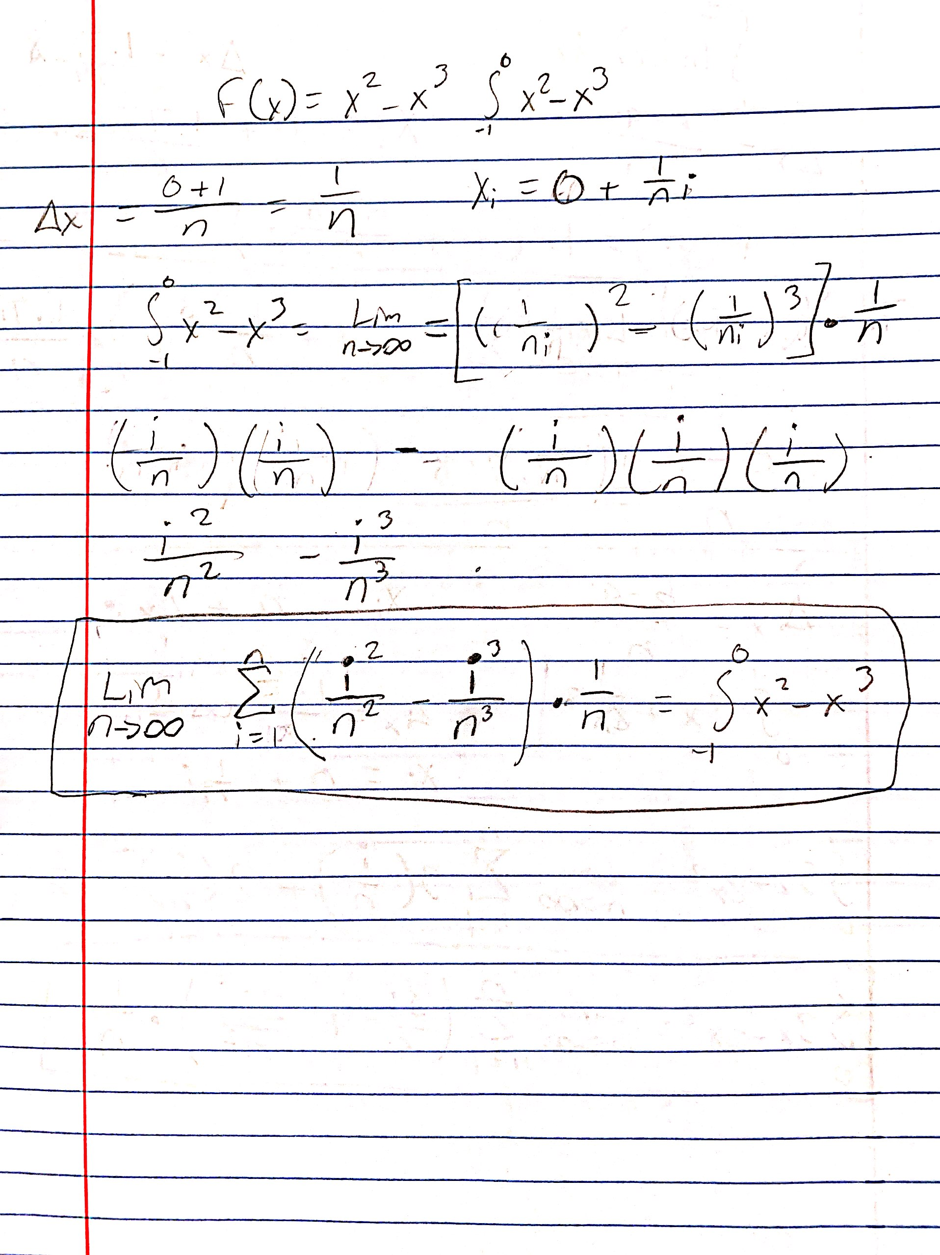

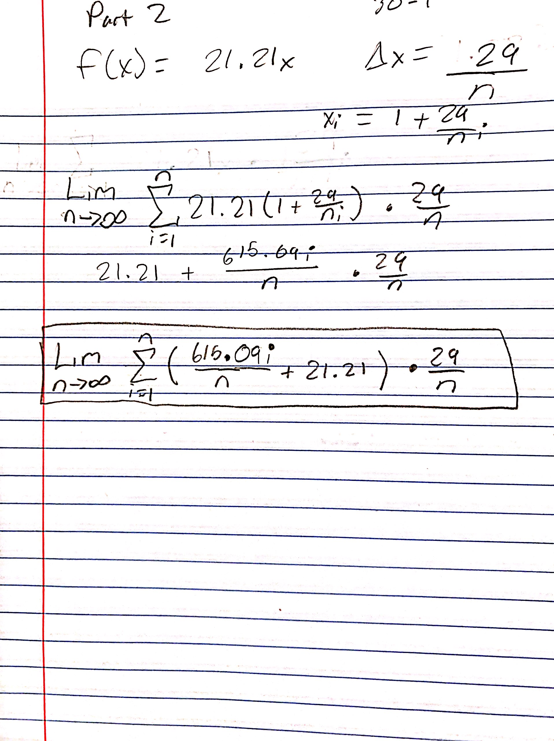

**Flowchart**

The flowchart below explains the steps that are to be taken to solve a dynamical system with the code of Project 8.

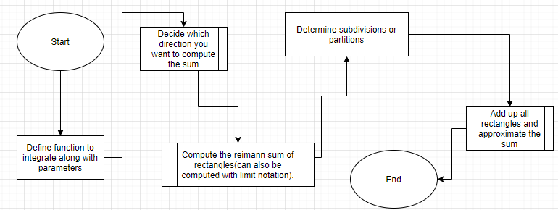

**Final Analysis:**

The output of this code represents how much data I downloaded during the 30 minutes of download time.

The formula I derived for the experiment is

Since the time period we had was 30 minutes, it would make sense to have the bounds be from one to 30, I showed my work on the paper below along with the output of the code I generated from this experiment. The output basically explains the data rate as a function of time, my was mostly constant, but the seems to not be as important because my internet connection is good and my data rate was mostly consistent. This can be modeled using Riemann sums because data is downloaded and stored in partitions similar to the partition method of the creation of rectangles. The output from the code is the area under the curve, signifying the total file size that was downloaded in 30 minutes. Since Y is a data rate and X is time, this can be implemented this way because this is how we visualize integrals and limits in certain cases. The file was over 50 gigabytes, the whole download would have taken one hour and 30 minutes. The data rate (mgb/s) can be modeled in partitions by minutes since there is a rate in the equation and the Riemann sum method can be used to approximate the output, which is the integral or area under the curve of the given equation/graph.





## References

1. https://www.khanacademy.org/math/ap-calculus-ab/ab-integration-new/ab-6-2/a/left-and-right-riemann-sums#:~:text=To%20make%20a%20Riemann%20sum,4%20rectangles%20of%20equal%20width.