Install Java 8 on Windows 10

Step 1- Download Java JDK 8

You can download Java 8 from the Oracle’s [**https://www.oracle.com/in/java/technologies/javase/javase8-archive-downloads.html**](https://www.oracle.com/in/java/technologies/javase/javase8-archive-downloads.html)

Go ahead, accept the license agreement and download the file.

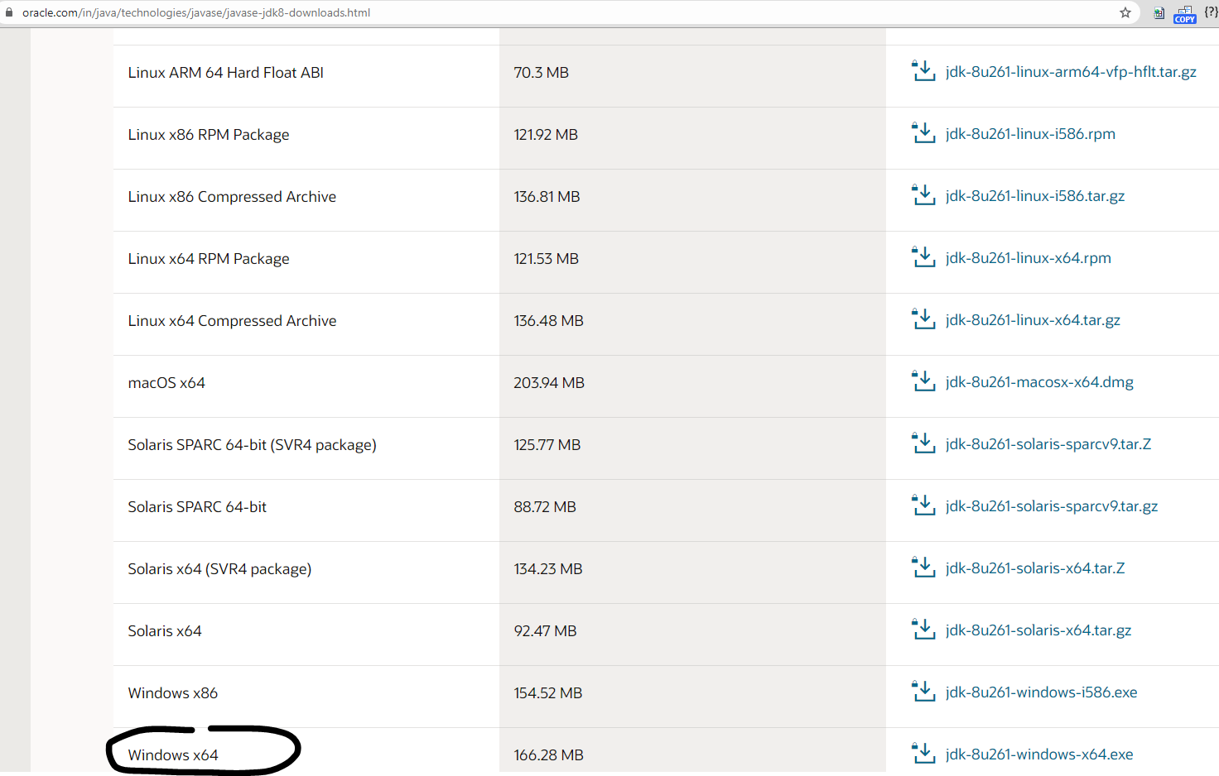

Oracle Java SE 8 website – Download Page screenshot

Step 2- Run the Installer

To start the installation process, run the installer by double clicking it. You will see the installation wizard.

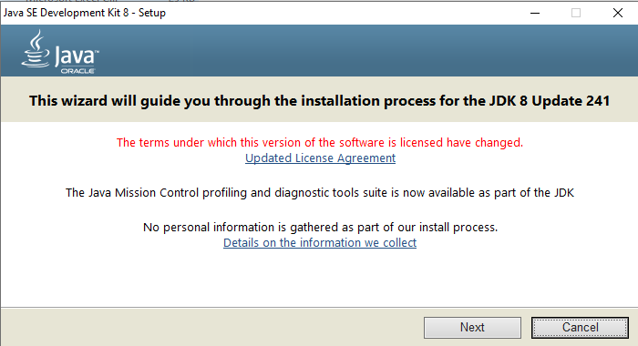

Java SE JDK 8 Installation Wizard

Click Next to continue

Step 3- Custom Setup

In this screen you can change certain installation defaults. I accept this as it is. You can change the installation directory if you want by clicking on change. Click next to continue.

[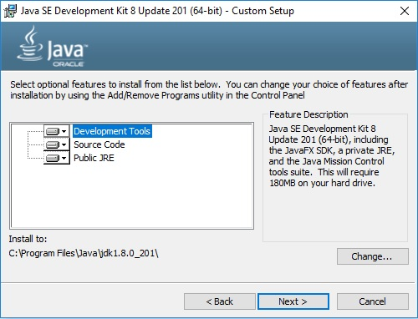](https://www.shaileshjha.com/step-by-step-how-to-download-and-install-java-se-jdk-8-on-windows-10/java-se-jdk-8-installation-wizard-custom-setup/)

Java SE JDK 8 Installation Wizard – Custom Setup

Step 4 – Installation begins

You will that the installation progress window

[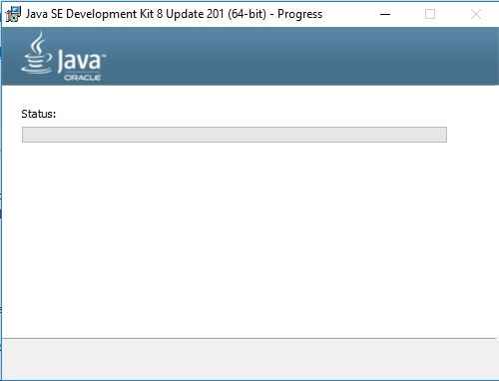](https://www.shaileshjha.com/step-by-step-how-to-download-and-install-java-se-jdk-8-on-windows-10/java-se-jdk-8-installation-progress/)

Java SE JDK 8 Installation Progress

Before the installation begins, you will be displayed a message for change in License terms and JRE destination folder. Accept the defaults and click on next to continue with the installation process.

[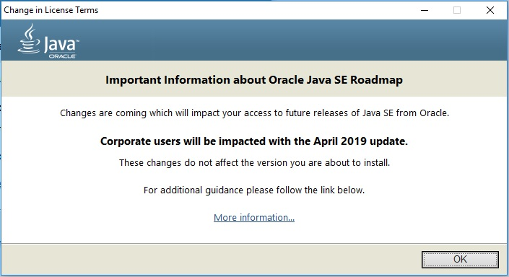](https://www.shaileshjha.com/step-by-step-how-to-download-and-install-java-se-jdk-8-on-windows-10/java-se-jdk-8-change-in-licence/)

[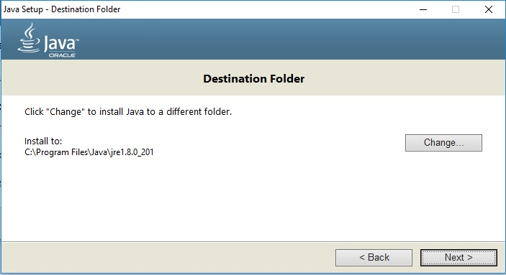](https://www.shaileshjha.com/step-by-step-how-to-download-and-install-java-se-jdk-8-on-windows-10/java-se-jdk-8-installation-specify-jre-destination-folder/)

After this the installation will begin. Wait for sometime for the installation process to complete.

[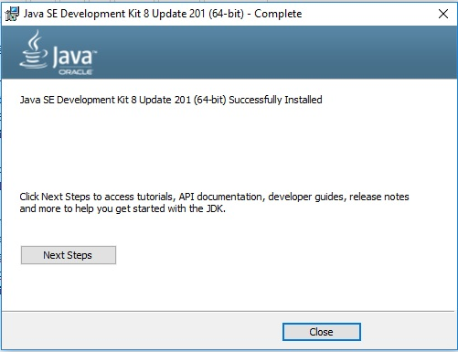](https://www.shaileshjha.com/step-by-step-how-to-download-and-install-java-se-jdk-8-on-windows-10/java-se-jdk-8-installation-complete/)

Java SE JDK 8 – Installation Complete

Click on close to complete the installation.

Step 5- Set Java Path

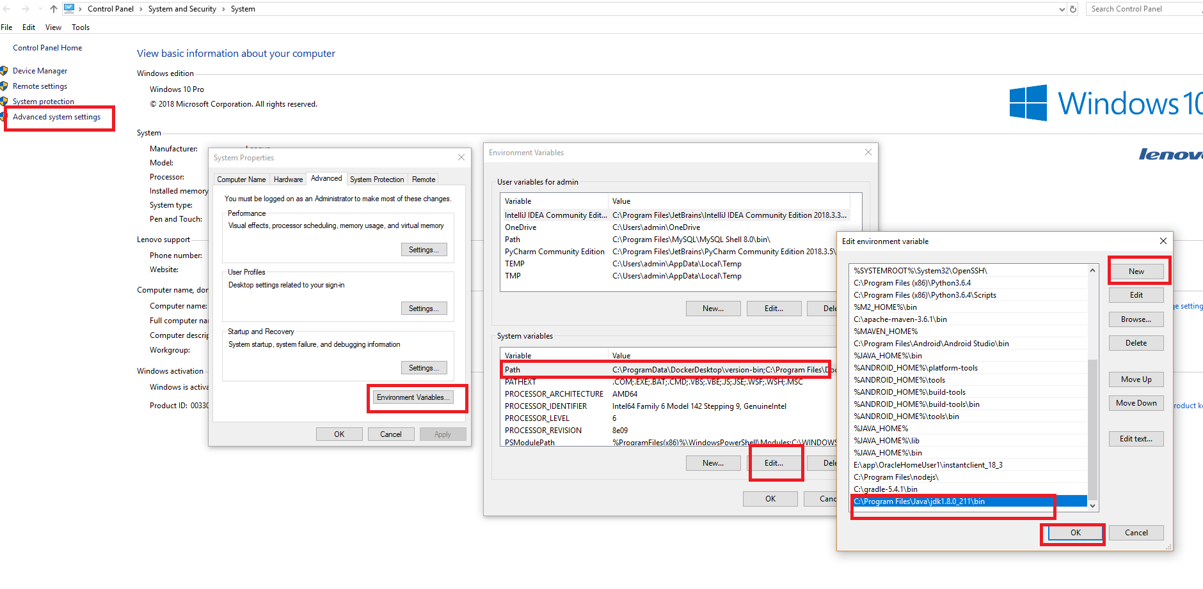

Step 6- Check the version of Java installed

Go to windows terminal cmd and run the command

java -version to check the version of Java installed.

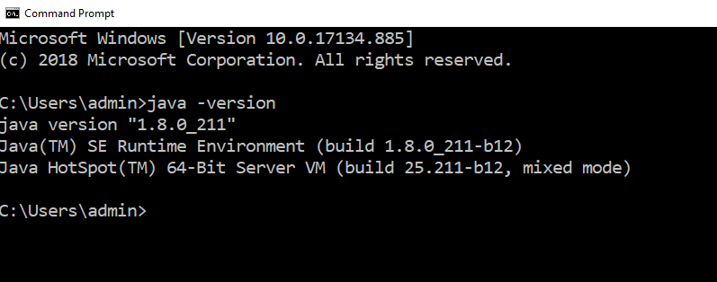

Eclipse Installation on Windows

**Download:** [**https://www.eclipse.org/downloads/**](https://www.eclipse.org/downloads/)

