Rebecca Cate

HW #1

Excel Topic: Startups

Story telling… What story do you to hear!

1. **What are three conclusions we can make about Kickstarter campaigns given the provided data?**

I am going to answer the question based off of the 3 pieces the project had us analyze.

* Outcome by Category
* Outcome by Sub-Category
* Outcome based off of the month the company was started

Outcome by Category yielded the following graph:

This graph seems to give a skewed perspective on things – because it appears “Theater” was so successful. However, if you look at the number that has failed compared to the “Music” it tells a different story. The main things this particular graph shows us is that “Theaters” were the greatest amount of startups – but in order to analyze this better we need to look at percentages as well. This would show Music being more successful.

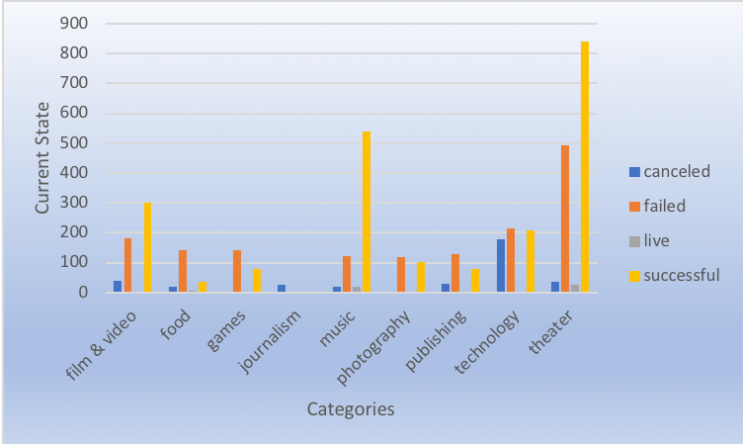

Outcome by Sub-Category yielded the following graph:

If I continue the thoughts about the Theater verses the Music and consider the percentages as I look at this data – I would also be able to see how things within each category is being spread. Clearly “Plays” carried the “Theater”, but SubCategories of music were more spread out within “Music” categories.

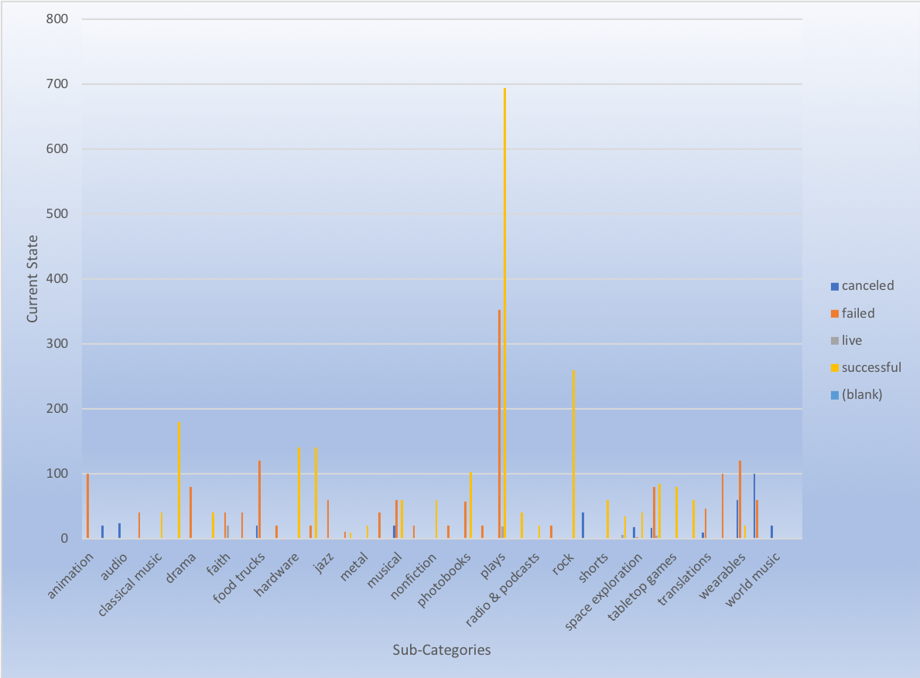

Outcome based off of the month the company was started yielded the following graph:

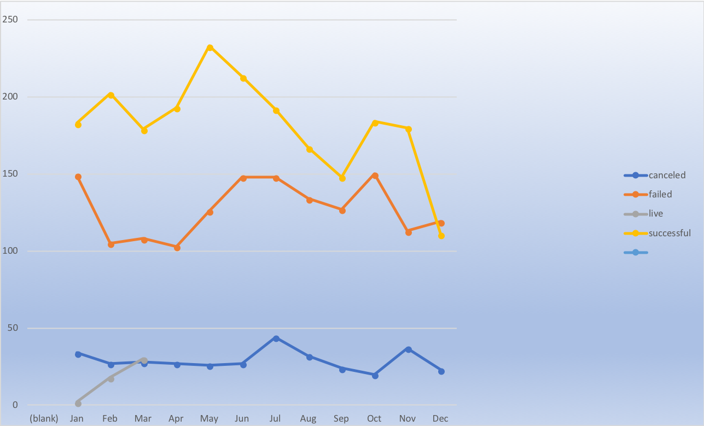

1. **What are some of the limitations of this dataset?**

* Additional information regarding how long it took till the “State” was declared (Excluding the live state.)
* Economic factors on each category.
* Additional economic things related to the years for the startup should be considered.
* Why such a heavy emphasis on “Theater”? Again, additional economic study on the years may provide the answer to this question – But seriously, why so many startups in “Theater”?

1. **What are some other possible tables/graphs that we could create?**

The Bonus graphs would be very enlightening and helpful to have used to answer Question #1.

Percentages – I would have used the percentages of the Categories to compare things to as well as the # of things.