**HackZeGarage***@sulfuroid / Dr CADIC Philippe*

**Portable USB Stick to replace garage doors and gate doors remote controls into one single 433 Mhz C1101 transceiver device. Data bank of gates digital signatures.**

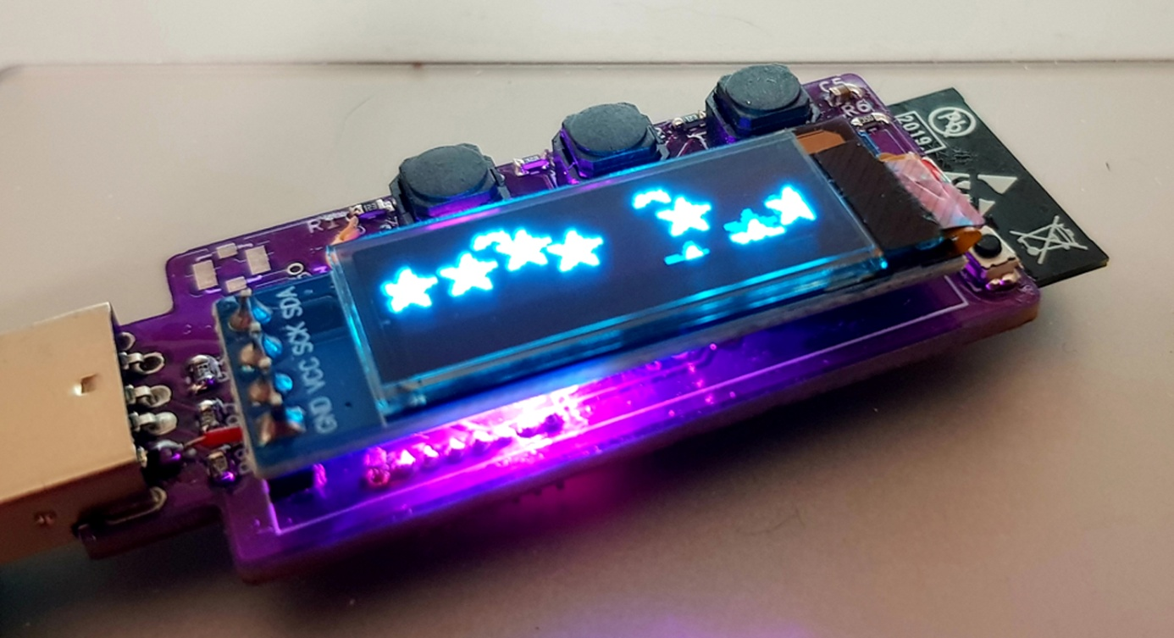

The ESP32 C1101 USB stick to ease the access to garages and parkings using 433 Mhz remote keys. HackZeGarage is a USB stick with ESP32 S2, battery and charging module with 3 buttons and a SSD1306 Oled display. This item can also be used as a password data bank.

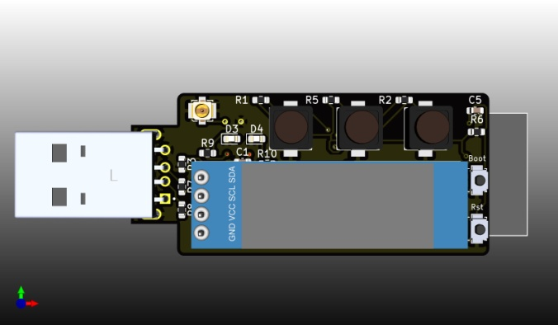 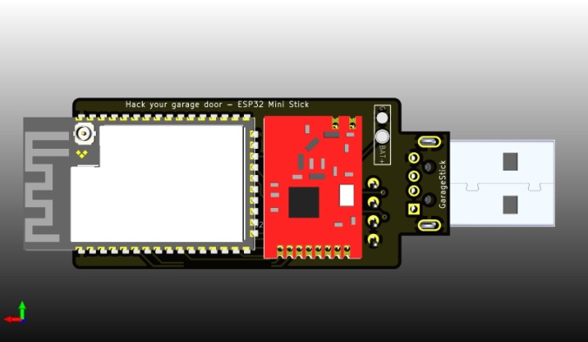

**List of components**

* 2 micro switches for ESP32 BOOT/RESET options
* 3 buttons on the top of the display
  + SW1/BUTTON3/GPIO 01
  + SW4/BUTTON1/GPIO 15
  + SW5/BUTTON2/GPIO 16
* 2 configurable LEDs
  + D3 : GPIO 21
  + D4 : GPIO 14
* A 128x32 SSD1306 OLD Display (I2C connected). The display’s power is controlled by GPIO 06
* A 433 MHZ SPI transceiver module. This device is also power controlled with GPIO 7

**Schematic diagram**

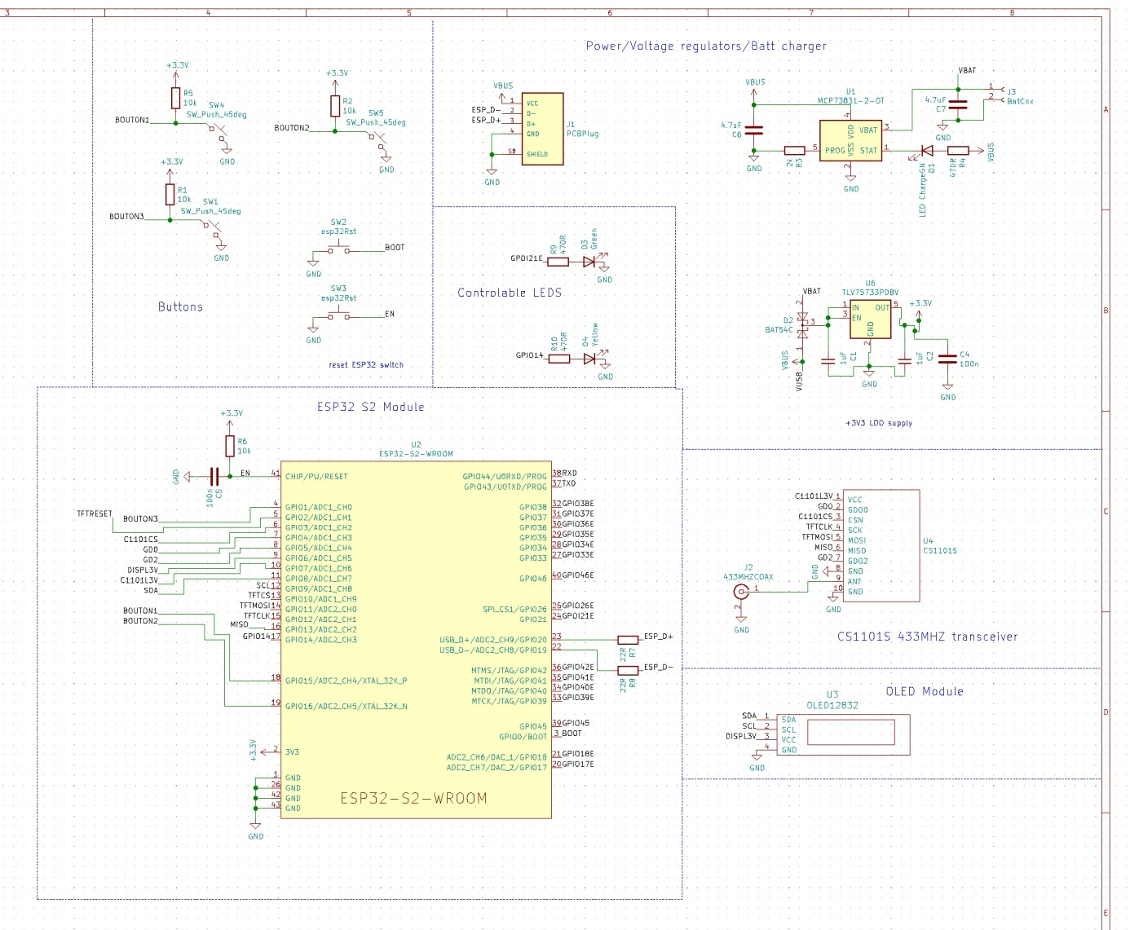

**UPLOADING SKETCHES**

Uploading sketches onto an ESP32S2 is a bit tricky. You have to plug the device onto the USB port of the PC running Arduino IDE. Then, you have to press RST and BOOT micro switch respecting this order :

1. Press both RESET & BOOT switches
2. Release RESET switch
3. Then release BOOT

If it is done properly , you should ear the computer recognize the device and a COMx port should appear.

**ARDUINO IDE setup**

The ESP32S2 is capable or direct USB connection. You have to select ESP32S2 DEV MODULE and select the option as shown in the image above.

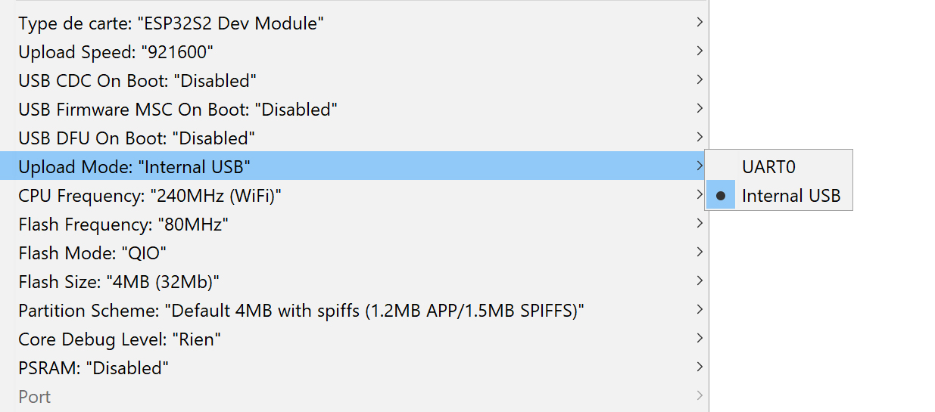

**BOM**: see BOM.XLS

This board has been designed to keep the budget as low as possible. Most of the components are classic components you may find everywhere.

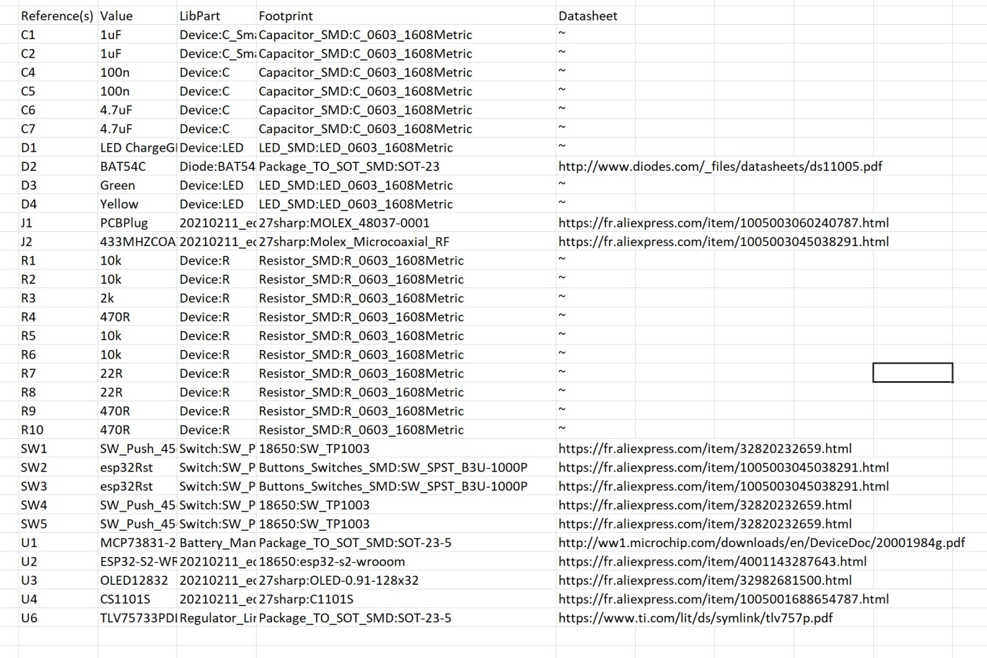

**Important note:**

You may get the 0.3 version of the board which has to issues you can easily fix. Beside this fix, there is no difference with V1 version. To protect the environment of our planet, we decided not to through the 50 V0.3 PCB to the bin as the fix is minor. If you get the V0.3 version, you will need to add 2 extra wires when assembling the device. See diagram above.

