Amrita Vishwa Vidyapeetham
Amrita School of Computing
Coimbatore
24ASD641- Pattern Recognition (2025-2026)
Case Study
Team No: 2
Rollno | Name | Dept/Section
CB.PS.I5DAS22125 | Jayasri N.V | DAS - B
CB.PS.I5DAS22130 | M.S.Anjali | DAS - B
CB.PS.I5DAS22133 | Nimisha R | DAS - B
CB.PS.I5DAS22137 | R Chahana | DAS - B

Title of the Case Study: Yfinance-GDELT Integrated Portfolio Management System for Cross-Market Trend and Sentiment Analysis
Description of the complete work done : (atleast 10 lines)
Collected historical stock data for 50 prominent companies from the US and Indian markets using the Yfinance API, spanning two years (2023-2024). After feature engineering key columns for portfolio management, trained various models, including LSTM, a hybrid LSTM-CNN approach, and RL algorithms (SAC and PPO). To evaluate performance, metrics like Sharpe Ratio, Sortino Ratio, Calmar Ratio, and Maximum Drawdown are calculated. Notably, the hybrid approach outperformed other models with a superior Sharpe Ratio, indicating effective risk-adjusted returns.
Developed a comprehensive sentiment-driven portfolio management system for 50 US and 50 Indian companies. For sentiment analysis (2024), collected historical news data (Q1 2024) using GDELT API, extracting article titles and metadata for all companies. Merged and preprocessed the datasets from both markets, removing duplicates and standardizing features. Applied FinBERT, a pre-trained financial sentiment analysis model, to classify news sentiment as positive, negative, or neutral, generating sentiment scores (-1 to +1) for each article. Validated the system using NewsAPI for real-time testing on live data, demonstrating immediate sentiment classification capabilities. Evaluated performance through inference metrics including average confidence scores (>0.70), sentiment distribution analysis, and processing speed (~20 articles/second), confirming the model's reliability for financial text analysis.
Datasets used name with size:
Dataset Name | Link(If Livedata specify how much is free) | Size
Yfinance – 2023&2024 | https://www.kaggle.com/datasets/rchahana19/yfinance-2023-and-2024 | (49551, 9)
GDELT 2.0 | https://www.kaggle.com/datasets/rchahana19/sentiment-data-from-gdelt | (162445,18)  merged csv.
Finbert model result | https://www.kaggle.com/datasets/rchahana19/news-with-sentiment | (162445,21)

Literature Survey paper title with author and journal details (minimum 6)
- Trend Prediction of DJIA index based on News Extraction from Yahoo Finance
Author: Batool, K., Fatima, U., & Ahmed, M.F.
Journal : International Journal of Computer Applications (0975 – 8887) – Q2
- Generative Adversarial Networks: A Systematic Review of Characteristics, Applications, and Challenges in Financial Data Generation and Market Modeling: 2019-2024
Author: D. Wilson*, A. Azmani
Journal : International Journal of Engineering-Q2
- A Novel RMS-Driven Deep Reinforcement Learning for Optimized Portfolio Management in Stock Trading
Author: Asma Sattar, Amna Sarwar,Saira Gillani,Maryam Bukhari,Seungmin Rho,Muhammad Faseeh
Journal: IEEE Access, 2025-Q1
- AI-fused construction portfolio investment system with risk hedging using machine learning and long-short strategies
Author: Jui-Sheng Chou,Kai-Chun Lin,Tran-Bao-Quyen Pham
Journal : Applied Soft Computing Journel, Elsevier, 2024-Q1
- Title: Sentiment index as a predictor of CPI: A lexicon-based approach using economic news data in Vietnam
Authors: Dang Phong Nguyen, Dang Thi Viet Duc, Nguyen Thi Mai Trang, Vu Quang Ket, Nguyen Anh Hoang
Journal: Journal of Open Innovation: Technology, Market and Complexity; Quartile- Q1
Year: 2025
- Title: Measuring news media sentiment using big data for Chinese stock markets
Authors: Shulin Shen, Le Xia, Yulin Shuai, Da Gao
Journal: Pacific-Basin Finance Journal ; Quartile- Q1
Year: 2022
Research Gaps in the allocated topic : (addressed in our project)
1. Real-time prediction capabilities
2. Global dataset collected using api key (Yfinance)
3. Not tested on live markets
4. Reliance on a Singular News Source for Sentiment.
5. Lacks generalization to global markets.
6. Lacks social media sentiment and No interpretability.
Proposed Work with Novelty :
The proposed work introduces a hybrid model that analyzes numerical patterns across Indian and American stock markets. Using the yfinance API, real-time data is collected to identify meaningful cross-market trends. Unlike existing single-market studies, this approach combines multi-regional data for broader insights. The hybrid framework blends statistical and machine learning methods to enhance prediction accuracy. Its novelty lies in integrating diverse markets to uncover global financial relationships in a unified system.

Algorithm /Methods and Tools used:
Numerical data
Alg 1: Long Short-Term Memory (LSTM)
Alg 2: Hybrid of LSTM - CNN
Alg 3: Soft Actor – Critic (SAC)
Alg 4: Proximal Policy Optimization (PPO)

Method 1 : Time-Series Data Collection using yfinance
Method 2: Multi-Market Comparative Pattern Analysis
Method 3: Hybrid Deep Learning–based Forecasting
Method 4: Reinforcement Learning–driven Optimization

Tool 1: Python
Tool 2 : TensorFlow / Keras
Tool 3 : Yfinance
Sentiment data
Algorithm 1: Data Collection Algorithm using GDELT API — the script iteratively queries the GDELT DOC 2.0 API for each companies (US and Indian) and month, retrieves English-language news articles, and stores them in structured form for further sentiment analysis
Method 1 :
Implemented Automated Web Data Extraction and Cleaning, involving dynamic query formulation, API response parsing in JSON format, conversion into structured DataFrames.
Used HTTP requests for API communication, data parsing and cleaning using pandas, and iterative looping with error handling, rate limiting, and checkpoint saving to ensure reliable large-scale data collection.
Tools:
Python (with requests, pandas, datetime, time libraries) and GDELT DOC 2.0 API for real-time global news extraction and storage in CSV format.
Algorithm 2:
Batched sentiment analysis using FinBERT — each news headline is tokenized and passed through the FinBERT model to classify as positive, negative, or neutral. Results include sentiment labels, confidence scores, and sentiment scores (positive − negative). Aggregation is performed daily and monthly per company.
Method 2:
- Data preprocessing and cleaning using pandas
- Batched inference with transformers tokenizer and FinBERT model
- Softmax probability calculation to determine sentiment confidence
- Aggregation of sentiment scores by day and month for trend analysis
Tools:
Python libraries: pandas, numpy, torch, transformers, tqdm for batch processing, GPU acceleration (if available) for model inference, and CSV output for storing results
Algorithm 3:
Descriptive and diagnostic analysis of sentiment-labeled news articles. Computes distribution, confidence metrics, score statistics, company- and market-level sentiment averages, and temporal trends. Includes visualizations and quality checks to assess model performance and data reliability.
Method 3:
- Statistical analysis using pandas and numpy (mean, std, quartiles, counts, ratios)
- Classification performance metrics (confusion_matrix, classification_report)
- Data visualization using matplotlib and seaborn (bar plots, histograms, scatter plots, line charts, boxplots)
- Temporal aggregation for daily trends and sentiment stability
- Data quality checks for missing values and class imbalance
Tools:
Python libraries: pandas, numpy, matplotlib, seaborn, scikit-learn for metrics, with warnings suppressed for clean outputs and CSV input as the data source.

Github Code Link : https://github.com/RChahana/PR_Portfolio_Management

Results :
CASE 1 – Stock data analysis
Numerical Stock data ( from yfinance)
LSTM : Hybrid(LSTM-CNN): SAC:
Sharpe: 3.3185 Sharpe: 27.7289 Sharpe: 0.6088
Sortino: 6.8958 Sortino: 164.7323 Sortino: 0.9092
Calmar: 0.0000 Calmar: 125.6955 Calmar: 0.4327
Max Drawdown: -1.00% Max Drawdown: -3.50% Max Drawdown: 22.33%

PPO:
Sharpe: 0.15368954149661015
Sortino: 0.212447991128546
Calmar: 0.07922509265734372
Max Drawdown: -30.79511148031176 %

Result Screen Shots : (With Description for each module and each case)
Numerical data (From Yfinance)
About Dataset:
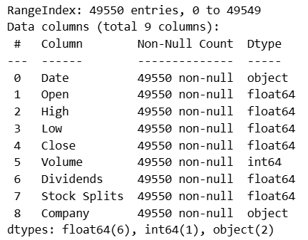
Feature engineered columns:
Daily_Return, Log_Return, Rolling_Volatility, Annualized_Volatility, MA10, MA50, MA200, EMA20, Momentum_5, Momentum_10.
Visualizations:
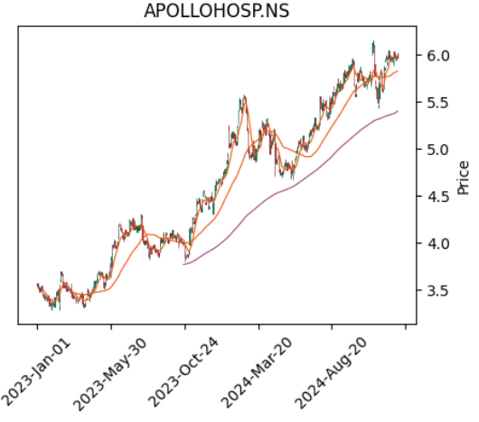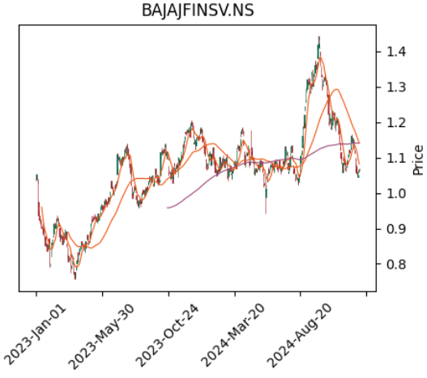
- LSTM:

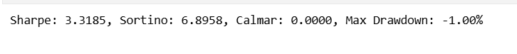
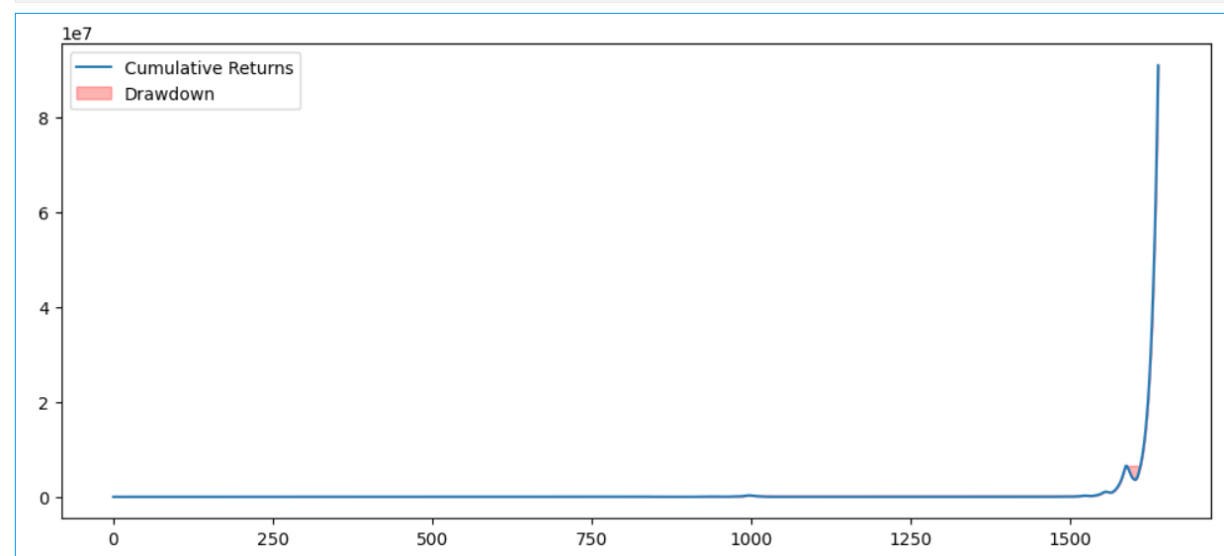
Max Drawdown: -1.00%
A value of -1.00% is exceptionally low, indicating the investment has been very stable and has avoided any significant or prolonged losses.
Sharpe Ratio: 3.3185
A value above 2 is considered very good, and 3.3185 is excellent. It suggests the strategy is generating a high level of excess return (above the risk-free rate) relative to the total volatility it takes on.
Sortino Ratio: 6.8958
A value of 6.8958 is exceptionally high, confirming that the high returns were generated with a remarkably small amount of harmful, negative price movement. This indicates the investment is very good at avoiding losses.
Calmar Ratio: 0.0000
A value of 0.0000 alongside a Max Drawdown of 1.00% is highly unusual, especially with such high Sharpe and Sortino ratios. This strongly suggests the Annualized Return was calculated to be zero (or near zero).
- Hybrid LSTM-CNN:
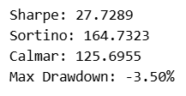
High Sharpe Ratio (27.7) → Excellent risk-adjusted returns. Usually, >1 is good, >2 is excellent. 27 is extremely high — indicates your strategy is capturing returns efficiently relative to volatility.
High Sortino Ratio (164.7) → Suggests almost all returns are positive relative to downside volatility; the portfolio rarely experiences losses.
Low Max Drawdown (-3.5%) → Very small historical peak-to-trough loss. Low drawdown means the portfolio is relatively safe in stress periods.
High Calmar Ratio (125.7) → Confirms the annualized return outweighs drawdown; your portfolio is stable.
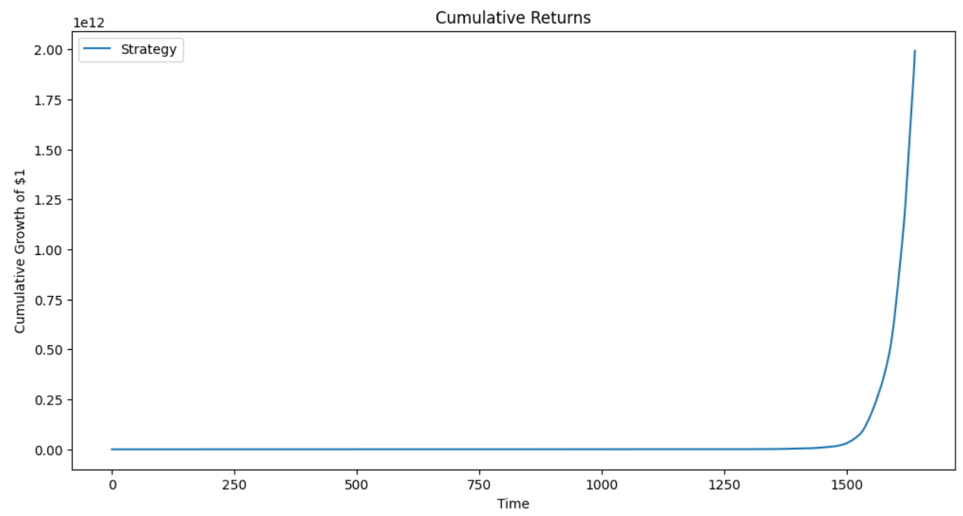
Tested on Live data:
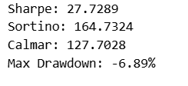
Sharpe = 27.7 → Extremely high risk-adjusted returns. Anything above 1 is considered good, so 27 is exceptional.
Sortino = 164.7 → Excellent downside risk management. High Sortino means losses are minimal relative to gains.
Calmar = 127.7 → Strong annualized return relative to drawdown.
Max Drawdown = -6.89% → Very small peak-to-trough loss, meaning the strategy is quite stable.
- SAC:
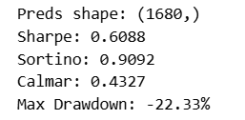
Sharpe Ratio: 0.6088 : model yields some excess returns over risk, but not strongly optimized yet.
Sortino Ratio: 0.9092: model performs better when focusing on downside protection.
Calmar Ratio: 0.4327: model gives decent returns, but with noticeable drawdowns.
Max Drawdown: -22.33% : largest observed loss from a peak to a trough during the test period.
-22.33% means at worst, the portfolio dropped by about 22% before recovering.
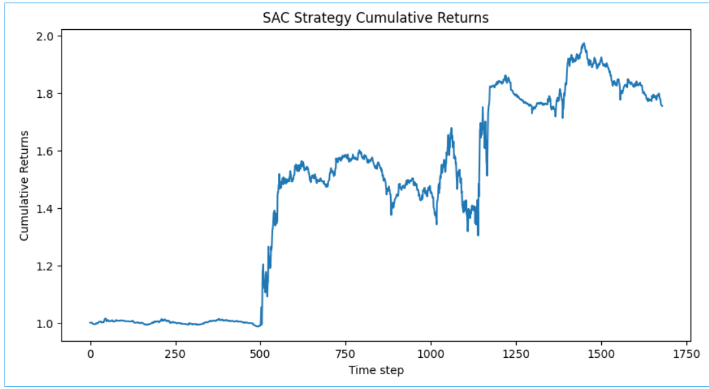
- PPO:
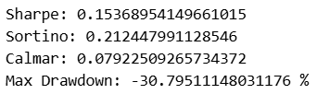
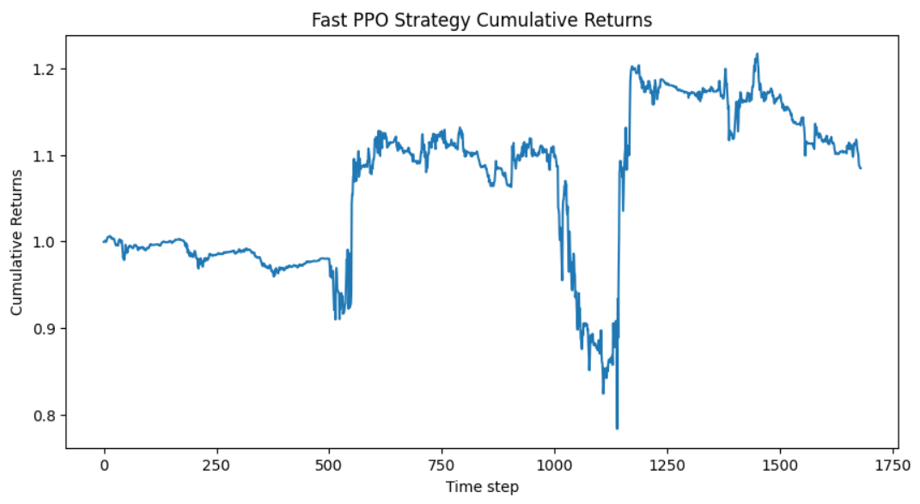
Low Performance: The Sharpe (0.15) and Sortino (0.21) ratios are quite low, indicating poor returns relative to the risk taken.
High Risk: The Max Drawdown of over 30% is a significant capital loss, and the low Calmar Ratio (0.079) confirms that the returns generated were very small in comparison to this maximum loss.
Performance Metrics used:
Sharpe Ratio, Sortino Ratio, Calmer Ratio, Max DrawDown

Performance measure result comparison Graph or table :
Models | Sharpe Ratio | Sortino Ratio | Calmar Ratio | Max Drawdown
Hybrid LSTM-Cnn | 27.7289 | 164.7323 | 125.6955 | -3.50%
PPO | 0.1537 | 0.2124 | 0.0792 | -30.79%
SAC | 0.6088 | 0.9092 | 0.4327 | -22.33%
LSTM | 3.3185 | 6.8958 | 0 | -1.00%

CASE 2 – Stock Sentiment Analysis
1. News Data Pre-processing and Analysis:
- The program successfully loads and merges news data collected from GDELT 2.0 for both Indian and US companies for the year 2024.
- Performs cleaning, standardization, and filtering, and outputs a unified dataset.
It removes duplicates, filters invalid entries, converts timestamps, and ensures uniform column structure across datasets.
Result Screen Shots: (With Description for each module and each case)
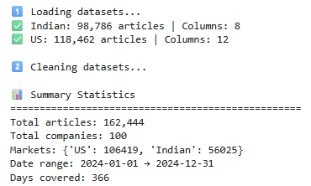

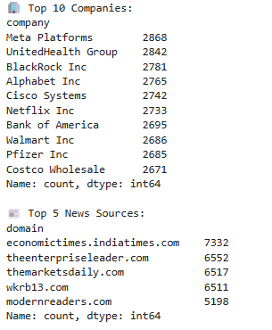
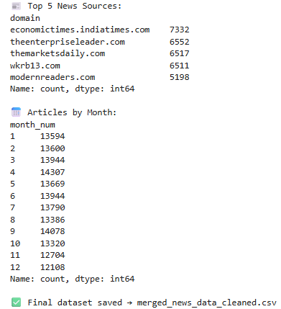

2. FinBERT Sentiment Analysis on Global Financial News
- The sentiment analysis was performed on a merged GDELT news dataset containing 162,444 financial articles across 100 companies from both U.S. (106,419 articles) and Indian (56,025 articles) markets. After processing with the FinBERT model, the overall sentiment distribution showed 61.7% neutral, 20.8% positive, and 17.5% negative tones, with an average model confidence of 0.845 and an average sentiment score of 0.047.
- The results indicate that most financial news headlines in 2024 were neutral, reflecting a balanced media tone toward market developments. The system also generated 30,096 daily sentiment records and 1,200 monthly aggregated records, enabling trend analysis of company-wise sentiment variations over time.
Result Screen Shots: (With Description for each module and each case)

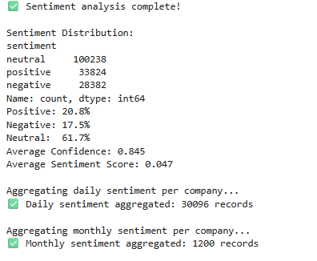
3. Real Time Live API Testing
The Live Sentiment Analysis successfully collected and analyzed the latest financial news articles for major technology companies such as Apple, Tesla, Microsoft, Google, and Amazon using the News API and FinBERT model. The system first attempted to fetch today’s news, and if unavailable, automatically retrieved articles from the past seven days.
Each article’s headline and description were processed using FinBERT to determine its sentiment (positive, negative, or neutral), along with a confidence score and a sentiment score. The results showed that:
- Apple and Microsoft had overall positive to neutral sentiment trends.
- Tesla exhibited a predominantly negative sentiment due to critical reports.
- Google and Amazon displayed mostly neutral coverage.
An overall market sentiment summary was generated based on the average sentiment score across all companies. In this run, the model indicated a neutral to slightly positive (bullish) market mood, suggesting balanced investor sentiment across the technology sector.
Result Screen Shots: (With Description for each module and each case)
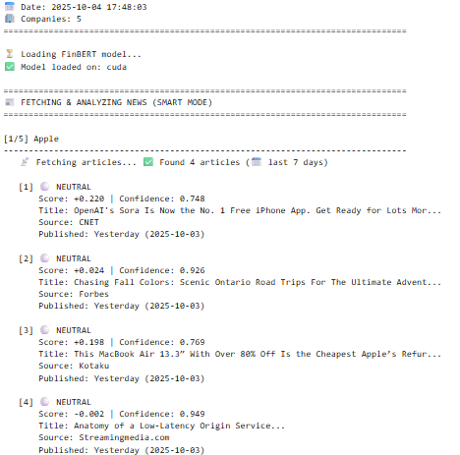

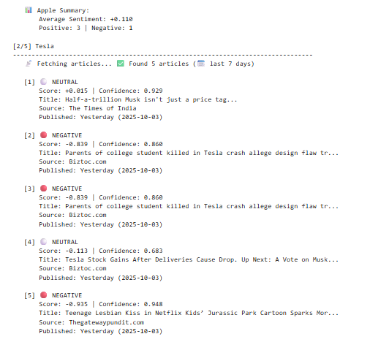



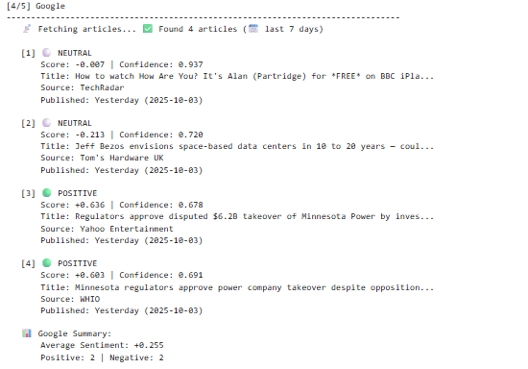
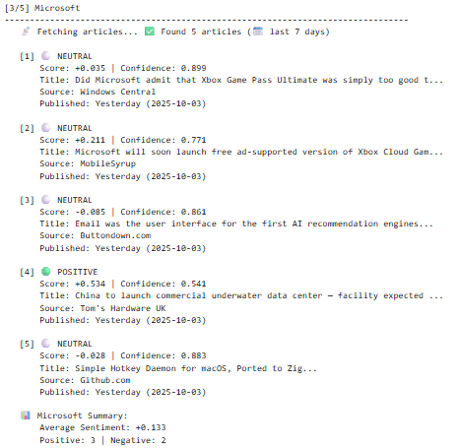

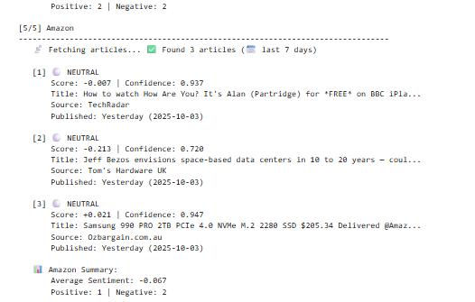

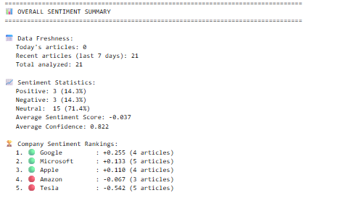
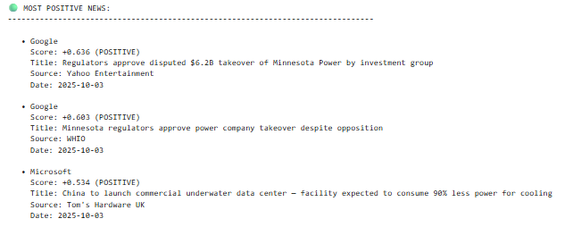
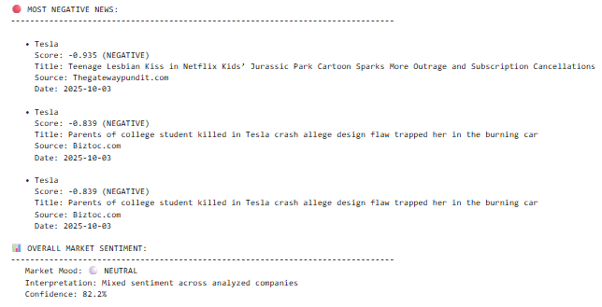

Performance Metrics used:

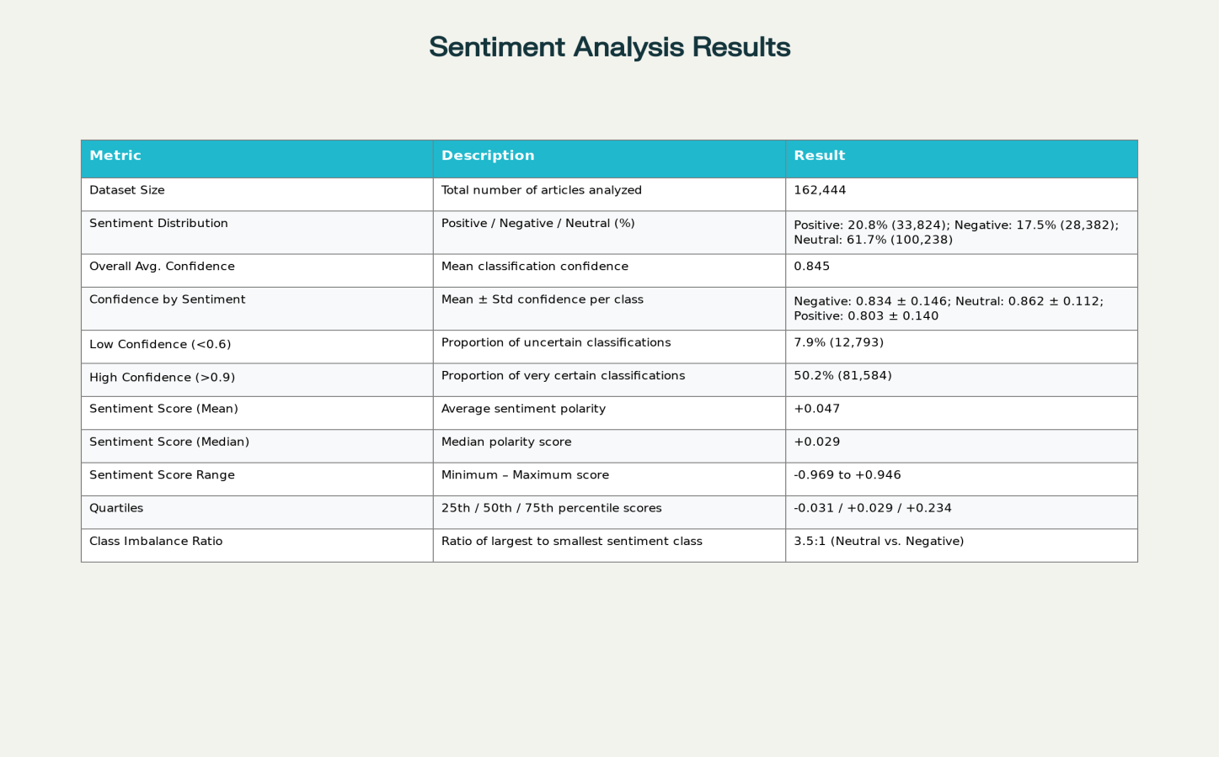

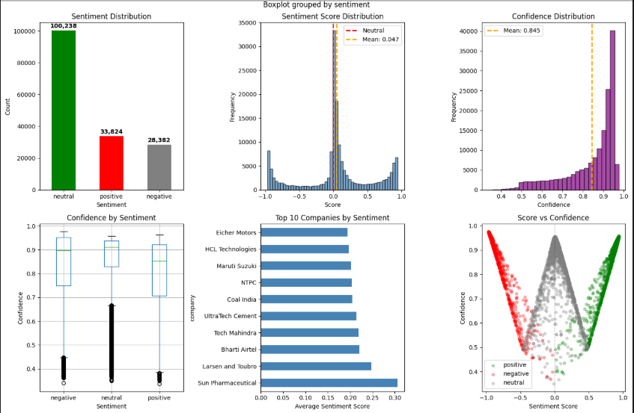

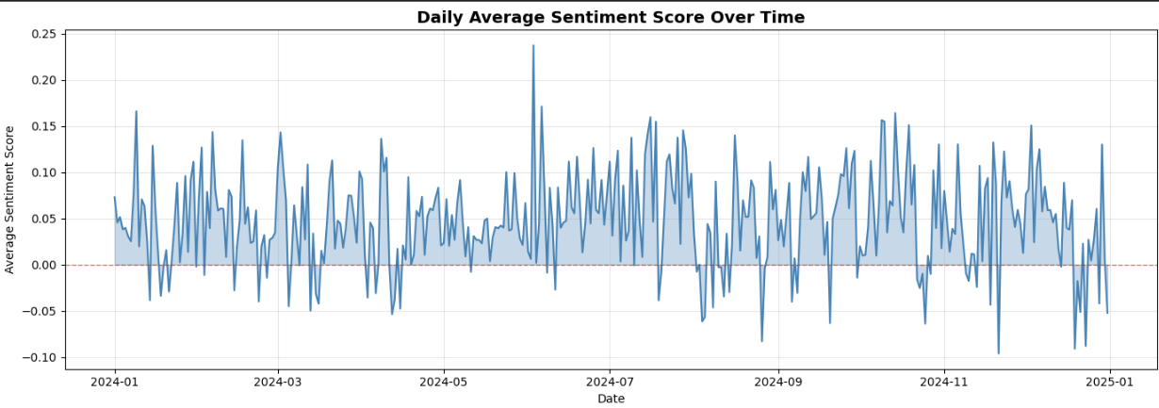

Comparison analysis:

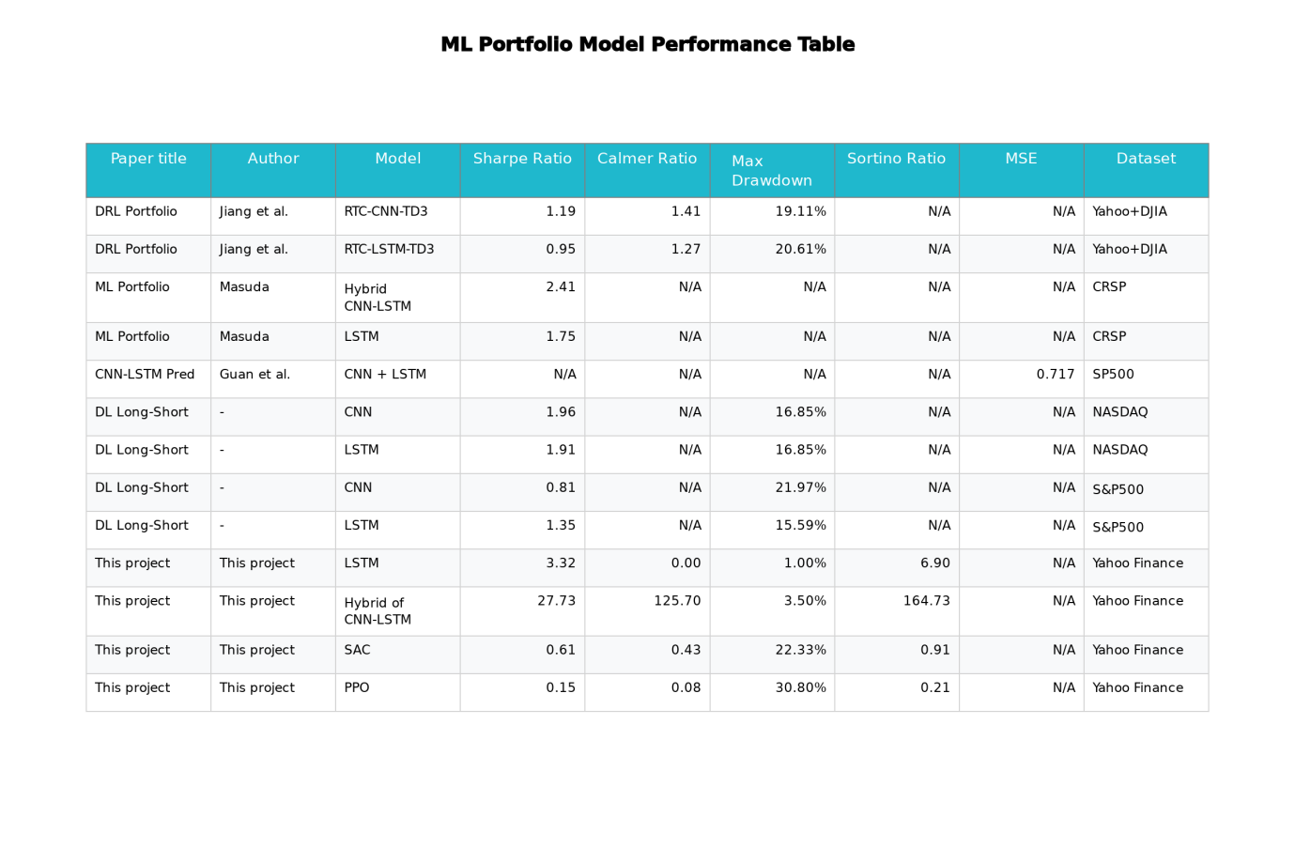

Sentiment analysis Performance Table
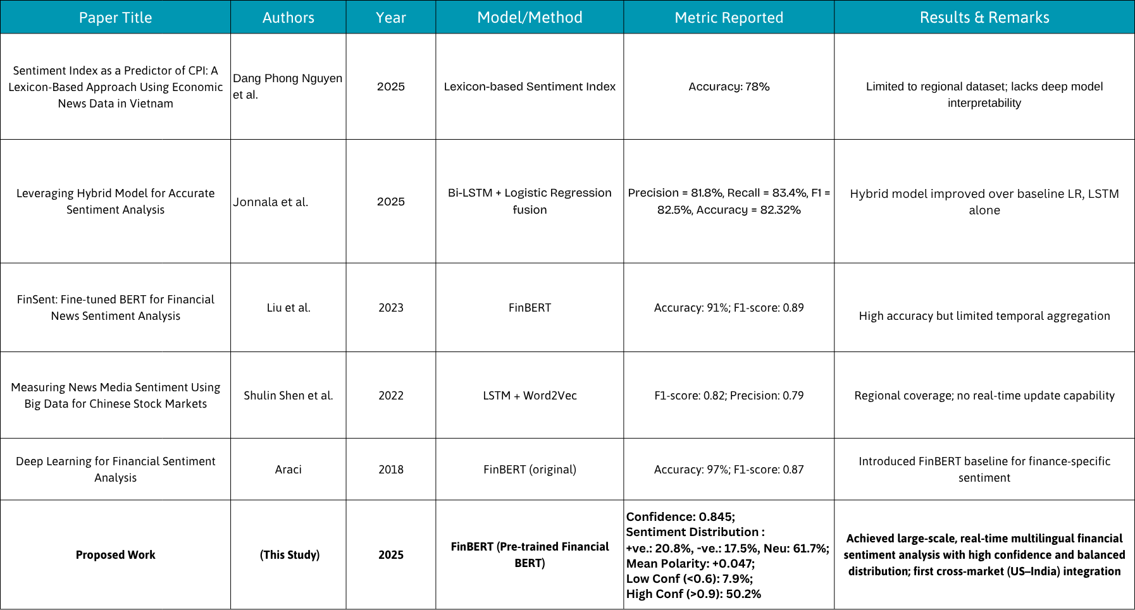

Future enhancements:
- Add more evaluation metrics — Information Ratio, Omega, Tail-Value-at-Risk, turnover, hit rate per regime.
- Hybrid ensembles with attention/transformers — combine LSTM–CNN with Transformer-based encoders for long-range dependencies.
- Model calibration for RL agents — shape rewards for SAC/PPO to penalize drawdowns and transaction frequency.
- Develop a real-time sentiment dashboard. Integrate with price data APIs for correlation analysis
- Build machine learning models to predict future sentiment trends.
- Add multi-language support to expand global reach.

