HomeCOG Batch1 PerfO Report 12-12

Coding for weekly audit of HomeCog Batch 1 data collection. The purpose of this document is to structure what will be circulated and reviewed by the HoPE Aim 1 team on a weekly basis.

## Exploration & Descriptives:

### 2. Items.

#### + PerfO mean score by item.

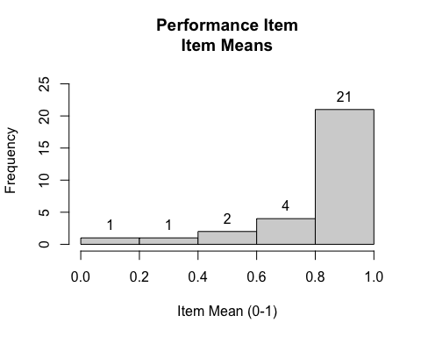

#### + PerfO item-total correlation.

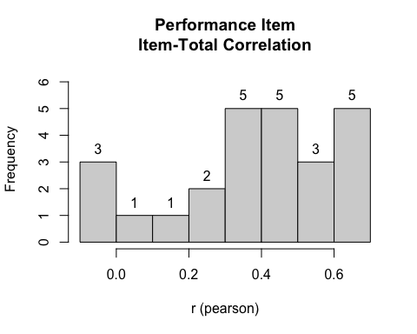

#### + Bivariate correlation.

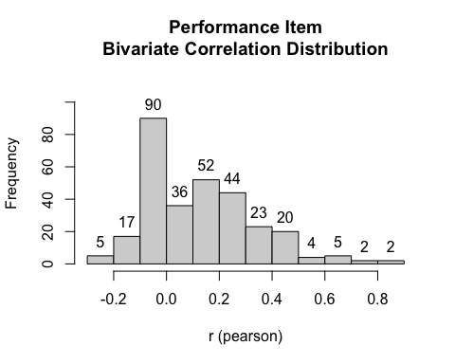

### 2. Persons.

#### + Scale scores.

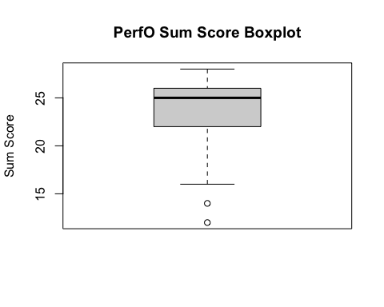

#### + Time to complete test.

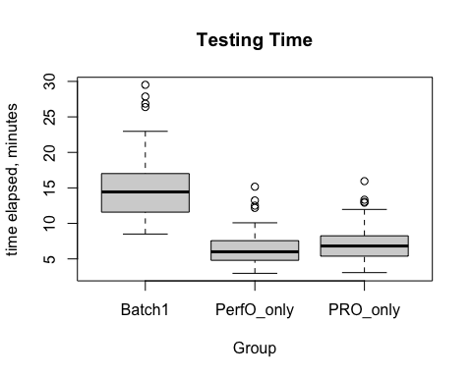

### 3. Missing data by item and persons.

#### + PerfO missing items.

