HomeCog Batch1 Weekly Reports

Coding for weekly audit of HomeCog Batch 1 data collection. The purpose of this document is to structure what will be circulated and reviewed by the HoPE Aim 1 team on a weekly basis.

### Load the data -> right now, using simulated data for code development.

# Manipulation:

1. Create variable for ‘impaired cognition’ flag (</>= -1.5 AC).

#FAMCAT AC Safety Flag (< -1.5 AC)  
data$AC_Flag= data$FAMCAT_AC < -1.5

1. Create variable for group membership.

#Group1 - those with ADRD diagnoses  
data$Group1= data$ADRD != 0  
  
#Group2 - those without ADRD diagnosis but FAMCAT AC < -1.5  
data$Group2= (data$ADRD == 0 & data$AC_Flag)  
  
#Group3 - those without ADRD and FAMCAT AC >=-1.5  
data$Group3= (data$ADRD == 0 & !data$AC_Flag)

1. Scale scores.

* PRO

data$PRO_SS=apply(data[,grep("^PRO[1-9]+",names(data))],1,sum,na.rm=TRUE)

* PerfO

data$PerfO_SS=apply(data[,grep("^PerfO[1-9]+",names(data))],1,sum,na.rm=TRUE)

# Data Cleaning.

1. Data recoding.

for(var in names(data)){  
 levels(data[,var])[which(levels(data[,var])=="Very Often")]<=1  
 levels(data[,var])[which(levels(data[,var])=="Often")]<=2  
 levels(data[,var])[which(levels(data[,var])=="Sometimes")]<=3  
 levels(data[,var])[which(levels(data[,var])=="Rarely")]<=4  
 levels(data[,var])[which(levels(data[,var])=="Never")]<=5   
   
 levels(data[,var])[which(levels(data[,var])=="None")]<=1  
 levels(data[,var])[which(levels(data[,var])=="A little")]<=2  
 levels(data[,var])[which(levels(data[,var])=="Some")]<=3  
 levels(data[,var])[which(levels(data[,var])=="A lot")]<=4  
 levels(data[,var])[which(levels(data[,var])=="Unable")]<=5   
}

1. Out of range data.

data$PRO_OOR_Flag=apply(data[,grep("^PRO[1-9]+",names(data))],1,function(r){!any(r %in% 1:5)})  
  
data$PerfO_OOR_Flag=apply(data[,grep("^PerO[1-9]+",names(data))],1,function(r){!any(r %in% 0:1)})

1. Unique values.

#PROs  
unique(c(unlist(apply(data[,grep("^PRO[1-9]+",names(data))], 2, unique))))

## [1] 4 3 2 5 1

#PerfOs  
unique(c(unlist(apply(data[,grep("^PerfO[1-9]+",names(data))], 2, unique))))

## [1] 0 1

# Exploration & Descriptives:

1. Recruitment Targets.

* Clinical Characteristics/Demographic breakdown (with targets).

#ADRD diag & those without ADRD diag but <-1.5 AC  
table(data$AC_Flag,data$ADRD)

##   
## 0 1 2 3 4 5  
## FALSE 9 9 2 4 7 4  
## TRUE 5 3 0 2 4 1

#gender should be 50% female  
prop.table(table(data$gender))

##   
## f m   
## 0.56 0.44

* Coordinator/administrator notes.

1. Items.

* PRO Freq response tables.

PROFreqTable=apply(data[,grep("^PRO[1-9].*",names(data))], 2, table)  
PROFreqTable

## PRO1 PRO2 PRO3 PRO4 PRO5 PRO6 PRO7 PRO8 PRO9 PRO10 PRO11 PRO12 PRO13 PRO14  
## 1 4 7 7 8 10 10 9 9 11 15 6 11 13 7  
## 2 15 7 8 10 8 8 10 11 7 12 11 7 11 14  
## 3 5 13 10 8 15 11 11 7 11 4 13 13 11 10  
## 4 15 13 13 12 6 11 7 14 10 7 8 8 10 12  
## 5 11 10 12 12 11 10 13 9 11 12 12 11 5 7  
## PRO15 PRO16 PRO17 PRO18 PRO19 PRO20 PRO21 PRO22 PRO23 PRO24 PRO25 PRO26 PRO27  
## 1 9 13 12 14 9 7 7 10 10 9 10 9 11  
## 2 7 8 8 10 9 12 6 12 8 7 12 12 7  
## 3 5 6 7 10 16 13 18 11 13 8 12 13 12  
## 4 14 11 13 10 4 9 12 10 13 12 7 8 6  
## 5 15 12 10 6 12 9 7 7 6 14 9 8 14  
## PRO28 PRO29 PRO30 PRO31 PRO32 PRO33 PRO34 PRO35  
## 1 12 12 3 14 7 6 10 15  
## 2 10 14 15 8 8 10 8 13  
## 3 9 12 14 10 9 9 8 6  
## 4 12 6 6 11 17 11 9 10  
## 5 7 6 12 7 9 14 15 6

PROPropFreqTable=apply(PROFreqTable, 2, prop.table)  
PROPropFreqTable

## PRO1 PRO2 PRO3 PRO4 PRO5 PRO6 PRO7 PRO8 PRO9 PRO10 PRO11 PRO12 PRO13 PRO14  
## 1 0.08 0.14 0.14 0.16 0.20 0.20 0.18 0.18 0.22 0.30 0.12 0.22 0.26 0.14  
## 2 0.30 0.14 0.16 0.20 0.16 0.16 0.20 0.22 0.14 0.24 0.22 0.14 0.22 0.28  
## 3 0.10 0.26 0.20 0.16 0.30 0.22 0.22 0.14 0.22 0.08 0.26 0.26 0.22 0.20  
## 4 0.30 0.26 0.26 0.24 0.12 0.22 0.14 0.28 0.20 0.14 0.16 0.16 0.20 0.24  
## 5 0.22 0.20 0.24 0.24 0.22 0.20 0.26 0.18 0.22 0.24 0.24 0.22 0.10 0.14  
## PRO15 PRO16 PRO17 PRO18 PRO19 PRO20 PRO21 PRO22 PRO23 PRO24 PRO25 PRO26 PRO27  
## 1 0.18 0.26 0.24 0.28 0.18 0.14 0.14 0.20 0.20 0.18 0.20 0.18 0.22  
## 2 0.14 0.16 0.16 0.20 0.18 0.24 0.12 0.24 0.16 0.14 0.24 0.24 0.14  
## 3 0.10 0.12 0.14 0.20 0.32 0.26 0.36 0.22 0.26 0.16 0.24 0.26 0.24  
## 4 0.28 0.22 0.26 0.20 0.08 0.18 0.24 0.20 0.26 0.24 0.14 0.16 0.12  
## 5 0.30 0.24 0.20 0.12 0.24 0.18 0.14 0.14 0.12 0.28 0.18 0.16 0.28  
## PRO28 PRO29 PRO30 PRO31 PRO32 PRO33 PRO34 PRO35  
## 1 0.24 0.24 0.06 0.28 0.14 0.12 0.20 0.30  
## 2 0.20 0.28 0.30 0.16 0.16 0.20 0.16 0.26  
## 3 0.18 0.24 0.28 0.20 0.18 0.18 0.16 0.12  
## 4 0.24 0.12 0.12 0.22 0.34 0.22 0.18 0.20  
## 5 0.14 0.12 0.24 0.14 0.18 0.28 0.30 0.12

* Mean score by item.

PRO_means=apply(data[,grep("^PRO[1-9].*",names(data))], 2, mean, na.rm=TRUE)  
names(PRO_means)=grep("^PRO[1-9].*",names(data), value=TRUE)  
PRO_means

## PRO1 PRO2 PRO3 PRO4 PRO5 PRO6 PRO7 PRO8 PRO9 PRO10 PRO11 PRO12 PRO13   
## 3.28 3.24 3.30 3.20 3.00 3.06 3.10 3.06 3.06 2.78 3.18 3.02 2.66   
## PRO14 PRO15 PRO16 PRO17 PRO18 PRO19 PRO20 PRO21 PRO22 PRO23 PRO24 PRO25 PRO26   
## 2.96 3.38 3.02 3.02 2.68 3.02 3.02 3.12 2.84 2.94 3.30 2.86 2.88   
## PRO27 PRO28 PRO29 PRO30 PRO31 PRO32 PRO33 PRO34 PRO35   
## 3.10 2.84 2.60 3.18 2.78 3.26 3.34 3.22 2.58

PerfO_means=apply(data[,grep("^PerfO[1-9].*",names(data))], 2, mean, na.rm=TRUE)  
names(PRO_means)=grep("^PerfO[1-9].*",names(data), value=TRUE)  
PerfO_means

## PerfO1 PerfO2 PerfO3 PerfO4 PerfO5 PerfO6 PerfO7 PerfO8 PerfO9 PerfO10   
## 0.44 0.54 0.52 0.52 0.52 0.48 0.46 0.50 0.42 0.44   
## PerfO11 PerfO12 PerfO13 PerfO14 PerfO15 PerfO16 PerfO17 PerfO18 PerfO19 PerfO20   
## 0.48 0.40 0.48 0.44 0.46 0.32 0.46 0.68 0.48 0.54   
## PerfO21 PerfO22 PerfO23 PerfO24 PerfO25 PerfO26 PerfO27 PerfO28 PerfO29 PerfO30   
## 0.42 0.44 0.62 0.50 0.46 0.62 0.44 0.40 0.52 0.52   
## PerfO31 PerfO32 PerfO33 PerfO34 PerfO35   
## 0.56 0.54 0.52 0.42 0.48

* item-total correlation.

PRO_ItemTotalCorr=apply(data[,grep("^PRO[1-9].*",names(data))], 2, function(x){cor(x,data$PRO_SS, use = "pairwise.complete.obs")})  
round(PRO_ItemTotalCorr,2)

## PRO1 PRO2 PRO3 PRO4 PRO5 PRO6 PRO7 PRO8 PRO9 PRO10 PRO11 PRO12 PRO13   
## 0.35 0.19 0.32 0.06 0.33 0.23 0.38 0.08 0.06 0.02 0.08 -0.17 0.26   
## PRO14 PRO15 PRO16 PRO17 PRO18 PRO19 PRO20 PRO21 PRO22 PRO23 PRO24 PRO25 PRO26   
## 0.17 0.34 0.11 0.37 0.20 0.05 0.03 0.36 0.21 -0.03 0.14 0.27 0.22   
## PRO27 PRO28 PRO29 PRO30 PRO31 PRO32 PRO33 PRO34 PRO35   
## 0.07 0.24 -0.23 0.10 0.23 0.09 0.42 0.07 0.44

PerfO_ItemTotalCorr=apply(data[,grep("^PerfO[1-9].*",names(data))], 2, function(x){cor(x,data$PerfO_SS, use = "pairwise.complete.obs")})  
round(PerfO_ItemTotalCorr,2)

## PerfO1 PerfO2 PerfO3 PerfO4 PerfO5 PerfO6 PerfO7 PerfO8 PerfO9 PerfO10   
## 0.32 -0.03 0.01 0.22 0.37 0.10 0.22 0.15 0.38 -0.07   
## PerfO11 PerfO12 PerfO13 PerfO14 PerfO15 PerfO16 PerfO17 PerfO18 PerfO19 PerfO20   
## 0.30 0.35 0.07 0.14 0.09 0.12 0.08 0.22 0.25 0.09   
## PerfO21 PerfO22 PerfO23 PerfO24 PerfO25 PerfO26 PerfO27 PerfO28 PerfO29 PerfO30   
## 0.20 0.24 0.24 0.33 0.02 -0.02 0.17 0.19 0.06 -0.02   
## PerfO31 PerfO32 PerfO33 PerfO34 PerfO35   
## -0.05 0.21 -0.02 0.30 0.21

* Bivariate correlation.

BVCorrTable=cor(data[,grep("^PRO[1-9].*|^PerfO[1-9].*|*._SS.*",names(data))], use="pairwise.complete.obs", method="spearman")  
  
hist(BVCorrTable[lower.tri(BVCorrTable)])

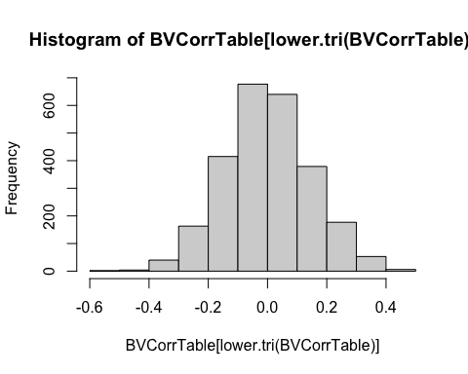

PROCorrTable=BVCorrTable[  
 grep("^PRO[1-9].*|^PRO_SS.*",rownames(BVCorrTable)),  
 grep("^PRO[1-9].*|^PRO_SS.*",colnames(BVCorrTable))]  
  
PerfOCorrTable=BVCorrTable[  
 grep("^PerfO[1-9].*|^PerfO_SS.*",rownames(BVCorrTable)),  
 grep("^PerfO[1-9].*|^PerfO_SS.*",colnames(BVCorrTable))]

1. Persons.

* Scale scores.

boxplot(data$PRO_SS, main="PRO Sum Score Boxplot")

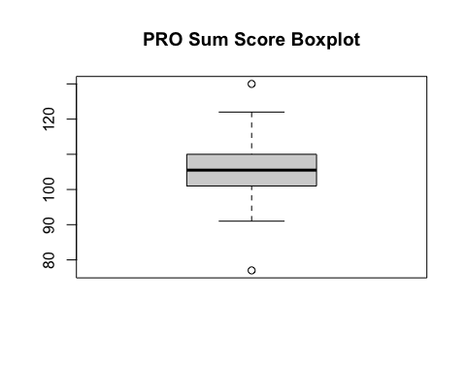

boxplot(data$PerfO_SS, main="PerfO Sum Score Boxplot")

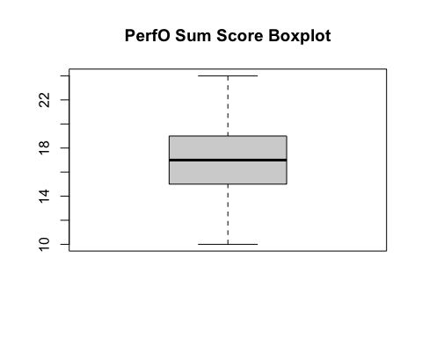

* Time distribution per items.
* Time to complete test.
* Characteristics (Clin/Demo) by items/scales

1. Missing data by item and persons.

PRO_Missing=apply(data[,grep("^PRO[1-9]+",names(data))], 2, function(x){sum(is.na(x))})  
names(PRO_Missing)=grep("^PRO[1-9]+",names(data),value=TRUE)  
PRO_Missing

## PRO1 PRO2 PRO3 PRO4 PRO5 PRO6 PRO7 PRO8 PRO9 PRO10 PRO11 PRO12 PRO13   
## 0 0 0 0 0 0 0 0 0 0 0 0 0   
## PRO14 PRO15 PRO16 PRO17 PRO18 PRO19 PRO20 PRO21 PRO22 PRO23 PRO24 PRO25 PRO26   
## 0 0 0 0 0 0 0 0 0 0 0 0 0   
## PRO27 PRO28 PRO29 PRO30 PRO31 PRO32 PRO33 PRO34 PRO35   
## 0 0 0 0 0 0 0 0 0

PerfO_Missing=apply(data[,grep("^PerfO[1-9]+",names(data))], 2, function(x){sum(is.na(x))})  
names(PerfO_Missing)=grep("^PerfO[1-9]+",names(data),value=TRUE)  
PerfO_Missing

## PerfO1 PerfO2 PerfO3 PerfO4 PerfO5 PerfO6 PerfO7 PerfO8 PerfO9 PerfO10   
## 0 0 0 0 0 0 0 0 0 0   
## PerfO11 PerfO12 PerfO13 PerfO14 PerfO15 PerfO16 PerfO17 PerfO18 PerfO19 PerfO20   
## 0 0 0 0 0 0 0 0 0 0   
## PerfO21 PerfO22 PerfO23 PerfO24 PerfO25 PerfO26 PerfO27 PerfO28 PerfO29 PerfO30   
## 0 0 0 0 0 0 0 0 0 0   
## PerfO31 PerfO32 PerfO33 PerfO34 PerfO35   
## 0 0 0 0 0

1. Track over time.