

Advanced Data Bases TC3041 – ITESM Puebla  
Professor: Dr. Daniel Pérez Rojas

Homework 2.4 – Library DB

______________________________________________

20/03/2018

Rafael Antonio Comonfort Viveros A01324276

Angel Roberto Ruíz Mendoza A01324489

This homework required a front-end for our previously developed database of a library. However, only 2 CRUD scenarios were asked from us and so, we chose to elaborate on Loans and Returns, which are the main action one can do on a library. We soon realized that to make a loan, one would need to see what books are available, to return a book, fines would need to be displayed in case it wasn’t returned on time, etc. This meant we would have to do some extra functions and files to make the system work.

# Implementation

We followed extremely closely the latest PHP example project provided in class. The idea behind it, is using a class corresponding to the desired entity, and write a method for retrieving, updating, deleting and inserting from and into the database. Said PHP class has the same attributes as its database counterpart, with setters for external files to modify them. We also declared interfaces for each class, specifying all methods to implement (save, get, delete and update). We generated the interface and class for the books, returns, fines and loans, although a class like that of books, only has a function to get the tuples from the database, as we didn’t want to let the user add new books, update them or delete them. You can find the interfaces in the “interfaces” folder, and the class files in the “models” folder.

The Database.php file is where the connection to Postgres occurs. It is included and used in all models to perform their database methods. We took the file provided in the sample project and simply changed the user, database name and password to match that of The Server (where this homework is to be mounted).

In the “app” folder, all PHP files concerning the front-end are placed. We have a list file for returns, fines, loans and loans to return. The latter being used when making a new return, and we wish to know for which loan we are making a return. We have an add, delete PHP file for books and loans. The former makes use of a save file to actually create an instance of that object, reads the form declared with the add file, and calls the save function. The most complex files are the list ones, where dynamically, all tuples are retrieved from the database using the “get” model’s function, and then displayed to the user with edit and delete buttons if it applies. Said buttons are bound to call other PHP files with the ID of the tuple or with the entire instance as parameter. Notice that all files that include HTML code in them, also have the left side navbar imposed on them.

At index.php, the server is told to go to the home landing page, which includes an image. A bootstrap template was used, to provide a better visual appeal to our homework. You will notice too, that it is the same utilized for the last front-end homework.

# Screenshots on Server

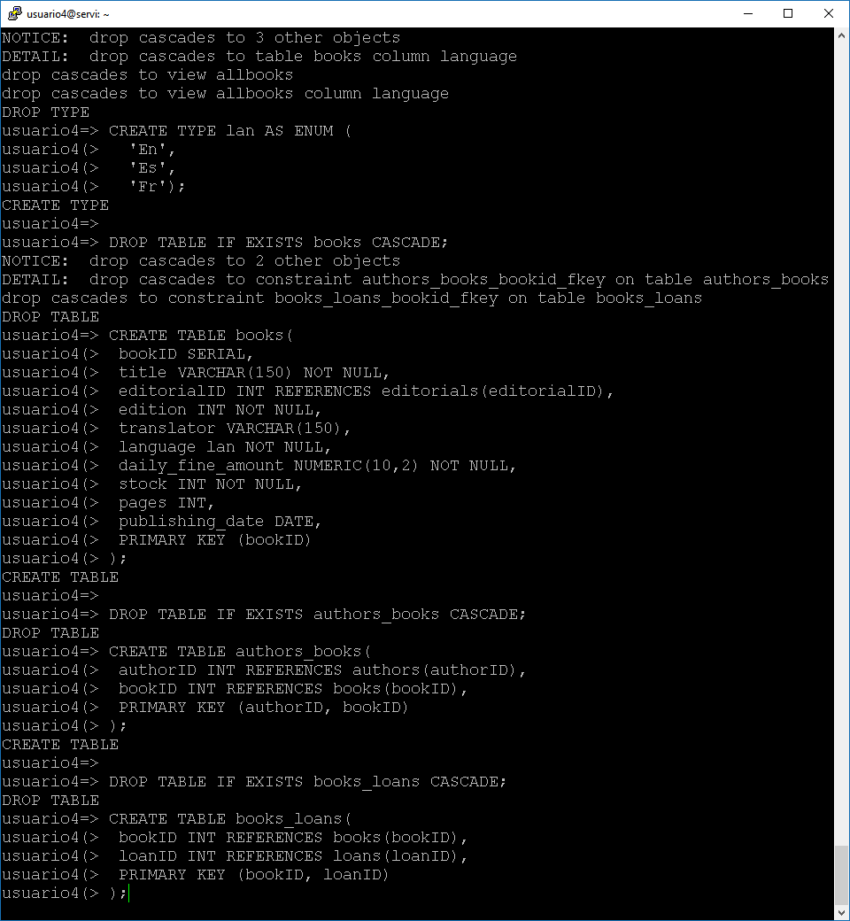

Tables creation on server’s Postgres

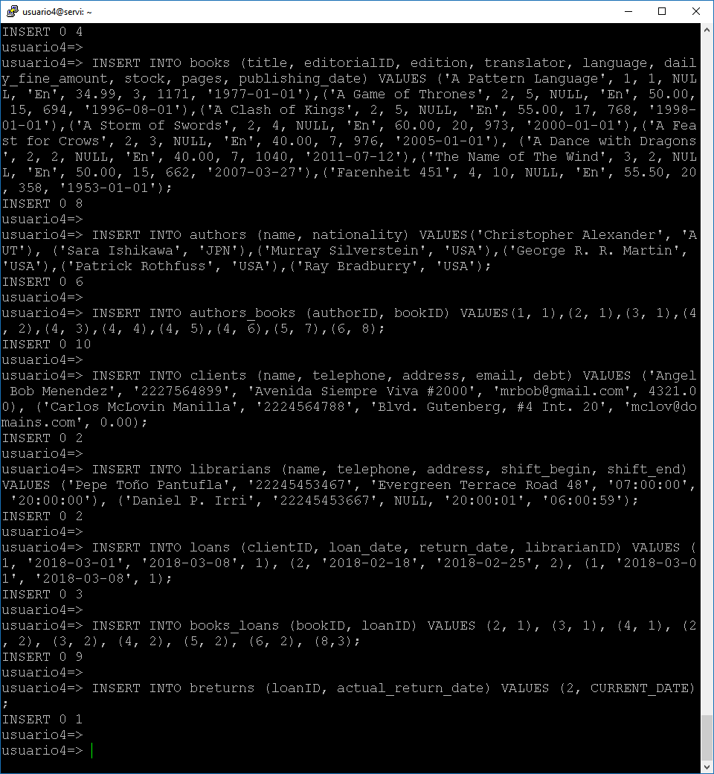

Database seeding for all tables

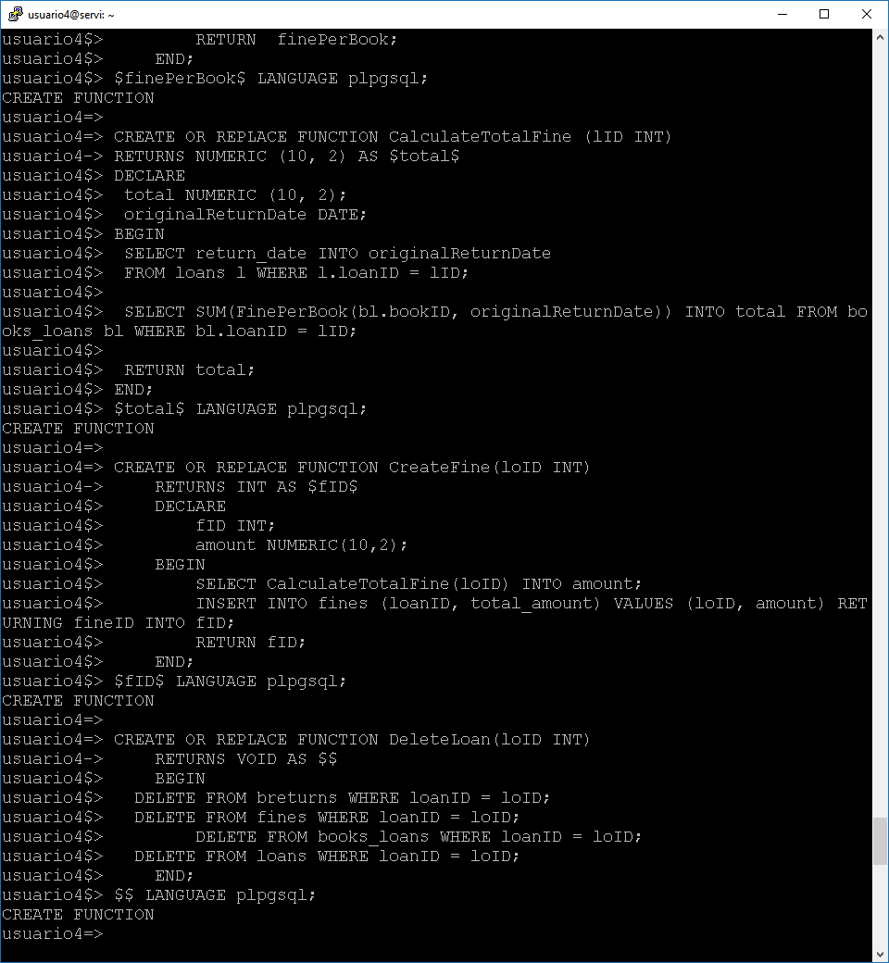

Creation of required functions, triggers, etc.

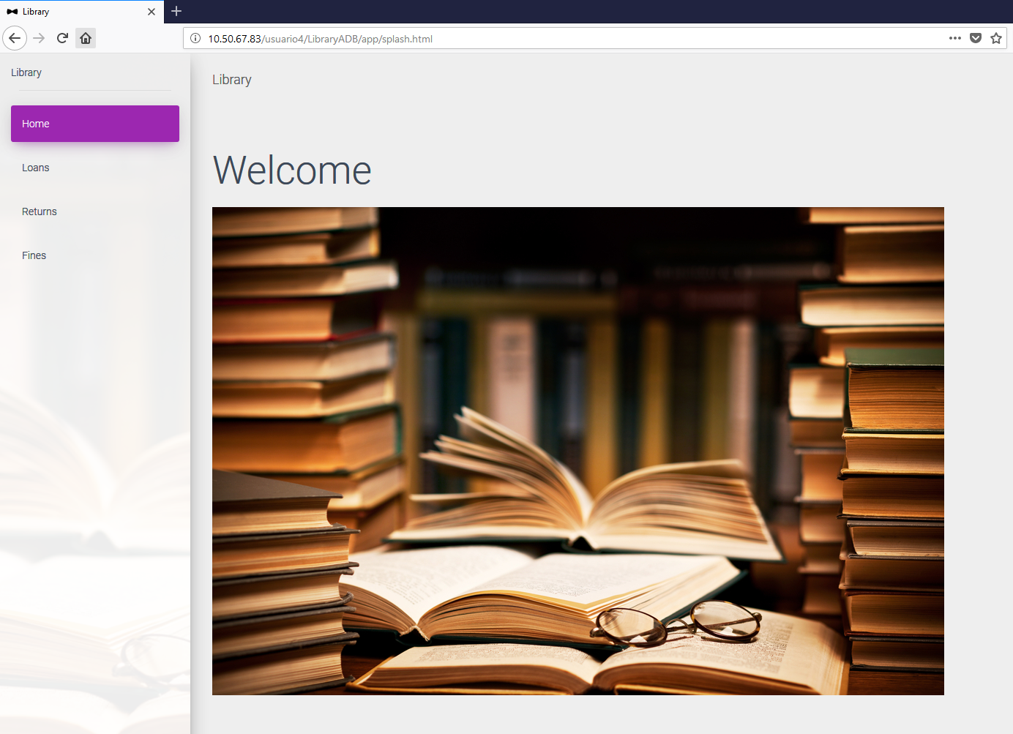

Homepage for the Library site

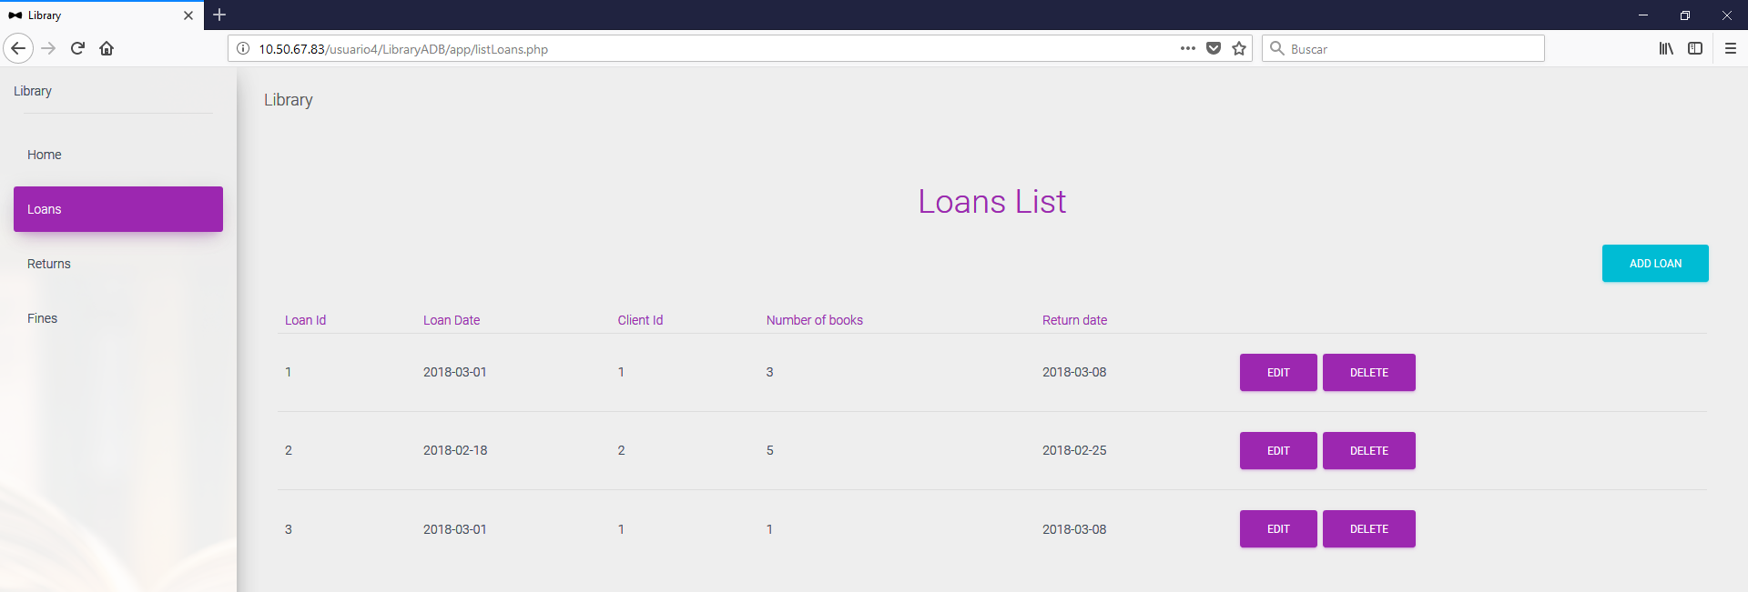

Listing of all registered loans, from here you can edit or delete any one of them, or add a new one

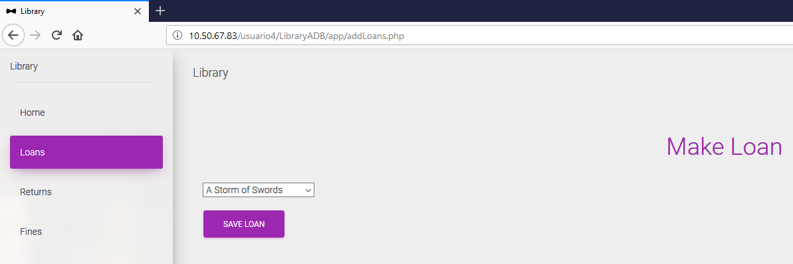

The new loan screen lets you select 1 book to start off a new loan. Its issue date is the current day, the planned returned date is 7 days later.

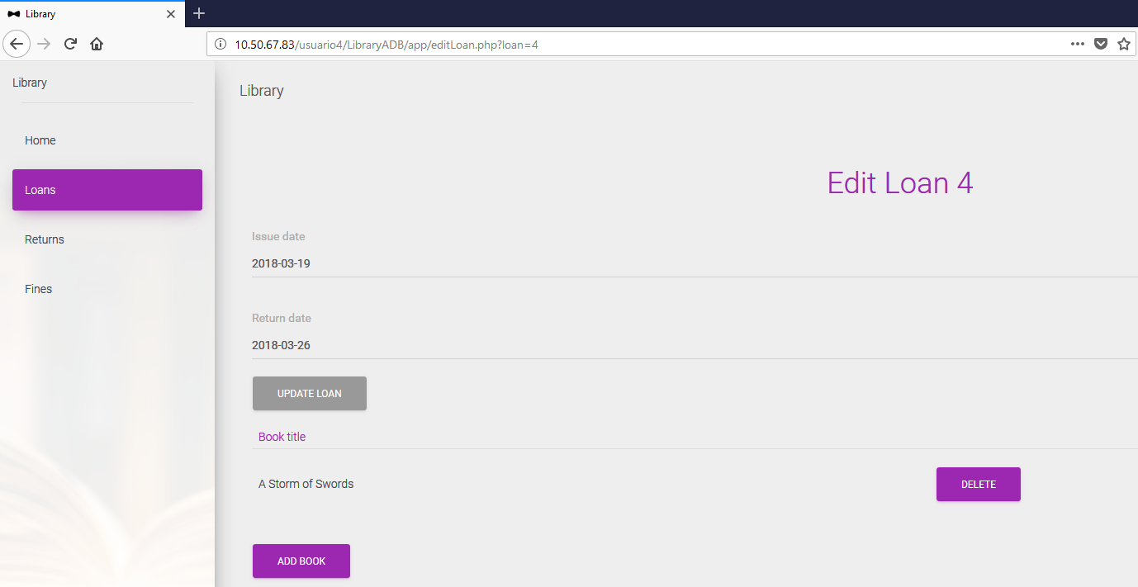

Edit page for a loan. You are able to change the issue date in the past or future and modify the lending time (by extending the return date) as you see fit, for demonstration purposes.

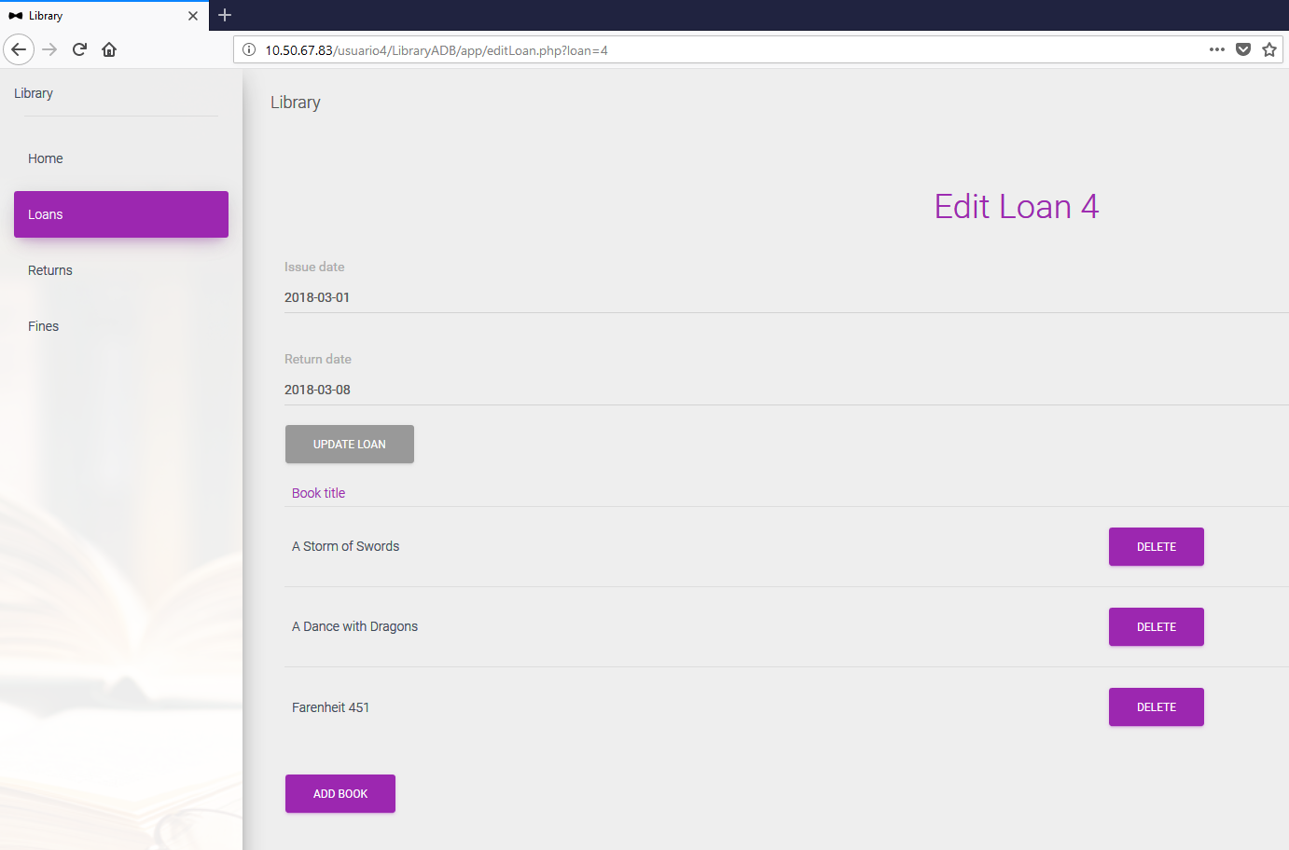

Added a couple books to loan with ID 4, this is the selected way to have one of this entities with more than 1 book lent.

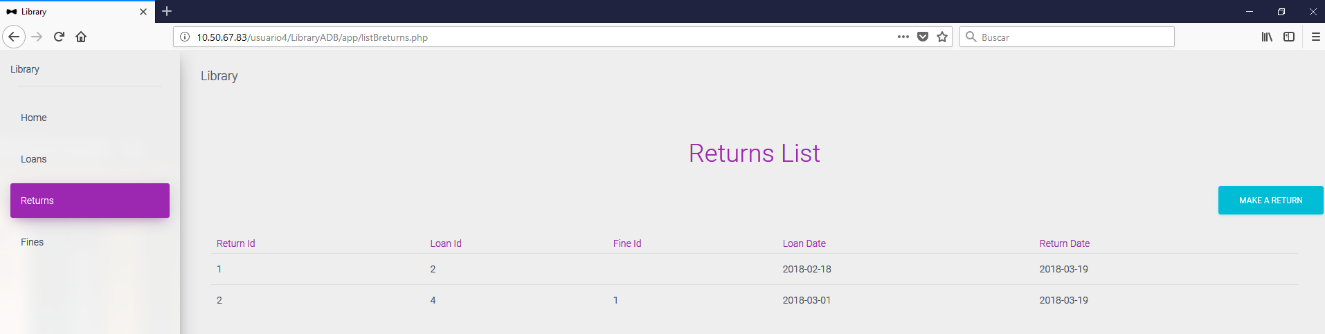

Page that displays all returns. A return cannot be deleted or edited.

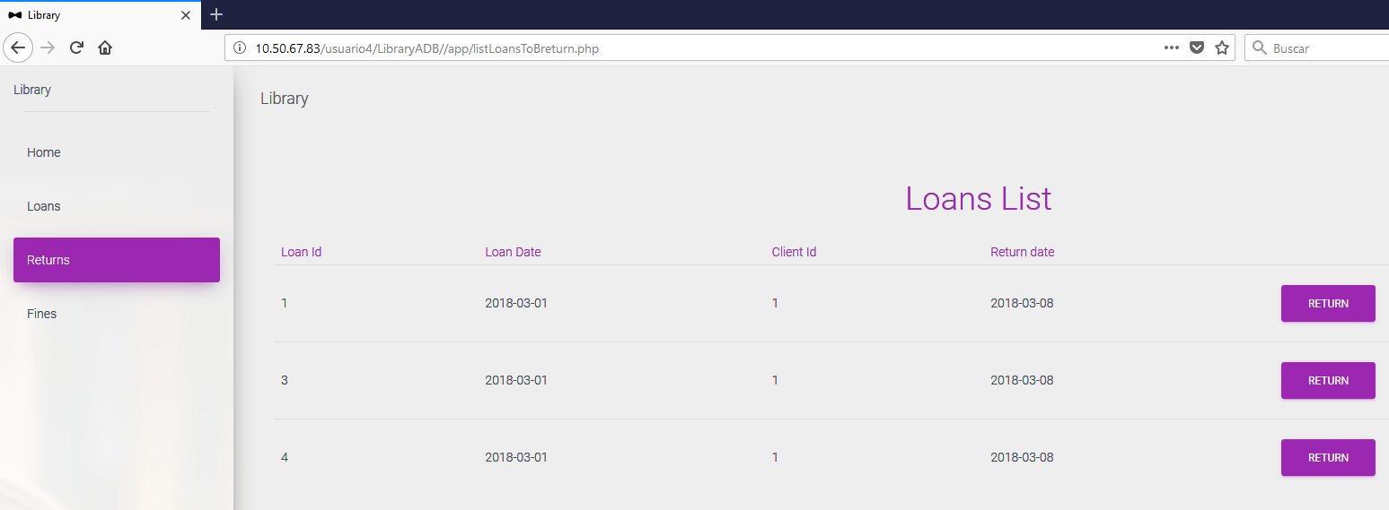

A list of pending loans is displayed, the returned is inserted automatically, with its date taken from the day it was added.

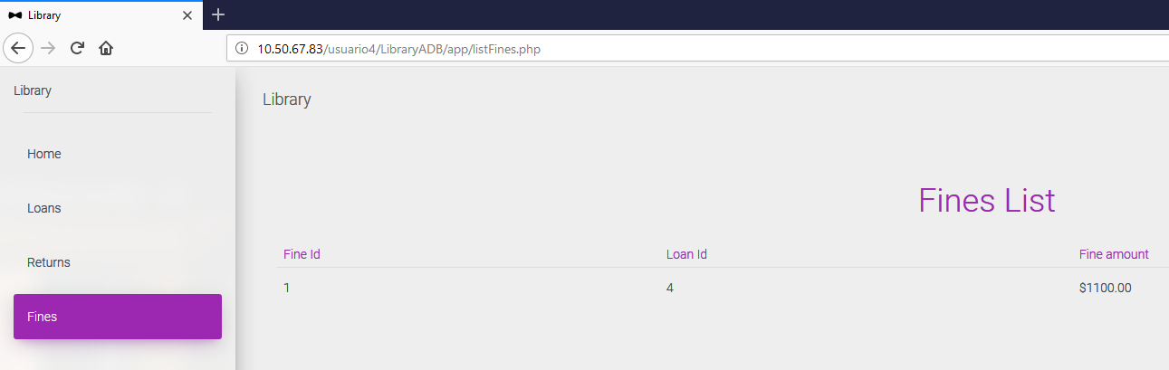

If the return inserted has a later return date than that specified by the loan, a fine is added by a trigger. All fines are displayed here.