Technical guide for wearable optical radiation dosimetry and visual experience assessment
  - Research Data Alliance Working Group Optical Radiation Exposure and Visual Experience Data
Johannes Zauner¹, Rigmor C. Baraas², Elise N. Harb³, Ali Heshmati⁴, Francisco Imai⁵, Pauline Kang⁶, Raymond P. Najjar⁷, Aaron Nicholls⁸, Lisa Ostrin⁹, Erik Page¹⁰, Oliver Stefani¹¹, and Manuel Spitschan¹²
2026-06-17
Table of contents

¹ Technical University of Munich (Germany)
² University of South-Eastern Norway (Norway)
³ University of California, Berkeley (USA); University of California, San Francisco (USA)”
⁴ Norwegian University of Science and Technology (Norway)”
⁵ Optica Color Technical Group (USA)
⁶ University of New South Wales (Australia)
⁷ National University of Singapore; Singapore Eye Research Institute; Duke-NUS (Singapore)
⁸ Meta Reality Labs Research (USA)
⁹ University of Houston (USA)
¹⁰ Blue Iris Labs, Inc. (USA)
¹¹ Lucerne University of Applied Sciences and Arts, Lucerne, CH
¹² Technical University of Munich (Germany); Max Planck Institute for Biological Cybernetics (Germany); TUMCREATE Ltd. (Singapore)
_{Source: Article Notebook}
This site hosts the Research Data Alliance (RDA) Research Guide. The Research Guide is authored by the Optical Radiation Exposure and Visual Experience Data Working Group. This is a living and developing document, built using Quarto, a scientific and technical publishing system.

Introduction
Exposure to the optical environment, sometimes called visual experience, fundamentally affects human physiology and behaviour at multiple time scales. Two examples of such effects that have received significant attention come from different research domains, but can be understood through a common retinally-referenced framework. The first concerns the ‘non-visual’ effect of light on human circadian and neuroendocrine physiology: The light-dark cycle synchronises the biological clock, and exposure to light at night suppresses melatonin production (Brown et al. 2022; Blume et al. 2019). The second concerns the potential effect of light exposure and visual experience on ocular development and specific myopia, in which time spent outdoors, and its associated visual experience, have been linked with ocular health outcomes (Dahlmann-Noor et al. 2025).
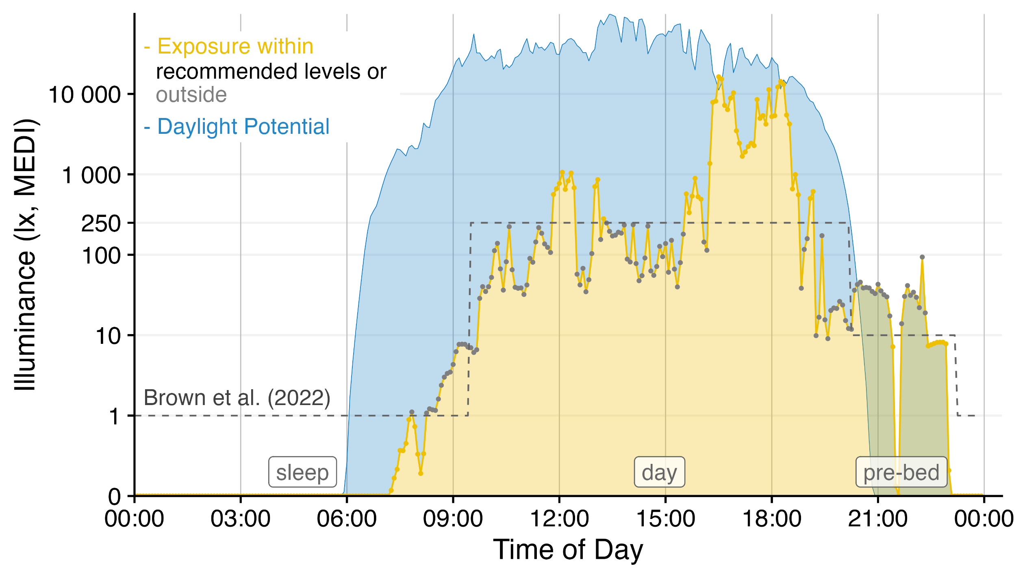
Example light exposure
In typical laboratory studies, light exposure can be fixed and held constant, or modulated parametrically. Such artificial exposures are very much unlike the real-world exposures to the optical environment that people received through the day. As people move in and between spaces (indoors and outdoors) and move their trunks, heads and eyes, the exposure to the optical environment varies significantly (Webler et al. 2019), and is modulated by behaviour (Biller et al. 2024). As a consequence, understanding real-world exposure to link to real-world impacts requires real-world measurements, faciliated by wearable devices.
Starting in the 1980s (Okudaira et al. 1983), technology to measure exposure to the optical environment has been developed and matured, with miniaturized illuminance sensors now (2025) being very common in consumer smartwatches. In research, several device and device types are available, which differ in their functionality, ranging from small pin-like devices measuring light exposure (Mohamed et al. 2021) to head-mounted multi-modal measurement devices capturing almost all relevant aspects of visual experience (Gibaldi et al. 2024). To make informed decisions about the properties of specific devices requires a careful ascertainment of their properties, and the specific trade-offs they entail.

Scope
The scope of this Researcher Guide is to provide a guide to using wearable devices measuring the optical environment. It is a living document and will be updated and versioned.

Workflow
Here, we consider the following workflow in a research project. We have built the researcher guide around each of these subsections.

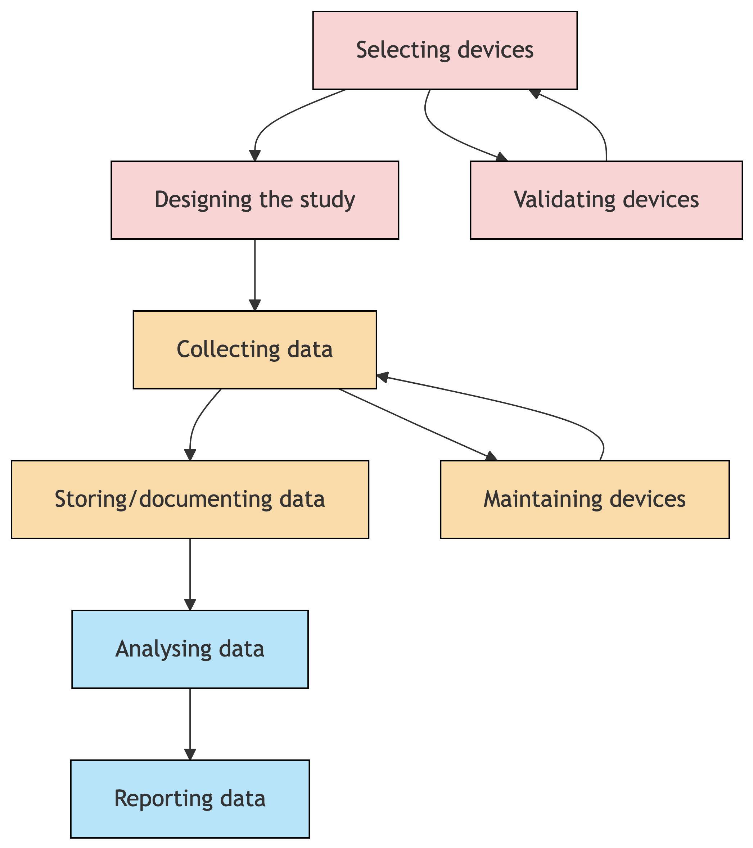

_{Source: Article Notebook}

Researcher Guide

Selecting devices
The first step in any project examining visual experience and light exposure is the choice of a device. This involves understanding the properties of different wearable devices, and several trade-offs. A recent survey found >50 wearable devices differing in form and function (van Duijnhoven et al. 2025; with previous overviews in Hönekopp and Weigelt 2023; Danilenko et al. 2022), indicating the need to make informed choices about selecting specific devices. As there are no standard or reference devices, each device needs to be considered individually. The following sections provide an overview of the technical properties that characterise individual devices and distinguish them.

Measurement capabilities and sensor characteristics
Devices differ in their ability to measure aspects of the visual environment. These differences arise from design decisions, choices of technical components and the specific use cases one that a manufacturer had in mind when making the device. Importantly, the manufacturers usually supplies a data or specification sheet for a product; the verification and validation of these aspects ultimately should also be in the hands of the users of the devices (Spitschan et al. 2022).

Spectral sensitivity functions
The goal of wearable optical radiation and visual experience loggers is to capture aspects of the environment relevant to human physiology and behaviour. As such, for most use cases, light is of interest. Light is defined as optical radiation within the visible region of the spectrum (approx. 380 to 780 nm). The photoreceptors in the human eye are sensitive to different parts of the spectrum, and serve different functions. The cones enable vision of space, colour and motion under daylight conditions, while the rods facilitate rudimentary vision under dim conditions. In addition to these ‘canonical’ photreceptors, the intrinsically photosensitive retinal ganglion cells (ipRGCs) encode aspects of the visual environment, specifically ambient light intensity, through the photopigment melanopsin. The specral sensitivities of the cones, rods and ipRGCs differ, and were standardized by the CIE in 2018 (CIE 2018; Lucas et al. 2014).
The International Standard CIE S 026/E:2018 (CIE 2018) prescribes the spectral sensitivities of the photoreceptors, and thereby also provides a key reference framework for quantifying light exposure with respect to human responses. Notably, the standard proposes the α-opic quantities, where “α” is a placeholder for the cones, rods or ipRGCs.
The CIE S 026 takes into account prereceptoral filtering by the ocular media before light reaches the photoreceptors. Thus, these functions do not merely describe the spectrum emitted by a light source or the raw absorption spectra of the photopigments. Instead, they provide physiologically relevant spectral weighting functions for estimating stimulation at the level of the retinal photoreceptor systems. This is particularly important for short-wavelength light, where transmission through the ocular media, especially the crystalline lens, can strongly influence the amount of light reaching the retina.
A common quantity in light measurements is photopic illuminance [lux]. Photopic illuminance is a quantity that weighs the long- and medium-wavelength sensitive cones and corresponds, roughly, to the psychophysical sensation of brightness. Photopic illuminance is not the same as the light quantity related to the ipRGCs, the melanopic equivalent equivalent daylight illuminance (melanopic EDI), and therefore needs to be measured independently.
Historically, many light therapy studies, for example, reported light exposure primarily as photopic illuminance, for example as “10,000 lx at 30 cm”. While this information is useful, it is not sufficient for interpreting non-visual effects of light. Photopic illuminance describes light weighted by the V(λ) function, which represents visual sensitivity under bright-light conditions, but it does not describe the spectral power distribution of the light source or its potential effect on the different retinal photoreceptor systems. For studies investigating circadian, neuroendocrine, alerting or clinical effects of light, researchers should therefore report additional information, including the spectrum of the light source, the measurement geometry, the participant’s viewing conditions and photoreceptor-weighted quantities.
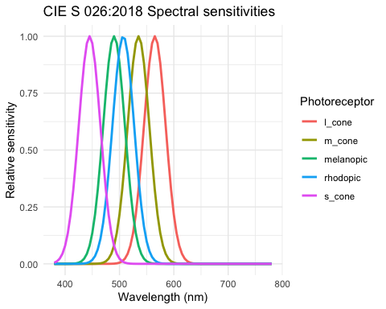
_{Source: Article Notebook}
Wearable light loggers usually measure the quantities directly through a series of discrete sensor channels, or measure the spectrum of light and then calculate the relevant quantities (e.g. photopic illuminance, melanopic equivalent daylight illuminance). Importantly, it is not guaranteed that the actual spectral sensitivity of a channel in a device corresponds to the standardised spectral sensitivity of the photoreceptor. It is therefore worth either calibrating the spectral sensitivity, or prompting the manufacturer to do so.
Standard lux meters should not be assumed to provide biologically meaningful light exposure metrics. Most ordinary lux meters measure only photopic illuminance. They usually do not provide spectral power distribution or α-opic quantities. Similarly, RGB-based sensors should not automatically be interpreted as representing photoreceptor-specific stimulation.

Directional properties
Irradiance and illuminance measurements are usually done in cosine weighted fashion: Light that comes directly from the sensor is weighed more importantly compared to light that comes from the angle. This behaviour follows a cosine function as a function of the incident angle. Each sensor has a specific directional sensitivity that needs to be provided by the manufacturer, or measured and characterised.
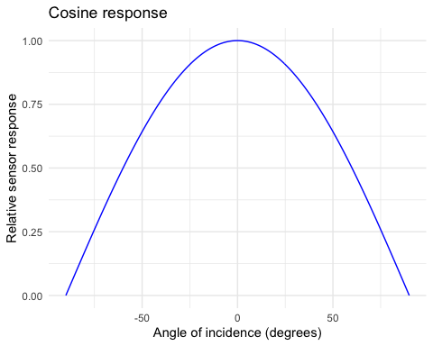
_{Source: Article Notebook}
The directional properties of a wearable light logging devices are important in so far as in the real world, different scenarios have different spatial configurations. As an example, a light logger that only captured light in the central 20° of the visual world would capture limited information, and omit the light coming from, e.g. overhead light sources.

Advanced and additional modalities
While most optical radiation and visual experience loggers measure light at a minimum, advanced devices also include other modalities by design. This includes optical radiation in the ultraviolet (UV) and infrared (IR) part of the spectrum, spatial information, distance information, and movement tracking.

UV and IR measurements
UV and IR measurements are interesting as they can enrich and augment the data set in different ways. Through the inclusion of optical radiation in this wavelength range, it may be possible to determine whether an individual spent time indoors or outdoors (as the UV radiation entering indoor spaces through usual window glazing is negligeable). Co-measuring UV and IR may also facilitate future-proofing measurements of hitherto unknown physiological responses to this part of the spectrum. As with the spectral sensitivity of wearable light loggers, it is key to ensure that the UV and IR responses measured by a wearable device are metrologically sound.

Spatially resolved measurements
The visual world around us is rich in its spatial and colourful detail, and we do not live in a Lambertian integrating sphere with homogenous illumination. In turn, the retinal image and the ensuing information available to the visual and non-visual pathways of the brain is spatially structured. A measurement of visual experience therefore could also include spatially resolved measurements such as those from a camera. Cameras, of course, also need to be characterised and calibrated, and importantly, the dynamic range of the visual environment needs to be included in considerations.

Distance information
As with spatial information, the world is three-dimensional, and as we shift our gaze from different objects or parts of the visual scene, our accommodative state changes. In previous studies, it has been observed that near and far work are determinants of myopia onset and progression, and therefore some devices include depth information, which are then aggregated.

Movement tracking
Stemming originally from research into circadian rhythms and sleep-wake cycles, some light loggers have integrated accelerometers and inertial measurement units (IMUs). These can be particularly relevant to determine various aspects of wearing behaviour. As an example, when a device is placed on a surface and not worn, this will present as non-movement. The exact ability to determine wear state from this sensor modality depends highly on the sensor sensitivity.

Manufacturer calibration
Devices designed to measure light exposure and other aspects of the optical environment should come with information from the manufacturer on the calibration procedures used to ensure high-quality measurements. Sometimes, information for one exemplary device is included in a data or specification sheet. It is worth consulting with the manufacturer on any calibrations they perform and specifically clarifying whether device-level information is available.
The manufacturer may also recommend recalibrations of the devices at regular intervals. It is worth understanding the rationale for any such recalibrations (in particular if they come at a cost), as well as any recalibrations that researchers themselves can do.

Size, form, and design
The size, form and design of a wearable light logger are particularly important for the specific contexts in which it will be used. Devices that are too heavy, bulky or impractically shaped will likely not be of particular use in field studies on light exposure. The most common form factors are devices that are wrist-worn, lanyard-worn, attached with a clip, or attached to spectacle frames.
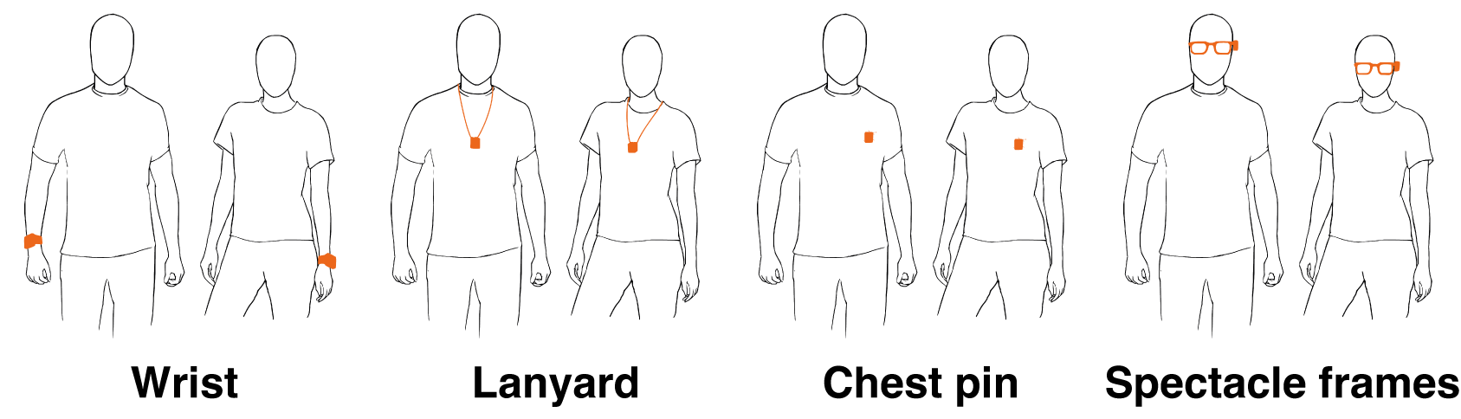
Form factors and wearing locations
Different form factors are susceptible to different types of occlusions, so beyond participant comfort, a device’s dimensions and intended use case are also directly linked to data reliability. As of 2025, no specific device can be used all the time in all contexts and provide reliable information.
Common problems include:
- Wrist-worn devices are susceptible to being occluded by sleeves, particularly in settings or cold weather seasons.
- Lanyard-worn and clip-worn devices are susceptible to being occluded by jackets or other outer garments.
- Devices attached to spectacle frames are impractical for long-term use in the real world.
Previous studies (Okudaira et al. 1983; Jardim et al. 2011; Aarts et al. 2017; Bhandari et al. 2021; Wen et al. 2023; Mohammadian et al. 2024) have shown that while wrist-worn measurements are correlated with chest or head measurements, they are not related by a simple relationship. This follows from the fact that the wrist and eyes point in different directions in different planes.

Battery capacity and charging
Devices differ in their battery capacity, which is a determinant factor for the way that the devices can be used in the real world. The battery capacity is typically known by the manufacturer, but will depend on a number of factors, including the sampling intervals. Additionally, the way that a device is charged is of important for the specific use. Wearables can usually be charge through one of the following methods: A direct cable connection, an insertable battery, or a charging dock. As with any electronic device, there may also be varying capacities over the lifetime of the wearable, which needs to be considered. Some wearable devices also feature a ‘power down’ function which puts the device into stand-by mode, thereby avoiding deep discharging.

Data storage
Data storage capacity is related to the battery capacity: For high-frequency sampling, the storage will run full, and the data would have to be downloaded from the device. Additionally, the sampling frequency itself may also reduce the battery capacity due to repeated operations. The behaviour of devices with respect to data storage when failure of any sort occurs is core. For example, when a device runs full, it could respond either by stopping any further data intake, or by starting the recording from the beginning. Similarly, when a device loses charge/the battery is empty, the data could be lost. Understanding the exact contingencies of these failure modes can mitigate data loss.
Where the data are stored is important, not only for practical considerations, but also for privacy concerns. Some devices allow for or have mandatory synchronization through a Bluetooth-enabled connection with a smartphone. This needs to be considered in the context of research ethics.

Raw data format and ease of transfer
To date, there is no commonly accepted data standard for data from wearable light exposure and visual experience loggers. As a consequence, manufacturers typically develop their own format, which are sometimes not well-documented. The consequence of this is that any researchers or research users working with these types of data will spend a considerable amount of time to write loading functions to wrangle the data. Within the graphical user interface (GUI) that is attached to a device, it is usually possible to export the data into a range of formats. The transfer speed for the data can be important in environments or use cases where fast analysis of data is important.

Wear/non-wear and occlusion detection
Some devices may be able to detect whether they are being worn, either online, or after analysis using the manufacturer-provided software. For wrist-worn devices, this could be implemented through a capacitance sensor, or temperature sensor, or in conjunction with data from the IMU. Additionally, devices might be able to detect it is occluded.
When wear detection is not available from the device-inherent capabilities, it is recommended that researchers investigate concise methods for estimating wear/non-wear state, e.g. through additional questionnaires or using a data-driven approach.

Interaction with the device
Some devices contain event buttons, which, when pressed, insert time-stamped information into the data log. This functionality can be very useful for determining wear/non-wear state and specific events taking place for the participant. It is worth noting that as they are a user interaction, participants are not guaranteed to do it consistently. Some devices also include a status LED that indicates the device state. It is important to inform the participant of the meaning of each of the possible states, and intervene if necessary.

Documentation
The quality of manufacturer documentation can vary significantly, and it is important to consult the manufacturer on its completeness. This includes, at a minimum:
- Sensor capabilities and calibration
  - Full description of sensor capabilities, including calibration information
  - Traceability of calibration (e.g., to national standards)
  - Documentation of validation procedures (e.g., lab vs. field performance)
  - Instructions for user-performed recalibration and required tools
  - Expected lifespan and stability of sensor performance over time (e.g., sensor drift)
- Environmental and operational conditions
  - Environmental operating conditions (e.g., temperature, humidity, altitude)
  - Known hardware/software limitations (e.g., maximum sampling rate, data loss risks)
  - Information on error states or error modes that may be encountered during data collection
- Device behaviour and data processing
  - Description of any onboard data processing, compression, or classification algorithms
  - Details on how timestamps are generated and synchronized (e.g., internal clock behavior, drift)
  - Firmware versioning and changelog history, especially for devices under active development
- Data structure and output
  - Full description of all data available from the device
  - Clear explanation of file formats (CSV, JSON, binary, proprietary, etc.)
- Usage and deployment guidance
  - Recommended positioning and usage instructions to ensure data validity
- Regulatory and support information
  - Any relevant compliance certifications (e.g., CE, FCC, ISO)
  - Contact information for technical support

Software ecosystem
Light loggers as hardware are bundled with software that enable their use. Software functionality usually includes:
- Setting up the device for logging
- Choosing parameters for logging (including intervals, participant ID)
- Live read-out of the data
- Information about device and battery status
- Data read-out from the device
- Data saving into proprietary and/or open text formats
- Manual data annotation and tagging of data
- Data selection and masking
- Data analysis
- Export from analysis results
A key consideration is the ease of use of these companion software packages, and their maturity. If simple errors in use can lead to data loss, that is undesirable. A further consideration is whether the software is available across multiple operating systems, such as Windows, OS X and Linux.
As the software packages supplied by the manufacturers are typically not released as open-source packages, the underlying functions, in particular those pertaining to data analysis, are not transparent. It is therefore important to always note down the software version if a given analysis is considered to be archival. Furthermore, it is recommended to keep an archive of the software installation packages or ZIPs, so that analyses can be re-performed with exactly the same analysis routines.
Generally, it is recommended that the analysis of light logger data is not performed with proprietary software, but with open-source alternatives (Zauner et al. 2025).

Validating devices
Once devices have been acquired, a key step prior to deployment in a scientific study is their validation (Spitschan et al. 2022). Validation ensures that the devices are performing according to specifications, measuring reliably, and delivering data that can be meaningfully interpreted .

Standardized validation procedures
Standardized validation procedures should be followed to evaluate the device’s accuracy, precision, and stability. Ideally, these procedures should be based on accepted metrological principles, using consistent methods and reference standards. The validation protocol should be clearly documented, replicable, and, if possible, aligned with relevant national or international standards.

Cross-comparison with reference measurements
Light loggers should be tested against calibrated reference instruments or standard light sources to verify their measurement accuracy. These reference conditions could include traceable spectroradiometers or other laboratory-grade equipment. By exposing the devices to known light spectra and intensities, any systematic measurement errors can be identified and, if necessary, corrected or documented.

Inter-device variability assessment
A simple and cost-effective method to characterize variability between devices is to place them side by side under an overcast sky (Markvart et al. 2015). Overcast conditions provide a diffuse, relatively uniform light environment, which allows the identification of measurement differences between individual devices. Substantial inter-device variability should be addressed through recalibration or adjustment before deployment.

Intra-device reliability assessment
In addition to comparing different devices, it is important to assess the repeatability of each device over time. This involves repeated measurements under stable light conditions to verify that the device produces consistent results. Intra-device reliability checks can reveal drift or other issues that could compromise data integrity in longitudinal studies.

Ease of calibration
Finally, devices should support straightforward recalibration procedures if required. Documentation from the manufacturer should describe how to recalibrate individual devices and what equipment or conditions are necessary to do so. This ensures that any detected deviations can be corrected efficiently, maintaining long-term accuracy of the measurements.

Designing the protocol
Once devices are in hand, a key consideration is the design of a protocol for collecting optical radiation exposure and visual experience data. In the literature, research groups usually follow their own custom protocols, but recently, a standard protocol for one-week measurements has been published (Guidolin et al. 2024). The design and choice of the protocol should include the following considerations.

Clarity on the research question and pre-registration
The research question, hypotheses, procedures, and methods need to be aligned in a tight way. In measuring visual experience and light exposure, this alignment becomes particularly important due to the changing and context-dependent nature of light. Measuring a single day of light exposure to draw conclusions about seasonal effects is methodologically flawed, neglecting intra- and inter-day fluctuations in weather, behaviour and exposures. For more robust measurements, typically, longer measurements are needed and include data from weekdays and weekends. Additionally, different work schedules (Daugaard et al. 2019; Price et al. 2022) and seasons at specific latitudes (Cole et al. 1995; Graw et al. 1999; Thorne et al. 2009; Ulaganathan et al. 2019; Dunster et al. 2023) can lead to significant differences in exposure. At the same time, coverage needs to be balanced with participant burden.
It is important to clearly formulate the research question, hypotheses, procedures, and methods before the data collection. An additional step is to write a pre-registration detailing the protocol and analysis plans, thereby ensuring intellectual clarity on the purpose and procedure of measurements. It is worth noting that this effort in any event has to be done, namely at the point of data analysis, and so firming up a pre-registration in advance simply frontloads this effort.

Participant burden vs. fidelity
For any research, participant burden is a key consideration. The desired biological quantity of interest is the retinal irradiance, whih cannot be measured, as only the retina can ‘measure’ it. The next best geometrical consideration is the near-corneal plane, which places a burden on the participant under real-world conditions and may even modify their behaviour (e.g., selecting out of social situations). A core question therefore is to what extent near-corneal measurements are necessary for the research question at hand. A pilot study can bring clarity on the uncertainty introduce by the use of, e.g., wrist-mounted vs. chest-mounted light loggers. For some research questions, including those where distance information is important, some wearing locations are nonsensical. For example, a wrist-worn sensor will not be able to measure viewing distance.
If a study aims to describe broad differences in daily light exposure, a less intrusive wearable device may be sufficient. However, if the aim is to detect small differences in exposure or to relate subtle variations in light exposure to physiological, behavioural or clinical outcomes, measurements should be as accurate as possible and taken as close to the eye as feasible. Eye-level or near-corneal measurements are therefore preferable in studies where precise estimation of retinal or corneal light exposure is required.
More remote placements, such as wrist-worn sensors, can be useful because they are comfortable and easy to wear, but they may not accurately represent the light reaching the eye. Wrist-worn devices can be affected by sleeves, posture, arm movement, desk position and the orientation of the body relative to the light source. These limitations should be considered when selecting a device, interpreting the data and reporting study results.

Measurement capabilities matched to use case
Similar to how the research question, hypotheses, procedures, and methods need to be tightly aligned, the measurement capabilities of the wearable devices needs to be matched to the measurement context (indoors, outdoors). For example, a wearable devices might not be suited to measure light exposure below 10 lx. If the goal is to measure dynamics in nocturnal light exposure, the device would not produce robust information. Similarly, distance sensors operate differently in different conditions (depending on the sensor technology).

Measurement length and sampling intervals
The measurement length, i.e., how long the protocol should last, and the sampling interval, i.e., how often measurements are taken, is partially determined by the battery and storage capacity of the device, and highly contingent on the research question. There is currently no knowledge on interdaily variability, and future research should characterise this carefully. Regarding sampling resolution, if the goal is to measure or approximate the retinal stimulus at high temporal resolution, then of course, 1-minute measurement sampling is not sufficient.

Inclusion of other data
Depending on the research question, additional data can be collected alongside the wearable device. This includes, for example, daily logs of mood, sleep and other aspects (Guidolin et al. 2024), and can be implemented using smartphone apps.

Participant reactivity and inadvertant behavioral modification
Different form factors and associated wearing locations could be susceptible to different ways that participants behave, a phenomenon similar to reactivity, in measurement leads to changes in the people being measured (French and Sutton 2010). For example, wearing a device attached to spectacle frames may not be very suitable for public environments, workplace, or specific recreational contexts. Consequently, participants may change their behaviour in response to the visibility, intrusiveness, or comfort of the device, leading to reactivity—i.e., modifications in naturalistic behaviour due to awareness of being monitored.
Such behavioural adaptations can include reduced social interaction, altered outdoor time, or avoidance of certain activities (e.g., sports, commuting via bicycle). These changes may introduce systematic biases in the collected data, particularly if the device form factor is not well tolerated across all settings or participants.
To probe for such biases, it may be advisable to include a questionnaire or single open-ended question after data collection asking whether they perceived any changes in their behaviour due to wearing the devices.

Collecting data
With the protocol final and registered, data collection commences. There are several aspects that need to be considered i nthe data collection process..

Briefing of participants
Participants should receive clear instructions on
- wearing the device, including suitable contexts and situations (related to the durability and IP rating of the device)
- handling the device when they take it off, including logging it
- charging the device regularly (if necessary)
To ensure that participants understand the instructions clearly, it is recommended that a short comprehension check be included after the briefing. This can be done by asking participants to repeat key instructions in their own words or having participants demonstrate how to wear, remove, and charge the device correctly. A printed or digital instruction sheet can be supplied for reference.
Visual instructions, short checklists and comprehension checks can reduce misuse. In clinical or applied studies, training should also include physicians, study nurses or other staff involved in device setup, participant instruction, troubleshooting and data retrieval. Standard operating procedures can help reduce operator errors and improve consistency across participants and study sites.
Additionally, if there are any known problems with the devices (such as common mechanical failures), these should be communicated to the participants alongside mitigation strategies.

Recurrent compliance checks
Throughout a measurement protocol, it could be helpful to implement regular checks to remind participants of key steps involved in the measurement, including charging. In case there is online access to the data, such as through clouds, it is possible to monitor light exposure instantaneously and remotely. This can bring several benefits, including the possibility of corrective action should a participant not comply to the study procedures.
Feedback mechanisms can improve data quality, but different types of feedback should be distinguished. Operational feedback, such as recording status, battery level, memory status or incorrect positioning, can help prevent data loss and improve compliance. In contrast, real-time feedback about light exposure itself, such as current illuminance, melanopic EDI or progress toward a daily light target, may alter participant behaviour. In observational studies, such exposure feedback should therefore be avoided, hidden from participants or explicitly justified in the study protocol.
Compliance related to usability can be probed and measured using specific questionnaires (Balajadia et al. 2023; Stefani et al. 2024).
Challenge | Potential consequence | Possible mitigation
Wrist-worn sensor covered by sleeves | Underestimation of light exposure | Provide clear wearing instructions. Consider eye-level placement where feasible.
Spectacle-mounted sensor is uncomfortable or visible | Reduced compliance or altered behaviour | Use small, lightweight devices. Assess acceptability during piloting. Brief participants on how to respond to reactions while wearing the device.
Device removed during work, sport or social activities | Systematic missing data | Use participant diaries, reminders or non-wear detection.
Unclear recording or battery status | Data loss | Provide operational feedback and regular device checks.
Real-time exposure feedback visible to participant | Behavioural reactivity | Hide exposure feedback or justify its use in the protocol.
Variable background light during intervention | Misinterpretation of intervention dose | Measure and report background light separately.
Missing or irregular timestamps | Biased duration or timing metrics | Define preprocessing rules for gaps, time zones and daylight-saving changes.
Outliers or implausible values | Distorted exposure metrics | Predefine exclusion criteria and outlier handling.

Device settings
A time-stamped and versioned standard operating procedure (SOP) document can help ensure the reproducibility of device settings when there are multiple operators setting up devices for studies. A key component is to ensure the same parameters, but also other configuration flags being consistently used for logging.
Logging configuration, time sync, DST handling.

Storing and documenting data
As data is collected and exported to file, it is important to take care that the data are stored safely and in a principled fashion.

Documentation principles
Study data is not self-explanatory. It is necessary to document:
- the location of stored data and their relative paths within the storage
- contents of files
- metadata and/or codebooks
- file and path naming conventions
- references to the protocol
A minimum approach includes the use of a README file that describes the data collected (Zielinski et al. 2023). A more complete approach is specified by the TIER protocol. In general, the goal of data documentation is that a third party without further insights can work with the data and all relevant information is contained within the documentation. A lean way to collect all information - data and metadata - in one place is through a Github repository. For most needs, these are free, can be automatically archived to Zenodo and assigned a DOI (with new versions every time data are updated).

Consistent file format
Individual files should be non-proprietary as well as human- and machine-readable. This is possible in almost all cases, with few exceptions for specific measurement devices. Ideally, data comes in a text-based, rectangular format, such as CSV (comma separated values). Rectangular means that each line of the file contains the same number of separators. CSV has the benefit that is is universally understood and can be interpreted even by technical novices, can be easily shared, and imported by software. Beware, however, that there are many dialects of CSV, often dependent on the locale of the researcher. Hierarchical data (e.g., metadata) often comes in a nested file format, such as JSON or XML. Effort should be undertaken to keep file formats as consistent as possible across different data sources and they need to be consistent within data sources (which can be a problem, e.g., after a device update that changes the output). Dates and times within files need to be handled with care and consistently as well. While deviations can be manually adjusted during data import, it is tedious, unnecessary, and error-prone work.

Auxiliary data
Wearable data on its own – even if it is high fidelity from a measurement perspective – is often lacking essential information beyond light but about the environment and the participant, e.g., non-wear time, physical activity, or climate-based information. Auxiliary data is defined as time-dependent (i.e. time-stamped) data relevant to the analysis of light logging data but not collected through wearable light logger devices. Data sources include but are not limited to diaries, companion apps, and concurrent measurements.
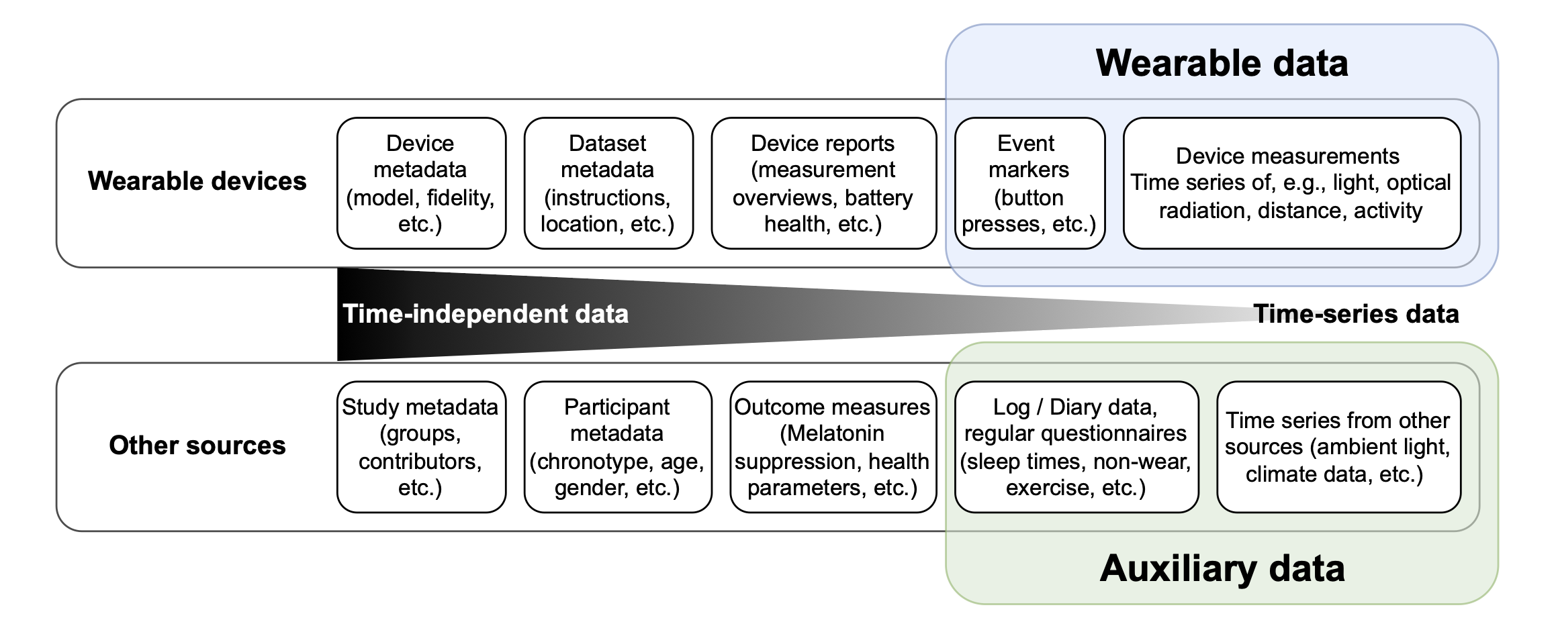

Standard directory structure
There are many ways to structure a data directory. Most importantly, it needs to be consistent, speaking, and well described. It is suggested to differentiate between data containing the whole group, or individuals. Further, continuous data (i.e. time-stamped data), can be contained in a sub-folder. Here is an exemplary file structure constructed from a real example.
Project/
ethics/
data/
raw/
group/
demographics/
discharge/
screening/
...
individual/
$ParticipantID/
chronotype/
continuous/
health_monitor/
sleepdiary/
wearlog/
wellbeingdiary/
...
discharge/
clinical/
OCT/
...
screening/
research_logs/
anomalies/
materials/
inperson_screening/
online_screening/
questionnaires/
output/
figures/
tables/
explorative/
participant_docs/
scripts/

Documentation of anomalies
It is good practice to instruct participants to report any issues occuring in the data collection, either through a specially provided log, or through ad-hoc emailing. Some wearable devices, for example, have a status LED, which the participants can be instructed to monitor and note down any changes. These anomalies should be collected in one file.
Similarly, necessary data manipulations need to be logged, e.g., when manually changing a datetime-format that was entered inconsistently by the participant or experimenter. The log can take the form of a simple CSV file. For example:
Date | Experimenter | File | Manipulation description | Rationale | Affected columns | Affected rows
2025-06-01 | John Doe | individual/  discharge/  data.csv | changed Datetime to standard format | Datetimes were entered inconsistently | 3 | all

Metadata
Metadata is data about data. Domain-specific metadata ensures data is annotated in a consistent way across projects and research groups. For wearable light logger a metadata descriptor was developed that contains study-level, participant-level, device-level, and dataset-level information (Spitschan et al. 2024). Implementations of the descriptor are in active development and will facilitate the creation and application of metadata in analyses.
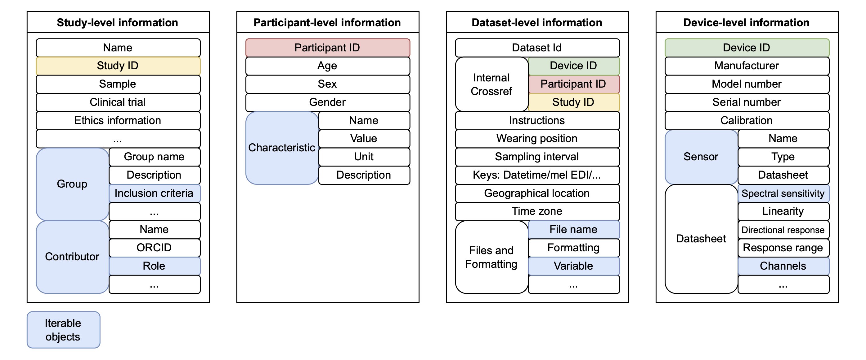

Privacy aspects
For any biomedical data collection, privacy principles relevant to the local jurisdictions need to be upheld (e.g. HIPAA, GDPR, …). Careful consideration needs to be placed on which aspects of data contain personally identifiable information. It is not clear whether visual experience and light exposure, or time courses thereof, constitute personally identifiable information. More research needs to be done to understand the identifiability of people from their visual experience data.

Locale consistency
Locale in computer software is a set of parameters that define how information is displayed and stored. The parameters cover language, region, and individual preferences. Locales are important because software, especially gui-heavy software like Microsoft Excel, interpret data based on a user’s locale: what is the decimal marker, how are columns separated in text files, what are datetime conventions, etc. More problematic, however, is that some software, even research-focused companion software to wearable devices, also save files with the settings defined by a users locale. This leads to a myriad of dialects in theoretically well defined text-based files, like CSV (comma separated values), thus making the FAIR exchange of data between researchers more burdensome. The most common CSV deviation, typical, e.g., for some European countries, uses a semicolon ‘;’ as a column divider instead of the eponymous comma ‘,’. Very likely, this is because the comma in this dialect is used as a decimal mark instead of the full stop ‘.’.
We do not necessarily recommend for a researcher to change their locale settings on research machines (although that would help). It is, however, important that researchers are aware of the nature and influence of the locale, and we recommend the following:
- Avoid wearable devices that store data based on a user’s locale without explicit prompt
- Make certain that whatever import routine is used for wearable data matches the raw files, and that there are no differences between the files. If this cannot be avoided, import files separately depending on the locale.
- Always check the correct interpretation of text-based data in the software of choice, especially regarding decimals, column separation, and datetimes
- The analysis software LightLogR provides import routines that are based on typical settings for wearable devices. This means that by default, LightLogR users do not have to take care about locale settings, exept when device data is stored with deviant settings. LightLogR’s documentation page for import will mention known deviations in file formats, and new ones can be reported.
- Never overwrite a text-based file with software that changes a files’ locale conventions without notice. Microsoft Excel is a common offender, as it seems to interpret foreign locales correctly, but switches to the user’s locale upon saving (if the user does not actively choose a different format). At best, this potentially fragments a study’s data base, if some files are opened and resaved (e.g., when removing a header or correct some spelling), while others are not. At worst, it will misinterpret a text-string, e.g. interpreting a value of ‘2.04’ as ‘2 April’, which will be stored in the text file as a date, e.g. as ‘02-04-2025’. This type of data corruption can be easily missed at first, only to be noticed during analysis, sometimes with no mode of recovery.

Recommended conventions for datetime
Timestamps for wearable data need to contain datetime information in a consistent, unambiguous, and machine-readable format. Because there are many time zones around the world, datetimes are a complex topic and need to be handled with care. A time zone should not be confused with the offset from Coordinated Universal Time (UTC), although for any given moment, a time zone can be related to a specific offset. Time zones also include information about whether or not there is daylight savings, and if the offset changes (e.g., due to policy). This means that local time + time zone contains more information than local time + offset. Date, time, and datetimes are standardized in ISO 8601, and it is recommended that datetimes follow its conventions. A comprehensive description of the structure can be found here.
At the time of this writing (2025), most devices do not store the offset to UTC as part of the timestamp, which regularly results in ambiguity following switches to and from daylight savings. This ambiguity can be avoided if:
- datetimes follow the conventions in iso 8601
- datetimes are stored in UTC format with a known time zone, taken from the Olson/IANA databases.

Maintaining devices
Throughout data collection, devices need to be maintained to ensure that data remains reliable and the devices remain usable. This is particular important in the field, where we cannot control directly what happens with devices and how they are treated.

Inspection
Upon receipt of a device from a participant, it is recommended to ensure that there are no obvious signs of damage, excessive dirt, moisture intrusion, or missing parts. Visually inspect the device housing, buttons, charging port, and any attached sensors or straps. If available, perform a quick functional check (e.g., power on the device, confirm data presence, test charging). Document any issues immediately and, if needed, flag the device for repair or cleaning before redeployment. It is recommended that this is kept in an inventory. Should there be major concerns, it is recommended to contact the manufacturer with a detailed report.

Firmware updates
Firmware updates are an important part of maintaining light loggers, as they may include bug fixes, feature enhancements, or security patches. However, it is essential to ask the manufacturer clearly what changes each firmware update introduces. For example, if a firmware update alters calibration factors or sensor processing algorithms, data collected before and after the update on the same device may no longer be directly comparable. Any firmware changes should therefore be thoroughly documented, with version numbers tracked alongside the data, and ideally tested on a small subset of devices before widespread deployment. Most light loggers include firmware version information in the supplied metadata of their data files, and this should be recorded systematically to ensure clear traceability. Maintaining consistent firmware across all devices helps preserve data quality and comparability.

Cleaning
Devices and attachment pieces such as lanyards and wristbands should be cleaned between different participants. The manufacturer should provide cleaning guidelines to ensure compatibility with the specific device materials. In the simplest case, textile lanyards can be washed, while wristbands can be carefully disinfected using appropriate cleaning agents. For replaceable components, such as lanyards, it may also be advisable to replace them periodically to maintain hygiene and device integrity.

Monitoring and correcting device drift
Over time, sensors in light loggers may experience drift, leading to systematic errors in recorded measurements. To monitor for drift, it is recommended to perform periodic reference checks against a calibrated standard light source or reference device. These checks should be scheduled at regular intervals, for example before and after each data collection cycle, or after prolonged storage.
If drift is detected, corrective action may include recalibration, manufacturer servicing, or applying a correction factor to the data — but only if such corrections are well-documented and scientifically justified. It is also important to record any detected drift, the correction procedures used, and the relevant dates, to ensure transparency and maintain data integrity across the study.

Analysing data
Following data collection, data are analysed. The following sections lay out theoretical and practical considerations for analysis

Data cleaning and preprocessing
Depending on the device, participant compliance, and other factors, it is commonly necessary to invalidate some of the measurements recorded by a device. Reasons include aspects such as:
- out of range measurements (beyond sensor saturation and at the noise level)
- non-wear
- device occlusion
- recordings outside relevant time frames
Often, these invalid data are randomly distributed, but due to non-wear at times of day at which specific activities occur (e.g., showering, contact sports, swimming, …), light exposure data may be missing systematically.
The following sanity checks are recommended:
- Visualisation of raw time series for the available sensors
- Visualisation of histograms to identify distributions of data and outliers

Non-wear
Participants likely have to remove their wearable devices at some point of a data collection. These times may or may not reflect the visual environment of the participants, but they need to be identified in any case. Ideally the protocol specifies certain actions when a device is removed and put on again. E.g., an entry in a companion app, putting the device in a black bag, or setting it on the night stand, face up, so that it can record the ambient light level of the sleep environment. Occlusion of the device is also to be considered non-wear. These are some typical ways how to identify non-wear times:
- Use external, time-stamped information, such as from a companion app that logs non-wear. These can be easily added to the time series and invalidated (see Section 4.7.3). The downside is that participants regularly forget to log these events which requires additional oversight by the experimenter or visual checks of the data.
- Order participants to put their devices in a black bag on non-wear. Then filter for zero lux values. The downside is that this only is sensible during daytime (as zero lux is common during nighttimes).
- Analyse the variance/standard deviation of the sensor reading or an actimetry measurement (if available) in a rolling window, e.g. 2 minutes when sampling every 10 seconds. Times of low variance often indicate non-wear, but can be show false positives if a person is not moving, the ambient environment would still be represented (night stand), and zero-lux readings. False negatives can occur if a device is not worn according to protocol, but still shows high variance, e.g. activity with occlusion, or a moving environment, such as a train. If the measurement interval is too large, it will also not be reliable.
- Some sensors have automated wear detection and usually show in a column, whether the device was worn or not. It is easy to invalidate those measurements, but may overwrite helpful readings of the ambient environment (night stand).
Every method to capture non-wear has up and downsides. (Guidolin et al. 2025) provides a comparison of different methods. In general it is recommended to brief participants on the importance of strict wear, following non-wear procedures laid out in the protocol, and to collect data over sufficiently long periods so that the likelihood of distorted results due to unidentified non-wear times is reduced.

Implicit and explicit missing data
An analysis time series should contain an uninterrupted sequence of equally spaced intervals from start to finish. Some cases fall outside:
- NA values in the data. These are denoted as explicit missing data or explicit gaps, because a time stamp is present, indicating an observation, but no valid reading is available. Explicit gaps are often unavoidable (if no aggregation is performed) and are often OK, as long as the ratio of missing to available data is good. There is no fixed value for this ratio and it heavily depends on whether and what metric is calculated from it. Bootstrap analysis of select circadian metrics have shown that for long data collection periods of one month (and random distribution of missing data), no significant change in mean daily metric values is present on the individual level, even when 25% of data are missing (Biller et al. 2025). For shorter recording periods this will be less.
- Gaps in the data, i.e., missing observations in the regular time series. These are denoted as implicit missing data or implicit gaps. Gaps in the data are problematic when calculated durations are based on time stamps, as they include the missing period. Explicit gaps need to be explicitly handled and are therefore always to be preferred.
- Observations at time points outside the regular time series are denoted as irregular data. Examples are slight fluctuations in the recording interval and interrupted recordings (e.g., recording 2 hours in the morning, stopping recording, and restarting in the afternoon. The chance that the second recording will fall exactly on the regular time series beginning to end is negligible). Irregular data are problematic when calculated durations are based on the number of observations times the regular interval. Irregular data can be handled either by aggregating data to a coarser interval (see next section) or - if deviations are small - by rounding the timestamp to the regular interval.
To illustrate these types of data, let us consider a week of data measured in the environment and from a participant.

Implicit gaps
If we remove all data below 1000 lx, we create implicit gaps, because the observations are dropped, as shown here (full time series is shown in grey):
sample.data.environment |>
gg_days(col = "grey") +
geom_line(data = \(x) filter(x, MEDI >= 1000))
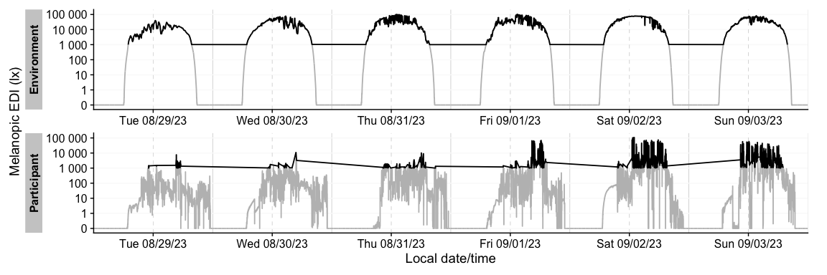
_{Source: Article Notebook}

Explicit gaps
If we set all data above 1000 lx to NA, we create explicit gaps, because the observations are not dropped, as shown here (full time series is shown in grey):
sample.data.environment |>
gg_days(col = "grey") +
geom_line(data = \(x) mutate(x, MEDI = ifelse(MEDI >=1000, MEDI, NA)))
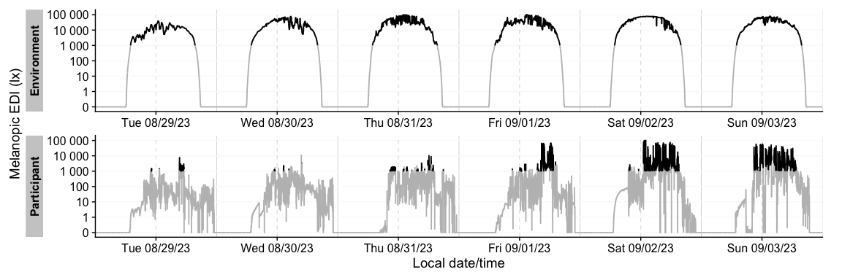
_{Source: Article Notebook}

Irregular data
We can simulate irregular data by offsetting measurements on the second day by 5 seconds.
irregular_data <- sample.data.environment |> add_Date_col(as.wday = TRUE) |> mutate(Datetime = ifelse(Date == "Wed", Datetime +5, Datetime) |> as.POSIXct(tz = "Europe/Berlin"))
irregular_data |>
gg_gaps(show.irregulars = TRUE, include.implicit.gaps = FALSE)
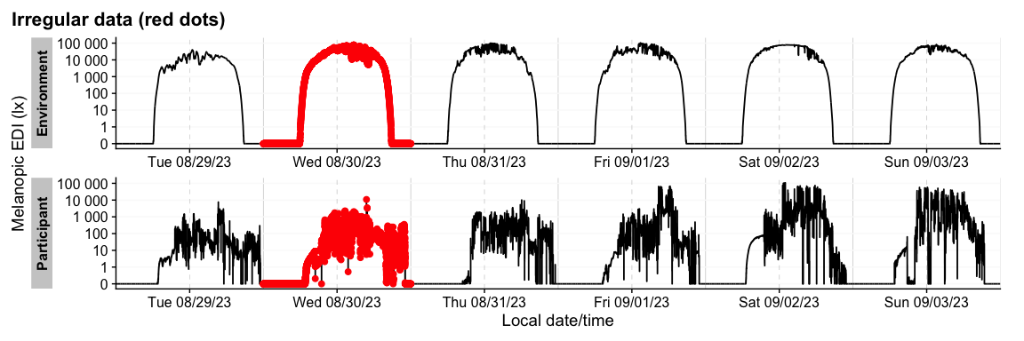
_{Source: Article Notebook}

Implicit gaps
Table 1: Summary of available and missing data
Variable: melanopic EDI
 | Data |  |  |  |  |  |  | Missing
 | Regular |  |  | Irregular | Range |  | Interval | Gaps |  |  |  |  |  | Implicit |  |  | Explicit
 | Time | % | n¹ | n^{1,2} | Time | n¹ | Time | N | ø | øn¹ | Time | % | n¹ | Time | % | n¹ | Time | % | n¹
Overall | 3d 21h 35m | 32.5%³ | 15,038 | 0 | 1w 5d | 69,120 | 30; 10 | 503 | 9h 43m 39s | 1,229 | 1w 1d 2h 25m | 67.5%³ | 54,082 | 1w 1d 2h 25m | 67.5%³ | 54,082 | 0s | 0.0%³ | 0
Environment
 | 3d 5h 43m | 54.0% | 9,326 | 0 | 6d | 17,280 | 30s | 7 | 9h 28m 9s | 1,136 | 2d 18h 17m | 46.0% | 7,954 | 2d 18h 17m | 46.0% | 7,954 | 0s | 0.0% | 0
Participant
 | 15h 52m | 11.0% | 5,712 | 0 | 6d | 51,840 | 10s | 496 | 15m 30s | 93 | 5d 8h 8m | 89.0% | 46,128 | 5d 8h 8m | 89.0% | 46,128 | 0s | 0.0% | 0
¹Number of (missing or actual) observations
²If n > 0: it is possible that the other summary statistics are affected, as they are calculated based on the most prominent interval.
³Based on times, not necessarily number of observations
_{Source: Article Notebook}
 Note
Note that the implicit line is connected, as the plot considers the time series as a single (uninterrupted) series.

Explicit gaps
Table 1: Summary of available and missing data
Variable: melanopic EDI
 | Data |  |  |  |  |  |  | Missing
 | Regular |  |  | Irregular | Range |  | Interval | Gaps |  |  |  |  |  | Implicit |  |  | Explicit
 | Time | % | n¹ | n^{1,2} | Time | n¹ | Time | N | ø | øn¹ | Time | % | n¹ | Time | % | n¹ | Time | % | n¹
Overall | 3d 21h 35m | 32.5%³ | 15,038 | 0 | 1w 5d | 69,120 | 30; 10 | 503 | 9h 43m 39s | 1,229 | 1w 1d 2h 25m | 67.5%³ | 54,082 | 0s | 0.0%³ | 0 | 1w 1d 2h 25m | 67.5%³ | 54,082
Environment
 | 3d 5h 43m | 54.0% | 9,326 | 0 | 6d | 17,280 | 30s | 7 | 9h 28m 9s | 1,136 | 2d 18h 17m | 46.0% | 7,954 | 0s | 0.0% | 0 | 2d 18h 17m | 46.0% | 7,954
Participant
 | 15h 52m | 11.0% | 5,712 | 0 | 6d | 51,840 | 10s | 496 | 15m 30s | 93 | 5d 8h 8m | 89.0% | 46,128 | 0s | 0.0% | 0 | 5d 8h 8m | 89.0% | 46,128
¹Number of (missing or actual) observations
²If n > 0: it is possible that the other summary statistics are affected, as they are calculated based on the most prominent interval.
³Based on times, not necessarily number of observations
_{Source: Article Notebook}

Irregular data
Table 1: Summary of available and missing data
Variable: melanopic EDI
 | Data |  |  |  |  |  |  | Missing
 | Regular |  |  | Irregular | Range |  | Interval | Gaps
 | Time | % | n¹ | n^{1,2} | Time | n¹ | Time | N | ø | øn¹ | Time | % | n¹
Overall | 1w 5d | 100.0%³ | 69,120 | 11,520 | 1w 5d | 69,120 | 30; 10 | 0 | 0s | 0 | 0s | 0.0%³ | 0
Environment
 | 6d | 100.0% | 17,280 | 2880 | 6d | 17,280 | 30s | 0 | 0s | 0 | 0s | 0.0% | 0
Participant
 | 6d | 100.0% | 51,840 | 8640 | 6d | 51,840 | 10s | 0 | 0s | 0 | 0s | 0.0% | 0
¹Number of (missing or actual) observations
²If n > 0: it is possible that the other summary statistics are affected, as they are calculated based on the most prominent interval.
³Based on times, not necessarily number of observations
_{Source: Article Notebook}
 Note
Note that this step creates not only irregular data, but also implicit gaps, because the original measurement at the regular interval is missing. For brevity, implicit gaps will be omitted in both representations

Aggregation
It can be sensible to change the analysis interval from the recording interval. Common use cases include:
- Removing irregular data
- Reducing n, both for computational time and/or easier legibility (visualizations)
- Satisfying requirements for certain metrics (e.g., interdaily stability is calculated based on hourly means)
When changing the observation interval two key aspects need to be considered:
- Is the resolution still sufficient to help answer the analysis question at hand? E.g., looking at the variance of data to assess movement or wear only makes sense in the seconds range. Measurement intervals above 15 seconds are not very valuable in that regard. To consider another case - if the time spent outside is of relevance, and short periods of 15 to 30 minutes are considered relevant, then looking at 1-hour intervals is too coarse.
- How are the values for the new interval calculated? Is it the mean, median, max, sum, mode, or some custom function? How are missing observations treated?
- How are time stamps binned? Are values around the new time points taken into consideration (round), or are they rounded up or down (floor/ceiling)? Are all values considered equally, or depending on their time distance (in the case of irregular data)
These decisions heavily influence the outcome und need to be made deliberately. For visualization purposes, 5-minute values show a good balance of readability while retaining the overall features well. The following tabs show aggregation through means.

10-second
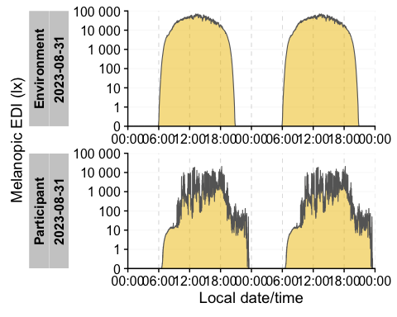
_{Source: Article Notebook}

30-second
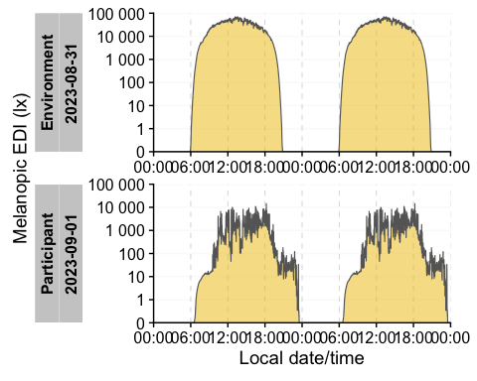
_{Source: Article Notebook}

1-minute
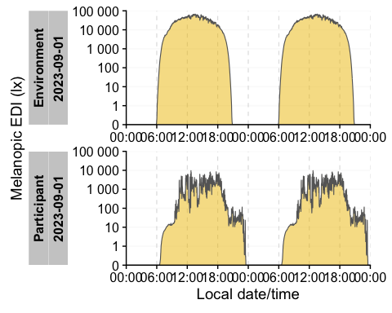
_{Source: Article Notebook}

5-minute
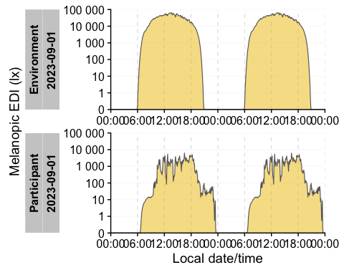
_{Source: Article Notebook}

15-minute
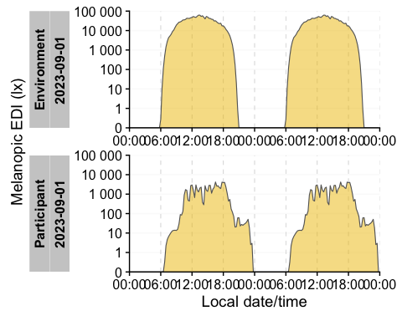
_{Source: Article Notebook}

30-minute
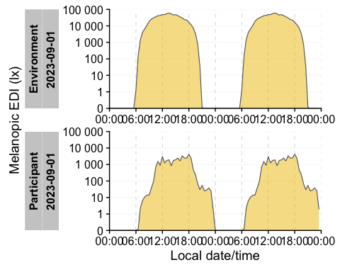
_{Source: Article Notebook}

1-hour
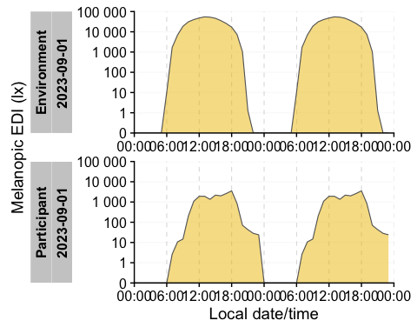
_{Source: Article Notebook}

2-hours
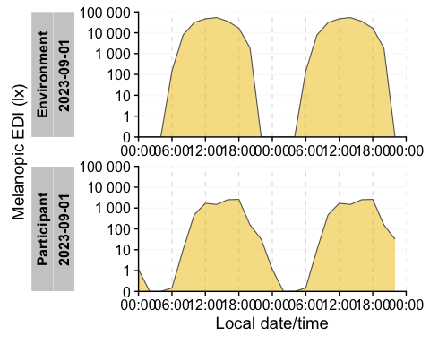
_{Source: Article Notebook}

6-hours
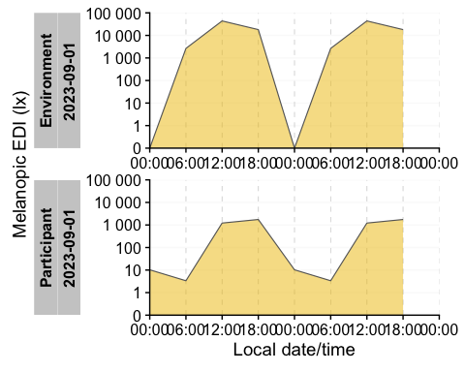
_{Source: Article Notebook}

Exploration and exploratory visualization
Exploring the time series in various regards is key for grasping typical and anomalous patterns. Common ways are shown below:

Heatmap
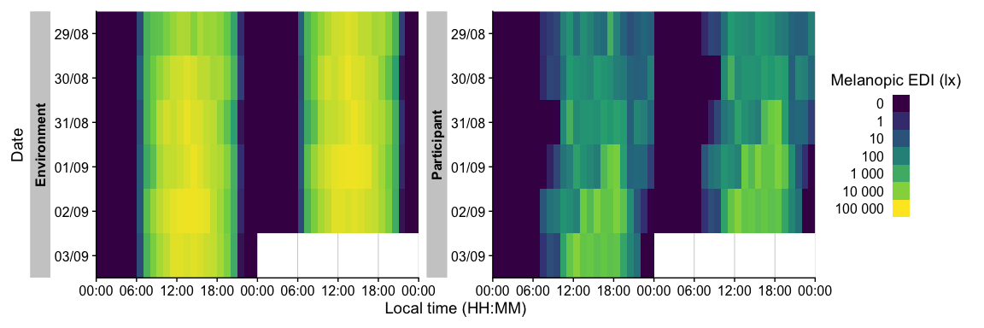
_{Source: Article Notebook}
Shows a dense, color-coded overview across long periods and many participants

Day-based
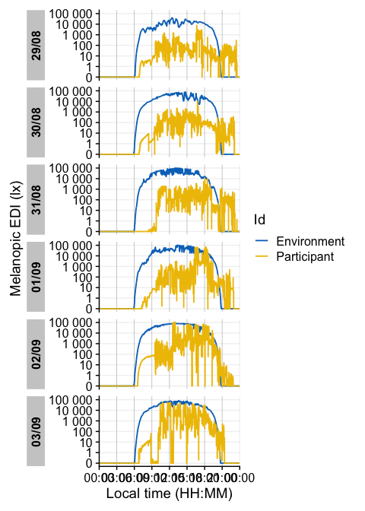
_{Source: Article Notebook}
Good solution to look at individual dates or days of the week.

Timeline-based
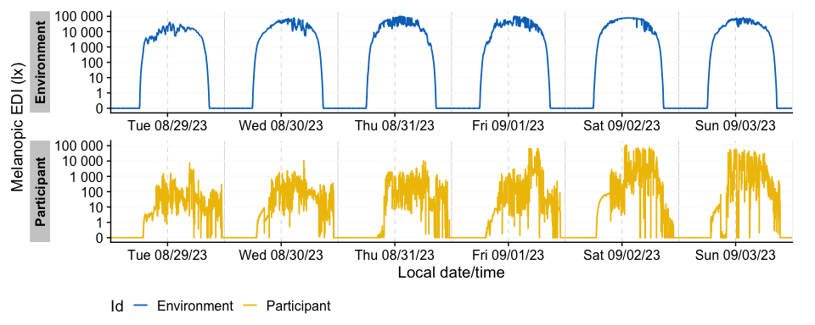
_{Source: Article Notebook}
Practical to visualize longer periods as a continuous timeline, separated by groups

Doubleplot
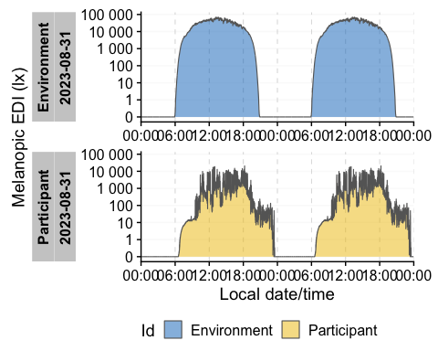
_{Source: Article Notebook}
Useful to inspect patterns across midnight.

Aggregated data
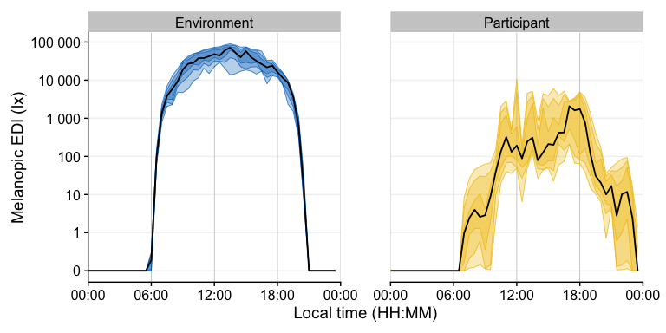
_{Source: Article Notebook}
Condense single datasets to one day, indicating the spread of (95%, 75%, 50%) of data through colored ribbons.
Note, data were aggregated to 30 minute intervals in addition to the aggregation into one day

Boxplot
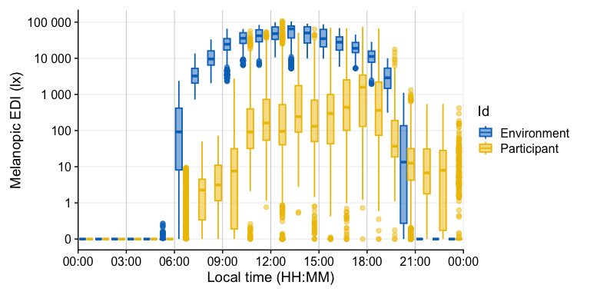
_{Source: Article Notebook}
Similar approach to aggregated data, but expressing the spread through boxplots (1-hour intervals)

Histogram
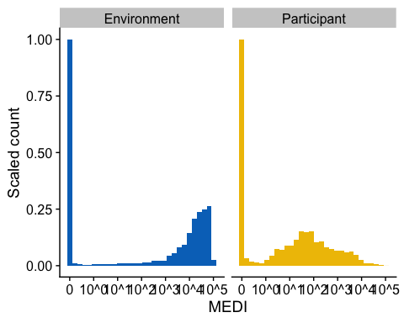
_{Source: Article Notebook}
Nice overview to catch outliers.

Cumulative distribution
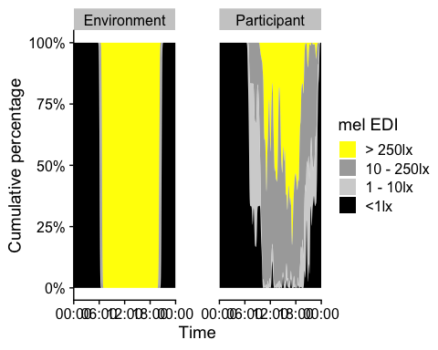
_{Source: Article Notebook}
Condensed dataset to value-bins per time of day across multiple days (5-minute bandwith for smoothing).

Merging data streams
Various time-stamped data stream have to be merged on a regular basis. This includes the addition of, e.g., a non-wear diary, sleep and wake times, or concurrent measurements, e.g. from environmental measurements.
In most circumstances, the data to be added to the time series will be of a much lower sampling interval (e.g., sleep-wake will only contain two values per day), which makes the addition easy through techniques like the non-equi join, e.g., adding a state of sleep to a light dataset for observations that are between (i.e., not equal to) sleep and wake moments.
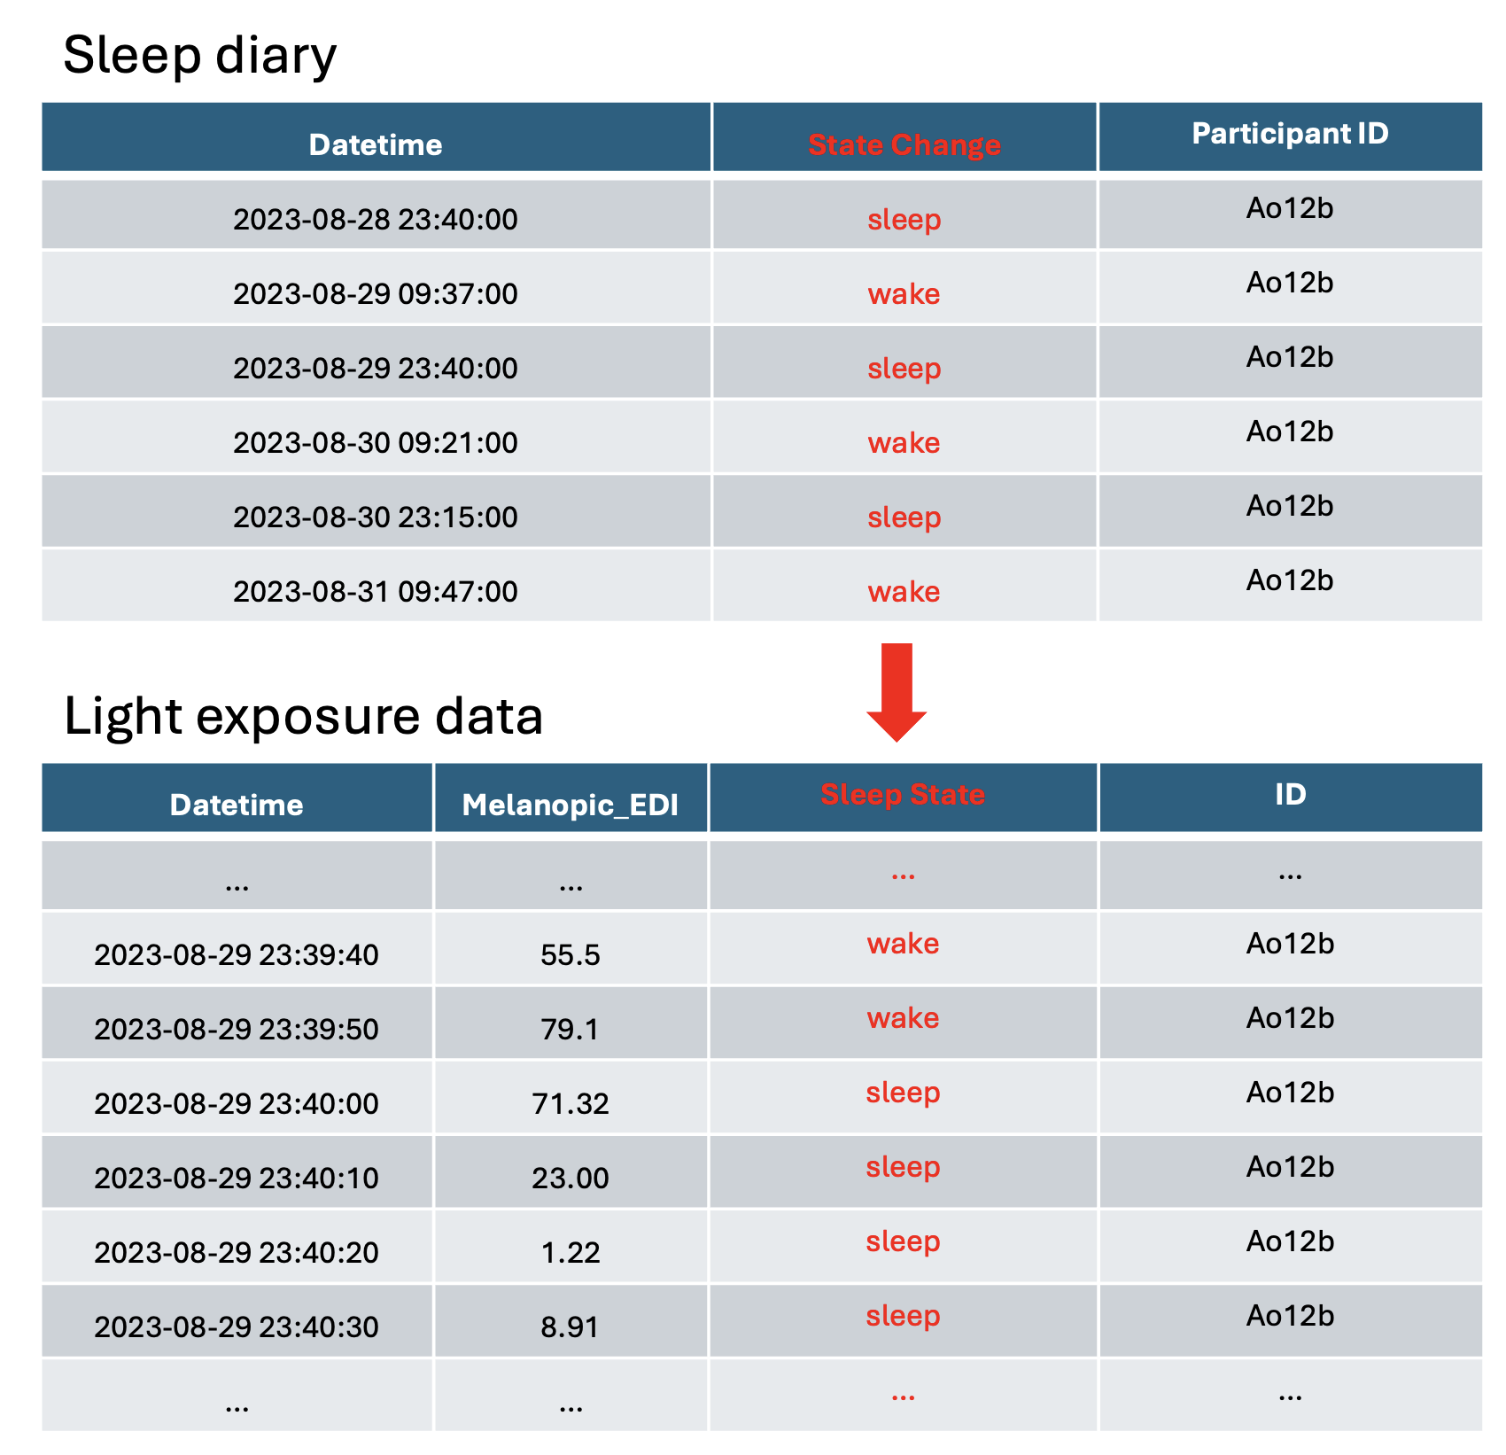
See Section 4.7.7 for standardized ways to realize these functions during analysis, e.g. from LightLogR
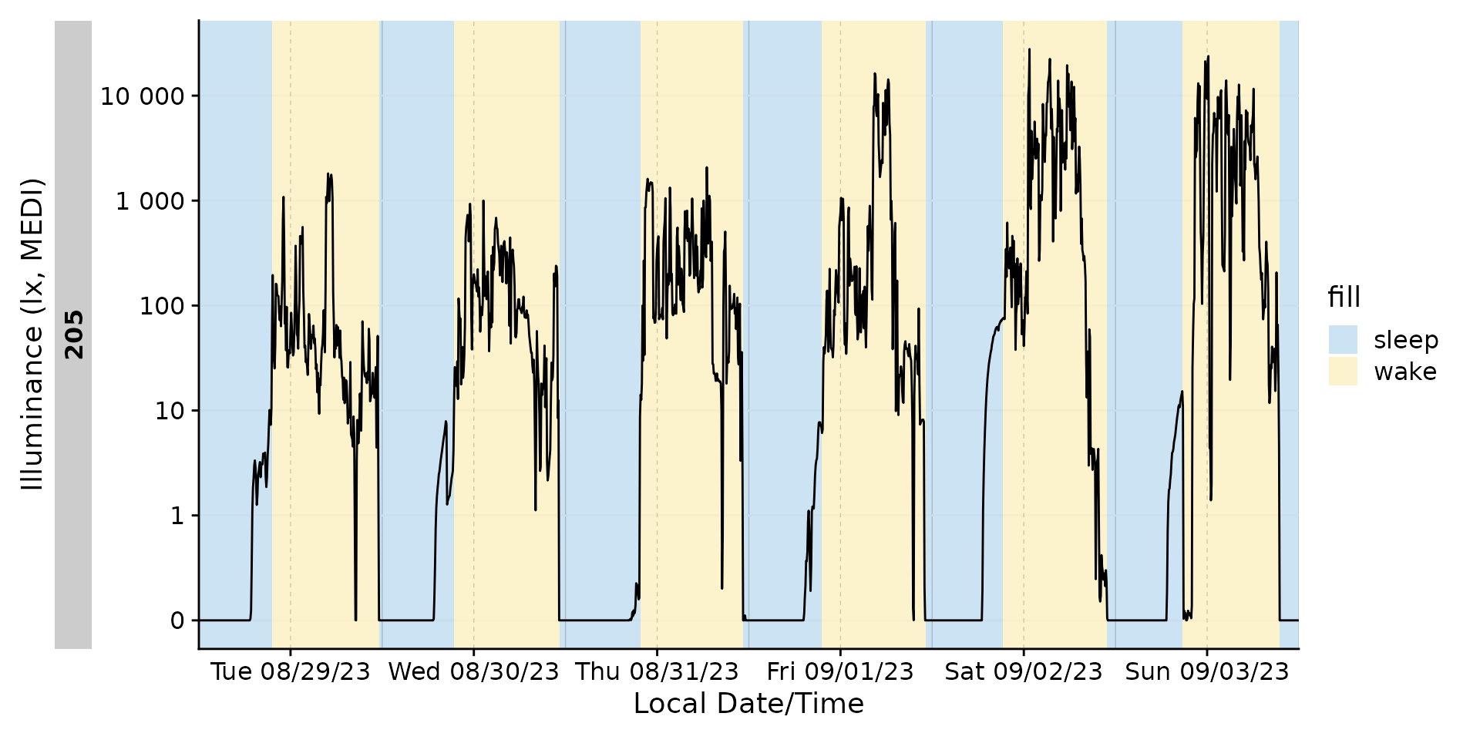

Adding context to the time series
Connecting time series data with context-specific data can provide valuable insights or be a necessary step towards metric calculation.
One example to highlight are location-specific details, such as photoperiod. Photoperiod (Dusk, dawn, duration) is purely based on coordinates and datetimes and has high relevance for the availability of daylight and behavioral outcomes. As such it is a low-hanging fruit that should be part of any light-related field study.
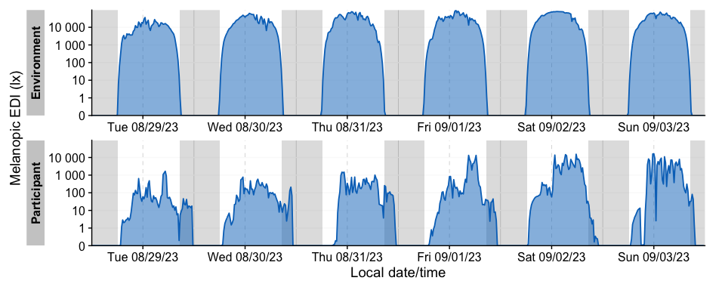
Table 1: Time above 10 lx mel EDI without taking photoperiod into account
Id | mean_duration_above_10 | episodes
Environment | 51325s (~14.26 hours) | 6
Participant | 42912s (~11.92 hours) | 6
Table 1: Time above 10 lx mel EDI taking photoperiod into account
 | mean_duration_above_10 | episodes
Environment
day | 51325s (~14.26 hours) | 6
night | 0s | 6
Participant
day | 38675s (~10.74 hours) | 6
night | 4237s (~1.18 hours) | 6
_{Source: Article Notebook}

Metric selection
Time-series of light exposure and visual experience data can be analysed using a series of metrics (Hartmeyer and Andersen 2023; Zauner et al. 2025). Importantly, there are no standard metrics for the analysis of light exposure data that have been robustly and reliably linked to outcome metrics. Given the lack of standard metrics, researchers must pay particular attention to analytic flexibility leading to inflated false positive rates in statistical analysis.
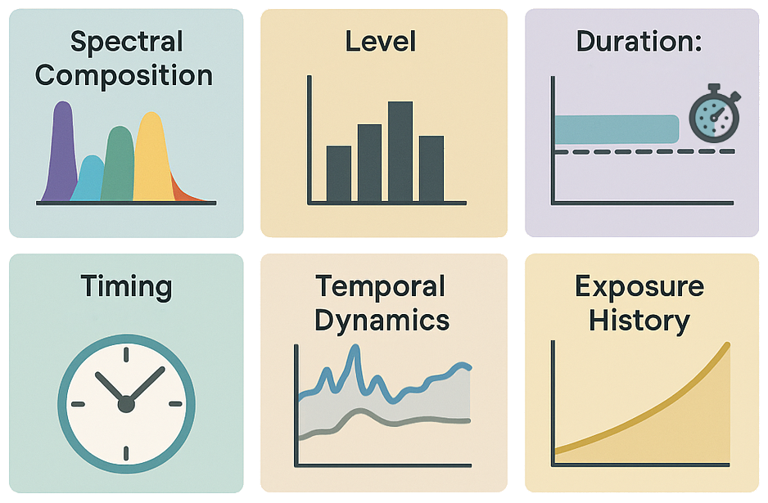
Very broady, metrics of light exposure can be categorised in several ways, as layed out by (Hartmeyer and Andersen 2023):
- Spectral composition: The distribution of wavelenghts in the spectrum influences non-visual responses. This is encoded in the alpha-opic metrics CIE S 026 puts forth. Visual brightness perception is coded in the $V(λ)$ function and several derivatives that deal with larger viewing angles (10° instead of 2°) or mesopic and scotopic conditions. Besides that, there are broader stroked attempts, e.g., when comparing spectral irradiance in the short compared to the long wavelength segment of the spectrum.
- Level, duration, and temporal dynamics: Non-visual responses have been shown do follow a dose-dependent relationship with the stimulus intensity (level) and the stimulus duration (length of exposition). Many metrics have been centered around these concepts, e.g., the time above a certain threshold (TAT), the mean or median of a given period, or the duration and length of pulses above a given threshold (PAT).
- Timing: besides the intensity and duration of a stimulus, when it is applied also carries important information, as humans react in a phase-response dependent manner to stimuli, e.g. with phase shifts more potent in the morning compared to midday. Common metrics in this category are the midpoint of the cumulative light exposure, or the midpoint of the brightest 10 hours (M10) or darkest 5 hours of the day (L5).
- Prior history: photic history, i.e., the amount of light prior to a given moment, shapes the intensity of a response. The non-visual circadian response (nvRC) encodes this behavior.
Importantly, many metrics share similar features and core metrics that express certain health-related outcomes have to be defined.

Special properties of light and visual experience data
Light exposure data spans a wide dynamic range, mirroring the differences in possible environmental exposures from the scotopic to the photopic range of light levels. This means that data are usually considered in a log₁₀-transformed fashion.
An additional statistical property of 24-hour light exposure data is that it is heavily zero-inflated, due to the lack of light at night, or light below the measurement threshold of the device.

Implementation
It is recommended that analysis of visual experience data is implemented using programmatic tools, such as R, Python or MATLAB. LightLogR (Zauner et al. 2025) offers a powerful open-source tool available on CRAN for the analysis of light exposure and visual experience data.

Reporting data
Upon conclusion of the data collection, the next step is to report the data and associated results.

Methods section
For transparency and to ensure that others can replicate and reproduce the measurement protocol and study, it is key to document various aspects related to the measurement of visual experience and light exposure. At a minimum, it is recommended to include text on the following points:
- Device-related properties
  - Manufacturer, brand and make of wearable device used
  - Wearing location
  - Sampling interval
  - Measured quantities
  - Calibration information on directional sensitivity, spectral sensitive, linearity and range properties
- Protocol-related properties
  - Location and season of data collection
  - Time zone and changes (e.g., daylight saving time)
  - Wearing location
  - Wearing duration
  - Instructions given to the participant for wear context and non-wear behaviour
  - Criteria for inclusion/exclusion based on wear time and compliance
  - Use of prompts/reminders to ensure compliance
- Analysis-related properties
  - Preprocessing of data, including outlier rejection, binning and smoothing
  - Handling of partial or missing data
  - Analysis routines and functions used
  - Software and version used for analysis and open-source availability
For light intervention studies, the light source and exposure conditions should be reported in sufficient detail to allow interpretation and replication of the intervention. This should include the manufacturer and model of the light source, spectral power distribution, photopic illuminance and relevant α-opic quantities, such as melanopic equivalent daylight illuminance, measured at the participant’s eye position. The measurement plane should be specified, for example vertical, corneal or gaze-directed, together with the distance and angle between the participant and the light source. Researchers should also describe the timing, duration and pattern of exposure, for example whether exposure was continuous or intermittent, as well as the participant’s activity during exposure, such as reading, working or looking toward the source.
Background light should be measured and reported separately from the intervention source whenever possible. The biological effect of a light intervention is not determined only by the intervention device, but also by room lighting, daylight, previous light exposure and light exposure after the intervention. Reporting the background lighting conditions helps distinguish the intended intervention dose from the wider visual and photic environment in which the intervention took place.
Future work may formalise these recommendations in the form of a consensus checklist.

Discussion section
It is recommended that the Discussion section discloses various limitations arising from the choice of devices or protocols, such as the inability to measure visual experience in the near-corneal plane using wrist-worn devices. Additionally, the rationale for device selection, protocol design and analysis choices should be explained.

Metadata documentation
Thorough sharing practices.

Sharing code
The code used to analyse the data is not just a byproduct of the research process, but a result by itself. There are several reasons to make code available under an open source license:
- The work underlying the scientific results is shared sustainably for re-use and independent checking
- The researcher community can benefit from the availability of existing and citable code
Code can be shared as static files attached to the supplementary material of a published article, or on a repository, such as GitHub or Bitbucket. For GitHub, Zenodo offers an integration module such that when creating a release on GitHub, Zenodo creates a DOI, making the code citable.
Importantly, when sharing code, it is necessary to select a license under which the code is available. Common licenses include the MIT License, which is permissive with respect to commercial use, and the GPL License, which is more restricted. Choose a License can help making an informed decisions about software licenses.
Code reproducibility can be ensured through independent validation through CODECHECK (Nüst and Eglen 2021).

Sharing materials
To ensure the reproducibility of research studies, it is recommended to share the materials used throughout the study, including any instruction sheets given to the participant, survey questions used, as well as debriefing documents. For any digital materials, such as forms served on a survey platform (such as REDCap), it is recommended, that the materials are provided in a format ingestible/importable by the platform

Sharing data
Data should be made available transparently and openly. It is recommended that when researchers submit their ethics approval request, they already include the provision of sharing data in anonymized form. It can be very difficult to impractical to share data after the fact or seek re-approval from the participants.

FAIR data
The FAIR principles state that data should be findable, accessible, interoperable and reusable, to make them easier to share (Wilkinson et al. 2016). Several points raised in this Researcher Guide are driven to ensure that visual experience and optical radiation data are FAIR, including standard file formats and documentation. Importantly, FAIR data guarantees that the collected data are used sustainably, and available well beyond the specific published research articles.
Data can be published as part of the supplementary material of journals. An alternative option is to add them as data packages to specific repositories, such as Zenodo or FigShare.
Software packages can be used to make datasets more accessible for analysis, both primary and secondary. One example is the melidosData R package, that facilitates quick access to data from the MeLiDos field study.

Funding
This research guide has been partially funded by the project MeLiDos (22NRM05 MeLiDos), which has received funding from the European Partnership on Metrology, co-financed from the European Union’s Horizon Europe Research and Innovation Programme and by the Participating States. Views and opinions expressed are however those of the author(s) only and do not necessarily reflect those of the European Union or EURAMET. Neither the European Union nor the granting authority can be held responsible for them.
Aarts, Mariëlle P. J., Juliëtte van Duijnhoven, Myriam B. C. Aries, and Alexander L. P. Rosemann. 2017. “Performance of Personally Worn Dosimeters to Study Non-Image Forming Effects of Light: Assessment Methods.” Journal Article. Building and Environment 117: 60–72. https://doi.org/10.1016/j.buildenv.2017.03.002.
Balajadia, E., S. Garcia, J. Stampfli, B. Schrader, C. Guidolin, and M. Spitschan. 2023. “Usability and Acceptability of a Corneal-Plane Alpha-Opic Light Logger in a 24-h Field Trial.” Journal Article. Digit Biomark 7 (1): 139–49. https://doi.org/10.1159/000531404.
Bhandari, K. R., H. Mirhajianmoghadam, and L. A. Ostrin. 2021. “Wearable Sensors for Measurement of Viewing Behavior, Light Exposure, and Sleep.” Journal Article. Sensors (Basel) 21 (21). https://doi.org/10.3390/s21217096.
Biller, A. M., P. Balakrishnan, and M. Spitschan. 2024. “Behavioural Determinants of Physiologically-Relevant Light Exposure.” Journal Article. Commun Psychol 2 (1): 114. https://doi.org/10.1038/s44271-024-00159-5.
Biller, Anna M, Johannes Zauner, Christian Cajochen, et al. 2025. “Physiologically-Relevant Light Exposure and Light Behaviour in Switzerland and Malaysia.” bioRxiv, ahead of print. https://doi.org/10.1101/2025.01.07.631760.
Blume, C., C. Garbazza, and M. Spitschan. 2019. “Effects of Light on Human Circadian Rhythms, Sleep and Mood.” Journal Article. Somnologie (Berl) 23 (3): 147–56. https://doi.org/10.1007/s11818-019-00215-x.
Brown, T. M., G. C. Brainard, C. Cajochen, et al. 2022. “Recommendations for Daytime, Evening, and Nighttime Indoor Light Exposure to Best Support Physiology, Sleep, and Wakefulness in Healthy Adults.” Journal Article. PLoS Biol 20 (3): e3001571. https://doi.org/10.1371/journal.pbio.3001571.
CIE. 2018. CIE s 026/e:2018: CIE System for Metrology of Optical Radiation for ipRGC-Influenced Responses to Light. Standard. CIE Central Bureau. https://doi.org/10.25039/S026.2018.
Cole, R. J., D. F. Kripke, J. Wisbey, et al. 1995. “Seasonal Variation in Human Illumination Exposure at Two Different Latitudes.” Journal Article. J Biol Rhythms 10 (4): 324–34. https://doi.org/10.1177/074873049501000406.
Dahlmann-Noor, A. H., D. Bokre, M. Khazova, and L. L. A. Price. 2025. “Measuring the Visual Environment of Children and Young People at Risk of Myopia: A Scoping Review.” Journal Article. Graefes Arch Clin Exp Ophthalmol, ahead of print. https://doi.org/10.1007/s00417-024-06719-z.
Danilenko, Konstantin V., Oliver Stefani, Kirill A. Voronin, et al. 2022. “Wearable Light-and-Motion Dataloggers for Sleep/Wake Research: A Review.” Journal Article. Applied Sciences 12 (22). https://doi.org/10.3390/app122211794.
Daugaard, S., J. Markvart, J. P. Bonde, et al. 2019. “Light Exposure During Days with Night, Outdoor, and Indoor Work.” Journal Article. Ann Work Expo Health 63 (6): 651–65. https://doi.org/10.1093/annweh/wxy110.
Dunster, G. P., I. Hua, A. Grahe, et al. 2023. “Daytime Light Exposure Is a Strong Predictor of Seasonal Variation in Sleep and Circadian Timing of University Students.” Journal Article. J Pineal Res 74 (2): e12843. https://doi.org/10.1111/jpi.12843.
French, D. P., and S. Sutton. 2010. “Reactivity of Measurement in Health Psychology: How Much of a Problem Is It? What Can Be Done about It?” Journal Article. Br J Health Psychol 15 (Pt 3): 453–68. https://doi.org/10.1348/135910710X492341.
Gibaldi, A., E. N. Harb, C. F. Wildsoet, and M. S. Banks. 2024. “A Child-Friendly Wearable Device for Quantifying Environmental Risk Factors for Myopia.” Journal Article. Transl Vis Sci Technol 13 (10): 28. https://doi.org/10.1167/tvst.13.10.28.
Graw, P., S. Recker, L. Sand, K. Krauchi, and A. Wirz-Justice. 1999. “Winter and Summer Outdoor Light Exposure in Women with and Without Seasonal Affective Disorder.” Journal Article. J Affect Disord 56 (2-3): 163–69. https://doi.org/10.1016/s0165-0327(99)00037-3.
Guidolin, C., S. Aerts, G. K. Agbeshie, et al. 2024. “Protocol for a Prospective, Multicentre, Cross-Sectional Cohort Study to Assess Personal Light Exposure.” Journal Article. BMC Public Health 24 (1): 3285. https://doi.org/10.1186/s12889-024-20206-4.
Guidolin, Carolina, Johannes Zauner, Steffen Lutz Hartmeyer, and Manuel Spitschan. 2025. “Collecting, Detecting and Handling Non-Wear Intervals in Longitudinal Light Exposure Data.” bioRxiv, ahead of print. https://doi.org/10.1101/2024.12.23.627604.
Hartmeyer, S. L., and M. Andersen. 2023. “Towards a Framework for Light-Dosimetry Studies: Quantification Metrics.” Journal Article. Lighting Research & Technology 56 (4): 337–65. https://doi.org/10.1177/14771535231170500.
Hönekopp, A., and S. Weigelt. 2023. “Using Light Meters to Investigate the Light-Myopia Association - a Literature Review of Devices and Research Methods.” Journal Article. Clin Ophthalmol 17: 2737–60. https://doi.org/10.2147/OPTH.S420631.
Jardim, A. C., M. D. Pawley, J. F. Cheeseman, M. J. Guesgen, C. T. Steele, and G. R. Warman. 2011. “Validating the Use of Wrist-Level Light Monitoring for in-Hospital Circadian Studies.” Journal Article. Chronobiol Int 28 (9): 834–40. https://doi.org/10.3109/07420528.2011.611603.
Lucas, R. J., S. N. Peirson, D. M. Berson, et al. 2014. “Measuring and Using Light in the Melanopsin Age.” Journal Article. Trends Neurosci 37 (1): 1–9. https://doi.org/10.1016/j.tins.2013.10.004.
Markvart, Jakob, Åse Marie Hansen, and Jens Christoffersen. 2015. “Comparison and Correction of the Light Sensor Output from 48 Wearable Light Exposure Devices by Using a Side-by-Side Field Calibration Method.” Journal Article. Leukos 11 (3): 155–71. https://doi.org/10.1080/15502724.2015.1020948.
Mohamed, A., V. Kalavally, S. W. Cain, A. J. K. Phillips, E. M. McGlashan, and C. P. Tan. 2021. “Wearable Light Spectral Sensor Optimized for Measuring Daily Alpha-Opic Light Exposure.” Journal Article. Opt Express 29 (17): 27612–27. https://doi.org/10.1364/OE.431373.
Mohammadian, N., A. Didikoglu, C. Beach, et al. 2024. “A Wrist-Worn Internet of Things Sensor Node for Wearable Equivalent Daylight Illuminance Monitoring.” Journal Article. IEEE Internet Things J 11 (9): 16148–57. https://doi.org/10.1109/JIOT.2024.3355330.
Nüst, D., and S. J. Eglen. 2021. “CODECHECK: An Open Science Initiative for the Independent Execution of Computations Underlying Research Articles During Peer Review to Improve Reproducibility.” Journal Article. F1000Res 10: 253. https://doi.org/10.12688/f1000research.51738.2.
Okudaira, N., D. F. Kripke, and J. B. Webster. 1983. “Naturalistic Studies of Human Light Exposure.” Journal Article. Am J Physiol 245 (4): R613–5. https://doi.org/10.1152/ajpregu.1983.245.4.R613.
Price, L. L. A., M. Khazova, and L. Udovicic. 2022. “Assessment of the Light Exposures of Shift-Working Nurses in London and Dortmund in Relation to Recommendations for Sleep and Circadian Health.” Journal Article. Ann Work Expo Health 66 (4): 447–58. https://doi.org/10.1093/annweh/wxab092.
Spitschan, M., G. Hammad, C. Blume, et al. 2024. “Metadata Recommendations for Light Logging and Dosimetry Datasets.” Journal Article. BMC Digit Health 2 (1): 73. https://doi.org/10.1186/s44247-024-00113-9.
Spitschan, M., K. Smolders, B. Vandendriessche, et al. 2022. “Verification, Analytical Validation and Clinical Validation (V3) of Wearable Dosimeters and Light Loggers.” Journal Article. Digit Health 8: 20552076221144858. https://doi.org/10.1177/20552076221144858.
Stefani, O., R. Marek, J. Schwarz, S. Plate, J. Zauner, and B. Schrader. 2024. “Wearable Light Loggers in Field Conditions: Corneal Light Characteristics, User Compliance, and Acceptance.” Journal Article. Clocks Sleep 6 (4): 619–34. https://doi.org/10.3390/clockssleep6040042.
Thorne, H. C., K. H. Jones, S. P. Peters, S. N. Archer, and D. J. Dijk. 2009. “Daily and Seasonal Variation in the Spectral Composition of Light Exposure in Humans.” Journal Article. Chronobiol Int 26 (5): 854–66. https://doi.org/10.1080/07420520903044315.
Ulaganathan, S., S. A. Read, M. J. Collins, and S. J. Vincent. 2019. “Influence of Seasons Upon Personal Light Exposure and Longitudinal Axial Length Changes in Young Adults.” Journal Article. Acta Ophthalmol 97 (2): e256–65. https://doi.org/10.1111/aos.13904.
van Duijnhoven, J., S. L. Hartmeyer, A. Didikoglu, et al. 2025. “Measuring Light Exposure in Daily Life: A Review of Wearable Light Loggers.” Journal Article. Build Environ 274. https://doi.org/10.1016/j.buildenv.2025.112771.
Webler, F. S., M. Spitschan, R. G. Foster, M. Andersen, and S. N. Peirson. 2019. “What Is the ’Spectral Diet’ of Humans?” Journal Article. Curr Opin Behav Sci 30: 80–86. https://doi.org/10.1016/j.cobeha.2019.06.006.
Wen, L., H. Liu, Z. Chen, et al. 2023. “Effect of Mount Location on the Quantification of Light Intensity in Myopia Study.” Journal Article. BMJ Open Ophthalmol 8 (1). https://doi.org/10.1136/bmjophth-2023-001409.
Wilkinson, M. D., M. Dumontier, I. J. Aalbersberg, et al. 2016. “The FAIR Guiding Principles for Scientific Data Management and Stewardship.” Journal Article. Sci Data 3: 160018. https://doi.org/10.1038/sdata.2016.18.
Zauner, J., S. Hartmeyer, and M. Spitschan. 2025. “LightLogR: Reproducible Analysis of Personal Light Exposure Data.” Journal Article. J Open Source Softw 10 (107): 7601. https://doi.org/10.21105/joss.07601.
Zielinski, T., J. J. L. Hodge, and A. J. Millar. 2023. “Keep It Simple: Using README Files to Advance Standardization in Chronobiology.” Journal Article. Clocks Sleep 5 (3): 499–506. https://doi.org/10.3390/clockssleep5030033.

