**Education**

**General Assemb.ly Flatiron**

School for programming/coding/web development Current

**Northwestern University** Sep 2008-Sep 2012

Weinberg College of Arts and Sciences, Class of 2012

Candidate for B.A. in Psychology, Film Studies minor

*Overall GPA:3.4 /4.0, Major GPA: 3.566/4.0*

Medill School of Journalism

Integrated Marketing Certificate

*Program GPA: 3.70/4.00*

**The Institute for the International Education of Students (IES)** Jul 2010-Dec 2010

Advanced Honors Program

Buenos Aires, Argentina

**Relevant Work Experience**

**The Drunken Ship**

*Bartender / BarBack*

* Worked 12 hour shifts in one of the busiest American bars in Rome Rome, Italy
* Covered all facets of barkeeping, including bartending, barbacking and bussing tables February 2011 - December 2011
* Contact Shane Siegel (former manager) at [ShaneSiegel@gmail.com](mailto:ShaneSiegel@gmail.com)

**The Alamo**

*Bartender/Wait Staff/ BarBack*

* Worked 12 hour shifts in one of the busiest American bars in Rome Buenos Aires, Argentina
* Covered all facets of barkeeping, including bartending, barbacking and bussing tables March 2010 December 2010
* Contact Allison Gallo (former manager) at 516-993-3870

**Stand Up Comedian**

Performed at several comedy clubs/open mics in Chicago for a year Chicago, IL

Jan 2009 – Jan 2010

**Robin Hood Country Day School** Long Island, New York

*Head of Lacrosse*  June 2007 – Aug 2008

* Managed and coordinated activities for campers age 8-16 yrs. for 6-7 hrs/day
* Charged with assessing employee efficiency and work ethic

**Skills and Interests**

* Stand-Up Comedy (performance and appreciation)
* Fluent in Spanish
* Organizing large events/parties (have guest bartended twice with attendance around 100 people each time)
* 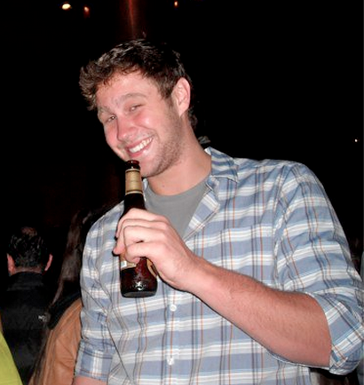Deep in multiple music scenes