Regression Analysis on Beaufort Memorial’s LifeFit Wellness Services Member Spending

Ricca Callis

Southern New Hampshire University

MAT-300

Instructor David Atwood

June 24, 2018

**Introduction**

Beaufort Memorial Hospital’s LifeFit Wellness Services is a medically-managed fitness and outpatient rehabilitation center. At LifeFit, medical professionals, rehabilitation specialists, and exercise physiologists work together to analyze member’s health status and design individualized wellness programs tailored to each person’s needs. As an outpatient facility for the hospital, LifeFit serves populations of individuals with injuries and other medically-related special needs, in addition to working toward improving the overall health and wellbeing of the general community within Beaufort County.

This analysis examined total annual revenue as a function of membership population demographic variables. Specifically, this analysis sought to identify the subpopulations that make the largest contribution to LifeFit’s total annual revenue. Understanding the parameters with the strongest contributions to total revenue will help identify areas for departmental growth and allow future marketing strategies to be directly targeted in a manner that is more likely to maximize profits.

For example, LifeFit has been approached by Silver Sneakers, a Medicare fitness program that offers reimbursements to gym facilities for qualified participants (ages 65+). Participants enrolled in Silver Sneakers receive free gym membership to all participating facilities and Medicare reimburses the facilities $2.50 per participant visit, up to $25 per month. In addition to other marketing demographic variables, this analysis included age and gym check-in frequency to determine whether Silver Sneakers may benefit the facility. To determine the potential for revenue within the surrounding area, Silver Sneakers provided us with insured participants in our highest zip code populations: 29902 has 382 Silver Sneakers members; 29907 has 508 Silver Sneakers members; 29935 has 90 Silver Sneaker members; 29906 has 347 members; and 29920 has 635 members.

The data was extracted and exported from LifeFit’s database (VirtualClubMate) within Fiscal Year 2017. VirtualClubMate cannot create customized reports. As a result, multiple separate reports were extracted, including: member name by member spending (which included retail, massage, specialty programs, and membership), member name by age, member name by zip code, member name by gender, member name by check-in frequency, and member name by membership category. After extraction, all reports were cleaned and combined into one excel file listing each member name along with their corresponding demographic variables listed above. All information was then transferred to IBM SPSS Statistics version 25 for data analysis. All analyses sought to determine the factors that contributed most significantly to total annual member spending. It was hypothesized that the membership types and ages with the highest utilization (as defined by check-in frequency) would yield the highest contribution to LifeFit’s total annual revenue.

**Regression Model Building**

This analysis sought to identify strong predictors of member spending at Beaufort Memorial’s LifeFit Wellness Services. The criterion variable (aka dependent variable) was defined as total member spending for fiscal year 2017. Total spending included all membership payments, retail purchases, massage purchases, personal training purchases, and special outpatient rehabilitation program purchases. The dependent variable is a quantitative, continuous, ratio variable obtained over the course of one fiscal year.

As LifeFit has only started acquiring member data, the only parameters available for analysis at this time included: age, gender, location (defined by zip code), membership-type, and utilization (defined by check-in frequency). The predictor variables (aka independent variables) age and utilization were both quantitative, continuous, ratio variables. On the other hand, the predictor variables membership-type, gender, and location were all qualitative, categorical, discrete variables. As such, these variables were all given a dummy code for analysis. The dummy variables zip code and membership-type were coded 1 to indicate inclusion in category and 0 to indicate exclusion from category. For gender, the dummy variables were coded 0 for male and 1 for female. Of the 2618 active members, 0 cases had missing gender data. There were 1830 females (69.9% of total members) and 788 males (30.1% of total members).

As LifeFit Wellness Services is a Beaufort Memorial Hospital program, it provides service to all of Beaufort and Jasper counties. As a result, 98 different zip codes were identified in the initial data extraction. Only the top five zip codes (29902, 29907, 29935, 29906, 29920) were included in this analysis, as they accounted for 73.7% of all LifeFit members. The remaining zip codes were wildly dispersed across the county, likely indicating enrollment through one of LifeFit’s mobile wellness services, most only representing less than 1% of the total number of LifeFit members. Each of the 5 included zip codes were given their own dummy variable, which meant that a 0 on all zip codes would represent member location within one of the other remaining zip codes. One hundred and ninety cases (7.26% of the total) had missing member zip codes. These missing cases were eliminated from analysis. There were 694 members living in zip code 29902 (26.53% of total members), 546 members living in zip code 29907 (20.87% of total members), 346 members in zip code 29906 (13.23% of total members), 220 members living in zip code 29920 (8.41% of total members), and 122 members living in zip code 29935 (4.66% of total members).

Only those members currently listed as ‘Active’ within LifeFit’s database. LifeFit Wellness Services offers 28 membership categories, 27 of which were assigned a dummy category (the last category represented by a 0 on all dummy variables). LifeFit currently charges a different monthly membership fee to each of it’s 28 membership categories. Upon discovery of the high number of membership categories, member frequencies were examined within each category prior to regression analysis (see Table 1). Utility of this many membership categories was determined an important analysis a priori. Scatter Plots of all predictors are presented in Figure 1.

Table 1

*Frequency Distribution of Membership Categories*

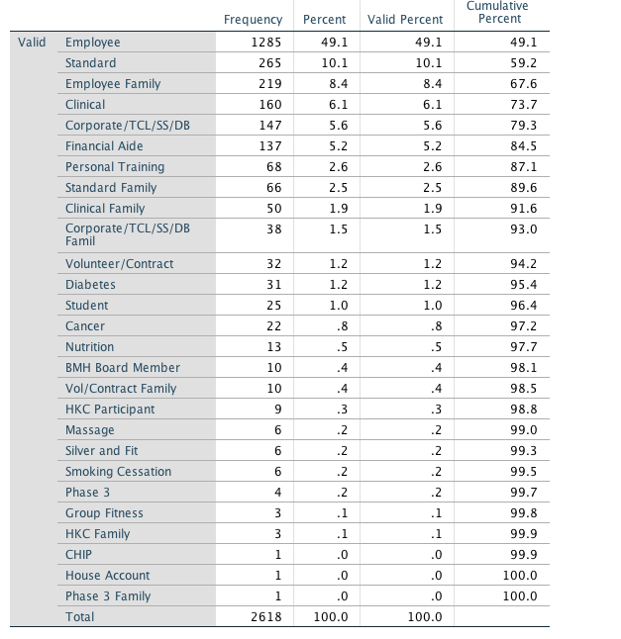

Figure 1

*Scatter Plot of All Predictors in Initial First Order Model*

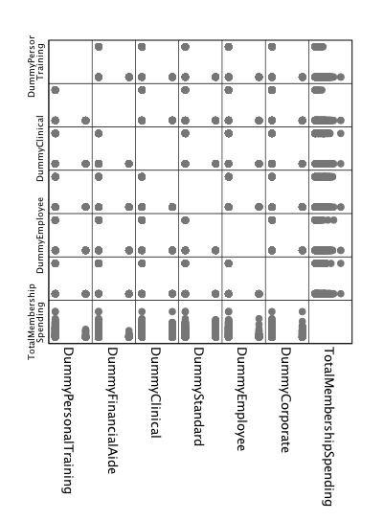

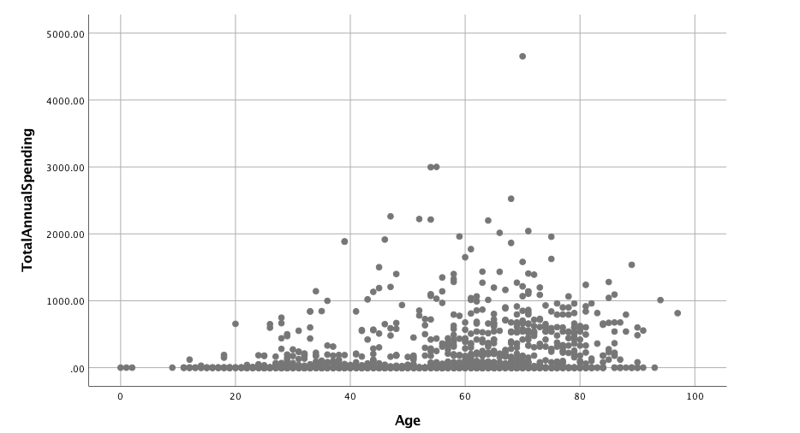

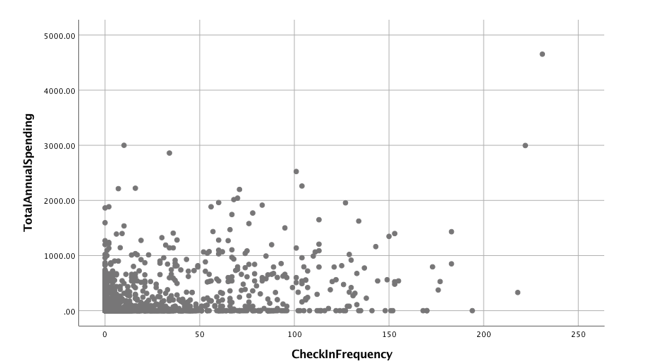

**First Order (Linear) Main Effect Multivariate Regression Model: All Variables Included**

The First Order Main Effect Multivariate Regression Model was conducted first. The general equation form is presented below:

Where:

The data was then analyzed using IBM SPSS Statistical Software 25, the complete regression output is shown below (Table 2, Table 3).

Table 2

*First Order Main Effect Model Multivariate Regression, Model & ANOVA Summary Including All Variables*

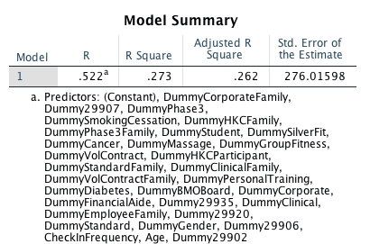

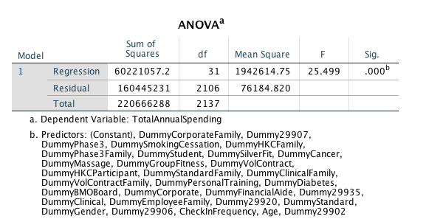

Table 3

*First Order Main Effect Model Multivariate Regression, Coefficient’s Summary, All Variables Included*

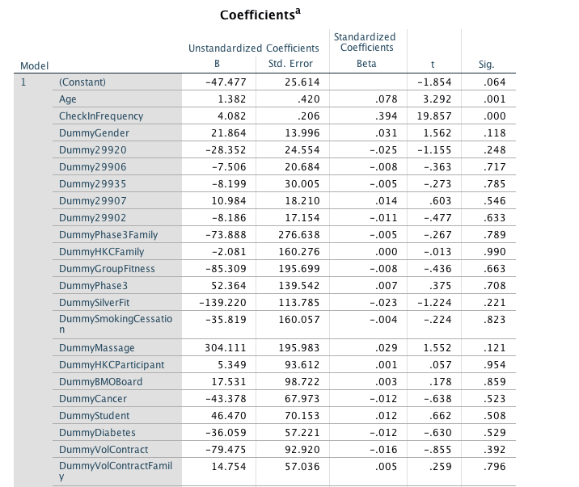

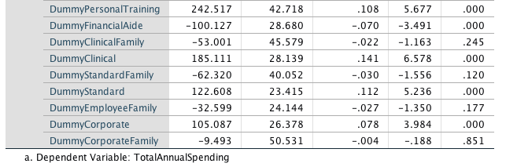

The results of the First Order (Linear) Main Effect Model Multivariate Regression are shown in Tables 2 and 3, above. The results present an evaluation of how well age, gender, zip code, check-in frequency, and membership-type predict total annual member spending. Using a global utility F-test at =.05, this regression (which included all 32 predictors) was significantly related to total member spending, F(31,2106) = 25.499, p < 0.0001. This result indicates that at least one of the -coefficients is non-zero. However, the total variability accounted for by this model is relatively low (R2 = .522; adjusted R2 = .273), indicating that either a different model may better fit this data, or other variables may more accurately predict total member spending.

The -coefficients, as labeled on the output, are the weights (or slope) associated with the regression equation. According to these coefficients, the regression equation is as follows: .

To understand the unique contributions of each predictor variable within this model, local t-tests were conducted for each predictor at =.05. Of the 32 predictor variables, only the following were found to make a significant contribution to the model: age (, check-in frequency (, personal training membership (, financial aide membership (, clinical membership (, standard membership(, and corporate membership (. Based off the regression coefficients for each significant predictor in this model, it appears that the most significant contribution to total annual member spending is personal training membership. Personal Training Membership includes no monthly gym fee. However, members only have access to the facility while training with one of LifeFit’s Personal Trainers. All personal training sessions are purchased as either individual sessions or as packaged sessions.

The following membership types do not significantly influence total annual member spending, and should be excluded from further model analyses: Phase 3 Family, HKC Family, Group Fitness, Phase 3, Silver and Fit, Smoking Cessation, Massage, HKC Participant, BMH Board Member, Cancer, Student, Diabetes, Volunteer/Contract, Volunteer/Contract Family, Clinical Family, Standard Family, Employee Family, and Corporate Family. From these results, it was also concluded that there is no significant main effect of gender or zip code on total member spending. As such, all insignificant variables were removed and the model was reassessed.

**First Order (Linear) Main Effect Multivariate Regression Model: Revised Variables**

The results of the First Order (Linear) Main Effect Model Multivariate Regression are shown in Table 4, below. The results present an evaluation of how well age, check-in frequency, and membership-type (Personal Training, Financial Aide, Clinical, Standard, Employee) predict total annual member spending. Using a global utility F-test at =.05, this regression (which included only 7 predictors) was significantly related to total member spending, F(7,2130) = 106.531, p < 0.0001. This result indicates that at least one of the -coefficients is non-zero. However, the total variability accounted for by this model yielded a lower value (R2 = .509, adjusted R2 = .259) than the previous model (R2 = .522; adjusted R2 = .273), indicating that either a different model may better fit this data, or other variables may more accurately predict total member spending (including one of the variables previously removed). As a result, the model was revised once more, adding back in the gender variable.

Table 4

*First Order (Linear) Main Effect Multivariate Regression Model: Revised Variables*

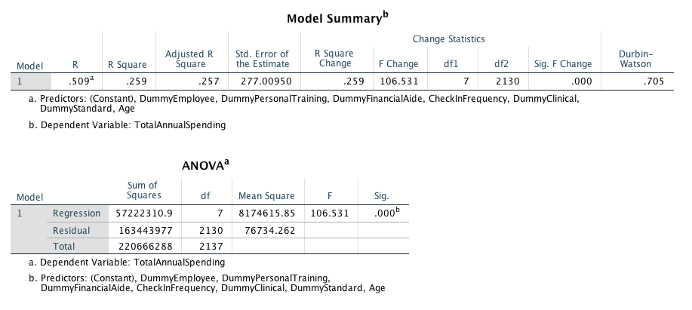

**First Order (Linear) Main Effect Multivariate Regression Model: Gender Included**

The results of the First Order (Linear) Main Effect Model Multivariate Regression are shown in Table 5, below. The results present an evaluation of how well age, gender, check-in frequency, and membership-type (Personal Training, Financial Aide, Clinical, Standard, Employee) predict total annual member spending. Using a global utility F-test at =.05, this regression (which included 8 predictors) was significantly related to total member spending, F(9,2128) = 87.016, p < 0.0001. This result indicates that at least one of the -coefficients is non-zero. While the total variability accounted for by this model (R2 = .519; adjusted R2= .269) was higher than when gender was removed (R2 = .509, adjusted R2 = .259), it is still lower than the first model which included all variables (R2 = .522; adjusted R2 = .273). Overall, results continue to suggest that either a different model may better fit this data, or other variables may more accurately predict total member spending.

According to these coefficients, the regression equation is as follows: .

To understand the unique contributions of each predictor variable within this model, local t-tests were conducted for each predictor at =.05. Of the 8 predictor variables, only the following were found to make a significant contribution to the model: age (, check-in frequency (, personal training membership (, financial aide membership (, clinical membership (, standard membership(, and corporate membership (. All of these -coefficients increased in size, suggesting this model more accurately reflects their unique contributions. Both gender and employee membership variables were found to be insignificant. However, both of these variables will remain in the regression equation. Employees make up 49.1% of LifeFit’s total members and improving employee health is part of Beaufort Memorial’s strategic plan for fiscal year 2018. Gender may play a role in medically-related conditions unavailable for analysis at this time.

Table 5

*First Order (Linear) Main Effect Multivariate Regression Model: Gender Included*

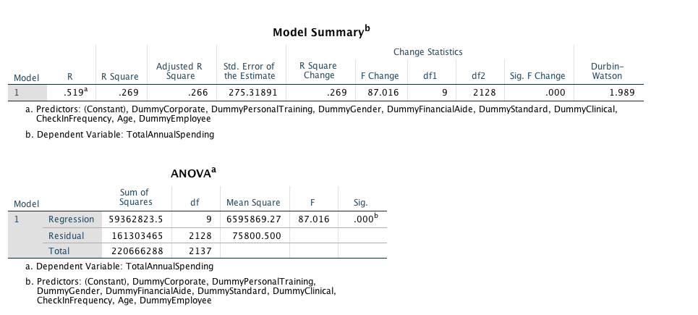

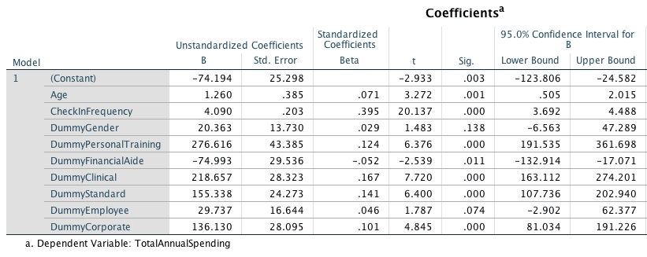

Upon assessing utility of variables and committing to this third model, residual plots were examined for homoscedasticity and linearity (see Figure 2 below). The residual scatter plot shows unequal spread, clustered heavily with low values of x and greater variance at higher predicted values. This funnel shape seems to suggest a possible multiplicative trend in Y-values and may require a Y-transformation. While data does appear to have a linear trend, significant outliers may contribute to the unequal variance observed.

As it is important to meet the assumption of normality for the p-values and t-tests to be valid, further graphical assessment of residuals was conducted for this model (see Figures 3 and 4 below). As seen in Figure 3, a Normal Probability plot was examined to compare the observed cumulative distribution function of the standardized residual to the expected cumulative distribution function of the normal distribution. If the standardized residuals are normally distributed, the scatter should fall on or tightly close to the normal distribution line. What is observed, instead, is an S-shaped P-P plot, indicating that the distribution has the correct median but that the mean is flattened due to data at the tail ends (confirmed when looking at Figure 4). This further suggests model in adequacy.

Figure 2

*Residual Scatter Plot for First Order Main Effect Model with Revised Variables*

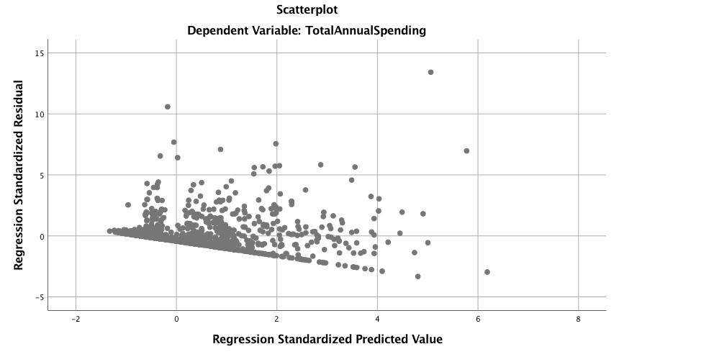

Figure 3

*Normal Probability Plot for First Order Main Effect Model with Revised Variables*

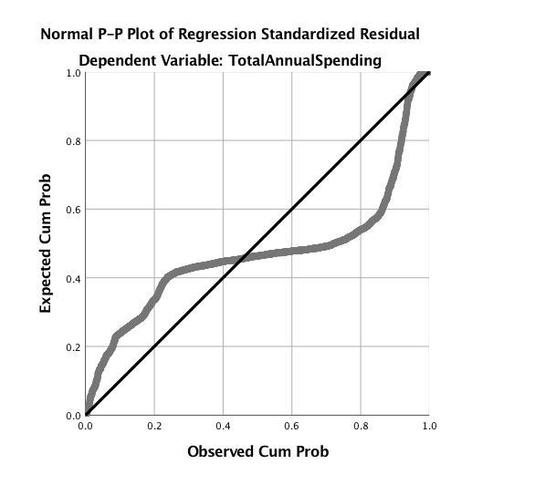

Figure 4

*Histogram Frequency Distribution for First Order Main Effect Model with Revised Variables*

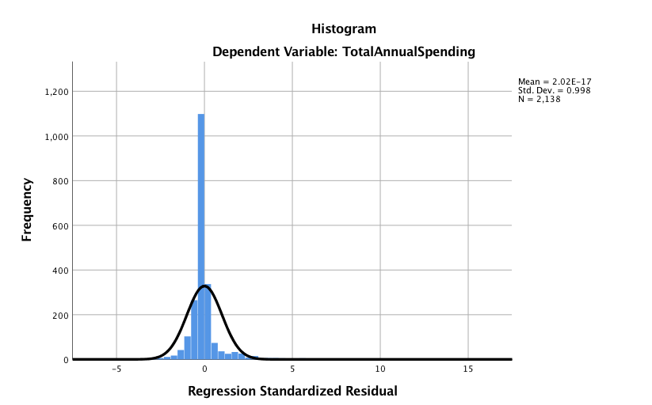

Finally, Q-Q plots were examined to compare the observed quartile with the theoretical quartile of a normal distribution (see Figure 5, below). If the distribution is normal, then we expect the points to cluster around the reference line. In this Q-Q plot, however, significant tail distribution is observed, indicating positive kurtosis. All plots indicate a violation in the assumption of homoscedasticity. Therefore, a Y-transformation was performed.

Figure 5

*Q-Q Plot for First Order Main Effect Model with Revised Variables*

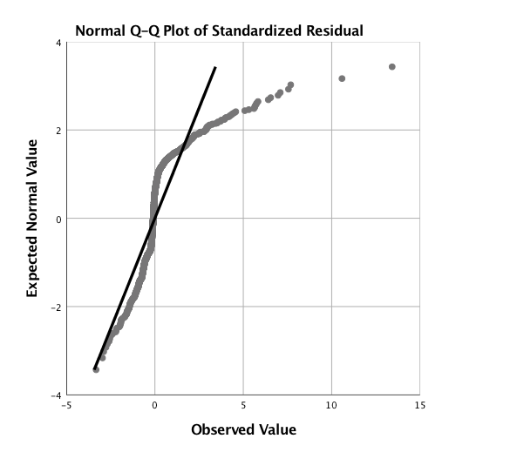

**Natural Log Transformation in First Order Main Effect Multivariate Model**

After performing a natural log Y-transformation, the first order (linear) main effect multivariate model was reassessed (see Table 6, below). The results present an evaluation of how well age, gender, check-in frequency, and membership-type (Personal Training, Financial Aide, Clinical, Standard, Employee) predict the natural log of total annual member spending. Using a global utility F-test at =.05, this regression (which included 8 predictors) was significantly related to the natural log of total member spending, F(9,532) = 30.273, p < 0.0001. This result indicates that at least one of the -coefficients is non-zero. This model yielded the highest observed account of total variability, thus far (R2 = .582; adjusted R2 = .339). However, it should be noted that this is still a low R2 and results continue to suggest that either a different model may better fit this data, or other variables may more accurately predict total member spending.

According to these coefficients, the regression equation is as follows: .

As with previous models, gender and employee variables remain insignificant but have remained in the model for the same reasons explained previously. As a result of the Y-transformation, -coefficients have changed dramatically. As now observed, the estimated natural log of total member spending is predicted to increase 0.014 for every 1-unit increase in age, holding all other variables constant. The estimated natural log of total member spending is predicted to increase by 0.009 for every 1-unit increase in check-in frequency. The estimated natural log of total member spending is predicted to decrease by 0.025 when gender is female. The estimated natural log of total member spending is predicted to increase by 0.716 when membership-type is Personal Training, holding all over variables constant. The estimated natural log of total member spending is predicted to decrease by 1.195 when membership-type is Financial Aide, holding all over variables constant. The estimated natural log of total member spending is predicted to increase by 0.530 when membership-type is Clinical, holding all over variables constant. The estimated natural log of total member spending is predicted to increase by 0.521 when membership-type is Standard, holding all over variables constant. The estimated natural log of total member spending is predicted to decrease by 0.007 when membership-type is employee, holding all over variables constant. The estimated natural log of total member spending is predicted to increase by 0.284 when membership-type is Corporate, holding all over variables constant.

Table 6

*Natural Log Y-Transformation, First Order (Linear) Main Effect Multivariate Regression Model: Gender Included.*

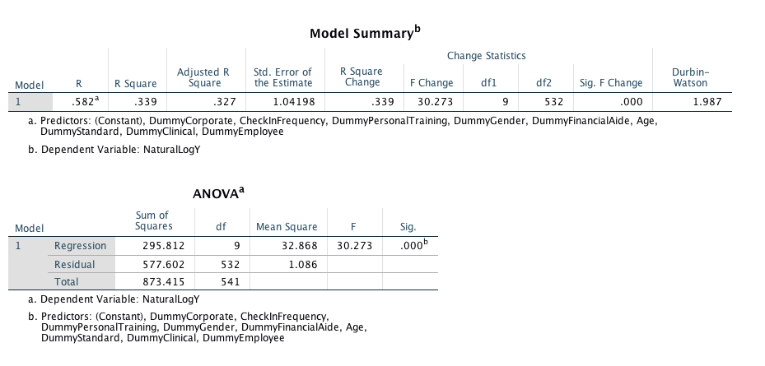

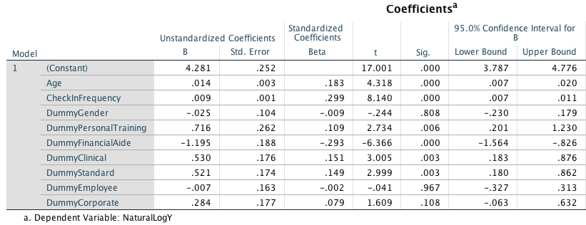

Residuals were re-examined to determine effect of Y-Transformation on the spread of variance. As observed in the scatter plot, P-P plot, and frequency distribution histogram, the natural log transformation of Y greatly improved equality of variance and helped improve normality (see Figure 6, 7, 8).

Figure 6

*Scatter Plot of Natural Log Transformation, First Order (Linear) Main Effect Model*

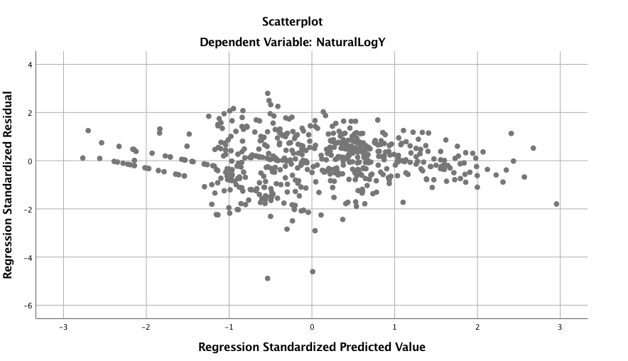

Figure 7

*P-P Plot of Natural Log Transformation, First Order Main Effect Model*

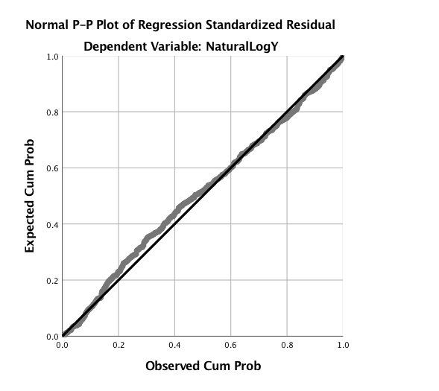

Figure 8

*Frequency Distribution Histogram: Natural Log Transformation, First Order Main Effect Model*

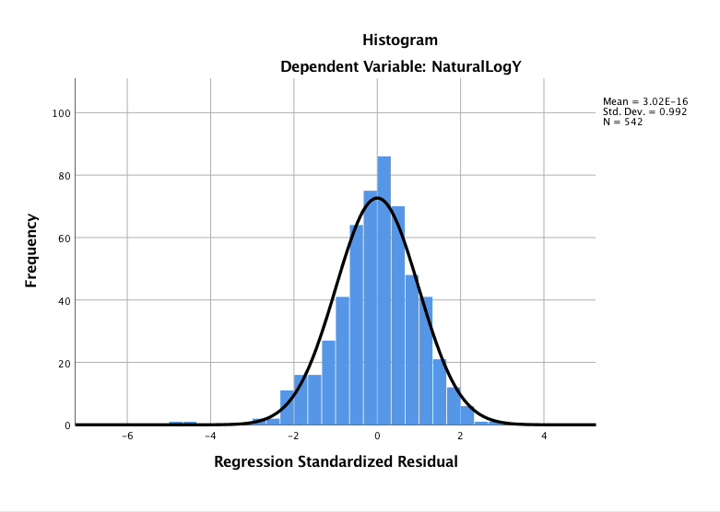

**Second Order Model Analyses: Curve Estimations**

The next step in analysis was to determine whether any interaction terms or higher order terms would be needed. However, as all membership-types were dummy coded as binary 0s or 1s, the only truly meaningful predictors useful for interaction or higher-order terms were age and check-in frequency. A brief curve estimation for age (see Table 6 & Figure 9) and check-in frequency (see Table 7 & Figure 10) were conducted to inspect utility of higher-order terms. Due to similarity between all R2, the linear model was retained.

Table 6

Curve Estimation for Age as a predictor of the natural log of total annual member spending.

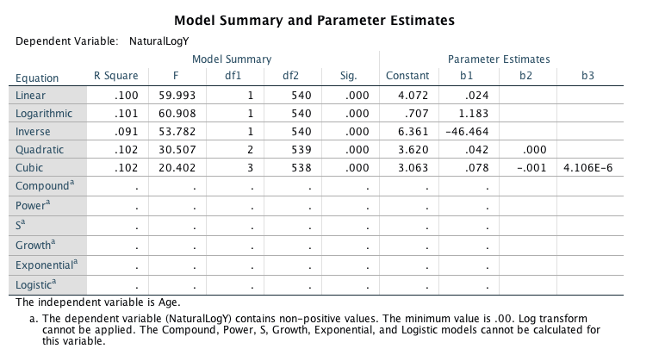

Figure 9

*Scatter Plot for Curve Estimation for Age as a predictor of the natural log of total annual member spending.*

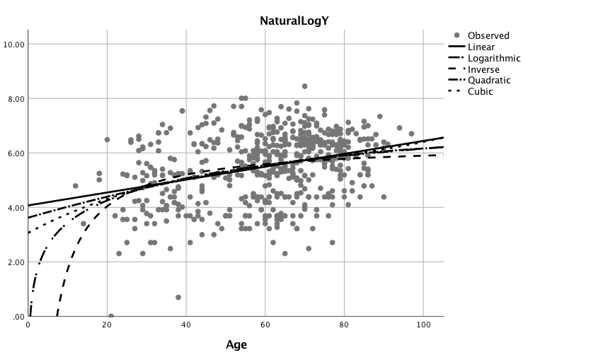

Table 7

*Curve estimation for check-in frequency as a predictor of the natural log of total annual member spending*

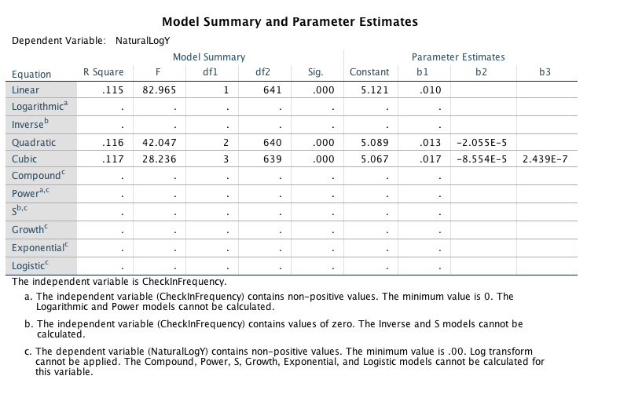

Figure 10

*Scatter Plot for curve estimation for check-in frequency as a predictor of the natural log of total annual member spending.*

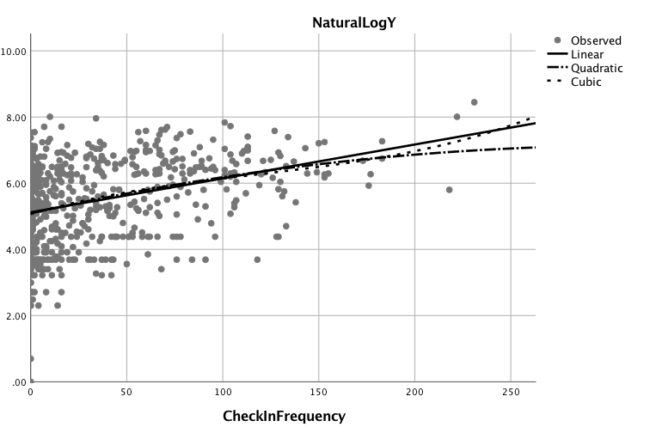

**First Order Analyses: Interaction Term Utility**

Finally, an interaction term was created by transforming variables age * check-in frequency. A First Order (Linear) Interaction Multivariate Model was conducted (see Table 8, below). The results present an evaluation of how well age, gender, check-in frequency, and membership-type (Personal Training, Financial Aide, Clinical, Standard, Employee), and the interaction between age and check-in frequency predict the natural log of total annual member spending. Using a global utility F-test at =.05, this regression (which included 9 predictors) was significantly related to the natural log of total member spending, F(10,531) = 28.166, p < 0.0001. This result indicates that at least one of the -coefficients is non-zero. This model yielded the highest observed account of total variability, thus far (R2 = .589; adjusted R2 = .347). However, it should be noted that this is still a low R2 and results continue to suggest that either a different model may better fit this data, or other variables may more accurately predict total member spending. However, upon further exploration into -coefficients, it was observed that the interaction term resulted in a 0 -coefficient, even though the t-test was significant. As a result, the interaction term was eliminated from the final analysis.

Table 8

*Utility of Interaction Term*

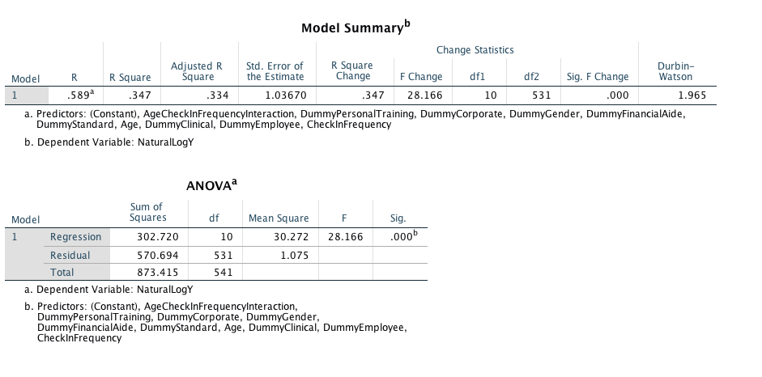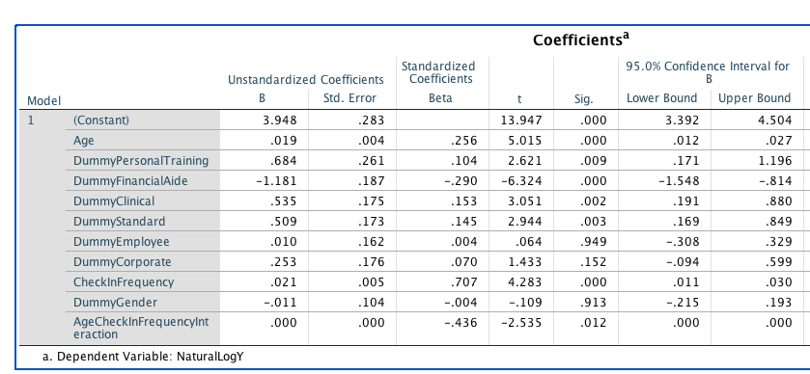

**Final Model: First Order (Linear) Main Effect Multivariate Regression**

The final model chosen to fit this data set was a First Order (Linear) Main Effect Multivariate Regression with a natural log y-transformation (see Table 9 for full output). As previously mentioned, this model evaluated how well age, gender, check-in frequency, and membership-type (Personal Training, Financial Aide, Clinical, Standard, Employee, Corporate) predict the natural log of total annual member spending. Using a global utility F-test at =.05, this regression (which included 9 predictors) was significantly related to the natural log of total member spending, F(9,532) = 30.273, p < 0.0001. This result indicates that at least one of the -coefficients is non-zero. This model accounted for 33.9% of the total variability observed (R2 = .582; adjusted R2 = .339). The general equation is listed below.

+

Where:

According to these coefficients, the regression equation is as follows: .

Table 9

*Final Model SPSS Output*

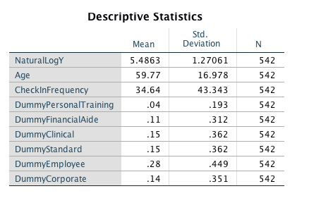

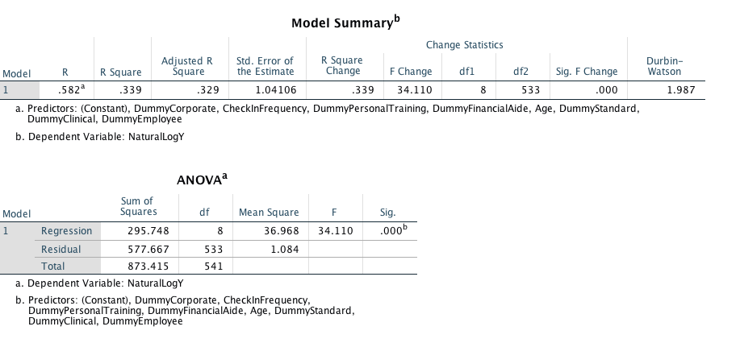

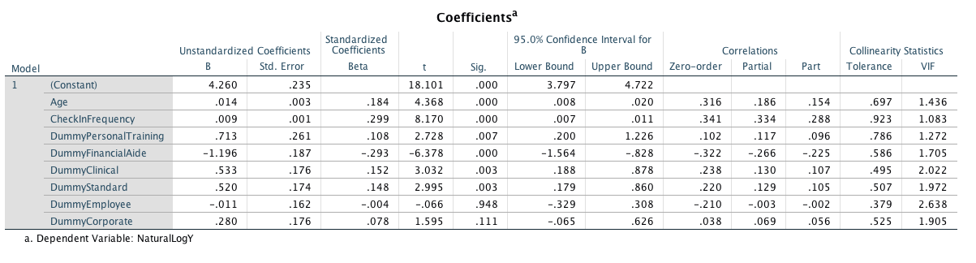

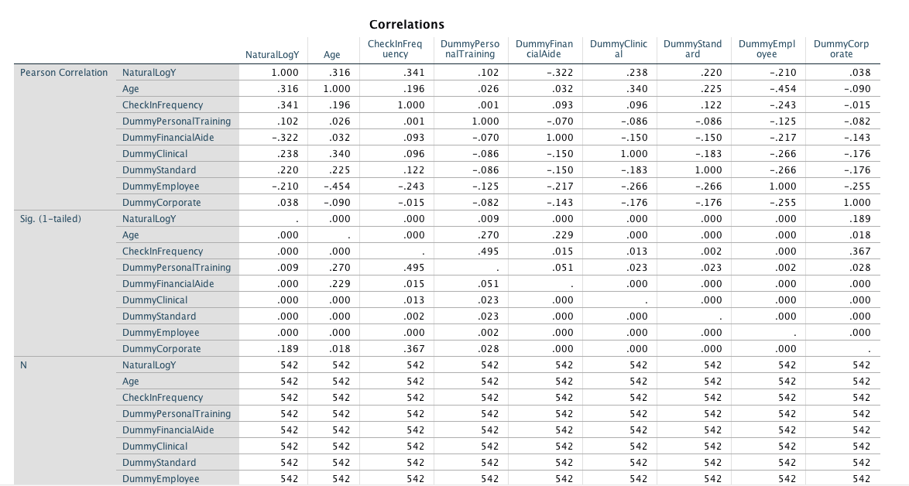

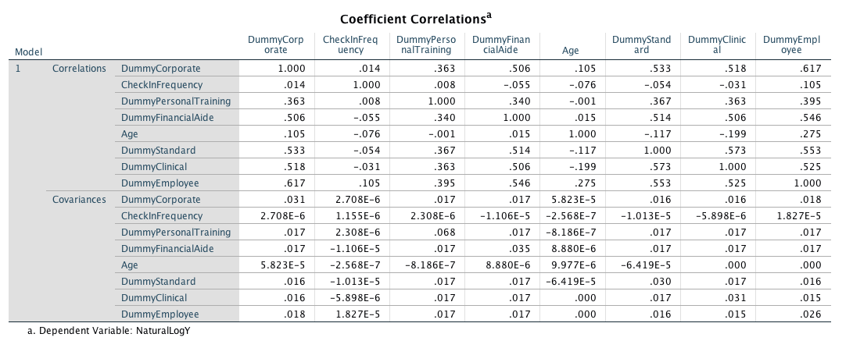

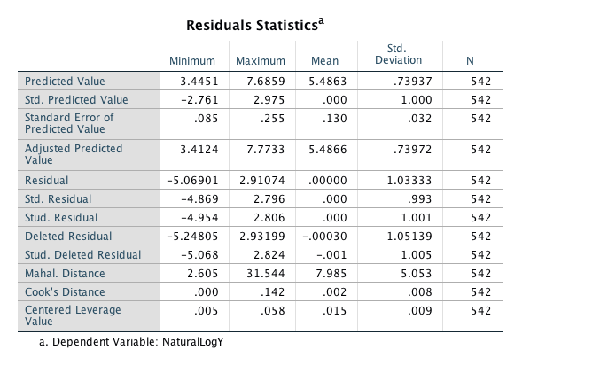

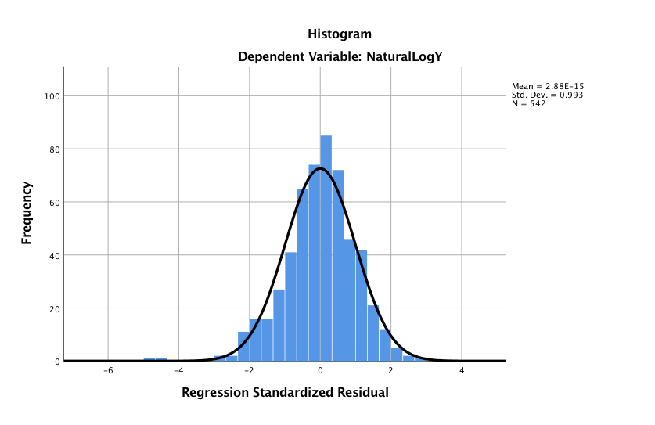

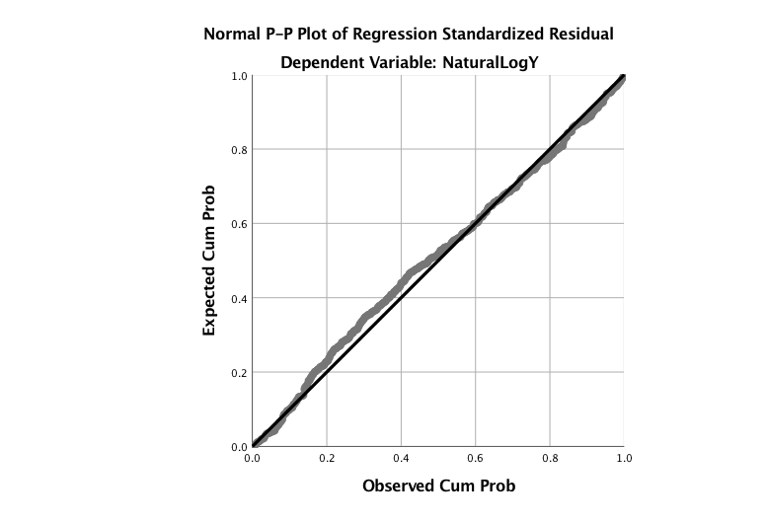

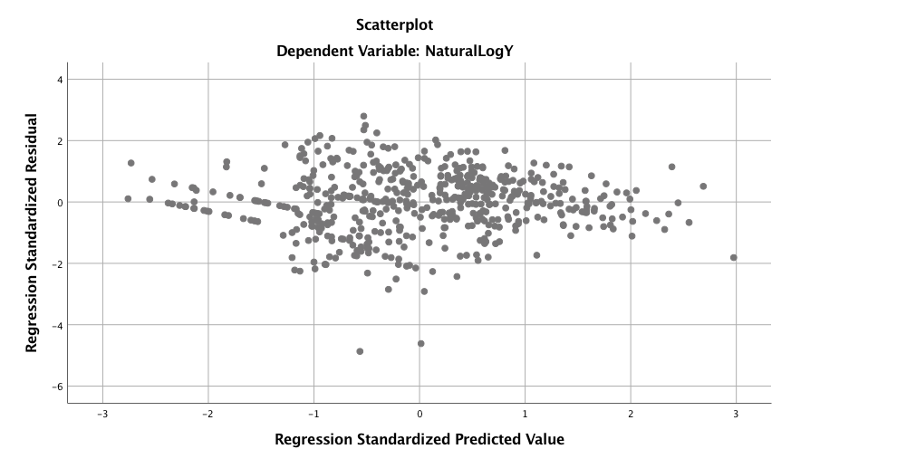

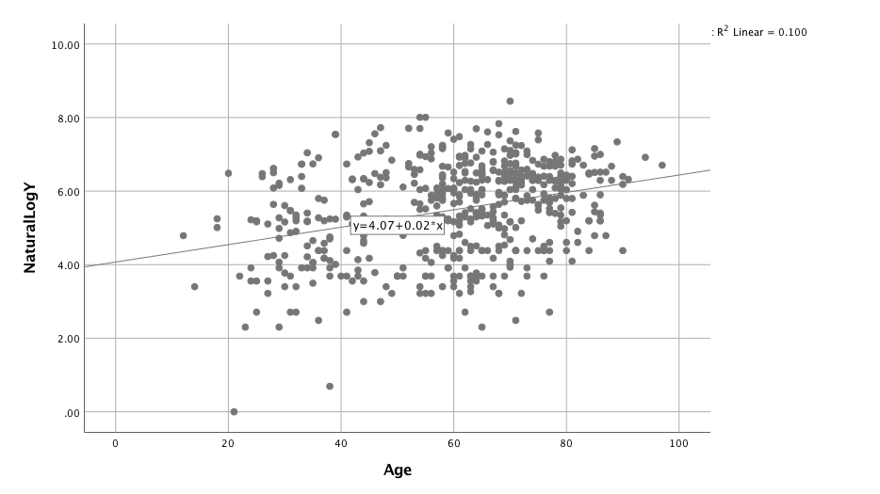

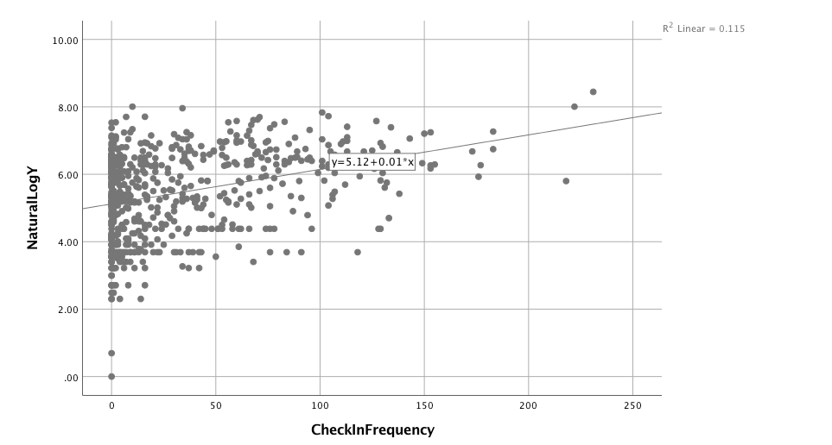

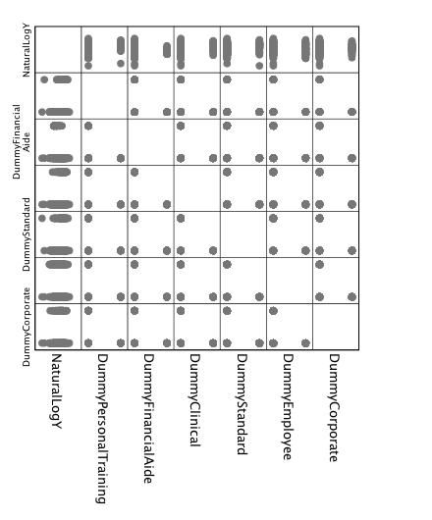

As the residuals and tests for homoscedasticity and normality have already been discussed, the only other regression diagnostics left to conduct were for: outlier detection and influence, collinearity, leverage, and tolerance. After examination of residual plots, outliers border 2 standard deviations from 0 were examined. ZRESIDs were sorted in descending order to identify high and low residual scores (Table 10). All data points were examined for data entry errors and no errors were found. High and low scores likely reflect differences in membership payment types. For example, employees do not pay a membership fee. Thus, their total member spending is only a result of retail, massage, or personal training purchases, or special outpatient program enrollment.

Table 10

*Highest and Lowest Standardized Residual Scores for Outlier Detection*

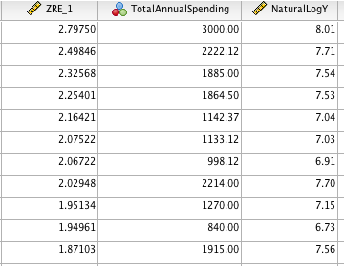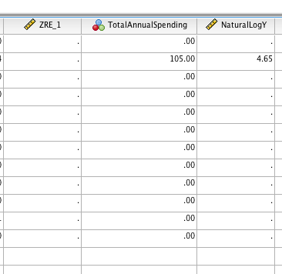

Leverage was also examined in the final model. Leverage (abbreviated hi) measures the extent to which the predictor differs from the mean of the predictor and it is a function of the scores on the independent variable. Large deviations of x1 from yield a large leverage. The maximum leverage allotted is 1 and the general rule of thumb to determine a high leverage is:

For this data set:

As displayed in Table 11, the Leverage values for each subject were sorted in descending order for further examination. Seventy cases (12.91% of all subjects) presented with a leverage score higher than the recommended value. The top 23 cases are displayed in Table 11. It appears that higher leverage scores are mostly associated with Personal Training Membership.

To further examine the influence of outliers, Cook’s Distances (Di) were also examined. Cook’s Distance combines information regarding residuals and leverage. As such, Cook’s Distance identifies influential observations whose influence is due to status on the independent variable, dependent variable, or both. Therefor, Cook’s Distance is large when the SRESID is large, the leverage is large, or both. Cook’s Distance starts at 0 (as the lowest possible value) and increases as the influence increases. The general rule of thumb for high Cook’s Distance is 4/n.

For this data set:

Nineteen cases (3.49% of total cases) were found to have a high Cook’s Distance (see Table 12). There were no data entry errors among any of these cases and total spending was varied across membership categories, check-in frequencies, age, and gender – no apparent trends were visible.

Table 11

*Top Cases with High Leverage*

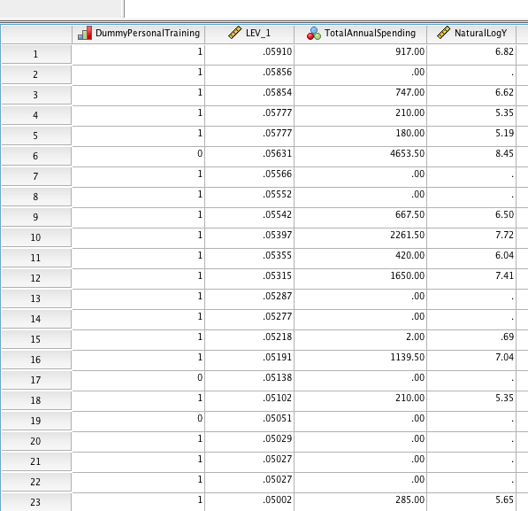

Table 12

*Top Cases with High Cook’s Distance*

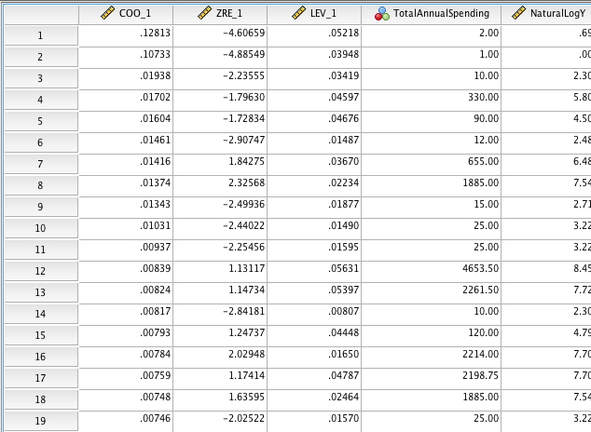

Examination of correlations yield no significant trends, variance inflation factors all remain well below the standard cutoff of 10, and all tolerance factors remain well above the standard cutoff of 0.01. As such, it is believed that the assumptions of fixed x and independent errors remain valid (see previous output in Table 9).

**Testing Model and Comparison of Models**

The final step in analysis was to examine all variables and only include necessary or relevant variables. To do so, a stepwise regression analysis was conducted, iterating the model-building processes by running a first order main effect model sequentially adding in one variable at a time (see Table 13). As observed from the output of the stepwise regression, with each sequential addition of one of the selected predictor variables, the total variance accounted for by the model (R2) increases, while the standard error of estimate (SEE) decreases. This trend continues until the final two variables are included. Step 8 (shown as Model 8 below) represents the addition of Personal Training membership-type. Notice that this membership category decreases the total variance accounted for and increases the SEE. However, the global F-test continued to show the overall model as significant and the local t-test continued to show the -coefficient as a significant contributor to the model. This change in variability and error likely have to do with high leverage in Personal Training Membership.

As previously mentioned, gender and employee memberships remained in the model. Step 9 (shown as Model 9 below) added Gender into the regression analysis. Although the total variance accounted for increases, the adjusted R2 remained the same. However, the SEE decreases with the inclusion of this variable. Step 10 (shown as Model 10 below) added Employee Membership into the regression equation. Here, the total variance accounted for does not change; however, the SEE increases from the value observed from model 9 (but is still less than that observed in model 8). As discussed previously, Employee’s do not pay a membership fee. As a result, there is a high variance amongst employee total spending – some paying absolutely nothing, some paying more than all others. By the end of the stepwise regression, the full model remained significant yielding a p<.0001 global F-statistic. The stepwise regression allows for researchers to easily manage a high number of predictor variables.

Table 13

*Stepwise Regression Analysis*

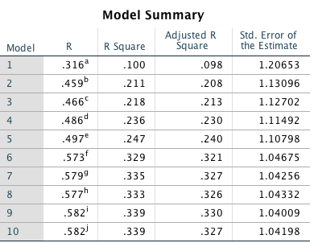

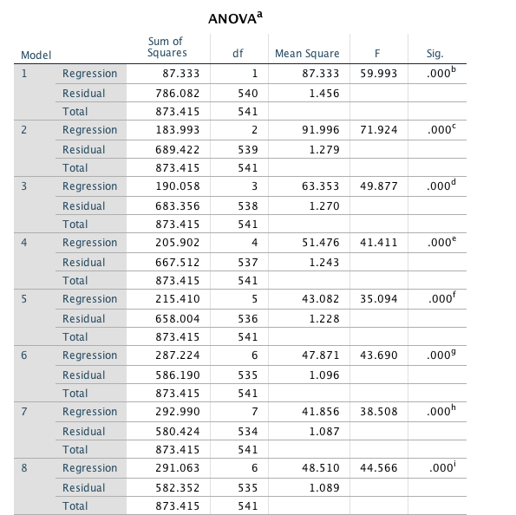

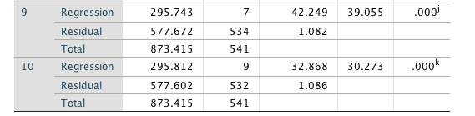

**Conclusion**

After all analyses were complete, the final First Order (linear) Main Effect Multivariate Model was:

+

Where:

This model evaluated how well age, gender, check-in frequency, and membership-type (Personal Training, Financial Aide, Clinical, Standard, Employee, Corporate) predict the natural log of total annual member spending. Using a global utility F-test at =.05, this regression (which included 9 predictors) was significantly related to the natural log of total member spending, F(9,532) = 30.273, p < 0.0001. This result indicates that at least one of the -coefficients is non-zero. This model accounted for 33.9% of the total variability observed (R2 = .582; adjusted R2 = .339).

According to these coefficients, the regression equation is as follows: .

**Interpretations**

There is a significant main effect of age on total member spending. As age increases, so too does member spending, if all other variables are held constant. While LifeFit members range in age from 9 to 97, 19.28% of LifeFit members are in their 60s and 16.05% are in their 50s. The average age of a LifeFit member is 50 years old. Marketing directed at these individuals may be more likely to increase total member spending.

There is a significant main effect of check-in frequency on total member spending. As check-in frequency increases, so too does member spending, if all other variables are held constant. Annual LifeFit check-ins range from 0 to 231. Unfortunately, check-ins average only 12 annually (i.e., once per month). Both the median and the mode check-in frequency is 0. While the majority of members pay for a membership they do not utilize, the members who do check-in are more likely to purchase other services and this likelihood increases as their check-in frequency increases. Special attention should be paid to the ways in which LifeFit can increase member utilization.

There was no significant main effect of zip code on total member spending (and the analysis was excluded from the model). Thus, marketing need not direct to any specific location. Similarly, there was no significant main effect of gender on total member spending. However, gender was included in the model as there is a large gender gap in membership. 69.90% of members are female while only 30.10% of members are males. Due to the fact that there was no observed difference in total member spending between genders, marketing may want to increasing its target to better include male members.

Only the following membership categories significantly influence total member spending: financial aid (decreasing total member spending, if all other variables are held constant), standard, clinical, corporate, and personal training (all of which increase total member spending, if all other variables are held constant). The strongest predictor of total member spending in this model is Financial Aid. Marketing may need to include socio-economic status, education, or employment in further analyses to help between identify patient population demographics requiring financial aid. Personal Training membership is the second strongest predictor of total member spending in this model. Personal training members spend more money than all other membership categories. Marketing may want to identify factors that influence members to purchase personal training.

Due to the fact that the remaining 22 membership categories did not contribute significantly to this model, it is suggested that LifeFit consider consolidating membership types. Not only would this ease confusion for Front Desk sales staff, but may provide better opportunity for further analyses in the future. LifeFit may consider consolidating all Family memberships into one category and combining all Chronic Disease Management-type memberships into another category. The remaining memberships may easily fit into one of the significant predictors.

Due to the fact that Beaufort Memorial Hospital values their employee health, all employees receive a free membership to LifeFit. Thus, total member spending within this category is distributed differently than other membership-types. To offset free membership, LifeFit should consider ways to increase employee utilization (check-in frequency) and encourage employees to purchase special-training programs.

As for targeted marketing to Senior Citizens with Silver Sneakers, based on these results, it is not recommended as a service line for LifeFit Wellness Services. All members ages 65 or older currently pay a monthly membership fee ranging from $25 to $55. This monthly membership fee is charged regardless of check-in frequency. Silver Sneakers would only reimburse LifeFit $2.50 per check-in up to $25 per month for each authorized member. A silver Sneakers member would need to check into the facility at least 12 times per month in order for LifeFit to receive full reimbursement. Of the 781 current LifeFit members ages 65+, only 11 of them check-in 12 times per month.

A fair amount of LifeFit’s revenue is accrued from gym non-use. However, as this regression analysis indicated, check-ins tend to increase member spending, if all other variables are held constant. It is highly recommended that LifeFit consider ways in which to increase overall membership utilization, increase personal training sales, target small population of male gym-goers, and target the high population of members between the ages of 50 and 60 years old.