**eSim2022 BTAP Workshop Exercise 1 Instructions**

Chris Kirney

2022-06-15

Exercise 1:

If you don’t like any of the stock building types available in BTAP, you can use your own OpenStudio model by using the following steps. Creating geometries is beyond the scope of this exercise but there are many tutorials online that can help guide you. This exercise assumes that you have an OpenStudio 3.2.1 (or previous) file containing the geometry of the building you want to model. The surfaces and sub-surfaces in this model should all be correctly defined and matched appropriately. The building stories should be correctly defined and each space should be assigned a building story. The ‘Standards Number of Stories’ and ‘Standards Number of Above Ground Stories’ (in the facilities tab) should also be correctly defined. Finally, the model should be not have anything else in it (no constructions, thermal zones, schedules, loads, HVAC, service hot water, etc.)

In this exercise we will modify an OpenStudio file with just a geometry to be used with BTAP.

1. In the OpenStudioApp open the ‘/btap_batch/esim2022/resources/space_type_libary/NECB2011_space_types.osm’ file (File>>Open>> btap_batch/esim2022/resources/space_type_libary/NECB2011_space_types.osm).
2. When asked if you want to save changes select ‘Discard’.
3. On the left side of the OpenStudioApp window select the ‘Space Types’ menu and then select the ‘Measure Tags’ tab (see below)

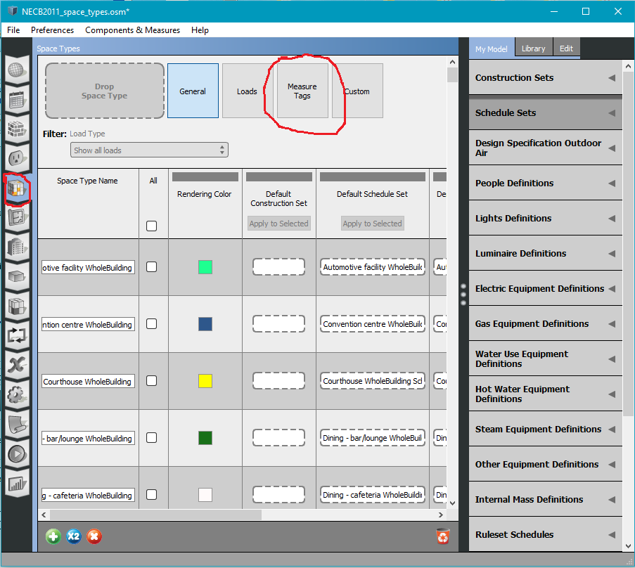

1. The screen may take a little while to open. When it does it should look like the following:

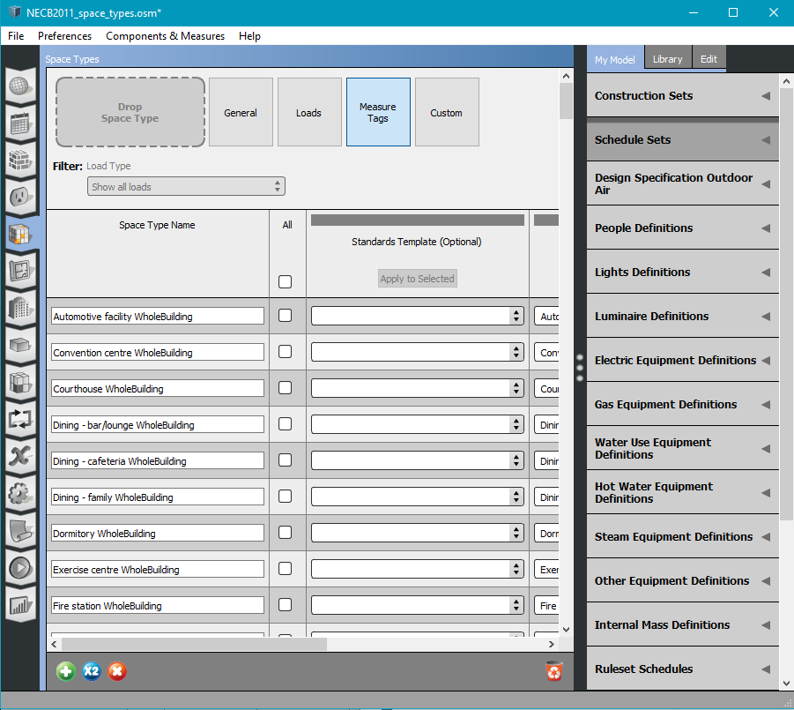

1. This screen shows all of the available NECB 2011 space types in BTAP. There are two types: ‘WholeBuilding’ and ‘Space Function’. The ‘WholeBuilding’ space types are intended to be used for an entire model. However, they are not fully implemented in BTAP yet so please do not use them. The ‘Space Function’ space types are intended to be used to define how individual spaces in a model are used. We will be using ‘Space Function’ space types for the remainder of this exercise.
2. Open a new instance of the OpenStudioApp and open the ‘/btap_batch/esim2022/exercise1.osm’ file (File>>Open>>btap_batch/esim2022/exercise1.osm).
3. In the ‘exercise1.osm’ file go to the ‘Measure Tags’ tab in the ‘Space Types’ menu.
4. We will now add the space types we want to use in the ‘exercise1.osm’ file. To start, in the ‘exercise1.osm’ file click the little green + at the bottom of the screen to add a new space type (see below):

1. Go back to the ‘NECB2011_space_types.osm’ file and look for ‘Space Function Dwelling Unit(s)’ in the ‘Space Type Name’ column (see below):

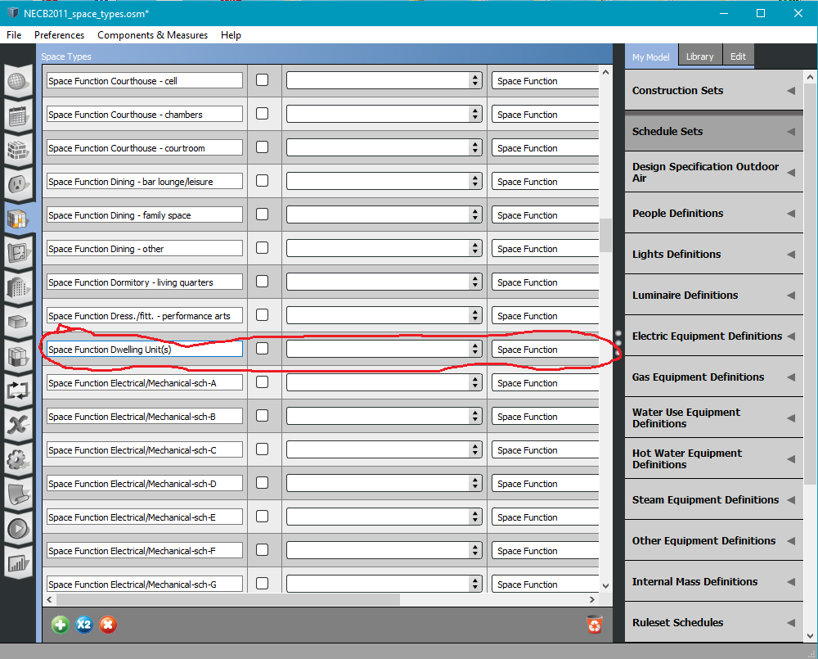

1. Copy the ‘Space Function Dwelling Unit(s)’ name and then switch to the ‘exercise1.osm’. Replace ‘Space Type 1’ under the ‘Space Type Name’ column with ‘Space Function Dwelling Units(s)’ (see below):

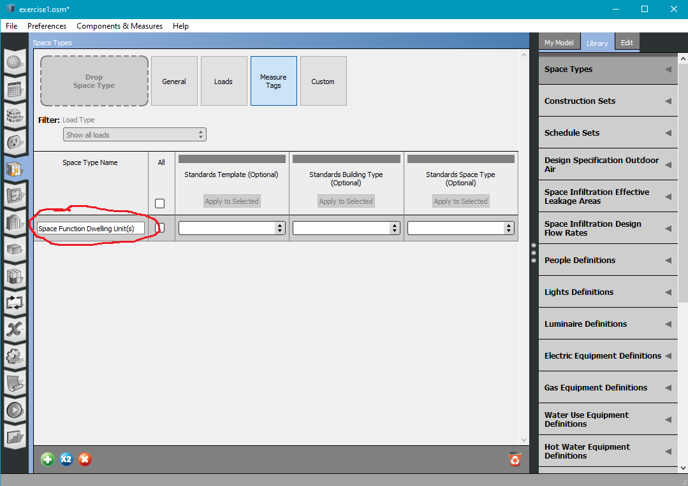

1. In the ‘exercise1.osm’ file type ‘Space Function’ in the empty box in the ‘Standard Building Type (Optional)’ column of the ‘Space Function Dwelling Units(s)’ row (see below):

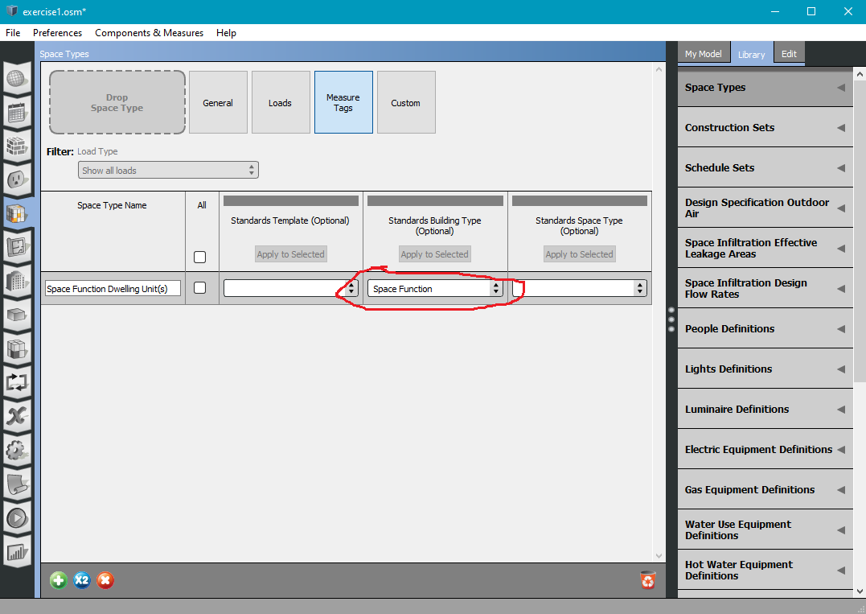

1. Add ‘Dwelling Units(s) in the empty box of the ‘Standards Space Type (Optional)’ column of the ‘Space Function Dwelling Unit(s) row (see below):

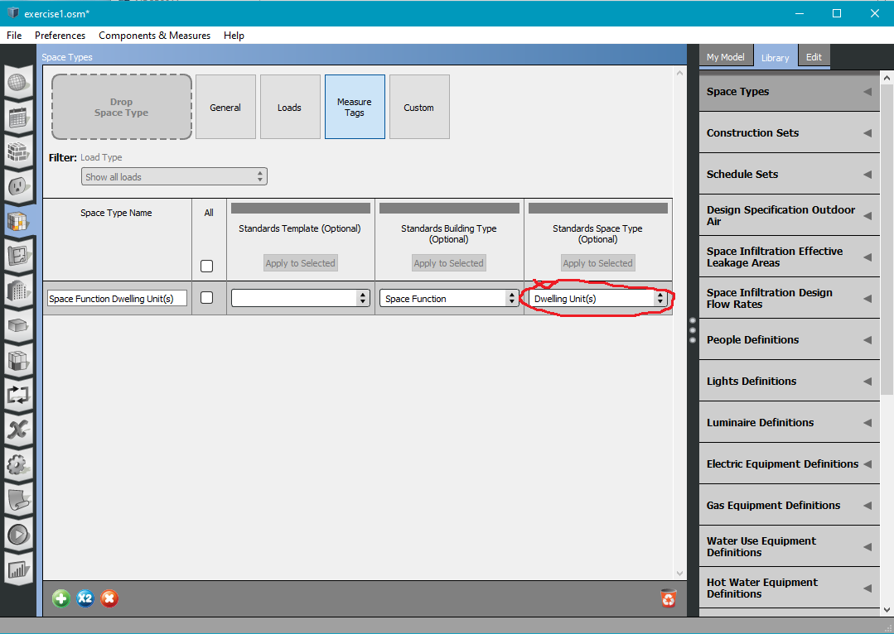

1. When you are done Add another space type by clicking on the little green ‘+’ (see below):

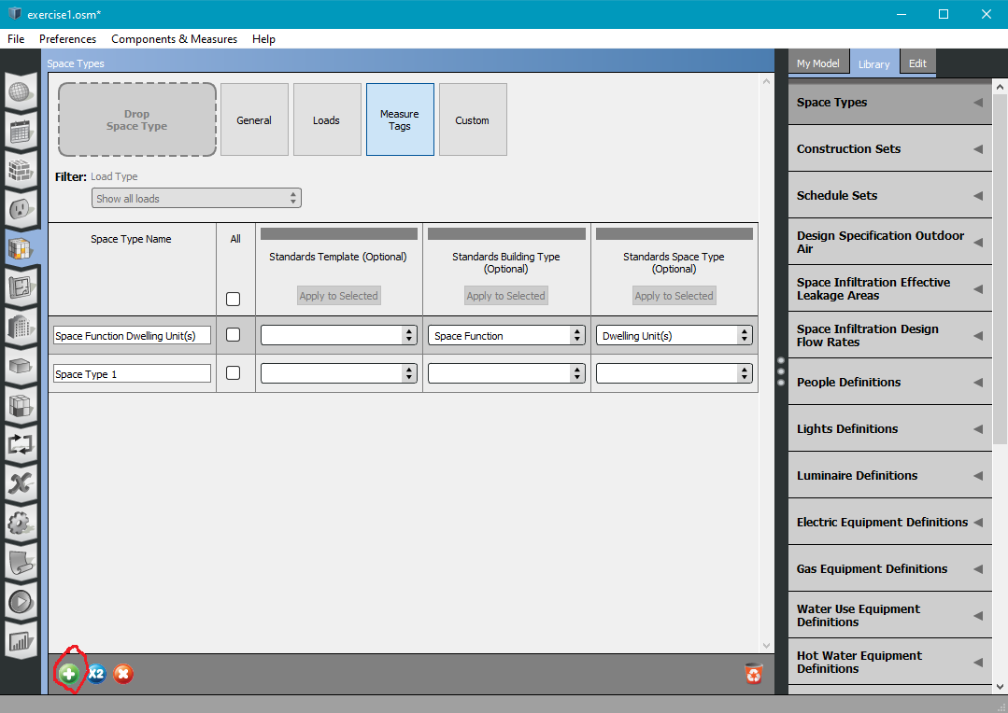

1. Save the modified ‘exercise1.osm’ file with a new name (File>>Save As>>exercise1a.osm).
2. Note that we added the first part of the space type name (‘Space Function’) in the ‘Standards Building Type (Optional)’ column.
3. Also note that we added the second part of the space type name (‘Dwelling Units(s)’) in the ‘Standards Space Type (Optional)’ column.
4. If you go back to the ‘NECB2011_space_types.osm’ file you will notice that, for ‘Space Function Dwelling Unit(s)’, the same information is in the ‘Standards Building Type (Optional’) and ‘Standards Space Type (Optional’ columns (see below):

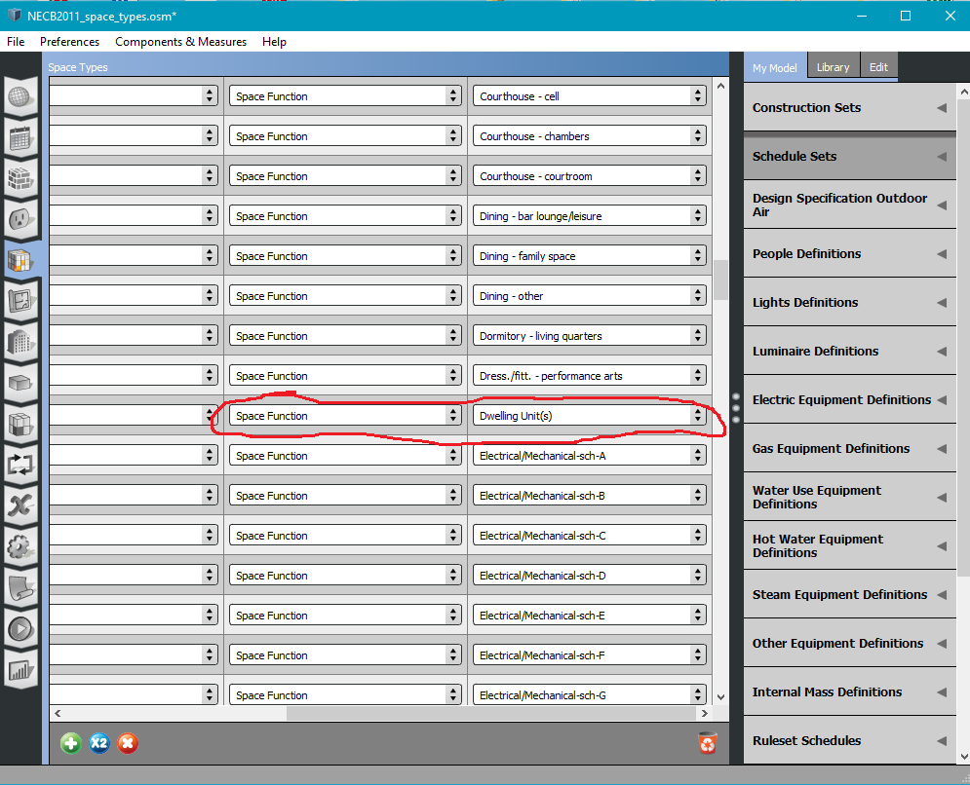

1. It is VERY IMPORTANT that what you added in the ‘Standards Building Type (Optional)’ and ‘Standards Space Type (Optional)’ columns of the ‘exercise1.osm’ file match what you found in the same columns in the ‘NECB_space_types.osm’ file. Make sure that the cases match and that there are no leading or trailing spaces. The reason for this is that BTAP will look for these names in its space type database to get the space type information.
2. Repeat steps 9 through 14 for the following 6 space types:

|  |  |  |
| --- | --- | --- |
| Space Type Name | Standards Building Type | Standards Space Type |
| Space Function Corr. < 2.4m wide-sch-G | Space Function | Corr. < 2.4m wide-sch-G |
| Space Function Conf./meet./multi-purpose | Space Function | Conf./meet./multi-purpose |
| Space Function Electrical/Mechanical-sch-A | Space Function | Electrical/Mechanical-sch-A |
| Space Function Electrical/Mechanical-sch-G | Space Function | Electrical/Mechanical-sch-G |
| Space Function Food preparation | Space Function | Food preparation |
| Space Function Office - open plan | Space Function | Office - open plan |

1. By the end, you should see something like the following:

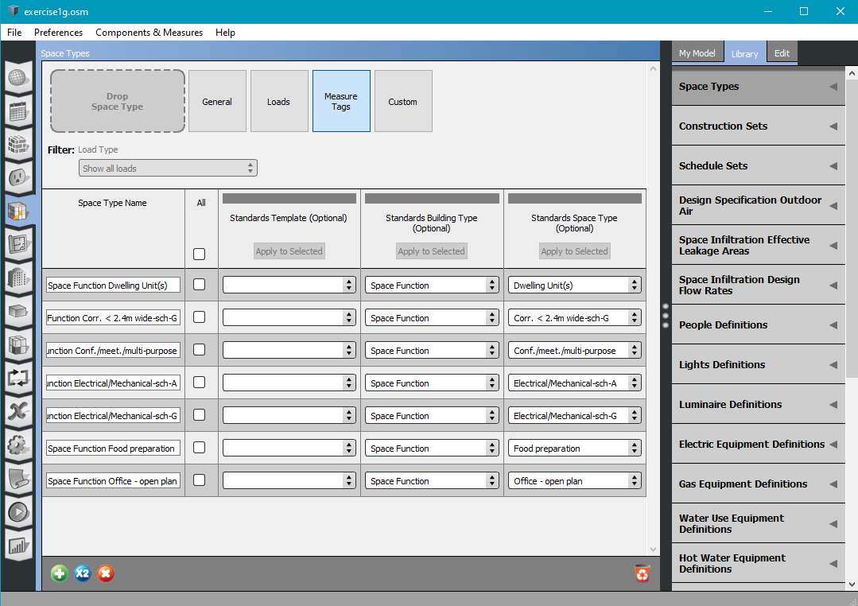

1. BTAP requires that every space has a thermal zone associated with it. These end of getting replaced later on however, initially they are necessary. In the exercise file click on the ‘Thermal Zones’ menu on the left. There are 17 spaces in the file so click the green + button until there are 17 thermal zones (see below):

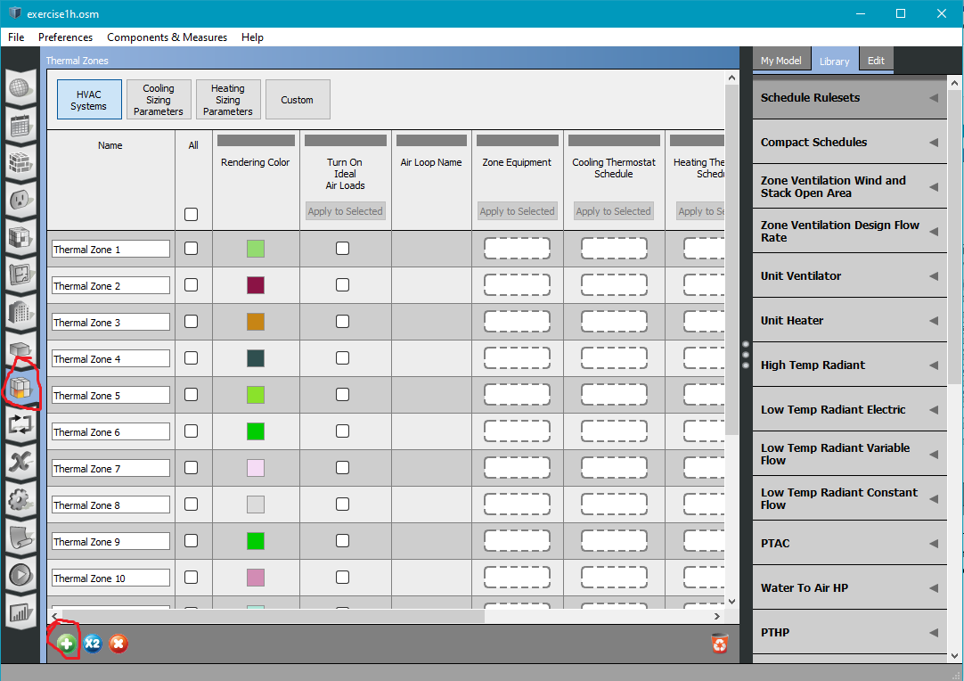

1. Save the file under a new name again (I’ll use ‘exercise1h.osm’).
2. Select the ‘Spaces’ menu on the left (see below):



1. Now we have to assign each space a thermal zone and a space type. To do this click on the ‘My Model’ tab on the left hand side of the screen and click on ‘Space Types’ (see below):

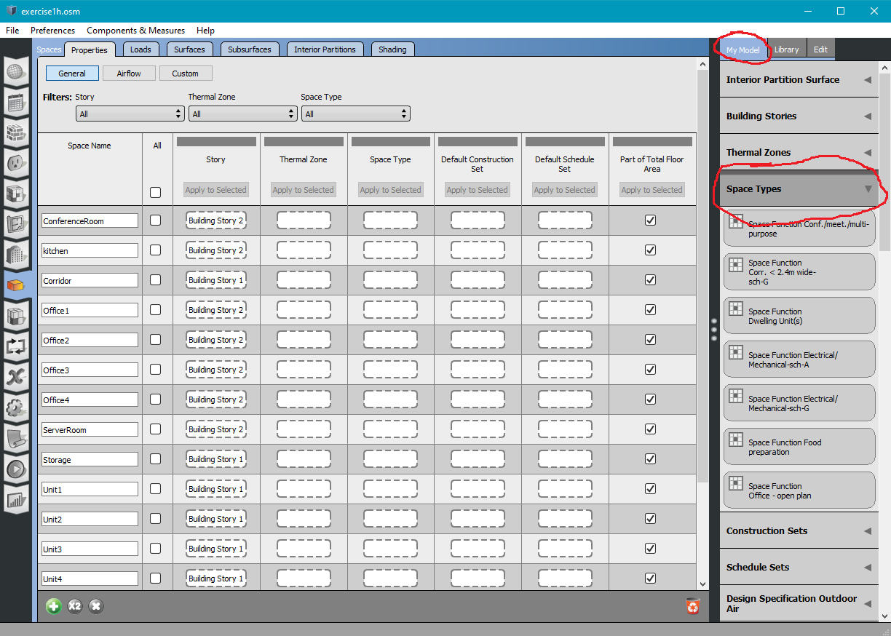

1. Look for the ‘Space Function Conf./meet./multi-purpose’ space type in the ‘Space Types’ drop-down menu then drag and drop it in the ‘Space Type’ Column spot for the ‘ConferenceRoom’ space (see below):

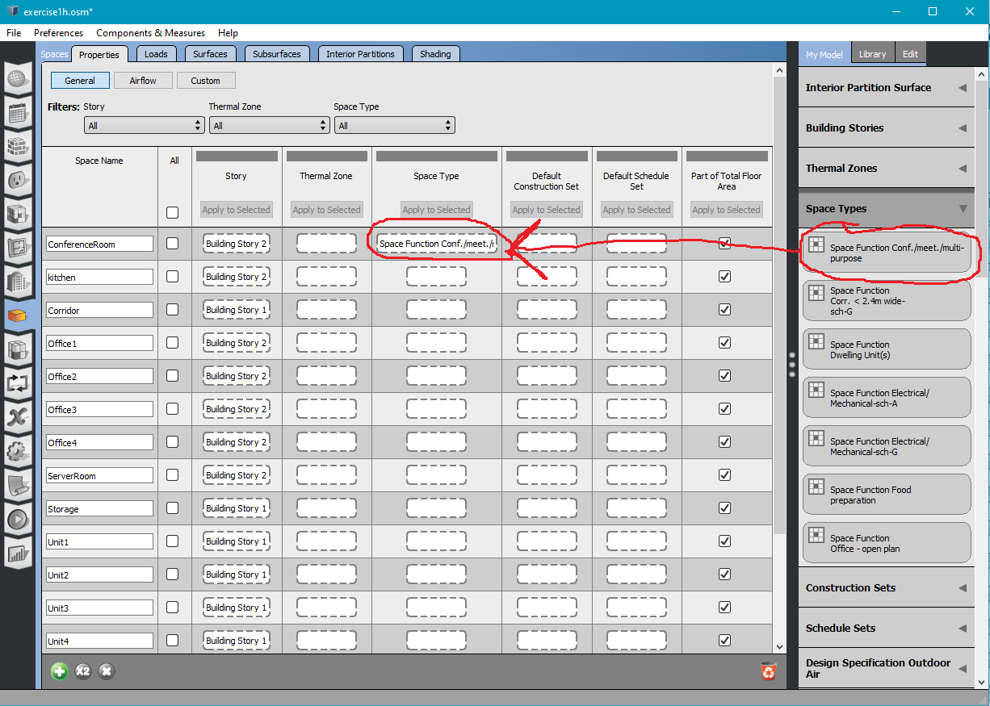

1. Repeat step 25 only assigning the space types to the spaces in the following table:

|  |  |
| --- | --- |
| Space Name | Space Type |
| Kitchen | Food preparation |
| Corridor | Corr. < 2.4m wide-sch-G |
| Office1 | Office - open plan |
| Office2 | Office - open plan |
| Office3 | Office - open plan |
| Office4 | Office - open plan |
| ServerRoom | Electrical/Mechanical-sch-A |
| Storage | Electrical/Mechanical-sch-G |
| Unit1 | Dwelling Unit(s) |
| Unit2 | Dwelling Unit(s) |
| Unit3 | Dwelling Unit(s) |
| Unit4 | Dwelling Unit(s) |
| Unit5 | Dwelling Unit(s) |
| Unit6 | Dwelling Unit(s) |
| Unit7 | Dwelling Unit(s) |
| Unit8 | Dwelling Unit(s) |

1. At the end you should see the following:

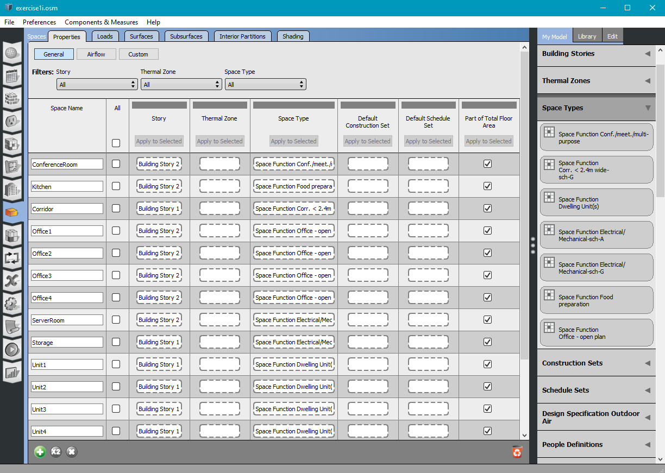

1. Now it is time to assign thermal zones. Under the ‘My Model’ heading (on the right side of the window) select the ‘Thermal Zones’ drop-down menu (see below):

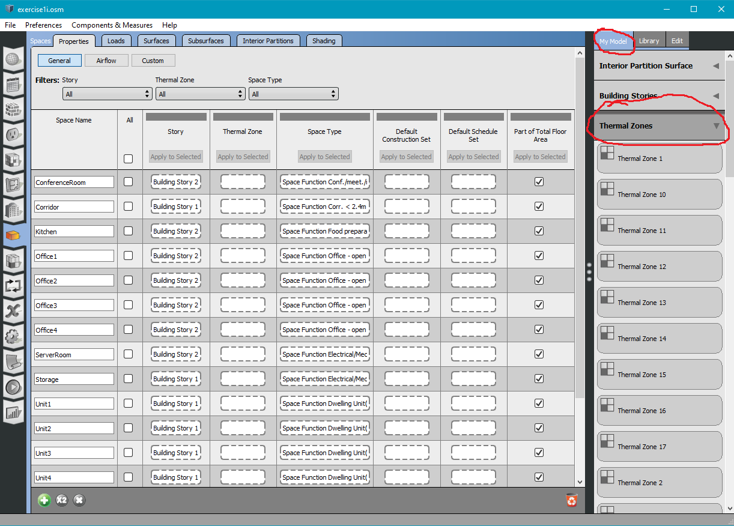

1. Find ‘Thermal Zone 1’ and drag and drop it in the ‘Thermal Zone’ column spot in the ‘ConferenceRoom’ space (see below):

1. Repeat step 29 assigning the thermal zones to the spaces in the table below:

|  |  |
| --- | --- |
| Space Name | Thermal Zone |
| Corridor | Thermal Zone 2 |
| Kitchen | Thermal Zone 3 |
| Office1 | Thermal Zone 4 |
| Office2 | Thermal Zone 5 |
| Office3 | Thermal Zone 6 |
| Office4 | Thermal Zone 7 |
| ServerRoom | Thermal Zone 8 |
| Storage | Thermal Zone 9 |
| Unit1 | Thermal Zone 10 |
| Unit2 | Thermal Zone 11 |
| Unit3 | Thermal Zone 12 |
| Unit4 | Thermal Zone 13 |
| Unit5 | Thermal Zone 14 |
| Unit6 | Thermal Zone 15 |
| Unit7 | Thermal Zone 16 |
| Unit8 | Thermal Zone 17 |

1. It is a good idea to save the file again with a new name now (I’ll use ‘exercise1j.osm’)
2. Now select the ‘Facilities’ menu on the left hand side of the Window (see below):

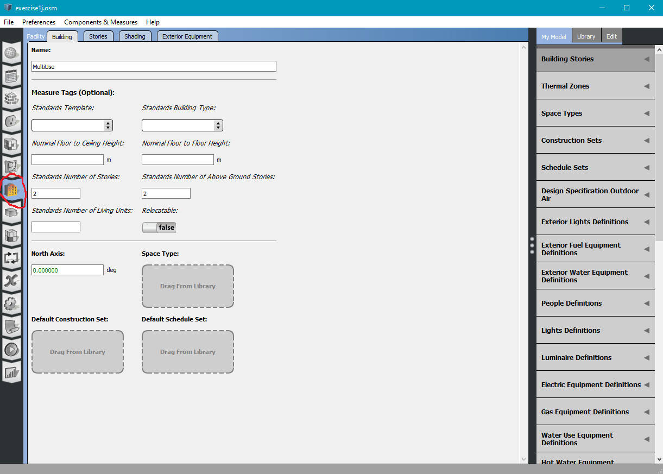

1. In the menu under ‘Standards Template:’ select ‘NECB2011’. In the menu under ‘Standards Building Type:’ type ‘multiuse’ (see below):

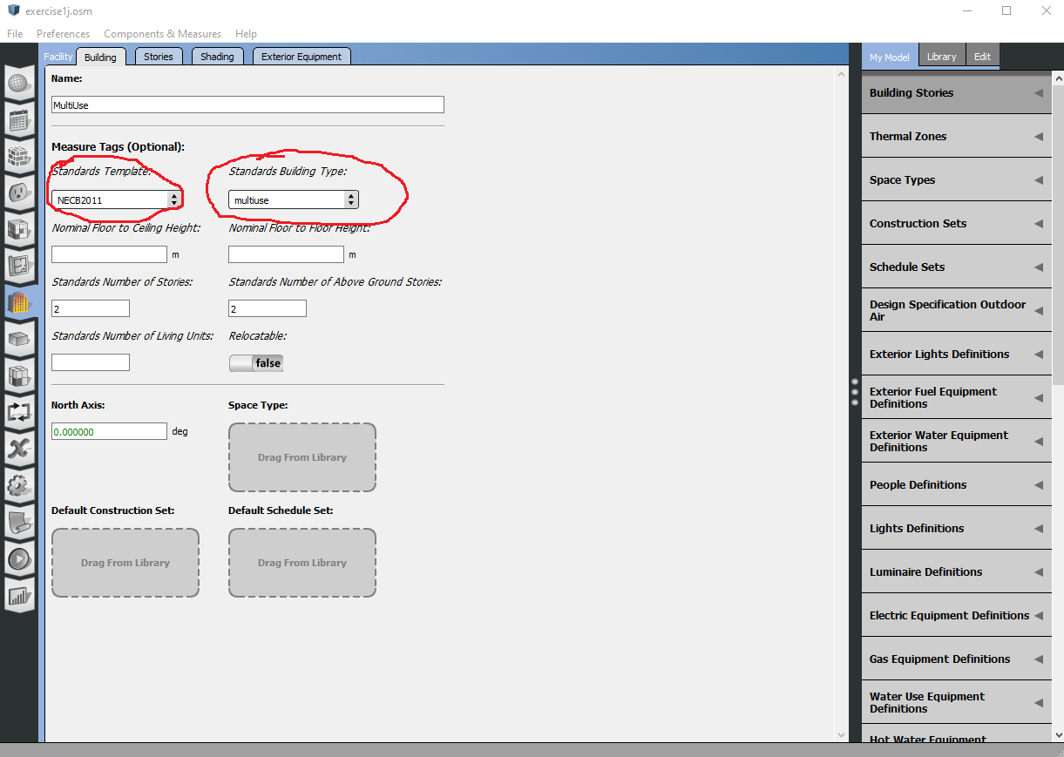

1. These aren’t really used but the current code requires it (this will likely be changed in future versions of BTAP.
2. Save the file again with a new name (I’ll use ‘exercise1k.osm’).
3. Congratulations! You now have a new geometry file that can be used with BTAP.
4. The next step is to use btap_batch to create NECB compliant reference buildings using this new geometry file.