**Learning to learn**

**Learning Objectives**

After completing this unit, you’ll be able to:



• Understand the 7 fundamentals of learning to learn

• Apply strategies to study more effectively

• Recognise the most important Self-learning skills

• Reflect on your study approach

**The fundamentals of learning to learn**

March 15, 2020 is a day that many Dutch primary school children, their parents, and teachers will not soon forget. That day, primary schools had to close their doors under the COVID-19 measures. Millions of people had to figure out what to do next (and fast).

Luckily many among millions asked themselves questions like these:

• What can I do if my school/college/job doesn’t reopen soon? • How can I make the most valuable use of my time? • What can I do now so I don’t fall behind learning/working? • If I wanted to start learning/teaching/working online, where would I even start?

TechGrounds has shown that through an online learning program dozens of participants can learn new skills and succeed in landing an IT job. These successful learning achievements are mainly based on an educational model in which learning to learn is central.

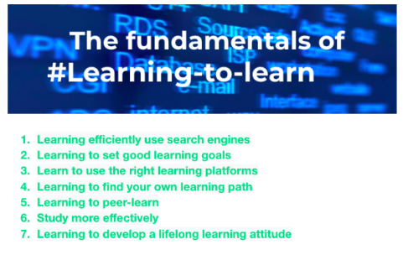**Self-directed learning**

The first four fundamentals of learning to learn are characteristics of self directed learning. A teacher is no longer the central figure in the learning environment. Instead, the participants are behind the wheel of their own learning journey.

Changing technologies in information technology are challenging the learning of individual students and workers. Companies more and more require their employees to be self-directed in their professional development. Learning and thus keeping pace with technological innovation and the expectations of companies is increasingly considered the responsibility of the individual professional and its team and takes place in practice without strong control of the organisation.

In short, self-directed learners can stay ahead by taking the initiative to set learning goals, find resources for learning, implementing appropriate strategies, and evaluate learning outcomes.

**Learning to peer-learn**

From the beginning of your learning journey you will be supported by your peers. Learning coaches serve as your guides, using their knowledge and experience to support you in creating a learning path and achieving your goals.

As described in ‘De onderwijs Principes van TechGrounds' Peer learning, or learning from and with each other, is an incredibly important part of TechGrounds for various reasons. You understand concepts a little better and remember it longer if you can explain it to someone else. Also, peer support in learning is more effective than teachers’ explanations (who we call learning coaches), because peers can give explanations or offer support based on their efforts to understand the same concepts or solve the same problems. They better understand what their peers don't understand and how to explain it. An important additional effect is that learning from and with each other brings cohesion in the group. Helping each other leads to build deeper relationships. It provides a safe learning environment. The role of peers is twofold. Peers support each other in the execution of assignments or project tasks. This with the aim that the other can independently perform these tasks. To do so peers should take into account the following:

• Peers help formulate questions

• Peers are providing direction (no direct answers)

• Peers listen to explanation when other Peer explains the solution or approach

• Peers share their insights plenary

In addition, peers also support each other as peer coaches in achieving professional and personal goals that they have set as OKRs. As shown, peers support each other in achieving their objectives. This can be during the lessons but also outside course sessions. Peer support can focus on both professional and personal objectives. For instance, modeling how to solve a coding problem or asking about your objective to go to bed on time are both examples of peer support.

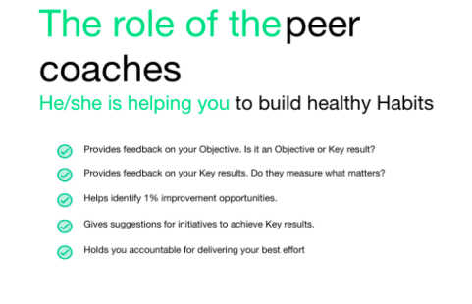**Study more effectively**

"That's not how I learn" or "I’m more of a … learner". Two statements that indicate that your conversation about learning has stalled. Whether you talk to your mother about updating an operating system or discuss in a (virtual) classroom how to prepare for an exam, sooner or later someone will make a statement about his or her learning style and basically say, "I'm doing this my way! “. Your beliefs about learning can influence whether or not you manage to process the course material. We have all developed beliefs about our learning. For example, someone may be convinced that they learn best by summarizing everything or rereading text several times.

It is not uncommon that our beliefs about learning aren’t accurate and based on false assumptions. Cognitive psychologist Dr. Stephen Chew calls these “beliefs that make you stupid” In his video, he unmasks inaccurate beliefs that “learning is fast”, “knowledge is composed of isolated facts” and “multitasking is a skill you can master”.

The Erasmus University in Rotterdam has developed a free mobile app (Ace your Self-Study) to support learners. The app provides information about study tasks and strategies, monitors progress, and provides an overview of used strategies. The Study app is used for research into study behaviour and the goal is to investigate how to support self-regulated learning. By signing up you permit to process the information you provide in the app anonymously for purposes of this research only.

**Switching between focused and diffuse mode.**

Our brain has two ways it learns? Professor Barbara Oakley popularised the concept of focused and diffuse forms of thinking. It turns out that our brain needs time to relax as well as time to focus. Let's learn a bit more about these two modes (or ways) of thinking.

When you are in the focused mode you are concentrating on the subject. It might be coding or watching a Youtube video on entry-level IT jobs or whatever you are studying on, if you are hard at work learning the content you are in the focused mode. It is important because it is in this mode that we begin to understand the concepts and we need to work in this mode to gain mastery of the concept.

So what is the diffuse mode? Evenly important as the focused mode is the need of the brain to relax and to let thought wander freely. When we are in the diffuse mode we are not engaged directly with the content. Instead, we might be resting day-dreaming, or taking a nap, or just wandering about. This allows our unconscious mind to work and make connections, without our realisation.

Have you ever woken up in the morning and realised you know the answer to the math problem you were struggling with? That is because the diffuse mode of learning was happening when you were sleeping.

How can you benefit from these insights? You need to spend time in the focus mode to master what you are learning, but you also need to spend time in the diffuse mode, allowing your brain to make connections. The Pomodoro technique suggests spending 25 minutes in the focused mode and then switching to the diffuse mode for about 5 minutes.

The most important Self-directed learning skills

**Set goals**

Online and self-directed learning is more effective when the goal is chosen wisely. Your learning goals can (and should) be entirely personal, whether they relate to your wider life and career goals or not. Those goals can be as small as exploring a concept like version control or as big as programming a website. Whatever it turns out to be, the questions below can help you set goals for your self-directed online learning experience:

• What do I want to learn?

• Why? What is my end goal? (Do I want to be able to complete a new task, acquire a new skill, understand how something works?) • What information do I need to achieve my goal (s)?

• What's the best way to get it?

Everything can and must be broken down until it’s achievable.Some signals that might mean you need to break your goal into smaller pieces

• What you’re doing is frustrating

• You don’t know what to do next

• You don’t know where to start

• You don’t really understand what you’re trying to do

• You don’t have a clear idea of your desired result

**Study successful role models**

Finding a mentor or role model who can point you in the right direction or literally show you how it is done, is one of the basic learning skills. Each discipline has its own leading experts or authorities. The assignment then consists of finding this leading expert whose vision, working method, and perhaps the tone of voice suit how you prefer to learn.

Thus, find people you admire and respect who have mastered the skill that you want to master. Read their interviews, watch their videos, examine their (bumpy) pathway to success, and so on. A well-known writer and entrepreneur Tim Ferriss, on Goal Setting: Rig the Game So You Can Win

**Find all the human and online resources you need**

Perhaps the crucial skill in online and self-directed learning is finding appropriate resources. The list of useful resources (containing learning platforms, blogs, videos, online communities, etc) for web developers is immense, but part of the journey is to create and update your own set of resources matching your tasks.

**Create something with your newly acquired skills**

The best way to sharpen your skillset is to apply it. Nothing is more satisfying than seeing your creation. Reward your learning efforts by making something yourself. For instance, building your WordPress website with the help of Darryl Wilson.

**Reflect on learning**

It is recommended to experiment with different learning strategies. A common belief is that each of us has a preferred learning style. Some of us swear by making summaries, while others insist on self-testing. Although the concept of preferred learning styles helps us among others to reflect on our learning, it may not hinder us from applying and combining multiple strategies to maximise our learning.

A good starting point when you consciously start studying more effectively is to reflect on your study behaviour. The following questions can help you with this:

• What did you learn this week?

• Did you come to class today prepared to learn and what did your preparation consist of?

• What resources do you have that can help you learn new material • Which activity (at home or in class) helps you learn more than others? Why?

• Could you teach something you have learned to others? Why or why not?

• Are you satisfied with your learning results for the past week? Why or why not?

• Did you help or hinder others in their learning process? How?

The purpose of reflection is to learn from your (learning) experiences. This is to make even better choices when you start with the next study task.