1. [Geany](https://www.geany.org/)
2. [Winavr](https://sourceforge.net/projects/winavr/)
3. 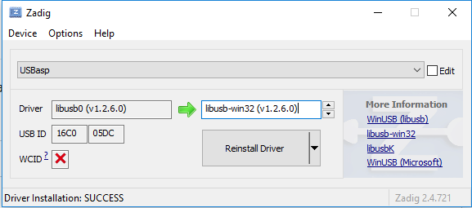[Zadig](https://zadig.akeo.ie/) to install libusb driver for USBasp