Automation of Weekly AGOL Audit Activity
PG&E | GIS Automation Initiative

1. Background / Problem Statement
The Geomart GIS team at PG&E conducts weekly ArcGIS Online (AGOL) audits to maintain a clean and well-governed environment by ensuring that all user accounts are active, properly licensed, and aligned with enterprise compliance standards.
Previously, the process of identifying and managing disabled AGOL accounts was entirely manual. It required downloading member reports from AGOL, filtering disabled enterprise users, verifying content ownership, and performing deletions or reassignments accordingly. This approach was time-consuming, prone to error, and required significant manual effort every week.

2. Objective
To automate the weekly AGOL audit process using ArcGIS API for Python, reducing manual intervention, improving accuracy, and ensuring efficient tracking of account management activities.

3. Solution Overview
A Python-based automation solution was developed to streamline the AGOL audit workflow. The process begins with downloading the AGOL members reports for both QA and PROD environments. Once the reports are available, the Python automation script processes them to identify disabled enterprise users, check for content ownership, and perform automated deletions or generate reports for manual review.
Key Features:
- - Manual download of AGOL members reports (QA & PROD).
- - Automatic processing of reports to identify disabled enterprise accounts.
- - Segregation of users into ‘No Content’ (auto-delete) and ‘With Content’ (manual review).
- - Automated updates to Excel logs with deletion timestamps.
- - Summary statistics shared with PG&E in centralized excel sheet for QA & PROD environments.

4. Automation Flow Diagram
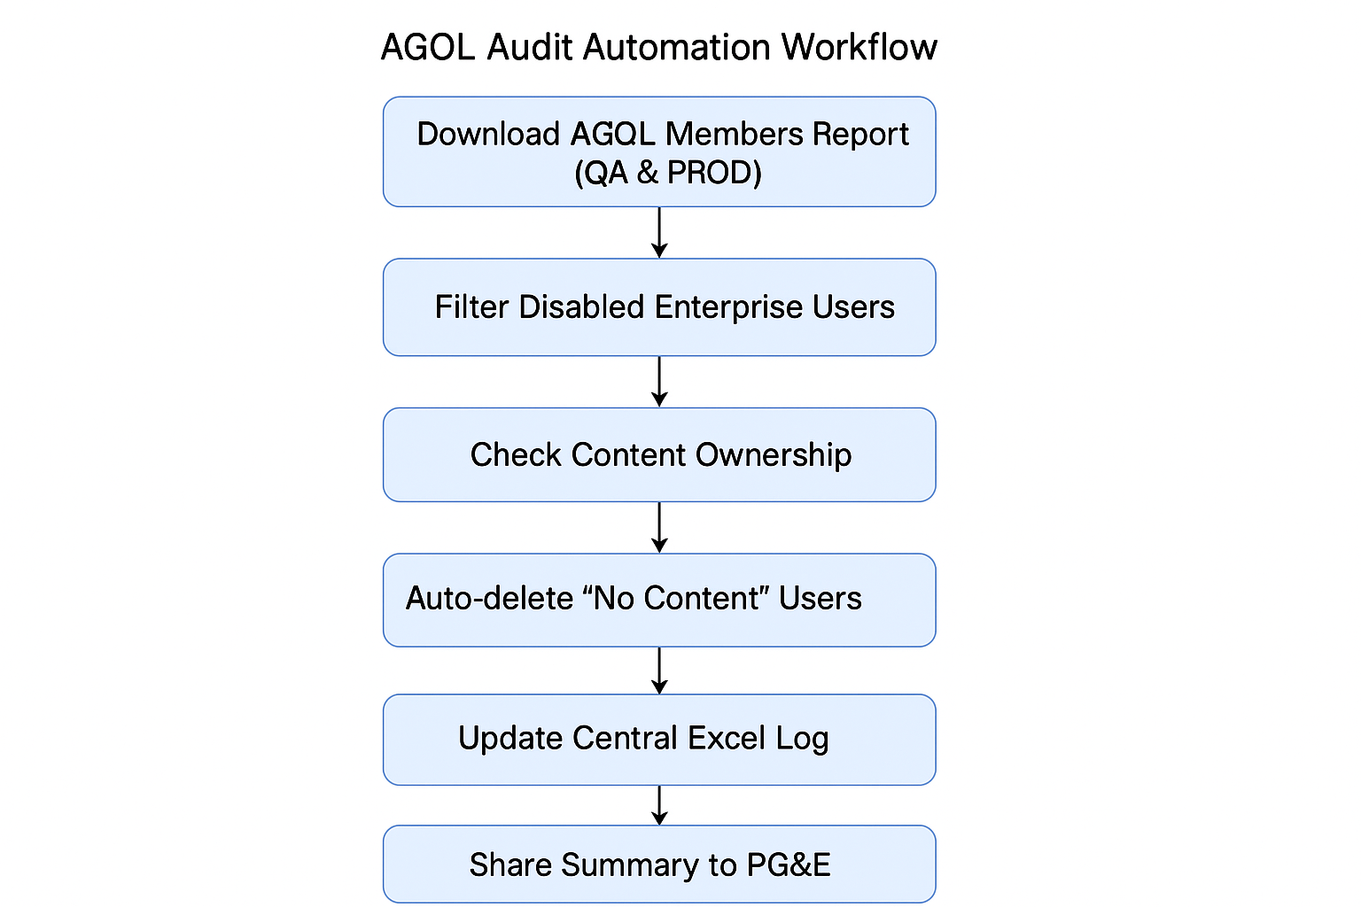
Figure 1: AGOL Audit Automation Workflow (Flow diagram placeholder)

5. Impact and Benefits
Parameter | Manual Process | Automated Process | Improvement
Weekly Effort | 6–8 hours/week | 30–45 mins/week | 80–90% reduction
Monthly Effort | 24–32 hrs/month | 2–3 hrs/month | ~90% time saved
Error Rate | 5–10% (manual filtering errors) | <1% | 90% accuracy improvement
Audit Tracking | Manual Excel updates | Auto-generated logs | 100% traceability
User Capacity | Limited (~500 users/run) | Handles 2K–3K users | High scalability
Bulk Deletion | Manual, limited | Fully automated | No limitations with proper token handling

6. Technical Implementation Summary
Technology Stack:
- ArcGIS API for Python
- Pandas (for Excel manipulation)
- OpenPyXL (for Excel operations)
- Scheduled execution via Windows Task Scheduler / Jenkins
Data Storage:
- A centralized Excel workbook stores audit results for both QA and PROD in separate sheets.
- This enables unified tracking, easier maintenance, and consistency across environments.

7. Conclusion
The AGOL Weekly Audit Automation has significantly optimized user account management for the GIS team. By automating the identification, deletion, and logging of disabled accounts, the process ensures accuracy, reduces manual workload, and maintains a clean, compliant AGOL environment.
This initiative supports PG&E’s broader goal of operational efficiency and governance compliance within GIS systems.

