FILE FORMAT 20

THE PAYMENT ORDER FILE
FILE FORMAT 20

THE PAYMENT ORDER FILE

CONTENTS

1. INTRODUCTION

1.1 General Approach

1.2 Usage and Data Standards

1.3 Payment Message Set

2. FILE STRUCTURE (MESSAGES AND SEGMENTS)

3. FILE STRUCTURE DIAGRAM

4. STANDARD MESSAGE FORMATS
FILE FORMAT 20
THE PAYMENT ORDER FILE

1. INTRODUCTION

1.1 General Approach

The provision of the Payment Order message and its associated set enables a payer to instruct his bank to make payments using electronic data interchange. This enables the business cycle to be completed using EDI. The use of this message does not require the payee to have an account at the payer's bank.

The general principles adopted are that:

I) payments in a file must be of one currency;
ii) payments must be made from accounts under the payer's control; and
iii) payments will be authenticated on a message by message basis by the payer.

The use of a Remittance Advice from payer to payee is recommended to enable the payment to be automatically reconciled.

1.2 Usage and Data Standards

The file has been designed to use UNGTDI construction which enables payment order messages to be batched within a payment order file.

Data elements have been defined to ensure that they are compatible with international standards and where codes are required bank industry standard codes have been applied whenever possible.

1.3 Payment Message Set

The payment order may result in the bank:
a) sending a debit advice to the payer when his instruction has been actioned;
b) sending an exception report to the payer if there is an error in the payment order. Depending on the severity, the payment message may or may not be actioned.

If the payment order cannot be actioned, the payer will receive an exception
report and no Debit Advice.

The transfer of funds will take place through banking industry standard methods. The payee may also receive a credit advice from the bank advising him that funds have been or will be received from the payer against a particular reference.
2. FILE STRUCTURE (MESSAGES AND SEGMENTS)

THE PAYMENT ORDER FILE

Message  PAYHDR  Payment Order File Header | Consisting of Segments  MHD = Message Header  TYP = Transaction Type Details  CDT = Customer Details  BDT = Bank Details  FIL = File Details  MTR = Message Trailer | Repeating as follows  One message only, at the start of the file
PAYINF  Payment Order Line Details | MHD = Message header  SDT = Supplier Details  SBK = Supplier's Bank Details  CBK = Customer's Bank Details  PYD = Payment Details  APD = Amount Payable  AUT = Authentication Result  MTR = Message Trailer | One message for each supplier payment
PAYTLR  Payment Order File Trailer | MHD = Message Header  TPM = Payment Message File Totals  MTR = Message Trailer | One message only, at the end of the file

NOTE: Every transmission must begin with segment STX and end with segment END.
3. FILE STRUCTURE DIAGRAM

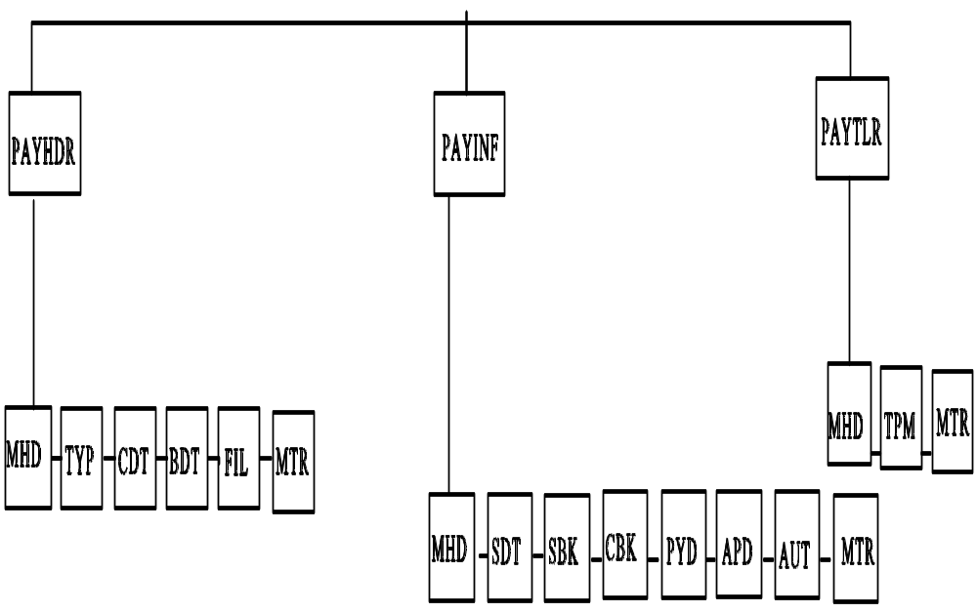

* Denotes repeating segment
FILE: PAYMENT ORDER FILE Page 1 of 3

SEGMENT |  |  | DATA  ELEMENT |  | DATA ELEMENT NAME | M/C | F/V | PICTURE | REMARKS  (See also General  Remarks in directory)
MHD | = |  |  |  | MESSAGE HEADER | M
 |  |  | MSRF |  | Message Reference | M | V | 9(12) | Consecutive count of messages within the transmission
 |  | + | TYPE | : | Type of Message  Type  Version Number | M  M  M | F  F | X(6)  9(1) | 'PAYHDR'  '3' for this version
TYP | = |  |  |  | TRANSACTION TYPE DETAILS | M
 |  |  | TCDE |  | Transaction Code | M | F | 9(4) | Code Values List 2; '0835'
 |  | + | TTYP |  | Transaction Type | C | V | X(12) | Code Values List 3
CDT | = |  |  |  | CUSTOMER DETAILS | M
 |  |  | CIDN | : | Customer's Identity  Customer's EAN Location Number  Customer's Identity Allocated by  Supplier | M  C  C | F  V | 9(13)  X(17) | EAN Location number identifying customer  Customer code as allocated/used by the supplier
 |  | + | CNAM |  | Customer's Name | C | V | X(40) | Customer's Legal Name

FILE: PAYMENT ORDER FILE Page 2 of 3

SEGMENT |  |  | DATA  ELEMENT |  | DATA ELEMENT NAME | M/C | F/V | PICTURE | REMARKS  (See also General  Remarks in directory)
 |  | + | CADD | :  :  :  : | Customer's Address  Customer's Address Line 1  Customer's Address Line 2  Customer's Address Line 3  Customer's Address Line 4  Customer's Post Code | C  C  C  C  C  C | V  V  V  V  V | X(35)  X(35)  X(35)  X(35)  X(8) | A maximum of five lines to give the customer's address
 |  | + | VATR | : | Customer's VAT Registration Number  Numeric VAT Registration Number  Alphanumeric VAT Registration  Number | C  C  C | F  V | 9(9)  X(17) | Trader's VAT number allocated by HM Customs & Excise  Government department or non-UK VAT number
BDT | = |  |  |  | BANK DETAILS | M
 |  |  | BKIC |  | Bank Identity Code | M | F | X(2) | Service Bank's own identity code
 |  | + | BNAM |  | Bank Name | C | V | X(35) | Service Bank/3rd Party Bank Name
 |  | + | SVID | : | Service Identity  Service Code  User Code | M  M  M | V  V | X(6)  X(8) | Name of service as allocated by Service Bank  Customer's user number as allocated by Bank

FILE: PAYMENT ORDER FILE Page 3 of 3
SEGMENT |  |  | DATA  ELEMENT |  | DATA ELEMENT NAME | M/C | F/V | PICTURE | REMARKS  (See also General  Remarks in directory)
 |  | + | BKIN |  | Bank Information | C | V | X(17) | Customer to Bank information, eg F/X Deal Number
 |  | + | CUIN |  | Currency Indicator | C | V | X(3) | Currency Code (List 31)
FIL | = |  |  |  | FILE DETAILS | M
 |  |  | FLGN |  | File Generation Number | M | V | 9(4) | This number is sequential per file type, per trading partner
 |  | + | FLVN |  | File Version Number | M | V | 9(4) | Original (which is always 1) is incremented by 1 for each additional copy created
 |  | + | FLDT |  | File Creation Date | M | F | 9(6) | Date the file is created.  Format: YYMMDD
 |  | + | FLID |  | File (Reel) Identification | C | V | X(6) | Reference on the outside of reel containing the file
MTR | = |  |  |  | MESSAGE TRAILER | M
 |  |  | NOSG |  | Number of Segments in Message | M | V | 9(10) | Control count of the number of segments comprising message. The count includes the MHD and MTR segments surrounding the message

FILE: PAYMENT ORDER FILE Page 1 of 4

SEGMENT |  |  | DATA  ELEMENT |  | DATA ELEMENT NAME | M/C | F/V | PICTURE | REMARKS  (See also General  Remarks in directory)
MHD | = |  |  |  | MESSAGE HEADER | M
 |  |  | MSRF |  | Message Reference | M | V | 9(12) | Consecutive count of messages within the transmission
 |  | + | TYPE | : | Type of Message  Type  Version Number | M  M  M | F  F | X(6)  9(1) | 'PAYINF'  '3' for this version
SDT | = |  |  |  | SUPPLIER DETAILS | M
 |  |  | SIDN | : | Supplier's Identity  Supplier's EAN Location Number  Supplier's Identity Allocated by  Customer | M  C  C | F  V | 9(13)  X(17) | EAN location number identifying the Supplier  Supplier's code as allocated/used by the customer
 |  | + | SNAM |  | Supplier's Name | C | V | X(40) | Supplier's Legal Name as printed on invoices
 |  | + | SADD | :  :  :  : | Supplier's Address  Supplier's Address Line 1  Supplier's Address Line 2  Supplier's Address Line 3  Supplier's Address Line 4  Supplier's Post Code | C  C  C  C  C  C | V  V  V  V  V | X(35)  X(35)  X(35)  X(35)  X8 | A maximum of five lines to give the supplier's address

FILE: PAYMENT ORDER FILE Page 2 of 4

SEGMENT |  |  | DATA  ELEMENT |  | DATA ELEMENT NAME | M/C | F/V | PICTURE | REMARKS  (See also General  Remarks in directory)
 |  | + | VATN | : | Supplier's VAT Registration Number  Numeric VAT Registration Number  Alphanumeric VAT Registration  Number | C  C  C | F  V | 9(9)  X(17) | Trader's VAT number allocated by HM Customs & Excise  Government department or non-UK VAT number
SBK | = |  |  |  | SUPPLIER'S BANK DETAILS | M
 |  |  | BBID |  | Bank/Branch Identifier | M | V | X(11) | eg Sort Code of receiving Bank
 |  | + | ACID | : | Account Identifier  Account Number  Account Name | M  M  C | V  V | X(17)  X(35) | Account to be credited
CBK | = |  |  |  | CUSTOMER'S BANK DETAILS | M
 |  |  | BBID |  | Bank/Branch Identifier | M | V | X(11) | eg Sort Code of remitting Bank
 |  | + | ACID | : | Account Identifier  Account Number  Account Name | M  M  C | V  V | X(17)  X(35) | Account to be debited

FILE: PAYMENT ORDER FILE Page 3 of 4

SEGMENT |  |  | DATA  ELEMENT |  | DATA ELEMENT NAME | M/C | F/V | PICTURE | REMARKS  (See also General  Remarks in directory)
PYD | = |  |  |  | PAYMENT DETAILS | M
 |  |  | PRRF | : | Primary Reference  Related message indicator  Primary Reference | M  M  M | F  V | X(1)  X(17) | To indicate related message:  A = Accompanying Remittance  Advice, I = Invoice, R = Remittance Advice, S = Statement, C = Credit  Note  Unique message reference, linking related messages
 |  | + | DATE |  | Date relating to message | M | F | 9(6) | Service Processing Date as agreed with Service Bank
 |  | + | SNIC |  | Supplier's Network Identity code | M | V | X(14) | Used by Bank to send message to supplier eg EAN location number
 |  | + | PAYM |  | Payment Method | C | V | X(6) | Express (or override) preference as defined by Bank
APD | = |  |  |  | AMOUNT PAYABLE | M
 |  |  | AMPY |  | Amount Payable | M | V | 9(13)V9(2) | Value with implied decimal point (eg in pence)

FILE: PAYMENT ORDER FILE Page 4 of 4

SEGMENT |  |  | DATA  ELEMENT |  | DATA ELEMENT NAME | M/C | F/V | PICTURE | REMARKS  (See also General  Remarks in directory)
AUT | = |  |  |  | AUTHENTICATION RESULT | C
 |  |  | AUTR | :  : | Authentication Result  Authentication Result 1  Authentication Result 2  Authentication Result 3 | M  M  C  C | V  V  V | X(70)  X(70)  X(70) | Results of authentication process specified by Bank
MTR | = |  |  |  | MESSAGE TRAILER | M
 |  |  | NOSG |  | Number of Segments in Message | M | V | 9(10) | Control count of the number of segments comprising message. The count includes the MHD and MTR segments surrounding the message

FILE: PAYMENT ORDER FILE Page 1 of 1

SEGMENT |  |  | DATA  ELEMENT |  | DATA ELEMENT NAME | M/C | F/V | PICTURE | REMARKS  (See also General  Remarks in directory)
MHD | = |  |  |  | MESSAGE HEADER | M
 |  |  | MSRF |  | Message Reference | M | V | 9(12) | Consecutive count of messages within the transmission
 |  | + | TYPE | : | Type of Message  Type  Version Number | M  M  M | F  F | X(6)  9(1) | 'PAYTLR'  '3' for this version
TPM | = |  |  |  | PAYMENT MESSAGE TOTALS | M
 |  |  | FTNP |  | File Total Number of Payment Messages | M | V | 9(10) | Number of 'PAYINF' Payment Detail Messages
 |  | + | TVLP |  | Total Value of Payment Messages | M | V | 9(13)V9(2) | Sum of all 'AMPY' segments in 'PAYINF' messages
MTR | = |  |  |  | MESSAGE TRAILER | M
 |  |  | NOSG |  | Number of Segments in Message | M | V | 9(10) | Control count of the number of segments comprising message. The count includes the MHD and MTR segments surrounding the message

