FILE FORMAT 22

THE CREDIT ADVICE FILE
FILE FORMAT 22

THE CREDIT ADVICE FILE

CONTENTS

1. INTRODUCTION

1.1 General Approach

1.2 Usage and Data Standards

1.3 Payment Message Set

2. FILE STRUCTURE (MESSAGES AND SEGMENTS)

3. FILE STRUCTURE DIAGRAM

4. STANDARD MESSAGE FORMATS
FILE FORMAT 22

THE CREDIT ADVICE FILE

1. INTRODUCTION

1.1 General Approach

The Credit Advice message will be sent by the bank to the payee to advise him that payment has been or will be received. It should enable the supplier (payee) to automatically reconcile the payment reported with the remittance advice or any other document through the primary reference.

1.2 Usage and Data Standards

Although the file allows batching, it is probable that each file will contain only one credit advice as the file is likely to be generated from individual payments or payment order messages.

The data elements have been defined to ensure that they are compatible with international standards and where codes are required, banking industry standards are applied wherever possible.

1.3 Payment Message Set

The Credit Advice transmission does not expect any response from the payee.
2. FILE STRUCTURE (MESSAGES AND SEGMENTS)

THE CREDIT ADVICE FILE

Message  CRAHDR  Credit Advice File Header | Consisting of Segments  MHD = Message Header  TYP = Transaction Type Details  SDT = Supplier Details  BDT = Bank Details  FIL = File Details  MTR = Message Trailer | Repeating as follows  One message only, at the start of the file
CRAINF  Credit Advice Line Details | MHD = Message header  CDT = Customer Details  SBK = Supplier's Bank Details  CBK = Customer's Bank Details  PYD = Payment Details  APD = Amount Payable  AUT = Authentication Result  MTR = Message Trailer | One message for each Credit Advice
CRATLR  Credit Advice File Trailer | MHD = Message Header  TCM = Credit Advice Message File Totals  MTR = Message Trailer | One message only, at the end of the file

NOTE: Every transmission must begin with segment STX and end with segment END
4. FILE STRUCTURE DIAGRAM

THE CREDIT ADVICE FILE
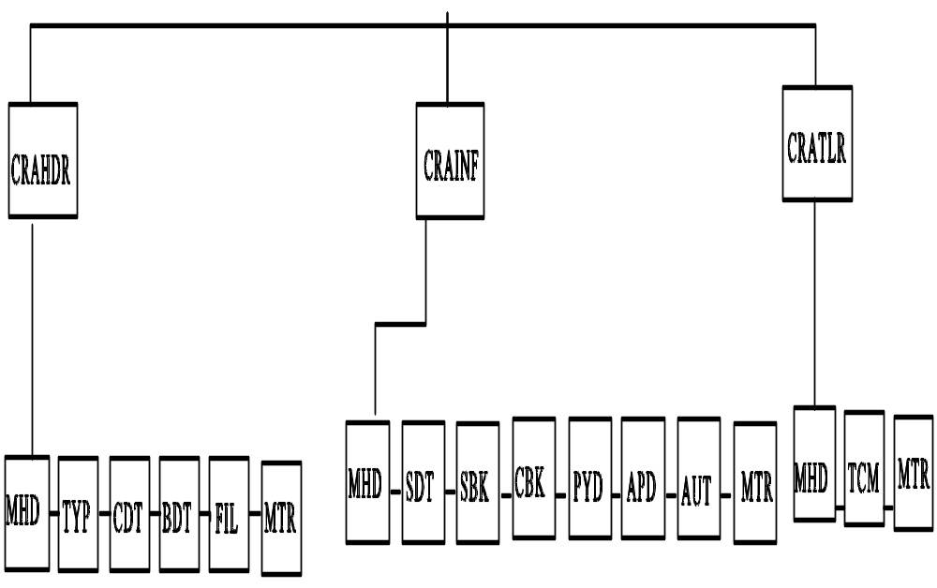

* Denotes repeating segment
FILE: CREDIT ADVICE FILE Page 1 of 3

SEGMENT |  |  | DATA  ELEMENT |  | DATA ELEMENT NAME | M/C | F/V | PICTURE | REMARKS  (See also General  Remarks in directory)
MHD | = |  |  |  | MESSAGE HEADER | M
 |  |  | MSRF |  | Message Reference | M | V | 9(12) | Consecutive count of messages within the transmission
 |  | + | TYPE | : | Type of Message  Type  Version Number | M  M  M | F  F | X(6)  9(1) | 'CRAHDR'  '3' for this version
TYP | = |  |  |  | TRANSACTION TYPE DETAILS | M
 |  |  | TCDE |  | Transaction Code | M | F | 9(4) | Code Values List 2; '0845'
 |  | + | TTYP |  | Transaction Type | C | V | X(12) | Code Values List 3
SDT | = |  |  |  | SUPPLIER DETAILS | M
 |  |  | SIDN | : | Supplier's Identity  Supplier's EAN Location Number  Supplier's Identity Allocated by  Customer | M  C  C | F  V | 9(13)  X(17) | EAN location number identifying supplier  Supplier code as allocated/used by the customer
 |  | + | SNAM |  | Supplier's Name | C | V | X(40) | Supplier's Legal Name as printed on invoices

FILE: CREDIT ADVICE FILE Page 2 of 3

SEGMENT |  |  | DATA  ELEMENT |  | DATA ELEMENT NAME | M/C | F/V | PICTURE | REMARKS  (See also General  Remarks in directory)
 |  | + | SADD | :  :  :  : | Supplier's Address  Supplier's Address Line 1  Supplier's Address Line 2  Supplier's Address Line 3  Supplier's Address Line 4  Supplier's Post Code | C  C  C  C  C  C | V  V  V  V  V | X(35)  X(35)  X(35)  X(35)  X(8) | A maximum of five lines to give the supplier's address
 |  | + | VATN | : | Supplier's VAT Registration Number  Numeric VAT Registration Number  Alphanumeric VAT Registration  Number | C  C  C | F  V | 9(9)  X(17) | Trader's VAT number allocated by HM Customs & Excise  Government department or non-UK VAT number
BDT | = |  |  |  | BANK DETAILS | M
 |  |  | BKIC |  | Bank Identity Code | M | F | X(2) | Service Bank's own identity code
 |  | + | BNAM |  | Bank Name | C | V | X(35) | Service Bank/3rd Party Bank Name
 |  | + | SVID | : | Service Identity  Service Code  User Code | M  M  M | V  V | X(6)  X(8) | Name of service as allocated by Service Bank  Customer's user number as allocated by Bank

FILE: CREDIT ADVICE FILE Page 3 of 3

SEGMENT |  |  | DATA  ELEMENT |  | DATA ELEMENT NAME | M/C | F/V | PICTURE | REMARKS  (See also General  Remarks in directory)
 |  | + | BKIN |  | Bank Information | C | V | X(17) | Customer to Bank information, eg F/X Deal Number
 |  | + | CUIN |  | Currency Indicator | C | V | X(3) | Currency Code (List 31)
FIL | = |  |  |  | FILE DETAILS | M
 |  |  | FLGN |  | File Generation Number | M | V | 9(4) | This number is sequential per file type, per trading partner
 |  | + | FLVN |  | File Version Number | M | V | 9(4) | Original (which is always 1) is incremented by 1 for each additional copy created
 |  | + | FLDT |  | File Creation Date | M | F | 9(6) | Date the file is created.  Format: YYMMDD
 |  | + | FLID |  | File (Reel) Identification | C | V | X(6) | Reference on the outside of reel containing the file
MTR | = |  |  |  | MESSAGE TRAILER | M
 |  |  | NOSG |  | Number of Segments in Message | M | V | 9(10) | Control count of segments including MHD and MTR

FILE: CREDIT ADVICE FILE Page 1 of 4

SEGMENT |  |  | DATA  ELEMENT |  | DATA ELEMENT NAME | M/C | F/V | PICTURE | REMARKS  (See also General  Remarks in directory)
MHD | = |  |  |  | MESSAGE HEADER | M
 |  |  | MSRF |  | Message Reference | M | V | 9(12) | Consecutive count of messages within the transmission
 |  | + | TYPE | : | Type of Message  Type  Version Number | M  M  M | F  F | X(6)  9(1) | 'CRAINF'  '3' for this version
CDT | = |  |  |  | CUSTOMER DETAILS | M
 |  |  | CIDN | : | Customer's Identity  Customer's EAN Location Number  Customer's Identity Allocated by  Supplier | M  C  C | F  V | 9(13)  X(17) | EAN location number identifying the customer  Customer's code as allocated/used by the supplier
 |  | + | CNAM |  | Customer's Name | C | V | X(40) | Customer's Legal Name
 |  | + | CADD | :  :  :  : | Customer's Address  Customer's Address Line 1  Customer's Address Line 2  Customer's Address Line 3  Customer's Address Line 4  Customer's Post Code | C  C  C  C  C  C | V  V  V  V  V | X(35)  X(35)  X(35)  X(35)  X(8) | A maximum of five lines to give the customer's address

FILE: CREDIT ADVICE FILE Page 2 of 4

SEGMENT |  |  | DATA  ELEMENT |  | DATA ELEMENT NAME | M/C | F/V | PICTURE | REMARKS  (See also General  Remarks in directory)
 |  | + | VATR | : | Customer's VAT Registration Number  Numeric VAT Registration Number  Alphanumeric VAT Registration  Number | C  C  C | F  V | 9(9)  X(17) | Trader's VAT number allocated by HM Customs & Excise  Government department or non-UK VAT number
SBK | = |  |  |  | SUPPLIER'S BANK DETAILS | M
 |  |  | BBID |  | Bank/Branch Identifier | M | V | X(11) | eg Sort Code of receiving Bank
 |  | + | ACID | : | Account Identifier  Account Number  Account Name | M  M  C | V  V | X(17)  X(35) | Account to be credited
CBK | = |  |  |  | CUSTOMER'S BANK DETAILS | M
 |  |  | BBID |  | Bank/Branch Identifier | M | V | X(11) | eg Sort Code of remitting Bank
 |  | + | ACID | : | Account Identifier  Account Number  Account Name | M  M  C | V  V | X(17)  X(35) | Account to be debited

FILE: CREDIT ADVICE FILE Page 3 of 4

SEGMENT |  |  | DATA  ELEMENT |  | DATA ELEMENT NAME | M/C | F/V | PICTURE | REMARKS  (See also General  Remarks in directory)
PYD | = |  |  |  | PAYMENT DETAILS | M
 |  |  | PRRF | : | Primary Reference  REMADV/PAYORD indicator  Primary Reference | M  M  M | F  V | X(1)  X(17) | To indicate related message:  A = Accompanying Remittance Advice, I = Invoice, R = Remittance Advice, S = Statement  Unique message reference, linking related messages
 |  | + | DATE |  | Date relating to message | M | F | 9(6) | Date of Credit Entry  Format: YYMMDD
 |  | + | SNIC |  | Supplier's Network Identity code | M | V | X(14) | Used by Bank to send message to supplier eg ANA location code
 |  | + | PAYM |  | Payment Method | C | V | X(6) | Express (or override) preference as defined by Bank
APD | = |  |  |  | AMOUNT PAYABLE | M
 |  |  | AMPY |  | Amount Payable | M | V | 9(13)V9(2) | Value with implied decimal point (eg in pence)

FILE: CREDIT ADVICE FILE Page 4 of 4

SEGMENT |  |  | DATA  ELEMENT |  | DATA ELEMENT NAME | M/C | F/V | PICTURE | REMARKS  (See also General  Remarks in directory)
AUT | = |  |  |  | AUTHENTICATION RESULT | C
 |  |  | AUTR | :  : | Authentication Result  Authentication Result 1  Authentication Result 2  Authentication Result 3 | M  M  C  C | V  V  V | X(70)  X(70)  X(70) | Results of authentication process specified by Bank
MTR | = |  |  |  | MESSAGE TRAILER | M
 |  |  | NOSG |  | Number of Segments in Message | M | V | 9(10) | Control count of segments including MHD and MTR

FILE: CREDIT ADVICE FILE Page 1 of 1

SEGMENT |  |  | DATA  ELEMENT |  | DATA ELEMENT NAME | M/C | F/V | PICTURE | REMARKS  (See also General  Remarks in directory)
MHD | = |  |  |  | MESSAGE HEADER | M
 |  |  | MSRF |  | Message Reference | M | V | 9(12) | Consecutive count of messages within the transmission
 |  | + | TYPE | : | Type of Message  Type  Version Number | M  M  M | F  F | X(6)  9(1) | 'CRATLR'  '3' for this version
TCM | = |  |  |  | CREDIT ADVICE MESSAGE TOTALS | M
 |  |  | FTNC |  | File Total Number of Credit Advice Messages | M | V | 9(10) | Number of 'CRAINF' Credit Advice Messages
 |  | + | TVLC |  | Total Value of Credit Advice Messages | M | V | 9(13)V9(2) | Sum of all 'AMPY' segments in 'CRAINF' messages
MTR | = |  |  |  | MESSAGE TRAILER | M
 |  |  | NOSG |  | Number of Segments in Message | M | V | 9(10) | Control count of segments including MHD and MTR

