FILE FORMAT 23

THE EXCEPTION CONDITION FILE
FILE FORMAT 23

THE EXCEPTION CONDITION FILE

CONTENTS

1. INTRODUCTION

1.1 General Approach

1.2 Usage and Data Standards

1.3 Payment Message Set

2. FILE STRUCTURE (MESSAGES AND SEGMENTS)

3. FILE STRUCTURE DIAGRAM

4. STANDARD MESSAGE FORMATS
FILE FORMAT 23

THE EXCEPTION CONDITION FILE

1. INTRODUCTION

1.1 General Approach

The Exception Report allows the bank to advise the payer that there is a problem with a particular payment order. This may be that the payment could not be made, or that there is data in the payment message which is incorrect but does not stop payment. This latter advice should be noted for future payment order preparation.

1.2 Usage and Data Standards

Each payment order may be subject to an exception report. Each Exception Report message may include one or more exception conditions against a particular payment order.

The data elements have been defined to ensure that they are compatible with international standards and where codes are required, banking industry standard codes have been applied wherever possible.

1.3 Payment Message Set

The Exception Report file will only be generated and sent where an error condition is found. Receipt of this may cause a payer to have to resubmit his payment order message, if the error is such that the bank was unable to make payment, or to amend his preparation technique if a "technical" error was reported.
2. FILE STRUCTURE (MESSAGES AND SEGMENTS)

THE EXCEPTION CONDITION FILE

Message  EXCHDR  Exception Condition File Header | Consisting of Segments | Repeating as follows
Message  EXCHDR  Exception Condition File Header | MHD = Message Header | One message only, at the start of the file
Message  EXCHDR  Exception Condition File Header | TYP = Transaction Type Details
Message  EXCHDR  Exception Condition File Header | CDT = Customer Details
Message  EXCHDR  Exception Condition File Header | BDT = Bank Details
Message  EXCHDR  Exception Condition File Header | FIL = File Details
Message  EXCHDR  Exception Condition File Header | MTR = Message Trailer
EXCINF  Exception Condition Line Details | MHD = Message Header | One message for each Exception Condition Message
EXCINF  Exception Condition Line Details | SDT = Supplier Details
EXCINF  Exception Condition Line Details | PYD = Payment Details
EXCINF  Exception Condition Line Details | EXC = Exception Condition(s) | Repeatable
EXCINF  Exception Condition Line Details | AUT = Authentication Result
EXCINF  Exception Condition Line Details | MTR = Message Trailer
EXCTLR  Exception Condition File Trailer | MHD = Message Header | One message only, at the end of the file
EXCTLR  Exception Condition File Trailer | TEM = Exception Condition Message File Totals
EXCTLR  Exception Condition File Trailer | MTR = Message Trailer

NOTE: Every transmission must begin with segment STX and end with segment END.
4. FILE STRUCTURE DIAGRAM

THE EXCEPTION CONDITION FILE
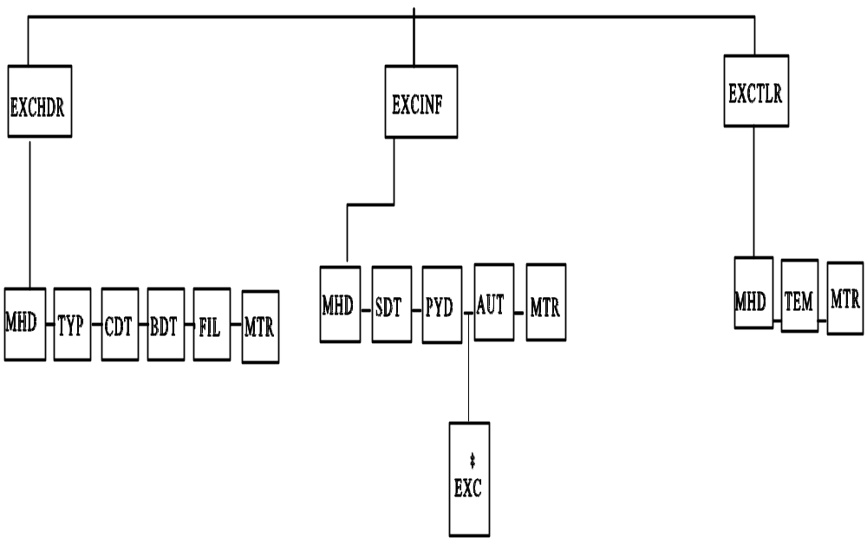

* Denotes repeating segment
FILE: EXCEPTION CONDITION FILE Page 1 of 3

SEGMENT |  |  | DATA  ELEMENT |  | DATA ELEMENT NAME | M/C | F/V | PICTURE | REMARKS  (See also General  Remarks in directory)
MHD | = |  |  |  | MESSAGE HEADER | M
 |  |  | MSRF |  | Message Reference | M | V | 9(12) | Consecutive count of messages within the transmission
 |  | + | TYPE | : | Type of Message  Type  Version Number | M  M  M | F  F | X(6)  9(1) | 'EXCHDR'  '3' for this version
TYP | = |  |  |  | TRANSACTION TYPE DETAILS | M
 |  |  | TCDE |  | Transaction Code | M | F | 9(4) | Code Values List 2; '0850'
 |  | + | TTYP |  | Transaction Type | C | V | X(12) | Code Values List 3
CDT | = |  |  |  | CUSTOMER DETAILS | M
 |  |  | CIDN | : | Customer's Identity  Customer's EAN Location Number  Customer's Identity Allocated by  Supplier | M  C  C | F  V | 9(13)  X(17) | EAN location number identifying customer  Customer code as allocated/used by the supplier
 |  | + | CNAM |  | Customer's Name | C | V | X(40) | Customer's Legal Name

FILE: EXCEPTION CONDITION FILE Page 2 of 3

SEGMENT |  |  | DATA  ELEMENT |  | DATA ELEMENT NAME | M/C | F/V | PICTURE | REMARKS  (See also General  Remarks in directory)
 |  | + | CADD | :  :  :  : | Customer's Address  Customer's Address Line 1  Customer's Address Line 2  Customer's Address Line 3  Customer's Address Line 4  Customer's Post Code | C  C  C  C  C  C | V  V  V  V  V | X(35)  X(35)  X(35)  X(35)  X(8) | A maximum of five lines to give the customer's address
 |  | + | VATR | : | Customer's VAT Registration Number  Numeric VAT Registration Number  Alphanumeric VAT Registration  Number | C  C  C | F  V | 9(9)  X(17) | Trader's VAT number allocated by HM Customs & Excise  Government department or non-UK VAT number
BDT | = |  |  |  | BANK DETAILS | M
 |  |  | BKIC |  | Bank Identity Code | M | F | X(2) | Service Bank's own identity code
 |  | + | BNAM |  | Bank Name | C | V | X(35) | Service Bank/3rd Party Bank Name
 |  | + | SVID | : | Service Identity  Service Code  User Code | M  M  M | V  V | X(6)  X(8) | Name of service as allocated by Service Bank  Customer's user number as allocated by Bank

FILE: EXCEPTION CONDITION FILE Page 3 of 3

SEGMENT |  |  | DATA  ELEMENT |  | DATA ELEMENT NAME | M/C | F/V | PICTURE | REMARKS  (See also General  Remarks in directory)
 |  | + | BKIN |  | Bank Information | C | V | X(17) | Customer to Bank information, eg F/X Deal Number
 |  | + | CUIN |  | Currency Indicator | C | V | X(3) | Currency Code (List 31)
FIL | = |  |  |  | FILE DETAILS | M
 |  |  | FLGN |  | File Generation Number | M | V | 9(4) | This number is sequential per file type, per trading partner
 |  | + | FLVN |  | File Version Number | M | V | 9(4) | Original (which is always 1) is incremented by 1 for each additional copy created
 |  | + | FLDT |  | File Creation Date | M | F | 9(6) | Date the file is created.  Format: YYMMDD
 |  | + | FLID |  | File (Reel) Identification | C | V | X(6) | Reference on the outside of reel containing the file
MTR | = |  |  |  | MESSAGE TRAILER | M
 |  |  | NOSG |  | Number of Segments in Message | M | V | 9(10) | Control count of segments including MHD and MTR

FILE: EXCEPTION CONDITION FILE Page 1 of 4

SEGMENT |  |  | DATA  ELEMENT |  | DATA ELEMENT NAME | M/C | F/V | PICTURE | REMARKS  (See also General  Remarks in directory)
MHD | = |  |  |  | MESSAGE HEADER | M
 |  |  | MSRF |  | Message Reference | M | V | 9(12) | Consecutive count of messages within the transmission
 |  | + | TYPE | : | Type of Message  Type  Version Number | M  M  M | F  F | X(6)  9(1) | 'EXCINF'  '3' for this version
SDT | = |  |  |  | SUPPLIER DETAILS | M
 |  |  | SIDN | : | Supplier's Identity  Supplier's EAN Location Number  Supplier's Identity Allocated by  Customer | M  C  C | F  V | 9(13)  X(17) | EAN location number identifying the supplier  Supplier's code as allocated/used by the customer
 |  | + | SNAM |  | Supplier's Name | C | V | X(40) | Supplier's Legal Name as printed on invoices
 |  | + | SADD | :  :  :  : | Supplier's Address  Supplier's Address Line 1  Supplier's Address Line 2  Supplier's Address Line 3  Supplier's Address Line 4  Supplier's Post Code | C  C  C  C  C  C | V  V  V  V  V | X(35)  X(35)  X(35)  X(35)  X8 | A maximum of five lines to give the supplier's address

FILE: EXCEPTION CONDITION FILE Page 2 of 4

SEGMENT |  |  | DATA  ELEMENT |  | DATA ELEMENT NAME | M/C | F/V | PICTURE | REMARKS  (See also General  Remarks in directory)
 |  | + | VATN | : | Supplier's VAT Registration Number  Numeric VAT Registration Number  Alphanumeric VAT Registration  Number | C  C  C | F  V | 9(9)  X(17) | Trader's VAT number allocated by HM Customs & Excise  Government department or non-UK VAT number
PYD | = |  |  |  | PAYMENT DETAILS | M
 |  |  | PRRF | : | Primary Reference  REMADV/PAYORD indicator  Primary Reference | M  M  M | F  V | X(1)  X(17) | To indicate related message:  A = Accompanying Remittance Advice, I = Invoice, R = Remittance Advice, S = Statement  Unique message reference, linking related messages
 |  | + | DATE |  | Date relating to message | M | F | 9(6) | Date of Exception Message  Format YYMMDD
 |  | + | SNIC |  | Supplier's Network Identity Code | M | V | X(14) | Used by Bank to send message to supplier, eg EAN Location Number
 |  | + | PAYM |  | Payment Method | C | V | X(6) | Express (or override) preference as defined by Bank

FILE: EXCEPTION CONDITION FILE Page 3 of 4

SEGMENT |  |  | DATA  ELEMENT |  | DATA ELEMENT NAME | M/C | F/V | PICTURE | REMARKS  (See also General  Remarks in directory)
EXC | = |  |  |  | EXCEPTION CONDITIONS | M |  |  | Repeatable for each exception condition to be reported
 |  |  | SEQA |  | Exception Sequence Number | M | V | 9(10) | Start at 1, incremented by 1 for each EXC segment in message
 |  | + | AEXC | : | Area of Exception Condition  Area of Exception Condition  Repeat of original content | C  M  C | F  V | X(13)  X(53) | Name of Message (M), Segment (S) and Element (E) in format:  MMMMMMSSSEEEE  Repeated content of original element
 |  | + | ECOD |  | Exception Code | M | F | X(4) | Exception Code as agreed with Service Bank
 |  | + | ETXT |  | Exception Text | C | V | X(35) | Free format text for Exception Condition not coded
AUT | = |  |  |  | AUTHENTICATION RESULT | C
 |  |  | AUTR | :  : | Authentication Result  Authentication Result 1  Authentication Result 2  Authentication Result 3 | M  M  C  C | V  V  V | X(70)  X(70)  X(70) | Results of authentication process specified by Bank

FILE: EXCEPTION CONDITION FILE Page 4 of 4

SEGMENT |  |  | DATA  ELEMENT |  | DATA ELEMENT NAME | M/C | F/V | PICTURE | REMARKS  (See also General  Remarks in directory)
MTR | = |  |  |  | MESSAGE TRAILER | M
 |  |  | NOSG |  | Number of Segments in Message | M | V | 9(10) | Control count of segments including MHD and MTR

FILE: EXCEPTION CONDITION FILE Page 1 of 1

SEGMENT |  |  | DATA  ELEMENT |  | DATA ELEMENT NAME | M/C | F/V | PICTURE | REMARKS  (See also General  Remarks in directory)
MHD | = |  |  |  | MESSAGE HEADER | M
 |  |  | MSRF |  | Message Reference | M | V | 9(12) | Consecutive count of messages within the transmission
 |  | + | TYPE | : | Type of Message  Type  Version Number | M  M  M | F  F | X(6)  9(1) | 'EXCTLR'  '3' for this version
TEM | = |  |  |  | EXCEPTION CONDITION MESSAGE FILE TOTALS | M
 |  |  | FTNE |  | File Total Number of Exception Condition Messages | M | V | 9(10) | Number of 'EXCINF' Exception Condition Messages
MTR | = |  |  |  | MESSAGE TRAILER | M
 |  |  | NOSG |  | Number of Segments in Message | M | V | 9(10) | Control count of segments including MHD and MTR

