FILE FORMAT 16

THE GENERAL COMMUNICATIONS FILE
FILE FORMAT 16

THE GENERAL COMMUNICATIONS FILE

CONTENTS

1. INTRODUCTION

2. ADDITIONAL NOTES

2.1 Addressing the Message

2.2 Length of Text

3. FILE STRUCTURE (MESSAGES AND SEGMENTS)

4. FILE STRUCTURE DIAGRAM

5. STANDARD MESSAGE FORMATS
FILE FORMAT 16

THE GENERAL COMMUNICATIONS FILE

1. INTRODUCTION

The General Text Message formats are designed to facilitate electronic exchange of plain language information. They provide a means of communicating messages, memos, letters, reports and any free-form business correspondence that needs to be transmitted.

2. ADDITIONAL NOTES

2.1 Addressing the Message

The recipient of the transmission is identified in the STX segment, using the EAN location number. Details of the precise location within the recipient's organisation are contained in the General Communications file header. Individual messages within a transmission can also be directed to specific people or departments by the use of code or plain language names. For example, codes can be used to distribute the messages automatically to specific terminals or printing areas.

2.2 Length of Text

The length of text that can be transmitted is virtually unlimited because the text element can be repeated up to 9,999,999,999 times within the text segment.
3. FILE STRUCTURE (MESSAGES AND SEGMENTS)

GENERAL COMMUNICATIONS FILE

Message  GENHDR  General Communications File Header | Consisting of Segments | Repeating as follows
Message  GENHDR  General Communications File Header | MHD = Message Header | One message only, at the start of the file
Message  GENHDR  General Communications File Header | CPT = Communicating Partners
Message  GENHDR  General Communications File Header | FIL = File Details
Message  GENHDR  General Communications File Header | MTR = Message Trailer
GENERAL  General Communications Text | MHD = Message Header | One message for each destination within recipient company
GENERAL  General Communications Text | MED = Message Details
GENERAL  General Communications Text | TXT = Text | Repeat for every 50 characters of text
GENERAL  General Communications Text | MTR = Message Trailer
GENTLR  General Communications Trailer | MHD = Message Header | One message only, at the end of the file
GENTLR  General Communications Trailer | GFT = General Communications File Total
GENTLR  General Communications Trailer | MTR = Message Trailer

NOTE: Every transmission must begin with segment STX and end with segment END.
4. FILE STRUCTURE DIAGRAM

THE GENERAL COMMUNICATIONS FILE
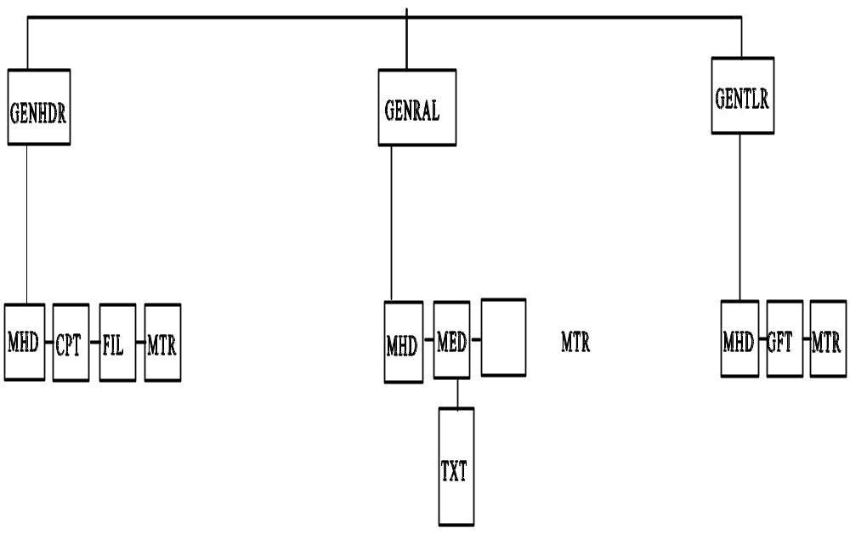

* Denotes repeating segment.
FILE: GENERAL COMMUNICATIONS FILE Page 1 of 2

SEGMENT |  |  | DATA  ELEMENT |  | DATA ELEMENT NAME | M/C | F/V | PICTURE | REMARKS  (See also General  Remarks in directory)
MHD | = |  |  |  | MESSAGE HEADER | M
 |  |  | MSRF |  | Message Reference | M | V | 9(12) | Consecutive count of messages within the transmission
 |  | + | TYPE | : | Type of Message  Type  Version Number | M  M  M | F  F | X(6)  9(1) | 'GENHDR'  '3' for this version
CPT | = |  |  |  | COMMUNICATING PARTNERS | M
 |  |  | SEID | : | Sender's Identity  Sender's EAN Location Number  Sender's Own Identity Code | M  C  C | F  V | 9(13)  X(17) | EAN Location number identifying sender  Sender's identification allocated/used by sender
 |  | + | REID | : | Recipient's Identity  Recipient's EAN Location Number  Recipient's Own Identity Code | M  C  C | F  V | 9(13)  X(17) | Used to direct the message from the transmission reception point  EAN Location number identifying recipient  Recipient identification as used by sender

FILE: GENERAL COMMUNICATIONS FILE Page 2 of 2

SEGMENT |  |  | DATA  ELEMENT |  | DATA ELEMENT NAME | M/C | F/V | PICTURE | REMARKS  (See also General  Remarks in directory)
FIL | = |  |  |  | FILE DETAILS | M
 |  |  | FLGN |  | File Generation Number | M | V | 9(4) | This number is sequential, per file type, per trading partner
 |  | + | FLVN |  | File Version Number | M | V | 9(4) | Original (which is always 1) is incremented by 1 for each additional copy created. May be zero-filled in this message if generation number is not needed
 |  | + | FLDT |  | File Creation Date | M | F | 9(6) | Date the file is created. Format YYMMDD
 |  | + | FLID |  | File (Reel) Identification | C | V | X(6) | Reference on the outside of the reel containing the file
MTR | = |  |  |  | MESSAGE TRAILER | M
 |  |  | NOSG |  | Number of Segments in Message | M | V | 9(10) | Control count of the number of segments comprising message. The count includes the MHD and MTR segments surrounding the message

FILE: GENERAL COMMUNICATIONS FILE Page 1 of 2

SEGMENT |  |  | DATA  ELEMENT |  | DATA ELEMENT NAME | M/C | F/V | PICTURE | REMARKS  (See also General  Remarks in directory)
MHD | = |  |  |  | MESSAGE HEADER | M
 |  |  | MSRF |  | Message Reference | M | V | 9(12) | Consecutive count of messages within the transmission
 |  | + | TYPE | : | Type of Message  Type  Version Number | M  M  M | F  F | X(6)  9(1) | 'GENERAL'  '3' for this version
MED | = |  |  |  | MESSAGE DETAILS | M
 |  |  | METO | :  : | Message to  EAN Location Number of Department  of Person  Title of Person  Name of Department of Person | M  C  C  C | F  V  V | 9(13)  X(40)  X(40) | EAN Location number for point for which message is intended  Formal title of person for whom message is intended  Plain language description
 |  | + | MEDT | : | Message Date and Time  Date of Message  Time of Message | M  M  C | F  F | 9(6)  9(6) | Date of message (rather than transmission).  Format: YYMMDD  Time of message (rather than transmission).  Format: HHMMSS

FILE: GENERAL COMMUNICATIONS FILE Page 2 of 2

SEGMENT |  |  | DATA  ELEMENT |  | DATA ELEMENT NAME | M/C | F/V | PICTURE | REMARKS  (See also General  Remarks in directory)
TXT | = |  |  |  | TEXT | M
 |  |  | SEQA |  | First Level Sequence Number | M | V | 9(10) | Sequence number starting at 1 within each message and incremented by 1 for each TXT segment in the message
 |  | + | TEXT |  | Text | M | V | X(50) | Any text not containing data for computer processing
MTR | = |  |  |  | MESSAGE TRAILER | M
 |  |  | NOSG |  | Number of Segments in Message | M | V | 9(10) | Control count of the number of segments comprising message. The count includes the MHD and MTR segments surrounding the message

FILE: GENERAL COMMUNICATIONS FILE Page 1 of 1

SEGMENT |  |  | DATA  ELEMENT |  | DATA ELEMENT NAME | M/C | F/V | PICTURE | REMARKS  (See also General  Remarks in directory)
MHD | = |  |  |  | MESSAGE HEADER | M
 |  |  | MSRF |  | Message Reference | M | V | 9(12) | Consecutive count of messages within the transmission
 |  | + | TYPE | : | Type of Message  Type  Version Number | M  M  M | F  F | X(6)  9(1) | 'GENTLR'  '3' for this version
GFT | = |  |  |  | GENERAL COMMUNICATIONS FILE TOTALS | M
 |  |  | NOTX |  | Number of Text Segments | M | V | 9(10) | Number of TXT segments in the file
MTR | = |  |  |  | MESSAGE TRAILER | M
 |  |  | NOSG |  | Number of Segments in Message | M | V | 9(10) | Control count of the number of segments comprising message. The count includes the MHD and MTR segments

