**Lab 08 – Temporal Analysis / Landscape Disturbance**

# Introduction

Temporal analysis can take many forms with remotely sensed images. But, generally speaking, it will either:

1. Attempt to determine trends in some metric (like NDVI)
2. Make a comparison between a specific year and the previous year (or years).
3. Compare thematic land cover/use classifications between two different years

The method that you use, like everything else, depends on what you want to analyze.

For instance. The plot below shows the NDVI value for a single pixel in a collection of MODIS images between 2010 and 2019.

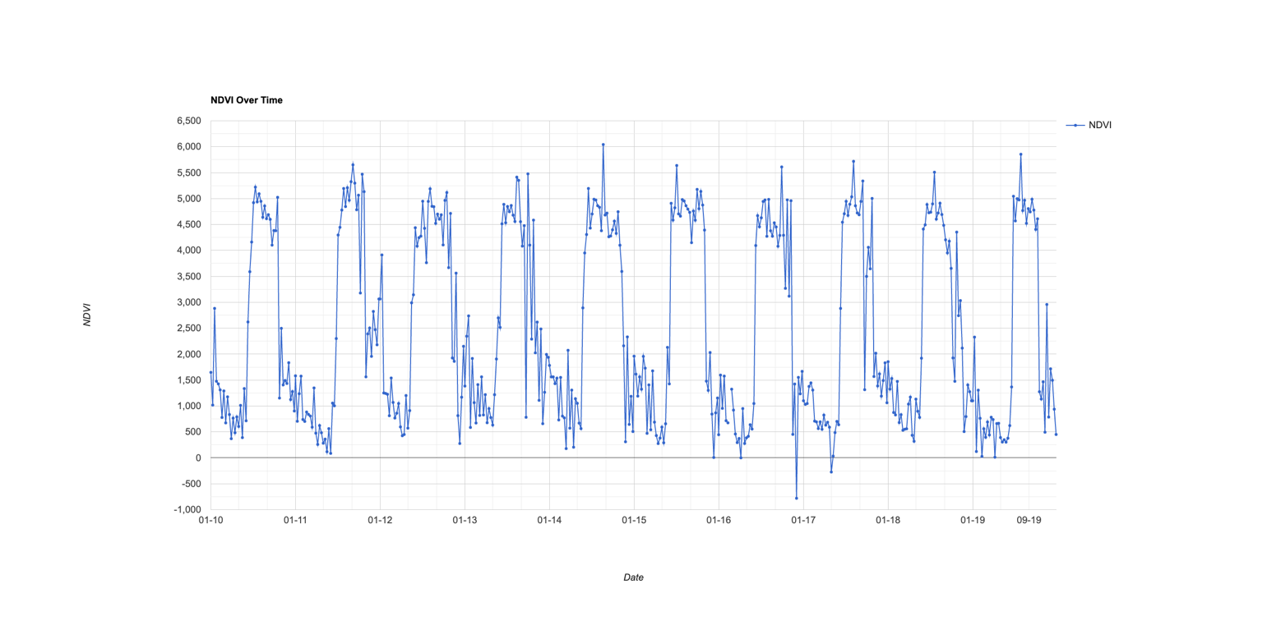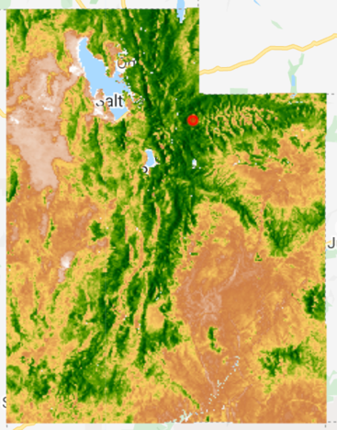

From this we can analyze possible changes in the intensity and timing of greenness across those years.

[**Click here for the script**](https://code.earthengine.google.com/1f2a373ddbe7c976da79e834ff980fd2)

Another method is to visualize changes in a landscape by comparing the current year (or the year you want) to the preceding years and identifying areas that have changed.

[**Here’s a script that will do that**](https://code.earthengine.google.com/dff802bc9ea0bd81231213b3641e5b27)

This script was inspired by a paper (Mildrexler, et al., 2007 - Ecological Applications) that described an **disturbance index** derived from Landsat imagery where the metric is derived from a ratio between the amount of greenness (NDVI) and the land surface temperature (LST) measured in Co. In this case, since NDVI has a -1 to 1 range, it is scaled by multiplying by 100 to better match the scale of Co. Thus:

LST / (NDVI * 100)

This metric can be calculated for every pixel and for any year or sequence of years.

Therefore, if for any given year, we calculate this metric for every image in our collection and then extract the maximum value of each for a given year (maximum yearly NDVI and LST) we can compare this index across years.

The rationale for this index is that as NDVI increases, we should have more vegetation cover which produces more shading as well as evapotranspiration which should act to reduce the LST. Combining both numbers into a metric should provide an indication of the type of vegetation we have.

The script calculates the index for each year and then compares a given year to the average index for all preceding years.

The output is a normalized difference between the current year and the average of all preceding years.

(Current Year – average of all preceding years)

(Current Year + average of all preceding years)

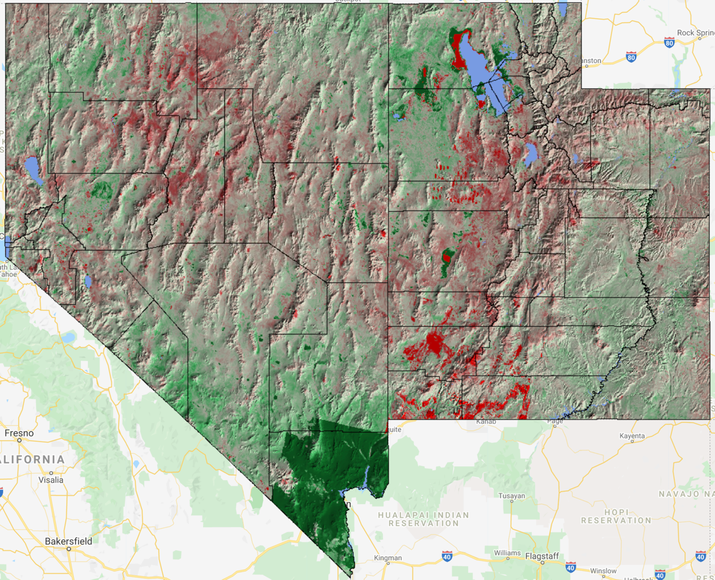The resulting image shows areas where the disturbance in 2020 is high compared to the previous 36 years (1984-2019) in red and where it’s lower in green (not sure what is going on in the Las Vegas area – looks like an imagery problem)

What are these disturbances?? We don’t know. It could be due to fire, changes in land use, or possibly just a dry year compared to the norm. To determine what the change in disturbance was we would need to examine imagery for the specific area of change (could prob do this with Google Earth)

**Assignment:**

1. Using the disturbance index, inspect the charts for any given pixel. Are there any “peaks” across the years?
   1. What could be causing those peaks? (review how that index was generated (LST / (NDVI * 100))
2. In the section of the script that generates the charts, change the chart to show LST, NDVI, or all three (Disturbance, LST, NDVI) at the same time.
   1. If you show all three parameters, can you explain some of the anomalies? Do they make sense?
3. Alter the year you want to look at. I have the script written for 2020.
   1. Do the disturbances change?